
Photogrammetry Tool - 3D Reconstruction
by Robotics Society

Abstract:
This project develops a low-cost photogrammetry tool that automates 3D model reconstruction. It uses a rotating platform and a vertically movable camera pointing towards the model. Designed with affordable components and Arduino control, it offers applications in product design, education, cultural preservation and 3D printing, making 3D scanning accessible to learners.

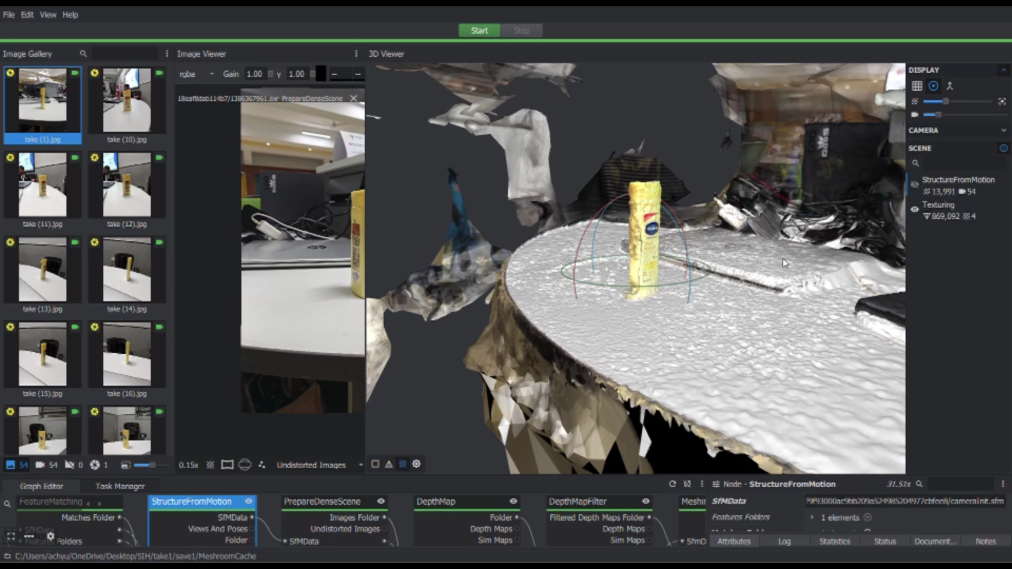
Subject 3D Reconstruction
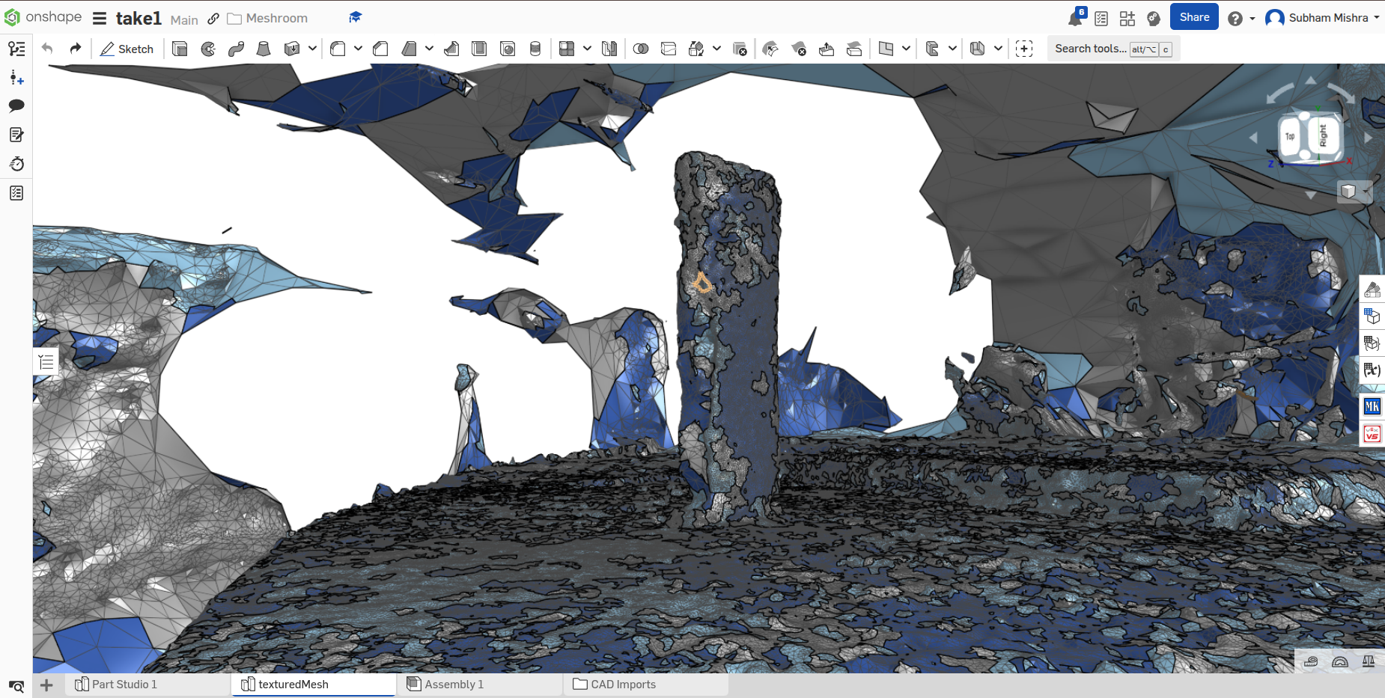
Mesh view in CAD Software

Approach:
The system uses a rotating subject plate
and a vertically movable camera mount, both driven by stepper motors and
controlled with an Arduino Nano and some drivers. As the object rotates, the camera captures images from multiple angles and heights. These images are then processed with photogrammetry software to reconstruct an accurate 3D digital model.

Design:
The tool is built with an aluminium extrusion frame supporting a rotating subject plate and a lead screw based vertical camera mount. Stepper motors provide

precise motion, controlled by an Arduino Nano and motor drivers. Key parts like the camera holder and subject plate are 3D-printed, while standard electronic components ensure affordability and easy replication.
We have acquired the design patent for this device.
Design Patent No: 461664-001
🔗 Certificate

Applications:
- Product Design & Prototyping: Quick 3D model generation for analysis and refinement.
- Education: Hands-on learning of 3D modeling, mechanics and image processing.
- 3D Printing: Scanning real objects for reproduction using 3D printers.
- Animation & Game Design: Creating accurate 3D assets from physical objects.

Future Aspects/Goals:
- Dual-axis camera movement for broader angle coverage.
- CNC machined parts to improve strength and precision.
- Infrared lighting for better image quality in low light.
- Wireless image transfer using Raspberry Pi integration.

Project By:
Shanti Sworup Biswal, Subham Mishra
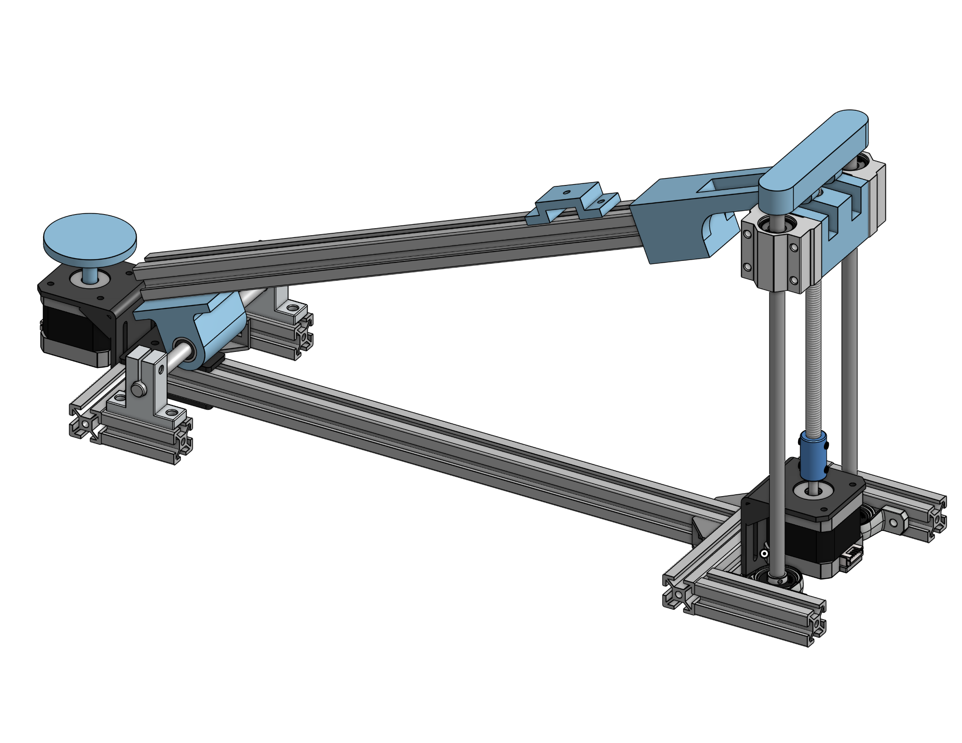
🔗Reference

