VISVESVARAYA TECHNOLOGICAL UNIVERSITY
“JnanaSangama”, Belgaum -590014, Karnataka.


LAB REPORT

On

ANALYSIS AND DESIGN OF ALGORITHMS (23CS4PCADA)

Submitted by

Aryan Sagar Vishwa (1BM24CS061)

in partial fulfillment for the award of the degree of BACHELOR OF ENGINEERING
in

COMPUTER SCIENCE AND ENGINEERING


B.M.S. COLLEGE OF ENGINEERING
(Autonomous Institution under VTU) BENGALURU-560019
February to June 2026

CERTIFICATE

B. M. S. College of Engineering,
Bull Temple Road, Bangalore 560019
(Affiliated To Visvesvaraya Technological University, Belgaum) Department of Computer Science and Engineering



This is to certify that the Lab work entitled “ANALYSIS AND DESIGN OF ALGORITHMS” carried out by Aryan Sagar Vishwa(1BM24CS061), who is bonafide student of B. M. S. College of Engineering. It is in partial fulfillment for the award of Bachelor of Engineering in Computer Science and Engineering of the Visvesvaraya Technological University, Belgaum during the year 2025-26. The Lab report has been approved as it satisfies the academic requirements in respect of Analysis and Design of Algorithms Lab - (23CS4PCADA) work prescribed for the said degree.

Syed Akram Dr. Kavitha Sooda
Assistant Professor Professor and Head
Department of CSE Department of CSE
BMSCE, Bengaluru BMSCE, Bengaluru

Index Sheet

Sl.  No. | Experiment Title | Page No.
1 | Write program to obtain the Topological ordering of vertices in a given digraph. | 4
2 | Implement Johnson Trotter algorithm to generate permutations. | 9
3 | Sort a given set of N integer elements using Merge Sort technique and compute its time taken. Run the program for different values of N and record the time taken to sort. | 12
4 | Sort a given set of N integer elements using Quick Sort technique and compute its time taken. | 15
5 | Sort a given set of N integer elements using Heap Sort technique and compute its time taken. | 17
6 | Implement 0/1 Knapsack problem using dynamic programming. (5 Marks) | 20
7 | Implement All Pair Shortest paths problem using Floyd’s algorithm. | 24
8 | - Find Minimum Cost Spanning Tree of a given undirected graph using Prim’s algorithm.  - Find Minimum Cost Spanning Tree of a given undirected graph using  Kruskal’s algorithm. | 28  30
9 | Implement Fractional Knapsack using Greedy technique. | 33
10 | From a given vertex in a weighted connected graph, find shortest paths to other vertices using Dijkstra’s algorithm. | 35
11 | Implement “N-Queens Problem” using Backtracking. | 37

Course outcomes:

CO1 | Analyze time complexity of algorithms using asymptotic notations.
CO2 | Apply various algorithm design techniques for the given problem.
CO3 | Evaluate the appropriate algorithm/design technique for solving a given problem.
CO4 | Conduct practical experiments by applying appropriate algorithm design technique to solve problems.

Lab program 1:Topological Sorting

#include <stdio.h>
#define MAX 100

int n;
int adj[MAX][MAX];
int indegree[MAX];

void topologicalSort(){
int i, j, count = 0;
int visited[MAX] = {0};
printf("Topological Ordering:\n");
while (count < n){
int found = 0;
for (i = 0; i < n; i++){
if (indegree[i] == 0 && visited[i] == 0){
printf("%d ", i);
visited[i] = 1;
found = 1;
count++;
for (j = 0; j < n; j++){
if (adj[i][j] == 1){
indegree[j]--;
}
}
}
}

if (!found){
printf("\nGraph contains a cycle. Topological ordering not possible.\n");
return;
}
}
printf("\n");
}

void main()
{
int i, j;
printf("Enter number of vertices: ");
scanf("%d", &n);
printf("Enter adjacency matrix:\n");
for (i = 0; i < n; i++){
for (j = 0; j < n; j++){
scanf("%d", &adj[i][j]);
}
}
for (j = 0; j < n; j++){
indegree[j] = 0;
for (i = 0; i < n; i++){
indegree[j] += adj[i][j];

}
}
topologicalSort();
}

OUTPUT:
Case 1:
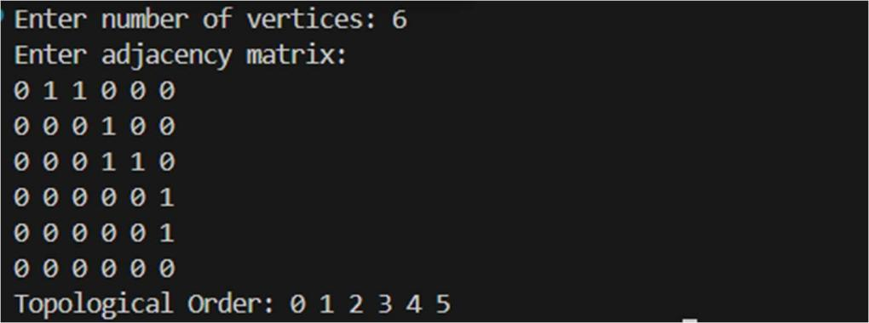

Case 2:
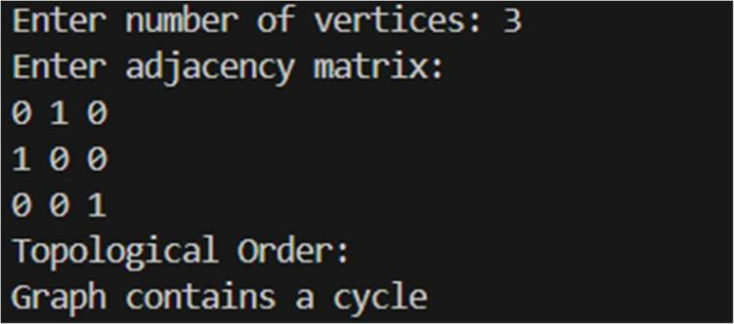

Leetcode Problem(207.Course Schedule):
#include <stdio.h>
#include <stdlib.h>
#include <stdbool.h>

bool canFinish(int numCourses, int** prerequisites, int prerequisitesSize, int* prerequisitesColSize){
int* T = (int*)malloc(numCourses * sizeof(int));
int t_index = 0;
int* visited = (int*)calloc(numCourses, sizeof(int));
int* in_degree = (int*)calloc(numCourses, sizeof(int));
for (int i = 0; i < prerequisitesSize; i++) {
int target = prerequisites[i][0];
in_degree[target]++;
}
int* Queue = (int*)malloc(numCourses * sizeof(int));
int head = 0, tail = 0;
for (int i = 0; i < numCourses; i++) {
if (in_degree[i] == 0) {
Queue[tail++] = i;
visited[i] = 1;
}
}
while (head < tail) {
int vertex = Queue[head++];
T[t_index++] = vertex;
for (int i = 0; i < prerequisitesSize; i++) {
if (prerequisites[i][1] == vertex) {
int j = prerequisites[i][0];
if (visited[j] == 0) {
in_degree[j]--;
if (in_degree[j] == 0) {
Queue[tail++] = j;
visited[j] = 1;
}
}
}
}
}
bool result = (t_index == numCourses);
return result;
}

int main() {
int numCourses = 2;
int prerequisitesSize = 2;
int prerequisitesColSize[] = {2, 2};
int** prerequisites = (int**)malloc(prerequisitesSize * sizeof(int*));
for (int i = 0; i < prerequisitesSize; i++) {
prerequisites[i] = (int*)malloc(2 * sizeof(int));
}
prerequisites[0][0] = 1;
prerequisites[0][1] = 0;
prerequisites[1][0] = 0;
prerequisites[1][1] = 1;
bool result = canFinish(numCourses, prerequisites, prerequisitesSize, prerequisitesColSize);

printf("%s\n", result ? "true" : "false");
for (int i = 0; i < prerequisitesSize; i++) {
free(prerequisites[i]);
}
free(prerequisites);
return 0;
}

OUTPUT:
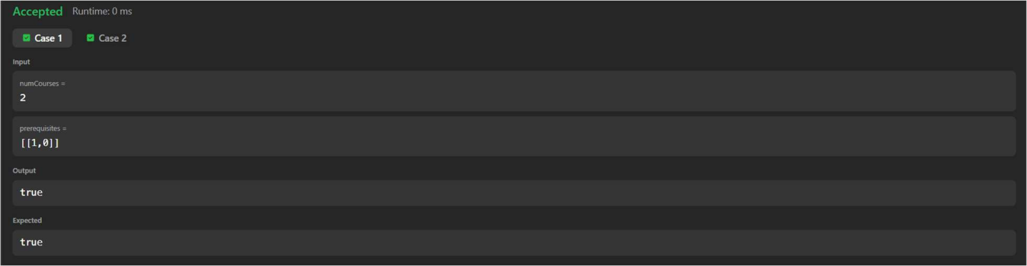

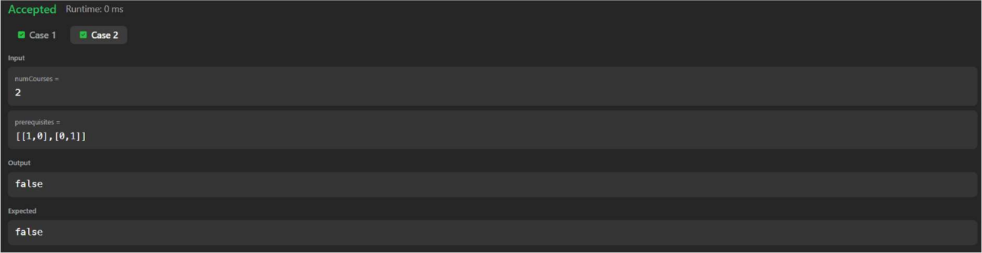

Lab program 2:Johnson Trotter Algorithm

#include <stdio.h>
#include<stdbool.h>

bool LEFT_TO_RIGHT = true;
bool RIGHT_TO_LEFT = false;

int searchArr(int a[], int n, int mobile){
for (int i = 0; i < n; i++)
if (a[i] == mobile)
return i + 1;
}

int getMobile(int a[], bool dir[], int n){
int mobile_prev = 0, mobile = 0;
for (int i = 0; i < n; i++) {
if (dir[a[i] - 1] == RIGHT_TO_LEFT && i != 0) {
if (a[i] > a[i - 1] && a[i] > mobile_prev) {
mobile = a[i];
mobile_prev = mobile;
}
}

if (dir[a[i] - 1] == LEFT_TO_RIGHT && i != n - 1) {
if (a[i] > a[i + 1] && a[i] > mobile_prev) {
mobile = a[i];
mobile_prev = mobile;
}
}
}

if (mobile == 0 && mobile_prev == 0)
return 0;
else
return mobile;
}

int printOnePerm(int a[], bool dir[], int n){
int mobile = getMobile(a, dir, n);
int pos = searchArr(a, n, mobile);

if (dir[a[pos - 1] - 1] == RIGHT_TO_LEFT){
int swap=a[pos-1];
a[pos-1]=a[pos-2];
a[pos-2]=swap;
}

else if (dir[a[pos - 1] - 1] == LEFT_TO_RIGHT){
int swap=a[pos];
a[pos]=a[pos-1];
a[pos-1]=swap;
}

for (int i = 0; i < n; i++) {
if (a[i] > mobile) {
if (dir[a[i] - 1] == LEFT_TO_RIGHT)
dir[a[i] - 1] = RIGHT_TO_LEFT;
else if (dir[a[i] - 1] == RIGHT_TO_LEFT)
dir[a[i] - 1] = LEFT_TO_RIGHT;
}
}

for (int i = 0; i < n; i++){
printf("%d",a[i]);
}
printf("\n");

}

int fact(int n){
int res = 1;
for (int i = 1; i <= n; i++)
res = res * i;
return res;
}

void printPermutation(int n){
int a[n];
bool dir[n];

for (int i = 0; i < n; i++) {
a[i] = i + 1;
printf("%d",a[i]);
}
printf("\n");

for (int i = 0; i < n; i++)
dir[i] = RIGHT_TO_LEFT;

for (int i = 1; i < fact(n); i++)
printOnePerm(a, dir, n);
}

void main(){
int n;
printf("Enter the vaue of n:\n");
scanf("%d",&n);
printPermutation(n);
}

OUTPUT:
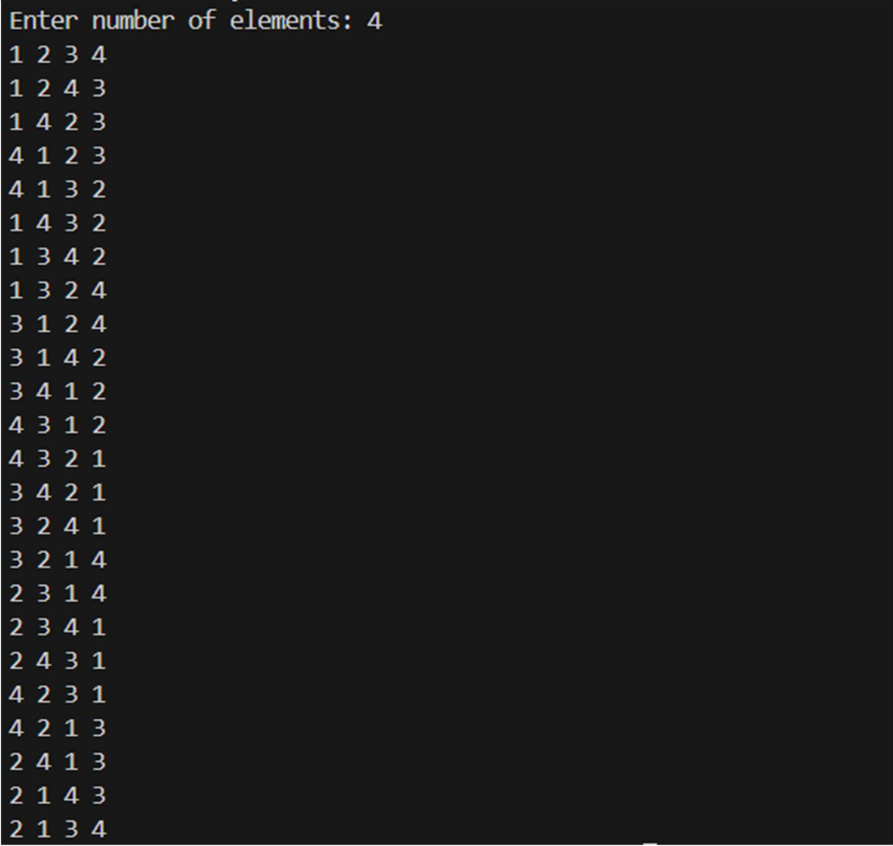

Lab program 3:Merge Sort

#include <stdio.h>

#include<time.h>

#include <stdlib.h>

void merge(int arr[], int l, int m, int r){

int i, j, k;

int n1 = m - l + 1;

int n2 = r - m;

int L[n1], R[n2];

for (i = 0; i < n1; i++)

L[i] = arr[l + i];

for (j = 0; j < n2; j++)

R[j] = arr[m + 1 + j];

i = 0;

j = 0;

k = l;

while (i < n1 && j < n2) {

if (L[i] <= R[j]) {

arr[k] = L[i];

i++;

}

else {

arr[k] = R[j];

j++;

}

k++;

}

while (i < n1) {

arr[k] = L[i];

i++;

k++;

}

while (j < n2) {

arr[k] = R[j];

j++;

k++;

}

}

void mergeSort(int arr[], int l, int r){

if (l < r) {

int m = l + (r - l) / 2;

mergeSort(arr, l, m);

mergeSort(arr, m + 1, r);

merge(arr, l, m, r);

}

}

int main(){

int arr[] = {38, 27, 43, 10};

int arr_size = sizeof(arr) / sizeof(arr[0]);

mergeSort(arr, 0, arr_size - 1);

int i;

for (i = 0; i < arr_size; i++)

printf("%d ", arr[i]);

printf("\n");

return 0;

}

OUTPUT:

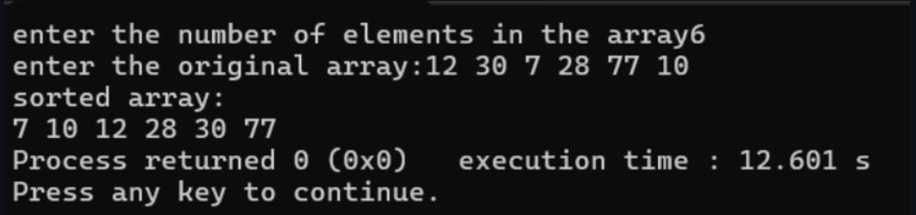

GRAPH:
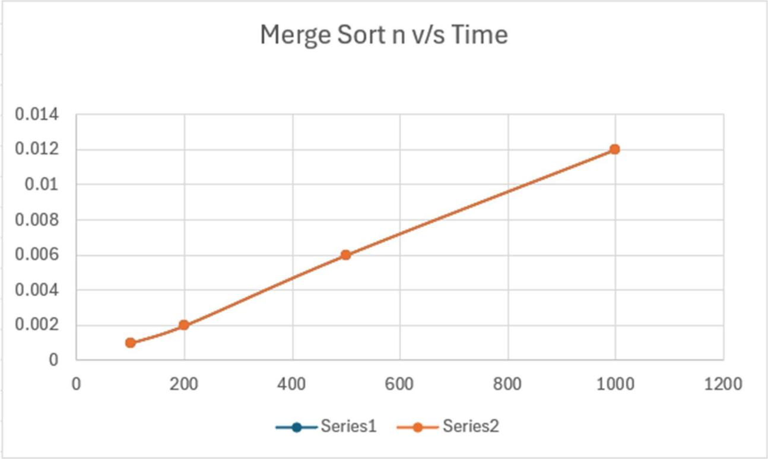

Lab program 4:Quick Sort

#include <stdio.h>
#include <time.h>

void swap(int *a, int *b) {
int temp = *a;
*a = *b;
*b = temp;
}

int partition(int arr[], int low, int high) {
int pivot = arr[low];
int i = low + 1;
int j = high;

while (1) {
while (i <= high && arr[i] <= pivot)
i++;

while (arr[j] > pivot)
j--;

if (i < j)
swap(&arr[i], &arr[j]);
else
break;
}

swap(&arr[low], &arr[j]);
return j;
}

void quickSort(int arr[], int low, int high) {
if (low < high) {
int pi = partition(arr, low, high);

quickSort(arr, low, pi - 1);
quickSort(arr, pi + 1, high);
}
}

void printArray(int arr[], int n) {
for (int i = 0; i < n; i++)
printf("%d ", arr[i]);
printf("\n");
}

int main() {
int arr[] = {10, 9, 8, 7, 6, 5};
int n = sizeof(arr) / sizeof(arr[0]);

clock_t start, end;

printf("Original array: ");
printArray(arr, n);

start = clock();

quickSort(arr, 0, n - 1);

end = clock();

printf("Sorted array: ");
printArray(arr, n);

double time_taken = ((double)(end - start)) / CLOCKS_PER_SEC;
printf("Execution time: %.2f seconds\n", time_taken);

return 0;
}

OUTPUT:
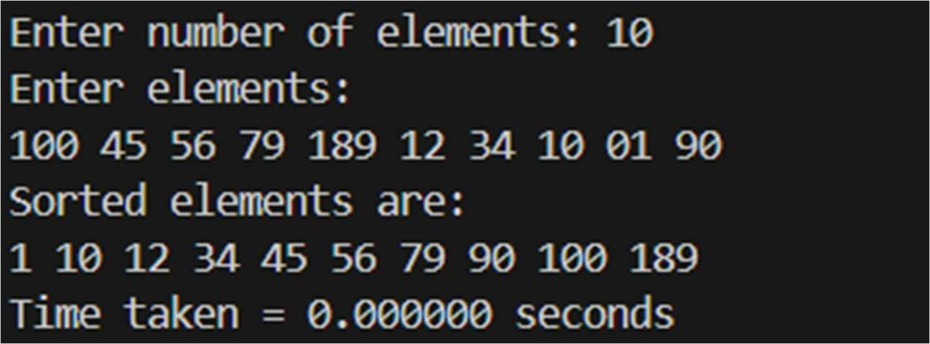

GRAPH:
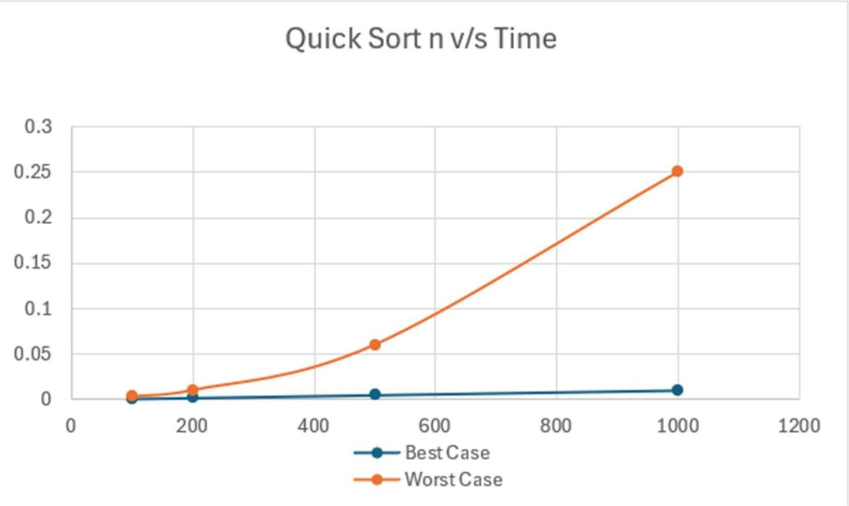
Lab program 5:Heap Sort

#include <stdio.h>

#define MAX 50

void heapify(int a[MAX], int n) {

int i, j, k, v, flag;

for (i = n/2; i >= 1; i--) {

k = i;

v = a[k];

flag = 0;

while (!flag && 2*k <= n) {

j = 2*k;

if (j < n && a[j] < a[j+1]) {

j = j + 1;

}

if (v > a[j]) {

flag = 1;

} else {

a[k] = a[j];

k = j;

}

}

a[k] = v;

}

}

void heapsort(int a[MAX], int n) {

int i, temp;

for (i = n; i > 1; i--) {

temp = a[1];

a[1] = a[i];

a[i] = temp;

heapify(a, i - 1);

}

}

int main() {

int i, n, a[MAX];

printf("Enter the value of n: ");

scanf("%d", &n);

printf("Enter the elements:\n");

for (i = 1; i <= n; i++) {

scanf("%d", &a[i]);

}

heapify(a, n);

heapsort(a, n);

printf("Array after performing heap sort:\n");

for (i = 1; i <= n; i++) {

printf("%d ", a[i]);

}

return 0;

}

OUTPUT:

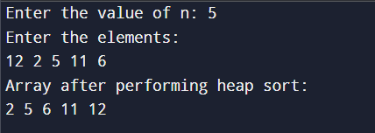

GRAPH:
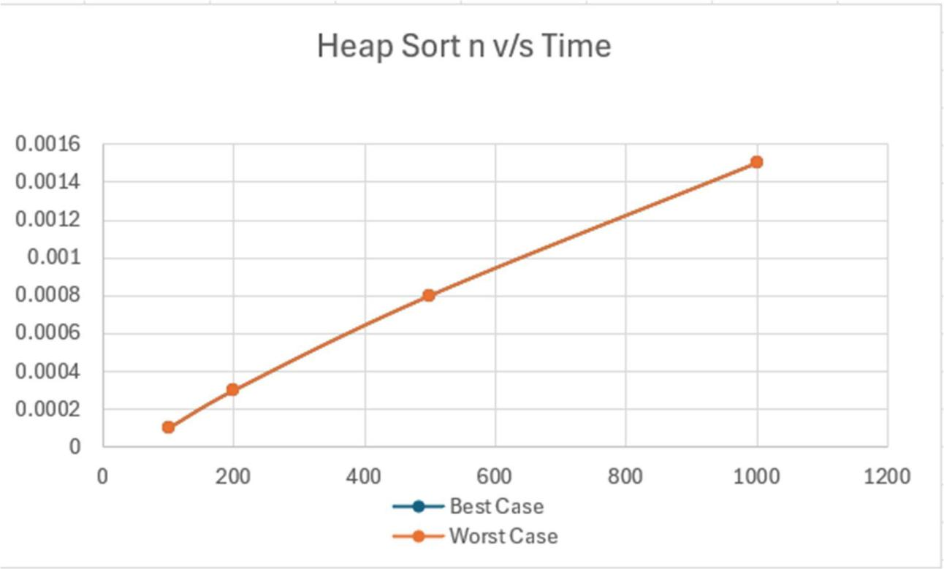

Lab program 6:0/1 Knapsack Problem Using Dynamic Programming

#include <stdio.h>

int max(int a, int b) { return ((a > b) ? a : b); }

int knapsack(int n, int m, int p[], int w[]) {

int i, j;

int k[n + 1][m + 1];

for (i = 0; i <= n; i++) k[i][0] = 0;

for (j = 0; j <= m; j++) k[0][j] = 0;

for (i = 1; i <= n; i++) {

for (j = 1; j <= m; j++) {

if (w[i] <= j) {

k[i][j] = max(k[i - 1][j], p[i] + k[i - 1][j - w[i]]);

} else {

k[i][j] = k[i - 1][j];

}

}

}

printf("The table is :\n");

for (i = 0; i <= n; i++) {

for (j = 0; j <= m; j++) {

printf("%d\t", k[i][j]);

}

printf("\n");

}

return k[n][m];

}

void main() {

int n = 3, m = 6;

int w[4] = {0, 1, 2, 4};

int p[4] = {0, 5, 6, 2};

int profit = knapsack(n, m, p, w);

printf("The highest profit is: %d\n", profit);

}

OUTPUT:
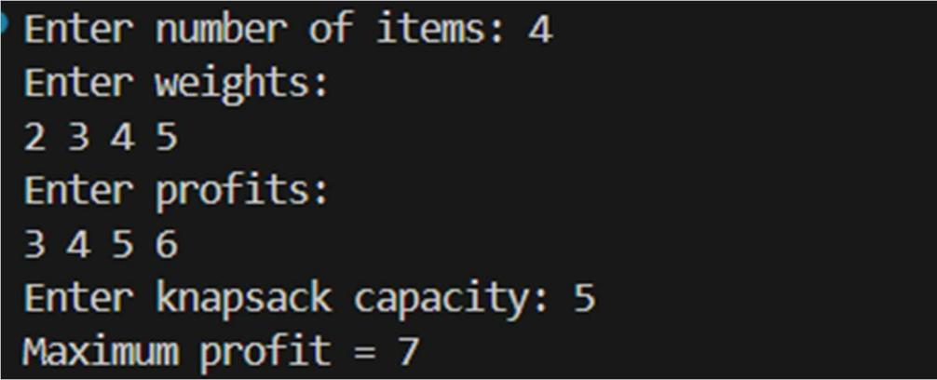

Leetcode Problem(801.Minimum Swaps):

#include <stdio.h>
int MIN(a, b) ((a) < (b) ? (a) : (b))

int minSwap(int* nums1, int nums1Size, int* nums2, int nums2Size) {
int keep = 0;
int swap = 1;
int INF = nums1Size + 1;
for (int i = 1; i < nums1Size; i++) {
int next_keep = INF;
int next_swap = INF;
if (nums1[i] > nums1[i - 1] && nums2[i] > nums2[i - 1]) {
next_keep = MIN(next_keep, keep);
next_swap = MIN(next_swap, swap + 1);
}
if (nums1[i] > nums2[i - 1] && nums2[i] > nums1[i - 1]) {
next_keep = MIN(next_keep, swap);
next_swap = MIN(next_swap, keep + 1);
}
keep = next_keep;
swap = next_swap;
}
return MIN(keep, swap);
}

void main() {
int nums1[] = {1, 3, 5, 4};
int nums2[] = {1, 2, 3, 7};
int size = sizeof(nums1) / sizeof(nums1[0]);
int result = minSwap(nums1, size, nums2, size);
printf("%d\n", result);

}

OUTPUT:
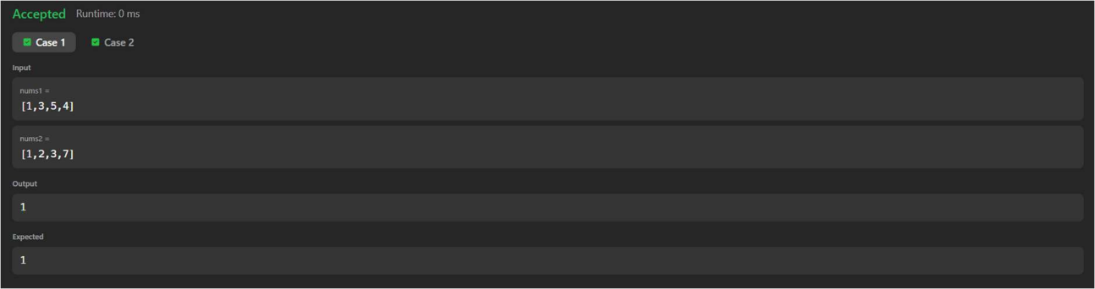

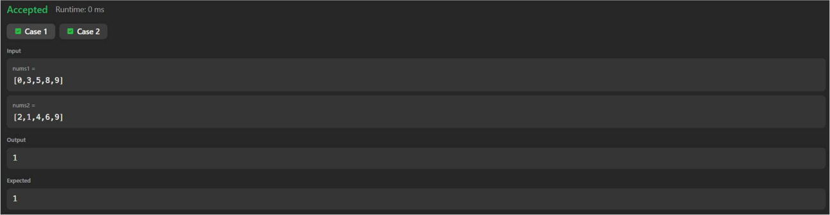

Lab program 7:Floyd’s Algorithm

#include<stdio.h>

#define INF 9999

void floydWarshall(int graph[10][10], int n){

int i, j, k;

for(k = 0; k < n; k++){

for(i = 0; i < n; i++){

for(j = 0; j < n; j++){

if(graph[i][k] + graph[k][j] < graph[i][j]){

graph[i][j] = graph[i][k] + graph[k][j];

}

}

}

}

printf("Shortest distance matrix:\n");

for(i = 0; i < n; i++){

for(j = 0; j < n; j++){

if(graph[i][j] == INF)

printf("INF ");

else

printf("%d ", graph[i][j]);

}

printf("\n");

}

}

void main(){

int n, i, j;

int graph[10][10];

printf("Enter number of vertices:\n");

scanf("%d", &n);

printf("Enter adjacency matrix:\n");

printf("Use %d for no direct edge\n", INF);

for(i = 0; i < n; i++){

for(j = 0; j < n; j++){

scanf("%d", &graph[i][j]);

}

}

floydWarshall(graph, n);

}

OUTPUT:
Case 1:
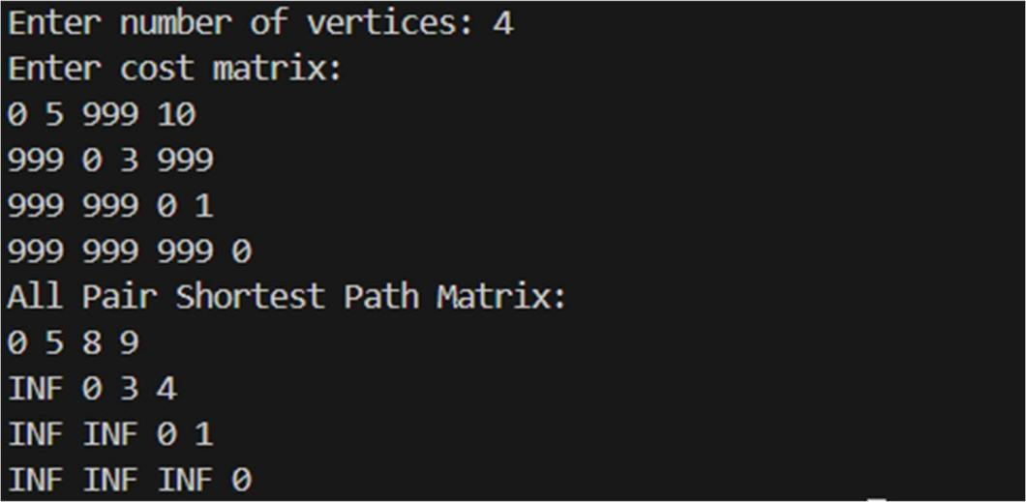

Case 2:
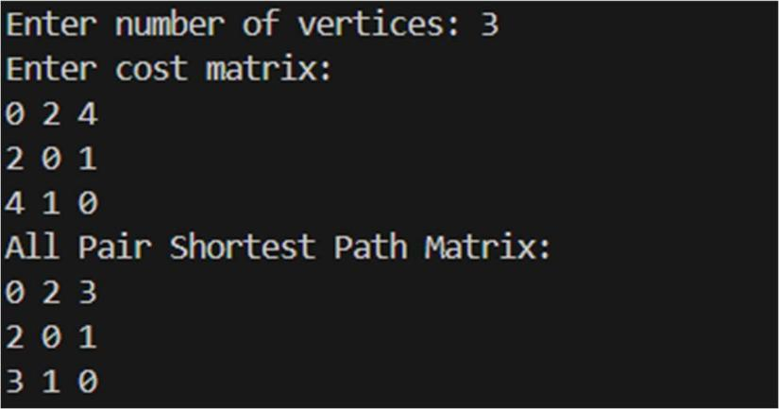

Leetcode Problem(287.Duplicate Number):

#include <stdio.h>

int findDuplicate(int* nums, int numsSize) {

int slow = nums[0];

int fast = nums[0];

do {

slow = nums[slow];

fast = nums[nums[fast]];

} while (slow != fast);

int start = nums[0];

while (start != slow) {

start = nums[start];

slow = nums[slow];

}

return start;

}

void main() {

int nums[] = {1, 3, 4, 2, 2};

int size = sizeof(nums) / sizeof(nums[0]);

printf("Input Array: [");

for (int i = 0; i < size; i++) {

printf("%d", nums[i]);

if (i < size - 1) printf(", ");

}

printf("]\n");

int duplicate = findDuplicate(nums, size);

printf("The duplicate number is: %d\n", duplicate);

}

OUTPUT:
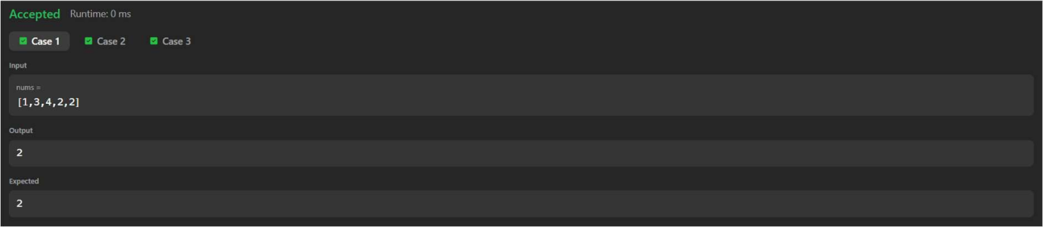

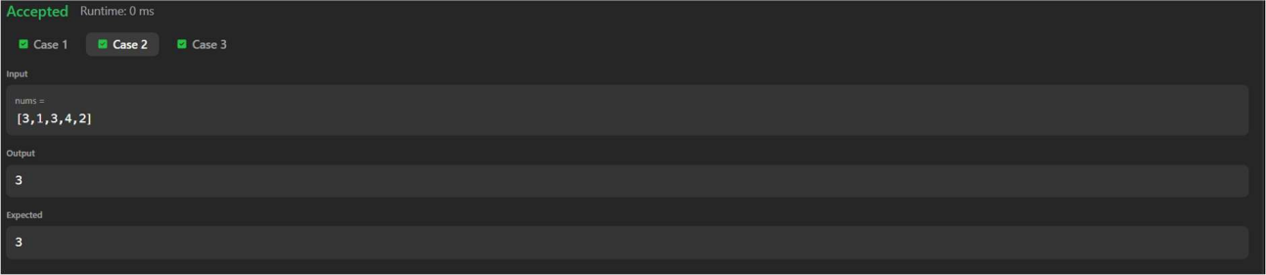

Lab program 8:(a)Prim’s Algorithm

#include <stdio.h>

#include <limits.h>

#define MAX 100

int main() {

int n, cost[MAX][MAX], visited[MAX] = {0};

int i, j, min, x = 0, y = 0, total = 0, edges = 0;

scanf("%d", &n);

for(i = 0; i < n; i++) {

for(j = 0; j < n; j++) {

scanf("%d", &cost[i][j]);

if(cost[i][j] == 0)

cost[i][j] = INT_MAX;

}

}

visited[0] = 1;

while(edges < n - 1) {

min = INT_MAX;

for(i = 0; i < n; i++) {

if(visited[i]) {

for(j = 0; j < n; j++) {

if(!visited[j] && cost[i][j] < min) {

min = cost[i][j];

x = i;

y = j;

}

}

}

}

printf("%d - %d\n", x, y);

total += min;

visited[y] = 1;

edges++;

}

printf("%d\n", total);

return 0;

}

OUTPUT:

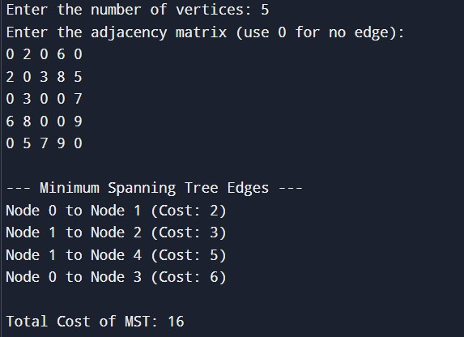

Lab program 8:(b)Kruskal’s Algorithm

#include <stdio.h>

#define INF 999

#define MAX 20

int parent[MAX];

int find(int i) {

while (parent[i] != i) {

i = parent[i];

}

return i;

}

void union_sets(int i, int j) {

int root_i = find(i);

int root_j = find(j);

if (root_i != root_j) {

parent[root_i] = root_j;

}

}

void kruskal(int n, int cost[MAX][MAX]) {

int mincost = 0;

int t[MAX][2];

int i = 0;

for (int v = 0; v < n; v++) {

parent[v] = v;

}

while (i < n - 1) {

int min = INF, u = -1, v = -1;

for (int r = 0; r < n; r++) {

for (int c = 0; c < n; c++) {

if (cost[r][c] < min) {

min = cost[r][c];

u = r;

v = c;

}

}

}

if (u == -1 || v == -1) {

break;

}

int root_u = find(u);

int root_v = find(v);

if (root_u != root_v) {

mincost += cost[u][v];

t[i][0] = u;

t[i][1] = v;

i++;

union_sets(root_u, root_v);

}

cost[u][v] = cost[v][u] = INF;

}

if (i != (n - 1)) {

printf("\nGraph is disconnected. MST CANNOT be constructed.\n");

} else {

printf("\nMinimum Spanning Tree Edges:\n");

for (int e = 0; e < n - 1; e++) {

printf("Edge: (%d, %d)\n", t[e][0], t[e][1]);

}

printf("\nTotal Minimum Cost: %d\n", mincost);

}

}

int main() {

int n;

int cost[MAX][MAX];

printf("Enter the number of vertices: ");

scanf("%d", &n);

printf("Enter the adjacency matrix (Enter %d for infinity/no edge):\n", INF);

for (int i = 0; i < n; i++) {

for (int j = 0; j < n; j++) {

scanf("%d", &cost[i][j]);

}

}

kruskal(n, cost);

return 0;

}

OUTPUT:

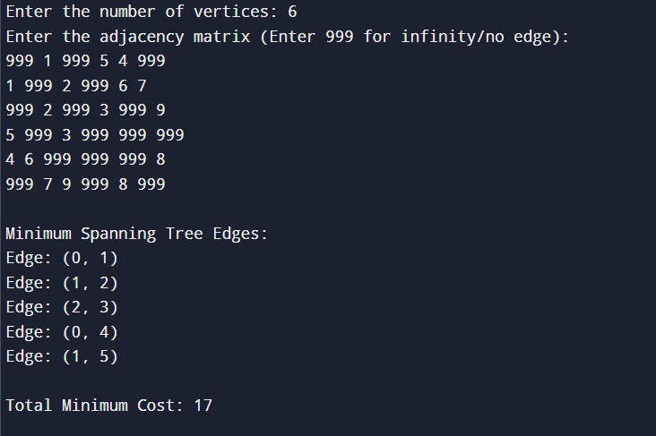

Lab program 9:Fractional Knapsack Using Greedy Technique

#include <stdio.h>

int main() {

int n, i, j;

float w[100], p[100], r[100];

float capacity, temp, TotProfit = 0;

printf("Enter number of items: ");

scanf("%d", &n);

printf("Enter weights of items:\n");

for (i = 0; i < n; i++) {

scanf("%f", &w[i]);

}

printf("Enter profits of items:\n");

for (i = 0; i < n; i++) {

scanf("%f", &p[i]);

}

printf("Enter knapsack capacity: ");

scanf("%f", &capacity);

for (i = 0; i < n; i++) {

r[i] = p[i] / w[i];

}

for (i = 0; i < n; i++) {

for (j = i + 1; j < n; j++) {

if (r[i] < r[j]) {

temp = r[i];

r[i] = r[j];

r[j] = temp;

temp = w[i];

w[i] = w[j];

w[j] = temp;

temp = p[i];

p[i] = p[j];

p[j] = temp;

}

}

}

for (i = 0; i < n; i++) {

if (w[i] > capacity)

break;

else {

TotProfit = TotProfit + p[i];

capacity = capacity - w[i];

}

}

if (i < n) {

TotProfit = TotProfit + (r[i] * capacity);

}

printf("\nMaximum profit = %.2f\n", TotProfit);

return 0;

}

OUTPUT:

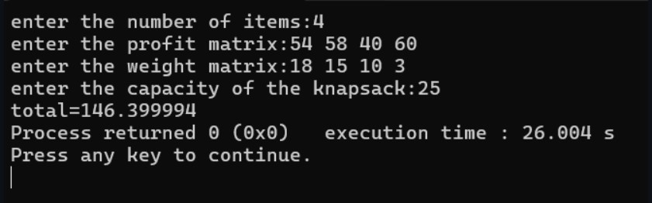

Lab program 10:Dijkstra’s Algorithm
#include <stdio.h> #define INF 999
void dijkstra(int n, int cost[10][10], int source) { int distance[10], visited[10];
int i, j, min, next; for(i = 0; i < n; i++) {
distance[i] = cost[source][i]; visited[i] = 0;
}
distance[source] = 0;
visited[source] = 1; for(i = 1; i < n; i++) {
min = INF;
for(j = 0; j < n; j++) {
if(!visited[j] && distance[j] < min) { min = distance[j];
next = j;
}
}
visited[next] = 1; for(j = 0; j < n; j++) {
if(!visited[j] && min + cost[next][j] < distance[j]) distance[j] = min + cost[next][j];
}
}
printf("Shortest distances from vertex %d:\n", source); for(i = 0; i < n; i++)
printf("%d -> %d = %d\n", source, i, distance[i]);

}
int main() {
int n, i, j, source; int cost[10][10];
printf("Enter number of vertices: "); scanf("%d", &n);
printf("Enter cost adjacency matrix:\n"); for(i = 0; i < n; i++) {
for(j = 0; j < n; j++) { scanf("%d", &cost[i][j]); if(cost[i][j] == 0 && i != j)
cost[i][j] = INF;
}
}
printf("Enter source vertex: "); scanf("%d", &source); dijkstra(n, cost, source); return 0;
}

OUTPUT:
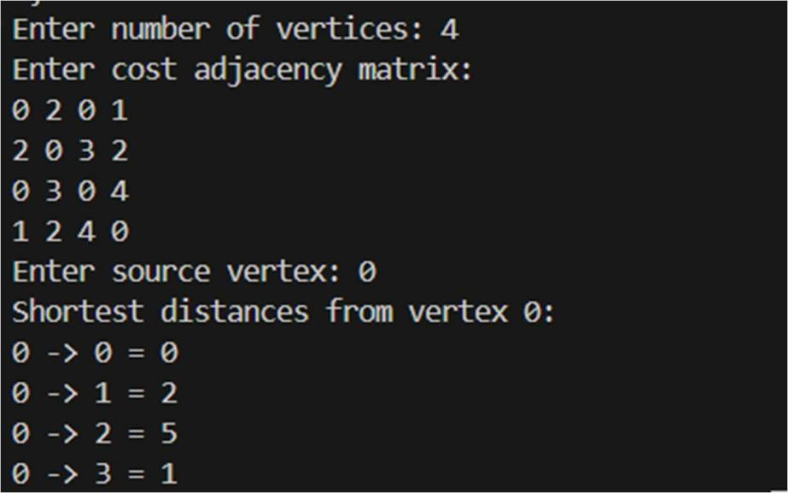

Lab program 11:N-Queens Problem Using Backtracking
#include <stdio.h> #include <stdlib.h> int x[20];
int count = 0;
int place(int k, int i) { int j;
for(j = 1; j < k; j++) {
if(x[j] == i || abs(x[j] - i) == abs(j - k)) return 0;
}
return 1;
}
void nQueens(int k, int n) { int i, j;
for(i = 1; i <= n; i++) { if(place(k, i)) {
x[k] = i;
if(k == n) { count++;
printf("\nSolution %d:\n", count); for(j = 1; j <= n; j++) {
for(i = 1; i <= n; i++) { if(x[j] == i)
printf("Q "); else
printf(". ");
}
printf("\n");

}
}
else {
nQueens(k + 1, n);
}
}
}
}
int main() { int n;
printf("Enter number of queens: "); scanf("%d", &n);
nQueens(1, n); if(count == 0)
printf("No solution exists"); return 0;
}
OUTPUT:
