**Q1) sum of natural numbers**

**#code**

x=input("How many n terms?")

i=1;

j=0;

while(i<=x)

j=j+i;

i=i+1;

end

disp('sum of natural number',j)

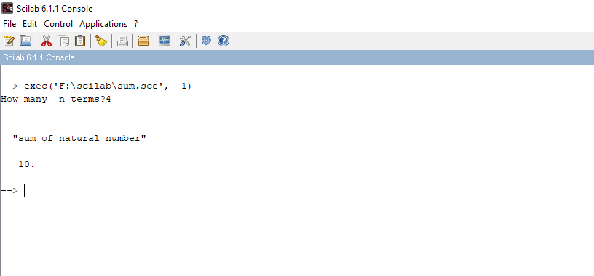

Q2)plot shphere

**#code**

a = linspace(0,360,100);

th = linspace(-90,90,50);

R = 1;

[A,Th] = meshgrid(a,th);

Z = R*sind(Th);

X = R*cosd(Th).*cosd(A);

Y = R*cosd(Th).*sind(A);

Ncolors = 100; *// Number of coding colors*

temp = pmodulo(A+Th,Ncolors)+1; *// Here gives the spherical mapping of your data*

clf

f = gcf();

f.color_map = jetcolormap(Ncolors);

surf(X,Y,Z,temp)

ax = gca();

ax.isoview = 'on';

e = gce();

e.thickness = 0;

e.thickness = 0; *// hides the mesh*

e.color_flag = 3; *// switches to interpolated colors*

and the result (without and with interpolated colors):

