**GALGOTIAS UNIVERSITY**

**Department of computer science and engineering**



**LAB REPORT EXPLORATION**

**WITH CAS–I**

# BBS01T1001

**B.TECH. (FALL2021-2022)**

SUBMITTED BY: SUBMITTED TO:

Name***: Unnati dohary (21SCSE1011664)***

Batch: First year section-24(P2)

**Experiment-1**

**To write a SCILAB -CODE for Arithmetic Operations (on scalars and variables) and Elementary Math Built-in functions.**

***Objectives:***

***1.1. To explain what is Scilab.***

***1.2. To download and install Scilab software in PC?***

1. ***3.To explain how to work in the main window of Scilab called console***

**1.4*. To explain how Scilab works as a calculator: Arithmetic Operations with scalars (numbers)* 1.5. *To explain some elementary Math Build-in functions in scilab library***

* 1. ***To explain the variables in Scilab.***
  2. ***To explain how to work in Scilab editor and write Script Files.***

## Exercises

**To write a Scilab code to find the solution of following problems:**

1. **Evaluate**
   1. **271/3+ 320.2 , (ii) sqrt 64 + e4 (iii) sin** π/6 + cos60°

**(iv)4!+ ln2+log100, *(*v) (2+3i)(4+5i)**

1. **By assigning values 2 and 5 to variables a and b respectively, compute (i) c= (a+b)2**
   1. ***d=4a-3b+lna+* c2**
2. **Write the script file for the problem:**

**The radius of a circle is 2cm. Find its area.**

***Solutions***

Ex. 1 - **271/3+ 320.2**

**Input** :

clc clear

a = 27^ (1/3) +32^ (0.2)

**Output :**

a = 5.

Ex. 2. – **Sqrt 64 + e4**

Input:

clc

clear

x=sqrt(64)

y=%e^4

z=x+y

disp(z)

Output:

62.598150

iii)

Input:

clc

clear

x=sin(%pi/6)

y=cosd(60)

z=x+y

disp(z)

**Output:**

1

iv) 4!+1n2+log100

**Input:**

clc

clear

a=factorial(4)

b=log(2)

c=log10(100)

z=a+b+c

disp(z)

***Output :***

**26.693147**

#### (v) (2+3i)(4+5i)

**Input:**

clc

clear

a=2+3*%i

b=4+5*%i

c=a*b

disp(c)

***Output:***

#### -7. + 22.i

**Q2).By assigning values 2 and 5 to variables a and b respectively, compute(i) c=(a+b)2  input**

**Input *:***

clc

clear

a=2

b=2

c=(a+b)^2

d=(4*a)-(3*b)+log(a)+(c^2)

disp("c=",c)

disp("d=",d)

***Output:***

“c=”

49.

“d=”

2394.6931

***Q3). Write the script for the problem:***

***The radius of the circle is 2cm. Find its area.***

**Input *:***

clc

clear

r=2

A=%pi*r^2

disp("Area= ",A)

***Output:***

“Area=”

12.566371

**Experiment-2**

**Objectives:**

2.1] Creating 1-d in arrays (vectors).

2.1.1] Creating a vector from a known list of numbers.

2.1.2] Creating a vector with constant spacing by specifying the first term, the spacing and the last term.

2.1.3] Creating a vector with linear (equal) spacing by specifying the first and last terms, and the number of terms.

2.2] Creating two-dimensional arrays (Matrix)

2.3] Mathematical operations with arrays

2.4] Finding roots of a polynomial

## Exercises​

**To write a Scilab code to find the solution of following problems:​**

**1. (i) create a row vector with 3 elements. ​**

**(ii) create a column vector with 4 elements​**

**2. By taking first term a=1 and the last term b=10 create a one dimensional array :​**

**(i) by taking the spacing between two consecutive terms d=2 ,​**

**(ii) by taking the number of terms n= 12​**

**3. Create two row vectors (one dimensional arrays) a and b such that the following operations are defined and hence find :​**

**(i) 2a-3b, (ii)2(transpose a)-3(transpose b)​**

**4. Create two matrices( two dimensional arrays)A and B  such that the following  operations are defined and hence : ​**

**(i) 3A-ABT​**

**5. Create a matrix A so that the following operations are defined and find:**​

**(i) determinant of A, (ii) Inverse of A, (iii) product of A and inverse of A**​

 6**. Find the roots of following polynomials: (i) x2-x-2=0, (ii) x3+1=0.**​

**To write a Scilab code to find the solution of following problems:**

**1.(i)** Create a row vector with 3 elements.

Input

clc

clear

x=[687]

disp(x)

Output

6. 7. 8.

(ii) Create a column vector with 4 elements

# Input

clc

clear

y=[6;7;8;9]

disp(y)

**Output**

6. 7. 8.

9.

2. By taking first term a=1 and the last term b=10 create a one dimensional array:

(i) By taking the spacing between two consecutive terms d=2

# Input

clc

clear

a=1

b=10

d=2

r=[a:d:b]

disp(r)

# Output

Column 1 to 3

1. 3. 5.

Column 4 to 5

7. 9.

(ii) By taking the Input: number of terms n= 12

Input:

clc

clear

a=1

b=10

n=12

r=linspace(a,b,n)

disp(r)

**Output**

Column 1 to 2

1. 1.8181818

Column 3

2.6363636

Column 4

3.4545455

Column 5

4.2727273

Column 6

5.0909091

Column 7

5.9090909

Column 8

6.7272727

Column 9

7.5454545

Column 10

8.3636364

Column 11 to 12

9.1818182 10.

3. Create two row vectors (one dimensional arrays) a and b such that the following operations are defined and hence find : (i) 2a-3b

# Input

clc

clear

A=[456]

B=[123]

R=(2*A)-(3*B)

disp(R)

## Output

5. 4. 3.

(ii) 2(transpose a)-3(transpose b)

### Input

clc

clear

A=[456]

B=[123]

R=(2*A')-(3*B')

disp(R)

# Output

5.

4.

3.

4. Create two matrices (two dimensional arrays) A and B such that the following operations are defined and hence: (i) 3A-ABt

Input

clc

clear A=[75;24]

B=[86;19] R=3*A-A*B'

disp(R)

## Output

-65. -37.

-34. -26.

5. Create a matrix A so that the following operations are defined and find: (i) determinant of A,

1. Inverse of A,
2. product of A and inverse of A

### Input

clc

clear

A=[576;943;156]

disp("(i) Determinant= ",det(A),"(ii) Inverse= ",inv(A))

disp("(iii) Product of A and Inverse of A",A*inv(A))

## Output

"(i) Determinant="

-66.

"(ii) Inverse="

-0.1363636 0.1818182 0.0454545

0.7727273 -0.3636364 -0.5909091

-0.6212121 0.2727273 0.6515152

"(iii) Product of A and inverse of A"

1. 4.441D-16 8.882D-16

-4.441D-16 1. 4.441D-16 -4.441D-16 2.220D-16 1.

6. Find the roots of following polynomials:

(i) x2 -x-2=0

Input

clc

clear

A=[1-1-2]

disp("Roots of A=",roots(A))

**Output**

"Roots of A="

2. + 0.i -1. + 0.i

# Experiment-3

**Write a SCILAB -CODE for programming:**

**Functions - Conditional statements-loops in Scilab**

***Objectives:***

Input function, conditional statements, loops and user defined functions

* 1. Input function
  2. Conditional statements
     1. the if-end structure
     2. the if-else-end structure
     3. the if-elseif-else-end structure

3.3. loops

* + 1. for-end loop
    2. while-end loop

3.4. user defined function

***Exercises:***

( All exercises to be solved on scinotes) Write a Scilab code in a script file:

Q1] To find volume and total surface area of a cone using input function.

Q2] To find whether an integer entered by user is odd or even, using if- else-end command.

Q3] To find whether a real number entered by user is negative, zero or a positive using if- elseif-else-end command.

Q4] To find the sum of squares of the first n natural numbers, using for loop.

Q5] To find the sum of squares of the first n natural numbers, using while loop.

Q6] To find factorial of a number using for loop.

Q7] To find factorial of a number using while loop.

Q8] To find first n terms of Fibonacci sequence using for loop

Q9] To find volume and total surface area of a cone using user defined function

•***SOLUTION-***

**1.Input**

clc

clear

r=input("Enter r= ")

h=input("Enter h= ")

v=1/3*%pi*r*r*h

disp("Volume of cone", v)

## Output

enter r=3 enter h=4

"volume of cone"

37.699112

**Input**

clc

clear

r=input("Enter r= ")

l=input("Enter l= ")

t=%pi*r*(r+l)

disp("Total surface area of clone", t)

### Output: enter r=3 enter L=5

"total surface area of cone"

75.39882

**2. Input**

clc

clear

a=input("Enter the number= ")

if(modulo(a,2)==0)

then disp("The number is Even");

else

disp("The number is odd");

end

### Output

Enter the number=12

"a is even"

***3.Input***

clc

clear

n=input("Enter a number= ")

if(n>0)

then

disp("The number is positive")

elseif n==0

disp("You entered zero")

else

disp("The number is negative")

end

***Output:***

Enter a number=8

"The number is positive**"**

**4.(i) *Input:***

clc

clear

n=0

a=input("Enter numbers of terms= ")

s=0

for n=(1:a)

s=s+(n^2)

end

disp("Sum+ ",s)

***Output:***

Enter numbers of terms= 65

"Sum+ "

93665.

***5.Input:***

clc

clear

n=input("Enter number of terms: ")

i=1

s=0

while i<=n;

s=s+(i^2);

i=i+1;

end

disp("Sum= ",s)

***Output:***

Enter no. of tearms12

"sum=" 650.

**6. *Input:***

clc

clear

n=input("Enter no. whose factorial is to be found: ")

f=1

for (i=1:n)

f=f*i;

end

disp("Factorial= ",f)

***Output:***

Enter no. whose factorial is to be found: 5

"Factorial= "

120.

***7. Input****:*

clc

clear

n=input("Enter no. whose factorial is to be found: ")

i=1

f=1

while i<=n;

f=f*i;

i=i+1;

end

disp("Factorial= ",f)

***Output:***

Enter no. whose factorial is to be found: 8

"Factorial= "

40320.

***8. (i) Input:***

clc

clear

n=input("Enter number of terms= ")

s=(1:n)

s(1)=1;

s(2)=1;

for i=3:n

s(i)=s(i-2)+s(i-1)

end

disp(s)

***Output:***

Enter no. of terms= 10

Column 1 to 9

1. 1. 2. 3. 5. 8. 13. 21. 34. Column 10

55.

***9. Input:***

clc

clear

function [**v**, **TSA**]=cone(**r**, **h**)++++

**v**=%pi*(**r**^2)\***h**

**TSA**=%pi*(**r**^2)

disp("Volume= ", **v**)

disp("Total Surface Area= ", **TSA**)

endfunction cone(6,12)

***Output***

"Volume= "

1357.1680

"Total Surface Area= "

113.09734

**Experiment-4**

***Objectives:***​

*4.1 To write a*SCILAB -CODE for 2D plots of curves :  parabola, circle, ellipse and hyperbola​

*4.2. To write a*SCILAB -CODE for 3D plots of surfaces: Planes, Paraboloid, cone, Sphere, Cylinder, Paraboloid, Ellipsoid, Hyperboloid

***Excercises***​

**Write a Scilab code in a script file:**​

1. **To plot *Parabola*x2=4ay.  Take  focal length a=1**​
2. **To plot *Circle*. x2+y2=a2 .  Take a=1**​
3. **To plot *Ellipse*. x2/ a2   + y2/ b2   =1. Take  a=4, b=3**​
4. **To plot *Hyperbola*. x2/ a2   - y2/ b2   =1 , Take  a=3, b=4**​
5. **To plot *a Plane     ax+ by +cz=d.  Take a=b=-1, c=1, d=4.  z=4+x+y***​
6. **To plot (*elliptical )paraboloid  z/c=*x2/a2 +y2/b2 . Take a=b=c=1**​
7. **To plot (*elliptical)Cone*.                        . Take a=b=c=1**​
8. **To plot right circular *Cylinder*. x2+y2=a2**​
9. **To plot *Sphere*x2+y2 +z2 =a2 , Take a=1**​
10. **To plot *Ellipsoid*.x2/a2 +y2/b2 + z2/c2 =1 . Take a=4,b=3,c=2**​
11. **To plot *Hyperboloid*x2/a2 +y2/b2 - z2/c2 =1 . Take a=4,b=3,c=2**​

**// 2d curves: 1 explicit method, 2,3 parametric, 4 implicit**​

**//surfaces: 5, 6, 7 explicit method and 8,9,10,11 parametric method**​

Solution

1. **To plot *Parabola*x2=4ay.  Take  focal length a=1**​

Input :

clc

clear

a=input("enter a =")

x=linspace(0,10,500)

y=(x^2)/(4*a)

plot(x,y,"+g")

xtitle("parabola","x","y")

Output:

enter a =1

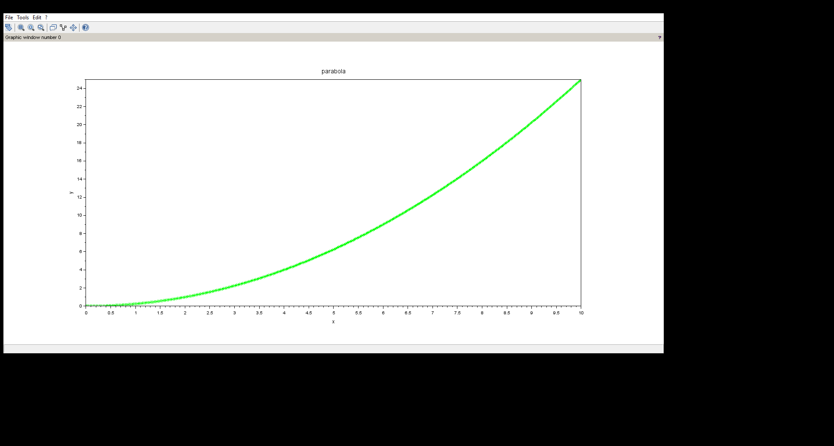

**2)To plot *Circle*. x2+y2=a2 .  Take a=1**

Input

1. clc
2. clear
3. clf
4. a=input("enter the value of a=")
5. t=linspace(0,2*%pi,100)
6. x=a*cos(t)
7. y=a*sin(t)
8. plot(x,y,"+g")
9. xtitle("circle","x","y")

output

enter the value of a=1

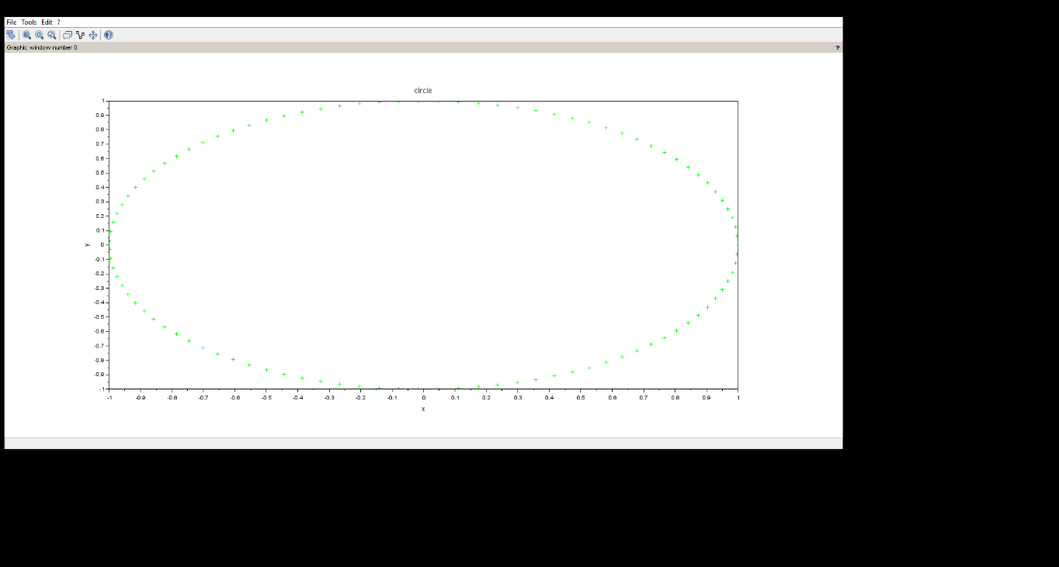

​3. **To plot *Ellipse*. x2/ a2   + y2/ b2   =1. Take  a=4, b=3**​

Input

clc

clear

clf

a=input("enter the value of a=")

b=input("enter the value of b=")

t=linspace(0,50,100)

x=a*cos(t)

y=b*sin(t)

plot(x,y,"+g")

xtitle("ellipse","x","y")

Output

enter the value of a=4

enter the value of b=3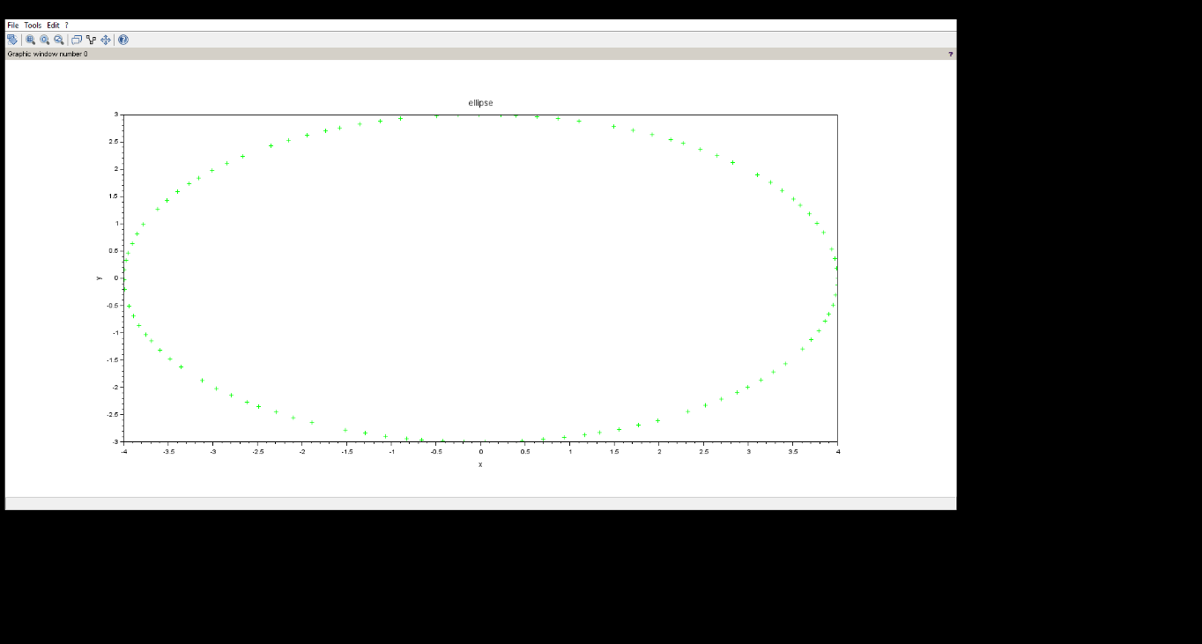

**4) To plot *Hyperbola*. x2/ a2   - y2/ b2   =1 , Take  a=3, b=4**​

**Input :**

clc

clear

function **f**=hyperbola(**x**, **y**)

**f**=(**x**^2/16)-(**y**^2/25)

endfunction

x=linspace(-10,10,1000)

y=linspace(-10,10,1000)

contour(x,y,hyperbola,1)

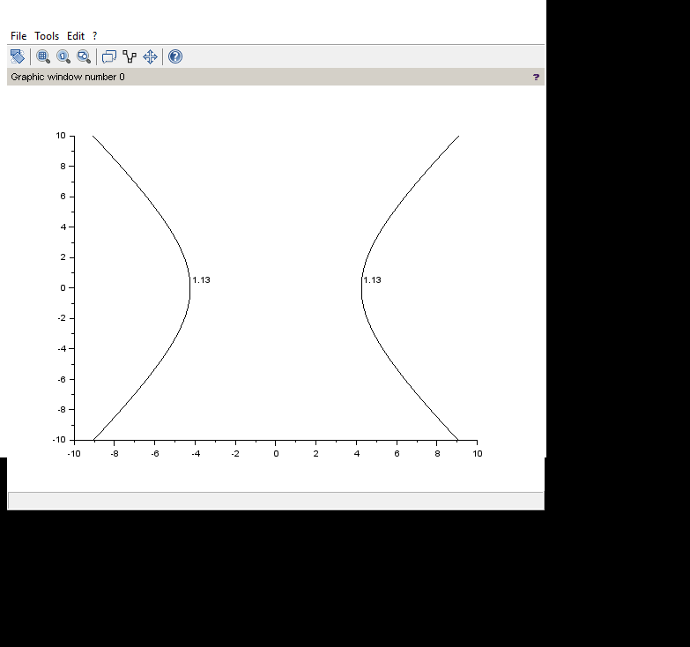

**5.To plot *a Plane     ax+ by +cz=d.  Take a=b=-1, c=1, d=4.  z=4+x+y***​

clc

clear

a=input("enter the value=")

b=input("enter the value=")

c=input("enter the value=")

d=input("enter the value=")

function **z**=plane(**x**, **y**)

**z**=(d-a\***x**-b\***y**)/c

endfunction

x=linspace(0,20,100)

y=linspace(0,20,100)

z=feval(x,y,plane)'

clf

surf(x,y,z)

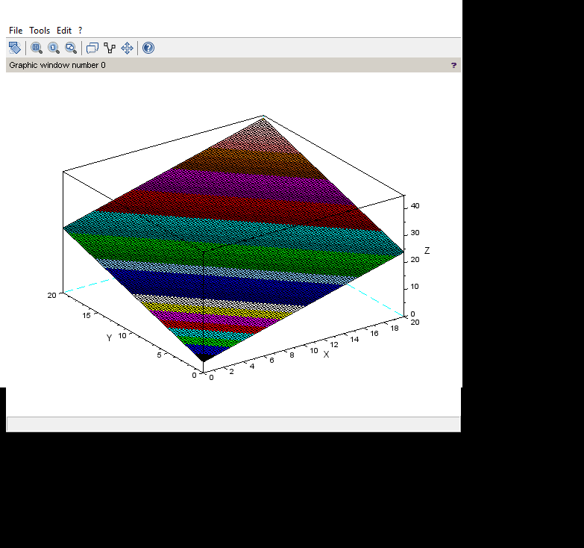

**6)To plot (*elliptical )paraboloid  z/c=*x2/a2 +y2/b2 . Take a=b=c=1**​

Input

clc

clear

a=input("enter the value=")

b=input("enter the value=")

c=input("enter the value=")

function **z**=paraboloid(**x**, **y**)

**z**=((**x**^2)/(a^2)+(**y**^2)/(b^2))*c

endfunction

x=linspace(-20,20,100)

y=linspace(-20,20,100)

z=feval(x,y,paraboloid)'

clf

surf(x,y,z)

Output

Enter the value =1

Enter the value =1

Enter the value =1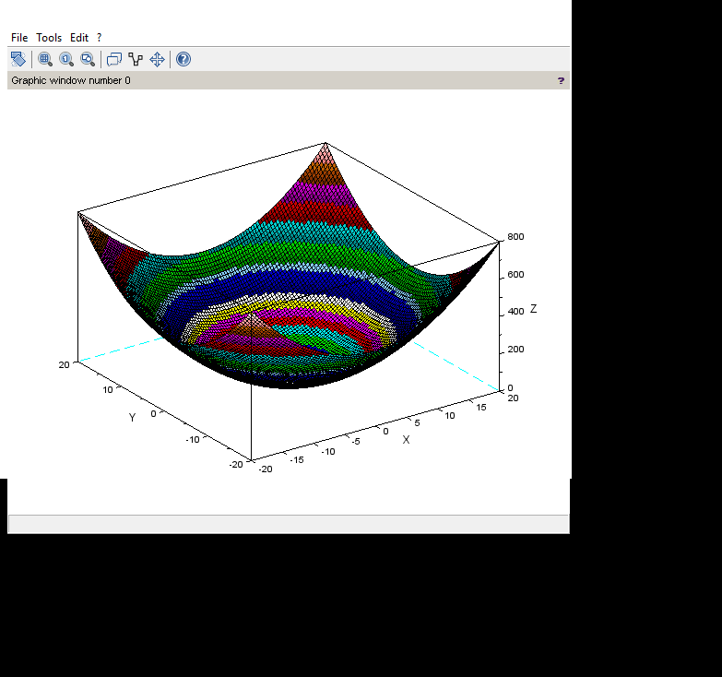

**7)To plot (*elliptical)Cone*.                        . Take a=b=c=1**​

Input

clc

clear

a=input("enter the value=")

b=input("enter the value=")

c=input("enter the value=")

function **z**=cone(**x**, **y**)

**z**=(sqrt((**x**^2)/(a^2)+(**y**^2)/(b^2)))*c

endfunction

x=linspace(-20,20,100)

y=linspace(-20,20,100)

z=feval(x,y,cone)'

clf

surf(x,y,z)

output

Enter the value =1

Enter the value =1

Enter the value =1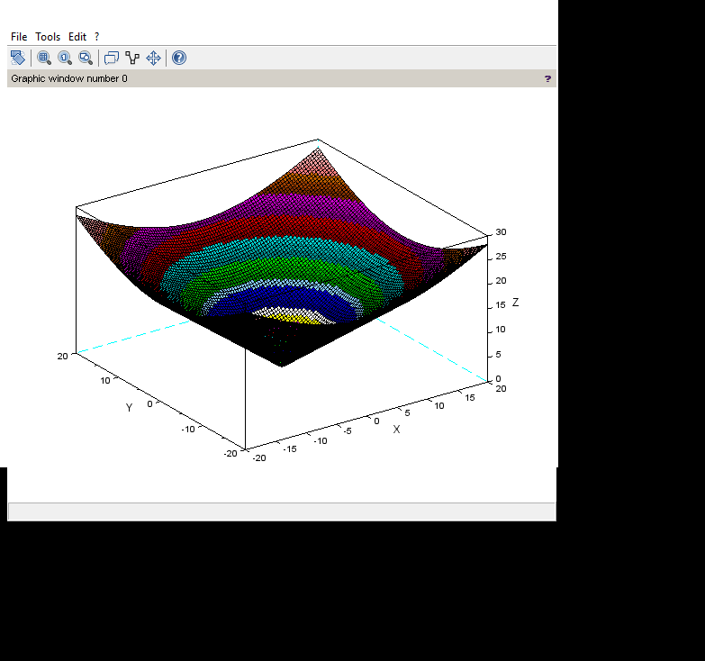

**8)To plot *Sphere*x2+y2 +z2 =a2 , Take a=1**

Input

clc

clear

a =linspace(0,360,100);

th=linspace(-90,90,50);

r=input("enter the value of radius=");

[A,Th]=meshgrid(a,th);

Z = r*sind(Th);

X = r*cosd(Th).*cosd(A);

Y = r*cosd(Th).*sind(A);

Ncolors=100;

clf

surf(X,Y,Z)

Output

enter the value of radius=1

graph

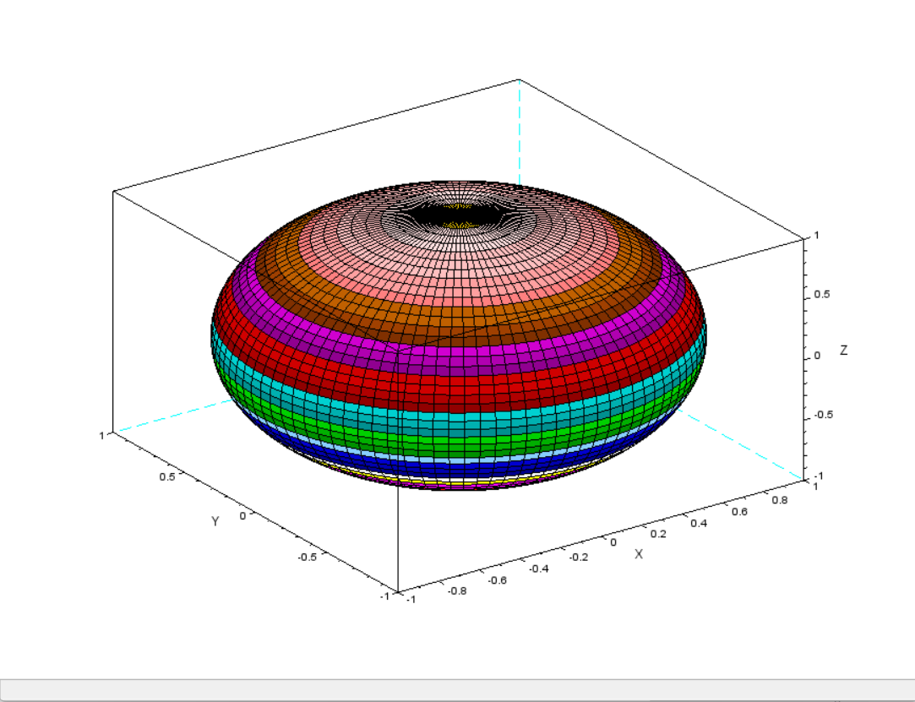

1. **To plot right circular *Cylinder*. x2+y2=a2**​

Input

clc

clear

t=linspace(0,2*%pi,100);

a=linspace(0,4,100);

[T,s]=meshgrid(t,a);

x=2*cos(T);

y=2*sin(T);

z=(s);

surf(x,y,z)

graph

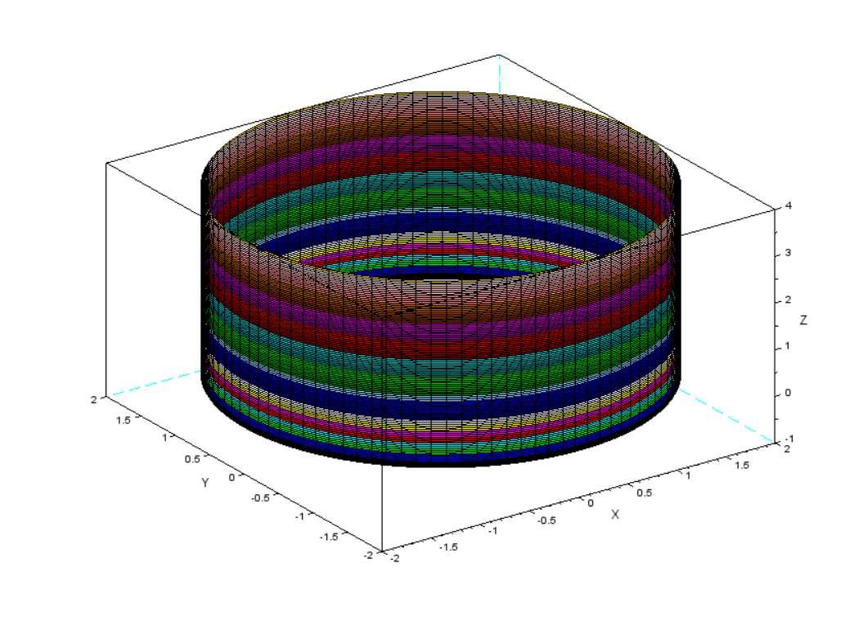

**10)To plot *Ellipsoid*.x2/a2 +y2/b2 + z2/c2 =1 . Take a=4,b=3,c=2**​

**Input**

clc

clear

a=linspace(0,360,100)

th=linspace(-90,90,50)

R=1

[A,Th]=meshgrid(a,th)

z=2*R*sind(Th)

x=3*R*cosd(Th).*cosd(A)

y=2*R*cosd(Th).*sind(A)

Ncolors=100

clf

surf(x,y,z)

graph

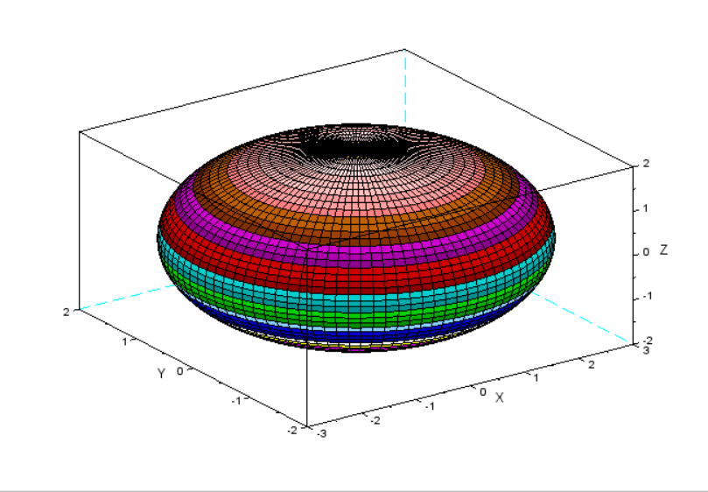

**11)To plot *Hyperboloid*x2/a2 +y2/b2 - z2/c2 =1 . Take a=4,b=3,c=2**​

**Input**

clc

clear

a=linspace(0,360,100)

th=linspace(-90,90,50)

R=1

[A,Th]=meshgrid(a,th)

z=2*R*sinh(Th)

x=3*R*cosh(Th).*cosd(A)

y=2*R*cosh(Th).*sind(A)

Ncolors=100

clf

surf(x,y,z)

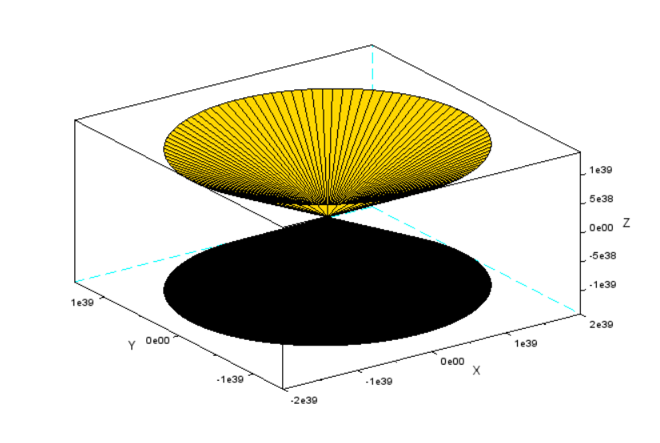

**Experiment 5**

**1.To find the error in estimating the value of function f(x)=e^x at x=1 using its Taylor series expansion about origin.**

**INPUT**

clc

clear

n=10

x=1

y=exp(x)

yest=0

for i=0:n

yest=yest+(x^i)/factorial(i)

end

disp("yest=",yest)

disp("y=",y)

error=abs(y-yest)

disp("error=",error)

**OUTPUT**

**"yest="**

**2.7182818**

**"y="**

**2.7182818**

**"error="**

**2.731D-08**

**2. To find the error in estimating the value of function f (x)=sin(x) at x=pi/2 using its Taylor series expansion about origin.**

**INPUT**

clc

clear

n=3

x=%pi/2

y=sin(x)

yest=0

for i=0:n

yest=yest+(((-1)^n)*x^(2*n+1))/factorial(2*n+1)

end

disp("yest=",yest)

disp("y=",y)

error=abs(y-yest)

disp("error=",error)

**OUTPUT**

**"yest="**

**-0.0187270**

**"y="**

**1.**

**"error="**

**1.0187270**

**3. To compare the function f (x)=e^x and its Taylor series expansion about origin by using 2d plots.**

**INPUT**

clc

clear

n=3

x=linspace(0,10,100)

y=exp(x)

yest=0

for i=0:n

yest=yest+(x^i)/factorial(i)

end

plot(x,y,"r")

**OUTPUT**

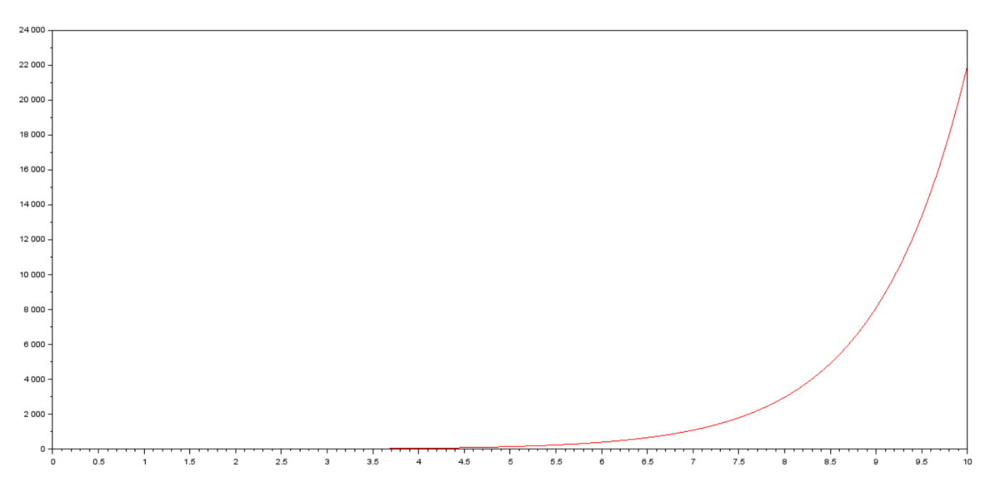

**4. To compare the function f (x)=sin(x) and its Taylor expansion about origin using 2d plot.**

**INPUT**

clc

clear

n=5

x=linspace(0,10,100)

y=sin(x)

yest=0

for i=0:n

yest=yest+(-1)^i*(x^2*n+1)/factorial(2*n+1)

end

plot(x,y,"*r-",x,yest,"+g")

**OUTPUT**

