Q1. Explain the following terms: i) DFMC ii) NST iii) CST iv) USG.

->DFMC chart in ninth month of pregnancy helps in identifying at risk fetus in low risk pregnancies in absence of any other adverse factors necessitating early delivery.

->The nonstress test (NST) is a simple, noninvasive way of checking on your [**baby's health**](https://www.webmd.com/parenting/baby/default.htm). It's called a nonstress test because the test won’t bother your baby. Your doctor won't use medications to make your baby move. The NST records what your baby is doing naturally.

->Contraction Stress Test -Some women who have complications during their [**pregnancy**](https://www.webmd.com/baby/default.htm) need a CST, CSTs are very uncommon in women carrying twins, because it can trigger early labor. The contraction stress test helps predict how your baby will do during labor.

->Ultrasound Scan Test-An ultrasound / SONOGRAPHY is a procedure that uses high-frequency sound waves to scan the internal organs of the body - woman’s abdomen and pelvic cavity

Q2. Discuss the working principle and significance of pulse oximeter.

Pulse oximetry is a simple, relatively cheap and non-invasive technique to monitor oxygenation. It monitors the percentage of haemoglobin that is oxygen-saturated. Oxygen saturation should always be above 95%

Principles of pulse oximetry

Oximeters work by the principles of spectrophotometry: the relative absorption of red (absorbed by deoxygenated blood) and infrared (absorbed by oxygenated blood) light of the systolic component of the absorption waveform correlates to arterial blood oxygen saturations. Measurements of relative light absorption are made multiple times every second and these are processed by the machine to give a new reading every 0.5-1 second that averages out the readings over the last three seconds.

Two light-emitting diodes, red and infrared, are positioned so that they are opposite their respective detectors through 5-10 mm of tissue. Probes are usually positioned on the fingertip, although earlobes and forehead are sometimes used as alternatives. One study has suggested that the ear lobe is not a reliable site to measure oxygen saturations. However, a more recent study advocated their use in patients admitted to intensive care units for coronary artery bypass surgery. Probes tend to use 'wrap' or 'clip' style sensors.

Q.3. Draw the structure of heart

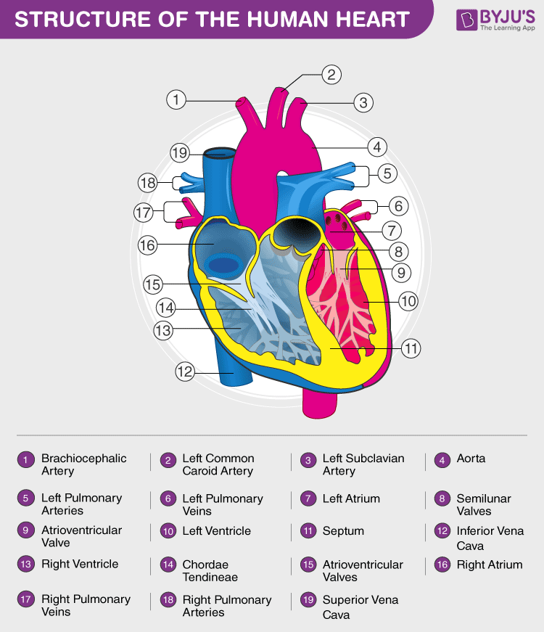

Q4. List electrodes used for i) ECG ii) EMG

There are three main types of electrodes:

1. Microelectrodes
2. Needle electrodes
3. [Body Surface electrodes](https://www.electrical4u.com/surface-electrodes/)

## Microelectrodes

Microelectrode measures the electric potential from within a single cell. It has very small diameter tips that can penetrate deep into the cell without damaging the human cell. The functions of microelectrodes are potential recording to inject medicines.

Generally,when microelectrode is inside cell, reference electrode is outside the cell. It has high impedances in range of mega ohm due to their small size. Two types of microelectrode are

* Metal Microelectrode
* Non- Metallic (Micropipette)

### Metal Microelectrode

The tungsten filament or stainless steel wire made into minute structure forms the tip of the microelectrode. This technique is electropointing. The [insulating material](https://www.electrical4u.com/electrical-insulator-insulating-material-porcelain-glass-polymer-insulator/) covers the entire electrode for safety purpose.

Few electrolytic processing is done to reduce the impedance. Measurement of bioelectric potentials requires two electrodes. The resulting voltage potential is the difference between the potential of microelectrode and reference electrode. The total sum of the three potentials is as follows.

Where,  
EA – metal electrode-electrolyte potential at microelectrode tip.  
EB – Reference electrode-electrolyte potential.  
EC – Variable cell membrane potential.

### Non-Metal Microelectrode (Micropipet)

This electrode uses Non – metallic material to measure the potential from a single cell. It consists of glass micropipette of diameter 1 micrometer. Micropipet filled with electrolyte solution that is compatible with cellular fluids is used. Stem of Micropipet has a thin flexible wire made out of chloride silver, stainless steel or tungsten. One end of the Micropipet attaches to the rigid support and other free end rests on the cell. The potential voltage generated is as follows.

EA – potential voltage between the metal wire and an electrolyte filled inside Micropipet.  
EB – potential between the reference electrode and extracellular fluid.  
EC – variable cell membrane potential.

ED – potential at the tip due to electrolytes present inside the pipet and the cell.

## Depth and Needle Electrodes

When electrode gets closer to the bioelectric generator, it penetrates into the skin. Therefore, the electrode should be sharp for penetration to obtain and record the bioelectric events.

### Depth Electrodes

**Depth electrode** studies the electrical activity of the neurons in the surface of the brain. This type of electrode consists of bundle of Teflon insulated platinum and iridium alloy wires.

For easy insertion of the electrodes into the brain, the end of the supporting wire is round-shaped. The number of individual electrodes forms the electrode array or bundle. In the bundle of electrodes, the end of each individual wires has the individual electrode.

#### Applications of Depth Electrodes

The applications of depth electrodes include:

1. To inject medicines into the brain.
2. To measure oxygen tension.

### Needle Electrodes

**Needle electrode** records the peripheral nerve action potential. It resembles a medicinal syringe. At one end a short insulated wire is bent. The bent portion passes through the lumen of the needle. This setup goes into the muscle. Now the needle is withdrawn. The bent wire remains inside the muscle. Two type of needle electrodes namely

Mono-polar Electrode: This type uses single reference electrode placed on the skin.

Bi – polar Electrode: This type has one reference electrode and one active electrode.

#### Applications of Needle Electrodes

Needle electrodes are mostly used in the measurement of EEG and EMG signals.

Q5. Which body parts are detected by: i) ECG ii) EMG iii) EOG iv) EEG v) oximeter.

a)An ECG determines heart activity by measuring signals from electrodes placed on the torso, arms and legs

b) EEG electrodes are uniformly attached to the forehead with the ears used as a reference for monitoring brain activity

c) Pairs of electrodes are used on a specific muscle and a separate location is used as a reference for EMG measurements

d) eye movement is measured by electrodes placed above, below and at the side of each eye. In fact, measurement of the retina within the eyes produces another type of measurement called an electroretinogram or ERG.

Q.6. What do you mean by synapse? List the three types of synapse in our body.

In the [central nervous system](https://www.verywellhealth.com/nervous-system-1298170), a synapse is a small gap at the end of a neuron that allows a signal to pass from one neuron to the next. Synapses are found where nerve cells connect with other nerve cells.

Parts of the Synapse

Synapses are composed of three main parts:

* The**presynaptic ending** that contains neurotransmitters
* The **synaptic cleft** between the two nerve cells
* The **postsynaptic ending** that contains receptor sites

## Types

There are two main types of synapses:

* Chemical synapses
* Electrical synapses

### **Chemical Synapses**

In a chemical synapse, the electrical activity in the presynaptic neuron triggers the release of chemical messengers, the neurotransmitters.

The neurotransmitters diffuse across the synapse and bind to the specialized receptors of the postsynaptic cell.

The neurotransmitter then either excites or inhibits the postsynaptic neuron. Excitation leads to the firing of an action potential while inhibition prevents the propagation of a signal.

### **Electrical Synapses**

In electrical synapses, two neurons are connected by specialized channels known as gap junctions.

Electrical synapses allow electrical signals to travel quickly from the presynaptic cell to the postsynaptic cell, rapidly speeding up the transfer of signals.

The special protein channels that connect the two cells make it possible for the positive current from the presynaptic neuron to flow directly into the postsynaptic cell.

7) Discuss the role of IPSP and EPSP in post synaptic transmission of action potential

Postsynaptic conductance changes and the potential changes that accompany them alter the probability that an [action potential](https://www.ncbi.nlm.nih.gov/books/n/neurosci/A2251/def-item/A2254/) will be produced in the [postsynaptic](https://www.ncbi.nlm.nih.gov/books/n/neurosci/A2251/def-item/A2771/) cell. At the [neuromuscular junction](https://www.ncbi.nlm.nih.gov/books/n/neurosci/A2251/def-item/A2671/), synaptic action increases the probability that an action potential will occur in the postsynaptic muscle cell; indeed, the large amplitude of the [EPP](https://www.ncbi.nlm.nih.gov/books/n/neurosci/A2251/def-item/A2441/) ensures that an action potential always is triggered. At many other synapses, PSPs actually *decrease* the probability that the postsynaptic cell will generate an action potential. PSPs are called **excitatory** (or **EPSPs**) if they increase the likelihood of a postsynaptic action potential occurring, and **inhibitory** (or **IPSPs**) if they decrease this likelihood. Given that most neurons receive inputs from both excitatory and inhibitory synapses, it is important to understand more precisely the mechanisms that determine whether a particular [synapse](https://www.ncbi.nlm.nih.gov/books/n/neurosci/A2251/def-item/A2905/) excites or inhibits its postsynaptic partner.

An [EPSP](https://www.ncbi.nlm.nih.gov/books/n/neurosci/A2251/def-item/A2461/) has a [reversal potential](https://www.ncbi.nlm.nih.gov/books/n/neurosci/A2251/def-item/A2830/) more positive than the [action potential](https://www.ncbi.nlm.nih.gov/books/n/neurosci/A2251/def-item/A2254/) [threshold](https://www.ncbi.nlm.nih.gov/books/n/neurosci/A2251/def-item/A2924/), whereas an [IPSP](https://www.ncbi.nlm.nih.gov/books/n/neurosci/A2251/def-item/A2543/) has a reversal potential more negative than threshold ([Figure 7.6D](https://www.ncbi.nlm.nih.gov/books/NBK11117/figure/A478/?report=objectonly)). Intuitively, this rule can be understood by realizing that an EPSP will tend to depolarize the membrane potential so that it exceeds threshold, whereas an IPSP will always act to keep the membrane potential more negative than the threshold potential.

8) Discuss the process of generation and propagation of action potential across neuronal membrane.

An **action potential** is defined as a sudden, fast, transitory, and propagating change of the [resting membrane potential](https://www.kenhub.com/en/library/anatomy/membrane-potential). Only [neurons](https://www.kenhub.com/en/library/anatomy/histology-of-neurons) and [muscle cells](https://www.kenhub.com/en/library/anatomy/types-of-muscle-cells) are capable of generating an action potential; that property is called the **excitability**.

An action potential is caused by either threshold or suprathreshold stimuli upon a neuron. It consists of four phases: depolarization, overshoot, and repolarization.

An action potential propagates along the cell membrane of an axon until it reaches the terminal button. Once the terminal button is depolarized, it releases a neurotransmitter into the synaptic cleft. The neurotransmitter binds to its receptors on the postsynaptic membrane of the target cell, causing its response either in terms of stimulation or inhibition.

Action potentials are propagated faster through the thicker and myelinated axons, rather than through the thin and unmyelinated axons. After one action potential is generated, a neuron is unable to generate a new one due to its refractoriness to stimuli.

Q.9. Explain diagrammatically the process of synaptic transfer from presynaptic membrane to postsynaptic membrane

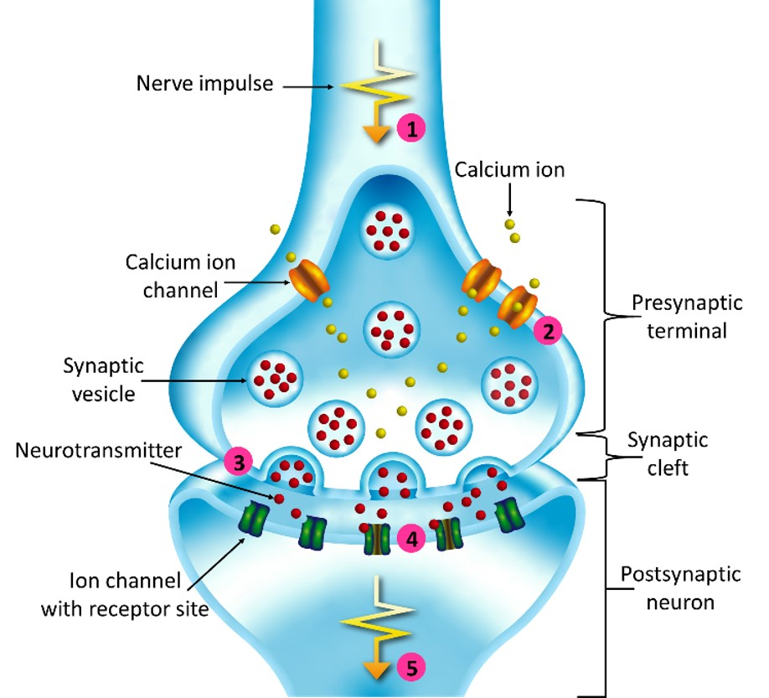

(1) A nerve impulse arrives.

(2) This causes calcium ion channels to open, resulting in an influx of calcium ions in the terminal.

(3) This causes synaptic vesicles to fuse with the terminal membrane, releasing neurotransmitter into the gap between neurons, known as the synaptic cleft.

(4) The neurotransmitters bind to receptor sites on ion channels in the postsynaptic membrane, causing them to open.

(5) Ions flow into the postsynaptic neuron, which generates an action potential when a threshold level is reached.

Q.10. What are bioelectrodes. List properties and applications of bioelectrode.