BBS01T1002 Semiconductor Physics

Assignment-2

( B.Tech. sem-II_ winter -2021-22)

***Note: Students are advised to solve the following questions (any ten) and submit the solution in hard copy on or before 07 June-2022.***

Q-1. In a p-n junction diode, explain a). Minority charge carrier b). Majority charge carrier

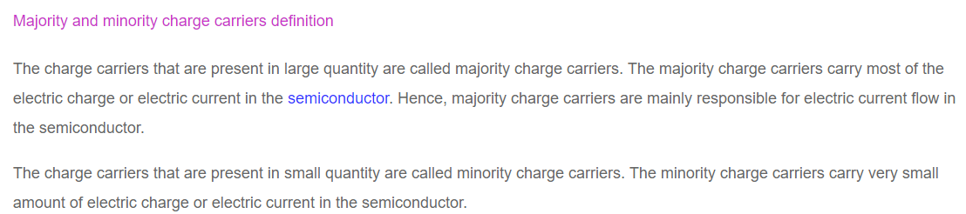

Q.2 Calculate energy band gap of semiconducting material if it emits light of wavelength 414 nm.

Q.3 Interpret the Zener breakdown in a p-n junction.

Zener Breakdown

The PN junction is formed by the combination of the p-type and the n-type semiconductor material. The combination of the P-type and N-type regions creates the depletion region.

The width of the depletion region depends on the doping of the P and N-type semiconductor material. If the material is heavily doped, the width of the depletion region becomes very thin.

The phenomenon of the Zener breakdown occurs in the very thin depletion region. The thin depletion region has more numbers of free electrons. The reverse bias applies across the PN junction develops the electric field intensity across the depletion region. The strength of the electric field intensity becomes very high.

The electric field intensity increases the kinetic energy of the free charge carriers. Thereby the carriers start jumping from one region to another. These energetic charge carriers collide with the atoms of the p-type and n-type material and produce the electron-hole pairs.

The reverse current starts flowing in the junction because of which depletion region entirely vanishes. This process is known as the Zener breakdown.

[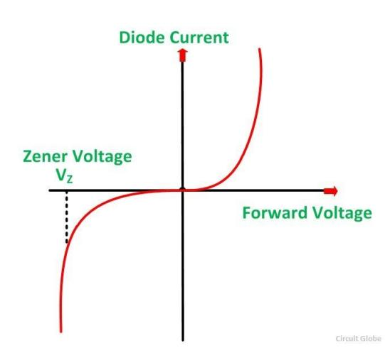](https://circuitglobe.com/wp-content/uploads/2015/12/ZENER-AND-AVALANCHE-BREAKDOWN-FIG-1-compressor.jpg)

In Zener breakdown, the junction is not completely damaged. The depletion region regians its original position after the removal of the reverse voltage.

Q.4 Define built-in-potential (potential barrier) and indicate the direction of internal electric field developed due to potential barrier in a zero biased p-n junction diode.

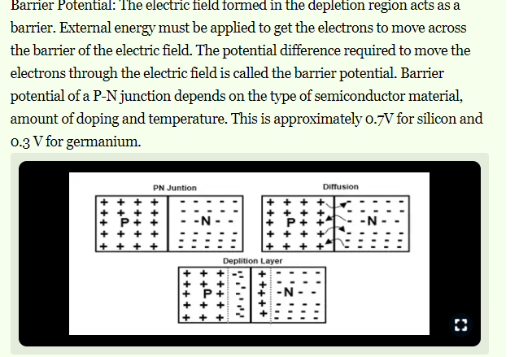

Q.5 Define current density and mobility of charge carriers for a semiconductor. Hall coefficient of a semiconductor is 3.22x10-4 m3/C and its resistivity is 9x10-3ohm-meter. Calculate the mobility in the semiconductor.

Q.6 Distinguish between the direct and indirect band gap semiconductors using band diagram along with one example each.

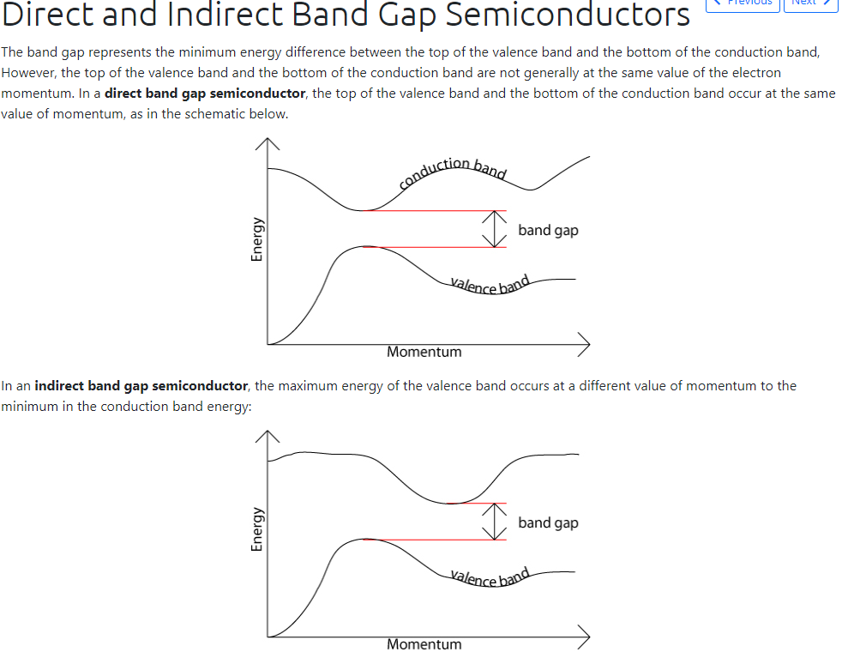

Q-7 Defined the biasing in a diode. Draw the different basing circuits in a p-n junction diode. Explain, in which biasing condition, the diode is considered as 'switch ON' state. Is current flowing through the p-n junction diode due to majority charge carriers in reversed biasing?

The effect described in the previous tutorial is achieved without any external voltage being applied to the actual PN junction resulting in the junction being in a state of equilibrium.

However, if we were to make electrical connections at the ends of both the N-type and the P-type materials and then connect them to a battery source, an additional energy source now exists to overcome the potential barrier.

The effect of adding this additional energy source results in the free electrons being able to cross the depletion region from one side to the other. The behaviour of the PN junction with regards to the potential barrier’s width produces an asymmetrical conducting two terminal device, better known as the **PN Junction Diode**.

A PN Junction Diode is one of the simplest semiconductor devices around, and which has the electrical characteristic of passing current through itself in one direction only. However, unlike a resistor, a diode does not behave linearly with respect to the applied voltage. Instead it has an exponential current-voltage ( I-V ) relationship and therefore we can not described its operation by simply using an equation such as Ohm’s law.

If a suitable positive voltage (forward bias) is applied between the two ends of the PN junction, it can supply free electrons and holes with the extra energy they require to cross the junction as the width of the depletion layer around the PN junction is decreased.

By applying a negative voltage (reverse bias) results in the free charges being pulled away from the junction resulting in the depletion layer width being increased. This has the effect of increasing or decreasing the effective resistance of the junction itself allowing or blocking the flow of current through the diodes pn-junction.

Then the depletion layer widens with an increase in the application of a reverse voltage and narrows with an increase in the application of a forward voltage. This is due to the differences in the electrical properties on the two sides of the PN junction resulting in physical changes taking place. One of the results produces rectification as seen in the PN junction diodes static I-V (current-voltage) characteristics. Rectification is shown by an asymmetrical current flow when the polarity of bias voltage is altered as shown below.

### Junction Diode Symbol and Static I-V Characteristics

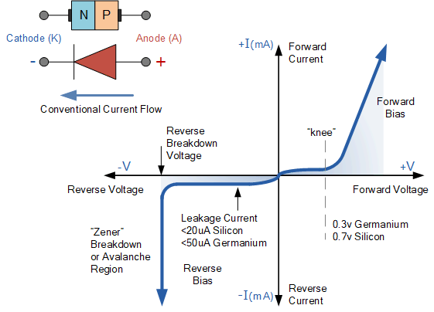

But before we can use the PN junction as a practical device or as a rectifying device we need to firstly **bias** the junction, that is connect a voltage potential across it. On the voltage axis above, “Reverse Bias” refers to an external voltage potential which increases the potential barrier. An external voltage which decreases the potential barrier is said to act in the “Forward Bias” direction.

There are two operating regions and three possible “biasing” conditions for the standard **Junction Diode** and these are:

* 1. Zero Bias – No external voltage potential is applied to the PN junction diode.
* 2. Reverse Bias – The voltage potential is connected negative, (-ve) to the P-type material and positive, (+ve) to the N-type material across the diode which has the effect of **Increasing** the PN junction diode’s width.
* 3. Forward Bias – The voltage potential is connected positive, (+ve) to the P-type material and negative, (-ve) to the N-type material across the diode which has the effect of **Decreasing** the PN junction diodes width.

Q.8 Interpret the recombination and generation of electron-hole pairs in a semiconductor. Find the wavelength corresponding to the band gap of GaAs (1.42eV) approximately.

Q-9 Explain the Hall effect phenomenon in a semiconductor and derive the expression for Hall coefficient. The carrier concentration in n-type semiconductor is 1019/m3, determine the value of Hall coefficient. Given [e=1.6x10-19 C ]

Hall effect is defined as the production of a voltage difference across an electrical conductor which is transverse to an electric current and with respect to an applied magnetic field it is perpendicular to the current. Edwin Hall discovered this effect in the year 1879.

Hall field is defined as the field developed across the conductor and Hall voltage is the corresponding potential difference. This principle is observed in the charges involved in the electromagnetic fields.

**Read More: [Hall Effect](https://byjus.com/physics/hall-effect/)**

## Hall Effect Derivation

Consider a metal with one type charge carriers that are electrons and is a steady-state condition with no movement of charges in the y-axis direction. Following is the derivation of Hall-effect:

(at equilibrium, force is downwards due to magnetic field which is equal to upward electric force)

Where,

* VH is Hall voltage
* EH is Hall field
* v is the drift velocity
* d is the width of the metal slab
* B is the magnetic field
* Bev is a force acting on an electron

Where,

* I is an electric current
* n is no.of electrons per unit volume
* A is the cross-sectional area of the conductor

Where,

: Hall coefficient (RH) is defined as the ratio between the induced electric field and to the product of applied magnetic field and current density. In [semiconductors](https://byjus.com/jee/semiconductors/), RH is positive for the hole and negative for free electrons.

Where,

* E is an electric field
* v is the drift velocity
* RHis the Hall coefficient
* 𝛍His the mobility of the hole

The ratio between density (x-axis direction) and current density (y-axis direction) is known as Hall angle that measures the average number of radians due to collisions of the particles.

Where,

* R is Hall resistance

### **Hall Effect Derivation in Semiconductors**

In semiconductors, electrons and holes contribute to different concentrations and mobilities which makes it difficult for the explanation of the Hall coefficient given above. Therefore, for the simple explanation of a moderate [magnetic field](https://byjus.com/physics/magnetic-field/), the following is the Hall coefficient:

Where,

* n is electron concentration
* p is hole concentration
* 𝛍eis the mobility of electron
* 𝛍His the mobility of the hole
* e is an elementary charge

### **Applications of Hall effect**

Hall effect finds many applications.

* It is used to determine if the given material is a semiconductor or insulator.
* It is used to measure the magnetic field and is known as a magnetometer
* They find applications in position sensing as they are immune to water, mud, dust, and dirt.
* They are used in integrated circuits as Hall effect sensors.

Q-10 Show that in an intrinsic semiconductor the conductivity of the material is given by: σ= e n (µe +µp), where [ σ =conductivity, n carrier density µe = mobility of electron and µp= mobility of hole and e= electronic charge]. The intrinsic carrier density of Ge at 27oC is 2.4 x 10 17 m-3. Calculate its resistivity, if the electron and hole mobility are 0.35 m2 V-1 s-1 and 0.18 m2 V-1 s-1 , respectively.

Q-11 Describe the formation of depletion layer in p-n junction diode. Write the expression of Diode equation and draw the V-I characteristics of a p-n Junction diode. Explain the knee voltage in a Silicon (Si) based p-n junction diode.

## What is P-N Junction?

**Definition:** A P-N junction is an interface or a boundary between two semiconductor material types, namely the p-type and the n-type, inside a semiconductor.

In a semiconductor, the P-N junction is created by the method of doping. The p-side or the positive side of the semiconductor has an excess of holes, and the n-side or the negative side has an excess of electrons. The process of doping is explained in further detail in the next section.

## Formation of P-N Junction

As we know, if we use different [semiconductor materials](https://byjus.com/jee/semiconductors/) to make a P-N junction, there will be a grain boundary that would inhibit the movement of electrons from one side to the other by scattering the electrons and holes and thus, we use the process of doping. We will understand the process of doping with the help of this example. Let us consider a thin p-type silicon semiconductor sheet. If we add a small amount of pentavalent impurity to this, a part of the p-type Si will get converted to n-type silicon. This sheet will now contain both the p-type region and the n-type region and a junction between these two regions. The processes that follow after forming a P-N junction are of two types – diffusion and drift. There is a difference in the concentration of holes and electrons at the two sides of a junction. The holes from the p-side diffuse to the n-side and the electrons from the n-side diffuse to the p-side. These give rise to a diffusion current across the junction.

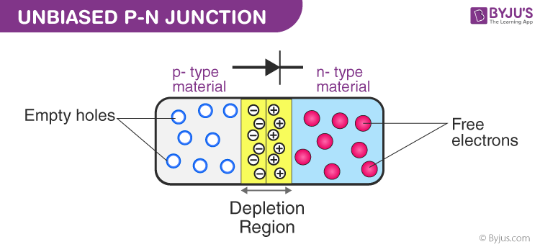

Also, when an electron diffuses from the n-side to the p-side, an ionised donor is left behind on the n-side, which is immobile. As the process goes on, a layer of positive charge is developed on the n-side of the junction. Similarly, when a hole goes from the p-side to the n-side, an ionized acceptor is left behind on the p-side, resulting in the formation of a layer of negative charges in the p-side of the junction. This region of positive charge and negative charge on either side of the junction is termed as the depletion region. Due to this positive space charge region on either side of the junction, an [electric field](https://byjus.com/physics/electric-field-of-point-charge/) with the direction from a positive charge towards the negative charge is developed. Due to this electric field, an electron on the p-side of the junction moves to the n-side of the junction. This motion is termed the drift. Here, we see that the direction of the drift current is opposite to that of the diffusion current.

### **Biasing Conditions for the P-N Junction Diode**

There are two operating regions in the P-N junction diode:

* P-type
* N-type

There are three biasing conditions for the P-N junction diode, and this is based on the voltage applied:

* Zero bias: There is no external voltage applied to the P-N junction diode.
* Forward bias: The positive terminal of the voltage potential is connected to the p-type while the negative terminal is connected to the n-type.
* Reverse bias: The negative terminal of the voltage potential is connected to the p-type and the positive is connected to the n-type.

## Forward Bias

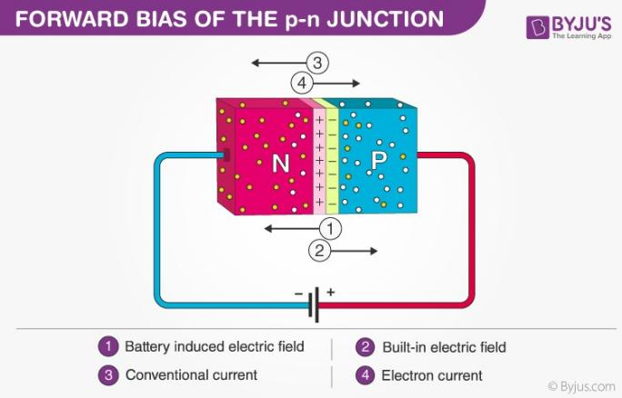

When the p-type is connected to the battery’s positive terminal and the n-type to the negative terminal, then the P-N junction is said to be forward-biased. When the P-N junction is forward biased, the built-in electric field at the P-N junction and the applied electric field are in opposite directions. When both the electric fields add up, the resultant electric field has a magnitude lesser than the built-in electric field. This results in a less resistive and thinner depletion region. The depletion region’s resistance becomes negligible when the applied voltage is large. In silicon, at the voltage of 0.6 V, the resistance of the depletion region becomes completely negligible, and the current flows across it unimpeded.

## Reverse Bias

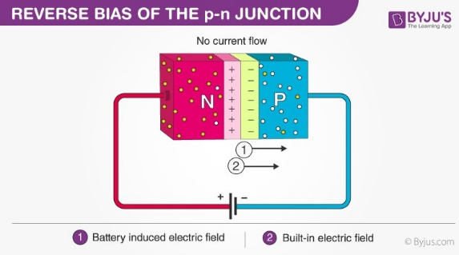

When the p-type is connected to the battery’s negative terminal and the n-type is connected to the positive side, the P-N junction is reverse biased. In this case, the built-in electric field and the applied electric field are in the same direction. When the two fields are added, the resultant electric field is in the same direction as the built-in electric field, creating a more resistive, thicker depletion region. The depletion region becomes more resistive and thicker if the applied voltage becomes larger.

## P-N Junction Formula

The formula used in the P-N junction depends upon the built-in [potential difference](https://byjus.com/physics/electrostatic-potential/) created by the electric field is given as:

|  |
| --- |
|  |

Where,

* E0 is the zero bias junction voltage
* VT is the thermal voltage of 26mV at room temperature
* ND and NA are the impurity concentrations
* ni is the intrinsic concentration.

### **How does current flow in PN junction diode?**

The flow of electrons from the n-side towards the p-side of the junction takes place when there is an increase in the voltage. Similarly, the flow of holes from the p-side towards the n-side of the junction takes place along with the increase in the voltage. This results in the concentration gradient between both sides of the terminals. Due to the concentration gradient formation, charge carriers will flow from higher concentration regions to lower concentration regions. The movement of charge carriers inside the P-N junction is the reason behind the current flow in the circuit.

## V-I Characteristics of P-N Junction Diode

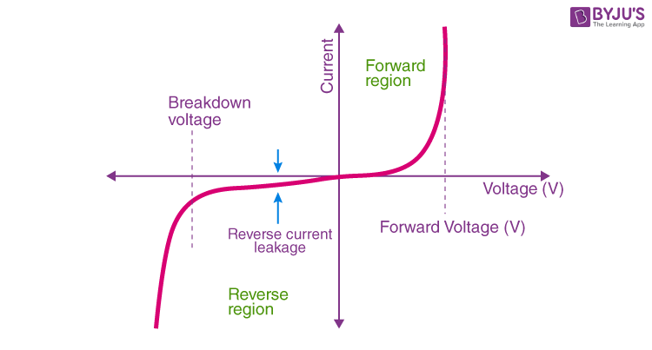

VI characteristics of P-N junction diodes is a curve between the voltage and current through the circuit. Voltage is taken along the x-axis while the current is taken along the y-axis. The above graph is the V-I characteristics curve of the P-N junction diode. With the help of the curve, we can understand that there are three regions in which the diode works, and they are:

* Zero bias
* Forward bias
* Reverse bias

When the P-N junction diode is in zero bias condition, there is no external voltage applied and this means that the potential barrier at the junction does not allow the flow of current.

When the P-N junction diode is in forward bias condition, the p-type is connected to the positive terminal while the n-type is connected to the negative terminal of the external voltage. When the diode is arranged in this manner, there is a reduction in the potential barrier. For silicone diodes, when the voltage is 0.7 V and for germanium diodes, when the voltage is 0.3 V, the potential barriers decrease, and there is a flow of current.

When the diode is in forward bias, the current increases slowly, and the curve obtained is non-linear as the voltage applied to the diode overcomes the potential barrier. Once the diode overcomes the potential barrier, the diode behaves normally, and the curve rises sharply as the external voltage increases, and the curve obtained is linear.

When the P-N junction diode is in negative bias condition, the p-type is connected to the negative terminal while the n-type is connected to the positive terminal of the external voltage. This results in an increase in the potential barrier. Reverse saturation current flows in the beginning as minority carriers are present in the junction.

When the applied voltage is increased, the minority charges will have increased kinetic energy which affects the majority charges. This is the stage when the diode breaks down. This may also destroy the diode.

## Applications of P-N Junction Diode

* P-N junction diode can be used as a photodiode as the diode is sensitive to the light when the configuration of the diode is reverse-biased.
* It can be used as a solar cell.
* When the diode is forward-biased, it can be used in LED lighting applications.
* It is used as rectifier in many electric circuits and as a voltage-controlled oscillator in varactors.

Q-12 Differentiate between the spontaneous and stimulated emission. Which type of emission produces coherent waves? Also, write two properties of coherent and incoherent waves.

We know light is an essential part of living and is classified based on wavelength, intensity, uses, sources, colour and frequencies. Light waves are composed of photons and the waves are characterised by various features like phase, amplitude, [frequency](https://byjus.com/physics/period-angular-frequency/" \l ":~:text=The%20time%20period%20is%20the,a%20point%20in%20unit%20time.)and period. The light produced by various sources is of different colours depending on the wavelength and frequency.

Depending on the source of light produced, they are classified as

1. Coherent sources
2. Incoherent sources

The interrelation between physical quantities of a single wave or between several waves is described by the property known as coherence. Let us know in detail about the coherent source and Incoherent source.

## Coherent Source

The source which emits a light wave with the same frequency, wavelength and phase or having a constant phase difference is known as a coherent source. A coherent source forms sustained interference patterns when the waves superimpose and the positions of maxima and minima are fixed.

Coherent sources produce waves that have a constant phase difference with the same frequency and amplitude. The light from a LASER is coherent, parallel, monochromatic and has unbroken wave chains. The pattern of the coherent wave is as shown in the picture below.

The coherent source is produced by using prisms, lenses and mirrors with specific specifications. Some of the techniques that help in the production of coherent sources are Fresnel’s biprism, [Young’s double-slit experiment](https://byjus.com/physics/youngs-double-slit-experiment-derivation/)and Lloyd’s mirror arrangement. In these techniques, the division of the wavefront takes place to produce a coherent source.

Considering the incoming beam and dividing its amplitude into various parts through a process of partial reflection or refraction aids in the creation of coherent sources. These divided beams travel in different paths and meet other waves and undergo interference, where the division in amplitude takes place to create a coherent source.

### **Examples of Coherent Sources**

* A LASER is a type of coherent source. LASER uses a phenomenon known as stimulated emission to generate highly coherent light.
* Sound waves produced from speakers are driven by electrical signals that have the same frequency and a definite phase.

## Incoherent Source

Conventional light sources are used to produce incoherent sources. An incoherent source emits a light wave having a different frequency, wavelength and phase. In these waves, the transitions between energy levels in an atom is a completely random process. Hence, no control can be established over an atom that is going to lose energy in the form of radiation. The pattern of the incoherent wave is as shown in the picture below.

### **Examples of Incoherent Sources**

Tungsten filament lamps aid in the production of the incoherent source. Normal fluorescent tubes emit incoherent light.

Read more about the [reflection of the light](https://byjus.com/physics/reflection-of-light/).

|  |  |
| --- | --- |
| Related links | |
| [Raman scattering](https://byjus.com/physics/raman-scattering/) | [Murphy’s law](https://byjus.com/physics/murphys-law/) |
| [Lenz law](https://byjus.com/physics/lenzs-law/) | [Radioactivity – alpha decay](https://byjus.com/physics/radioactivity-alpha-decay/) |