**Write a detail report on Key distribution**

**with example.**

**Prepared for**

**Mr. Rajkamal Kishor Gupta**

**Galgotias University**

**Prepared By**

**Group-17**

**Neeraj Singh**

**21SCSE1011675**

**SEC-6**

**December,7,2022**

**TABLE OF CONTENTS**

INTRODUCTION TO THE STUDY……………………………………………………………………………………….….3

**1.0 Introduction**………………………………………………………………………………………………………3

**1.1** Statement of the Problem……………………………………………………………………..3

**2.0 Distribution of Public Key:…………………**…………………………………………………………….3

2.1 Public announcement

2.2 Publicly available directory

2.3 Public-key authority

2.4 Public-key certificates.

**3.0 Public announcement** ……………………………………………………………………………………..3

1. **Publicly available directory** ……………………………………………………………………………..4
2. **Public-key authority..**……………………………………………………………………………………….5

## 6.0 Public-key certificates …………………………………………………………………………………….7

## 7.0 END…………………………………………………………………………………………………………………..9

**INTRODUCTION**

1. **General Introduction**

In cryptography, it is a completely tedious challenge to distribute the private and non-private keys among sender and receiver. If the key's recognised to the third party (forger/eavesdropper) then the entire security mechanism becomes nugatory. So, there comes the need to at ease the change of keys.

There are two aspects for Key management:

* Distribution of public keys.
* Use of public-key encryption to distribute secrets and techniques.

**2.0 Distribution of Public Key:**

the general public key can be allotted in four approaches:

1. Public announcement
2. Publicly available directory
3. Public-key authority
4. Public-key certificates.

**2.1 these are defined as following under:**

1. **Public announcement**: here the public key's broadcasted to all people. The foremost weakness of this technique is a forgery. everyone can create a key claiming to be someone else and broadcast it. until forgery is located can masquerade as claimed consumer.

on the face of it, the point of public-key encryption is that the general public key is public. accordingly, if there's a few extensively ordinary public-key algorithm, together with RSA, any par- ticipant can ship his or her public key to any other participant or broadcast the important thing to the community at big . as an example, due to the developing pop- ularity of PGP, which uses RSA, many PGP customers have adopted the exercise of appending their public key to messages that they send to public boards, such as USENET newsgroups and net mailing lists.  
although this technique is handy, it has a main weak point. anybody can forge this

type of public declaration. that is, a few consumer may want to fake to be consumer A and ship a public key to any other participant or broadcast this kind of public key. till such time as person A discovers the forgery and alerts other members, the forger is capable of read all encrypted messages meant for A and can use the solid keys for authentication

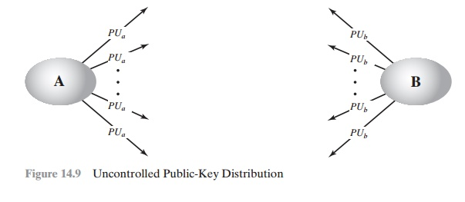

1. **Publicly available directory:** in this type, the public secret is stored in a public listing. Directories are trusted here, with properties like player Registration, get right of entry to and permit to modify values at any time, includes entries like {name, public-key}. Directories can be accessed electronically nonetheless prone to forgery or tampering.

A more degree of security can be completed by using retaining a publicly available dynamic listing of public keys. renovation and distribution of the general public direc- tory would should be the obligation of some trusted entity or business enterprise. this kind of scheme could consist of the subsequent elements:  
  
1. The authority continues a listing with a {call, public key} access for each participant.  
  
2. every participant registers a public key with the directory authority. Registration could should be in person or by using some shape of comfortable authenti- cated conversation.  
  
three. A participant may additionally update the prevailing key with a brand

new one at any time, both due to the desire to update a public key that has already been used for a massive amount of information, or due to the fact the corresponding personal key has been com- promised in a few manner.

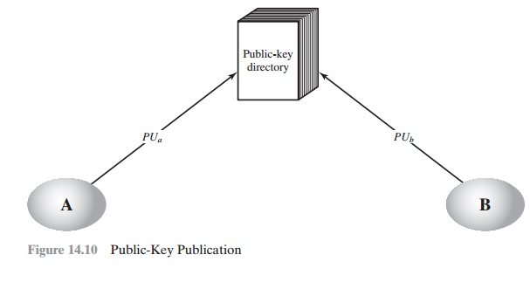

participants may also access the listing electronically. For this cause, at ease, authenticated communique from the authority to the participant is mandatory.  
This scheme is certainly more relaxed than individual public bulletins however nevertheless has vulnerabilities. If an adversary succeeds in obtaining or computing the private key of the listing authority, the adversary may want to authoritatively bypass out counterfeit public keys and subsequently impersonate any participant and eaves- drop on messages sent to any participant. another manner to obtain the identical quit is for the adversary to tamper with the information kept by way of the authority.

**3.Public-key authority:** it's far much like the directory however, improves safety through tightening manage over the distribution of keys from the directory. It calls for users to know the public key for the listing. whenever the keys are needed, real-time access to the listing is made by means of the person to gain any preferred public key securely.

Stronger security for public-key distribution can be achieved by providing tighter control over the distribution of public keys from the directory.. As before, the scenario assumes that a central authority maintains a dynamic directory of public keys of all participants.

In addition, each participant reliably knows a public key for the authority, with only the authority knowing the corresponding private key. The following steps occur.

1. A sends a timestamped message to the public-key authority containing a request for the current public key of B.

2. The authority responds with a message that is encrypted using the authority’s pri- vate key, PRauth.Thus,A is able to decrypt the message using the authority’s pub- lic key.Therefore,A is assured that the message originated with the authority.The message includes the following:

•B’s public key, PUb, which A can use to encrypt messages destined for B

•The original request used to enable A to match this response with the cor- responding earlier request and to verify that the original request was not altered before reception by the authority

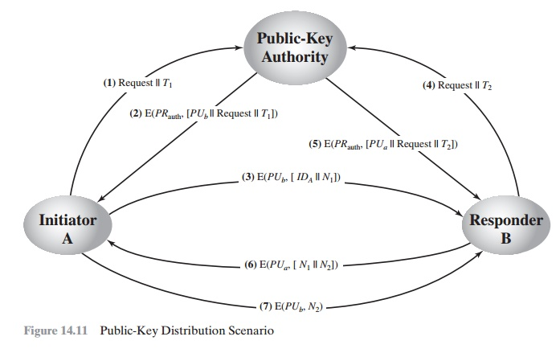

• The original timestamp given so A can decide that this is not an antique mes- sage from the authority containing a key other than B’s contemporary public key  
  
3. A stores B’s public key and also makes use of it to encrypt a message to B containing an identifier of A (IDA) and a nonce (N1), that is used to discover this transaction uniquely.  
  
four, five. B retrieves A’s public key from the authority in the same way as A retrieved B’s public key.  
  
At this point, public keys were securely introduced to A and B, and they may begin their protected change. but, two extra steps are applicable:  
  
6. B sends a message to A encrypted with PUa and containing A’s nonce (N1) in addition to a new nonce generated by means of B (N2). due to the fact best B could have decrypted message (three), the presence of N1 in message (6) assures A that the correspondent is B.  
  
6. A returns N2, that is encrypted using B’s public key, to assure B that its cor- respondent is A.  
  
as a result, a complete of 7 messages are required. but, the initial four mes- sages need be used only every now and then because each A and B can keep the other’s public key for future use—a technique referred to as caching. Periodically, a person have to request fresh copies of the general public keys of its correspondents to ensure forex.

**4.Public-key certificates:** This time authority offers a certificate (which binds an identification to the general public key) to permit key trade with out real-time access to the public authority each time. The certificate is followed via some other data consisting of period of validity, rights of use, and many others. All of this content material is signed through the personal key of the certificate authority and it can be demonstrated by all people owning the authority’s public key.

First sender and receiver both request CA for a certificate which contains a public key and other information and then they can trade these certificates and might start conversation.

The situation of  eleven is appealing, but it has some drawbacks. the general public-key authority can be quite of a bottleneck within the machine, for a person must attraction to the authority for a public key for every different consumer that it needs to touch. As before, the directory of names and public keys maintained by way of the authority is vul- nerable to tampering.  
  
An opportunity approach, first cautioned via Kohnfelder [KOHN78], is to apply certificates that may be utilized by participants to change keys with out contacting a public-key authority, in a manner that is as reliable as if the keys were acquired at once from a public-key authority. In essence, a certificates consists of a public key, an identifier of the key proprietor, and the whole block signed by way of a relied on 1/3 celebration. typically, the 1/3 celebration is a certificate authority, along with a

government company or a financial institution, that is depended on with the aid of the user community. A person can gift his or her public key to the authority in a cozy manner and reap a cer- tificate. The person can then put up the certificate. every person needing this user’s pub- lic key can reap the certificates and verify that it is legitimate by way of way of the connected relied on signature. A player can also deliver its key information to every other with the aid of transmitting its certificates. different contributors can affirm that the certificate changed into created by using the authority. we will vicinity the subsequent requirements on this scheme:  
  
1. Any player can examine a certificate to decide the call and public key of the certificates’s owner.  
  
2. Any participant can verify that the certificates originated from the certificates authority and isn't counterfeit.  
  
3. best the certificate authority can create and replace certificate.  
  
those requirements are happy by the original inspiration in [KOHN78]. Denning [DENN83] brought the following additional requirement:  
  
four. Any player can verify the foreign money of the certificate.  
  
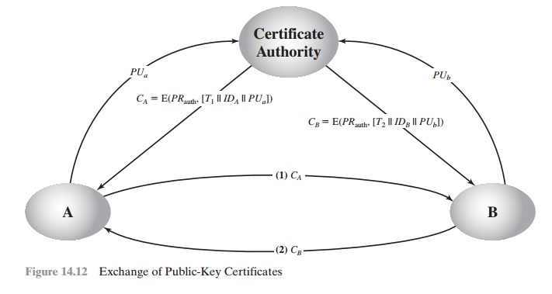

utility must be in individual or by means of a few shape of relaxed authenticated communi- cation. For player A, the authority provides a certificates of the shape

CA = E(PRauth, [T || IDA || PUa])  
wherein PRauth is the non-public key utilized by the authority and T is a timestamp. A may also then bypass this certificates directly to another player, who reads and verifies the cer- tificate as follows:

D(PUauth, CA) = D(PUauth, E(PRauth, [T || IDA || PUa])) = (T || IDA || PUa)  
The recipient makes use of the authority’s public key, PUauth, to decrypt the certifi- cate. because the certificate is readable best the use of the authority’s public key, this verifies that the certificates got here from the certificates authority. The factors IDA and PUa offer the recipient with the name and public key of the certificates’s holder. The timestamp T validates the currency of the certificates. The timestamp counters the subsequent scenario. A’s private secret's learned via an adversary. A gen- erates a new private/public key pair and applies to the certificate authority for a brand new certificate. meanwhile, the adversary replays the old certificate to B. If B then encrypts messages the use of the compromised old public key, the adversary can study the ones messages.

on this context, the compromise of a private secret is similar to the loss of a credit score card. The owner cancels the credit card range but is at hazard until all possible communicants are conscious that the vintage credit score card is out of date. for that reason, the timestamp serves as something like an expiration date. If a certificates is satisfactorily antique, it's miles assumed to be expired.  
One scheme has grow to be universally familiar for formatting public-key cer- tificates: the X.509 standard. X.509 certificate are used in most community security packages, consisting of IP safety, transport layer security (TLS), and S/MIME, all of which can be discussed in element five. X.509 is tested in detail inside the next segment.

………………..………………………………END………………………………………………..