BABU BANARASI DAS
UNIVERSITY
2026-2027
SCHOOL OF COMPUTER APPLICATIONS
NoSQL Project On
College Admission Management System Using MongoDB
Submitted to:  Mr. Harendra Singh  Department: BCA (DS & AI)  Date: 25th September | Submitted by:  Aryan Yadav  Roll no: 1250258139  Section: BCADS22  student's name  Roll no: ()  university roll no

1. CREATE DATABASE
MongoDB Query:
use CollegeDB
Explanation: Creates or switches to the CollegeDB database.
Output Screenshot:
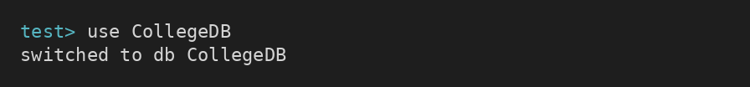

2. CREATE COLLECTION
MongoDB Query:
db.createCollection("admissions")
Explanation: Creates a collection named admissions.
Output Screenshot:
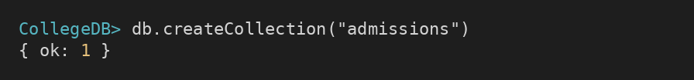

3. INSERT 50 ADMISSIONS
MongoDB Query:
db.admissions.insertMany([
{admissionId:1, name:"Aarav", age:18, fees:65500, course:"B.Sc"},
{admissionId:2, name:"Bhavya", age:18, fees:53500, course:"B.Sc"},
{admissionId:3, name:"Chirag", age:23, fees:95000, course:"B.Com"},
{admissionId:4, name:"Divya", age:24, fees:55500, course:"BCA"},
{admissionId:5, name:"Ekansh", age:18, fees:78000, course:"BBA"},
{admissionId:6, name:"Farhan", age:18, fees:82500, course:"BCA"},
{admissionId:7, name:"Garima", age:24, fees:31000, course:"B.Tech CSE"},
{admissionId:8, name:"Harsh", age:23, fees:57000, course:"BBA"},
{admissionId:9, name:"Ira", age:22, fees:73000, course:"B.Sc"},
{admissionId:10, name:"Jatin", age:18, fees:48000, course:"BCA"},
{admissionId:11, name:"Kavya", age:21, fees:61500, course:"B.Com"},
{admissionId:12, name:"Lakshya", age:19, fees:64500, course:"BCA"},
{admissionId:13, name:"Meera", age:22, fees:92000, course:"B.Com"},
{admissionId:14, name:"Nikhil", age:23, fees:36500, course:"B.Com"},
{admissionId:15, name:"Ojas", age:24, fees:39500, course:"B.Com"},
{admissionId:16, name:"Pooja", age:24, fees:75500, course:"B.Sc"},
{admissionId:17, name:"Rahul", age:21, fees:78500, course:"B.Sc"},
{admissionId:18, name:"Simran", age:24, fees:93000, course:"B.Sc"},
{admissionId:19, name:"Tanvi", age:17, fees:53500, course:"B.Tech CSE"},
{admissionId:20, name:"Uday", age:17, fees:91500, course:"BCA"},
{admissionId:21, name:"Vaishali", age:23, fees:85000, course:"B.Tech CSE"},
{admissionId:22, name:"Yash", age:24, fees:54000, course:"BCA"},
{admissionId:23, name:"Zainab", age:24, fees:94000, course:"B.Sc"},
{admissionId:24, name:"Aditi", age:21, fees:76000, course:"BBA"},
{admissionId:25, name:"Bharat", age:24, fees:76000, course:"B.Com"},
{admissionId:26, name:"Charvi", age:20, fees:62500, course:"BBA"},
{admissionId:27, name:"Deepak", age:17, fees:29000, course:"B.Tech CSE"},
{admissionId:28, name:"Esha", age:24, fees:91500, course:"B.Com"},
{admissionId:29, name:"Faizan", age:22, fees:50500, course:"BBA"},
{admissionId:30, name:"Gauri", age:24, fees:84500, course:"B.Sc"},
{admissionId:31, name:"Hemant", age:24, fees:80500, course:"B.Sc"},
{admissionId:32, name:"Isha", age:17, fees:62000, course:"BBA"},
{admissionId:33, name:"Jiya", age:24, fees:37500, course:"B.Com"},
{admissionId:34, name:"Karan", age:21, fees:82500, course:"B.Tech CSE"},
{admissionId:35, name:"Lalit", age:23, fees:86000, course:"BCA"},
{admissionId:36, name:"Mansi", age:21, fees:29000, course:"BBA"},
{admissionId:37, name:"Neeraj", age:18, fees:49500, course:"B.Com"},
{admissionId:38, name:"Parth", age:19, fees:82500, course:"BCA"},
{admissionId:39, name:"Riya", age:18, fees:25000, course:"B.Com"},
{admissionId:40, name:"Sahil", age:18, fees:50000, course:"B.Tech CSE"},
{admissionId:41, name:"Tanya", age:18, fees:30500, course:"B.Sc"},
{admissionId:42, name:"Utsav", age:21, fees:70500, course:"B.Tech CSE"},
{admissionId:43, name:"Vivek", age:17, fees:65000, course:"B.Sc"},
{admissionId:44, name:"Waseem", age:24, fees:42000, course:"B.Sc"},
{admissionId:45, name:"Anjali", age:20, fees:25000, course:"B.Sc"},
{admissionId:46, name:"Bhavesh", age:19, fees:89500, course:"BBA"},
{admissionId:47, name:"Chhavi", age:18, fees:78000, course:"B.Tech CSE"},
{admissionId:48, name:"Devansh", age:19, fees:64000, course:"B.Sc"},
{admissionId:49, name:"Ekta", age:23, fees:74500, course:"B.Tech CSE"},
{admissionId:50, name:"Fatima", age:20, fees:73000, course:"BCA"}
])
Explanation: Inserts multiple admission documents into the collection.
Output Screenshot:
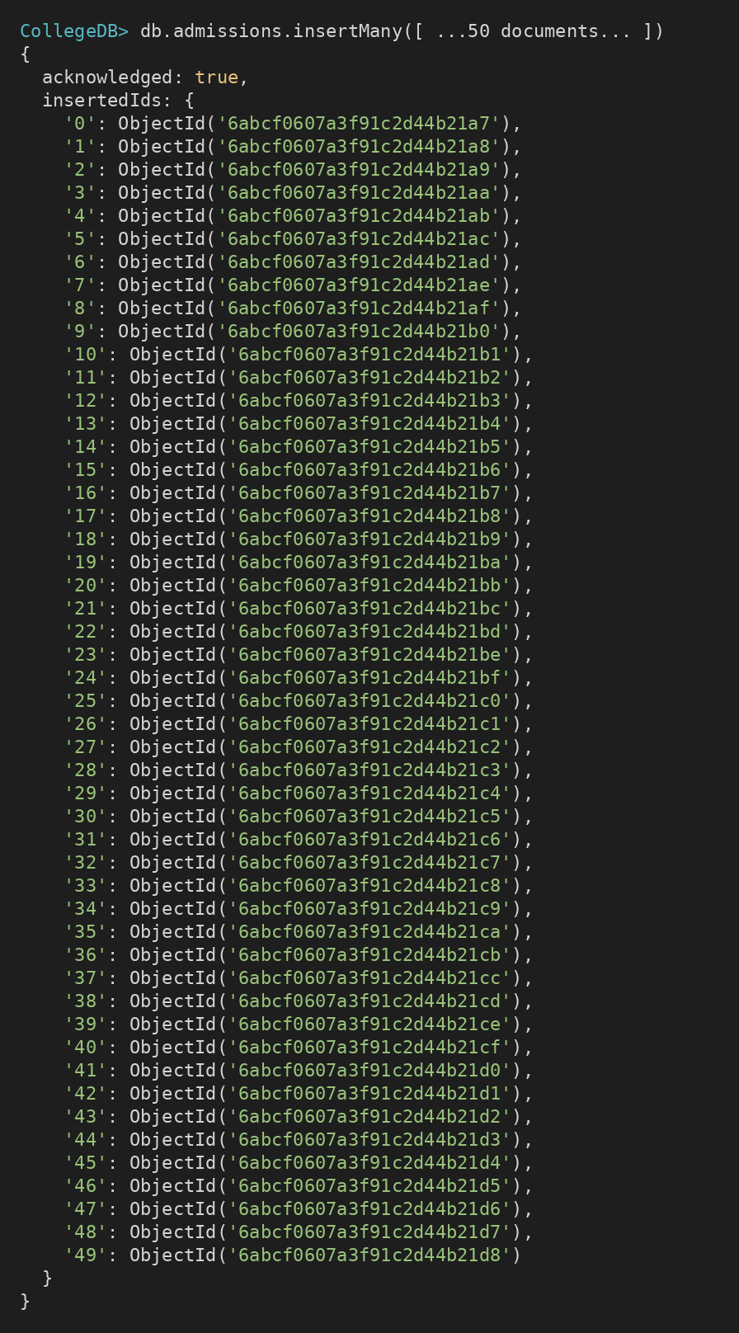

4. DISPLAY ALL ADMISSIONS
MongoDB Query:
db.admissions.find()
Explanation: Retrieves all documents from the admissions collection.
Output Screenshot:
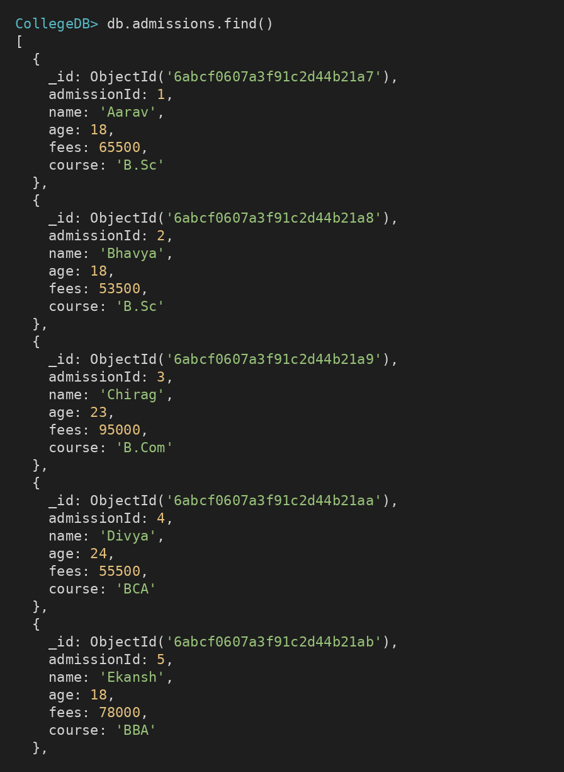

5. EQUAL TO — $eq
MongoDB Query:
db.admissions.find({fees: {$eq: 65500}})
Explanation: Finds admissions whose fees are exactly 65500.
Output Screenshot:
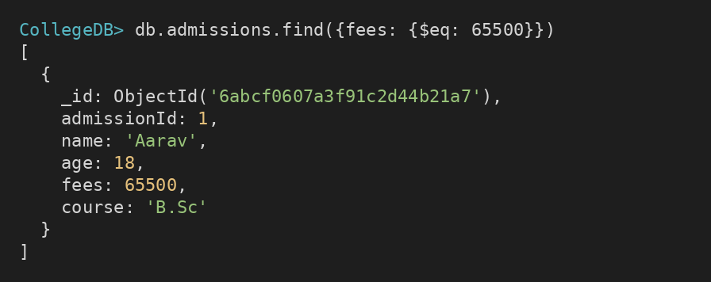

6. GREATER THAN — $gt
MongoDB Query:
db.admissions.find({fees: {$gt: 85000}})
Explanation: Finds admissions whose fees are greater than 85000.
Output Screenshot:
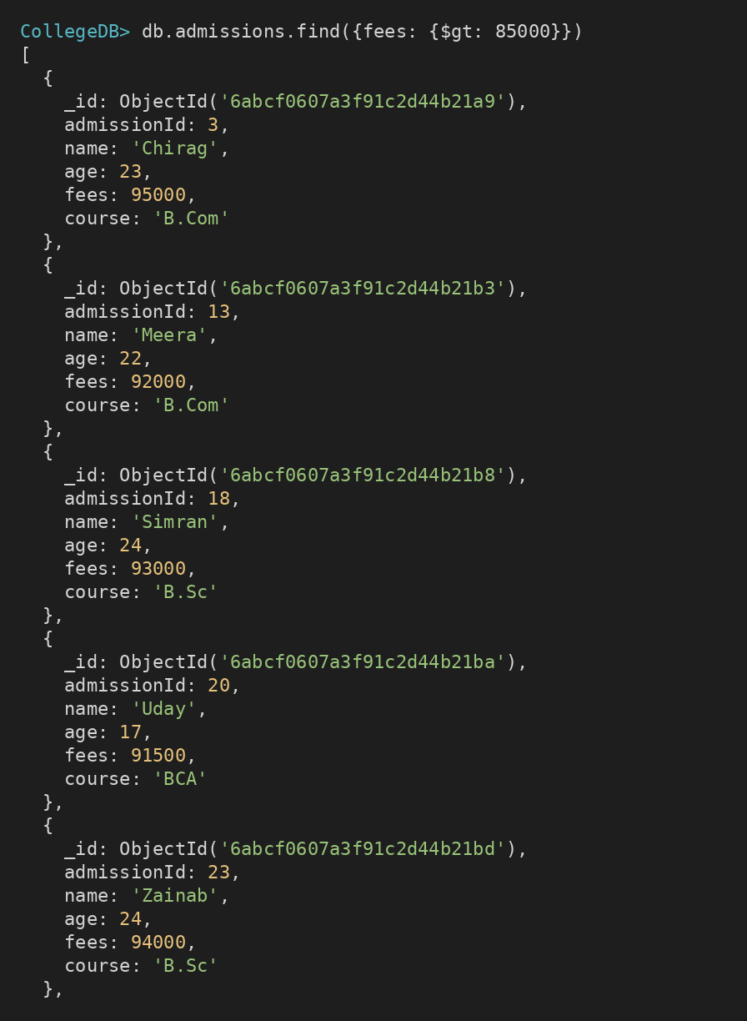

7. LESS THAN — $lt
MongoDB Query:
db.admissions.find({fees: {$lt: 35000}})
Explanation: Finds admissions whose fees are less than 35000.
Output Screenshot:
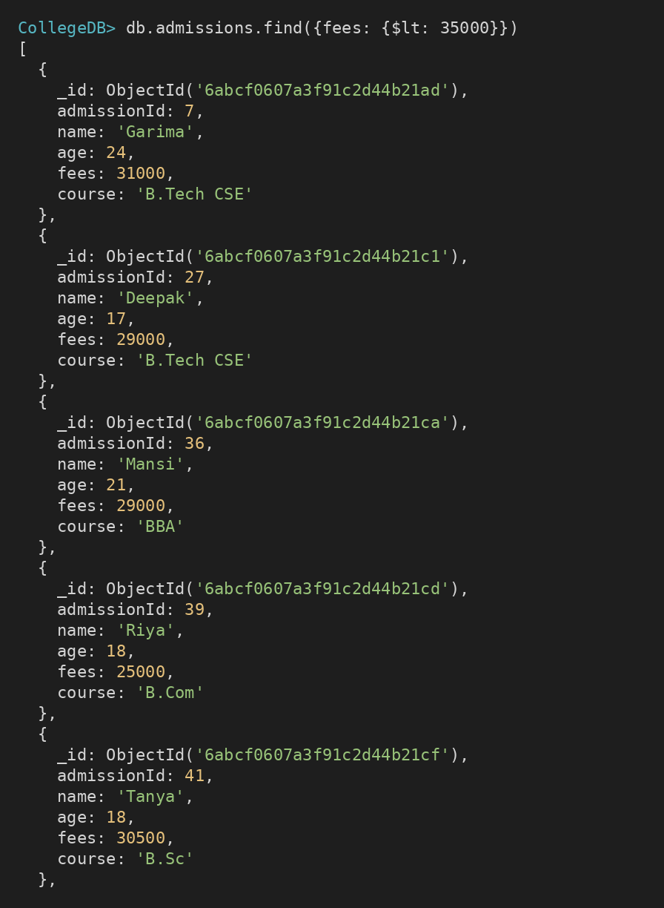

8. GREATER THAN OR EQUAL TO — $gte
MongoDB Query:
db.admissions.find({fees: {$gte: 90000}})
Explanation: Finds admissions whose fees are 90000 or above.
Output Screenshot:
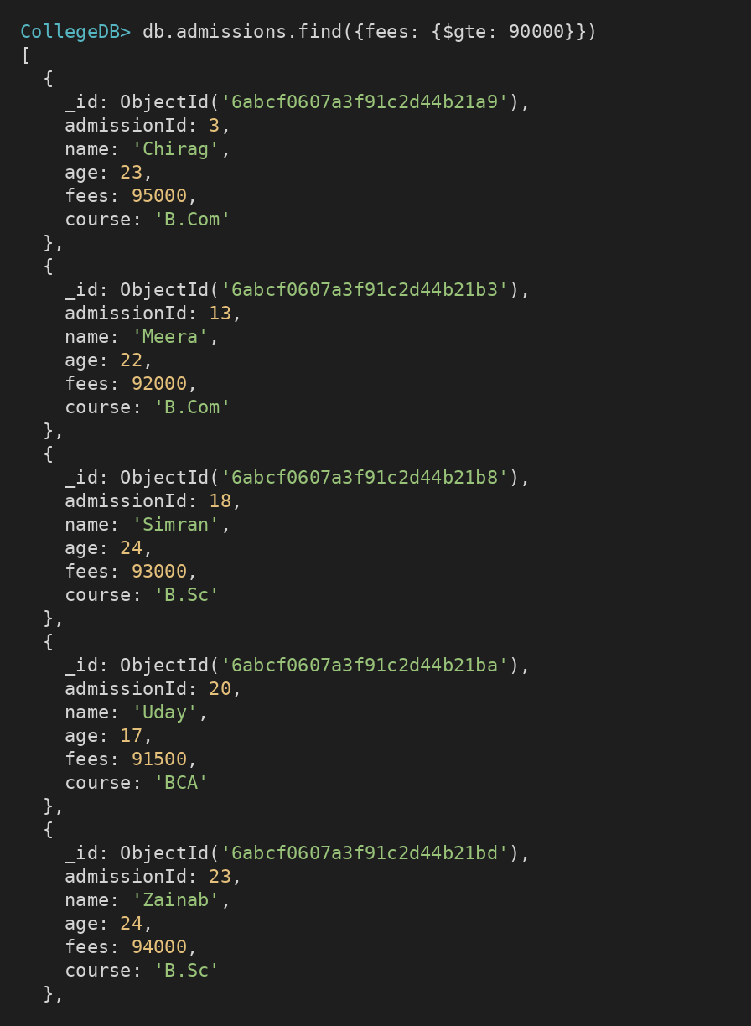

9. LESS THAN OR EQUAL TO — $lte
MongoDB Query:
db.admissions.find({fees: {$lte: 40000}})
Explanation: Finds admissions whose fees are 40000 or below.
Output Screenshot:
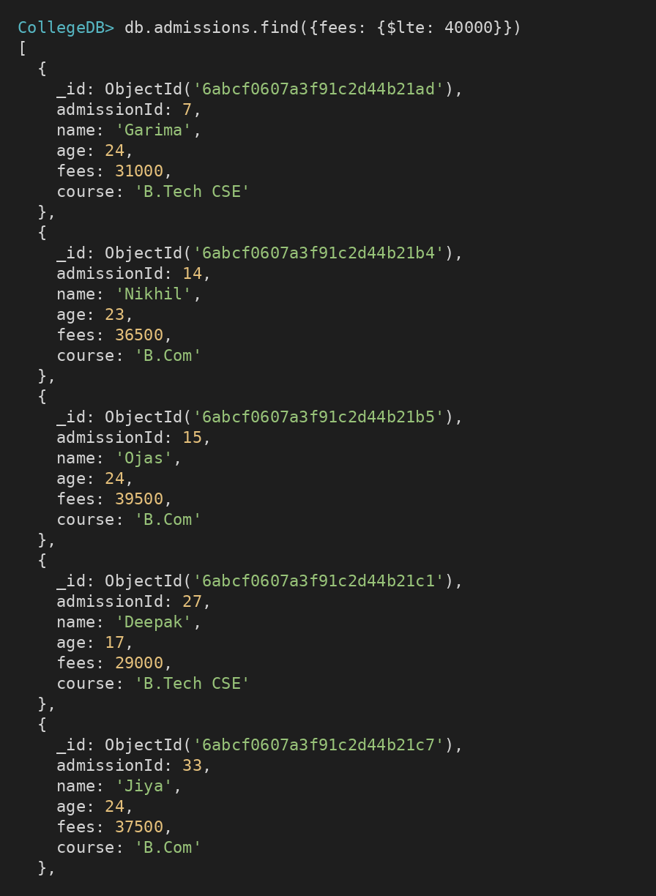

10. UPDATE OPERATION
MongoDB Query:
db.admissions.updateOne(
{admissionId:5},
{$set:{fees:95000}}
)
Explanation: Updates the fees to 95000 of the admission with admissionId 5.
Output Screenshot:
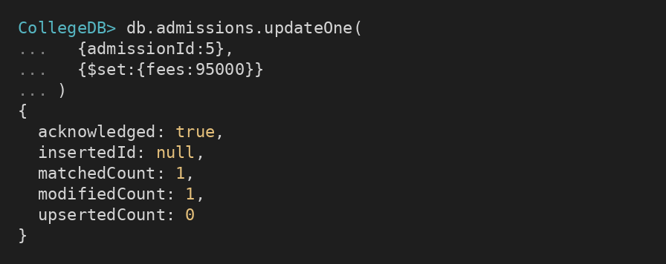

11. DELETE ONE OPERATION
MongoDB Query:
db.admissions.deleteOne({admissionId:10})
Explanation: Deletes one document matching admissionId 10.
Output Screenshot:
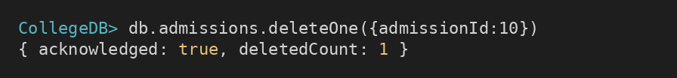

12. DELETE MANY OPERATION
MongoDB Query:
db.admissions.deleteMany({
fees: {$lt:35000}
})
Explanation: Deletes all admissions having fees below 35000.
Output Screenshot:
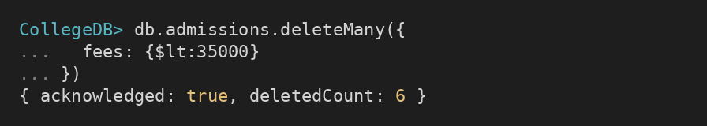

13. AND OPERATION — $and
MongoDB Query:
db.admissions.find({
$and:[
{fees:{$gt:80000}},
{age:19}
]
})
Explanation: Finds admissions satisfying both conditions.
Output Screenshot:
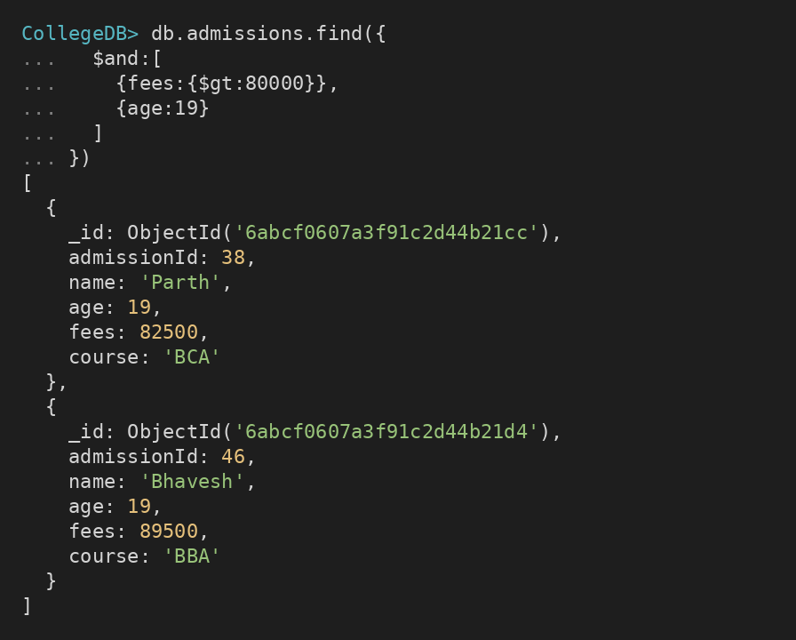

14. OR OPERATION — $or
MongoDB Query:
db.admissions.find({
$or:[
{course:"BCA"},
{course:"BBA"}
]
})
Explanation: Finds students who took admission in BCA or BBA course.
Output Screenshot:
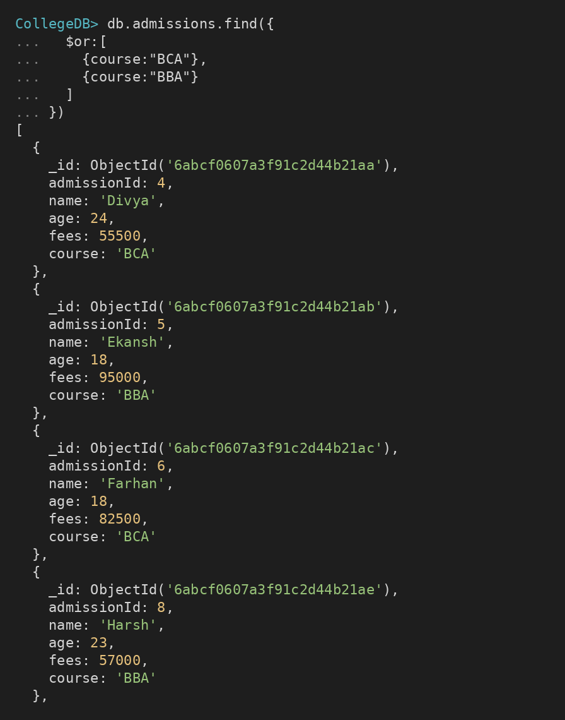

15. SORT OPERATION
A. MongoDB Query:
db.admissions.find().sort({fees: 1})
Explanation: Sorts admissions by fees from lowest to highest. Use 1 for ascending order.
Output Screenshot:
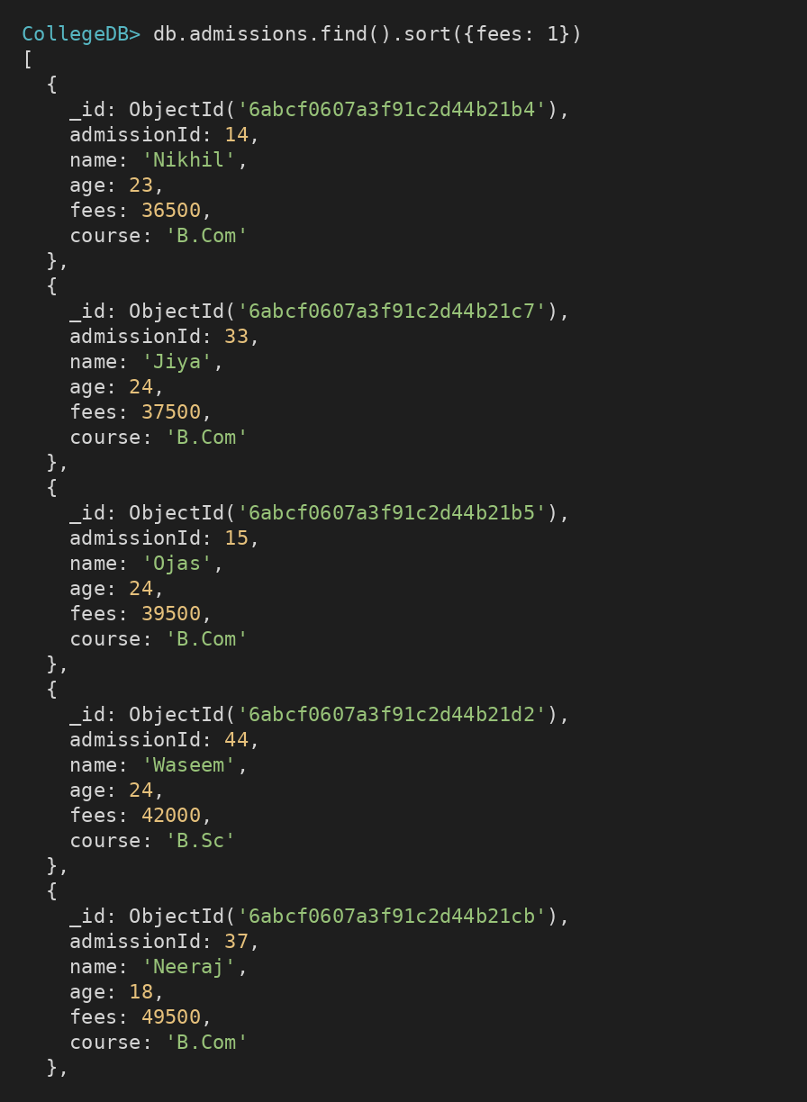
B. MongoDB Query:
db.admissions.find().sort({fees: -1})
Explanation: Sorts admissions by fees from highest to lowest. Use -1 for descending order.
Output Screenshot:
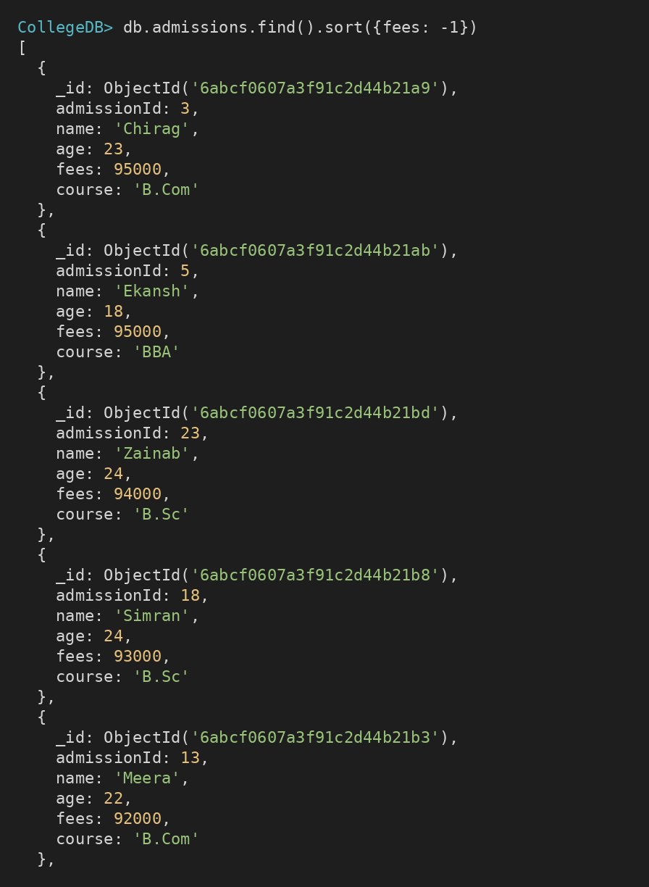

16. LIMIT OPERATION
MongoDB Query:
db.admissions.find().limit(5)
Explanation: Displays only the first five documents.
Output Screenshot:
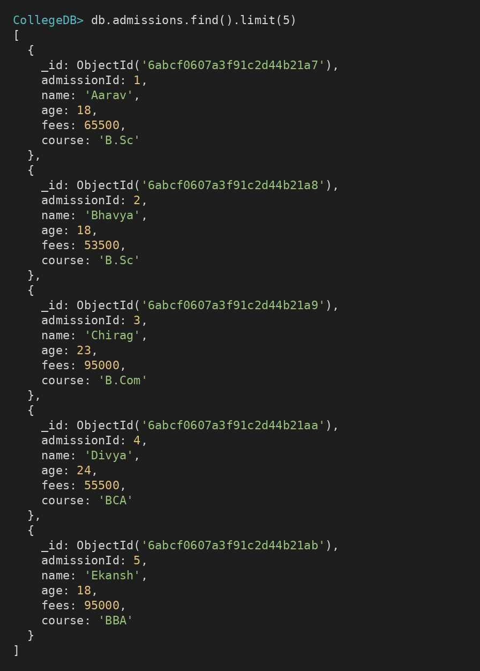

17. SEARCH BY COURSE
MongoDB Query:
db.admissions.find({course:"BCA"})
Explanation: Finds all students who took admission in the BCA course.
Output Screenshot:
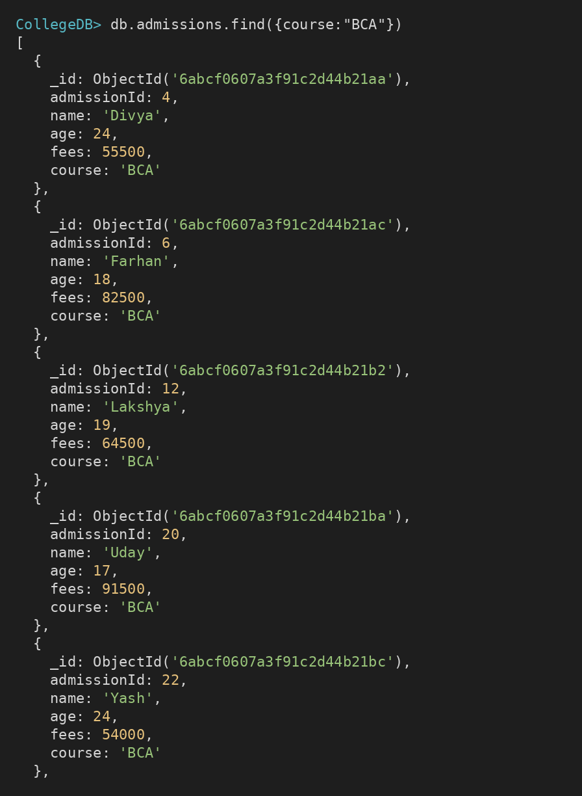

18. COUNT DOCUMENTS
MongoDB Query:
db.admissions.countDocuments()
Explanation: Counts documents currently present in the collection (performed after the delete operations).
Output Screenshot:
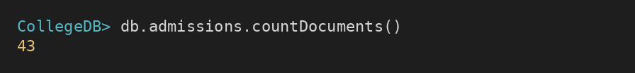

MONGODB OPERATORS USED
Operator | Meaning | Example
$eq | Equal to | fees: {$eq:65500}
$gt | Greater than | fees: {$gt:85000}
$lt | Less than | fees: {$lt:35000}
$gte | Greater than or equal to | fees: {$gte:90000}
$lte | Less than or equal to | fees: {$lte:40000}
$and | All conditions true | $and:[...]
$or | At least one condition true | $or:[...]

CONCLUSION
This project provided practical knowledge of NoSQL databases using MongoDB. A College Admission Management System containing student admission information was created and different MongoDB operations were performed on the data.
Through this project, I learned how to insert, retrieve, update, and delete documents. I also learned how to arrange data in ascending and descending order, how comparison operators such as $eq, $gt, $lt, $gte, and $lte work, along with logical operators such as $and and $or.
Overall, this project helped me understand how MongoDB can be used to manage and query admission data efficiently.

