Q5)

#include <iostream>

using namespace std;

int fib(int n)

{

if (n <= 1)

return n;

return fib(n - 1) + fib(n - 2);

}

int main()

{

int n;

cout << "Enter number : ";

cin >> n;

cout << "First " << n << " fibonacci terms" << endl;

for (int i = 0; i < n; i++)

cout << fib(i) << " ";

cout << endl;

return 0;

}

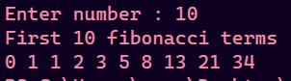

Q6)

#include <iostream>

using namespace std;

void towerOfHanoi(int n, char src, char dest, char aux)

{

if (n == 1)

{

cout << "From " << src << " to " << dest << endl;

return;

}

towerOfHanoi(n - 1, src, aux, dest);

towerOfHanoi(1, src, dest, aux);

towerOfHanoi(n - 1, aux, dest, src);

}

int main()

{

int n;

cout << "Enter number of discs : ";

cin >> n;

towerOfHanoi(n, 'A', 'C', 'B');

return 0;

}

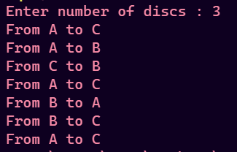

Q7)

#include <iostream>

using namespace std;

class Array

{

int n;

int \*arr;

public:

Array(int a)

{

n = a;

arr = new int[a];

}

void takeInput()

{

for (int i = 0; i < n; i++)

cin >> arr[i];

}

void displayArr()

{

for (int i = 0; i < n; i++)

cout << arr[i] << " ";

cout << endl;

}

int binarySearch(int left, int right, int key)

{

if (left > right)

return -1;

int mid = (left + right) / 2;

if (arr[mid] == key)

return mid;

else if (arr[mid] < key)

return binarySearch(mid + 1, right, key);

else

return binarySearch(left, mid - 1, key);

}

};

int main()

{

int n, key, pos;

cout << "Enter size of array : ";

cin >> n;

// declaring array object

Array A(n);

cout << "Enter elements of array" << endl;

A.takeInput();

cout << "Enter element to be searched : ";

cin >> key;

pos = A.binarySearch(0, n - 1, key);

if (pos == -1)

cout << key << " not found" << endl;

else

cout << key << " found at index " << pos << endl;

return 0;

}

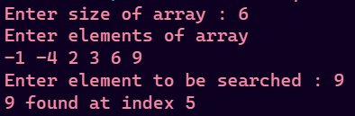

Q11)

#include <iostream>

using namespace std;

int nCr(int n, int r)

{

if (r == n || r == 0)

return 1;

return nCr(n - 1, r - 1) + nCr(n - 1, r);

}

int nPr(int n, int r)

{

if (r == 0)

return 1;

if (r > n)

return 0;

return nPr(n - 1, r) + r \* nPr(n - 1, r - 1);

}

int main()

{

int n, r;

cout << "Enter values of n , r" << endl;

cin >> n >> r;

cout << n << "P" << r << " : " << nPr(n, r) << endl;

cout << n << "C" << r << " : " << nCr(n, r) << endl;

return 0;

}

