Q6)

import java.io.File;

import java.io.FileWriter;

import java.io.IOException;

import java.util.Scanner;

public class q6 {

    public static void main(String[] args) {

        if (args.length == 0) {

            System.out.println("No command line arguments given");

            return;

        }

        String source = args[0];

        String destination = args[1];

        try{

            File sourceFile = new File(source);

            FileWriter destinationFile = new FileWriter(destination);

            Scanner sc = new Scanner(sourceFile);

            String line;

            while(sc.hasNextLine()){

                line = sc.nextLine();

                destinationFile.write(line + "\n");

            }

            destinationFile.close();

            sc.close();

        }

        catch(IOException e){

            System.out.println("Error occured : " + e);

        }

    }

}



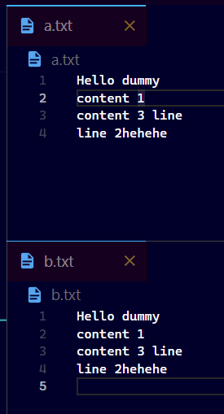

Q7)

import java.io.IOException;

import java.util.Scanner;

import java.io.File;

*/\*\**

*\* q7*

*\*/*

public class q7 {

    public static void main(String[] args) {

        String file;

        Scanner sc = new Scanner(System.in);

        System.out.println("Enter name of file");

        file = sc.next();

        try {

            File myFile = new File(file);

            Scanner fileReader = new Scanner(myFile);

            System.out.println("Lines starting with //");

            String line;

            while (fileReader.hasNextLine()) {

                line = fileReader.nextLine();

                if (line.startsWith("//"))

                    System.out.println(line);

            }

            fileReader.close();

        } catch (IOException e) {

            System.out.println("Error occured : " + e);

        }

        sc.close();

    }

}

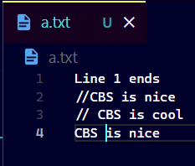

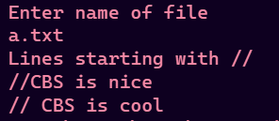

Q8)

import java.awt.*\**;

import java.awt.event.*\**;

class MyWindowAdapter extends WindowAdapter {

    public void windowClosing(WindowEvent we) {

        System.exit(0);

    }

}

class MouseEventDemo extends Frame implements MouseListener, MouseMotionListener {

    public MouseEventDemo() {

        addMouseListener(*this*);

        addMouseMotionListener(*this*);

        addWindowListener(new MyWindowAdapter());

    }

*// Handle mouse entered*

    public void mouseEntered(MouseEvent me) {

        setSize(new Dimension(900, 900));

    }

*// Handle mouse clicked*

    public void mouseClicked(MouseEvent me) {

        setSize(new Dimension(300, 300));

    }

*// Handle mouse exited*

    public void mouseExited(MouseEvent me) {

        System.exit(0);

    }

*// Handle mouse Dragged*

    public void mouseDragged(MouseEvent me) {

    }

*// Handle mouse moved*

    public void mouseMoved(MouseEvent me) {

    }

*// Handle mouse Pressed*

    public void mousePressed(MouseEvent me) {

    }

*// Handle mouse Released*

    public void mouseReleased(MouseEvent me) {

    }

}

public class q8 {

    public static void main(String[] args) {

        MouseEventDemo appwin = new MouseEventDemo();

        appwin.setSize(new Dimension(300, 300));

        appwin.setTitle("Q8 java frame");

        appwin.setVisible(true);

    }

}

