Q8)

// Using swing

import java.awt.*\**;

import java.awt.event.*\**;

import javax.swing.*\**;

class MouseEventDemo extends JFrame implements MouseListener, MouseMotionListener {

    public MouseEventDemo() {

        addMouseListener(*this*);

        addMouseMotionListener(*this*);

        setDefaultCloseOperation(WindowConstants.EXIT_ON_CLOSE);

    }

*// Handle mouse entered*

    public void mouseEntered(MouseEvent me) {

        setSize(new Dimension(900, 900));

    }

*// Handle mouse clicked*

    public void mouseClicked(MouseEvent me) {

        setSize(new Dimension(300, 300));

    }

*// Handle mouse exited*

    public void mouseExited(MouseEvent me) {

        System.exit(0);

    }

*// Handle mouse Dragged*

    public void mouseDragged(MouseEvent me) {

    }

*// Handle mouse moved*

    public void mouseMoved(MouseEvent me) {

    }

*// Handle mouse Pressed*

    public void mousePressed(MouseEvent me) {

    }

*// Handle mouse Released*

    public void mouseReleased(MouseEvent me) {

    }

}

public class q8Swing {

    public static void main(String[] args) {

        MouseEventDemo appwin = new MouseEventDemo();

        appwin.setSize(new Dimension(300, 300));

        appwin.setTitle("Q8 java frame");

        appwin.setVisible(true);

    }

}

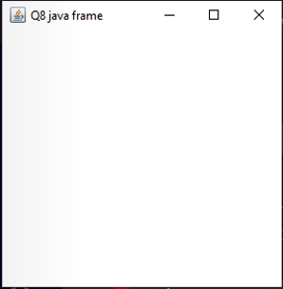

Q9)

// Using AWT

import java.awt.*\**;

import java.awt.event.*\**;

class MyWindowAdapter extends WindowAdapter {

    public void windowClosing(WindowEvent we) {

        System.exit(0);

    }

}

class Demo extends Frame {

    Label label = new Label("This is my First Frame", Label.CENTER);

    Demo() {

        add(label);

        addWindowListener(new MyWindowAdapter());

        setBackground(Color.pink);

        setSize(400, 400);

        setVisible(true);

        setTitle("My Frame");

    }

}

public class q9Awt {

    public static void main(String[] args) {

        Demo f = new Demo();

    }

}

//Using Swing

import javax.swing.*\**;

import java.awt.*\**;

class Demo extends JFrame {

    Demo() {

        setLayout(new FlowLayout());

        JLabel lbl = new JLabel("This is my First Frame", JLabel.CENTER);

        add(lbl);

    }

}

public class q9Swing {

    public static void main(String[] args) {

        Demo f = new Demo();

        f.setVisible(true);

        f.getContentPane().setBackground(Color.pink);

        f.setSize(400, 400);

        f.setDefaultCloseOperation(WindowConstants.EXIT_ON_CLOSE);

    }

}

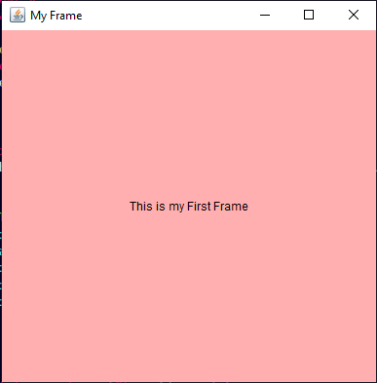

Q10 )

// using AWT

import java.awt.*\**;

import java.awt.event.*\**;

class MyWindowAdapter extends WindowAdapter {

    public void windowClosing(WindowEvent we) {

        System.exit(0);

    }

}

class Demo extends Frame implements ActionListener {

    Button bb = new Button("Blue");

    Button rb = new Button("Red");

    Demo() {

        setLayout(new FlowLayout());

        setSize(400, 400);

        setVisible(true);

        setTitle("My Frame");

        rb.addActionListener(*this*);

        bb.addActionListener(*this*);

        addWindowListener(new MyWindowAdapter());

        add(rb);

        add(bb);

    }

    @Override

    public void actionPerformed(ActionEvent e) {

        if (e.getSource() == bb)

            setBackground(Color.blue);

        if (e.getSource() == rb)

            setBackground(Color.red);

    }

}

public class q10Awt {

    public static void main(String[] args) {

        {

            Demo f = new Demo();

        }

    }

}

// Using Swing

import java.awt.*\**;

import javax.swing.*\**;

import java.awt.event.*\**;

class Demo extends JFrame implements ActionListener {

    JButton bb = new JButton("Red");

    JButton rb = new JButton("Blue");

    Demo() {

        setLayout(new FlowLayout());

        setSize(400, 400);

        setVisible(true);

        rb.setBounds(50, 100, 80, 30);

        bb.setBounds(150, 100, 80, 30);

        rb.addActionListener(*this*);

        bb.addActionListener(*this*);

        add(rb);

        add(bb);

    }

    public void actionPerformed(ActionEvent e) {

        if (e.getSource() == bb)

            getContentPane().setBackground(Color.red);

        if (e.getSource() == rb)

            getContentPane().setBackground(Color.blue);

    }

}

public class q10Swing {

    public static void main(String[] args) {

        Demo m1 = new Demo();

        m1.setDefaultCloseOperation(m1.EXIT_ON_CLOSE);

    }

}

Q11)

// Using AWT

import java.awt.*\**;

import java.awt.event.*\**;

class MyWindowAdapter extends WindowAdapter {

    public void windowClosing(WindowEvent we) {

        System.exit(0);

    }

}

class KeyEventDemo extends Frame implements KeyListener {

    Label label = new Label("Typed Character is : ", Label.CENTER);

    KeyEventDemo() {

        setLayout(new FlowLayout());

        addWindowListener(new MyWindowAdapter());

        addKeyListener(*this*);

        add(label);

        setSize(400, 400);

        setVisible(true);

    }

    public void keyPressed(KeyEvent e) {

    }

    public void keyReleased(KeyEvent e) {

    }

    public void keyTyped(KeyEvent e) {

        char ch = e.getKeyChar();

        label.setText("");

        label.setText("Typed character is : " + ch);

    }

}

public class q11Awt {

    public static void main(String[] args) {

        KeyEventDemo k = new KeyEventDemo();

    }

}

// Using Swing

import java.awt.*\**;

import java.awt.event.*\**;

import javax.swing.*\**;

class KeyEventDemo extends JFrame implements KeyListener {

    JLabel label = new JLabel("Typed Character is : ");

    KeyEventDemo() {

        setLayout(new FlowLayout());

        addKeyListener(*this*);

        add(label);

        setSize(400, 400);

        setVisible(true);

        setDefaultCloseOperation(WindowConstants.EXIT_ON_CLOSE);

    }

    public void keyPressed(KeyEvent e) {

    }

    public void keyReleased(KeyEvent e) {

    }

    public void keyTyped(KeyEvent e) {

        char ch = e.getKeyChar();

        label.setText("");

        label.setText("Typed character is : " + ch);

    }

}

public class q11Swing {

    public static void main(String[] args) {

        KeyEventDemo k = new KeyEventDemo();

    }

}

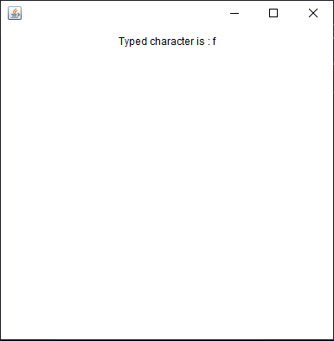

Q12)

// Using AWT

import java.awt.*\**;

import java.awt.event.*\**;

class MyWindowAdapter extends WindowAdapter {

    public void windowClosing(WindowEvent we) {

        System.exit(0);

    }

}

class Demo extends Frame implements ActionListener {

    Button a = new Button("A");

    Button b = new Button("B");

    Label label = new Label("                                           ");

    Demo() {

        setLayout(new FlowLayout());

        setSize(400, 400);

        setVisible(true);

        setTitle("My Frame");

        b.addActionListener(*this*);

        a.addActionListener(*this*);

        addWindowListener(new MyWindowAdapter());

        add(b);

        add(a);

        add(label);

    }

    @Override

    public void actionPerformed(ActionEvent e) {

        if (e.getSource() == a)

            label.setText("George, BMS, 6969 , CBS");

        if (e.getSource() == b)

            label.setText("Previous GPA : 8");

    }

}

public class q12Awt {

    public static void main(String[] args) {

        {

            Demo f = new Demo();

        }

    }

}

// Using Swing

import java.awt.*\**;

import java.awt.event.*\**;

import javax.swing.*\**;

class Demo extends JFrame implements ActionListener {

    JButton a = new JButton("A");

    JButton b = new JButton("B");

    JLabel label = new JLabel("                                                       ");

    Demo() {

        setLayout(new FlowLayout());

        setSize(400, 400);

        setVisible(true);

        setTitle("My Frame");

        setDefaultCloseOperation(WindowConstants.EXIT_ON_CLOSE);

        b.addActionListener(*this*);

        a.addActionListener(*this*);

        add(b);

        add(a);

        add(label);

    }

    @Override

    public void actionPerformed(ActionEvent e) {

        if (e.getSource() == a)

            label.setText("George, BMS, 6969 , CBS");

        if (e.getSource() == b)

            label.setText("Previous GPA : 8");

    }

}

public class q12Swing {

    public static void main(String[] args) {

        {

            Demo f = new Demo();

        }

    }

}

