Q12)

from matplotlib import pyplot as plt

def make_histogram(nums):

    plt.hist(nums)

    plt.xlabel("Value")

    plt.ylabel("Frequency")

    plt.xlim(min(nums)-1, max(nums)+1)

    plt.title("Histogram")

    plt.show()

num_str = input("Enter space separated numbers to plot histogram\n")

data = num_str.split()

data = [int(i) for i in data]

make_histogram(data)

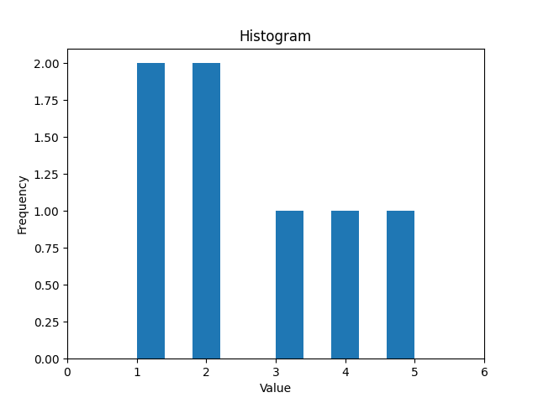

Q13)

from matplotlib import pyplot as plt

from math import sin, cos, exp

def plotFunctions():

    x = range(0, 100)

    y_sin = [sin(i) for i in x]

    y_cos = [cos(i) for i in x]

    y_poly = [i**5 for i in x]

    y_exp = [exp(i) for i in x]

    plt.subplot(2, 2, 1)

    plt.plot(x, y_sin)

    plt.xlabel("x")

    plt.ylabel("sin(x)")

    plt.title("x vs sin(x)")

    plt.subplot(2, 2, 2)

    plt.plot(x, y_cos)

    plt.xlabel("x")

    plt.ylabel("cos(x)")

    plt.title("x vs cos(x)")

    plt.subplot(2, 2, 3)

    plt.plot(x, y_exp)

    plt.xlabel("x")

    plt.ylabel("exp(x)")

    plt.title("x vs exp(x)")

    plt.subplot(2, 2, 4)

    plt.plot(x, y_poly)

    plt.xlabel("x")

    plt.ylabel("x**5")

    plt.title("x vs x**5")

    plt.tight_layout()

    plt.show()

plotFunctions()

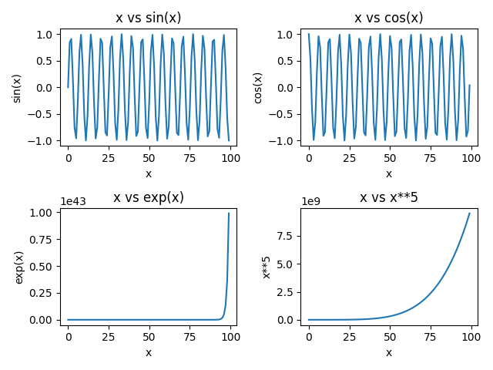

Q14)

try:

    src = input("Enter name of source file : ")

    dest = input("Enter name of destination file : ")

    with open(src, "r") as f1:

        with open(dest, "w") as f2:

            lines = f1.readlines()

            alternate_lines = lines[::2]

            f2.writelines(alternate_lines)

except IOError:

    print("Error opening your files")

