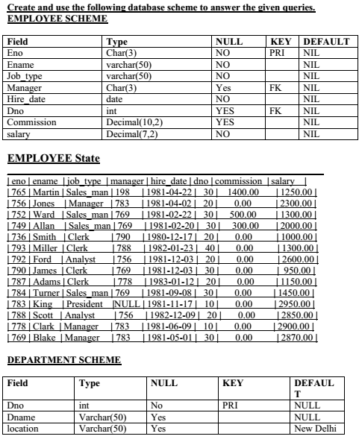

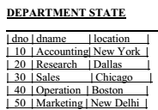

1) Query to display Employee Name, Job, Hire Date, Employee Number; for each employee with the Employee Number appearing **first.**

2) Query to display Unique Jobs from the Employee Table.

3) Query to display the Employee Name concatenated by a Job separated by a comma.

4) Query to display all the data from the Employee Table. Separate each Column by a comma and name the said column as THE_OUTPUT.

5) Query to display the Employee Name & Salary of all the employees earning more than $2850.

6) Query to display Employee Name & Department Number for the Employee No= 7900.

7) Query to display Employee Name & Salary for all employees whose salary **is not in**  
**the range of** $1500 and $2850.

8) Query to display Employee Name, Job, and Hire Date of all the employees hired between Feb 20, 1981 and May 1, 1981. Order the query in **ascending order of**  
**Start Date**.

9) Query to display Employee Name & Department No. of all the employees in Dept 10 and Dept 30 in the **alphabetical order by name**.

10) Query to display Employee Name & Salary of employees who earned more than $1500 and are in Department 10 or 30.

11) Query to display Name & Hire Date of every Employee who was hired in 1981.

12) Query to display Name & Job of all employees who don’t have a current Manager.

13) Query to display the Name, Salary & Commission for all the employees who earn commission. Sort the data in **descending order** of Salary and Commission.

14) Query to display Name of all the employees where the third letter of their name is ‘A’.

15) Query to display Name of all employees either have two ‘R’s or have two ‘A’s in their name & are either in Dept No = 30 or their Manger’s Employee No = 788.

16) Query to display Name, Job and Salary of all employees whose Job is Clerical or Analyst & their **salaries are not equal** to 1000, 3000, or 5000.

17) Query to display Name, Salary and Commission for all employees whose Commission Amount is greater than their Salary increased by 5 %.

18) Query to display the Current Date.

19) Query to display Employee No., Name, Salary and the Salary increased by 15 % expressed as a absolute whole number.-

20)Query to display Name, Hire Date and Salary Review Date which is the 1st Monday after six months of employment.

21) Query to display the employees that earn a salary that is higher than the salary of any of the clerks.

22) Query to display Name and calculate the number of months between today and the date each employee was hired.

23) Query to display the following for each employee:- <E-Name> earns < Salary> monthly but wants < 3 * Current Salary >. **Label** the Column as **Dream Salary**.

24) Query to display Name and Salary for all employees. Format the salary to be **15** character long, **left padded** with **$** sign.

25) Query to display Name with the 1st letter capitalized and all other letter lower case & length of their name of all the employees whose name starts with ‘J’,’A’ and ‘M’.

26) Query to display Name, Hire Date and Day of the week on which the employee started.

27) Query to display Name and Commission Amount. If the employee does not earn commission then use default value ‘No Commission’.

28) Query to display Name, Department Name and Department No for all the employees.

29) Query to display Unique Listing of all Jobs that are in Department # 30.

30) Query to display Name, Department Name and Location for all employees earning a commission.

31) Query to display Name, Dept Name of all employees who have an ‘A’ in their name.

32) Query to display Name, Job, Department No. and Department Name for all the employees working at the **Dallas location**.

33) Query to display Name and Employee No. along with their Manager’s Name and Manager’s employee no.

34) Query to display Name and Employee no. along with their Manger’s Name and the Manager’s employee no; along with the Employees’ Name who **do not** have a Manager.

35) Query to display the Employee No, Name and Salary for all employees who earn than the average salary and who work in a Department with any employee with a ‘T’ in his/her name.

36) Query to display Name, Dept No. & Salary of any employee whose department No. and salary matches both the department no. and the salary of any employee who earns a commission.

37) Query to display Name, Hire Date of any employee hired **after** the employee **Blake** was hired by the Company.

38) Query to display Name and Hire Dates of all Employees along with their Manager’s Name and Hire Date for all the employees **who were hired before** their managers.

39) Query to display Name and Salaries represented by Asteristisks – “Each asterisks **(*)** signifying **$100**.

40) Query to display the Highest, Lowest, Sum and Average Salaries of all the employees

41) Query to display Highest, Lowest, Sum and Average Salary for each unique Job Type

42) Query to display the number of employees performing the same Job type functions.

43) Query to display the no. of managers without listing their names.

44) Query to display the Difference b/w the Highest and Lowest Salaries.

45) Query to display the Manager’s No. & the Salary of the Lowest paid employee for that respective manager. **Exclude** anyone where the Manager ID **is not known**. Exclude any groups where the minimum salary is less than $1000.

46) Query to display the Department Name, Location Name, No. of Employees & the average salary for all employees in that department.

47) Query to display Name and Hire Date for all employees in the **same dept. as Blake**.

48) Query to display the Employee No. & Name for all employees who earn more than the average salary.

49) Query to display Employee Number & Name for all employees who work in a department with any employee whose name contains a ‘T’.

50) Query to display the employee name and salary of all employees who report to King.

51) Query to display the Department No, Name & Job for all employees in the Sales Dept.

52) Select manager name getting salary greater than average salary of employees in his department.