MyCycle
Product abstract: privacy-preserving, personal-baseline menstrual health screening
216U50P501 Community Engagement Project with Design Thinking. Guide: Dr. Makarand G. Kulkarni. Team: Aryan Lomte, Liza Patel, Saanj Patil, Aditya Lokhande.
Every number in this document is read from a results file produced by a script in the project repository (commit a9499e8932ae1286a2714f280e522d3e498d0e14-dirty). Simulated / preliminary, public and synthetic data, not real deployment data. MyCycle is a screening aid: it never gives a diagnosis and every flag suggests consulting a doctor.

Abstract
PCOS, iron-deficiency anemia and thyroid problems are often noticed late, because lab tests and ultrasound cost money or are far away, myths fill the information gap, and people are wary of apps that store intimate data on company servers. MyCycle screens for patterns that look like these conditions using only what a woman can log herself (cycle length, flow, pain and eight symptoms), comparing each new cycle with her own history rather than a population average. Raw logs never leave the phone. A Tier 1 detector (an adaptive z-score and CUSUM with a rule layer) caught 99% of simulated PCOS-like, 92% of anemia-like and 99% of thyroid-like changes on held-out test users, at 4.27 false alarms per 100 normal cycles. On real hospital data (n=541), symptom-only PCOS screening reached AUC 0.891 (95% CI 0.862 to 0.918) against 0.959 when lab and ultrasound values are allowed. On India's NFHS-5 survey (1,26,625 women), symptoms predicted self-reported thyroid disease reasonably (AUC 0.768) but anemia only weakly (AUC 0.620), so the anemia flag recommends a blood test. Federated learning, which keeps data on each phone, recovered AUC 0.878 against 0.892 for pooling all data and 0.740 for phones learning alone; adding differential privacy gave a stated privacy budget (for example epsilon 4.27 at noise 1.0) at a measured accuracy cost. A GRU neural network was tested and found weaker than the simple statistics, and is reported as such.

1. The product in plain words

The problem
- Clinical access: hormone tests, blood counts and ultrasound cost money and are often far away.
- Information: myths fill the gap, for example "irregular periods are just stress".
- Privacy: most existing cycle apps keep raw data on company servers.
- Culture: shame and taboo stop people discussing symptoms, even at home.

What MyCycle does
- Learns her own normal. After a few logged cycles it knows her usual cycle length, flow and symptoms, and how much they usually vary.
- Raises a screening flag when her own pattern changes in a way that looks like PCOS, anemia or thyroid trouble, or an irregular cycle. The flag names what changed and always says: consider consulting a doctor.
- Keeps logs on the phone. Optionally, phones improve a shared model by sending only a clipped, noise-added model update (federated learning with differential privacy).
- Backend serves flag wording, education cards and reminder rules, and accepts only anonymous counts. It refuses anything that looks like a cycle log.

What it is not
It is not a diagnostic tool, it has not been clinically validated on real patients, and the phone app screens are still being built. What is built and measured today is the engine: detector, screening models, private learning and backend.

2. How it works
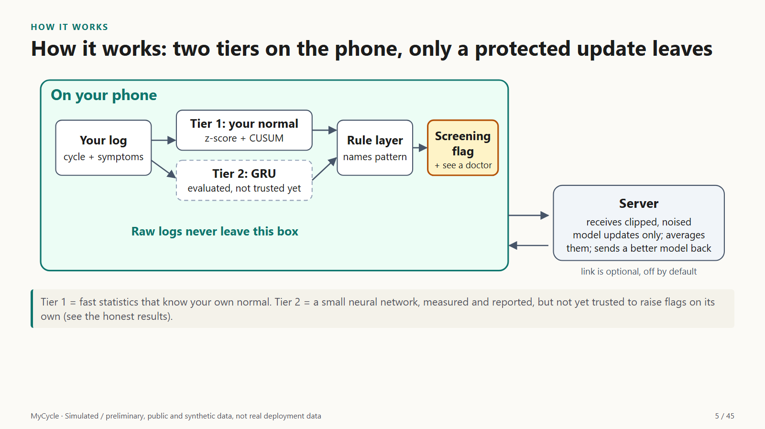
Figure 1: System architecture. Everything that touches personal data happens on the phone; only an optional, protected model update can leave.
Tier 1 (used for flags): an adaptive z-score measures how unusual this cycle is for her; CUSUM adds up small excesses so a slow drift is caught; a rule layer turns the signals that changed into one named flag. Tier 2 (evaluated): a small GRU neural network that predicts her next cycle; it was measured and is currently weaker than Tier 1, so it does not raise flags.
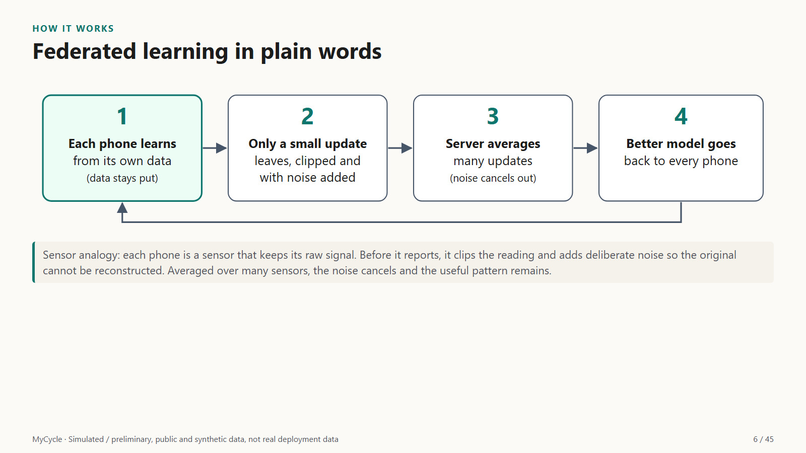
Figure 2: Federated learning in four steps. Raw data stays on each phone; only a clipped, noised update travels.
Job | Algorithm used | Why
Notice a change in her pattern | Hybrid: adaptive z-score (EWMA) + CUSUM + rule layer | Sudden jumps + slow creeps + a named pattern
Predict next cycle | GRU (ONNX export) | Measured; weaker than Tier 1 today
Screen from symptoms | Random forest (8 models compared) | Near-top everywhere, significant in 2 comparisons
Learn across phones | FedAvg with differential privacy | Raw logs stay on the phone, stated epsilon

Formulas, with every symbol explained
m(t) = m(t-1) + a (x(t) - m(t-1))
her running average; x = this cycle's value, a = 0.3
z(t) = (x(t) - m(t-1)) / s(t-1)
how unusual this cycle is for her; s = her usual spread
S(t) = max(0, S(t-1) + z(t) - k), flag when S(t) > h
CUSUM; k = 0.5, h tuned on validation data
g_i clipped = g_i x min(1, C / ||g_i||)
no single person's update can exceed size C
g_noisy = (1/B) (sum of clipped g_i + N(0, sigma^2 C^2 I))
noise on the SUM of clipped updates, then divide by batch size B
w_new = sum over phones k of (n_k / n) w_k
FedAvg: average of phone models weighted by data size
P[M(D) in S] <= e^epsilon P[M(D') in S] + delta
(epsilon, delta) privacy: one person changes any outcome's chance by at most e^epsilon

3. Exact input and output
Input: one logged cycle (contract 5.3). This is cycle 6 of Person B, exactly as stored on the phone:
{
"cycle_index": 6,
"start_date": "2024-07-22",
"cycle_length_days": 40,
"flow": 2,
"pain": 3,
"symptoms": {
"acne": 0,
"excess_hair": 0,
"hair_loss": 3,
"fatigue": 2,
"mood": 0,
"weight_change": 1,
"dizziness": 0,
"pallor": 0
}
}
Output: what the real Tier 1 detector returned for that cycle (contract 5.2):
{
"cycle_index": 6,
"flag": "pcos_pattern",
"score": 1.5104,
"confidence": "medium",
"contributing_signals": [
"cycle_length_high",
"acne_high",
"hair_loss_high"
],
"message_key": "flag.pcos_pattern.v1",
"detector": "zscore",
"simulated": true
}
What the user sees: the app looks up the message key in the backend's wording (it never invents flag text):
PCOS-Like Screening Pattern Noticed. Longer cycles paired with symptom changes match a pattern sometimes seen in PCOS. This screening flag reflects cycle lengthening alongside acne or hair pattern changes. This is a risk screening indicator, not a clinical determination. To evaluate these hormonal patterns accurately, consider consulting a doctor.

Backend calls (real server, throwaway database)
Call | Purpose | Status | What it proves
GET /v1/health | Is the server alive | 200 | Backend runs
GET /v1/content/messages | Flag wording for the app | 200 | The app never invents flag text
GET /v1/content/cards | Education cards | 200 | Content is served, not hard-coded
GET /v1/reminders/rules | Reminder rules | 200 | Rules are evaluated on the phone, server only sends definitions
POST /v1/metrics/aggregate | Send one anonymous count | 201 | Only allowed counts are accepted
POST /v1/metrics/aggregate | Try to smuggle a cycle length | 422 | Log data is refused (must be 422)
POST /v1/metrics/aggregate | Try an unknown metric | 422 | Anything off the allow-list is refused (must be 422)

Status 200/201 means accepted; 422 means refused. The refused request tried to send a cycle length along with an anonymous count. The server's reply:
{
"detail": [
{
"type": "extra_forbidden",
"loc": [
"body",
"cycle_length_days"
],
"msg": "Extra inputs are not permitted",
"input": 29
}
]
}

4. Worked example: four people, cycle by cycle
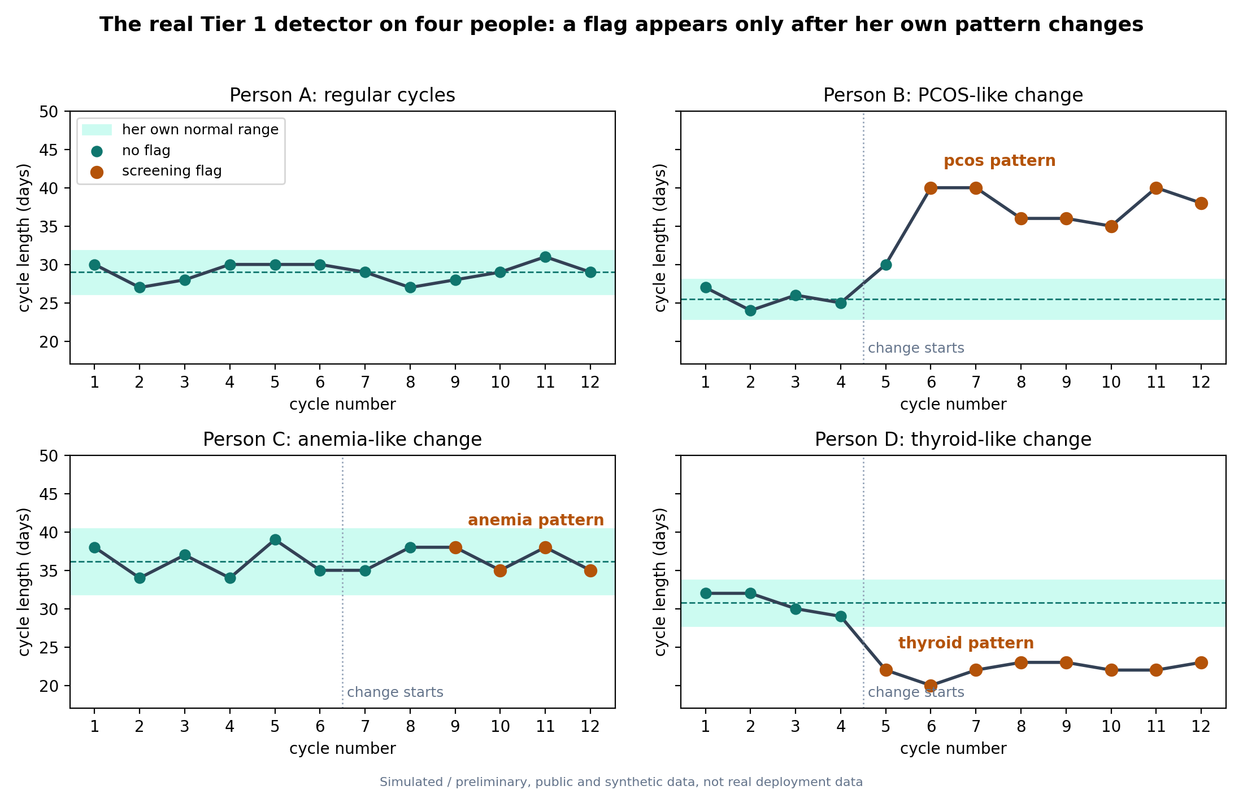
Figure 3: The real Tier 1 detector on four simulated people. Shaded band = her own normal (mean plus or minus 2 SD of early cycles). Simulated / preliminary, public and synthetic data, not real deployment data.
Person | Change starts | First flag | Matches expected?
Person A: regular cycles | none | never | yes
Person B: PCOS-like change | cycle 5 | cycle 6: pcos pattern | yes
Person C: anemia-like change | cycle 7 | cycle 9: anemia pattern | yes
Person D: thyroid-like change | cycle 5 | cycle 5: thyroid pattern | yes

Person B, every cycle
Narrative: her first cycles sit inside her own band, so nothing is flagged. Then her cycles lengthen and androgen-type symptoms (acne, hair changes) appear. The detector flags a PCOS-like pattern as soon as a cycle-length signal and a matching symptom signal coincide, and names both.
Cycle | Days | Flow | Pain | Symptoms logged | Detector output | What changed
1 | 27 | medium | 2/10 | none | no flag | -
2 | 24 | light | 4/10 | weight change (mild) | no flag | -
3 | 26 | medium | 1/10 | weight change (moderate) | no flag | -
4 | 25 | medium | 3/10 | weight change (mild) | no flag | -
5 | 30 | medium | 1/10 | acne (moderate), tiredness (mild), weight change (moderate), pale skin (moderate) | no flag | -
6 | 40 | medium | 3/10 | hair loss (severe), tiredness (moderate), weight change (mild) | pcos pattern (medium) | cycle longer than her normal, more acne, more hair loss
7 | 40 | light | 3/10 | excess hair (moderate), hair loss (mild) | pcos pattern (high) | cycle longer than her normal, more acne, more hair growth, more hair loss
8 | 36 | medium | 3/10 | acne (mild), mood change (mild), weight change (mild), pale skin (mild) | pcos pattern (high) | cycle longer than her normal, more hair growth, more hair loss
9 | 36 | medium | 3/10 | acne (severe), hair loss (moderate), dizziness (mild), pale skin (moderate) | pcos pattern (high) | cycle longer than her normal, more acne, more hair growth
10 | 35 | medium | 4/10 | acne (severe), excess hair (severe), hair loss (moderate), dizziness (mild) | pcos pattern (high) | cycle longer than her normal, more acne, more hair growth
11 | 40 | medium | 2/10 | acne (moderate), excess hair (severe), hair loss (moderate), dizziness (moderate) | pcos pattern (high) | cycle longer than her normal, more acne, more hair growth
12 | 38 | medium | 4/10 | acne (moderate), excess hair (moderate), hair loss (moderate), dizziness (mild) | pcos pattern (high) | cycle longer than her normal, more acne, more hair growth

5. Data
Category | Dataset | Size | Used for
Clinical, tabular (real) | Kaggle PCOS, 10 Kerala hospitals | 541 women | Symptom-only PCOS model
Population survey (real) | NFHS-5, India | 1,26,625 non-pregnant women | Anemia (real haemoglobin) and thyroid
Real cycle lengths | FedCycleData | 159 women, 1,665 cycles | Checking the simulator
Synthetic | MyCycle simulator, labeled synthetic | 3,000 users, 69,317 cycles | Change detection with known truth
Qualitative | Community interviews | 10 people | Design only, never training

No cheating: every hormone lab, ultrasound and haemoglobin column was removed from the symptom-only models; cleaning is learned inside each training fold; thresholds are tuned on validation data and the code refuses to tune on the test set.

Is the simulator realistic?
Measure | Real women | Simulator
Average cycle length (days) | 29.30 | 29.05
Variation across all cycles (days) | 3.89 | 3.22
Typical variation within one woman (days) | 2.17 | 1.85
Share of cycles outside 24 to 38 days | 4% | 5%

The average and the share of unusual cycles match closely; real cycles vary slightly more. This checks normal cycles only; disease-like drifts are stated assumptions.

6. Results

6.1 Personal-baseline detection (simulated test users)
Detector | PCOS-like | Anemia-like | Thyroid-like | False alarms / 100 | Healthy ever flagged
Fixed range 21 to 35 days (what most apps do) | 100% | 99% | 85% | 3.36 | 33%
z-score only | 94% | 36% | 65% | 2.91 | 35%
EWMA control chart only | 100% | 88% | 100% | 2.92 | 20%
CUSUM only | 100% | 94% | 100% | 4.39 | 13%
Isolation Forest | 95% | 79% | 89% | 1.79 | 45%
Our Tier 1 hybrid | 99% | 92% | 99% | 4.27 | 28%
Exponential smoothing | 90% | 63% | 30% | not measured | not measured
GRU neural network | 85% | 48% | 27% | not measured | not measured
LSTM neural network | 84% | 46% | 29% | not measured | not measured
1D CNN neural network | 85% | 47% | 32% | not measured | not measured

Reading: every tuned statistical detector catches nearly all PCOS-like changes. The fixed 21 to 35 day range (what most apps do) is a strong baseline here and raises fewer false alarms per cycle (3.36 vs 4.27); the hybrid is better on thyroid-like changes and flags fewer healthy people. The EWMA chart is a credible alternative. Neural networks were clearly weaker.

6.2 Symptom-only PCOS screening (real data)
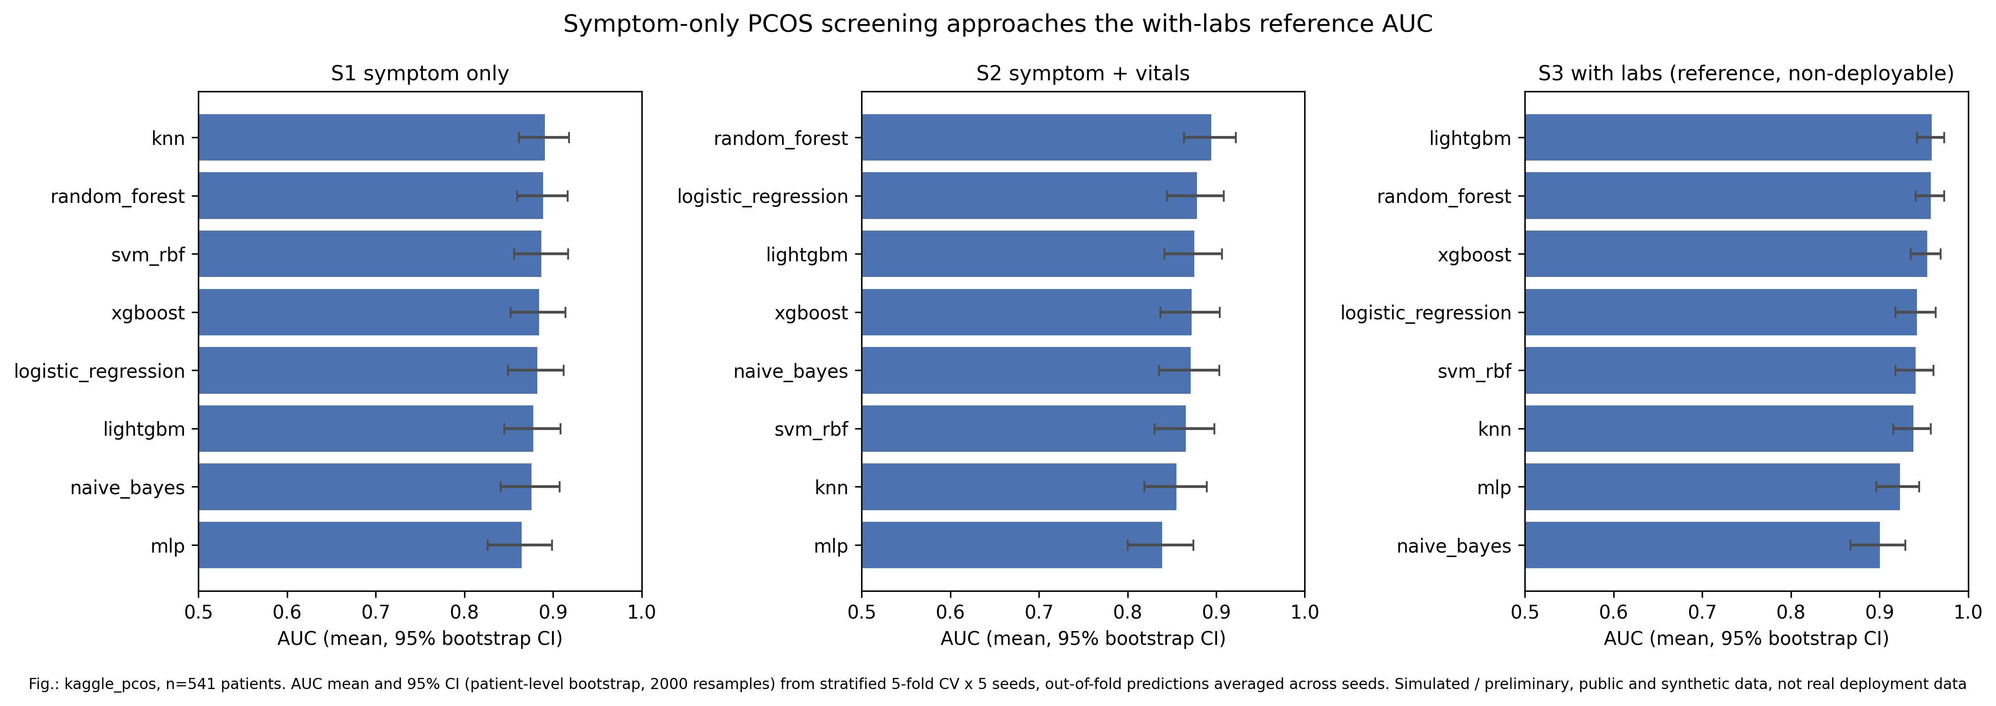
Figure 4: AUC with 95% bootstrap CI, 8 models x 3 feature sets, kaggle_pcos n=541, 5-fold CV x 5 seeds. Simulated / preliminary, public and synthetic data, not real deployment data.
Inputs | Best model | AUC (95% CI) | Sens @90% spec | Spec @90% sens | Brier
Symptoms only | knn | 0.891 (0.862 to 0.918) | 71% | 63% | 0.120
Symptoms + vitals | random forest | 0.894 (0.864 to 0.922) | 69% | 71% | 0.120
With labs + ultrasound (reference only) | lightgbm | 0.959 (0.942 to 0.973) | 88% | 85% | 0.074

Model (symptoms only) | AUC | 95% CI | Sens @90% spec
knn | 0.891 | 0.862 to 0.918 | 71%
random forest | 0.889 | 0.860 to 0.916 | 67%
svm rbf | 0.887 | 0.856 to 0.917 | 73%
xgboost | 0.884 | 0.852 to 0.914 | 71%
logistic regression | 0.882 | 0.849 to 0.912 | 73%
lightgbm | 0.878 | 0.845 to 0.908 | 71%
naive bayes | 0.876 | 0.841 to 0.907 | 73%
mlp | 0.865 | 0.826 to 0.899 | 73%

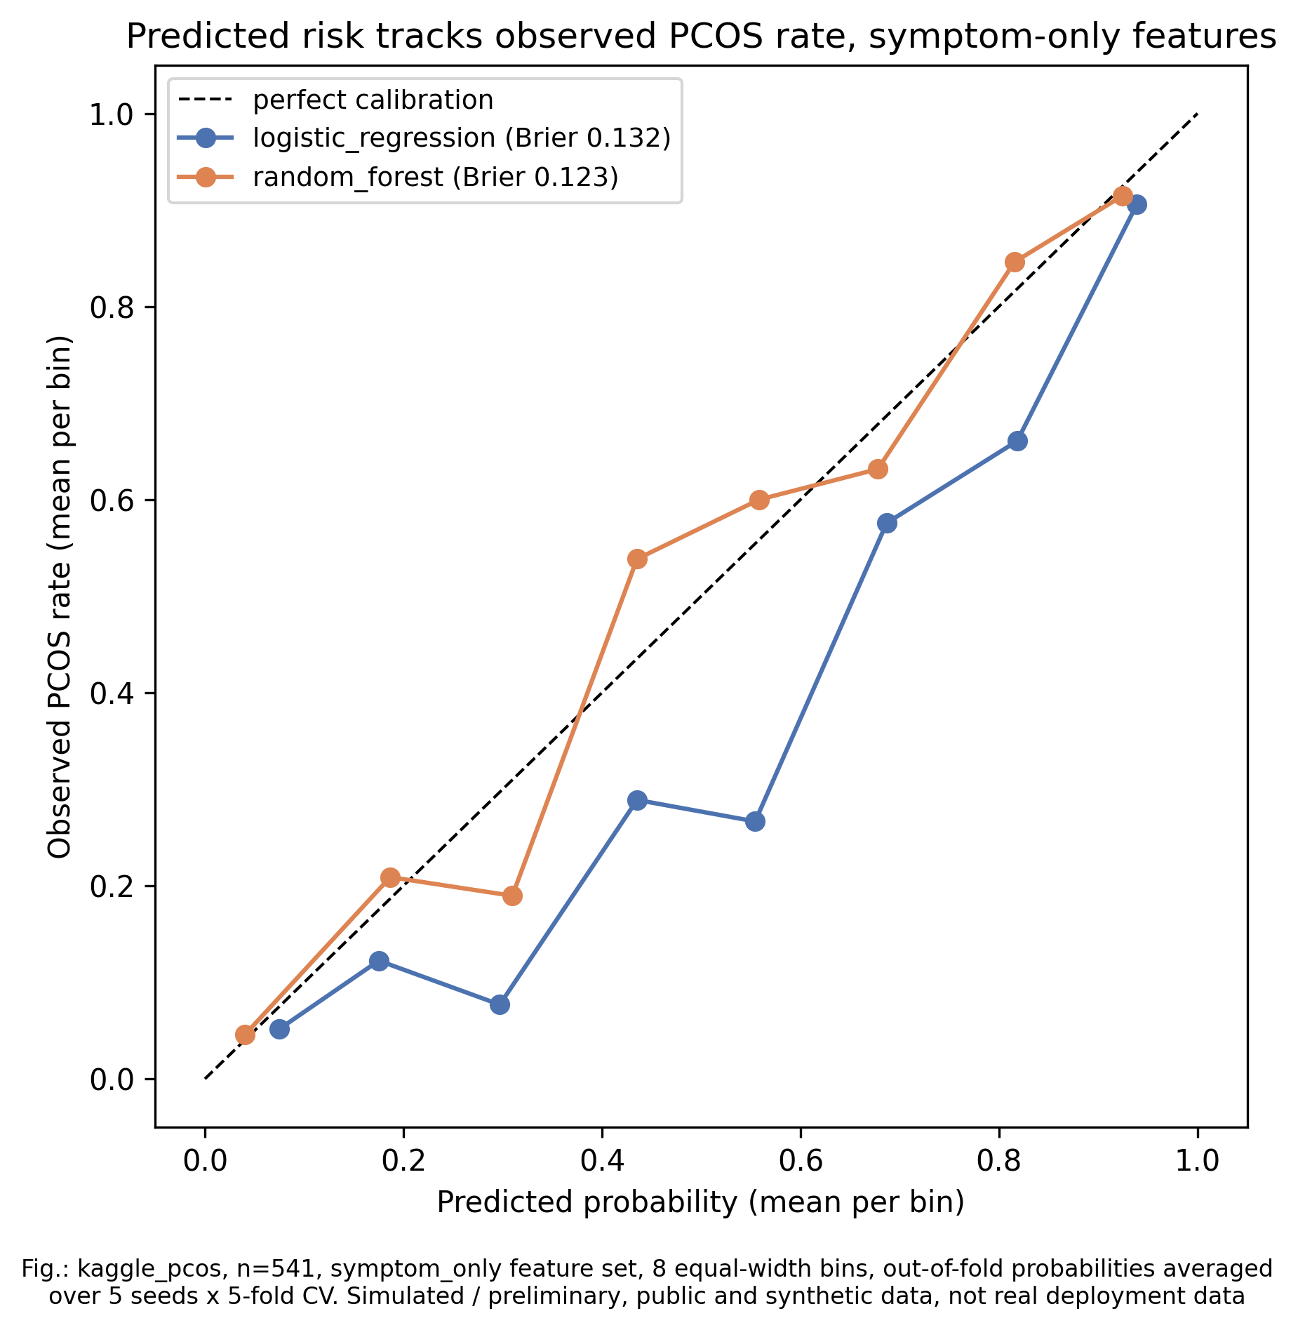
Figure 5: Calibration, symptom-only features: predicted risk vs observed PCOS rate.

6.3 Anemia and thyroid on NFHS-5 (real survey)
Condition | Features | Best model | AUC (95% CI)
Anemia (real haemoglobin, WHO cut-off) | symptom only | logistic regression | 0.615 (0.601 to 0.628)
Anemia (real haemoglobin, WHO cut-off) | symptom plus vitals | logistic regression | 0.620 (0.605 to 0.633)
Thyroid (self-reported diagnosis) | symptom only | random forest | 0.755 (0.709 to 0.800)
Thyroid (self-reported diagnosis) | symptom plus vitals | random forest | 0.768 (0.730 to 0.807)

Anemia from symptoms alone is close to a coin toss (a real negative result): it needs a blood count, which is what the anemia flag recommends. Thyroid is usefully predicted. Models were trained on a 6,000-row stratified sample to fit the compute budget.

6.4 Without FL, with FL, with FL plus differential privacy
Setting | Data per phone | Noise | Epsilon (delta 1e-5) | AUC | Accuracy
Without FL: all data pooled | similar | none | no guarantee | 0.892 | 83%
Without FL: each phone alone | different | none | no guarantee | 0.740 | 64%
With FL: FedAvg (similar data per phone) | similar | none | no guarantee | 0.866 | 88%
With FL: FedAvg | different | none | no guarantee | 0.878 | 83%
With FL: FedProx | different | none | no guarantee | 0.894 | 68%
With FL: FedPer (personal head) | different | none | no guarantee | 0.635 | 54%
With FL + DP: FedAvg | different | 0.5 | 23.92 | 0.846 | 67%
With FL + DP: FedAvg | different | 1.0 | 4.27 | 0.842 | 67%
With FL + DP: FedAvg | different | 1.5 | 2.04 | 0.880 | 69%
With FL + DP: FedAvg | different | 2.0 | 1.36 | 0.860 | 67%
With FL + DP: FedAvg | different | 3.0 | 0.81 | 0.859 | 67%

40 rounds, 8 clients, Dirichlet alpha=0.3, clip_norm=1.0, delta=1e-05. Epsilon computed with the Opacus accountant (our first formula understated it up to 4 times and was replaced).
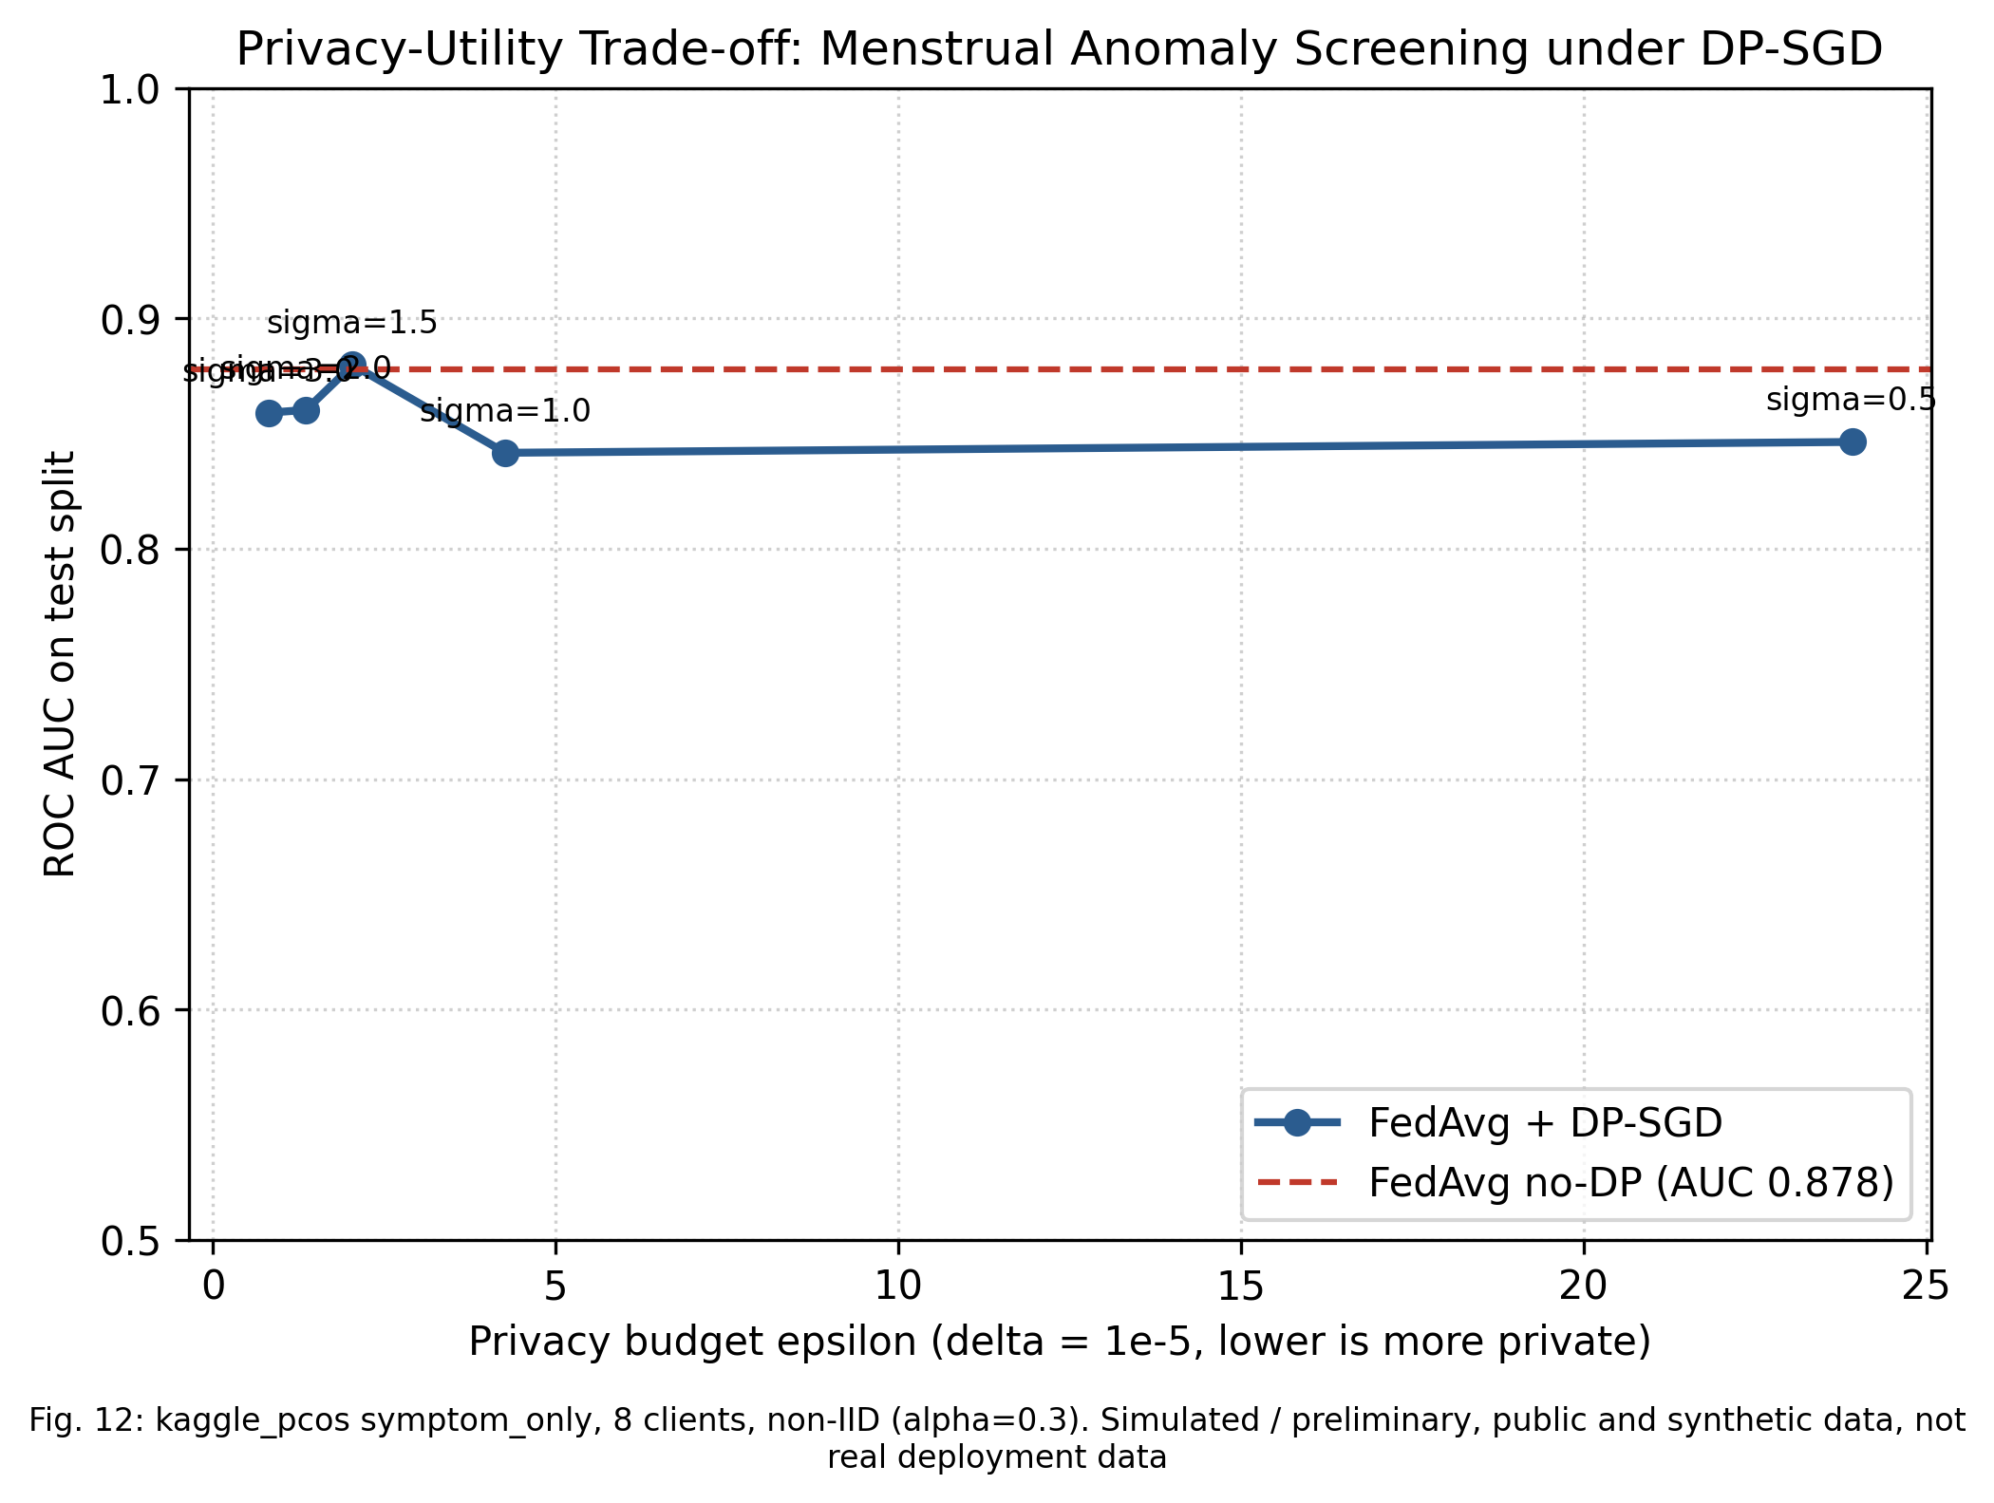
Figure 6: Privacy vs usefulness. Smaller epsilon = stronger privacy.
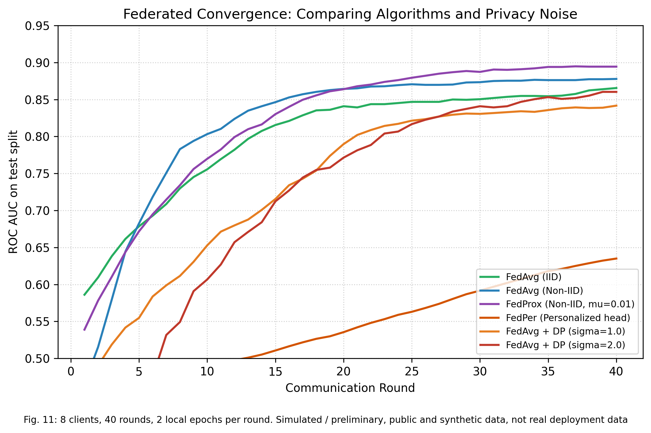
Figure 7: AUC per federated round for each setting.

6.5 Neural network and personalization
The GRU caught 85%, 48% and 27% of PCOS-, anemia- and thyroid-like changes, against 99%, 92% and 99% for Tier 1. Fine-tuning it per user:
Measure | Before fine-tuning | After fine-tuning
PCOS-like caught | 67% | 83%
Anemia-like caught | 50% | 92%
Thyroid-like caught | 11% | 67%
False alarms per 100 normal cycles | 0.85 | 18.64

More changes caught, but far more false alarms, so fine-tuning is not used.

7. Why this, not that: every choice compared honestly
WINS = measurably better. TIE = numbers close, chosen for a stated reason. LOSES = tested, lost, not relied on. TRADE-OFF = worse on accuracy, chosen on purpose. MIXED = better on some measures, worse on others. NOT MEASURED = reasoned choice only.
Decision | We use | Verdict
Personal baseline vs one fixed range for everyone | Personal baseline | MIXED
Which change detector for Tier 1 | Hybrid (z-score + CUSUM + rules) | TIE
Neural network (GRU) vs simple statistics for spotting change | Simple statistics (Tier 1); GRU kept as Tier 2 under evaluation | LOSES
Which screening model (symptoms to risk) | Random forest | TIE
Symptoms only vs using lab tests | Symptoms only | TRADE-OFF
Where the learning happens | Federated learning | WINS
Which federated method | FedAvg | TIE
Adding differential privacy | FedAvg with differential privacy | TRADE-OFF
Personalizing the neural network per user | Not used (statistical baseline is already personal) | LOSES
Filling in missing answers | Median fill | TIE
Indian survey (NFHS-5) vs US survey (NHANES) for anemia and thyroid | NFHS-5 | NOT MEASURED
PyTorch + ONNX for the model file | PyTorch, exported to ONNX | NOT MEASURED

Personal baseline vs one fixed range for everyone
MIXED We use: Personal baseline
Measure | Fixed range 21 to 35 days | Our personal baseline (hybrid)
PCOS-like caught | 100% | 99%
Anemia-like caught | 99% | 92%
Thyroid-like caught | 85% | 99%
False alarms per 100 normal cycles | 3.36 | 4.27
Healthy people ever flagged | 33% | 28%

In plain words: A fixed range judges everyone against the average woman. A woman whose normal cycle is 37 days gets flagged every single month, even though nothing is wrong for her (our tests check exactly this case). The personal baseline learns her own normal. Measured: it catches more thyroid-like changes (99% vs 85%) and flags fewer healthy people, but on this simulator the fixed range raises slightly fewer false alarms per cycle (3.36 vs 4.27).
Where we could be wrong: Most simulated women have normal cycles well inside 21 to 35 days, which flatters the fixed range. The advantage of a personal baseline should be larger for women whose normal sits near the edges; we have not measured that subgroup separately yet.

Which change detector for Tier 1
TIE We use: Hybrid (z-score + CUSUM + rules)
Detector | PCOS / anemia / thyroid caught | False alarms per 100 | Healthy ever flagged
z-score only | 94% / 36% / 65% | 2.91 | 35%
EWMA chart only | 100% / 88% / 100% | 2.92 | 20%
CUSUM only | 100% / 94% / 100% | 4.39 | 13%
Isolation Forest | 95% / 79% / 89% | 1.79 | 45%
Our hybrid | 99% / 92% / 99% | 4.27 | 28%

In plain words: A z-score alone reacts to sudden jumps but misses slow creeps (it caught only 36% of anemia-like changes). CUSUM catches slow creeps but reacts later. The hybrid combines both and catches PCOS-like changes in the same cycle they start. But the EWMA chart alone does about as well with fewer false alarms (2.92 vs 4.27) and flags fewer healthy people (20% vs 28%).
Where we could be wrong: On these numbers the EWMA chart is a credible replacement for the hybrid. We are reporting that, and it is an open decision for the team.

Neural network (GRU) vs simple statistics for spotting change
LOSES We use: Simple statistics (Tier 1); GRU kept as Tier 2 under evaluation
Method | PCOS / anemia / thyroid caught
Tier 1 statistics | 99% / 92% / 99%
Exponential smoothing | 90% / 63% / 30%
GRU | 85% / 48% / 27%
LSTM | 84% / 46% / 29%
1D CNN | 85% / 47% / 32%

In plain words: Neural networks need lots of examples per person. Each simulated person has only 16 to 30 cycles, so simple statistics that track one person's average beat all three neural networks. GRU, LSTM and CNN were almost identical to each other.
Where we could be wrong: With much longer histories, or real data with richer patterns, a neural network could catch up. The GRU is kept, exported and tested, but it does not raise flags.

Which screening model (symptoms to risk)
TIE We use: Random forest
Comparison | Best | Runner-up | Is the gap real? (p-value)
PCOS, symptoms only | knn 0.891 | random_forest 0.889 | No (p = 0.8205)
PCOS, symptoms + vitals | random_forest 0.894 | logistic_regression 0.878 | Yes (p = 0.0465)
Thyroid, NFHS-5 | random_forest 0.768 | lightgbm 0.736 | Yes (p = 0.0235)
Deep network (MLP), PCOS symptoms only | mlp 0.865 | last of 8 | Deep model was the weakest

In plain words: Eight models scored almost the same on symptoms alone, so the data sets the ceiling, not the model. Random forest is near the top everywhere and is the significant winner in two comparisons. It also shows which symptoms mattered and needs no special hardware. The deep neural network was the weakest, which is typical for small tables of data.
Where we could be wrong: On symptoms alone k-NN was fractionally higher and the difference is not significant; any of the top four would be a defensible choice.

Symptoms only vs using lab tests
TRADE-OFF We use: Symptoms only
Inputs | Best AUC
Symptoms only | 0.891
Symptoms + vitals | 0.894
With labs + ultrasound (reference) | 0.959

In plain words: Lab tests make the model better (AUC 0.96 vs 0.89), but anyone who already has those tests has seen a doctor. The point of MyCycle is to nudge people before that step, at home, for free. We accept the lower accuracy and state it.
Where we could be wrong: Symptom-only screening will miss some cases; that is why every flag says consider consulting a doctor, and a quiet result is not an all-clear.

Where the learning happens
WINS We use: Federated learning
Setting | Raw data leaves phone? | AUC
All data pooled on a server | Yes | 0.892
Each phone alone | No | 0.740
Federated learning (FedAvg) | No | 0.878

In plain words: Pooling everyone's data gives the best accuracy but puts intimate data on a server. Keeping it on each phone alone is private but weak (AUC 0.74). Federated learning keeps data on the phone and gets 0.88, close to pooling.
Where we could be wrong: Measured with 8 simulated phones on the PCOS dataset, not real phones; real networks add dropouts and delays.

Which federated method
TIE We use: FedAvg
Method | AUC | Accuracy
FedAvg | 0.878 | 83%
FedProx | 0.894 | 68%
FedPer (personal head) | 0.635 | 54%

In plain words: FedProx ranked slightly better (AUC 0.89 vs 0.88) but got far fewer answers right at the default cut-off (68% vs 83%). FedPer was weakest. FedAvg is the simplest, most standard method and the best balance here.
Where we could be wrong: One run per setting on a small dataset; FedProx's AUC edge could be real. SCAFFOLD and FedAdam were not run.

Adding differential privacy
TRADE-OFF We use: FedAvg with differential privacy
Setting | Epsilon | AUC | Accuracy
No privacy noise | none | 0.878 | 83%
Noise 0.5 | 23.92 | 0.846 | 67%
Noise 1.0 | 4.27 | 0.842 | 67%
Noise 1.5 | 2.04 | 0.880 | 69%
Noise 2.0 | 1.36 | 0.860 | 67%
Noise 3.0 | 0.81 | 0.859 | 67%

In plain words: Without noise, a clever server could learn things about one person from her update. Differential privacy adds noise so that any one person barely changes the result, with a measured budget, epsilon. It costs accuracy, and we show exactly how much.
Where we could be wrong: Secure aggregation and homomorphic encryption are other ways to hide updates; we did not test them. DP gives a bounded leak, never zero.

Personalizing the neural network per user
LOSES We use: Not used (statistical baseline is already personal)
Measure | Before fine-tuning | After fine-tuning
PCOS-like caught | 67% | 83%
Thyroid-like caught | 11% | 67%
False alarms per 100 normal cycles | 0.85 | 18.64

In plain words: Tuning the model on a user's first 4 cycles made it catch more changes, but it also started crying wolf far more often. Too many false alarms make people ignore flags, so we do not use it.
Where we could be wrong: With more cycles for fine-tuning, or a false-alarm penalty during tuning, this could improve.

Filling in missing answers
TIE We use: Median fill
Model | Median fill AUC | Nearest-neighbour fill AUC
logistic regression, symptom only | 0.883 | 0.882
random forest, symptom only | 0.889 | 0.887
logistic regression, symptom plus vitals | 0.877 | 0.877
random forest, symptom plus vitals | 0.893 | 0.893

In plain words: Only 2 of 541 records had a missing answer, so both methods give the same result. We use the simpler one.
Where we could be wrong: On data with many gaps (real app logs), this choice would matter more and should be re-tested.

Indian survey (NFHS-5) vs US survey (NHANES) for anemia and thyroid
NOT MEASURED We use: NFHS-5
Reason | NFHS-5
Population | Indian women aged 15 to 49, our users
Size | 126,625 non-pregnant women
Anemia label | Real measured haemoglobin
Licence | Public domain (CC0)

In plain words: Our users are Indian women. A US survey would describe a different population, diet and anemia rate. NFHS-5 is India's own survey with real blood measurements.
Where we could be wrong: We did not run NHANES, so this is a reasoned choice, not a measured comparison.

PyTorch + ONNX for the model file
NOT MEASURED We use: PyTorch, exported to ONNX
Check | Result
Same answers after export | Largest difference under 0.0001 (tested)
Runs in a browser | Yes, via ONNX Runtime Web
Keras / TFLite | Not compared

In plain words: We needed one model file that runs inside a web page on the phone. PyTorch exports to ONNX in one step and we verified the exported model gives the same answers.
Where we could be wrong: Phone speed and memory have not been measured yet; that benchmark is in progress.

8. Privacy proof
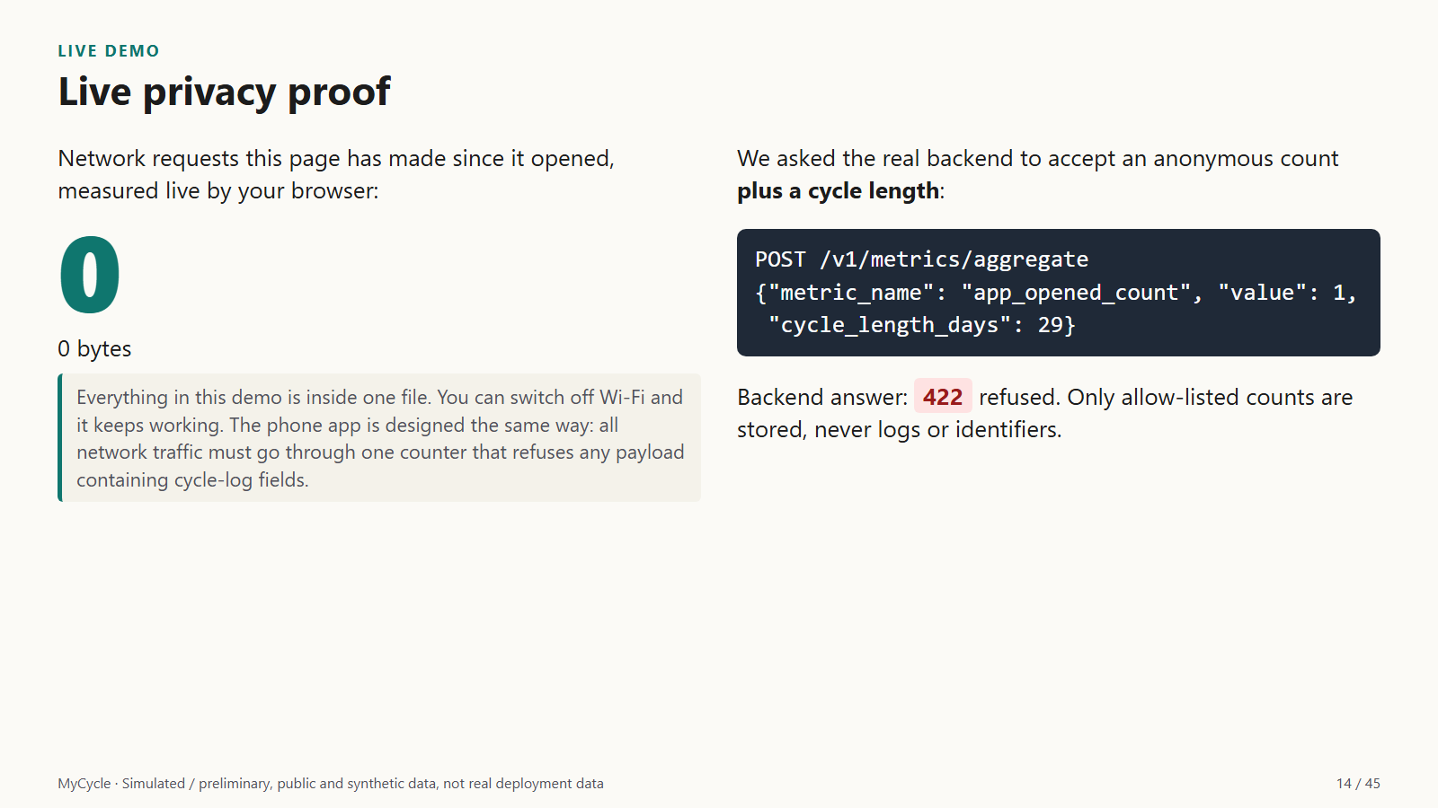
Figure 8: Live demo slide: the page's own network request count, and the backend refusing a cycle length.
The demo is a single file that makes zero network requests, measured live by the browser. The backend accepts only allow-listed anonymous counts and returns 422 for anything carrying cycle-log fields. The phone app is designed so that all traffic passes through one counter that refuses such payloads.

9. What we claim, and what we do not

We claim
- Symptom-only PCOS screening at AUC 0.891 on real data, with confidence intervals
- A personal-baseline detector tested on a labeled synthetic benchmark whose normal cycles match real data
- Federated learning keeps raw data on the phone and recovers most pooled accuracy (0.878 vs 0.892)
- A measured privacy vs accuracy curve with a stated epsilon

We do not claim
- Diagnosis, or clinical validation on real patients
- Real deployment results
- That the neural network beats simple statistics
- That we are more accurate than any named app
- Millions of real rows: real data is 541 + 1,26,625 women; the simulator is labeled synthetic

Limitations and next steps
- Detection tested on simulated people: next step, a consented clinical validation study.
- Anemia from symptoms is weak: next step, keep recommending a blood count.
- Simulator's clinical thresholds are stated assumptions: next step, verify against Rotterdam, WHO and FIGO sources.
- Phone speed and memory not yet measured: next step, on-device benchmark (in progress).
- Privacy law review not done: next step, review under India's DPDP Act 2023.

10. Reproduce
python demo/run_demo.py --run-tests # the smart-board demo
python demo/make_abstract.py # this document
python scripts/check.py # tests, language rules, contracts

