

|  |
| --- |
|  |
|  |
|  |

|  |  |
| --- | --- |
| Name | ARYAN NAVRAJ BHUSHAN |
| Branch | CSE |
| Section | A1 |
| Roll no | 1676/17 |
| Subject | JAVA ASSIGNMENT |
| Programming language input | JAVA |

Submitted to : Sheerin Zadoo

# Student Recommendation Program

Content

* REQUIREMENT SPECIFICATIONS
* DESIGN SPECIFICATIONS
* IMPLEMENTATION
* TESTING
* EXECUTIVE CODE

Requirement Specification

List of use case

Use case 1:In this we are taking the details of the student which is uploaded by the user such as (Name and Marks).

Use case 2:In this the sorting is done on the basis of the percentage and backlog of student and are recommended for the placement .

Design Specification

Class diagram show the function that are included in the program that we are making . This class diagram consist of two tables.

1. Student Table: The table represent four things , which consist of Name, Marks, Percentage and Backlog count of the student.
2. Student Recommender: This is the main table in which student are sorted on the basis of Percentage and Backlog count.

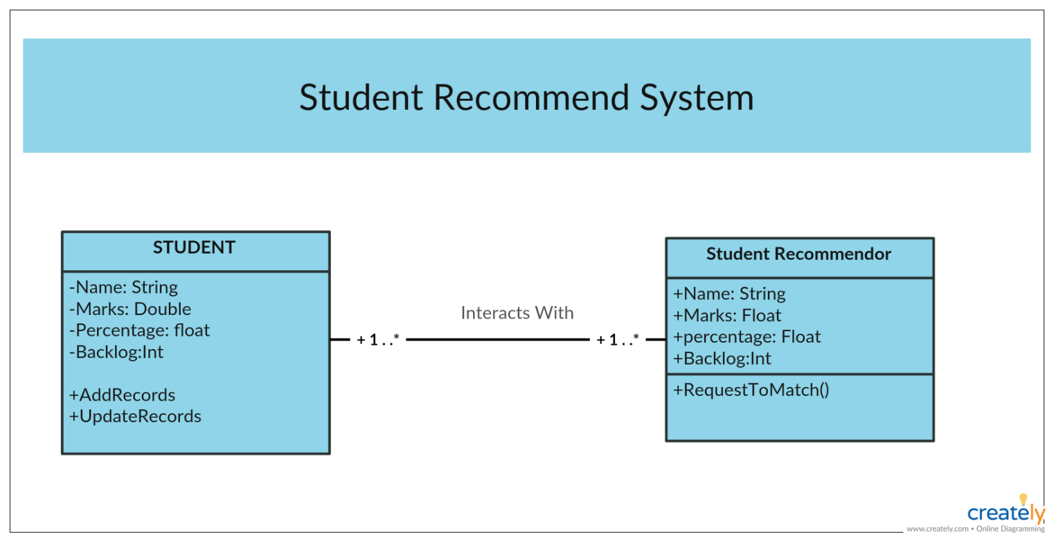

Sequence Diagram

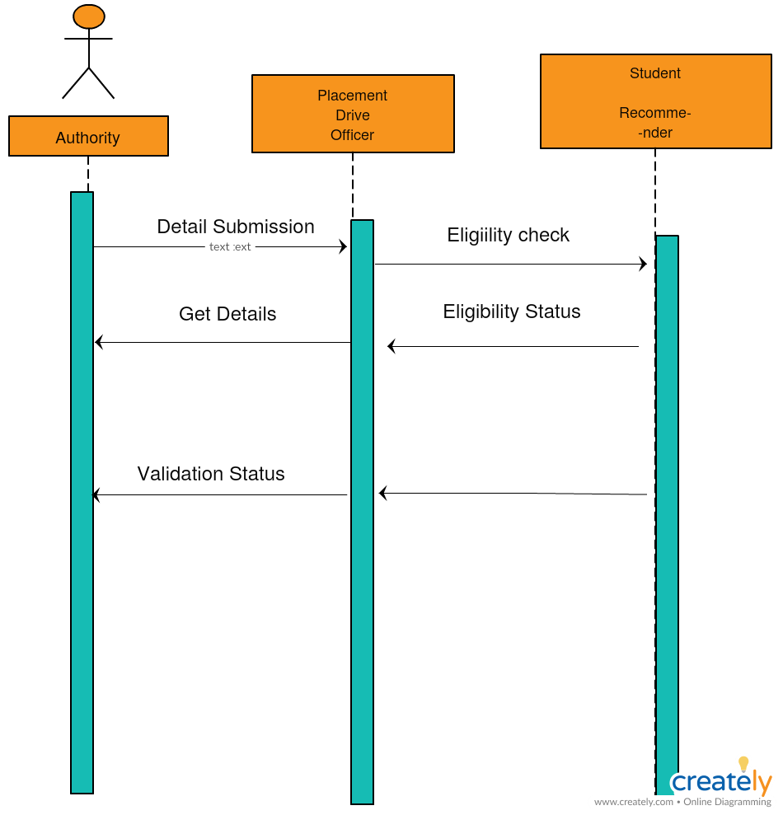

Sequence Diagram show the sequence in which program works. In these sequence diagram there are mainly three parts.

1. Authority: It submit all the detail for the placement drive to placement drive officer.
2. Placement Drive Officer: The Officer make use of student recommender system for the sorting of the student.
3. Student Recommender: It check the eligibility of the Student whether the student is eligible to sit in the placement drive or not.

After that the Student Recommender get the details of the student and pass the eligibility result to the placement officer .

Implementation

This the link for the Github repository for the Student Recommender Program.

<https://github.com/Aryan-navraj/student-recomender-prog/tree/master>

TESTING

Unit testing Specification and Execution Logs

1. While entering the Name:

While entering the name if we had entered the input name as numeric input or some special character input, it should have given an error but instead of giving an error the program has accepted the error input.

1. While entering the marks:

While entering the marks if we had entered the input marks as alphabetic input or some special input , it should have given an error.

Executive Code

Program(Placement.java)

import java.util.*;

class Placement

{

public static void main(String args[])

{

int n_students;

System.out.println(" How Many students details do you want to enter ? ");

Scanner scan = new Scanner(System.in);

n_students = scan.nextInt();

double subject1[]=new double[n_students];

double subject2[]=new double[n_students];

double subject3[]=new double[n_students];

double subject4[]=new double[n_students];

double subject5[]=new double[n_students];

double total[]=new double[n_students];

String[] S_name = new String[n_students];

int backlogs[] = new int[n_students];

double percentage[] = new double[n_students];

int[] flag = new int[n_students];

int pass =0;

int fail =0;

for(int i =0 ;i<n_students;++i)

{

System.out.println();

System.out.println("Enter the details for student "+(i+1));

System.out.print(" NAME - ");

scan.nextLine();

S_name[i] =scan.nextLine();

System.out.println();

scan.nextLine();

System.out.println();

System.out.println("enter the marks for subject 1 (MAX 100)");

subject1[i]=scan.nextDouble();

System.out.println("enter the marks for subject 2 ");

subject2[i]=scan.nextDouble();

System.out.println("enter the marks for subject 3 ");

subject3[i] = scan.nextDouble();

System.out.println("enter the marks for subject 4 ");

subject4[i] = scan.nextDouble();

System.out.println("enter the marks for subject 5 ");

subject5[i] = scan.nextDouble();

}

for(int i =0 ;i<n_students;++i)

{ backlogs[i]=0;

total[i] = (subject5[i] + subject4[i] + subject3[i] +subject2[i] +subject1[i]);

if(subject5[i]<40) backlogs[i]++;

if(subject4[i]<40) backlogs[i]++;

if(subject3[i]<40) backlogs[i]++;

if(subject2[i]<40) backlogs[i]++;

if(subject1[i]<40) backlogs[i]++;

percentage[i] = ((total[i]/500)*100);

}

System.out.println();

for(int i =0 ;i<n_students;++i)

{ if(((backlogs[i] == 0)) && ((percentage[i] >= 60)))

{flag[i] = 1; pass++;}

else

{flag[i] = 0; fail++;}

}

if(pass >0)

{System.out.println("List of Eligible Students are ");

for(int i =0 ;i<n_students;++i)

{ if(flag[i] == 1)

{System.out.println( S_name[i] + " With prcentage");

System.out.println(percentage[i]);}

}} if(fail >0)

{System.out.println("List of Non-Eligible Students are ");

for(int i =0 ;i<n_students;++i)

{ if(flag[i] == 0)

{System.out.println( S_name[i] + " With percentage "+ percentage[i] );

System.out.println(" With numbers of backlogs = "+ backlogs[i]);}

}}

}

}