Game Design Document

Fill up the following document

1. Write the title of your project.

Answer : Fortnite

1. What is the goal of the game?

Answer : The goal of the game to eliminate other players

1. Write a brief story of your game.

Answer : The game doesn’t have a story. It is a battle royale game

where a player has to eliminate other players.

1. Which are the playing characters of this game?

* Playing characters are the ones who respond to the user based on the input from the user.
* Cars, monkeys, dinos, wizards, etc., are the playing characters in the game.

|  |  |  |
| --- | --- | --- |
| Number | Character Name | What can this character do? |
| 1 | Player1 | Move through the canvas and eliminate other players |
| 2 | Player 2 | Move through the canvas and eliminate other players |
| 3 | Player 3 | Move through the canvas and eliminate other players |
| 4 | Player 4 | Move through the canvas and eliminate other players |
| 5 | Player 5 | Move through the canvas and eliminate other players |
| 6 | Player 6 | Move through the canvas and eliminate other players |
| 7 | Player 7 | Move through the canvas and eliminate other players |
| 8 | Player 8 | Move through the canvas and eliminate other players |

1. Which are the Non-Playing Characters of this game?

* Non-Playing characters are the ones that don't have an action or behavior when the user interacts with the game.
* Hurdles, stones, bananas, coins, etc., are non-playing characters in the game.

|  |  |  |
| --- | --- | --- |
| Number | Character Name | What can this character do? |
| 1 | Mountains | Stationary |
| 2 | Huge Rocks | Stationary |
| 3 | Buildings | Stationary |
| 4 | Road | Stationary |
| 5 | Trees | Stationary |
| 6 | Sky | Stationary |
| 7 | Clouds | Stationary |
| 8 |  |  |

Draw your imagination of this game. What does this game look like?

* Draw the game either on your computer or on paper.
* Add images of the game scenes to show each of the playing and non-playing characters at least once.

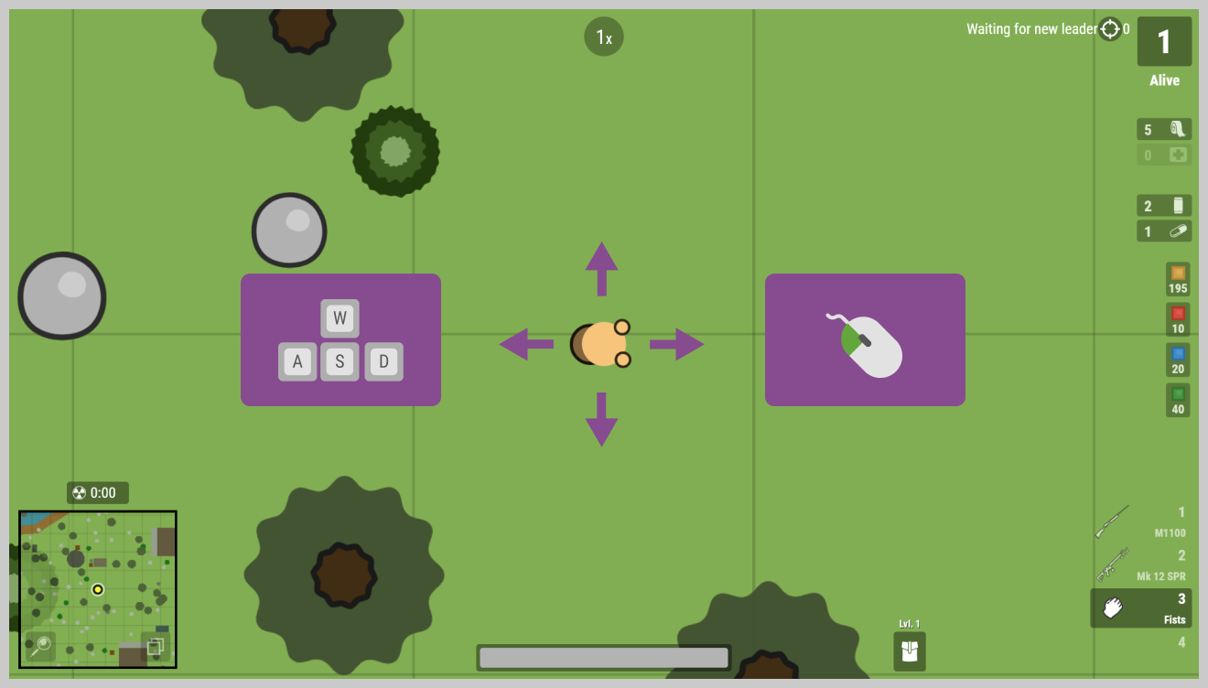

How do you plan to make your game engaging?

Answer: Levels Up as soon as a player eliminates another player. Rewards like coins with each win and etc.