VRB GROUP
HOMEPAGE SECTION-BY-SECTION AUDIT
What is missing • Why it matters • How to redesign it • What business information is needed

REPORT PURPOSE
Ye report management/client ko homepage ka visual redesign samjhane ke liye hai. Har section ke liye current state, problem, recommended change, required content/data aur business impact clear kiya gaya hai.

Executive Summary
VRB Group ki homepage par core information maujood hai — projects, development segments, company positioning, numbers, trust statements aur testimonials. Lekin current structure kaafi template-driven hai: multiple sections ek doosre se naturally connected nahi lagte, kuch generic/placeholder content visible hai, aur visitor ko “main kis project me interested hoon → kya proof hai → next action kya hai?” ka clear journey nahi milta.
- Homepage ko brochure se conversion-oriented real-estate sales page banana hai.
- Har section ka ek defined job hona chahiye: attract, explain, prove, qualify, ya convert.
- Numbers sirf wahi use hon jo internal records se verify ho sakein; unhe design ke saath source/date ke context me dikhaya ja sakta hai.
- Project cards me location, approval/RERA status, project scale, key amenities aur CTA ko standardized format me dikhana chahiye.
- Generic template sections (Lorem ipsum, unrelated agents/international cities, generic service labels) ko remove/replace karna chahiye.

1. Header / Navigation
PRIORITY: P1
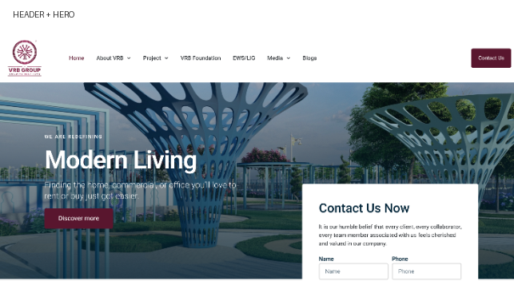

A. Abhi kya hai
Current header me logo, About VRB, Project, VRB Foundation, EWS/LIG, Media, Blogs aur Contact Us navigation hai.

B. Main problem / kya kami hai
- Navigation me primary sales journey clearly prioritized nahi hai.
- Project menu broad hai, lekin visitor ko Ongoing / Completed / Jaipur / Kota jaise buying-oriented paths clearly guide kiye ja sakte hain.
- Header ka visual treatment premium real-estate positioning ko strongly communicate nahi karta.
- Contact CTA hai, lekin site visit, brochure, callback jaise intents separate nahi hain.

C. Isko kaise improve karna hai
- Navigation ko Projects, About, Why VRB, Media/Insights aur Contact jaise high-value items tak simplify karein.
- Projects ke andar Jaipur/Kota + Ongoing/Completed ko clear hierarchy dein.
- Header ko sticky banayein; scroll par compact version + persistent enquiry CTA rakhein.
- Primary CTA: Book a Site Visit ya Explore Projects; secondary CTA: Talk to Advisor.

D. Recommended section structure
- Logo → Projects → Why VRB → About → Media/Insights → Contact.
- Right side: Book Site Visit / Talk to Advisor.
- Mobile: hamburger + visible CTA.

E. Business impact
Clear navigation reduces friction and gives high-intent visitors a direct path to projects and enquiries.
CLIENT KO SIMPLE LANGUAGE ME KAISE SAMJHAYE
“Header / Navigation me abhi information hai, lekin presentation aur conversion logic weak hai. Hum is section ko sirf beautiful nahi banayenge; iska kaam clear karenge — visitor ko next step tak le jaana.”

2. Hero Section
PRIORITY: P1

A. Abhi kya hai
Hero currently says “We are Redefining Modern Living” with supporting text and a “Discover more” CTA over a large visual.

B. Main problem / kya kami hai
- Headline brand-level hai, but visitor ko immediately nahi batata ki VRB exactly kya develop karta hai aur kis geography me.
- Hero me hard proof absent hai: years, projects delivered, plots sold, locations, approvals etc.
- CTA generic “Discover more” hai.
- Image attractive hai, lekin actual VRB project/location ki authenticity stronger ho sakti hai.

C. Isko kaise improve karna hai
- Headline ko outcome + category based banayein, e.g. “Planned Townships & Real Estate Developments Built for Long-Term Value.”
- Subheading me geography + project categories + trust signal add karein.
- 2 CTAs: Explore Ongoing Projects and Book a Site Visit.
- Hero ke bottom/side me 3–4 verified proof metrics add karein.
- Actual project photography / aerial / masterplan imagery ko preference dein.

D. Recommended section structure
- Eyebrow: VRB GROUP • REAL ESTATE DEVELOPMENT
- Headline: clear category + value proposition.
- Subtext: geography + development type.
- CTA 1: Explore Projects | CTA 2: Book Site Visit.
- Proof strip: verified numbers only.

E. Business impact
Hero is the first sales moment. Visitor ko seconds me samajh aana chahiye ki VRB kya karta hai, kahan karta hai, aur next step kya hai.
CLIENT KO SIMPLE LANGUAGE ME KAISE SAMJHAYE
“Hero Section me abhi information hai, lekin presentation aur conversion logic weak hai. Hum is section ko sirf beautiful nahi banayenge; iska kaam clear karenge — visitor ko next step tak le jaana.”

3. Development Segments
PRIORITY: P1
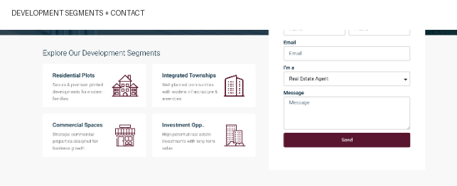

A. Abhi kya hai
Four cards show Residential Plots, Integrated Townships, Commercial Spaces and Investment Opportunities.

B. Main problem / kya kami hai
- Cards mostly explain categories, but actual projects choose karne me help nahi karte.
- No quick proof, location, project count, price band, or View Projects context.
- Investment language ko concrete project information se support karna chahiye.

C. Isko kaise improve karna hai
- Each card ko actual project pathway banayein.
- Relevant imagery + verified count/proof add karein.
- Category-specific CTA use karein.
- Investment card ko documented project facts se support karein.

D. Recommended section structure
- Category title
- 1-line value proposition
- Relevant image
- Verified count / key proof
- CTA to filtered project listing

E. Business impact
Section should help a visitor self-qualify instead of browsing the whole site.
CLIENT KO SIMPLE LANGUAGE ME KAISE SAMJHAYE
“Development Segments me abhi information hai, lekin presentation aur conversion logic weak hai. Hum is section ko sirf beautiful nahi banayenge; iska kaam clear karenge — visitor ko next step tak le jaana.”

4. Contact / Lead Capture Form
PRIORITY: P1

A. Abhi kya hai
The contact form asks for Name, Phone, Email, “I'm a” selection and Message.

B. Main problem / kya kami hai
- Form early placed hai, but reason to submit strongly communicate nahi hota.
- Project selection field visible nahi hai.
- Preferred callback/site-visit timing nahi hai.
- Long message field first enquiry ke liye friction create kar sakta hai.

C. Isko kaise improve karna hai
- Intent-based first step: Site Visit / Brochure / Call Back / Investment Details.
- Project dropdown add karein.
- Preferred contact time add karein.
- First step short rakhein; extra qualification submission ke baad le sakte hain.

D. Recommended section structure
- Name
- Phone
- I'm interested in: Project / Site Visit / Brochure / Call
- Preferred project
- Preferred contact time
- Submit: Request Project Details

E. Business impact
More relevant fields can reduce friction and improve lead qualification.
CLIENT KO SIMPLE LANGUAGE ME KAISE SAMJHAYE
“Contact / Lead Capture Form me abhi information hai, lekin presentation aur conversion logic weak hai. Hum is section ko sirf beautiful nahi banayenge; iska kaam clear karenge — visitor ko next step tak le jaana.”

5. Latest Properties / Featured Projects
PRIORITY: P1
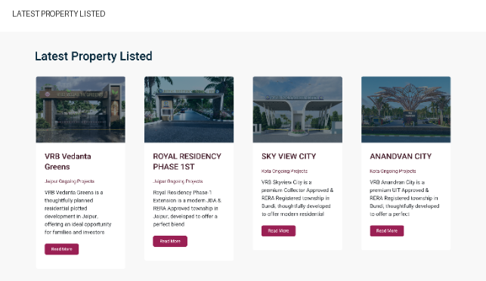

A. Abhi kya hai
Homepage four project cards dikhati hai: VRB Vedanta Greens, Royal Residency Phase 1st, Sky View City and Anandvan City.

B. Main problem / kya kami hai
- Cards visually small hain aur information density inconsistent hai.
- Location, approval status, scale and buyer-relevant highlights standardized nahi hain.
- Ongoing/completed/featured hierarchy instantly clear nahi hai.
- Descriptions truncated hain, so user ko click karna padta hai before enough context.

C. Isko kaise improve karna hai
- Standardized project card system banayein.
- Top labels: ONGOING / COMPLETED + location.
- 3–4 facts: project size, plots/units, approval/RERA status, key amenity/location benefit — only verified.
- CTA: View Project + optional Book Site Visit.
- Consistent image ratio use karein.

D. Recommended section structure
- Project name
- Location
- Status
- Approval / RERA
- Project scale
- 3 key highlights
- View Project / Book Site Visit

E. Business impact
This is the core discovery section. Better cards reduce uncertainty before the detail page.
CLIENT KO SIMPLE LANGUAGE ME KAISE SAMJHAYE
“Latest Properties / Featured Projects me abhi information hai, lekin presentation aur conversion logic weak hai. Hum is section ko sirf beautiful nahi banayenge; iska kaam clear karenge — visitor ko next step tak le jaana.”

6. Business Numbers / Proof Metrics
PRIORITY: P1
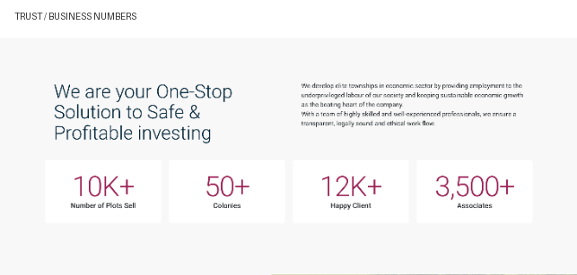

A. Abhi kya hai
Visible screenshot me 10K+ plots sold, 50+ colonies, 12K+ happy clients aur 3,500+ associates dikhte hain.

B. Main problem / kya kami hai
- Numbers powerful hain, but definition/time period/verification context nahi diya gaya.
- Public page extraction me counters ke underlying text me zero-style placeholder values bhi expose ho rahe hain; animation fail hone par data-quality risk ho sakta hai.
- Sales, colonies, clients and associates different definitions hain; user ko counting basis nahi pata.

C. Isko kaise improve karna hai
- Dedicated “VRB by the Numbers” proof block banayein.
- Updated: Month Year / source note where appropriate.
- Only internally verified figures publish karein.
- Define every metric precisely.
- Unverified number ko qualitative proof statement se replace karein.

D. Recommended section structure
- Metric
- Verified value
- Definition
- As-of date
- Optional proof/source

E. Business impact
Numbers trust build karte hain, but only when precise, current and defensible.
CLIENT KO SIMPLE LANGUAGE ME KAISE SAMJHAYE
“Business Numbers / Proof Metrics me abhi information hai, lekin presentation aur conversion logic weak hai. Hum is section ko sirf beautiful nahi banayenge; iska kaam clear karenge — visitor ko next step tak le jaana.”

7. Trust / Why Choose VRB
PRIORITY: P1
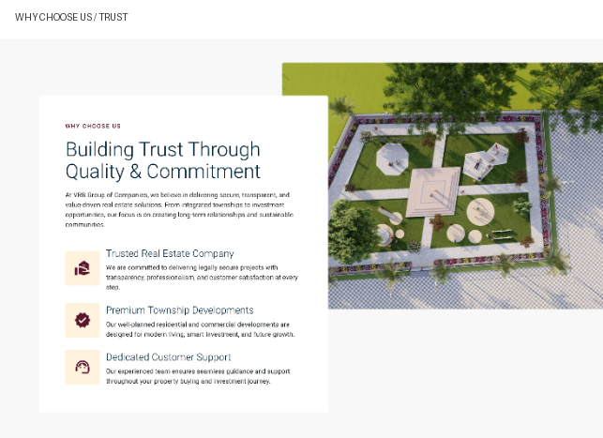

A. Abhi kya hai
A trust section presents “Building Trust Through Quality & Commitment” with Trusted Real Estate Company, Premium Township Developments and Dedicated Customer Support.

B. Main problem / kya kami hai
- Claims ke saath immediate evidence limited hai.
- Trusted, premium, legally secure, long-term value jaise words broad claims hain.
- Aerial image ka project name/location visible nahi hai.

C. Isko kaise improve karna hai
- Claim + Proof format use karein.
- Trusted → registrations, approvals, years/projects, documented delivery record.
- Premium township → masterplan, amenities, infrastructure images.
- Customer support → site visit process, contact/support process.
- Every project image ko project name + location se label karein.

D. Recommended section structure
- Why VRB
- 3–4 trust pillars
- Proof under each pillar
- Project image / masterplan
- See all proof / About VRB

E. Business impact
Evidence-backed trust is more persuasive than generic adjectives and helps visitors perform due diligence.
CLIENT KO SIMPLE LANGUAGE ME KAISE SAMJHAYE
“Trust / Why Choose VRB me abhi information hai, lekin presentation aur conversion logic weak hai. Hum is section ko sirf beautiful nahi banayenge; iska kaam clear karenge — visitor ko next step tak le jaana.”

8. Six Value Proposition Cards
PRIORITY: P1
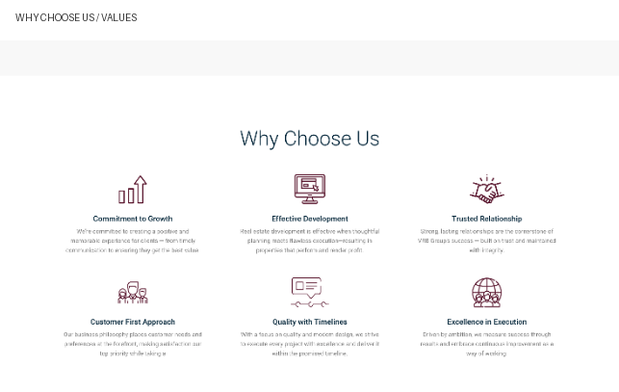

A. Abhi kya hai
Page lists Commitment to Growth, Effective Development, Trusted Relationship, Customer First Approach, Quality with Timelines and Excellence in Execution.

B. Main problem / kya kami hai
- Six cards previous trust section ko repeat karte hain.
- Copy generic hai aur almost any real-estate site par use ho sakti hai.
- Project-specific evidence attached nahi hai.
- Significant vertical space use hota hai without much new decision-making information.

C. Isko kaise improve karna hai
- Six generic cards ko 3–4 differentiators me reduce karein.
- Concrete operational proof use karein.
- Abstract phrases ko planning, approval, infrastructure, communication, delivery milestones se replace karein.
- Six cards ki jagah proof timeline/process consider karein.

D. Recommended section structure
- Transparent & Compliant
- Planned Development
- Delivery & Customer Support
- Each with 1 proof line + visual

E. Business impact
Removing repetition creates space for stronger proof, projects and conversion elements.
CLIENT KO SIMPLE LANGUAGE ME KAISE SAMJHAYE
“Six Value Proposition Cards me abhi information hai, lekin presentation aur conversion logic weak hai. Hum is section ko sirf beautiful nahi banayenge; iska kaam clear karenge — visitor ko next step tak le jaana.”

9. Testimonials / Social Proof
PRIORITY: P1

A. Abhi kya hai
Public page me named customer testimonials and 5-star ratings ka section hai, although supplied screenshot me ye crop visible nahi hai.

B. Main problem / kya kami hai
- Testimonial ko context chahiye.
- Star rating without source/platform on-site marketing claim jaisa lag sakta hai.
- Customer quote ke saath project context, date/location, or consent useful hai.

C. Isko kaise improve karna hai
- 3–5 concise testimonials with project name and customer context.
- Where available, link to independently hosted reviews.
- Customer images only with consent.
- Unsupported ROI/return claims avoid karein; documented facts use karein.

D. Recommended section structure
- Customer name/photo with consent
- Project
- Short quote
- Date/location where useful
- Optional external review source

E. Business impact
Contextualized social proof trust barriers reduce kar sakta hai.
CLIENT KO SIMPLE LANGUAGE ME KAISE SAMJHAYE
“Testimonials / Social Proof me abhi information hai, lekin presentation aur conversion logic weak hai. Hum is section ko sirf beautiful nahi banayenge; iska kaam clear karenge — visitor ko next step tak le jaana.”

10. Footer / Final Conversion
PRIORITY: P1
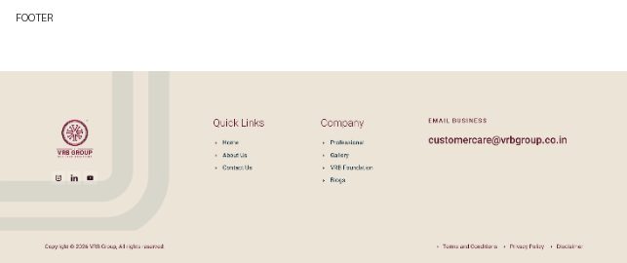

A. Abhi kya hai
Footer me logo, quick links, company links, email and legal links hain.

B. Main problem / kya kami hai
- Footer primarily navigational hai; final conversion message missing hai.
- No prominent final Book Site Visit / Request Brochure / Talk to Advisor CTA.
- Newsletter real-estate buyer ke liye highest-value action nahi ho sakta.
- Official phone, WhatsApp, address and business hours add kiye ja sakte hain if verified.

C. Isko kaise improve karna hai
- Footer se pehle final conversion band add karein.
- Headline: Looking for the right project?
- CTA 1: Book a Site Visit.
- CTA 2: Talk to a Project Advisor.
- Contact and legal information clean and verifiable rakhein.

D. Recommended section structure
- Final CTA band
- Phone / WhatsApp / Email
- Office address + map
- Quick links
- Privacy / Terms / Disclaimer

E. Business impact
Page end par obvious next action dena high-intent visitors ke liye important hai.
CLIENT KO SIMPLE LANGUAGE ME KAISE SAMJHAYE
“Footer / Final Conversion me abhi information hai, lekin presentation aur conversion logic weak hai. Hum is section ko sirf beautiful nahi banayenge; iska kaam clear karenge — visitor ko next step tak le jaana.”

11. Template / Placeholder Content That Should Be Removed
- Public page me Lorem ipsum placeholder copy ko replace karein.
- Featured Agent block ke generic agent names/property counts VRB corporate story se match nahi karte; replace or remove.
- International city list (Indonesia, Singapore, Malaysia, Vietnam, Thailand, France, Germany etc.) ko actual VRB operating geographies se replace ya remove karein.
- Selling Properties / Buying Properties / Rent Properties / Property Consultations jaise generic service labels ko actual VRB business model ke according rewrite karein.
- Our Support section me placeholder copy ko replace karein; logos tabhi show karein jab real partners/support entities aur permission available ho.

12. Recommended New Homepage Flow
# | Section | Purpose
01 | Hero | What VRB does + where + primary CTA
02 | Trust Strip | 3–4 verified numbers / approvals / years
03 | Featured Ongoing Projects | Current inventory + project facts
04 | Explore by Need | Residential / Township / Commercial / Investment
05 | Why VRB | 3–4 proof-backed differentiators
06 | Project Proof | Masterplans, site progress, approvals, location
07 | Completed / Delivered | Evidence of execution
08 | Customer Stories | Contextual testimonials / reviews
09 | About VRB | Company story + leadership
10 | Final CTA | Site visit / brochure / advisor
11 | Footer | Contact + legal + navigation

13. Data Required From VRB Before Redesign
- Verified company founding year / operating history.
- Verified completed, ongoing and upcoming project counts.
- Verified total plots/units sold + exact metric definition.
- Verified customer count + definition.
- Project-wise land area, units, approvals and RERA numbers.
- Project-wise status: launched / ongoing / completed.
- Latest project photography, aerial images, masterplans and site-progress images.
- Official phone, WhatsApp, email, office address and business hours.
- Customer testimonials + publishing consent.
- Independent review links, awards, certifications or memberships, where applicable.

14. One-Line Client Explanation
THE MAIN IDEA
“Hum homepage ko sirf modern look nahi de rahe. Hum har section ka business purpose define kar rahe hain — pehle attention, phir projects, phir proof, phir trust, aur end me enquiry/site visit. Isse design directly sales journey se connect hoga.”

Source & Scope
Audit is based on the public VRB Group homepage reviewed on 18 September 2026 and the supplied homepage screenshot. Public page content includes project navigation, project cards, business metrics, trust/value sections, testimonials, and footer/legal links. All business numbers proposed for final publication should be verified against VRB's internal records before launch.
Website reviewed: https://vrbgroup.co.in/
This is a UX/content/conversion audit, not a legal, financial, RERA, or independent business-performance audit.

