PROJECT REPORT OF INDUSTRY ORIENTED HANDS ON EXPERIENCE (IOHE)
ON
Job Listing Portal
submitted in partial fulfilment of the requirements for the award of degree of

BACHELOR OF ENGINEERING
In
COMPUTER SCIENCE AND ENGINEERING

Submitted by: Supervised By:
Aryan Dr. Monika Aggarwal

2211981100 Assistant Professor
Chitkara University


DEPARTMENT OF COMPUTER SCIENCE AND ENGINEERING

CHITKARA UNIVERSITY INSTITUTE OF ENGINEERING AND TECHNOLOGY
CHITKARA UNIVERSITY, PUNJAB, INDIA

CONTENTS

S.No. | Title | Page No.
 | Acknowledgement | iv
 | List of Figures and Tables
 | Abstract
1 | Introduction | v
2 | Methodology | vi-vii
3 | Tools and Technologies | viii-ix
4 | Implementation | ix-x
5 | Major Findings/Outcomes/Output/Results | xi-xii
6 | Conclusion and Future Scope | xii-xiii
 | References | xiii
 | Appendices | xiii-xvi

DECLARATION

I hereby certify that the work which is being presented in the project report entitled “Job Listing Portal” in partial fulfilment of requirement for the award of the degree of Bachelor of Engineering (Computer Science and Engineering) submitted in the department of Computer Science and Engineering at Chitkara University Institute of Engineering and Technology, Chitkara University, Punjab, India, is an authentic record of my own work carried out under the supervision of Dr. Monika Aggarwal. The matter presented in this project report has not been submitted in any other university/institute for the award of any degree.

Place: Rajpura Aryan
Date: 29-04-2026 University Roll No: 2211981100

This is to certify that the above statement made by the candidate is correct to the best of my knowledge and belief.

Dr. Monika Aggarwal
Assistant Professor
Department of Computer Science and Engineering
Chitkara University Institute of Engineering and Technology,
Chitkara University, Punjab, India

ACKNOWLEDGEMENT

I would like to express my deepest sense of gratitude and sincere thanks to all those who have helped me directly or indirectly in the successful completion of my project titled “Job Listing Portal”, which has been submitted in partial fulfilment of the requirements for the award of the degree of Bachelor of Engineering in Computer Science and Engineering at Chitkara University Institute of Engineering and Technology, Chitkara University, Punjab, India.
First and foremost, I am highly grateful to my project supervisor Dr. Monika Aggarwal, Assistant Professor, Department of Computer Science and Engineering, for her constant guidance, valuable suggestions, continuous encouragement, and unwavering support throughout the development of this project. Her expert advice and constructive feedback helped me to improve the quality of my work and complete the project successfully within the given time frame.
I would also like to thank the Head of the Department and all the faculty members of the Department of Computer Science and Engineering for providing me with a strong academic foundation and necessary technical knowledge that proved essential during the course of this project work. Their teaching and guidance have always inspired me to learn and improve my skills.
I sincerely acknowledge the support provided by Chitkara University, which offered me a disciplined academic environment, well-equipped laboratories, and access to necessary resources that played an important role in the successful implementation of this project. The infrastructure and learning environment of the university have contributed significantly to my academic and professional growth.
I would also like to extend my gratitude to my friends and classmates for their cooperation, motivation, and assistance throughout the project development phase. Their valuable discussions and suggestions helped me overcome various challenges during the implementation process.
Last but not least, I am deeply thankful to my family for their unconditional love, encouragement, patience, and continuous support throughout my academic journey. Their belief in me has always been a strong source of motivation.
I am truly grateful to everyone who contributed in any manner towards the successful completion of this project.
- Introduction

In today’s digital era, the recruitment process has significantly shifted from traditional offline methods to modern online platforms. Companies and job seekers now rely heavily on web-based systems to streamline the hiring process, making it faster, more efficient, and accessible from anywhere. However, many existing systems are either too complex, lack user-friendly interfaces, or fail to provide an integrated solution for both recruiters and applicants. This creates a need for a simplified and efficient job listing and application management platform.

The Job Listing Portal is a web-based application developed to bridge the gap between employers and job seekers. The main objective of this project is to create a centralized platform where employers can post job opportunities and manage applications, while job seekers can easily browse available jobs and apply based on their skills and preferences. The system is designed to provide a smooth and user-friendly experience for both types of users.

This project focuses on building a full-stack application that handles multiple functionalities such as user authentication, job posting, job searching, application submission, and profile management. It ensures that users can securely register and log in, maintain their profiles, and interact with the system without any difficulty. Employers can create, update, and delete job postings, while applicants can apply for jobs and track their application status
.
One of the key goals of this project is to improve efficiency in the recruitment process by reducing manual work and minimizing communication gaps between recruiters and candidates. The platform provides a structured approach to managing job listings and applications, making it easier to organize and access information. Additionally, the system is designed to be scalable and can be further enhanced with advanced features such as notifications, analytics, and recommendation systems.
The development of this project involves the use of modern web technologies for both frontend and backend. The frontend is designed to be responsive and interactive, ensuring a seamless user experience across different devices. The backend handles the business logic, database operations, and API integration, ensuring secure and efficient data management.
Overall, the Job Listing Portal aims to provide a reliable and efficient solution for online recruitment by combining simplicity, functionality, and performance. This project not only demonstrates the practical implementation of full-stack development concepts but also addresses real-world challenges faced in the hiring process.

2.Methodology

2.1 Requirement Analysis

The first step in the development process involves understanding the requirements of the system. The project identifies two main types of users: job seekers and employers (recruiters). Job seekers need functionalities such as registration, login, profile creation, job browsing, and application submission. On the other hand, employers require features like job posting, application management, and candidate review. The system is designed to fulfill the needs of both user groups efficiently.

2.2 System Design
After gathering requirements, the system architecture is designed. The application follows a client-server architecture, where the frontend (client side) interacts with the backend (server side) through APIs. The database is structured to store user data, job listings, and application details. Proper planning of routes, controllers, and models ensures smooth data flow within the application.

2.3 Frontend Development
The frontend is developed to provide a user-friendly and responsive interface. It includes pages such as Home, Login, Register, Dashboard, Job Listings, and Profile. The design focuses on simplicity and ease of navigation so that users can interact with the system without confusion. Components are structured in a modular way to improve reusability and maintainability.

2.4 Backend Development
The backend is responsible for handling business logic, authentication, and database operations. It includes APIs for user authentication, job management, and application processing. Secure authentication mechanisms are implemented to protect user data. The backend also ensures proper validation of inputs and error handling

2.5 Database Management
A database is used to store and manage all the application data. It includes collections/tables for users, jobs, and applications. Efficient database design ensures quick data retrieval and storage. Relationships between different data entities are maintained to ensure consistency and integrity.

2.6 Integration
In this phase, the frontend and backend are connected through API calls. The data flows seamlessly between the client and server, allowing users to perform actions such as applying for jobs or posting new opportunities. Proper integration ensures that all components of the system work together effectively.

2.7 Testing
Testing is an important part of the methodology to ensure that the system works correctly. Different types of testing such as functional testing, integration testing, and user testing are performed. Bugs and errors are identified and fixed to improve system performance and reliability.

2.8 Deployment and Version Control
The project uses version control systems like Git for managing code changes. The application can be deployed on online platforms for real-world usage. Proper version control helps in tracking updates and collaborating efficiently.

3.Tools and Technologies

The development of the Job Listing Portal involves the use of modern tools and technologies that help in building a scalable, efficient, and user-friendly web application. These technologies are categorized into frontend, backend, database, and development tools.

3.1 Frontend Technologies

React.js is used to build a dynamic and responsive user interface. It follows a component-based architecture, which allows reuse of components and improves maintainability of the code. It also helps in faster rendering using a virtual DOM.
HTML, CSS, JavaScript These are the core web technologies used to structure, design, and add functionality to the web pages.
Tailwind, CSS Tailwind CSS is used for styling the application. It helps in creating responsive and modern UI designs quickly with predefined utility classes.

  - Backend Technologies
Node.js is used as a runtime environment to execute JavaScript on the server side. It allows building scalable and high-performance applications.
Express.js is a lightweight framework used with Node.js to build RESTful APIs. It simplifies routing and server management.

3.3 Database
Mongo DB is a NoSQL database used to store data such as user information, job postings, and applications. It provides flexibility and scalability for handling large amounts of data.

3.4 Version Control
Git is used for tracking changes in the project and managing different versions of the code.
GitHub is used as an online platform to store and manage the project repository. It also helps in collaboration and code sharing.

3.5 Development Tools

VS Code is used as the primary code editor for writing and managing code efficiently.
Postman is used for testing APIs and ensuring proper communication between frontend and backend.

  - Other Technologies

REST APIs are used for communication between frontend and backend.
JSON is used for data exchange between client and server.

4. Implementation

4.1 System Architecture
The Job Listing Portal is developed using a client-server architecture. The frontend acts as the client side, where users interact with the application through a web interface, while the backend acts as the server side, handling requests, processing data, and communicating with the database. The frontend and backend are connected through REST APIs, ensuring smooth data exchange and proper system functionality.

4.2 User Authentication and Authorization
The system implements secure user authentication to allow users to register and log in. During registration, users provide necessary details which are stored securely in the database. Authentication mechanisms ensure that only valid users can access the system. Role-based access is implemented to differentiate between job seekers and employers, allowing them to access specific features based on their roles.

4.3 Job Management System
The application allows employers to create, update, and delete job postings. Employers can add details such as job title, description, required skills, and other relevant information. These job listings are stored in the database and displayed on the frontend, where job seekers can easily browse and search for suitable opportunities.
4.4 Application Management
Job seekers can apply for jobs directly through the portal. The application data is stored in the database and linked with both the user and the job posting. Employers can view the list of applicants for each job and manage applications efficiently. This ensures a structured and organized hiring process.

4.5 User Interface Implementation
The frontend is designed with a focus on simplicity and usability. Different pages such as Home, Login, Register, Dashboard, Job Listings, and Profile are implemented to provide smooth navigation. The interface is responsive, ensuring compatibility across different devices. Proper layout and design improve the overall user experience.

4.6 API Integration
The frontend and backend are integrated using REST APIs. API endpoints are created for different operations such as user authentication, job management, and application handling. The frontend sends requests to the backend, and the backend processes these requests and returns the appropriate responses.

4.7 Data Handling and Validation
Proper data validation techniques are implemented on both frontend and backend to ensure that only valid data is processed and stored. Error handling mechanisms are also implemented to handle unexpected situations and provide appropriate feedback to users.

4.8 Testing and Debugging
The system is tested at different stages of development to ensure that all functionalities work correctly. Testing includes checking user authentication, job posting, application submission, and API responses. Bugs and errors are identified and fixed to improve system performance and reliability.

- Major Findings / Outcomes / Results

5.1 Successful Development of Full-Stack Application

The project successfully demonstrates the development of a complete full-stack web application. Both frontend and backend components are integrated effectively, allowing smooth communication between client and server. The system performs all core functionalities such as user authentication, job posting, and application handling without major issues.

5.2 Efficient User Management System

The application provides a structured system for managing different types of users, including job seekers and employers. Role-based access ensures that each user interacts only with the features relevant to them. This improves both usability and security of the system.

5.3 Functional Job Listing and Application Process

The portal enables employers to post job opportunities and manage them efficiently. Job seekers can browse available jobs and apply directly through the platform. The application process is streamlined, reducing manual effort and making the system user-friendly.

5.4 Secure Authentication and Data Handling

The system implements secure authentication mechanisms to protect user data. Proper validation techniques are applied to ensure that only valid data is stored in the database. This enhances the reliability and security of the application.

5.5 Responsive and User-Friendly Interface

The frontend of the application is designed to be responsive and easy to use. Users can navigate through different sections such as dashboard, job listings, and profile without difficulty. This improves the overall user experience.

5.6 Effective Integration of Frontend and Backend

The integration of frontend and backend through REST APIs works efficiently. Data flows smoothly between different components of the system, ensuring that user actions are processed correctly and quickly.

5.7 Improved Understanding of Full-Stack Development

The project provides practical experience in building a real-world web application. It enhances understanding of frontend and backend integration, database management, API development, and version control systems.

- Conclusion and Future Scope
6.1 Conclusion

The Job Listing Portal project successfully demonstrates the development of a full-stack web application that connects job seekers and employers on a single platform. The system is designed to simplify the recruitment process by allowing employers to post job opportunities and manage applications, while job seekers can easily search for jobs and apply online. The integration of frontend and backend ensures smooth communication and efficient handling of data.

The project highlights the importance of using modern web technologies to build scalable and user-friendly applications. Features such as user authentication, job management, and application tracking are implemented effectively, making the system reliable and functional. The application also ensures proper data validation and error handling, which improves overall performance and user experience.

Overall, the project achieves its objective of creating an efficient job management system and provides a practical understanding of full-stack development, including frontend design, backend logic, database management, and API integration.

References

The development of this project is supported by various online resources, documentation, and learning platforms that helped in understanding and implementing different technologies used in the system.

- Official documentation of React.js for frontend development and component-based architecture.
- Official documentation of Node.js and Express.js for backend development and API creation.
- MongoDB documentation for database design, data storage, and retrieval.
- Git and GitHub documentation for version control and project management.
- Tutorials and learning resources from platforms such as YouTube, GeeksforGeeks, and W3Schools for concept clarification and implementation guidance.
- Postman documentation for API testing and debugging.

Appendices
Figure A.1: Home Page of the Job Listing Portal

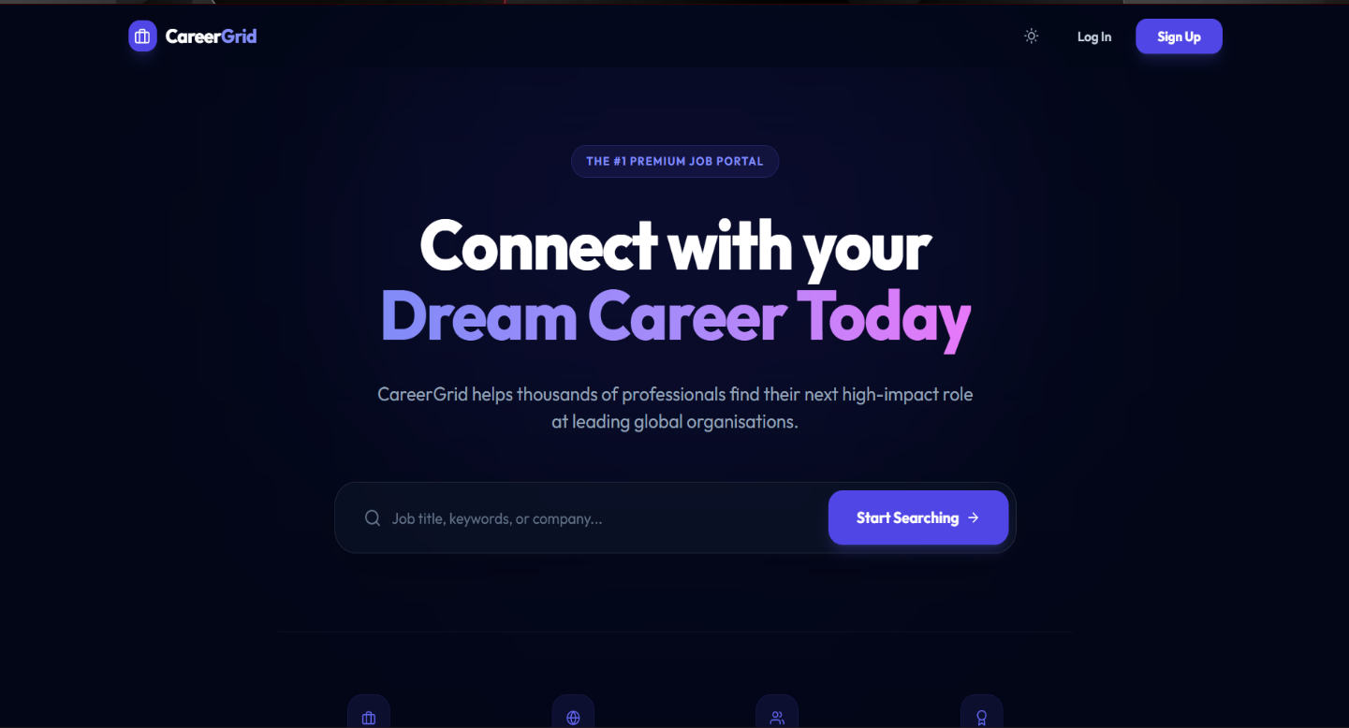
Figure A.2: Login Page

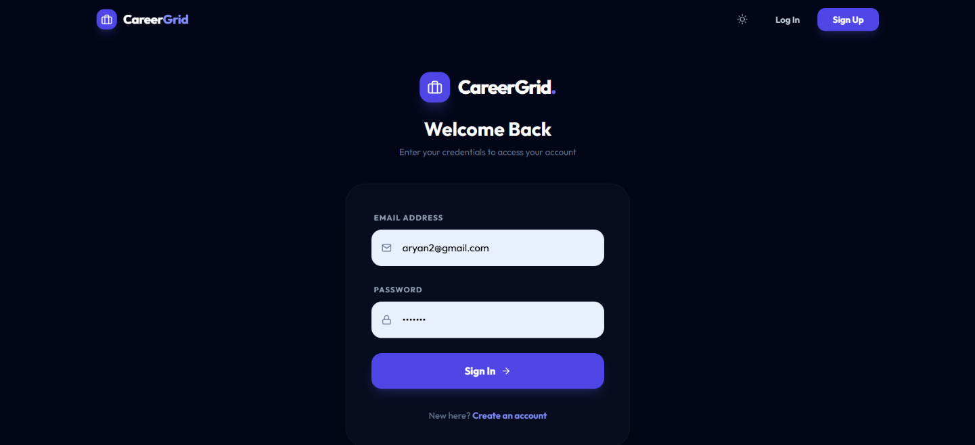

Figure A.3: Registration Page

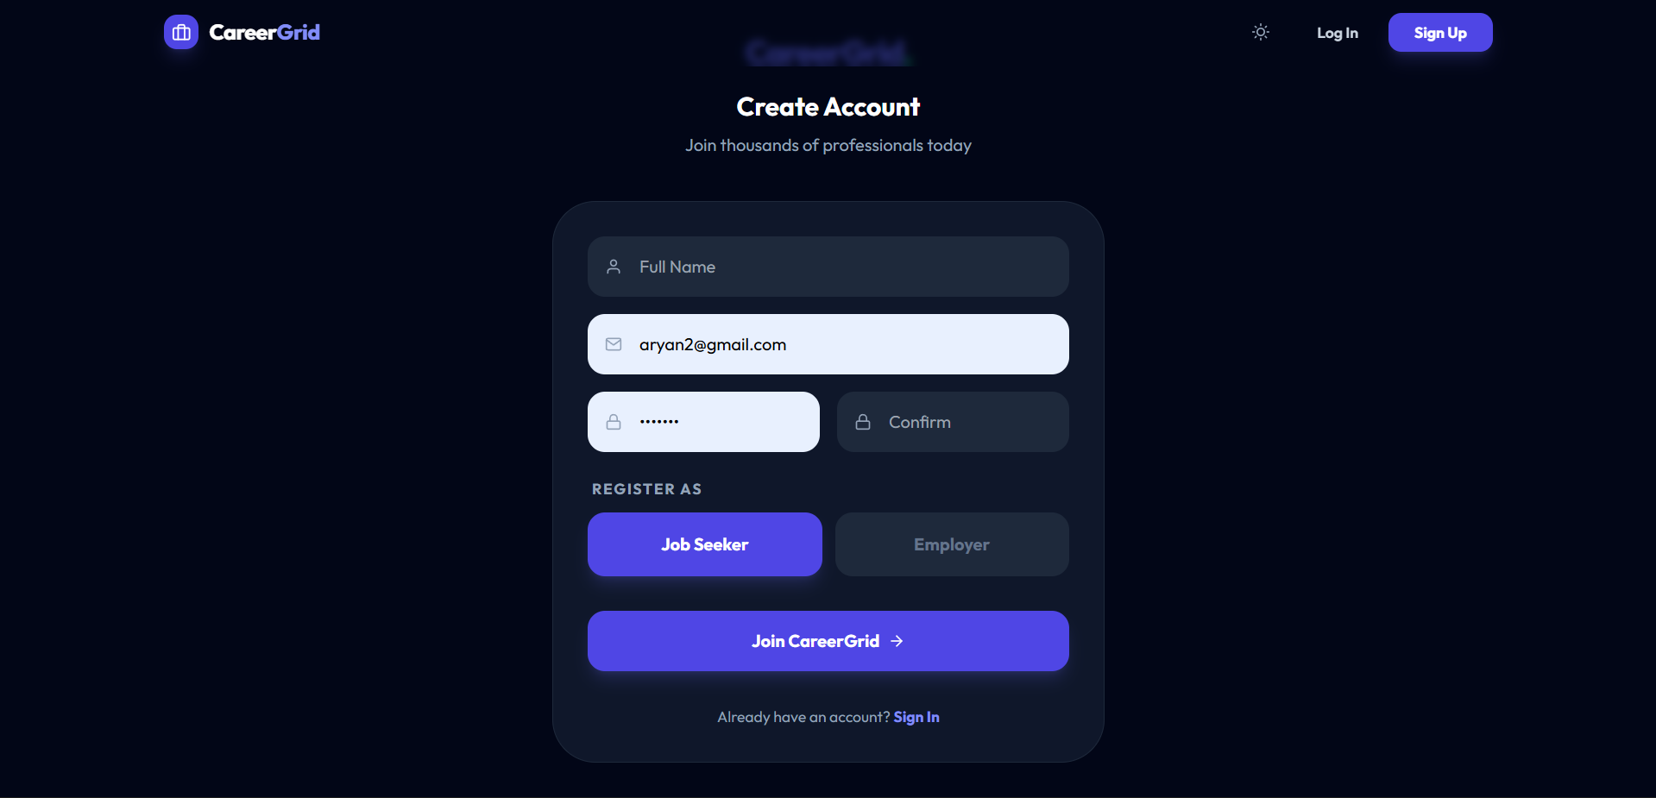

Figure A.4: Dashboard Page

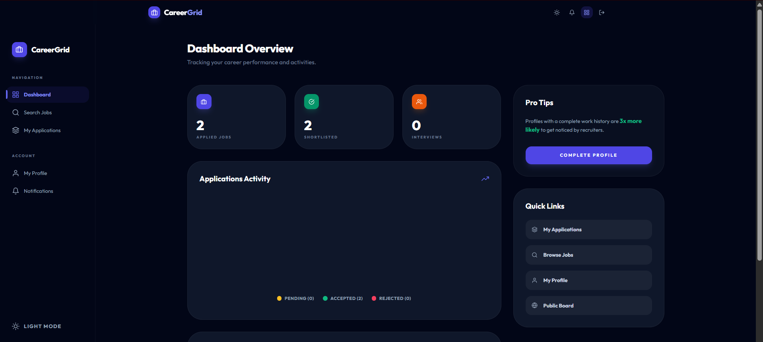

Figure A.5: Job Listings Page

