Shopify Pipeline
A multi-brand Shopify data pipeline — orders, sessions, checkout events, page speed, and dashboard summaries, kept up to date automatically.

What it does
For every brand it manages, the pipeline pulls in new data, keeps that brand's own MySQL database up to date, and rebuilds dashboard tables — only for the parts that actually changed. Specifically, it:
- Fetches new and updated Shopify orders into that brand's own MySQL database.
- Pulls session and traffic data via ShopifyQL (Shopify's analytics query language).
- Syncs checkout-initiated and buy-now events from MongoDB.
- Syncs page-speed (“web vitals”) data from MongoDB.
- Rebuilds dashboard summary tables incrementally, only for changed dates.
- Rolls up “bundle” product sales (TMC and PTS today) — bundle products are discovered automatically by Shopify product type, not a hardcoded list.
- Sends live alerts to QStash: sales/session numbers and page-speed averages, per brand.
Each brand is fully isolated — its own database, its own Shopify store, its own failure boundary. If one brand's run fails, the others still complete.

Architecture
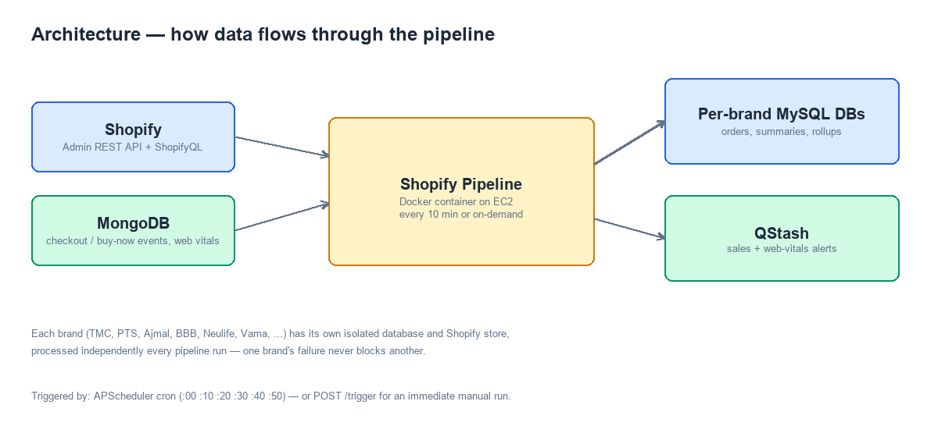

How it runs
- Automatically, every 10 minutes, via an internal scheduler (APScheduler).
- On demand, via POST /trigger (manual runs, or an external pipeline manager).
- Packaged as a Docker container, deployed on an EC2 instance.

Project structure
The pipeline used to be a single ~10,000-line file. It's now split into focused modules under pipeline/, all tied together through aws_background.py, which remains the entrypoint.
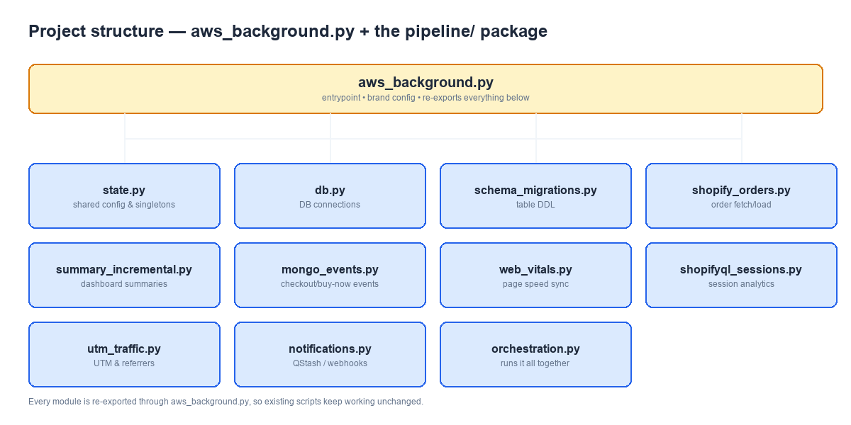
Module | Responsibility
aws_background.py | Entrypoint, brand configuration, and the facade that re-exports everything below
pipeline/state.py | Shared config and long-lived objects (logger, Flask app, scheduler, brand registries)
pipeline/db.py | Database connections, retries, and cleanup
pipeline/schema_migrations.py | Table creation / schema upkeep
pipeline/shopify_orders.py | Order fetching, transforming, and loading
pipeline/summary_incremental.py | Rebuilding dashboard summary tables
pipeline/mongo_events.py | Checkout-initiated / buy-now event sync
pipeline/web_vitals.py | Page-speed data sync
pipeline/shopifyql_sessions.py | Session and city-level traffic analytics
pipeline/utm_traffic.py | UTM and referrer attribution
pipeline/notifications.py | QStash alerts and webhook triggers
pipeline/orchestration.py | Runs everything above, per brand, per pipeline tick
bundle_rollups.py | Bundle product discovery and sales rollups (TMC, PTS)
workers/events_summary_worker.py | Separate worker rolling up daily event totals, own Docker container
backfill scripts/ | Standalone scripts to re-run specific pieces over a historical date range

Configuration
Brands are configured through numbered environment variables — one full set per brand index, e.g. BRAND_NAME_0, BRAND_TAG_0, DB_HOST_0, SHOP_NAME_0, ACCESS_TOKEN_0. In production, brand configuration is instead pulled from an internal brand-config API. Local/dev runs use TEST_MODE=true, which loads brand config from .env.local instead and disables outbound QStash calls.
Variable | Purpose
SELF_RUN | true = auto-run every 10 minutes; false = manual trigger only
BACKFILL_MODE | true = process a specific historical date window instead of “since last run”
BACKFILL_BRAND_INDICES | Restrict a backfill run to specific brands
ALERTS_WEBHOOK_URL | Where QStash-forwarded sales/web-vitals alerts get delivered

No secrets or real credentials are ever meant to live in source control — see .env.local / .env locally, and the deployment's own secret store in production.

Running it locally
pip install -r requirements.txt
python aws_background.py
With TEST_MODE=true, this loads brand config from .env.local, starts the scheduler, and serves the API on port 5000.
Check it's alive: curl http://localhost:5000/health
Trigger a run manually: curl -X POST http://localhost:5000/trigger -H "x-pipeline-key: <key>" -d '{"runId": "manual-test-1"}'

API endpoints
Endpoint | Method | Purpose
/health | GET | Basic liveness check
/trigger | POST | Runs the pipeline immediately (requires x-pipeline-key + runId)

Deployment
Runs as two Docker services (see docker-compose.yml): shopify-pipeline (the main pipeline) and events-summary-worker (a separate container rolling up daily event totals across all brands, on its own daily schedule).
To deploy an update on the server:
- git pull origin master
- docker compose build shopify-pipeline
- docker compose up -d shopify-pipeline

Testing
python -m unittest discover -p "test_*.py"
Covers brand-activation filtering, bundle rollup logic, UTM source mapping, and the events summary worker.

Backfill scripts
backfill scripts/ holds standalone tools for re-running one specific piece of the pipeline over a chosen date range — useful for fixing a gap in historical data without re-running everything. Each script is run directly with Python and reads the same brand configuration as the main pipeline.
Category | Examples
Orders & addresses | backfill_shopify.py, backfill_shopify_order_addresses.py, backfill_shopify_order_tags.py
Returns / RTO | backfill_returns_fact_order_created_date.py, backfill_rto_summary.py
Checkout / buy-now events | backfill_checkout_initiated_ci_events.py, backfill_buy_now_events.py (+ variant-level)
Sessions & web vitals | backfill_hourly_sessions.py, backfill_web_vitals_summary.py, backfill_daily_web_vitals_summary.py
UTM & traffic | utm_sessions_backfill.py, referrer_sessions_backfill.py, backfill_product_traffic_split.py
Bundles | bundle_rollup_backfill.py

