SIMATS ENGINEERING (SAVEETHA SCHOOL OF ENGINEERING)
Department of Artificial Intelligence and Data Science
ASSESSMENT TOOL 2 – TECHNICAL PRESENTATION
Demonstration Programs (all 15 topics) with Output Screenshots
Course Code: | DSA03 | Course Title: | Natural Language Processing
CO Assessed: | CO1 – Imitation (L1) | Weightage: | 30% of CIA
Student Name: | Aryan.K.S | Reg. No.: | 192325051
Section / Batch: |  | Date:

Team 1 | TP-01: Evolution of Natural Language Processing: From Rule-Based Systems to Modern NLP
Question
Analyze the historical development of NLP models, key milestones, and how language processing has evolved from handcrafted rules to intelligent systems.
Answer Python program: tp01_evolution_of_nlp.py
"""TP-01 - Evolution of NLP: Rule-Based -> Statistical -> Modern NLP (working demo)."""
import re
from collections import Counter, defaultdict

TIMELINE = [
("1950s", "Rule-based", "Turing test; Georgetown-IBM translation (1954)"),
("1966", "Pattern rules", "ELIZA chatbot: hand-written regex rules"),
("1980s-90s", "Statistical", "n-gram models, HMM taggers, prob. parsers"),
("2000s", "Machine Learning", "Naive Bayes, SVM, CRF + hand-made features"),
("2013", "Embeddings", "Word2Vec / GloVe - dense word vectors"),
("2017", "Transformers", "Self-attention ('Attention Is All You Need')"),
("2018+", "Pre-trained LLMs", "BERT, GPT family - fine-tuned / prompted"),
]

print("=== NLP TIMELINE ===")
for year, era, note in TIMELINE:
print(f"{year:<10}{era:<18}{note}")

# ---- Era 1: rule-based (ELIZA-style regex rules) ----
RULES = [(r"i need (.*)", "Why do you need {0}?"),
(r"i am (.*)", "How long have you been {0}?"),
(r".*\bmother\b.*", "Tell me more about your family."),
(r".*", "Please tell me more.")]

def eliza(sentence):
for pattern, reply in RULES:
m = re.match(pattern, sentence.lower())
if m:
return reply.format(*m.groups())

print("\n=== ERA 1: RULE-BASED (hand-written rules) ===")
for s in ["I need a holiday", "I am feeling tired", "My mother called", "The weather is nice"]:
print(f"User : {s}\nBot : {eliza(s)}")

# ---- Era 2: statistical (bigram language model learnt from data) ----
corpus = "i love nlp . i love python . i like nlp . we love nlp .".split()
bigrams = defaultdict(Counter)
for w1, w2 in zip(corpus, corpus[1:]):
bigrams[w1][w2] += 1

print("\n=== ERA 2: STATISTICAL (bigram probabilities learnt from corpus) ===")
for prev in ["i", "love"]:
total = sum(bigrams[prev].values())
probs = ", ".join(f"P({w}|{prev})={c}/{total}={c/total:.2f}"
for w, c in bigrams[prev].most_common())
print(probs)

print("\n=== ERA 3: NEURAL / TRANSFORMER ===")
print("Learns contextual vectors from billions of words (BERT / GPT).")
Output Screenshot
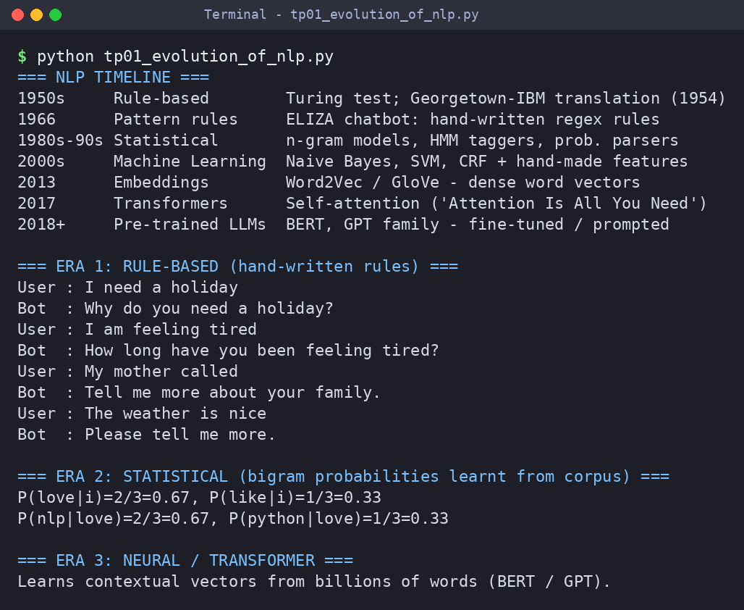

Team 2 | TP-02: Comparative Study of NLP Models and Algorithms
Question
Explore different NLP models and algorithms used for language processing, comparing their working principles, strengths, and limitations.
Answer Python program: tp02_comparative_nlp_models.py
"""TP-02 - Comparative study: Rule-based vs Naive Bayes vs k-NN (cosine) on sentiment data."""
import math
from collections import Counter, defaultdict

TRAIN = [("i love this phone great camera", "pos"), ("excellent battery and amazing display", "pos"),
("really good value i love it", "pos"), ("wonderful sound great quality", "pos"),
("happy with the fast delivery", "pos"), ("best purchase amazing", "pos"),
("terrible battery worst phone", "neg"), ("i hate the poor camera", "neg"),
("bad quality and very slow", "neg"), ("awful display total waste", "neg"),
("disappointed with slow delivery", "neg"), ("worst purchase poor value", "neg")]
TEST = [("great display and amazing sound", "pos"), ("poor battery and slow phone", "neg"),
("not good at all", "neg"), ("i love the fast delivery", "pos"),
("waste of money", "neg"), ("good camera", "pos"),
("slow display and bad sound", "neg"), ("amazing value", "pos")]

POS_LEX = {"love", "great", "excellent", "amazing", "good", "wonderful", "happy", "best"}
NEG_LEX = {"hate", "terrible", "worst", "bad", "poor", "awful", "slow", "disappointed"}

def rule_based(text):
w = text.split()
score = sum(x in POS_LEX for x in w) - sum(x in NEG_LEX for x in w)
return "pos" if score > 0 else "neg" if score < 0 else "unk" # unk = no lexicon word found

class NaiveBayes:
def __init__(self):
self.wc, self.cc, self.vocab = defaultdict(Counter), Counter(), set()
for text, label in TRAIN:
self.cc[label] += 1
for w in text.split():
self.wc[label][w] += 1; self.vocab.add(w)
def predict(self, text):
best, best_lp = None, -1e9
for c in self.cc:
lp = math.log(self.cc[c] / sum(self.cc.values()))
n = sum(self.wc[c].values())
for w in text.split(): # Laplace smoothing
lp += math.log((self.wc[c][w] + 1) / (n + len(self.vocab)))
if lp > best_lp: best, best_lp = c, lp
return best

def cosine(a, b):
ca, cb = Counter(a.split()), Counter(b.split())
dot = sum(ca[w] * cb[w] for w in ca)
norm = math.sqrt(sum(v*v for v in ca.values())) * math.sqrt(sum(v*v for v in cb.values()))
return dot / (norm or 1)

def knn(text, k=3):
top = sorted(TRAIN, key=lambda t: -cosine(text, t[0]))[:k]
return Counter(l for _, l in top).most_common(1)[0][0]

nb = NaiveBayes()
models = {"Rule-based": rule_based, "Naive Bayes": nb.predict, "k-NN (k=3)": knn}
print(f"{'Test sentence':<36}{'Gold':<6}" + "".join(f"{m:<13}" for m in models))
print("-" * 81)
correct = Counter()
for text, gold in TEST:
row = f"{text:<36}{gold:<6}"
for name, fn in models.items():
p = fn(text); correct[name] += (p == gold)
row += f"{p + (' ✔' if p == gold else ' ✘'):<13}"
print(row)
print("-" * 81)
print("Accuracy".ljust(42) + "".join(f"{correct[m]/len(TEST):<13.2f}" for m in models))
print("\nRule-based : transparent, no data needed, but brittle (misses negation: 'not good').")
print("Naive Bayes: fast, probabilistic, needs labelled data, ignores word order.")
print("k-NN : simple, non-parametric, but slow on large data; sensitive to overlap.")
Output Screenshot
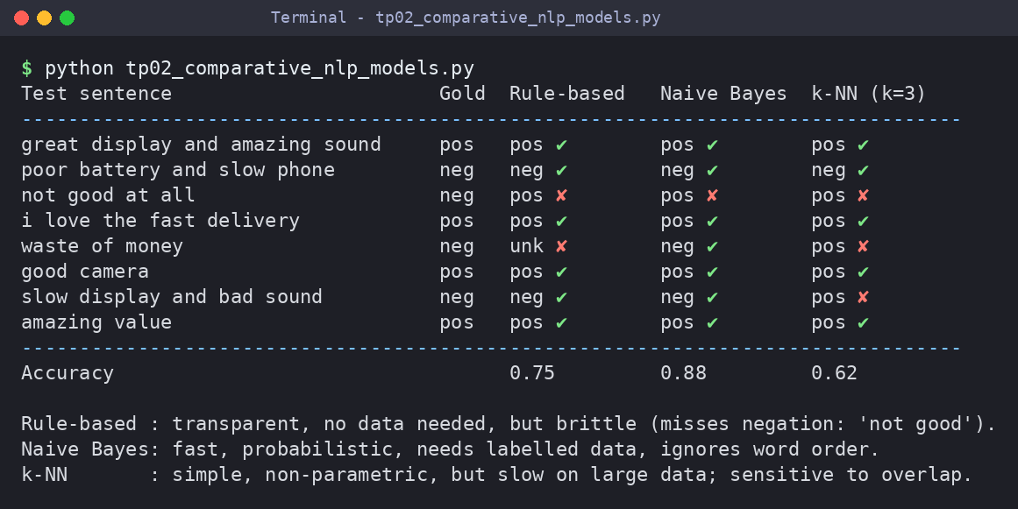

Team 3 | TP-03: Regular Expressions for Real-World Text Processing
Question
Demonstrate how regular expressions are used for data validation, text extraction, log analysis, and information retrieval in practical applications.
Answer Python program: tp03_regex_real_world.py
"""TP-03 - Regular Expressions for Real-World Text Processing."""
import re
from collections import Counter

print("=== 1. DATA VALIDATION ===")
checks = {
"PAN card": (r"[A-Z]{5}\d{4}[A-Z]", ["ABCDE1234F", "abcde1234f", "ABCD12345F"]),
"PIN code": (r"[1-9]\d{5}", ["600077", "012345", "60007"]),
"Vehicle no": (r"[A-Z]{2}\d{2}[A-Z]{1,2}\d{4}", ["TN09AB1234", "TN9AB1234"]),
}
for name, (rx, samples) in checks.items():
for s in samples:
print(f"{name:<11} {s:<12} -> {'Valid' if re.fullmatch(rx, s) else 'Invalid'}")

LOG = """192.168.1.10 - [07/Oct/2026:10:01:22] "GET /index.html" 200
192.168.1.11 - [07/Oct/2026:10:01:25] "GET /login" 404
10.0.0.5 - [07/Oct/2026:10:02:01] "POST /api/pay" 500
192.168.1.10 - [07/Oct/2026:10:02:09] "GET /courses" 200
10.0.0.5 - [07/Oct/2026:10:03:45] "POST /api/pay" 500
172.16.0.8 - [07/Oct/2026:10:04:10] "GET /logo.png" 304"""

print("\n=== 2. LOG ANALYSIS ===")
LOG_RE = re.compile(r'^(?P<ip>\d{1,3}(?:\.\d{1,3}){3}) - \[(?P<time>[^\]]+)\] '
r'"(?P<method>[A-Z]+) (?P<url>\S+)" (?P<status>\d{3})$', re.M)
entries = [m.groupdict() for m in LOG_RE.finditer(LOG)]
print("Total requests :", len(entries))
print("Status counts :", dict(Counter(e["status"] for e in entries)))
print("Top client IP :", Counter(e["ip"] for e in entries).most_common(1)[0])
errors = [(e["time"][-8:], e["url"]) for e in entries if e["status"].startswith("5")]
print("Server errors :", errors)

print("\n=== 3. INFORMATION RETRIEVAL (keyword in sentences) ===")
DOC = "NLP is growing fast. Regex is a classic NLP tool. Deep learning changed NLP. Cats are cute."
for sent in re.findall(r"[^.]+\.", DOC):
if re.search(r"\bregex\b", sent, re.I):
print("Match ->", sent.strip())
print("Words with 'ing':", re.findall(r"\b\w+ing\b", DOC))
Output Screenshot
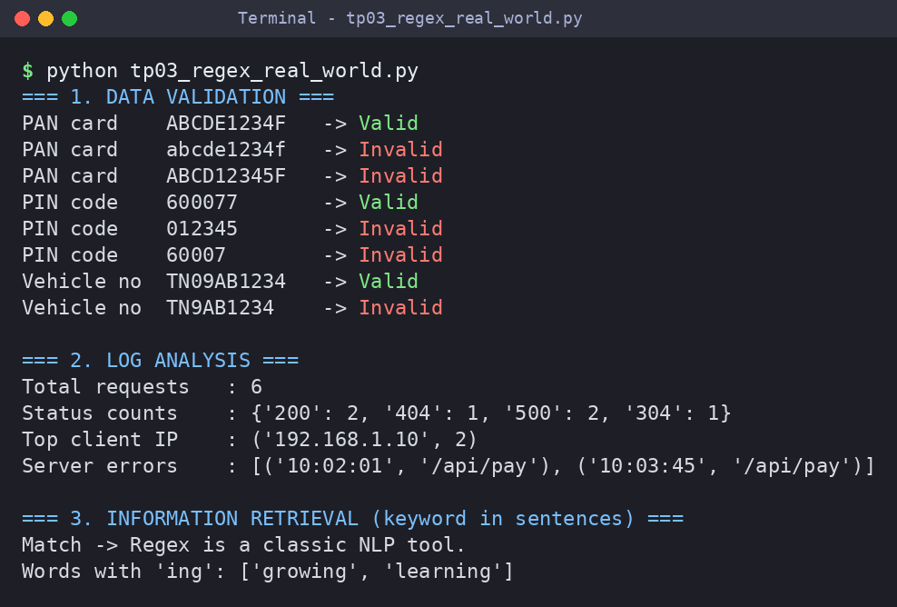

Team 4 | TP-04: Designing Efficient Regular Expression Patterns for Information Extraction
Question
Analyze complex regular expression patterns used to extract emails, phone numbers, URLs, dates, and structured information from unstructured text.
Answer Python program: tp04_efficient_regex_extraction.py
"""TP-04 - Designing Efficient Regular Expression Patterns for Information Extraction."""
import re

TEXT = """Contact admissions@simats.edu or placement.cell@saveetha.com for details.
Call +91-9876543210 or 98765 43211 (office: 044-2681 1234). Visit https://www.saveetha.com/nlp?id=5
or http://simats.edu. Exam on 12/09/2026, results by 25-10-2026.
Invoice no 123456789012 is not a phone."""

# Patterns are compiled ONCE (re-used many times), use named groups, anchors and boundaries.
PATTERNS = {
"Email": re.compile(r"\b[\w.%+-]+@[A-Za-z0-9-]+(?:\.[A-Za-z0-9-]+)*\.[A-Za-z]{2,}\b"),
"Mobile": re.compile(r"(?<!\d)(?:\+91[-\s]?)?[6-9]\d{4}[-\s]?\d{5}(?!\d)"),
"URL": re.compile(r"https?://[\w-]+(?:\.[\w-]+)+(?:/[\w./?=&%-]*)?"),
"Date": re.compile(r"\b(?:0[1-9]|[12]\d|3[01])[/-](?:0[1-9]|1[0-2])[/-](?:19|20)\d{2}\b"),
}

print("=== EXTRACTION FROM UNSTRUCTURED TEXT ===")
for name, rx in PATTERNS.items():
found = rx.findall(TEXT)
print(f"{name:<7} ({len(found)}): {found}")

print("\n=== WHY PATTERN DESIGN MATTERS: naive vs efficient ===")
naive, good = r"\d{10}", r"(?<!\d)[6-9]\d{9}(?!\d)"
for label, rx in (("naive ", naive), ("designed", good)):
print(f"{label} {rx:<24} ->", re.findall(rx, TEXT))

print("\n=== Greedy vs Lazy quantifier on HTML ===")
html = "<b>NLP</b> and <i>Regex</i>"
print("greedy <.*> :", re.findall(r"<.*>", html))
print("lazy <.*?> :", re.findall(r"<.*?>", html))
print("\nTips: compile once, word boundaries, lookarounds, lazy quantifiers.")
Output Screenshot
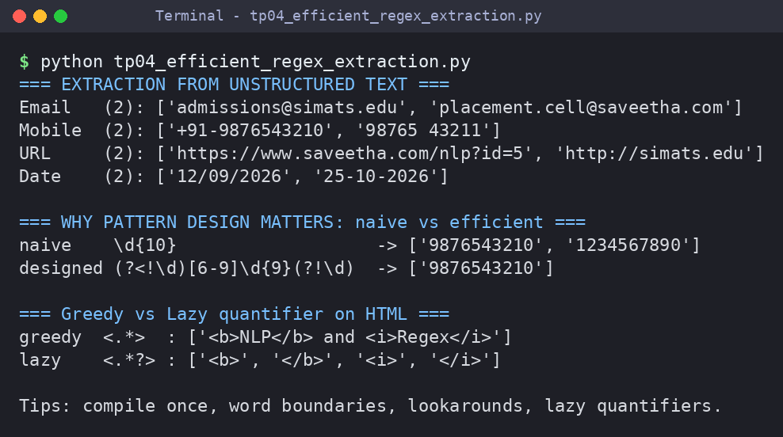

Team 5 | TP-05: Finite State Automata in Natural Language Processing
Question
Explain the concepts of deterministic and non-deterministic finite automata and their role in lexical analysis and language recognition.
Answer Python program: tp05_fsa_in_nlp.py
"""TP-05 - Finite State Automata in NLP: DFA and NFA recognisers."""

# ---------- DFA : the classic "sheep language" baa+! (baa!, baaa!, baaaa! ...) ----------
DFA = {("q0", "b"): "q1", ("q1", "a"): "q2", ("q2", "a"): "q3",
("q3", "a"): "q3", ("q3", "!"): "q4"}
START, FINAL = "q0", {"q4"}

def run_dfa(s):
state, path = START, [START]
for ch in s:
state = DFA.get((state, ch))
if state is None: # missing transition = dead state
return False, path + ["(dead)"]
path.append(state)
return state in FINAL, path

print("=== DFA for baa+! ===")
for w in ["baa!", "baaaa!", "ba!", "baa", "abaa!"]:
ok, path = run_dfa(w)
print(f"{w:<8}{' → '.join(path):<38}{'Accepted' if ok else 'Rejected'}")

# ---------- NFA : strings over {a,b} that END with "ab" (several possible moves) ----------
NFA = {("p0", "a"): {"p0", "p1"}, ("p0", "b"): {"p0"}, ("p1", "b"): {"p2"}}
NFA_START, NFA_FINAL = "p0", {"p2"}

def run_nfa(s):
current, trace = {NFA_START}, [{NFA_START}]
for ch in s:
nxt = set()
for st in current:
nxt |= NFA.get((st, ch), set())
current = nxt
trace.append(current)
return bool(current & NFA_FINAL), trace

print("\n=== NFA for strings ending with 'ab' (set of active states) ===")
for w in ["aab", "abb", "bab"]:
ok, trace = run_nfa(w)
path = " → ".join("{" + ",".join(sorted(t)) + "}" for t in trace)
print(f"{w:<5}{path:<42}{'Accepted' if ok else 'Rejected'}")

print("\nDFA: exactly one next state per input symbol.")
print("NFA: a SET of states; accepted if any state in the set is final.")
Output Screenshot
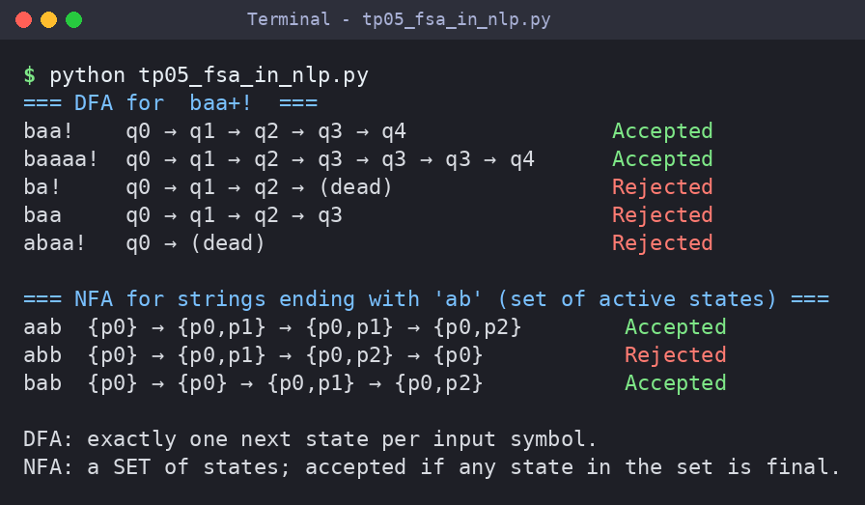

Team 6 | TP-06: Building a Finite State Automaton for Token Recognition
Question
Design and demonstrate a finite state automaton that recognizes tokens such as identifiers, keywords, and numbers in textual data.
Answer Python program: tp06_fsa_token_recognition.py
"""TP-06 - Building a Finite State Automaton for Token Recognition (identifiers, keywords, numbers)."""

KEYWORDS = {"int", "float", "if", "else", "while", "return", "print"}

def char_class(ch):
if ch.isalpha() or ch == "_": return "letter"
if ch.isdigit(): return "digit"
if ch == ".": return "dot"
return "other"

# DFA transition table: (state, character class) -> next state
DELTA = {("S", "letter"): "ID", ("ID", "letter"): "ID", ("ID", "digit"): "ID",
("S", "digit"): "INT", ("INT", "digit"): "INT", ("INT", "dot"): "DOT",
("DOT", "digit"): "FLOAT", ("FLOAT", "digit"): "FLOAT"}
ACCEPT = {"ID": "IDENTIFIER", "INT": "INTEGER", "FLOAT": "FLOAT"}

def next_token(text, i):
"""Maximal-munch: keep following DFA transitions as long as they exist."""
state, j, last_accept = "S", i, None
while j < len(text) and (state, char_class(text[j])) in DELTA:
state = DELTA[(state, char_class(text[j]))]
j += 1
if state in ACCEPT: last_accept = (j, ACCEPT[state])
return last_accept

def tokenize(text):
i, tokens = 0, []
while i < len(text):
if text[i].isspace():
i += 1; continue
res = next_token(text, i)
if res:
end, kind = res
lexeme = text[i:end]
if kind == "IDENTIFIER" and lexeme in KEYWORDS: kind = "KEYWORD"
tokens.append((lexeme, kind)); i = end
else:
two = text[i:i + 2]
if two in {">=", "<=", "==", "!="}: tokens.append((two, "OPERATOR")); i += 2
else: tokens.append((text[i], "OPERATOR" if text[i] in "+-*/=<>" else "SYMBOL")); i += 1
return tokens

print("DFA states: S (start), ID, INT, DOT, FLOAT accepting: ID, INT, FLOAT")
print("Transitions:", ", ".join(f"{s}-{c}->{n}" for (s, c), n in list(DELTA.items())[:3]), "...")
for source in ["int total_1 = count + 25.5;", "while x2 >= 10 print x2"]:
print(f"\nInput : {source}")
print(f"{'Lexeme':<10}{'Token Type'}")
print("-" * 24)
for lexeme, kind in tokenize(source):
print(f"{lexeme:<10}{kind}")
Output Screenshot
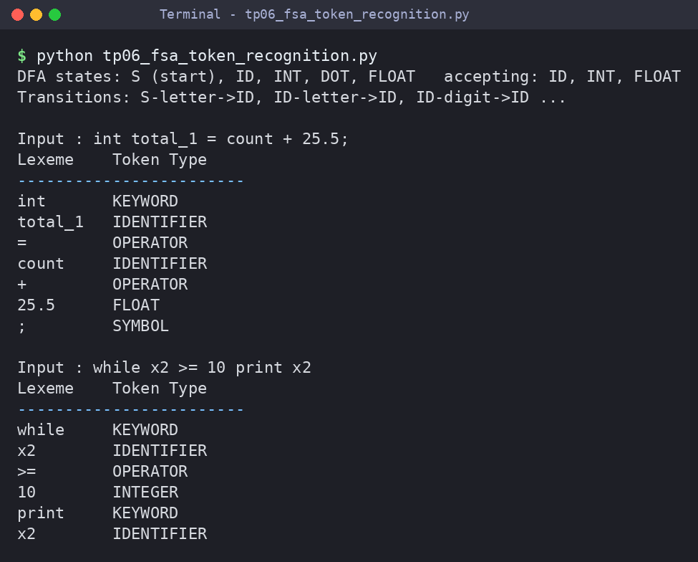

Team 7 | TP-07: Morphology and Word Formation in Natural Languages
Question
Investigate how words are structured and formed using morphemes, and analyze the importance of morphology in NLP systems.
Answer Python program: tp07_morphology_word_formation.py
"""TP-07 - Morphology and Word Formation: segmenting words into morphemes."""

PREFIXES = ["dis", "un", "re", "pre", "in"]
SUFFIXES = ["ness", "ment", "able", "ful", "ing", "ed", "er", "ly", "s"]
ROOTS = {"happy", "agree", "play", "kind", "break", "teach", "care", "run", "form", "friend"}

def variants(stem):
"""Undo spelling changes made at morpheme boundaries."""
yield stem
yield stem + "e" # making -> mak -> make
if stem.endswith("i"): yield stem[:-1] + "y" # happi -> happy
if len(stem) > 2 and stem[-1] == stem[-2]: yield stem[:-1] # runn -> run

def analyse(word, depth=0):
if word in ROOTS: return [word]
if depth > 5: return None
for suf in SUFFIXES:
if word.endswith(suf) and len(word) > len(suf):
for v in variants(word[:-len(suf)]):
r = analyse(v, depth + 1)
if r: return r + ["-" + suf]
for pre in PREFIXES:
if word.startswith(pre):
r = analyse(word[len(pre):], depth + 1)
if r: return [pre + "-"] + r
return None

def kind(m):
return "prefix" if m.endswith("-") else "suffix" if m.startswith("-") else "root"

print(f"{'Word':<15}{'Morphemes':<30}Count Structure")
print("-" * 78)
for w in ["unhappiness", "disagreements", "replaying", "unbreakable", "teachers",
"carefully", "running", "friends", "table"]:
parts = analyse(w)
if parts:
print(f"{w:<15}{' + '.join(parts):<30}{len(parts):<7}{', '.join(kind(p) for p in parts)}")
else:
print(f"{w:<15}{'(not analysed - unknown root)':<30}")
Output Screenshot
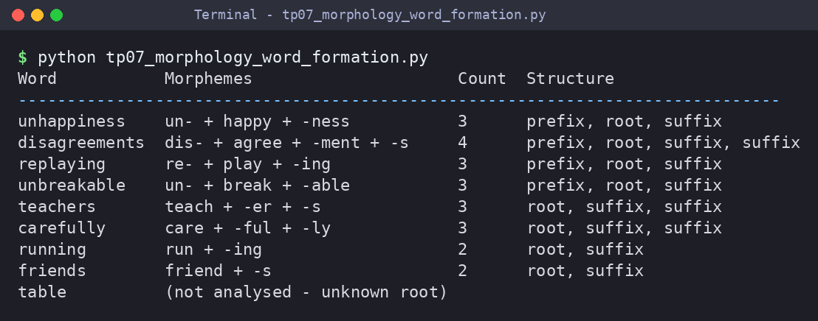

Team 8 | TP-08: Inflectional Morphology: Understanding Grammatical Variations
Question
Examine how inflectional changes affect word forms based on tense, number, gender, and case across different languages.
Answer Python program: tp08_inflectional_morphology.py
"""TP-08 - Inflectional Morphology: generating and normalising grammatical word forms."""

IRREG_NOUN = {"child": "children", "mouse": "mice", "man": "men", "foot": "feet"}
IRREG_VERB = {"go": ("goes", "went", "gone", "going"), "be": ("is", "was", "been", "being"),
"eat": ("eats", "ate", "eaten", "eating")}
VOWELS = "aeiou"

def plural(noun):
if noun in IRREG_NOUN: return IRREG_NOUN[noun]
if noun.endswith(("s", "x", "z", "ch", "sh")): return noun + "es"
if noun.endswith("y") and noun[-2] not in VOWELS: return noun[:-1] + "ies"
return noun + "s"

def verb_forms(v):
"""3rd-person singular, past, past participle, present participle."""
if v in IRREG_VERB: return IRREG_VERB[v]
if v.endswith(("s", "x", "z", "ch", "sh", "o")): s = v + "es"
elif v.endswith("y") and v[-2] not in VOWELS: s = v[:-1] + "ies"
else: s = v + "s"
if v.endswith("e"): past, ing = v + "d", v[:-1] + "ing"
elif v.endswith("y") and v[-2] not in VOWELS: past, ing = v[:-1] + "ied", v + "ing"
elif (len(v) >= 3 and v[-3] not in VOWELS and v[-2] in VOWELS and v[-1] not in VOWELS + "wxy"
and sum(c in VOWELS for c in v) == 1): # short consonant-vowel-consonant word
past, ing = v + v[-1] + "ed", v + v[-1] + "ing" # stop -> stopped / stopping
else: past, ing = v + "ed", v + "ing"
return s, past, past, ing

print("=== NOUN NUMBER (singular -> plural) ===")
nouns = ["cat", "box", "city", "boy", "child", "mouse"]
for i in range(0, len(nouns), 3):
print("".join(f"{n:<7}-> {plural(n):<12}" for n in nouns[i:i + 3]))
print("\n=== VERB TENSE / FORM ===")
print(f"{'Base':<8}{'3sg (-s)':<10}{'Past':<10}{'Past Part.':<12}{'Pres. Part.'}")
print("-" * 52)
for v in ["walk", "love", "study", "stop", "play", "go", "eat"]:
f = verb_forms(v)
print(f"{v:<8}{f[0]:<10}{f[1]:<10}{f[2]:<12}{f[3]}")

# ---- Normalisation: inflected form -> lemma + grammatical features ----
LOOKUP = {w: (b, "NOUN+PL") for b, w in IRREG_NOUN.items()}
for b, (s3, pa, pp, ing) in IRREG_VERB.items():
LOOKUP.update({s3: (b, "VERB+3SG"), pa: (b, "VERB+PAST"),
pp: (b, "VERB+PASTPART"), ing: (b, "VERB+PRESPART")})
BASES = {"cat", "box", "city", "walk", "love", "study", "stop", "play", "child"}

def lemmatise(word):
if word in LOOKUP: return LOOKUP[word]
for suf, feat in (("ies", "PL/3SG"), ("ing", "PRESPART"), ("ed", "PAST"),
("es", "PL/3SG"), ("s", "PL/3SG")):
if word.endswith(suf):
stem = word[:-len(suf)]
for cand in (stem, stem + "e", stem + "y", stem[:-1]):
if cand in BASES: return cand, feat
return word, "BASE"

print("\n=== NORMALISATION (word -> lemma + grammatical feature) ===")
for w in ["cats", "boxes", "cities", "walked", "loving", "studies",
"stopped", "children", "went", "eaten"]:
lemma, feat = lemmatise(w)
print(f"{w:<10}-> {lemma:<8} [{feat}]")
Output Screenshot
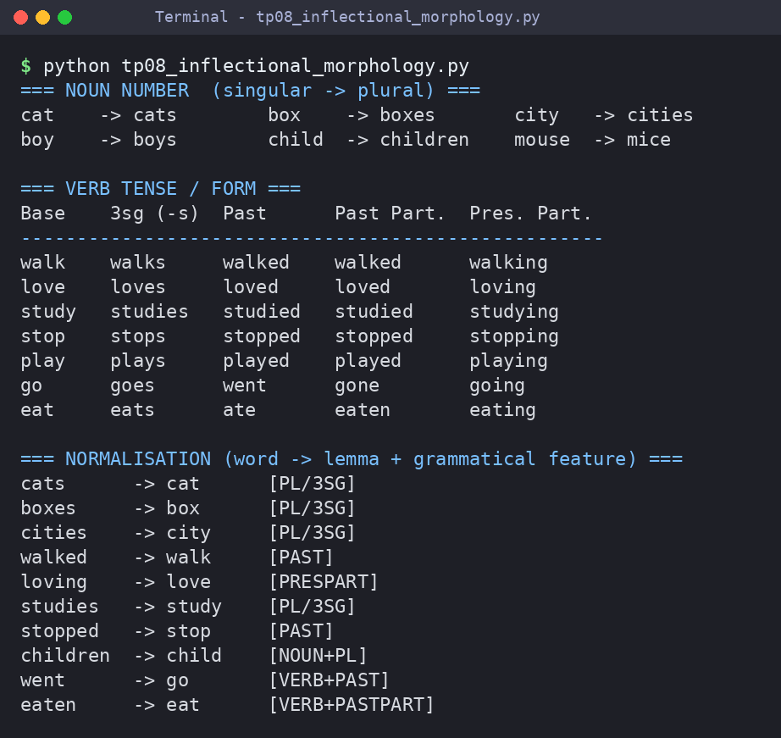

Team 9 | TP-09: Derivational Morphology and Vocabulary Expansion
Question
Analyze derivational processes that create new words and study their impact on semantic interpretation and language understanding.
Answer Python program: tp09_derivational_morphology.py
"""TP-09 - Derivational Morphology and Vocabulary Expansion."""

# (affix, type, from-POS, to-POS, meaning change)
RULES = [("un-", "prefix", "ADJ", "ADJ", "negation"),
("re-", "prefix", "V", "V", "repeat action"),
("dis-", "prefix", "V", "V", "reverse action"),
("-ness", "suffix", "ADJ", "N", "state / quality"),
("-ment", "suffix", "V", "N", "result of action"),
("-er", "suffix", "V", "N", "doer of action"),
("-ly", "suffix", "ADJ", "ADV", "manner"),
("-able", "suffix", "V", "ADJ", "capable of being"),
("-ful", "suffix", "N", "ADJ", "full of"),
("-ize", "suffix", "ADJ", "V", "make / become"),
("-al", "suffix", "N", "ADJ", "relating to")]

SEED = {"happy": "ADJ", "kind": "ADJ", "quick": "ADJ", "modern": "ADJ", "agree": "V", "use": "V",
"teach": "V", "play": "V", "read": "V", "nation": "N", "care": "N"}
VOCAB = {"unhappy", "unkind", "happiness", "kindness", "quickness", "happily", "kindly", "quickly",
"modernize", "agreement", "teacher", "player", "reader", "readable", "usable", "replay",
"reuse", "reread", "disagree", "playful", "careful", "national", "unhappiness",
"usability", "nationalize", "unusable", "disagreement", "readably"}

def attach(word, affix, kind):
a = affix.strip("-")
if kind == "prefix": return a + word
if word.endswith("y") and word[-2] not in "aeiou" and a[0] != "i":
word = word[:-1] + "i" # happy -> happi
if word.endswith("e") and a[0] in "aeiou":
word = word[:-1] # use -> us
return word + a

derived, lexicon = {}, dict(SEED)
for rnd in (1, 2): # two rounds: derived words can be re-used as bases
new = {}
for base, pos in lexicon.items():
for affix, kind, frm, to, meaning in RULES:
word = attach(base, affix, kind)
if pos == frm and word in VOCAB and word not in lexicon and word not in new:
new[word] = to
derived[word] = (base, pos, affix, to, meaning, rnd)
lexicon.update(new)

print(f"{'Base (POS)':<16}{'Affix':<8}{'Derived (POS)':<19}{'Meaning shift'}")
print("-" * 64)
for word, (base, pos, affix, to, meaning, rnd) in derived.items():
print(f"{base + ' (' + pos + ')':<16}{affix:<8}{word + ' (' + to + ')':<19}{meaning}")
print("-" * 64)
print(f"Vocabulary expansion: {len(SEED)} base words -> {len(lexicon)} words "
f"(+{len(derived)} derived, round-2 words: {sum(d[5] == 2 for d in derived.values())})")
Output Screenshot
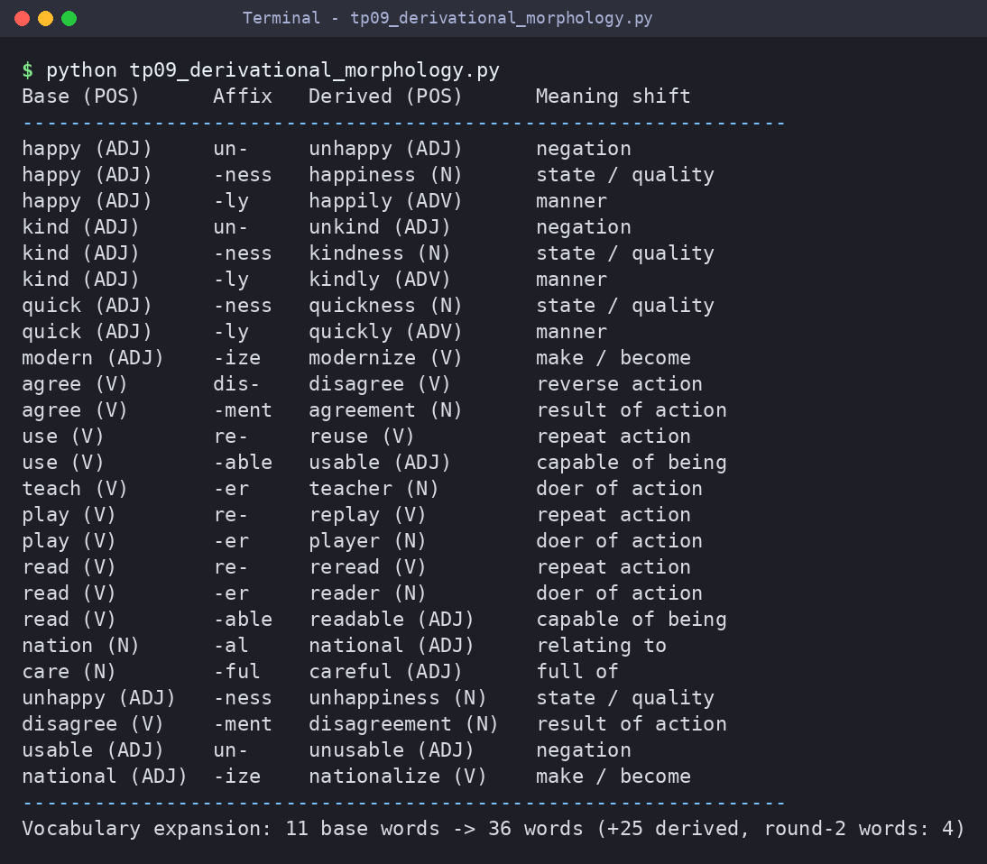

Team 10 | TP-10: Comparative Analysis of Inflectional and Derivational Morphology
Question
Compare the characteristics, applications, and challenges of inflectional and derivational morphology in NLP tasks.
Answer Python program: tp10_inflectional_vs_derivational.py
"""TP-10 - Comparative Analysis of Inflectional and Derivational Morphology."""

# (base, base POS, affixed form, new POS, affix)
PAIRS = [("walk", "V", "walked", "V", "-ed"), ("walk", "V", "walker", "N", "-er"),
("cat", "N", "cats", "N", "-s"), ("happy", "ADJ", "happiness", "N", "-ness"),
("big", "ADJ", "bigger", "ADJ", "-er"), ("kind", "ADJ", "unkind", "ADJ", "un-"),
("teach", "V", "teaching", "V", "-ing"), ("nation", "N", "national", "ADJ", "-al"),
("play", "V", "replay", "V", "re-")]
INFLECTIONAL_AFFIXES = {"-s", "-ed", "-ing", "-er(comp)", "-est", "-en"}

def classify(base, bpos, word, npos, affix):
# Heuristic: inflection keeps the category AND only marks a grammatical feature
if bpos != npos:
return "Derivational", "category changes (%s -> %s)" % (bpos, npos)
grammatical = affix in {"-s", "-ed", "-ing"} or (affix == "-er" and bpos == "ADJ")
if grammatical:
return "Inflectional", "same category, marks tense/number/degree"
return "Derivational", "same category but new lexeme/meaning"

print(f"{'Base':<8}{'Form':<11}{'Affix':<7}{'Type':<14}Reason")
print("-" * 78)
tally = {"Inflectional": 0, "Derivational": 0}
for p in PAIRS:
kind, why = classify(*p)
tally[kind] += 1
print(f"{p[0]:<8}{p[2]:<11}{p[4]:<7}{kind:<14}{why}")
print("-" * 78)
print("Tally ->", tally)

print("\n=== COMPARISON TABLE ===")
rows = [("Feature", "Inflectional", "Derivational"),
("Changes POS?", "No", "Often yes"),
("Changes meaning?", "No (same lexeme)", "Yes (new lexeme)"),
("Productivity", "Highly regular", "Irregular / selective"),
("Number of affixes", "Small closed set", "Large open set"),
("Position in word", "Outermost (last)", "Closer to the root"),
("Example", "walk -> walked", "walk -> walker")]
for r in rows:
print(f"{r[0]:<20}{r[1]:<20}{r[2]}")
print("\nOrdering check: 'nation-al-iz-ation-s' -> derivational affixes first,")
print("inflectional '-s' always last.")
Output Screenshot
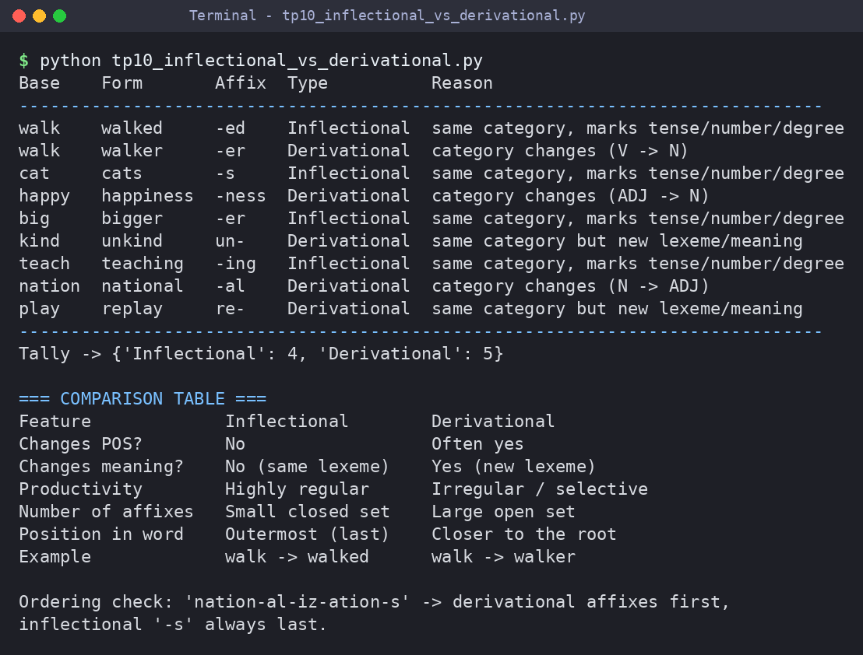

Team 11 | TP-11: Finite-State Morphological Parsing Techniques
Question
Explore finite-state transducers and parsing techniques used to analyze and generate morphological structures in natural languages.
Answer Python program: tp11_fst_morphological_parsing.py
"""TP-11 - Finite-State Morphological Parsing using a Finite-State Transducer (FST)."""
from collections import defaultdict

class FST:
"""Arcs are (input symbol, output string, next state); '' input = epsilon move."""
def __init__(self):
self.arcs, self.finals, self.count = defaultdict(list), set(), 0
def add(self, src, inp, out, dst):
self.arcs[src].append((inp, out, dst)); self.count += 1
def parse(self, word):
results = []
def dfs(state, pos, out, seen):
if pos == len(word) and state in self.finals:
results.append(out)
for inp, o, dst in self.arcs[state]:
if inp == "":
if (dst, pos) not in seen: dfs(dst, pos, out + o, seen | {(dst, pos)})
elif pos < len(word) and word[pos] == inp:
dfs(dst, pos + 1, out + o, seen)
dfs("q0", 0, "", frozenset())
return results

fst = FST()
NOUNS_REG = ["cat", "dog", "book", "walk"]
NOUNS_ES = ["fox", "bus"]
VERBS = ["walk", "play", "jump", "talk"]

def add_stem(stem, cls):
prev = "q0"
for i, ch in enumerate(stem): # one arc per letter, shared via a prefix trie
node = "t:" + stem[:i + 1]
if not any(a[2] == node for a in fst.arcs[prev]): fst.add(prev, ch, ch, node)
prev = node
fst.add(prev, "", "", cls) # epsilon move into the morphotactic class

for s in NOUNS_REG: add_stem(s, "N_reg")
for s in NOUNS_ES: add_stem(s, "N_es")
for s in VERBS: add_stem(s, "V_reg")

# morphotactics (suffix sub-automata) -> every path ends in the final state 'F'
fst.add("N_reg", "", "+N+SG", "F"); fst.add("N_reg", "s", "+N+PL", "F")
fst.add("N_es", "", "+N+SG", "F")
fst.add("N_es", "e", "", "N_es2"); fst.add("N_es2", "s", "+N+PL", "F")
fst.add("V_reg", "", "+V+BASE", "F"); fst.add("V_reg", "s", "+V+3SG", "F")
fst.add("V_reg", "e", "", "V_e"); fst.add("V_e", "d", "+V+PAST", "F")
for k, ch in enumerate("ing"): fst.add("V_reg" if k == 0 else f"V_i{k}", ch, "", f"V_i{k+1}")
fst.add("V_i3", "", "+V+PRESPART", "F")
# irregular forms are stored directly
def add_irregular(surface, lexical):
"""Whole irregular word as one path: first arc outputs the lexical form."""
prev = "q0"
for i, ch in enumerate(surface):
nxt = "F" if i == len(surface) - 1 else f"irr:{surface}:{i}"
fst.add(prev, ch, lexical if i == 0 else "", nxt)
prev = nxt

add_irregular("mice", "mouse+N+PL")
add_irregular("went", "go+V+PAST")
fst.finals = {"F"}

print(f"FST built: {len(fst.arcs)} states, {fst.count} arcs\n")
print(f"{'Surface form':<14}Lexical form (parse)")
print("-" * 46)
for w in ["cat", "cats", "foxes", "walk", "walks", "walked", "walking",
"played", "mice", "went", "xyz"]:
res = fst.parse(w)
print(f"{w:<14}{' | '.join(res) if res else '*unknown word*'}")
Output Screenshot
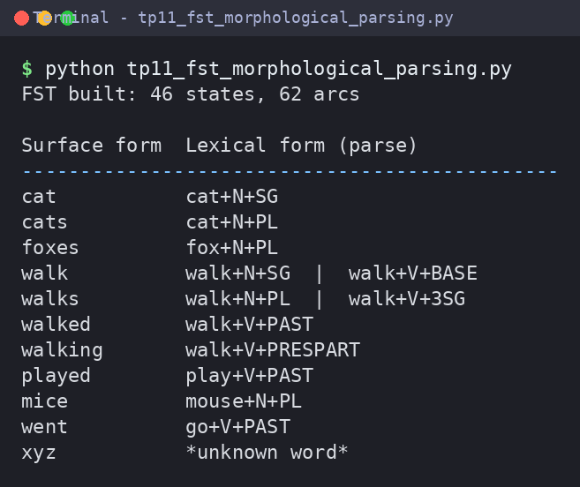

Team 12 | TP-12: Morphological Analysis for Indian Languages
Question
Study the challenges and solutions involved in performing morphological processing for morphologically rich Indian languages such as Tamil, Hindi, and Telugu.
Answer Python program: tp12_indian_language_morphology.py
"""TP-12 - Morphological Analysis for Indian Languages (Tamil, Hindi, Telugu - romanised)."""

# suffix -> grammatical feature (tables are small samples for demonstration)
SUFFIXES = {
"Tamil": {"galukku": "PL+DAT", "gal": "PL", "ukku": "DAT", "il": "LOC",
"aargal": "3PL.HON", "in": "PAST"},
"Hindi": {"yon": "OBL.PL", "on": "OBL.PL", "oge": "2PL.FUT", "unga": "1SG.FUT.M"},
"Telugu": {"aalu": "PL", "lo": "LOC", "aadu": "PAST.3SG.M", "aanu": "PAST.1SG"},
}
# surface stem -> (lemma, category, meaning); includes sandhi-changed stems (veett <- veedu)
STEMS = {
"Tamil": {"maanavar": ("maanavar", "N", "student"), "veett": ("veedu", "N", "house"),
"paad": ("paadu", "V", "sing")},
"Hindi": {"kitaab": ("kitaab", "N", "book"), "ladki": ("ladki", "N", "girl"),
"jaa": ("jaa", "V", "go"), "khaa": ("khaa", "V", "eat")},
"Telugu": {"pustak": ("pustakam", "N", "book"), "int": ("illu", "N", "house"),
"chadiv": ("chadivu", "V", "read"), "vell": ("vellu", "V", "go")},
}
WORDS = {"Tamil": ["maanavargalukku", "veettil", "paadinaargal"],
"Hindi": ["kitaabon", "ladkiyon", "jaaoge", "khaaunga"],
"Telugu": ["pustakaalu", "intlo", "chadivaadu", "vellaanu"]}

def analyse(lang, word):
"""Peel suffixes from the right (agglutination) until a known stem remains."""
tags, w = [], word
while w not in STEMS[lang]:
for suf in sorted(SUFFIXES[lang], key=len, reverse=True): # longest suffix first
if w.endswith(suf) and len(w) > len(suf):
tags.insert(0, SUFFIXES[lang][suf]); w = w[:-len(suf)]; break
else:
return None
lemma, cat, meaning = STEMS[lang][w]
return lemma, cat, meaning, tags

for lang, words in WORDS.items():
print(f"=== {lang.upper()} ===")
for word in words:
r = analyse(lang, word)
if r:
lemma, cat, meaning, tags = r
print(f"{word:<17}-> {lemma} ({meaning}, {cat}) + {' + '.join(tags)}")
else:
print(f"{word:<17}-> unknown")
print()
print("Challenges: agglutination (many suffixes per word), sandhi (veedu -> veett-),")
print("rich case / gender-number-person agreement, scarce annotated corpora,")
print("script and Unicode variation.")
Output Screenshot
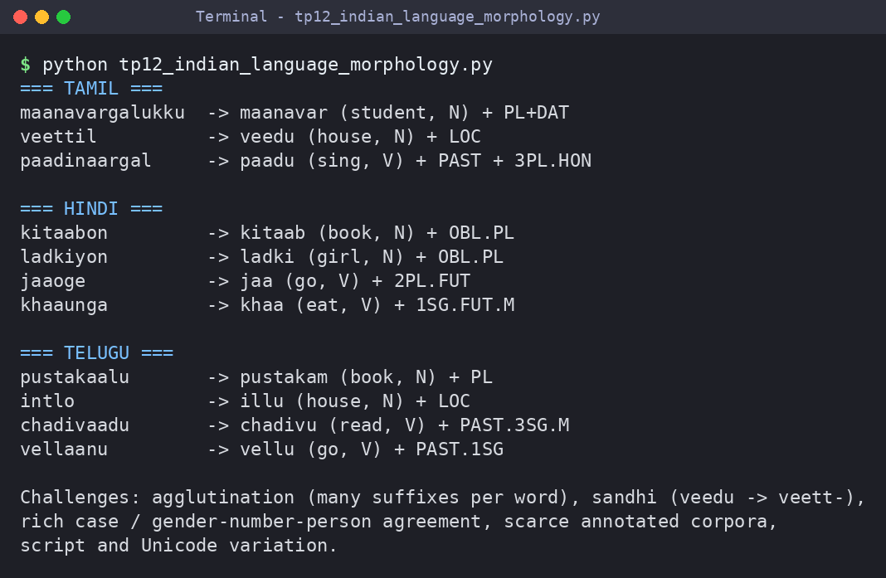

Team 13 | TP-13: Porter Stemmer: Design, Working Mechanism, and Applications
Question
Analyze the Porter Stemming algorithm, its rule-based approach, implementation steps, and role in information retrieval systems.
Answer Python program: tp13_porter_stemmer.py
"""TP-13 - Porter Stemmer: rule-based working (Steps 1a-1c implemented by hand) vs full NLTK Porter."""
from nltk.stem import PorterStemmer

VOWELS = "aeiou"

def is_cons(w, i):
c = w[i]
if c in VOWELS: return False
if c == "y": return i == 0 or not is_cons(w, i - 1) # 'y' is a vowel after a consonant
return True

def measure(stem):
"""m in [C](VC)^m[V] = number of vowel->consonant transitions."""
form = "".join("C" if is_cons(stem, i) else "V" for i in range(len(stem)))
return form.count("VC")

def has_vowel(stem): return any(not is_cons(stem, i) for i in range(len(stem)))
def double_cons(w): return len(w) > 1 and w[-1] == w[-2] and is_cons(w, len(w) - 1)
def cvc(w):
"""consonant-vowel-consonant ending, last consonant not w, x or y"""
n = len(w)
return (n >= 3 and is_cons(w, n - 1) and not is_cons(w, n - 2)
and is_cons(w, n - 3) and w[-1] not in "wxy")

def step1a(w):
for suf, rep in (("sses", "ss"), ("ies", "i"), ("ss", "ss"), ("s", "")):
if w.endswith(suf): return w[:-len(suf)] + rep
return w

def step1b(w):
if w.endswith("eed"):
return w[:-1] if measure(w[:-3]) > 0 else w
for suf in ("ed", "ing"):
if w.endswith(suf) and has_vowel(w[:-len(suf)]):
w = w[:-len(suf)]
if w.endswith(("at", "bl", "iz")): return w + "e"
if double_cons(w) and w[-1] not in "lsz": return w[:-1]
if measure(w) == 1 and cvc(w): return w + "e"
return w
return w

def step1c(w):
return w[:-1] + "i" if w.endswith("y") and has_vowel(w[:-1]) else w

ps = PorterStemmer()
print(f"{'Word':<12}{'Step 1a':<11}{'Step 1b':<11}{'Step 1c':<11}{'Full Porter (NLTK)'}")
print("-" * 62)
for word in ["caresses", "ponies", "cats", "feed", "agreed", "plastered", "motoring",
"conflated", "hopping", "falling", "happy", "sky", "relational"]:
a = step1a(word); b = step1b(a); c = step1c(b)
print(f"{word:<12}{a:<11}{b:<11}{c:<11}{ps.stem(word)}")
print("\nm(tr)=%d m(trouble)=%d m(oaten)=%d (measure of a stem = number of VC pairs)" % (
measure("tr"), measure("trouble"), measure("oaten")))
Output Screenshot
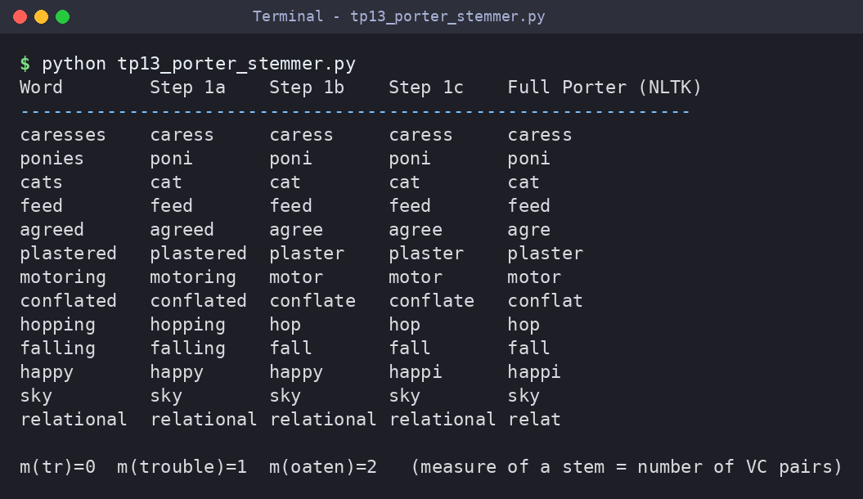

Team 14 | TP-14: Stemming vs Morphological Parsing: A Comparative Study
Question
Compare stemming and morphological parsing techniques based on accuracy, computational complexity, and application scenarios.
Answer Python program: tp14_stemming_vs_morph_parsing.py
"""TP-14 - Stemming vs Morphological Parsing: a comparative study."""
from nltk.stem import PorterStemmer

VOCAB = {"study", "good", "run", "child", "be", "happy", "organize", "care", "mouse", "better",
"go", "wolf", "leaf", "swim", "walk", "teach"}
IRREGULAR = {"better": ("good", "ADJ+COMP"), "was": ("be", "V+PAST"), "children": ("child", "N+PL"),
"went": ("go", "V+PAST"), "mice": ("mouse", "N+PL"), "swam": ("swim", "V+PAST")}
RULES = [("ies", "y", "N+PL/V+3SG"), ("ves", "f", "N+PL"), ("ing", "", "V+PRESPART"),
("ness", "", "+NESS (N)"),
("ation", "e", "+ATION (N)"), ("ed", "", "V+PAST"), ("s", "", "N+PL/V+3SG")]

def morph_parse(word):
"""Dictionary + rules: returns a *valid lemma* and its morphological features."""
if word in IRREGULAR: return IRREGULAR[word]
if word in VOCAB: return word, "BASE"
for suf, rep, feat in RULES:
if word.endswith(suf):
stem = word[:-len(suf)]
for cand in (stem + rep, stem, stem + "e", stem[:-1], stem[:-1] + "y", stem + "ize"):
if cand in VOCAB: return cand, feat
return word, "UNKNOWN"

ps = PorterStemmer()
words = ["studies", "better", "running", "children", "was",
"happiness", "organization", "caring", "wolves"]
print(f"{'Word':<14}{'Porter stem':<13}{'Valid?':<8}{'Morph. lemma':<14}{'Valid?':<8}Features")
print("-" * 76)
sv = mv = 0
for w in words:
stem = ps.stem(w); lemma, feat = morph_parse(w)
s_ok, m_ok = stem in VOCAB, lemma in VOCAB
sv += s_ok; mv += m_ok
print(f"{w:<14}{stem:<13}{'yes' if s_ok else 'no':<8}{lemma:<14}{'yes' if m_ok else 'no':<8}{feat}")
print("-" * 76)
print(f"Valid dictionary words -> Porter stemmer: {sv}/{len(words)} "
f"Morphological parser: {mv}/{len(words)}")
print("\nStemming : fast, no lexicon; output may be a non-word (studi, happi).")
print("Morph. parsing : needs lexicon + rules, slower, but gives lemma + features.")
Output Screenshot
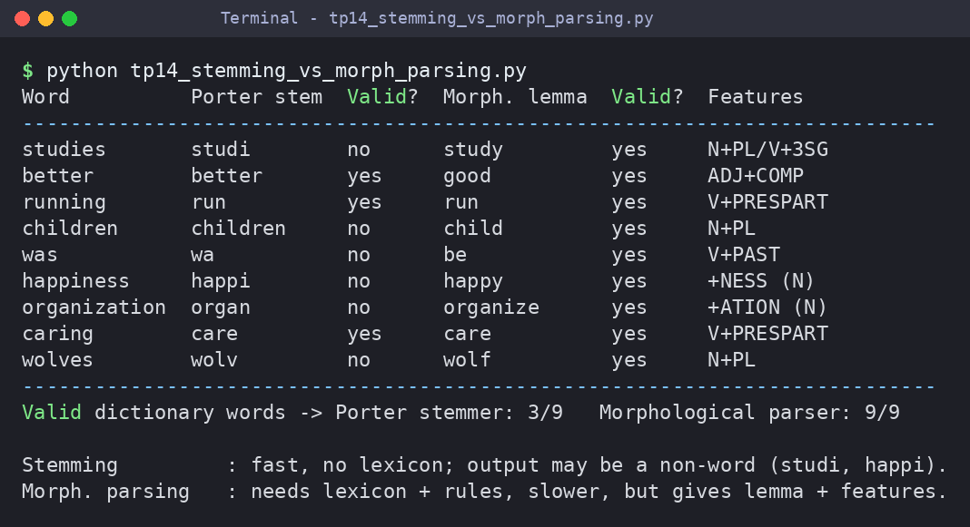

Team 15 | TP-15: Integrated NLP Pipeline: From Regular Expressions to Morphological Processing
Question
Demonstrate a complete NLP preprocessing pipeline incorporating regular expressions, finite state automata, stemming, and morphological analysis for text processing.
Answer Python program: tp15_integrated_nlp_pipeline.py
"""TP-15 - Integrated NLP Pipeline: Regex -> FSA tokenizer -> Stop-words -> Stemming -> Morphology."""
import re
import textwrap
from nltk.stem import PorterStemmer

RAW = ("Dr. Rao's students were studying NLP techniques! Mail rao@simats.edu or call 9876543210 "
"before 12/09/2026. See https://simats.edu/nlp #NLP")

# ---- Stage 1: regular expressions (normalise noisy text) ----
def regex_clean(text):
text = re.sub(r"https?://\S+", " <URL> ", text)
text = re.sub(r"\b[\w.]+@[\w.]+\.[a-z]{2,}\b", " <EMAIL> ", text)
text = re.sub(r"(?<!\d)[6-9]\d{9}(?!\d)", " <PHONE> ", text)
text = re.sub(r"\b\d{2}/\d{2}/\d{4}\b", " <DATE> ", text)
text = re.sub(r"#\w+", " ", text)
return re.sub(r"\s+", " ", text.lower()).strip()

# ---- Stage 2: finite-state tokenizer (states: START, WORD, TAG) ----
def fsa_tokenize(text):
tokens, buf, state = [], "", "START"
for ch in text + " ":
if state == "START":
if ch.isalpha(): state, buf = "WORD", ch
elif ch == "<": state, buf = "TAG", ch
elif state == "WORD":
if ch.isalpha(): buf += ch
elif ch == "'": tokens.append(buf); state, buf = "START", "" # drop clitic 's
else: tokens.append(buf); state, buf = "START", ""
elif state == "TAG":
buf += ch
if ch == ">": tokens.append(buf); state, buf = "START", ""
return tokens

STOP = {"were", "or", "before", "see", "mail", "call", "s", "dr"}
IRREG = {"were": "be"}
VOCAB = {"rao", "student", "study", "nlp", "technique"}

def lemma(w):
if w in VOCAB: return w
for suf, rep in (("ies", "y"), ("ing", ""), ("s", "")):
if w.endswith(suf) and (w[:-len(suf)] + rep) in VOCAB: return w[:-len(suf)] + rep
return w

ps = PorterStemmer()
clean = regex_clean(RAW)
tokens = fsa_tokenize(clean)
filtered = [t for t in tokens if t not in STOP]
stems = [ps.stem(t) if not t.startswith("<") else t for t in filtered]
lemmas = [lemma(t) if not t.startswith("<") else t for t in filtered]

def show(label, value, width=84):
print(textwrap.fill(str(value), width=width, initial_indent=f"{label:<24}",
subsequent_indent=" " * 24))

show("Raw text:", RAW)
print()
show("1) Regex cleaning:", clean)
show("2) FSA tokens:", tokens)
show("3) Stop-word removal:", filtered)
show("4) Porter stems:", stems)
show("5) Morph. lemmas:", lemmas)
print(f"\nTokens: {len(tokens)} -> {len(filtered)} after filtering; "
f"vocabulary: {len(set(lemmas))} unique lemmas")
Output Screenshot
