SIMATS ENGINEERING (SAVEETHA SCHOOL OF ENGINEERING)
Department of Artificial Intelligence and Data Science
ASSESSMENT TOOL 3 – CODING CHALLENGE
Solutions with Python Programs and Output Screenshots
Course Code: | DSA03 | Course Title: | Natural Language Processing
CO Assessed: | CO1 – Imitation (L1) | Weightage: | 30% of CIA
Student Name: | Aryan.KS | Reg. No.: | 192325051
Section / Batch: |  | Date:

Question 1 | Section 1: Intelligent Email and Password Validator using Regular Expressions
Question
Problem Statement: A software company is developing a user registration system. Before creating an account, the system must validate user credentials based on predefined security policies.
Develop a Python application that validates Email Address, Password and Mobile Number using Regular Expressions.
Validation Rules
Email:
- Must start with an alphabet.
- May contain letters, digits, '.', '_' before '@'.
- Domain should contain only alphabets.
- Valid extensions: .com, .org, .edu, .net, .in
Password:
- Minimum 8 characters
- At least one uppercase letter
- At least one lowercase letter
- At least one digit
- At least one special character (@, #, $, %, &, !)
Mobile Number:
- Must contain exactly 10 digits.
- First digit should be between 6–9.
Expected Output: Valid Email / Invalid Email; Strong Password / Weak Password; Valid Mobile Number / Invalid Mobile Number
Answer Python program: q1_email_password_validator.py
"""Q1 - Intelligent Email, Password and Mobile Number Validator using Regular Expressions."""
import re

# Email: starts with a letter; letters/digits/'.'/'_' before '@';
# domain only alphabets; extension in {com, org, edu, net, in}
EMAIL_RE = re.compile(r"^[A-Za-z][A-Za-z0-9._]*@[A-Za-z]+\.(?:com|org|edu|net|in)$")

# Password: look-aheads enforce each rule independently; {8,} enforces minimum length
PASSWORD_RE = re.compile(r"^(?=.*[A-Z])(?=.*[a-z])(?=.*\d)(?=.*[@#$%&!]).{8,}$")

# Mobile: exactly 10 digits, first digit between 6 and 9
MOBILE_RE = re.compile(r"^[6-9]\d{9}$")

def validate_email(email):
return "Valid Email" if EMAIL_RE.fullmatch(email) else "Invalid Email"

def validate_password(pwd):
return "Strong Password" if PASSWORD_RE.fullmatch(pwd) else "Weak Password"

def validate_mobile(mobile):
return "Valid Mobile Number" if MOBILE_RE.fullmatch(mobile) else "Invalid Mobile Number"

def password_feedback(pwd):
"""List the policy rules that a weak password fails (helpful error handling)."""
checks = [(r".{8,}", "min 8 characters"), (r"[A-Z]", "uppercase letter"),
(r"[a-z]", "lowercase letter"), (r"\d", "digit"), (r"[@#$%&!]", "special char")]
return [msg for rx, msg in checks if not re.search(rx, pwd)]

def main():
print("====== USER REGISTRATION CREDENTIAL VALIDATOR ======")
count = 0
while True:
count += 1
print(f"\n--- User {count} ---")
email = input("Enter Email : ").strip()
password = input("Enter Password : ").strip()
mobile = input("Enter Mobile Number : ").strip()
print("\nResult:")
print(" Email ->", validate_email(email))
pw = validate_password(password)
print(" Password ->", pw)
if pw == "Weak Password":
print(" missing:", ", ".join(password_feedback(password)))
print(" Mobile ->", validate_mobile(mobile))
if input("\nValidate another user? (y/n): ").strip().lower() != "y":
break
print("\nValidation session ended.")

if __name__ == "__main__":
main()
Output Screenshot
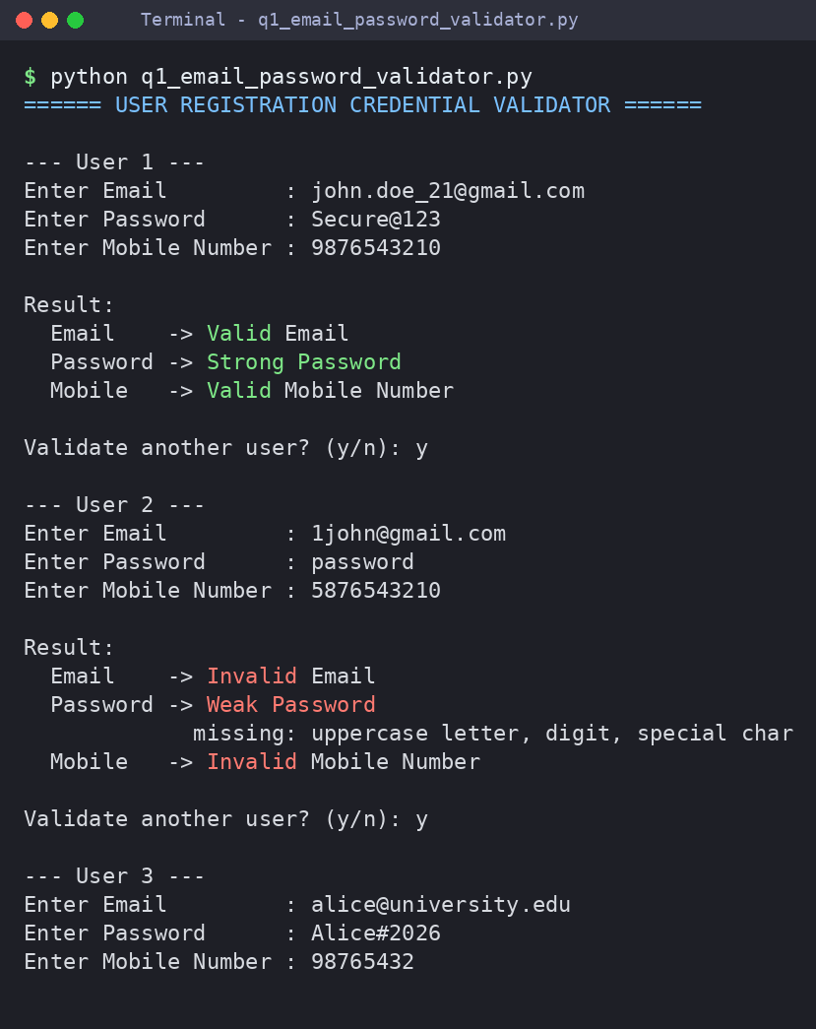
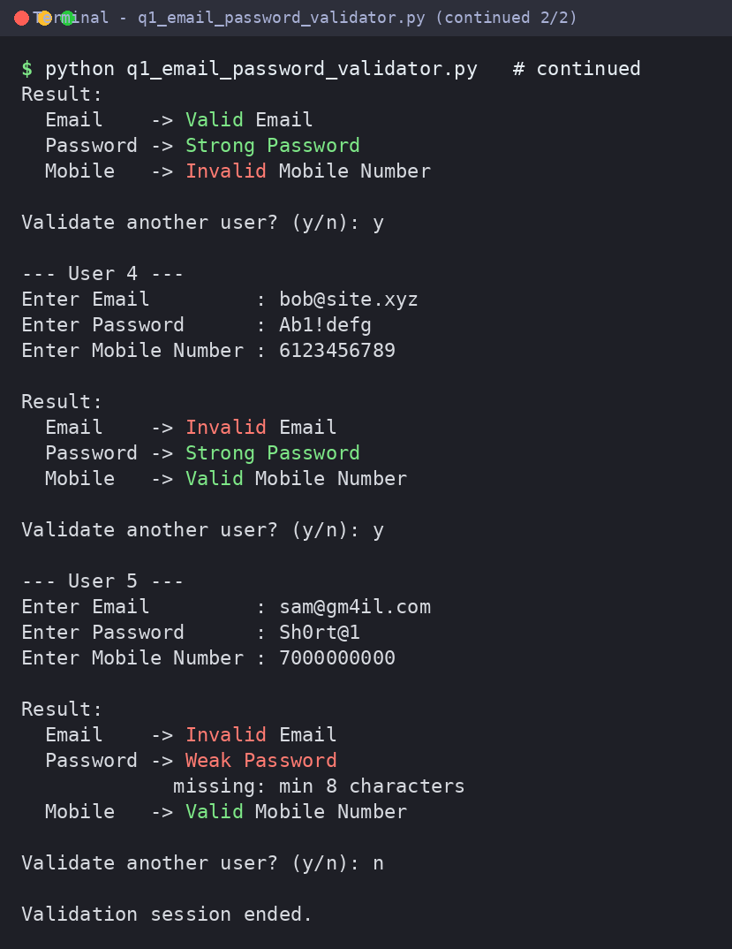
Justification of the output
The e-mail regex enforces a leading letter, the allowed characters before “@”, an alphabetic-only domain and one of the five extensions. The password regex uses four look-aheads (upper-case, lower-case, digit, special character) plus .{8,} for length, so every rule is checked independently. The mobile regex needs exactly 10 digits starting with 6–9. User 1 passes everything; user 2 fails all three checks; users 3–5 show partial failures (8-digit mobile, “.xyz” extension, short password and a digit in the domain).

Question 2 | Section 2: Design a Finite State Automata (FSA) Simulator
Question
Problem Statement: Develop a Python-based Deterministic Finite Automata (DFA) simulator.
The program should:
- Accept the DFA description: states, input alphabet, transition table, initial state, final state(s).
- Accept multiple input strings.
- Simulate state transitions.
- Display whether the string is Accepted or Rejected.
Example – Language: strings ending with “ab”. Input: abaab Output: Transition Path and Accepted
Answer Python program: q2_dfa_simulator.py
"""Q2 - Deterministic Finite Automata (DFA) Simulator."""

def read_dfa():
"""Accept the complete DFA description from the user."""
states = input("Enter states (space separated) : ").split()
alphabet = input("Enter input alphabet (space separated): ").split()
initial = input("Enter initial state : ").strip()
finals = set(input("Enter final state(s) : ").split())
print("Enter transitions as: <state> <symbol> <next_state> (type 'done' to finish)")
delta = {}
while True:
line = input(" > ").strip()
if line.lower() == "done":
break
src, sym, dst = line.split()
delta[(src, sym)] = dst
return states, alphabet, initial, finals, delta

def print_table(states, alphabet, initial, finals, delta):
print("\nTransition Table (-> start, * final)")
print(" " + "State".ljust(8) + "".join(a.ljust(6) for a in alphabet))
for s in states:
mark = ("->" if s == initial else " ")[:2]
label = mark + ("*" if s in finals else " ") + s
print(" " + label.ljust(8) + "".join(delta.get((s, a), "-").ljust(6) for a in alphabet))

def simulate(string, initial, finals, alphabet, delta):
"""Run the DFA on a string; return (accepted, path, reason)."""
state, path = initial, [initial]
for ch in string:
if ch not in alphabet:
return False, path, f"symbol '{ch}' not in alphabet"
if (state, ch) not in delta:
return False, path, f"no transition from {state} on '{ch}'"
state = delta[(state, ch)]
path.append(state)
return state in finals, path, f"ended in {state}"

def main():
print("========== DFA SIMULATOR ==========")
states, alphabet, initial, finals, delta = read_dfa()
print_table(states, alphabet, initial, finals, delta)
print("\nEnter input strings to test (type 'exit' to stop; empty line = empty string)")
while True:
s = input("\nInput String: ")
if s.strip().lower() == "exit":
break
accepted, path, reason = simulate(s.strip(), initial, finals, alphabet, delta)
print("Transition Path:", " → ".join(path))
print("Result :", "Accepted" if accepted else "Rejected", f"({reason})")
print("\nSimulation finished.")

if __name__ == "__main__":
main()
Output Screenshot
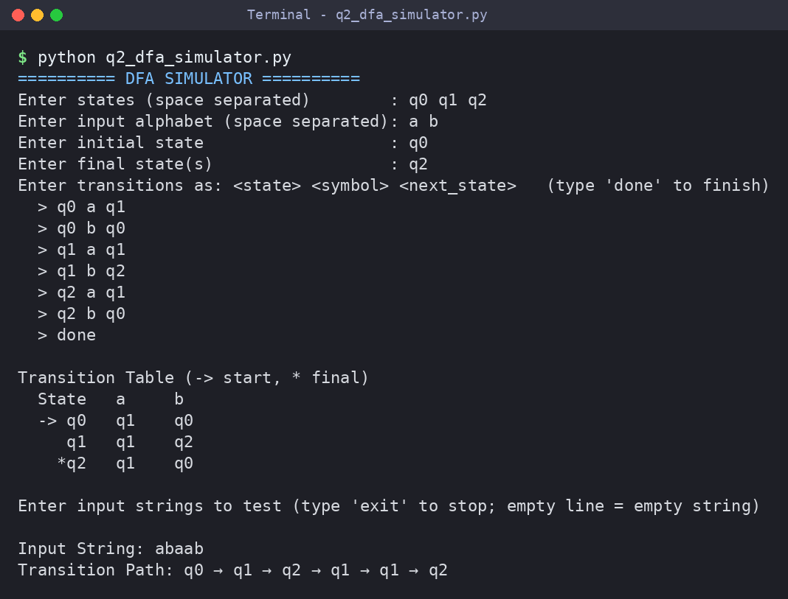
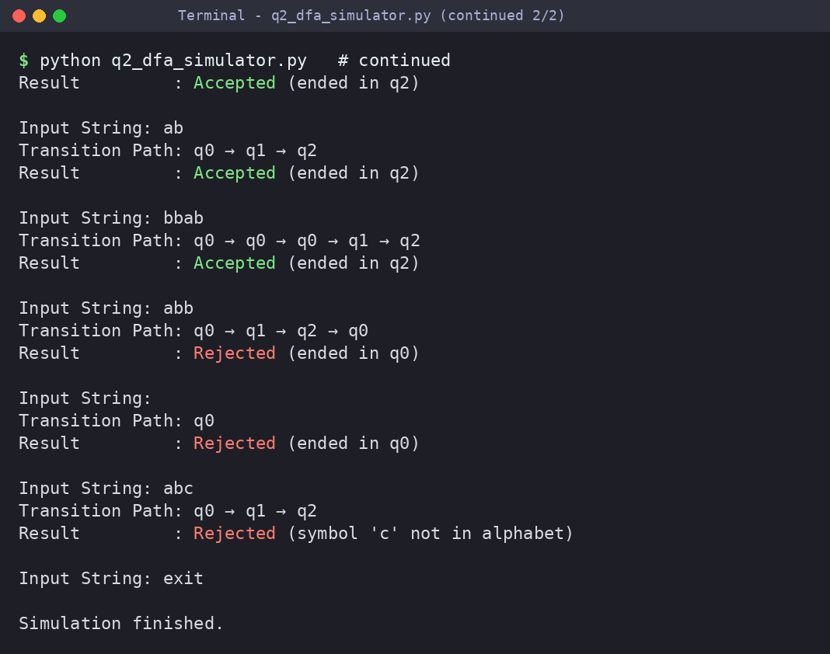
Justification of the output
The DFA is read from the user and stored as a dictionary δ[(state, symbol)] → next state. The simulator follows one transition per input symbol, records the path and accepts when the last state is a final state. For “strings ending with ab” (q0 –a→ q1 –b→ q2) the input abaab follows q0 → q1 → q2 → q1 → q1 → q2 and is Accepted. “abb” (ends in q0), the empty string and “abc” (symbol not in the alphabet) are Rejected.

Question 3 | Section 3: Smart Pattern Matching Engine using Regular Expressions
Question
Problem Statement: Develop a Python-based text search engine that performs pattern matching using Regular Expressions.
The system should support: Word Search, Prefix Search, Suffix Search, Date Search, Phone Number Search, Hashtag Search and Mention (@username) Search.
Example Input: Meeting on 12/09/2026 | Call 9876543210 | #NLP | @OpenAI | natural language processing
User Menu: 1. Search Date 2. Search Phone Number 3. Search Hashtag 4. Search Mention 5. Search Prefix 6. Search Suffix
Expected Output: Display all matching patterns based on user selection.
Answer Python program: q3_pattern_matching_engine.py
"""Q3 - Smart Pattern Matching Engine using Regular Expressions."""
import re

TEXT = """Meeting on 12/09/2026
Call 9876543210
#NLP
@OpenAI
natural language processing
Deadline: 25-12-2026, helpline +91-9123456780 #AI @simats_edu"""

# Compiled patterns for the fixed search types
DATE_RE = re.compile(r"\b(?:0[1-9]|[12]\d|3[01])([/.-])(?:0[1-9]|1[0-2])\1\d{4}\b")
PHONE_RE = re.compile(r"(?<!\d)(?:\+91[-\s]?)?[6-9]\d{9}(?!\d)")
HASHTAG_RE = re.compile(r"#\w+")
MENTION_RE = re.compile(r"(?<![\w.])@\w+")

def find_all(regex, text):
return [(m.start(), m.group()) for m in regex.finditer(text)]

def word_pattern(word): return re.compile(rf"\b{re.escape(word)}\b", re.IGNORECASE)
def prefix_pattern(pre): return re.compile(rf"\b{re.escape(pre)}\w*", re.IGNORECASE)
def suffix_pattern(suf): return re.compile(rf"\w*{re.escape(suf)}\b", re.IGNORECASE)

def show(title, matches):
print(f"\n[{title}] {len(matches)} match(es) found")
for pos, text in matches:
print(f" position {pos:<4} -> {text}")

def main():
print("Input Text:")
for line in TEXT.splitlines():
print(" |", line)
print("""
=========== USER MENU ===========
1. Search Date 5. Search Prefix
2. Search Phone Number 6. Search Suffix
3. Search Hashtag 7. Search Word
4. Search Mention 0. Exit""")
while True:
choice = input("\nEnter your choice: ").strip()
if choice == "1": show("Date", find_all(DATE_RE, TEXT))
elif choice == "2": show("Phone Number", find_all(PHONE_RE, TEXT))
elif choice == "3": show("Hashtag", find_all(HASHTAG_RE, TEXT))
elif choice == "4": show("Mention", find_all(MENTION_RE, TEXT))
elif choice == "5":
pre = input("Enter prefix: ").strip()
show(f"Prefix '{pre}'", find_all(prefix_pattern(pre), TEXT))
elif choice == "6":
suf = input("Enter suffix: ").strip()
show(f"Suffix '{suf}'", find_all(suffix_pattern(suf), TEXT))
elif choice == "7":
w = input("Enter word : ").strip()
show(f"Word '{w}'", find_all(word_pattern(w), TEXT))
elif choice == "0":
print("Exiting search engine. Goodbye!")
break
else:
print("Invalid choice! Please select 0-7.")

if __name__ == "__main__":
main()
Output Screenshot
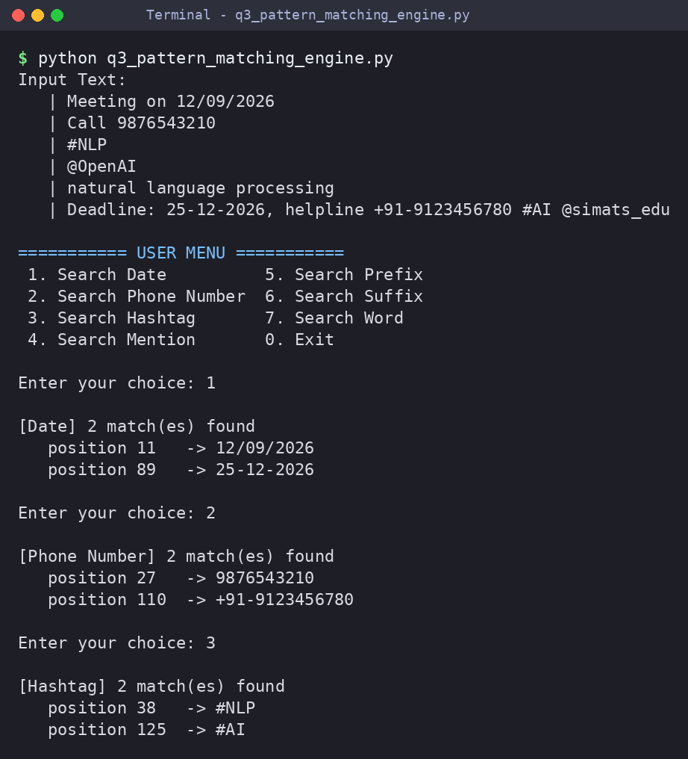
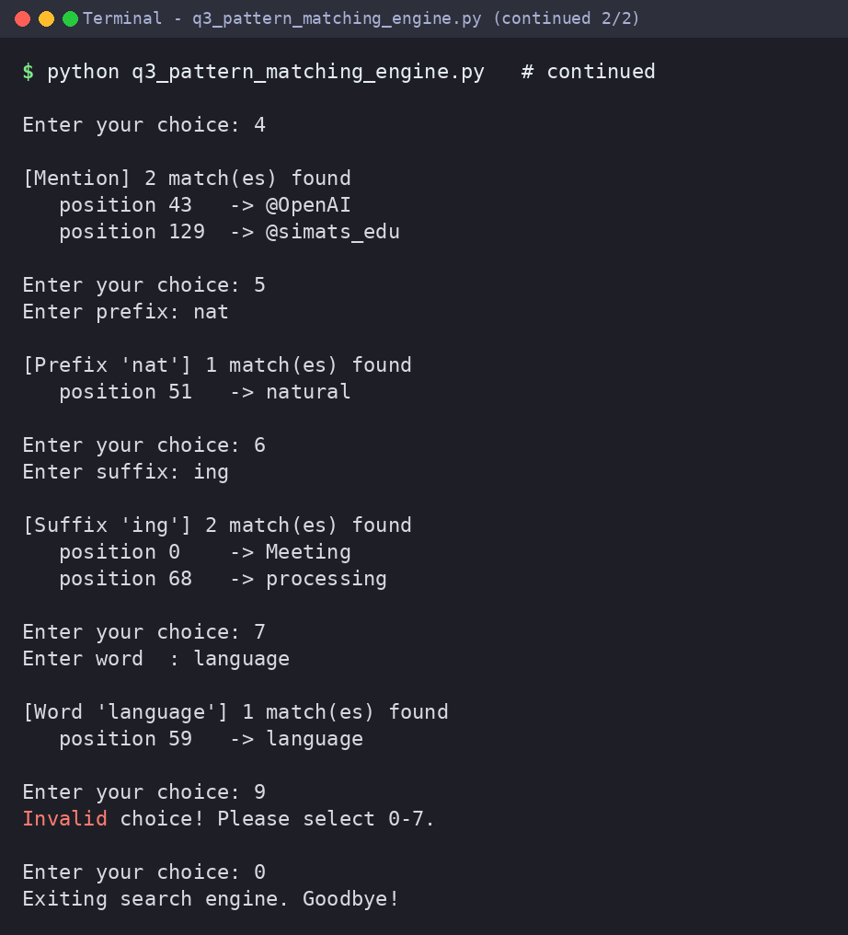
Justification of the output
A menu-driven loop applies the chosen pattern with finditer and prints every match with its position. The date pattern uses a back-reference so the separator stays consistent (12/09/2026, 25-12-2026); phone, hashtag and mention patterns use look-arounds and \w+. Prefix “nat” returns “natural”; suffix “ing” returns “Meeting” and “processing”. An invalid menu choice prints an error message instead of crashing.

