MOTILAL NEHRU NATIONAL INSTITUTE OF TECHNOLOGY ALLAHABAD
Prayagraj, Uttar Pradesh – 211004
Department of Electronics and Communication Engineering

A Project Report on
MEMS GYROSCOPES
Submitted to
Dr. Nirmal Roy
Submitted by
Anshul Yadav (20244028)
Aryan Gupta (20244042)
Ishwar Kumawat (20244082)
Sarthak Modi (20244145)
Ujjwal Pratap Singh (20244166)
INDEX
S. No. | Contents | Page No.
1. | Introduction | 1
2. | Fabrication of a MEMS Gyroscope | 1
3. | Working Principle | 3
4. | Capacitive Sensing and Signal Readout | 4
5. | Gyroscope Architectures | 4
6. | Comparison with Other Gyroscopes | 5
7. | Applications | 5
8. | Performance Limitations | 5
9. | Sensor Fusion and Future Trends | 6
10. | Conclusion | 6
 | References | 7

LIST OF FIGURES AND TABLES
Fig. No. | Title | Page No.
1 | Silicon die of the InvenSense MPU-6050 motion sensor | 1
2 | Surface-micromachining process flow (steps 1–4) | 2
3 | Drive, rotation and Coriolis (sense) motion of the proof mass | 3
4 | Fabricated tuning-fork MEMS gyroscope (SEM) | 4
Table 1 | Comparison of gyroscope technologies | 5

ABSTRACT
A gyroscope measures how fast an object rotates. Classical gyroscopes used heavy spinning wheels mounted on gimbals; today the same function is performed by a Micro-Electro-Mechanical Systems (MEMS) gyroscope, a vibrating structure of silicon only a few millimetres across that is built with the same tools used to make integrated circuits. This report explains how such a device is made and how it works. It first describes the surface-micromachining process used to fabricate a MEMS gyroscope: deposition of sacrificial and structural layers, photolithography, deep reactive-ion etching, release of the moving mass, vacuum capping and packaging.
The report then explains the operating principle, in which a proof mass is kept vibrating at resonance and the Coriolis force produced by rotation moves it in a perpendicular direction by an amount proportional to the rotation rate. Detection of this motion by differential capacitive sensing and the associated readout electronics is discussed, followed by the tuning-fork and ring-resonator architectures that improve shock rejection and sensitivity. MEMS gyroscopes are compared with mechanical, ring-laser, fibre-optic and hemispherical resonator gyroscopes, and their applications in consumer electronics, automotive safety, drones and space exploration are reviewed. Finally, the main performance limitations, namely angle random walk and bias instability, are described, together with sensor fusion and the trends that are pushing MEMS gyroscopes towards navigation-grade performance.

ACKNOWLEDGEMENT
We express our sincere gratitude to Dr. Nirmal Roy for giving us the opportunity to work on this project, and for the guidance, encouragement and valuable suggestions we received throughout its preparation.
We are also thankful to the Department of Electronics and Communication Engineering, Motilal Nehru National Institute of Technology Allahabad, for providing the resources and the academic environment that made this work possible.
Finally, we thank our classmates and our families for their constant support and encouragement, and we acknowledge the authors and photographers whose published work and openly licensed images are cited in this report.

1. INTRODUCTION

1.1 Micro-Electro-Mechanical Systems
Micro-Electro-Mechanical Systems (MEMS) are devices in which moving mechanical structures and electronic circuits are built together on a single silicon chip. They are made with the same processes used for integrated circuits, namely thin-film deposition, photolithography and etching, and their features are typically 1–100 µm in size. The accelerometer, gyroscope, microphone and pressure sensor in a modern smartphone are all MEMS devices [1], [3].

1.2 Measuring Motion
Two sensors are needed to describe the motion of a body. An accelerometer measures linear acceleration, including gravity, in m/s² or g, by sensing the force on a proof mass (F = ma). A gyroscope measures angular rate, i.e. how fast the body turns, in degrees per second (°/s). A phone lying still on a table therefore reads 1 g on its accelerometer and 0 °/s on its gyroscope. The two have complementary weaknesses: the accelerometer is noisy while the device moves, and the gyroscope drifts slowly over time.

1.3 The MEMS Advantage
The guidance system of the Apollo missions in the 1960s used spinning-wheel gyroscopes mounted on gimbals, assembled by hand. Today a complete six-axis inertial measurement unit (IMU), such as the Bosch BMI270, measures 2.5 mm × 3 mm × 0.8 mm and draws about 0.7 mA with its accelerometer and gyroscope running at full rate [10]. Because thousands of chips are made on one wafer at the same time, MEMS gyroscopes are cheap enough to be fitted in the roughly 1.2 billion smartphones shipped every year. Fig. 1 shows the silicon die of such a sensor.
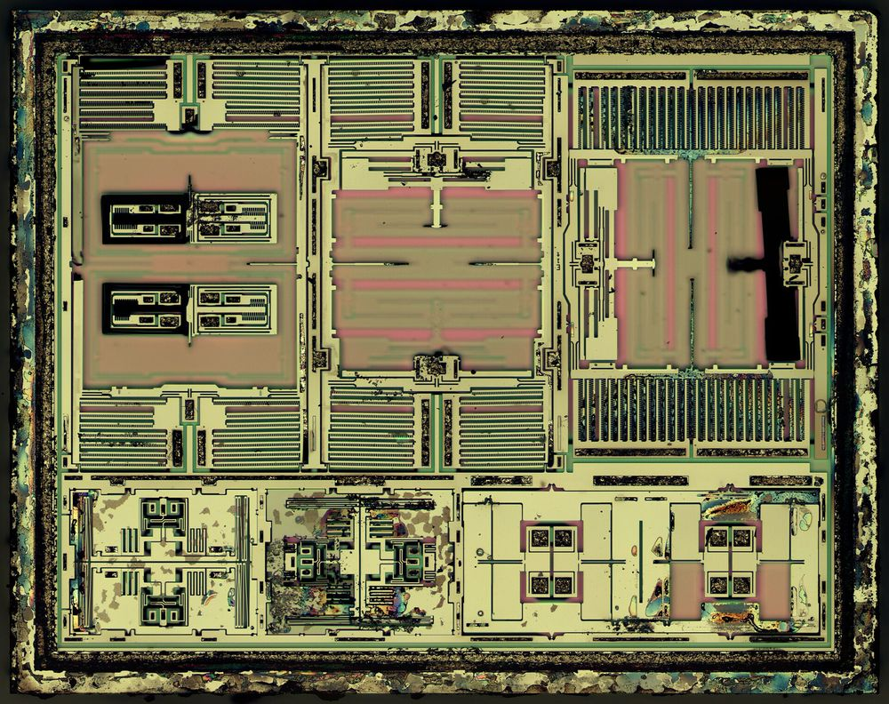
Fig. 1: Silicon die of the InvenSense MPU-6050 motion sensor under a microscope.
Source: ZeptoBars, Wikimedia Commons, licensed under CC BY 3.0.

1.4 Objective and Scope of the Report
The objective of this report is to explain how a MEMS gyroscope is fabricated, how it converts rotation into an electrical signal, how it compares with other gyroscopes, where it is used, and what limits its performance.

2. FABRICATION OF A MEMS GYROSCOPE
A MEMS gyroscope is made by surface micromachining: thin films are deposited on a silicon wafer, patterned and etched, and a temporary layer underneath is then dissolved so that the structure becomes free to move. Every step treats the whole wafer at once, so thousands of identical gyroscopes are produced together (batch fabrication) [1], [3]. The process can be divided into six steps; the first four are illustrated in Fig. 2.
(1) Deposition. A sacrificial layer of silicon dioxide (SiO₂) about 2 µm thick is formed on the wafer; its thickness later becomes the gap under the moving mass. Holes are opened in it where the structure will be anchored, and structural polysilicon is then deposited by chemical vapour deposition (CVD), filling the anchor holes.
(2) Patterning. Photoresist is spun onto the wafer and exposed to ultraviolet light through a chrome-on-glass mask. The developer removes the exposed resist, leaving the exact shape of the proof mass, springs, anchors and comb fingers on every die.
(3) Etching. Deep reactive-ion etching (DRIE) by the Bosch process alternates short SF₆ plasma etch steps with C₄F₈ passivation steps that coat the side walls. The trenches therefore go straight down, with a depth more than 20 times their width, and the etch stops at the oxide.
(4) Release. Hydrofluoric acid (HF) dissolves the oxide through the trenches and through small release holes in the mass, but oxide remains under the wide anchors. The mass is now suspended about 2 µm above the substrate on its springs. Liquid left in the gap can pull the mass down permanently (stiction), which is avoided by vapour-phase HF release or supercritical CO₂ drying.
(5) Vacuum capping. A cap wafer is bonded on in a vacuum chamber, sealing each gyroscope in its own cavity, and a getter absorbs any remaining gas. Without air damping the mass vibrates with a high quality factor (Q), giving a larger and cleaner motion.
(6) Packaging. The wafer is diced, and each gyroscope die is packaged next to its readout chip (ASIC), connected by gold wire bonds. Every part is then tested and calibrated, for example for bias and sensitivity at different temperatures.
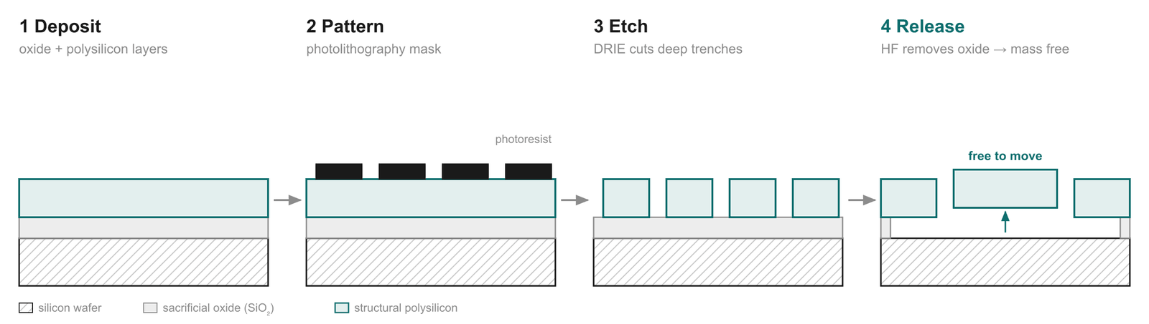
Fig. 2: Surface-micromachining process flow: deposition, patterning, etching and release (not to scale).
Design considerations. The process is chosen to suit the mechanical requirements of the gyroscope. A thicker structural layer gives a heavier proof mass and, since the Coriolis force is proportional to mass, a larger and less noisy signal. Many commercial devices therefore use structural layers 10 µm or more thick, made from epitaxially grown polysilicon or from the single-crystal device layer of a silicon-on-insulator (SOI) wafer, instead of the thin films of conventional surface micromachining. The high aspect ratio of DRIE is equally important: capacitance and electrostatic force both scale with the area of the facing side walls, so tall, closely spaced comb fingers give strong drive and sensitive detection in a small chip area.

3. WORKING PRINCIPLE

3.1 The Coriolis Effect
The structure produced above is a small mass suspended on springs. It senses rotation through the Coriolis effect. A mass m moving with velocity v inside a frame that rotates at angular rate Ω experiences an apparent sideways force, the Coriolis force [1], [2]:
F_{c} = −2m (Ω × v) (1)
This force is perpendicular to both the rotation axis and the velocity, and its magnitude is proportional to Ω, so measuring the force gives the rotation rate. In a typical MEMS gyroscope, with m ≈ 1 µg, v ≈ 1 m/s and Ω = 1 rad/s, the force is only about 2 nN and the resulting motion is less than a nanometre.

3.2 Drive and Sense Modes
The Coriolis force acts only on a moving mass. Instead of spinning a wheel on bearings, a MEMS gyroscope keeps a proof mass vibrating on silicon springs (Fig. 3). Electrostatic comb electrodes drive the mass along the x-axis (drive mode) at its resonant frequency, typically 10–30 kHz, while a control loop holds the amplitude constant. When the chip rotates about the z-axis, the Coriolis force pushes the mass along the y-axis (sense mode), at 90° to the drive. This sense motion oscillates at the drive frequency and its amplitude is proportional to Ω. Since nothing spins, there are no bearings to wear out, and such devices are typically rated to survive shocks of up to 10,000 g.
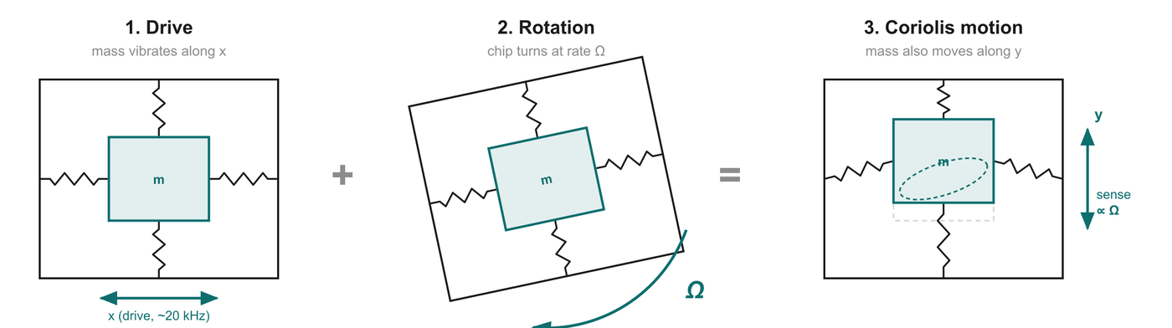
Fig. 3: Drive motion along x, rotation of the chip at rate Ω, and the resulting Coriolis (sense) motion along y.

3.3 Resonance and Mode Matching
The drive and sense motions are two vibration modes of the same mass–spring structure, each with its own resonant frequency f = (1/2π)√(k/m), where k is the spring stiffness. Driving at the resonant frequency of the drive mode multiplies the motion by the quality factor Q, so a few volts can produce a drive amplitude of several micrometres. The sense response is largest when the sense-mode frequency equals the drive frequency (mode matching), because the Coriolis motion is then also amplified by Q. However, a matched high-Q device has a narrow bandwidth, responds slowly, and its sensitivity changes strongly with temperature. Most commercial gyroscopes therefore separate the two frequencies by a small, controlled amount (the mode split), trading some sensitivity for bandwidth and stability. Small fabrication imperfections, such as slightly asymmetric springs, also couple part of the drive motion directly into the sense direction. This quadrature error can be much larger than the Coriolis signal, but it is 90° out of phase with it and can therefore be separated electronically or cancelled with trimming electrodes.

4. CAPACITIVE SENSING AND SIGNAL READOUT
The sense motion is detected capacitively. The moving mass forms one plate of a parallel-plate capacitor, C = ε₀A/d, so a change in the gap d changes the capacitance. In a differential arrangement the mass sits between two fixed electrodes; a displacement y narrows one gap and widens the other, giving
ΔC = C₁ − C₂ ≈ 2C₀ · y / d (2)
Taking the difference doubles the signal and cancels errors common to both capacitors, such as temperature drift and stray capacitance. The capacitance changes are as small as a few attofarads (10⁻¹⁸ F). A charge amplifier converts ΔC into a voltage; a demodulator that uses the drive signal as its reference converts the oscillating signal into a steady value proportional to Ω and rejects the out-of-phase quadrature error; finally a filter and an analog-to-digital converter produce the rotation rate in °/s.
The drive side has its own control electronics. Separate drive-pickoff combs measure the drive motion, and a phase-locked loop with automatic gain control keeps the mass oscillating exactly at resonance with a constant amplitude. This is essential because the Coriolis force is proportional to the drive velocity, so any change in drive amplitude would appear directly as a change in sensitivity. In modern devices all of these functions, together with temperature compensation and a digital interface such as I²C or SPI, are integrated in the ASIC packaged next to the MEMS die.

5. GYROSCOPE ARCHITECTURES

5.1 Tuning-Fork Gyroscope
A single vibrating mass cannot distinguish rotation from a mechanical shock, because both push it sideways. A tuning-fork gyroscope uses two identical masses driven in opposite directions. Rotation produces Coriolis forces in opposite directions on the two masses, so the difference of their outputs is doubled, whereas a shock or vibration moves both masses the same way and cancels in the difference [2]. A fabricated device is shown in Fig. 4.

5.2 Ring and Disk Resonators
Highly symmetric resonators such as rings and disks vibrate in an elliptical "wine-glass" mode. Rotation drags this vibration pattern around the ring, and electrodes read its new orientation, an effect first described by G. H. Bryan in 1890 [6]. Because of the symmetry, the drive and sense modes share the same frequency, which gives high sensitivity. Such devices are often operated in closed loop (force rebalance): feedback electrodes hold the sense motion at zero, and the force required is the output, improving range and linearity.
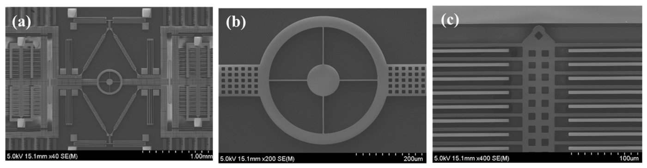
Fig. 4: SEM images of a tuning-fork MEMS gyroscope: (a) full device, (b) coupling ring, (c) comb fingers.
Source: M. N. Nguyen et al., via Wikimedia Commons, licensed under CC BY 4.0.

6. COMPARISON WITH OTHER GYROSCOPES
Table 1 compares MEMS gyroscopes with other gyroscope technologies. Bias stability, the slow wander of the output when there is no rotation, is the usual figure of merit; a lower value is better. MEMS gyroscopes are hundreds to thousands of times less stable than navigation-grade optical gyroscopes, but they are millimetre-sized, consume milliwatts of power and cost very little [4].
Table 1: Comparison of gyroscope technologies
Type | Operating principle | Bias stability (°/h) | Typical use
Mechanical | Spinning wheel resists change in orientation | 0.001 – 1 | Early aircraft, ships
Ring laser (RLG) | Two laser beams in a closed loop; rotation shifts their frequency (Sagnac effect) | 0.0005 – 0.01 | Airliners
Fibre-optic (FOG) | Light sent both ways round a fibre coil; rotation shifts the phase | 0.0005 – 1 | Submarines, satellites
Hemispherical resonator (HRG) | Vibrating quartz "wine glass" | 0.0001 – 0.005 | Spacecraft
MEMS | Vibrating silicon mass, Coriolis force | 0.05 – 100 | Phones, cars, drones
Source: approximate ranges from published specifications [4].

7. APPLICATIONS
- Consumer electronics. In optical image stabilisation (OIS) the gyroscope senses hand shake and the lens is shifted the opposite way, giving a sharp photograph. Gyroscopes also provide screen rotation, gaming control, and head tracking for augmented and virtual reality.
- Automotive safety. Electronic Stability Control (ESC) compares the turn rate the driver intends, estimated from steering angle and speed, with the actual yaw rate measured by a MEMS gyroscope; if the car begins to skid, individual wheels are braked to correct it. ESC is mandatory in the USA and the EU, and a 2025 NHTSA evaluation found a 47.7% reduction in the risk of single-vehicle rollover crashes [8], [9].
- Aerospace and robotics. A drone flight controller reads its gyroscope thousands of times a second to stay level. Where GPS is unavailable, gyroscopes provide inertial navigation: NASA's Ingenuity helicopter flew on Mars using a phone-grade Bosch BMI160 IMU combined with a downward-looking camera [10].

8. PERFORMANCE LIMITATIONS
Because the angle is obtained by integrating the measured rate, small errors accumulate. Two error sources dominate. Angle random walk (ARW) is white noise on the rate signal; after integration the angle wanders randomly and its error grows in proportion to √t. It is specified in °/√h, typically about 0.3 °/√h for a consumer device. Bias instability is a small offset that wanders slowly with time, temperature, stress and ageing; its angle error grows in proportion to t. A consumer gyroscope with a bias of 10 °/h accumulates an error of about 10° in one hour, comparable to the Earth's own rotation of 15 °/h, which is why bias is the main limit for navigation.
Several further errors affect real devices. Scale-factor error is a deviation of the sensitivity from its nominal value, so that a given rotation produces a slightly too large or too small output. Vibration sensitivity arises when linear acceleration or vibration near the drive frequency leaks into the output, which is reduced by the tuning-fork design of Section 5. Temperature changes and ageing alter the spring stiffness, the gaps and the electronics, shifting both bias and sensitivity. These errors are reduced by calibrating every device over the full temperature range and storing correction coefficients in the ASIC.
To characterise the noise, the gyroscope is kept still at constant temperature for several hours and its output is recorded. The Allan deviation is computed by averaging the data over intervals of length τ and comparing consecutive averages. On a log–log plot of Allan deviation against τ, the region with slope −½ gives the ARW and the flat minimum gives the bias instability, so a single test characterises both; the method is specified in IEEE Std 952 [5].

9. SENSOR FUSION AND FUTURE TRENDS
The gyroscope is fast and smooth but drifts; the accelerometer knows which way is down from gravity but is noisy during motion; the magnetometer gives heading but is disturbed by nearby metal. Sensor fusion combines them so that each covers the others' weaknesses. A complementary filter, θ = α(θ + ωΔt) + (1 − α)θ_{acc} with α ≈ 0.98, trusts the gyroscope over short times and the accelerometer over long times. The first term integrates the gyroscope rate ω over the time step Δt to update the angle θ, which is smooth but drifts; the second pulls the estimate slightly towards the tilt angle θ_{acc} calculated from the accelerometer. Over many steps these small corrections remove the drift, while the accelerometer noise is diluted by the factor (1 − α). Kalman and Madgwick filters perform the same task optimally and can also estimate and remove the gyroscope bias [7]. Current research is pushing MEMS gyroscopes towards navigation-grade bias stability, using machine-learning models to predict and compensate drift, and developing chip-scale optical gyroscopes that bring Sagnac-effect sensing onto a photonic chip.

10. CONCLUSION
A MEMS gyroscope senses rotation by keeping a microscopic silicon mass vibrating and measuring the tiny perpendicular motion caused by the Coriolis force. Batch micromachining makes these sensors small, robust, low-power and inexpensive, which is why they are found in billions of phones, cars and drones. Differential capacitive sensing and careful drive control allow motions far smaller than a nanometre to be measured reliably. Their precision is still well below that of optical gyroscopes because of noise and bias drift, but calibration, sensor fusion and continuing advances in design and fabrication are steadily closing this gap.

REFERENCES
[1] V. Kempe, Inertial MEMS: Principles and Practice. Cambridge, U.K.: Cambridge University Press, 2011.
[2] C. Acar and A. Shkel, MEMS Vibratory Gyroscopes: Structural Approaches to Improve Robustness. New York: Springer, 2009.
[3] N. Yazdi, F. Ayazi and K. Najafi, "Micromachined inertial sensors," Proc. IEEE, vol. 86, no. 8, pp. 1640–1659, 1998.
[4] V. M. N. Passaro, A. Cuccovillo, L. Vaiani, M. De Carlo and C. E. Campanella, "Gyroscope technology and applications: a review in the industrial perspective," Sensors, vol. 17, no. 10, p. 2284, 2017.
[5] IEEE Standard Specification Format Guide and Test Procedure for Single-Axis Interferometric Fiber Optic Gyros, IEEE Std 952.
[6] G. H. Bryan, "On the beats in the vibrations of a revolving cylinder or bell," Proc. Cambridge Philosophical Society, vol. 7, pp. 101–111, 1890.
[7] S. O. H. Madgwick, "An efficient orientation filter for inertial and inertial/magnetic sensor arrays," Report, University of Bristol, 2010.
[8] J. N. Dang, "Statistical analysis of the effectiveness of electronic stability control (ESC) systems," NHTSA, Washington, DC, Rep. DOT HS 810 794, 2007.
[9] C. N. Webb, "Evaluation of Electronic Stability Control: FMVSS No. 126, an Update," NHTSA, Washington, DC, Rep. DOT HS 813 749, 2025.
[10] Bosch Sensortec, "BMI270 Inertial Measurement Unit," datasheet; and Bosch Sensortec, "CES 2022" (BMI160 on NASA's Ingenuity Mars helicopter).

