import pandas as pd import json

import pickle import h5py

import matplotlib.pyplot as plt from wordcloud import WordCloud from PIL import Image

1. CSV Format

print("\nReading CSV Format...") df_csv = pd.read_csv("iris.csv")

print("Properties (CSV):",df_csv.describe()) print(df_csv.head())

df_csv.iloc[:, :4].plot(kind="line", title="Line Graph (CSV)") plt.show()

Reading CSV Format...

Properties (CSV): sepal_length sepal_width petal_length petal_width

|  |  |  |  |  |
| --- | --- | --- | --- | --- |
| count | 150.000000 | 150.000000 | 150.000000 | 150.000000 |
| mean | 5.843333 | 3.054000 | 3.758667 | 1.198667 |
| std | 0.828066 | 0.433594 | 1.764420 | 0.763161 |
| min | 4.300000 | 2.000000 | 1.000000 | 0.100000 |
| 25% | 5.100000 | 2.800000 | 1.600000 | 0.300000 |
| 50% | 5.800000 | 3.000000 | 4.350000 | 1.300000 |
| 75% | 6.400000 | 3.300000 | 5.100000 | 1.800000 |
| max | 7.900000 | 4.400000 | 6.900000 | 2.500000 |
| sepal_length sepal_width petal_length petal_width species | | | | |
| 0 | 5.1 | 3.5 | 1.4 | 0.2 setosa |
| 1 | 4.9 | 3.0 | 1.4 | 0.2 setosa |
| 2 | 4.7 | 3.2 | 1.3 | 0.2 setosa |
| 3 | 4.6 | 3.1 | 1.5 | 0.2 setosa |
| 4 | 5.0 | 3.6 | 1.4 | 0.2 setosa |

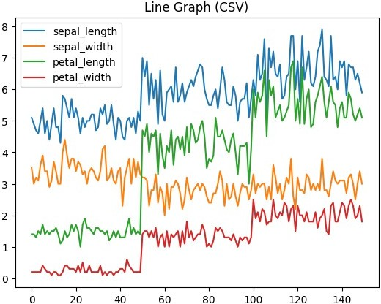

1. XLSX Format

print("\nReading Excel Format...") df_excel = pd.read_excel("Data1.xlsx")

print("Properties (Excel):",df_excel.describe()) print(df_excel.head())

df_excel.iloc[:, :4].plot(kind="hist", bins=15, alpha=0.7, figsize=(10, 6), title="Histogram of Features") plt.xlabel("Values")

plt.ylabel("Frequency") plt.show()

Reading Excel Format...

Properties (Excel): Id SepalLengthCm SepalWidthCm PetalLengthCm PetalWidthCm

count 150.000000 150.000000 150.000000 150.000000

150.000000

|  |  |  |  |  |  |
| --- | --- | --- | --- | --- | --- |
|  | mean | 75.500000 | 5.843333 | 3.054000 | 3.758667 |
| 1.198667 |  |  |  |  |
| std | 43.445368 | 0.828066 | 0.433594 | 1.764420 |
| 0.763161 |  |  |  |  |
| min | 1.000000 | 4.300000 | 2.000000 | 1.000000 |
|  | 0.100000 |  |  |  |  |

|  |  |  |  |  |  |
| --- | --- | --- | --- | --- | --- |
|  |  |  |  |  |  |
| 25% | 38.250000 | 5.100000 | 2.800000 | 1.600000 |
| 0.300000 |  |  |  |  |
| 50% | 75.500000 | 5.800000 | 3.000000 | 4.350000 |
|  | 1.300000  75% 112.750000 6.400000 3.300000 5.100000  1.800000  max 150.000000 7.900000 4.400000 6.900000 | | | | |

2.500000

Id SepalLengthCm SepalWidthCm PetalLengthCm PetalWidthCm Species

|  |  |  |  |  |  |
| --- | --- | --- | --- | --- | --- |
| 0 1 | 5.1 | 3.5 | 1.4 | 0.2 | Iris- |
| setosa |  |  |  |  |  |
| 1 2 | 4.9 | 3.0 | 1.4 | 0.2 | Iris- |
| setosa |  |  |  |  |  |
| 2 3 | 4.7 | 3.2 | 1.3 | 0.2 | Iris- |
| setosa |  |  |  |  |  |
| 3 4 | 4.6 | 3.1 | 1.5 | 0.2 | Iris- |
| setosa |  |  |  |  |  |
| 4 5 | 5.0 | 3.6 | 1.4 | 0.2 | Iris- |
| setosa |  |  |  |  |  |

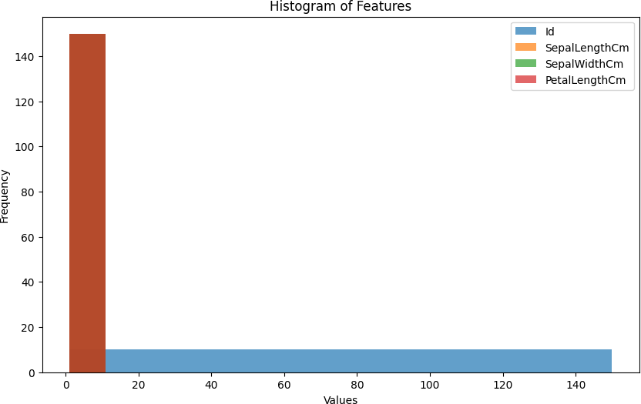

1. JSON Format

print("\nReading JSON Format...") df_json = pd.read_json("Data2.json")

print(f"Properties :",df_json.describe()) print(df_json.head())

df_json.iloc[:, :4].plot(kind="box", title="Box Plot (JSON)") plt.show()

Reading JSON Format...

Properties : sepalLength sepalWidth petalLength petalWidth count 150.000000 150.000000 150.000000 150.000000

|  |  |  |  |  |
| --- | --- | --- | --- | --- |
| mean | 5.843333 | 3.057333 | 3.758000 | 1.199333 |
| std | 0.828066 | 0.435866 | 1.765298 | 0.762238 |
| min | 4.300000 | 2.000000 | 1.000000 | 0.100000 |
| 25% | 5.100000 | 2.800000 | 1.600000 | 0.300000 |
| 50% | 5.800000 | 3.000000 | 4.350000 | 1.300000 |
| 75% | 6.400000 | 3.300000 | 5.100000 | 1.800000 |
| max | 7.900000 | 4.400000 | 6.900000 | 2.500000 |
| sepalLength sepalWidth petalLength petalWidth species | | | | |
| 0 | 5.1 | 3.5 | 1.4 | 0.2 setosa |
| 1 | 4.9 | 3.0 | 1.4 | 0.2 setosa |
| 2 | 4.7 | 3.2 | 1.3 | 0.2 setosa |
| 3 | 4.6 | 3.1 | 1.5 | 0.2 setosa |
| 4 | 5.0 | 3.6 | 1.4 | 0.2 setosa |

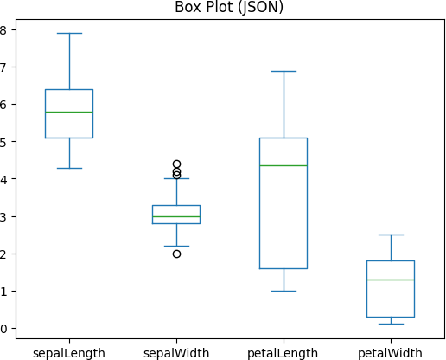

1. Pickle Format

print("\nReading Pickle Format...") with open("Data3.pkl", "rb") as f:

df_pkl = pickle.load(f) print(f"Properties :",df_pkl.describe()) print(df_pkl.head())

Reading Pickle Format...

Properties : sepal_length sepal_width petal_length petal_width

|  |  |  |  |  |
| --- | --- | --- | --- | --- |
| count | 150.000000 | 150.000000 | 150.000000 | 150.000000 |
| mean | 5.843333 | 3.054000 | 3.758667 | 1.198667 |
| std | 0.828066 | 0.433594 | 1.764420 | 0.763161 |
| min | 4.300000 | 2.000000 | 1.000000 | 0.100000 |
| 25% | 5.100000 | 2.800000 | 1.600000 | 0.300000 |
| 50% | 5.800000 | 3.000000 | 4.350000 | 1.300000 |
| 75% | 6.400000 | 3.300000 | 5.100000 | 1.800000 |
| max | 7.900000 | 4.400000 | 6.900000 | 2.500000 |

|  |  |  |  |  |  |
| --- | --- | --- | --- | --- | --- |
| sepal_leng  0 | th sepal_width petal_length petal_width species  5.1 3.5 1.4 0.2 setosa | | | |  |
| 1 | 4.9 | 3.0 | 1.4 | 0.2 setosa |  |
| 2 | 4.7 | 3.2 | 1.3 | 0.2 setosa |  |
| 3 | 4.6 | 3.1 | 1.5 | 0.2 setosa |  |
| 4 | 5.0 | 3.6 | 1.4 | 0.2 setosa |  |
|  |  |  |  |  |  |
| 5.Image Format |  |  |  |  |  |

print("\nReading Image Format...") img = Image.open("Data4.jpg") plt.figure(figsize=(8, 6)) plt.imshow(img)

plt.axis('off') plt.show()

Reading Image Format...

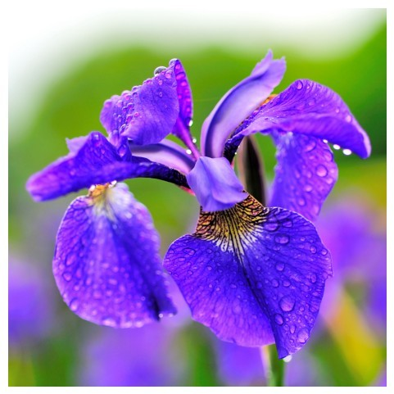

1. Audio Format

import librosa

import IPython.display as ipd

y, sr = librosa.load("sample.mp3") ipd.display(ipd.Audio(data=y, rate=sr))

<IPython.lib.display.Audio object>

1. Text Format

df_csv.to_csv('iris.txt', sep='\t', index=False)

with open('iris.txt', 'r') as file: text_data = file.read()

wordcloud = WordCloud(width=800, height=400, background_color='white').generate(text_data)

plt.figure(figsize=(10, 5)) plt.imshow(wordcloud, interpolation='bilinear')

plt.axis('off')

plt.title('Word Cloud of iris.txt', fontsize=16) plt.show()

