📝 Technical Report: Shadow Gateway - Ghost Protocol
1. Executive Summary
Shadow Gateway is a specialized security framework designed to neutralize API reconnaissance. By enforcing a Ghost State, the system ensures that backend services remain invisible to unauthorized entities by returning standard 404 Not Found responses, effectively creating a software-defined air-gap.
2. Problem Statement
Traditional API security relies on 403 Forbidden or 401 Unauthorized status codes. While these protect resources, they inadvertently confirm to an attacker that a service exists at that endpoint. This allows for "footprinting" and targeted brute-force attacks.
3. The Engineering Team
The development of this protocol was a collaborative effort by:
- Aryan (GitHub: @Aryan0819)
- Adya Priyam (GitHub: @bluesky-adi)
- Raj Lakshmi (GitHub: @Rajlakshmi -ai)
4. Technical Architecture
The system is divided into two distinct planes to maintain zero-trust integrity:
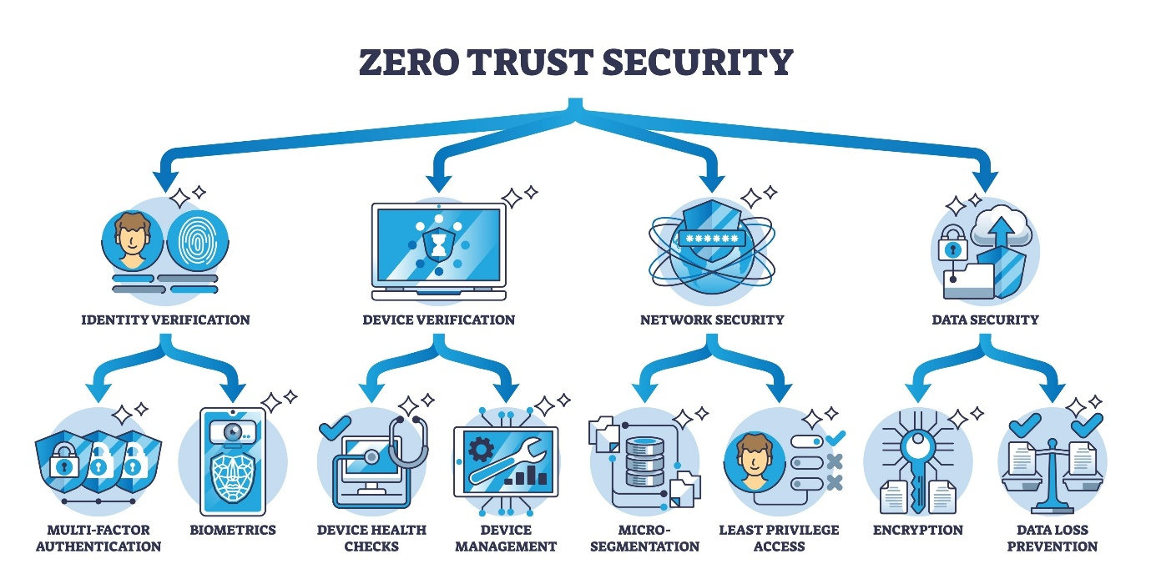
Shutterstock
Explore
4.1 The Enforcement Layer (Backend)
Built with FastAPI (Python), this layer handles the raw traffic filtering.
- Stealth Middleware: Intercepts every incoming HTTP request. It queries the Firebase Realtime Database to check if the requester's IP is currently whitelisted.
- Temporal Bridge Management: Uses background threads to monitor the TTL (Time-to-Live) of active sessions. Once the 30-minute JIT window expires, the bridge is purged automatically.
4.2 The Control Plane (Frontend)
Developed using React.js and Tailwind CSS, this acts as the administrative portal.
- Authentication: Leverages Firebase Auth to ensure only verified developers can access the "Summoning" trigger.
- State Synchronization: Updates the global Firebase state, which is instantly propagated to the Enforcement Layer.
5. Technology Stack Purpose
Technology | Role in Project
Python / FastAPI | High-performance asynchronous enforcement and middleware logic.
Node.js / React | Runtime and UI framework for the secure Control Plane dashboard.
Firebase RTDB | Real-time global state orchestration and IP-whitelisting persistence.
Firebase Auth | Identity provisioning and secure developer access.
Tailwind CSS | Implementation of the high-fidelity security terminal user interface.
6. Security Philosophies
- Mimetic Obscurity: The system hides in plain sight by mimicking the behavior of a non-existent server.
- Just-In-Time (JIT) Access: Reduces the window of vulnerability by ensuring access is temporary (30 minutes) rather than permanent.
- Zero-Trust: No request is trusted based on previous history; every packet must have an active entry in the synchronized state.
7. Conclusion
Shadow Gateway successfully demonstrates that security can be achieved through invisibility. By combining modern cloud synchronization with low-level middleware filtering, the project provides a robust defense mechanism against the first stage of any cyberattack: discovery.

