Feynn: Project 1 Abstract prototype/business model

Take on existing or unique ideas

Grades assigned: 5% (for the abstract prototype report)

Bonus Grades: 5% (for viable code implementation/validation on small scale)

AI Product/Service Prototyping for Small Businesses. (Solo Project)]

ML + Product development

Deadline: 14th Jan

* Identify Real World Business Markets where AI can be applied and come up with sellable AI Product/Service ideas.
* Develop an abstract Product Design.
* Prepare a **detailed report** on how you will implement it based on touchpoints listed below. – Implementation, Opposition

Description:

Basically this a Product Ideation task, Interns have to come up with a Business Idea which will primarily use Machine Learning & Artificial Intelligence to solve business problems and prepare a report on the abstract prototype/business model. (You don't need to develop the actual Product)

You can cover industries like tourism, agriculture, education, supply chain, import/export, medical etc. By Small/Medium Businesses we mean startups, single person companies, small community shop chains, local food chains etc. (Try to avoid how big corporate use ML/DS like Google, Microsoft, Amazon etc). In Feynn Labs we try to help mostly small/medium business operations with help of ML/DS.

This is a solo project, so each intern has to come up with their own business idea. Interns can prepare the report on existing product/service ideas but the Report & Implementation need to be unique.

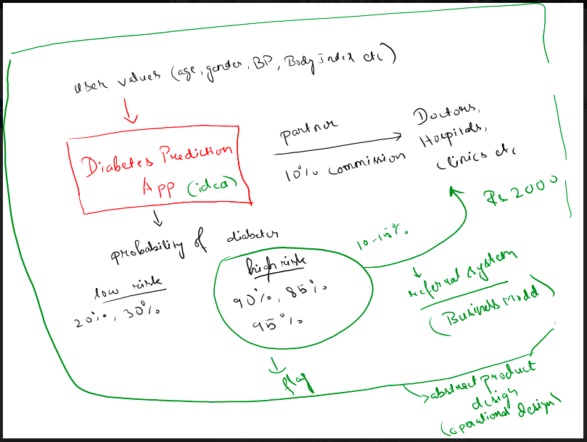

Abstract product design: Operational design w/ ML integration – Business model

Practicality

Initial ideas:

* AI in dermatology: Similar to the diabetic diagnosis app

Required Table of Contents

0. Title of Paper along with your name

1. (Imp) Problem Statement

2. (Imp) Market/Customer/Business Need Assessment

3. Target Specifications and Characterization (your customer characteristic) – Demographic

4. External Search (online information sources/references/links)

5. Bench marking alternate products (comparison with existing products/services)-Opposition

6. Applicable Patents (Patent of Tech/Software/Framework etc you are going to use in your Product/Service idea)

7. Applicable Regulations (government and environmental regulations imposed by countries)

8. Applicable Constraints (need for space, budget, expertise)

9. (Imp) Business Model (Monetization Idea)

10. Concept Generation (process of coming up with Idea)

11. Concept Development (Brief summary of Product/Service will be developed)

12. (Very Imp) Final Product Prototype (abstract) with Schematic Diagram

13. Product details

- How does it work?

- Data Sources

- Algorithms, frameworks, software etc. needed

- Team required to develop.

- What does it cost? etc

14. Code Implementation/Validation on Small Scale (Optional - Bonus Grades)

What can be included?

- Some Basic Visualizations on Real World or Augmented Data

- Simple EDA

- ML Modelling

- Github link to the code implementation

15. Conclusion