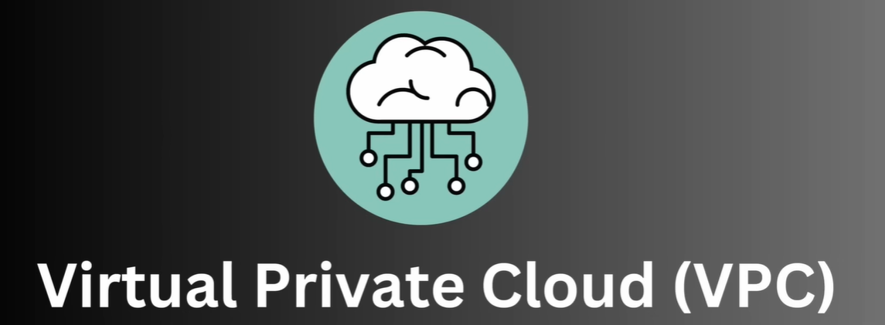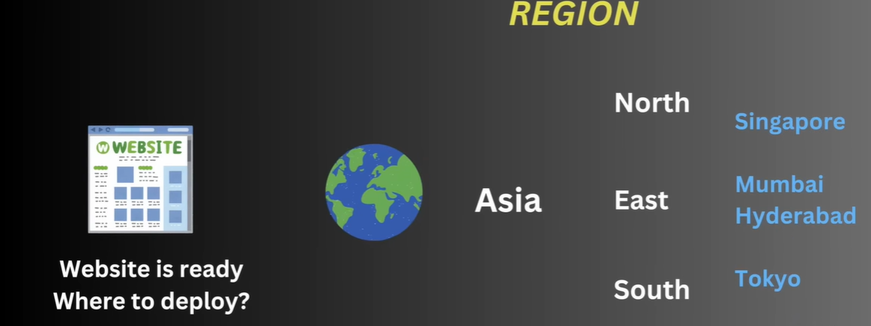
Suppose we selected Mumbai region for our project deployment.

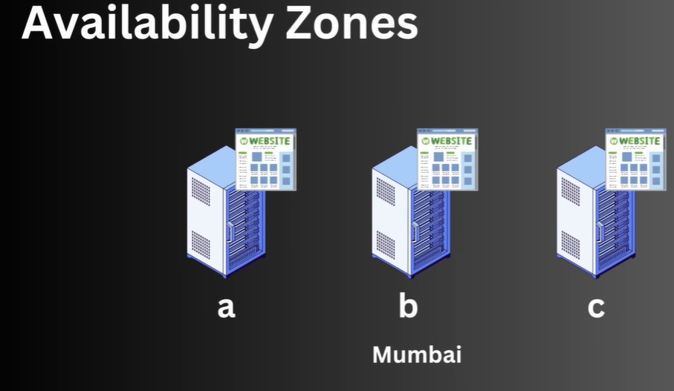
Then we have to decide zone.
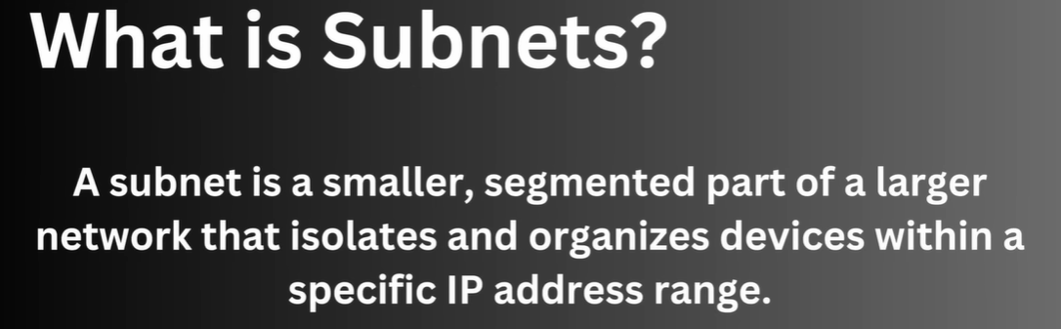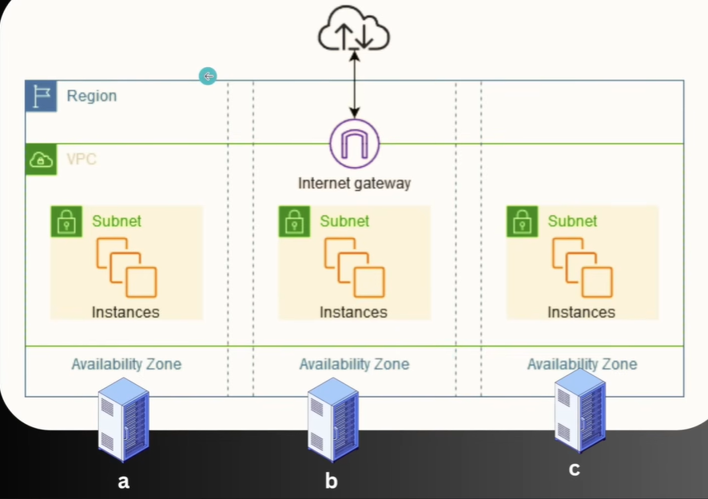
VPC is cover one particular region and Subnet is for specific zone in that region and can deploy our resource on that subject.
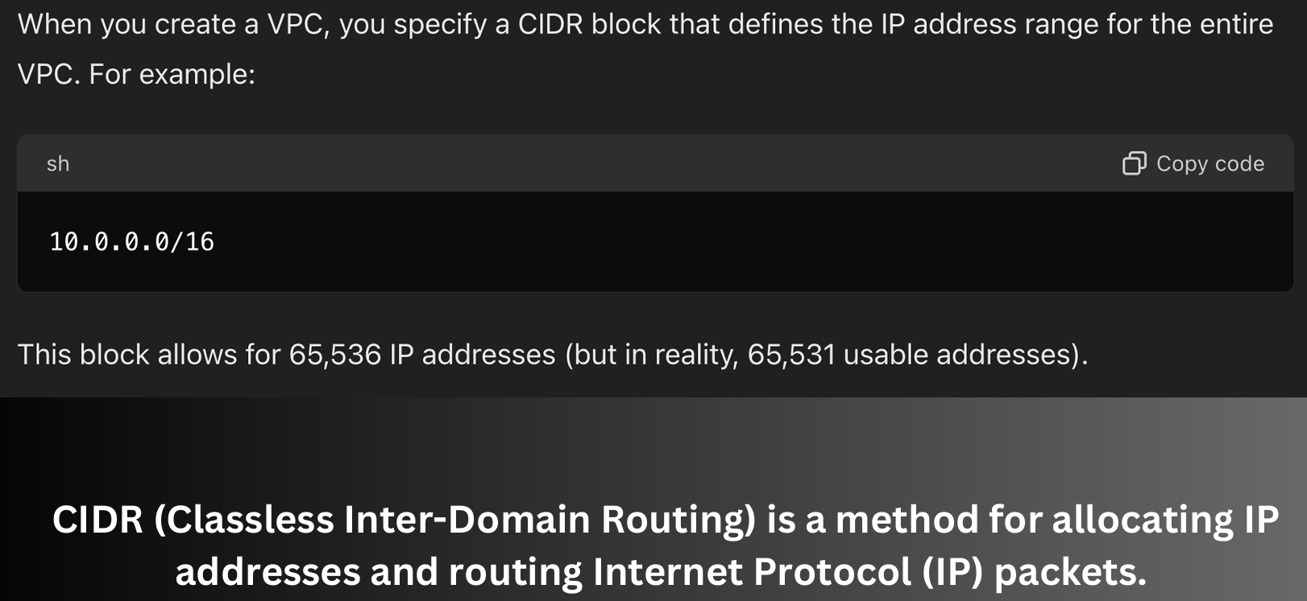
Suppose we need 10 EC2 instances and each instance need IP, so we allocate a range of IP on our network. Here we got 65536 IP.
16 bit in last is used for hosting purpose and previous 16 bit is used for network purpose.
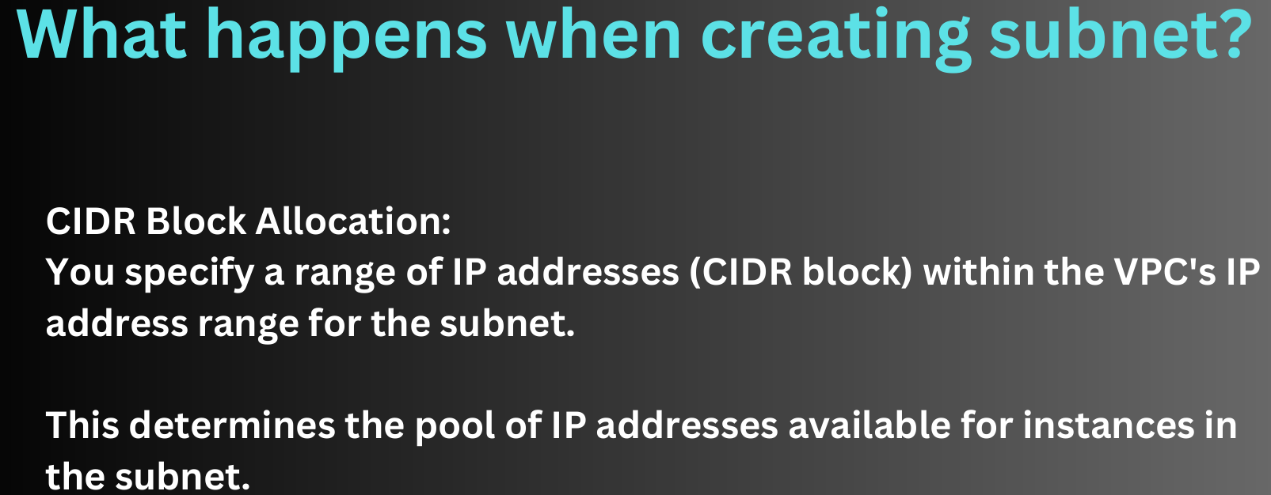
- 65K IP are very huge so we can specify a smaller number of IP in subnet say 150 IP.
- There can be multiple purpose of this subnet. We can assign some IP for accessing/exposing with network like frontend but data base not require to expose with network. For data purpose we can create private subnet for some IP under which we can deploy data base and that ip will not be expose to internet.
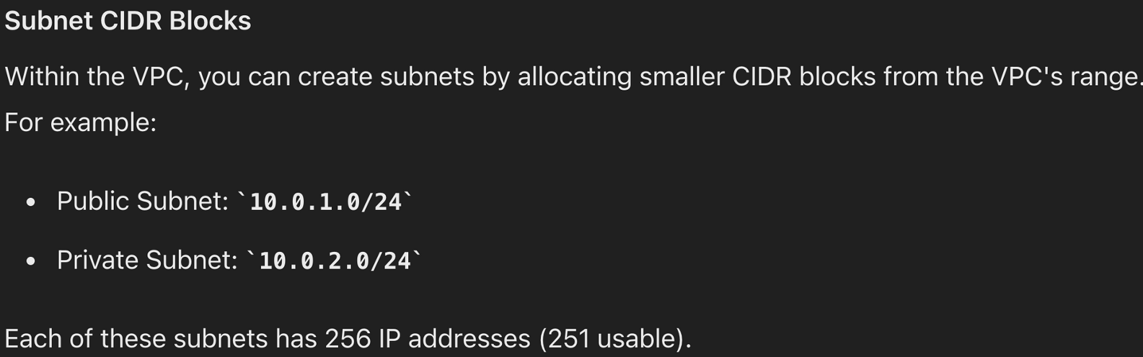
We create instance under subnet.
10.0.1.0/24- The range of IP between from 1.0 to 24 assign to Public subnet and 2.0 to 24 assign to private subnet.
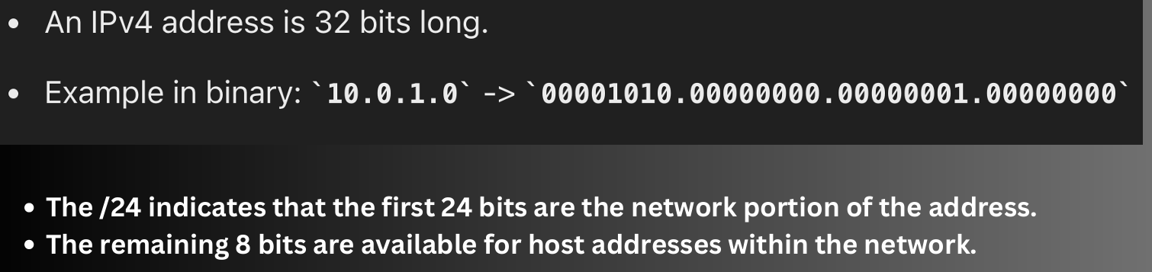

Suppose we create a public subnet and we have to expose it to internet, so this is define by route table that this particular subnet has to expose with internet.

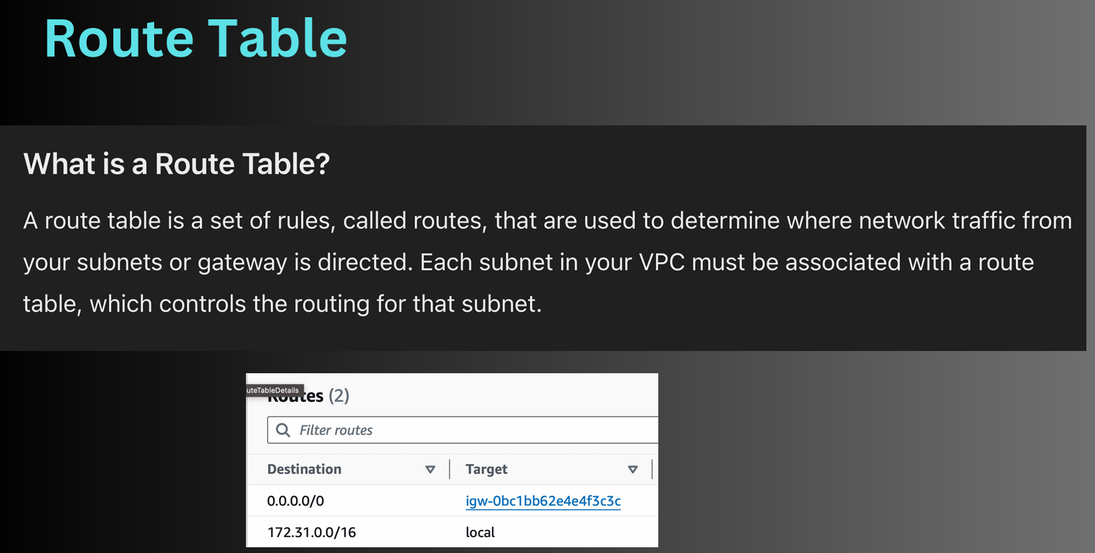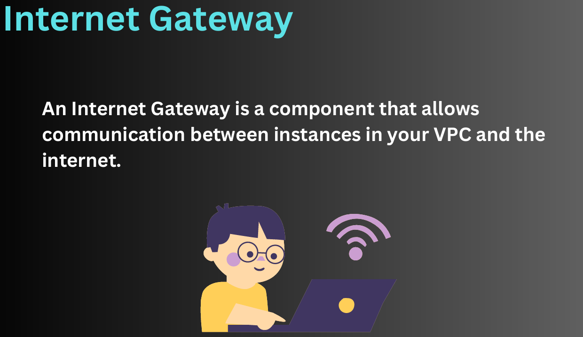
We need some services to be accessible to internet and for that purpose internet gateway is used.
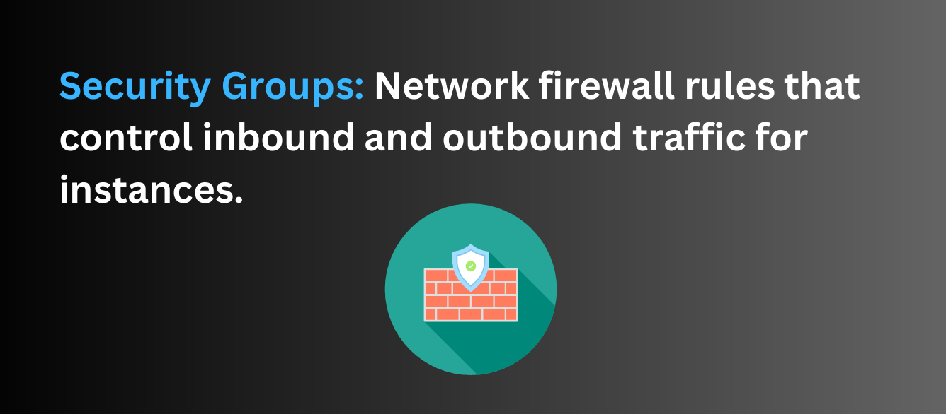

Creating VPC manually
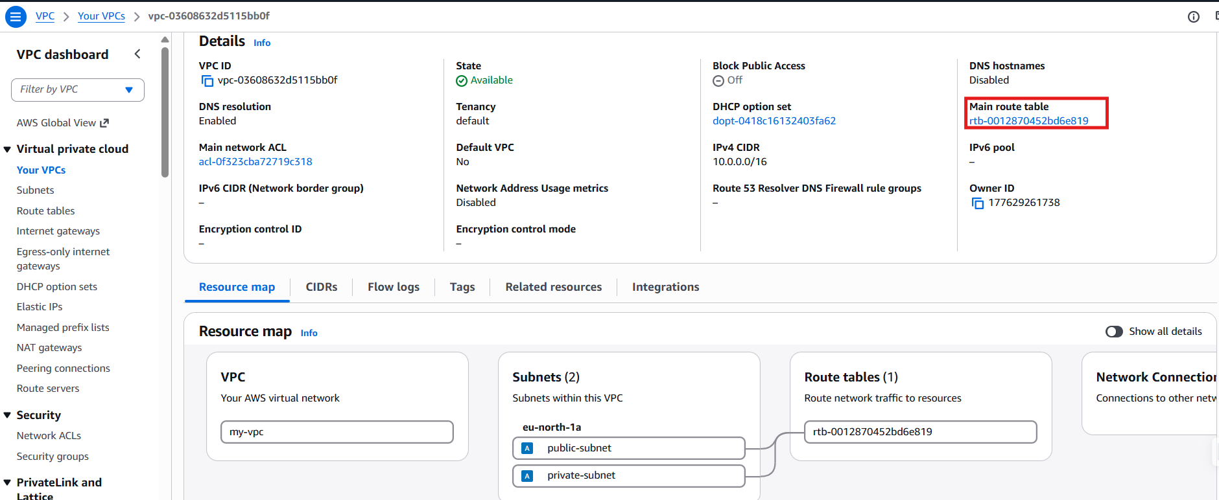
We have not created rout table yet still it`s showing route table. Since without route table network is useless so whenever we create a VPC then it creates a default route table i.e called main route table.

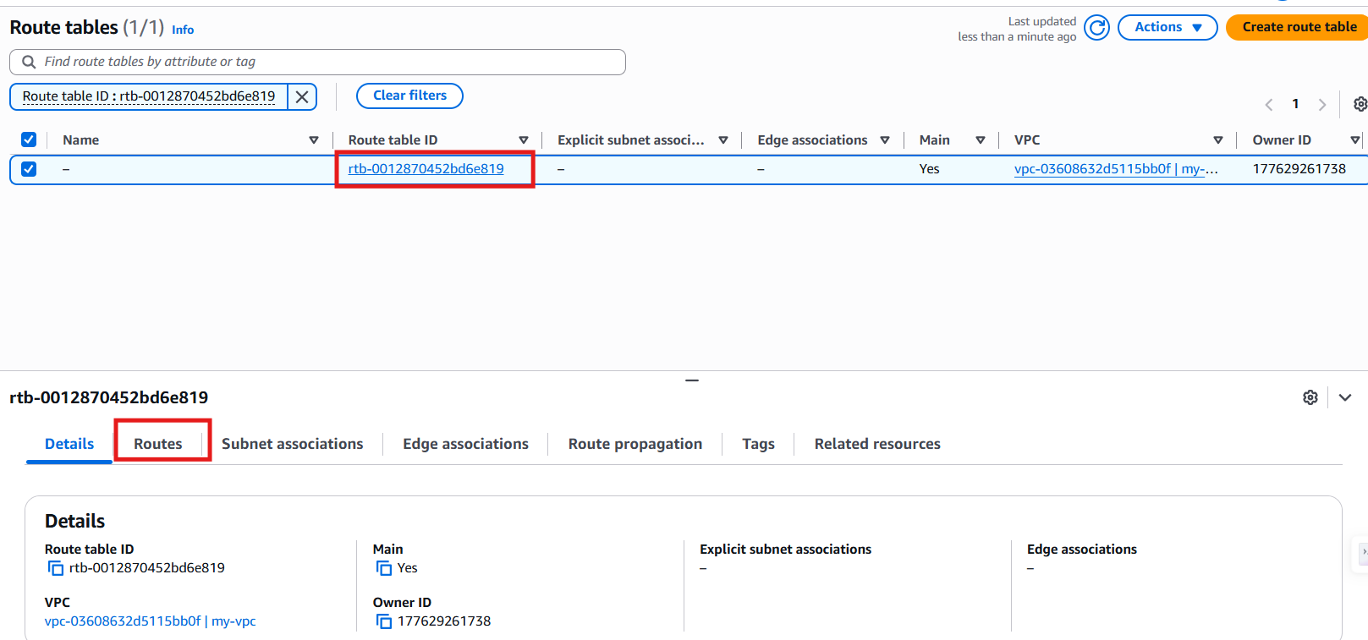

Create Route table

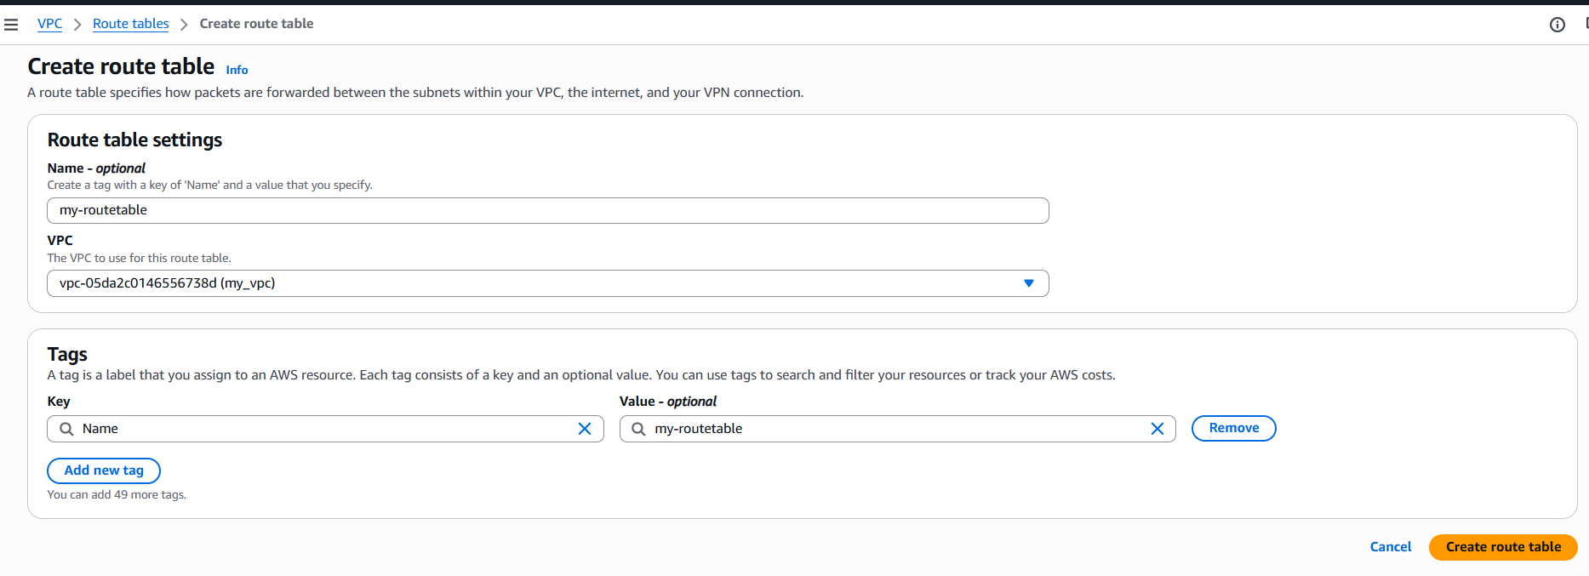
Create Internet gateway
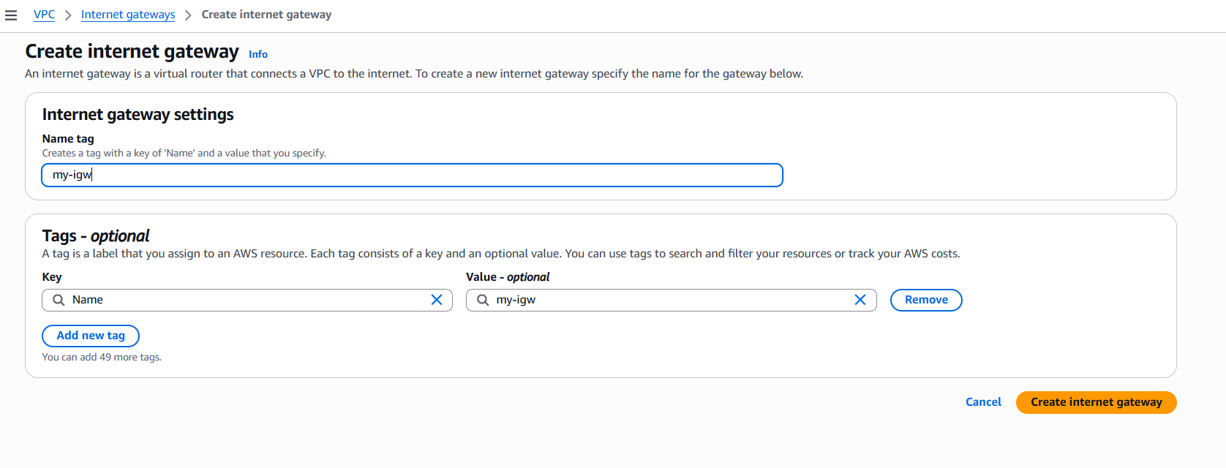
Now go to action and attach to VPC and choose VPC

Now go to Route tables > Subnet asssociations
Then to associate with any route table click
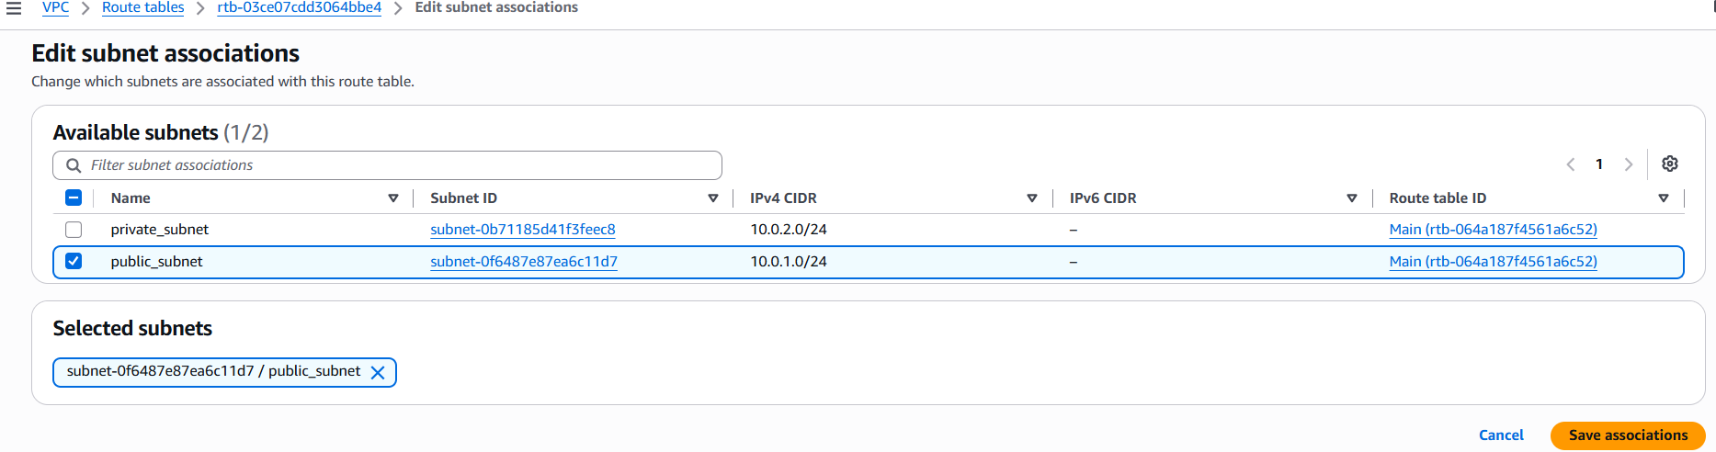

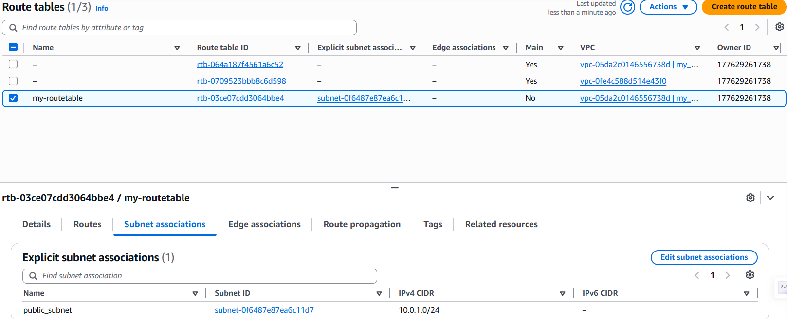
Now we can see in my-routetable public subnet is associated.

- Now in Go to routes and for public subnet, we will edit the route
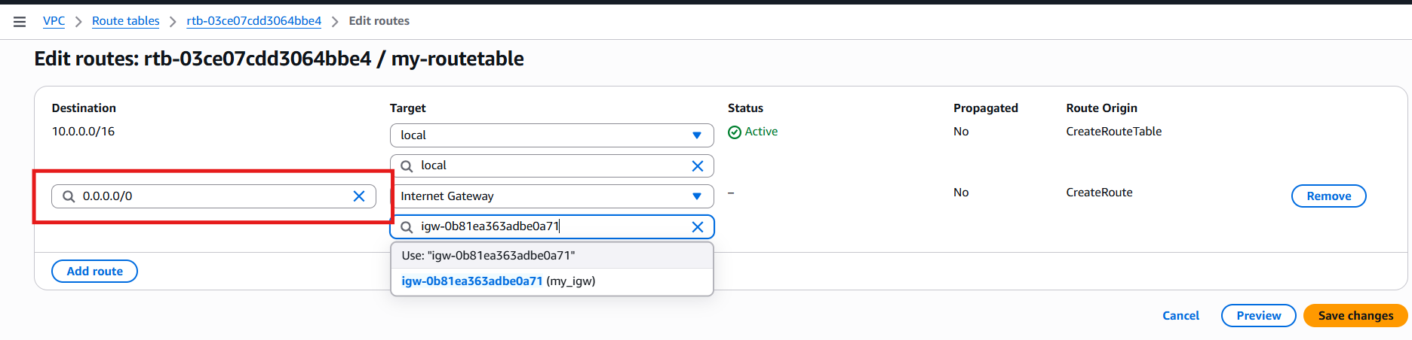
0.0.0.0/0 - All IP of within this range
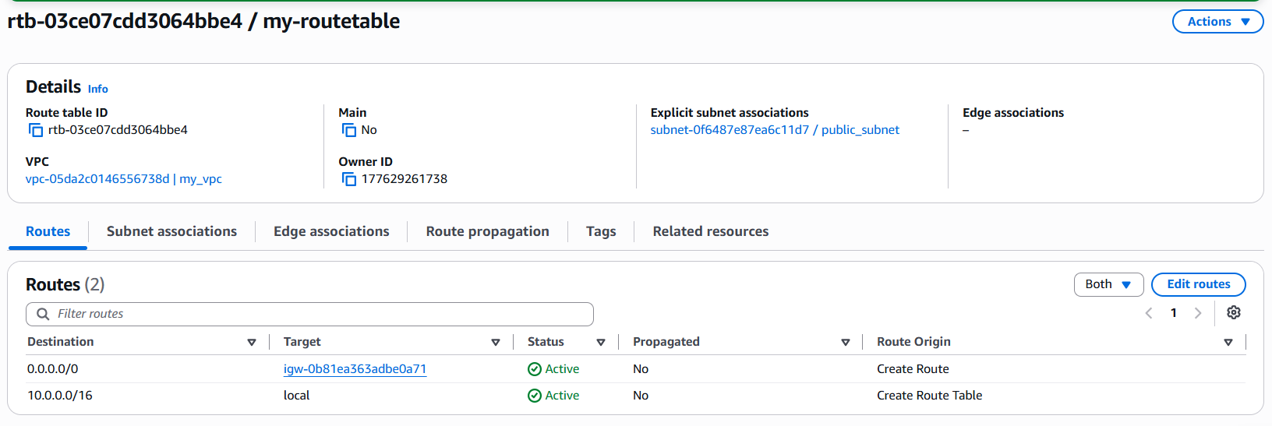

To check what changes has been done.

Your VPC (lift side option) > my_vpc > Resoure map
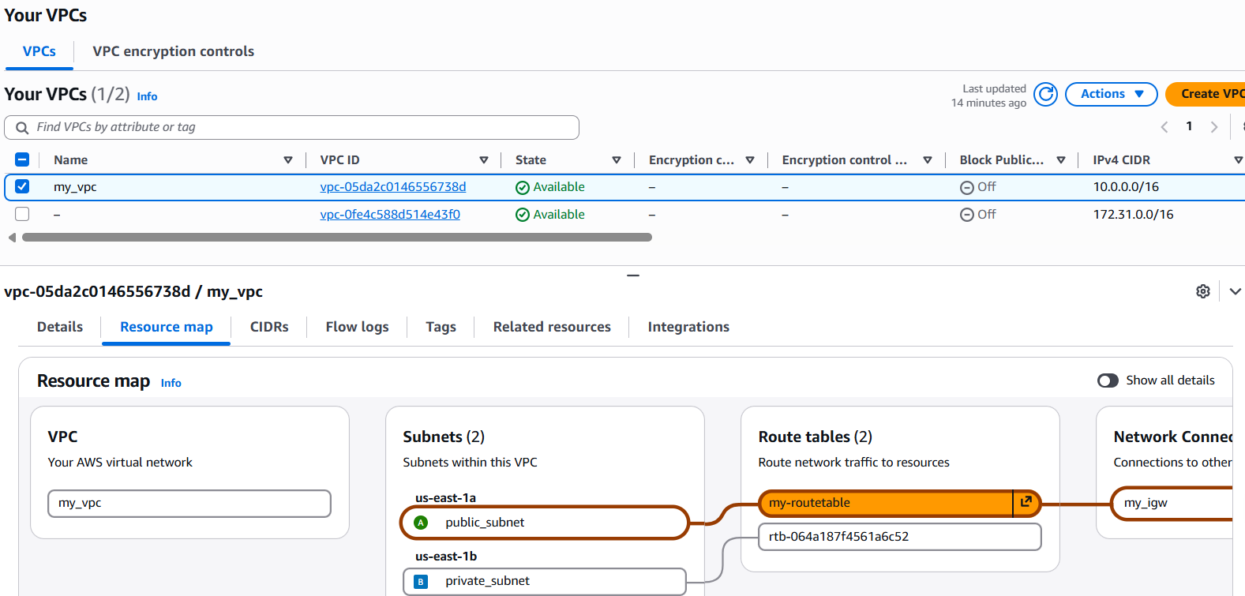

VPC and subnet is created and we have to create instance.
Create EC2 > choose VPC and Subnet
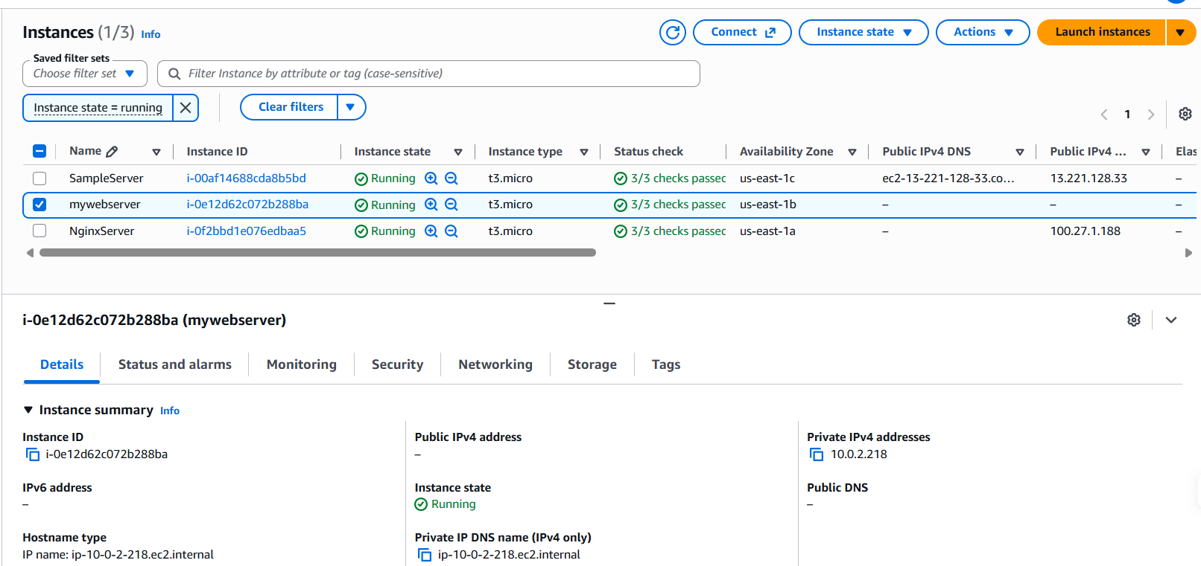
IP has been assigned in the given range.

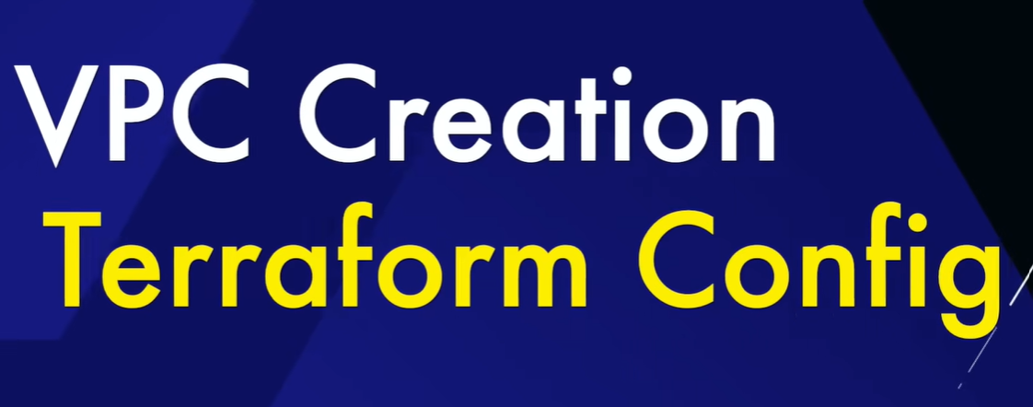
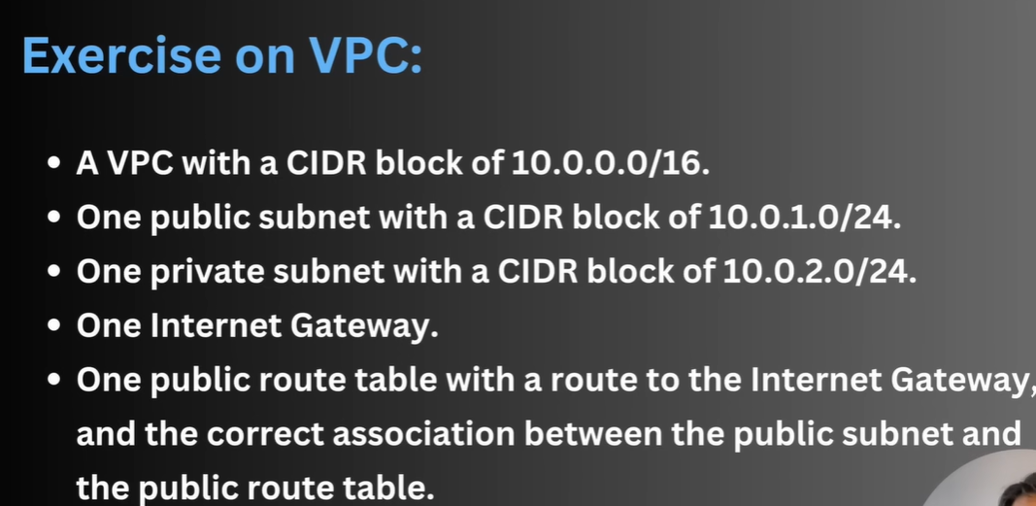
Steps are mention, we go step by step
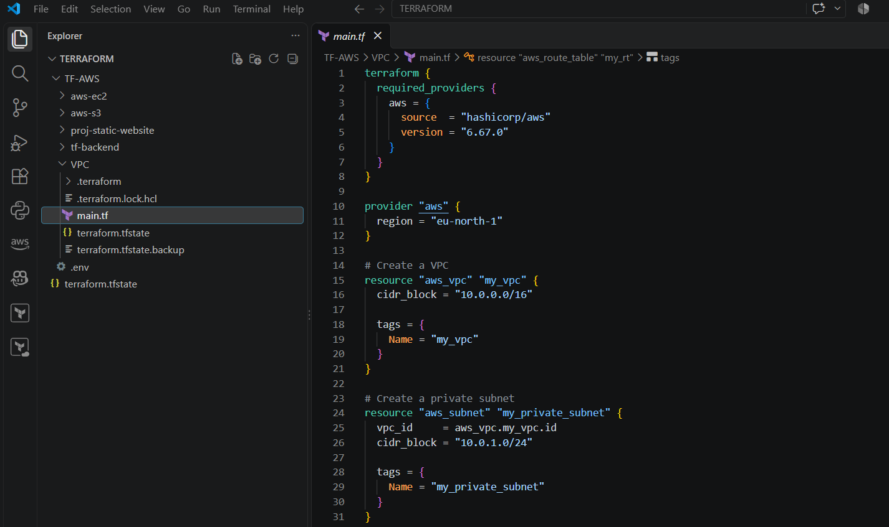
Now we will step other resources like internet gateway and Routing table to use the gateway.
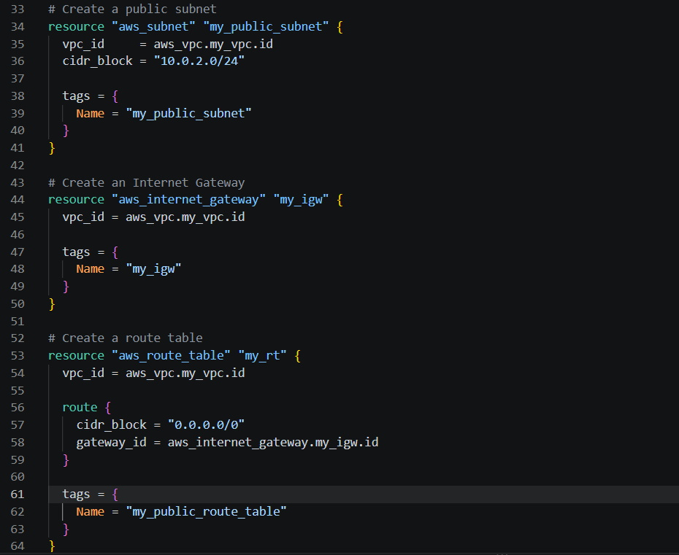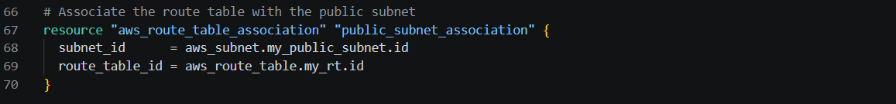
Now we can see entire flow created in one click
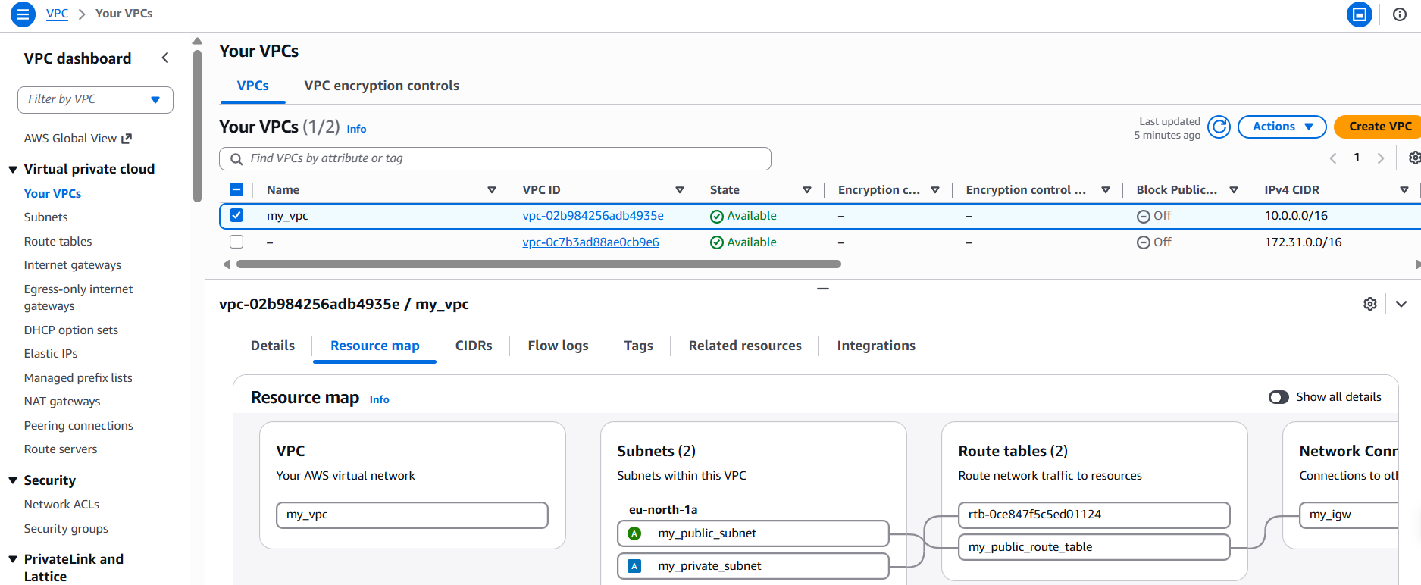

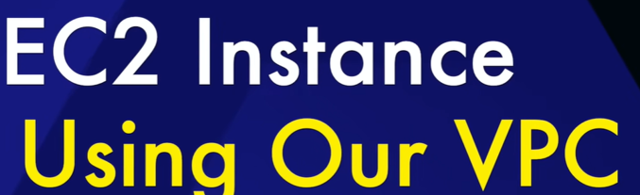
Now we will create EC2 using same VPC using private or public subnet.
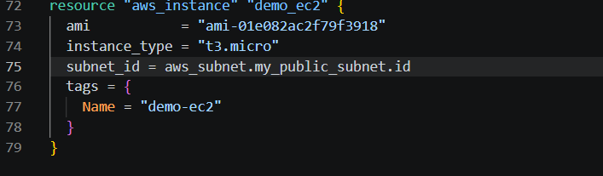
Added with previous part
