Suppose I have to used already created VPC or other resources by other then we can do it by this process.
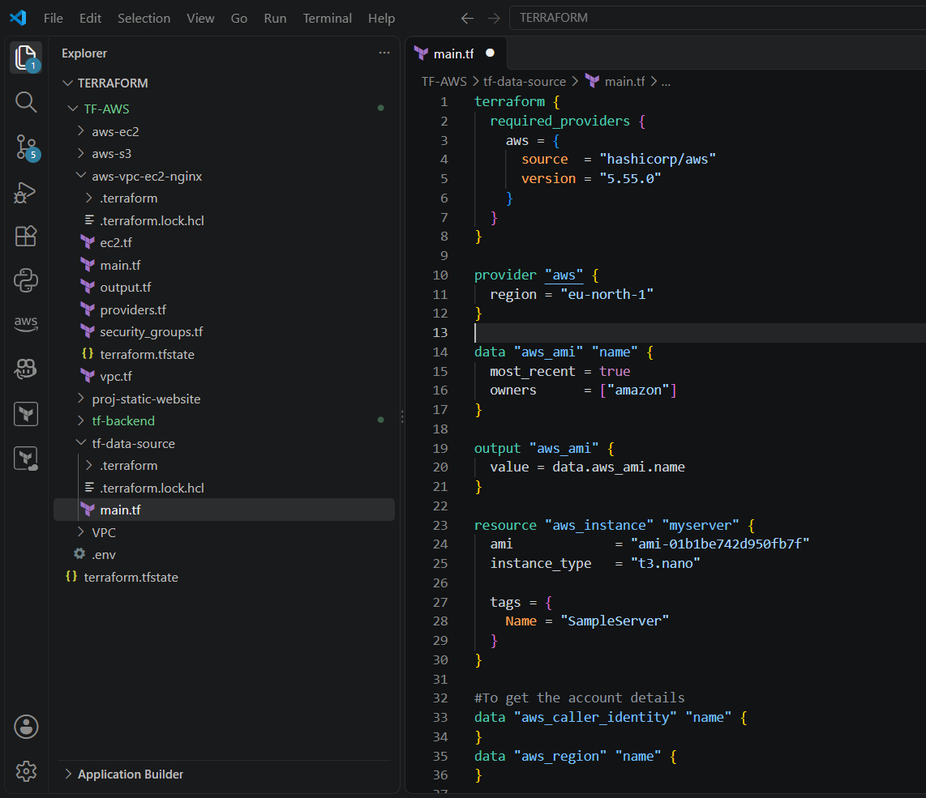
Terraform plan
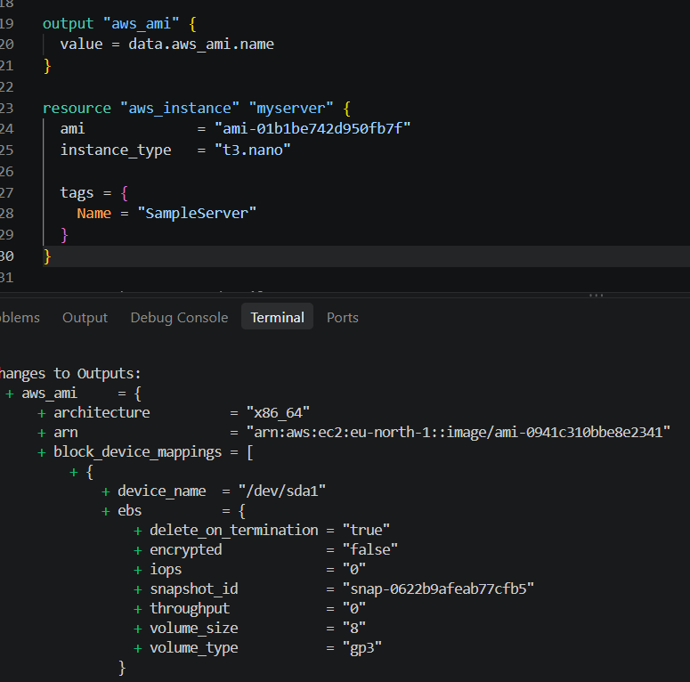
We can search ami by name before creating it.
We can show id in output
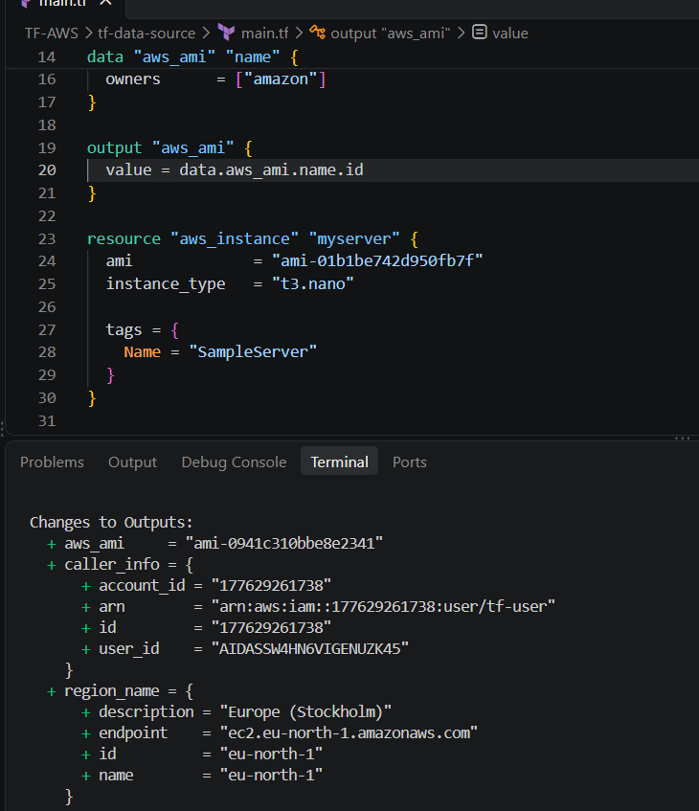
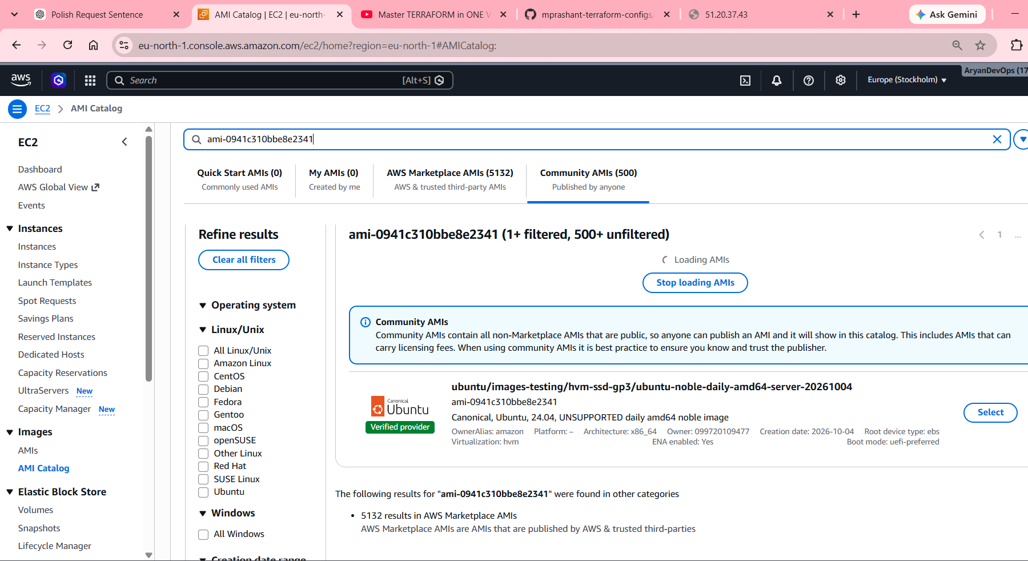

We can check here too
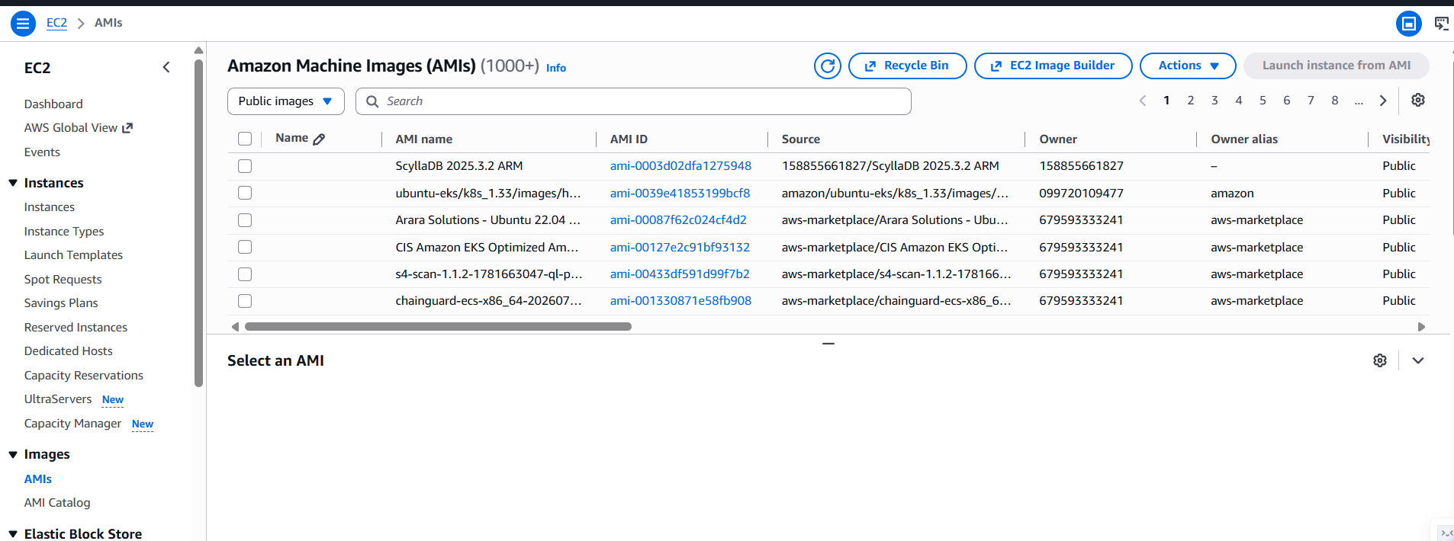

We can put variable instead of hard quoted value
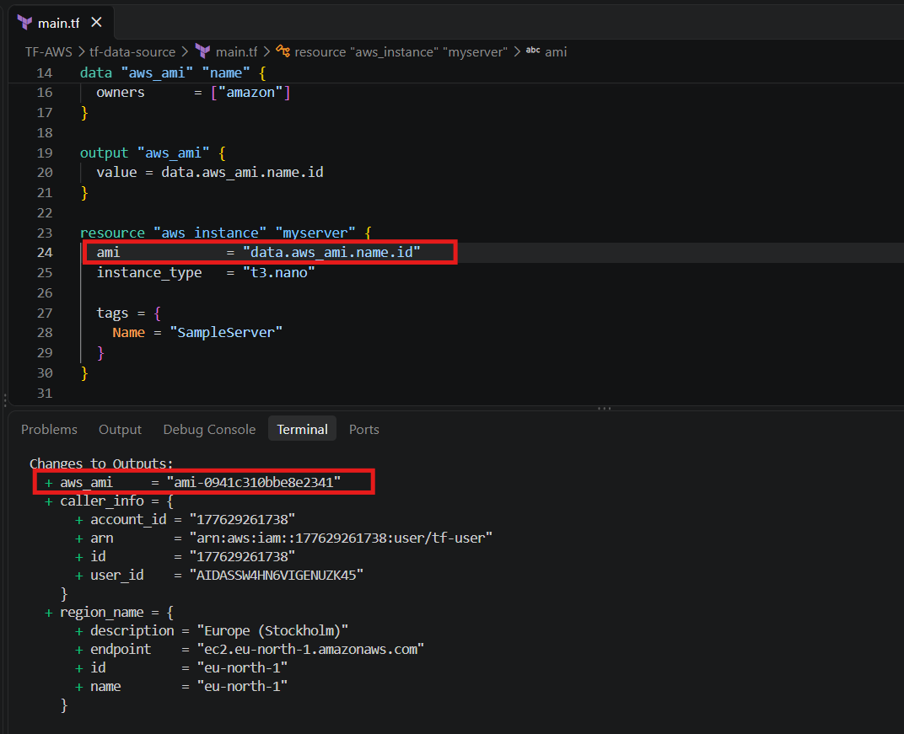
This is how dynamic ami is generated

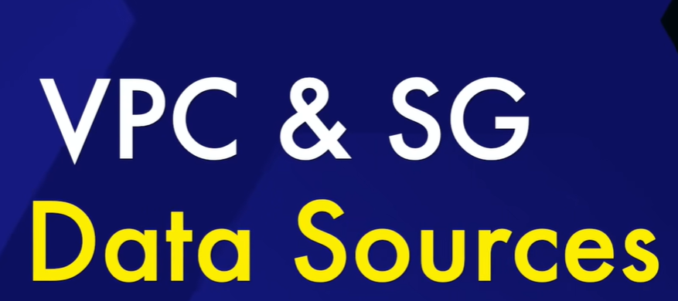
Already one security group is created.
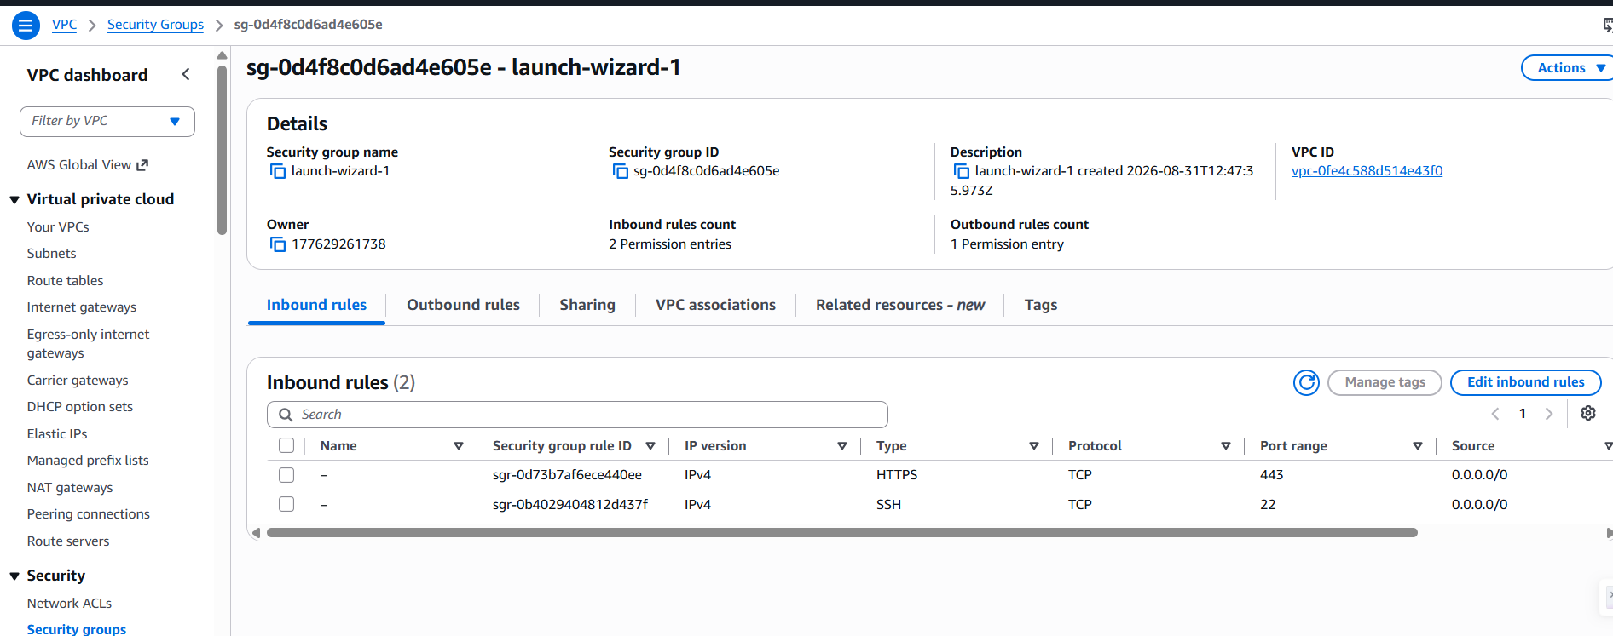
Tag name
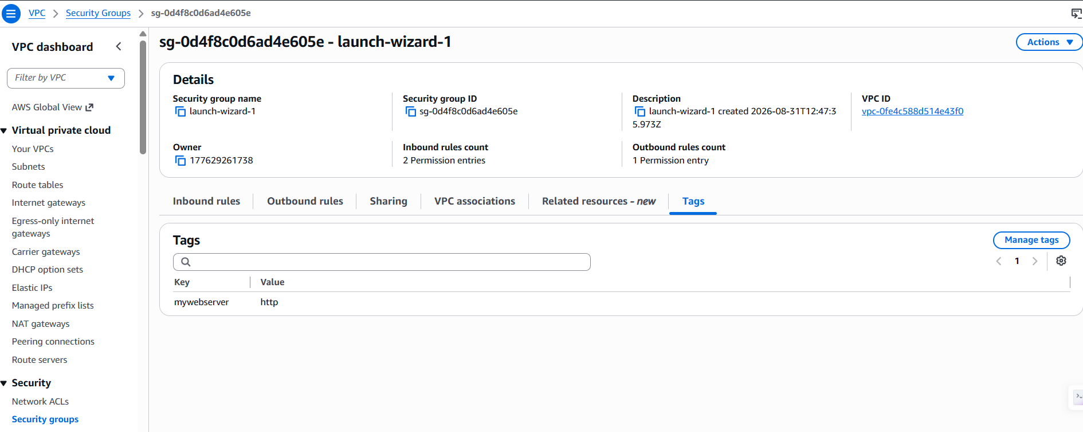

Now we have to use this existing security group and checking by terraform apply
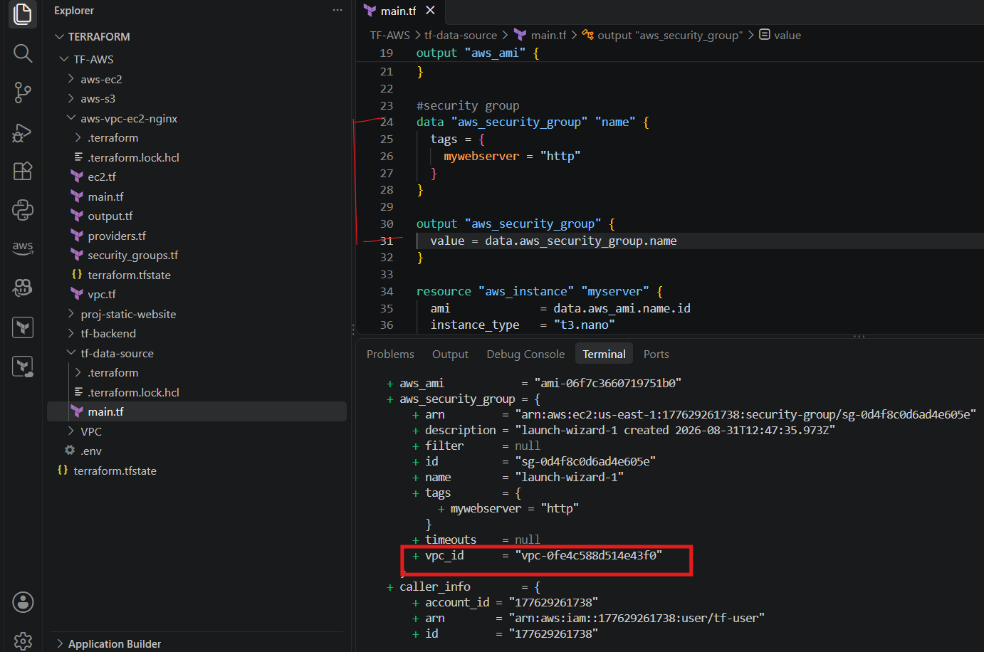
And we can get vpc what is there in aws, we got end point and other details for creating url.
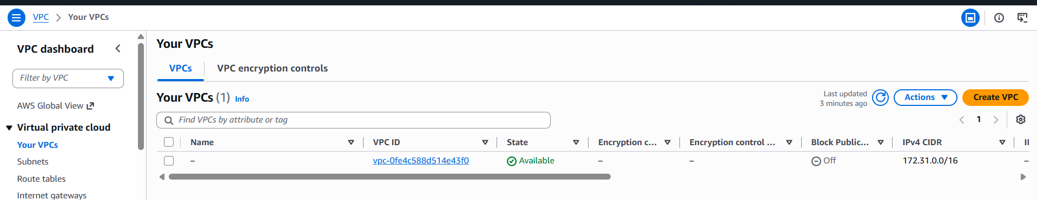

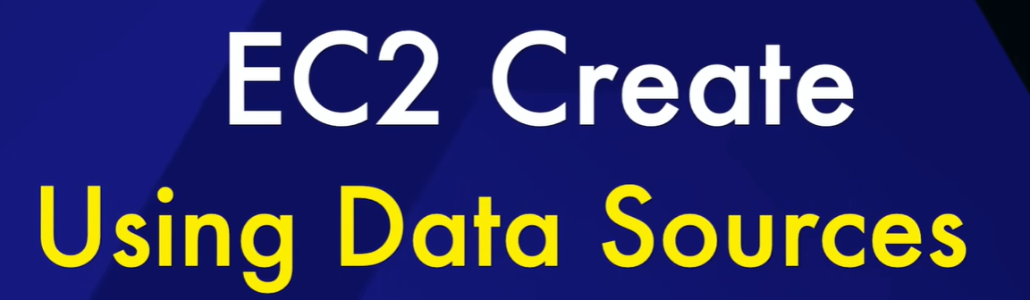
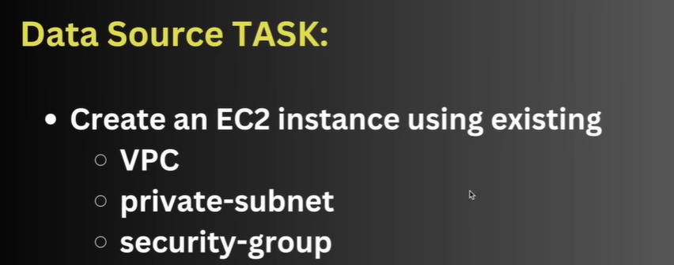
We should have these 3 already created.
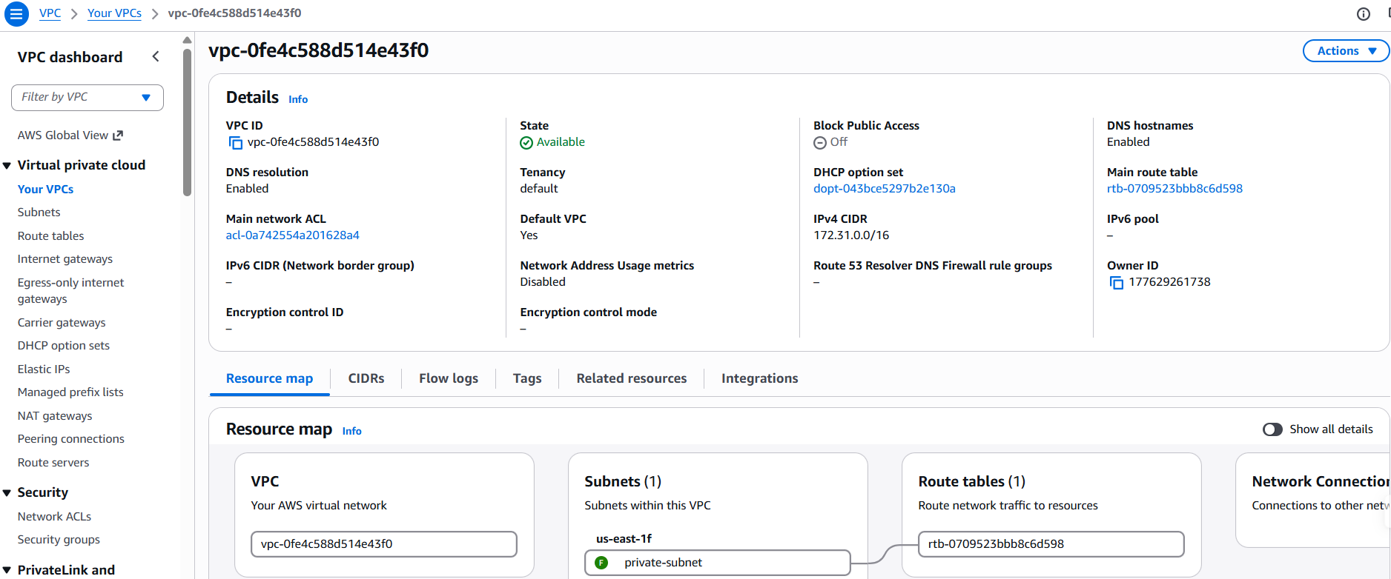
VPC & subnet.
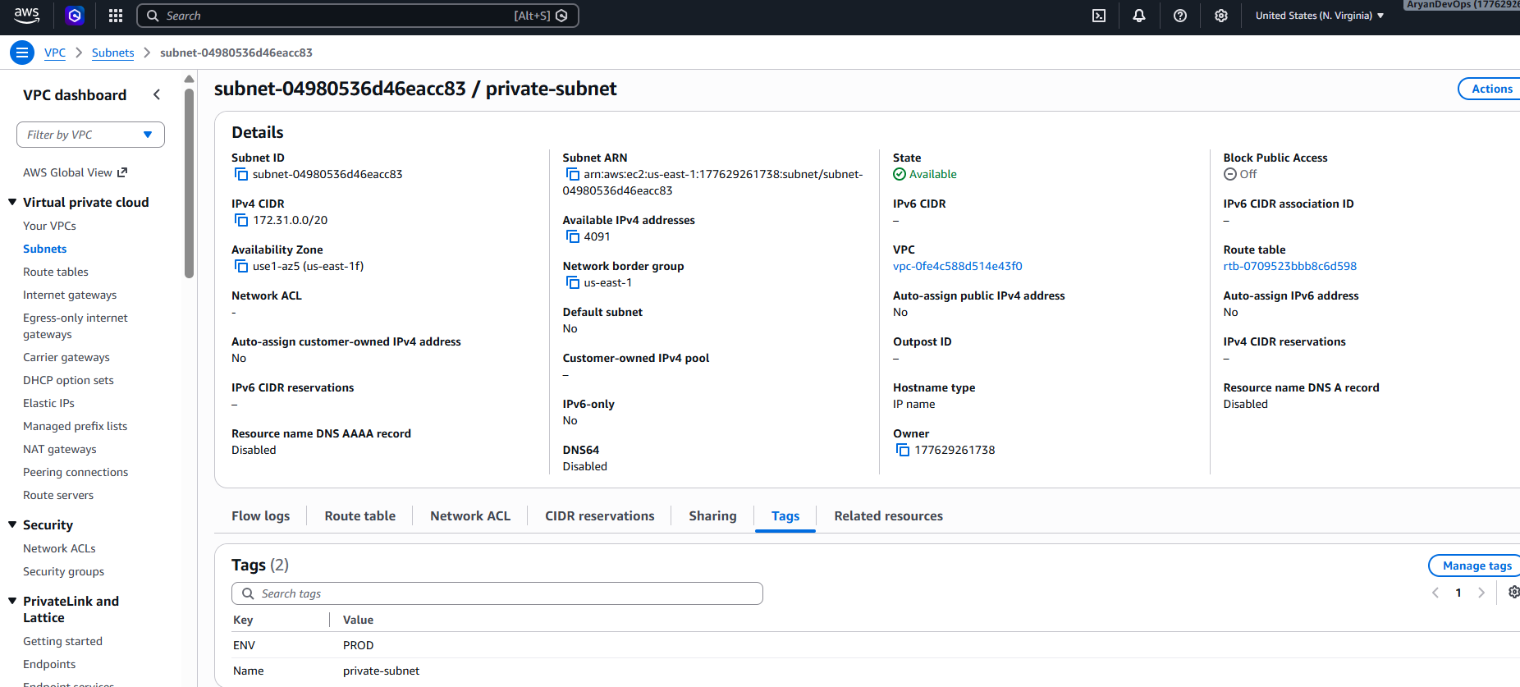
Name and ENV is mention for subnet and on the basis of these 2 we can find it.

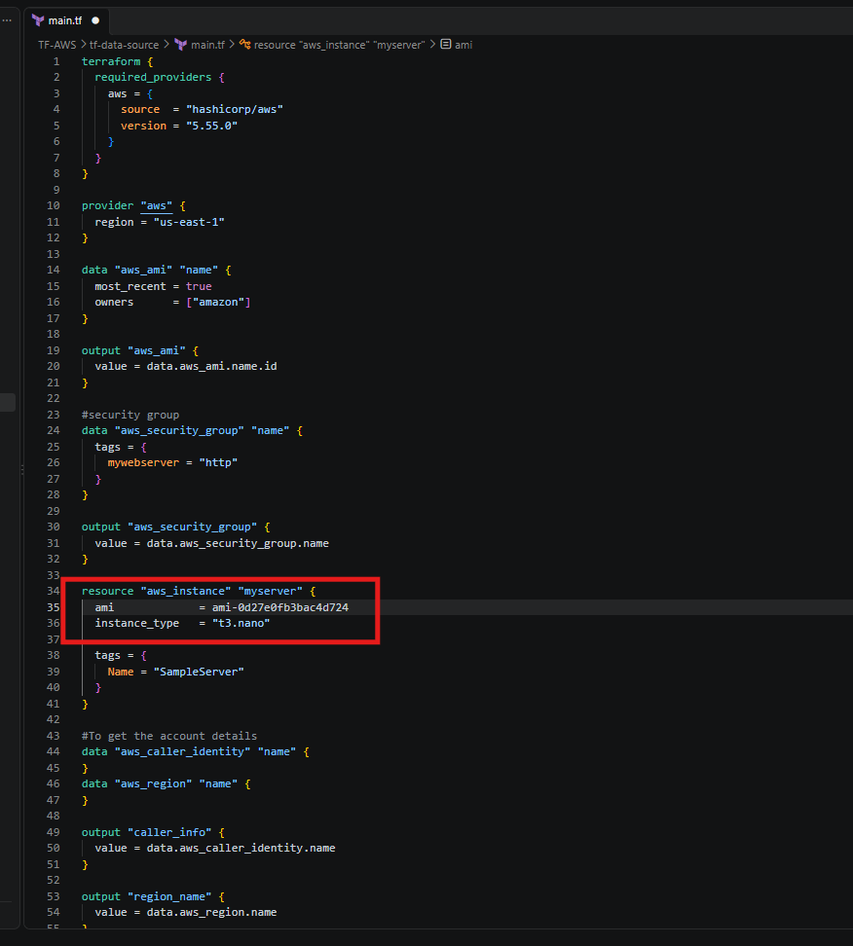
As of using ami from aws
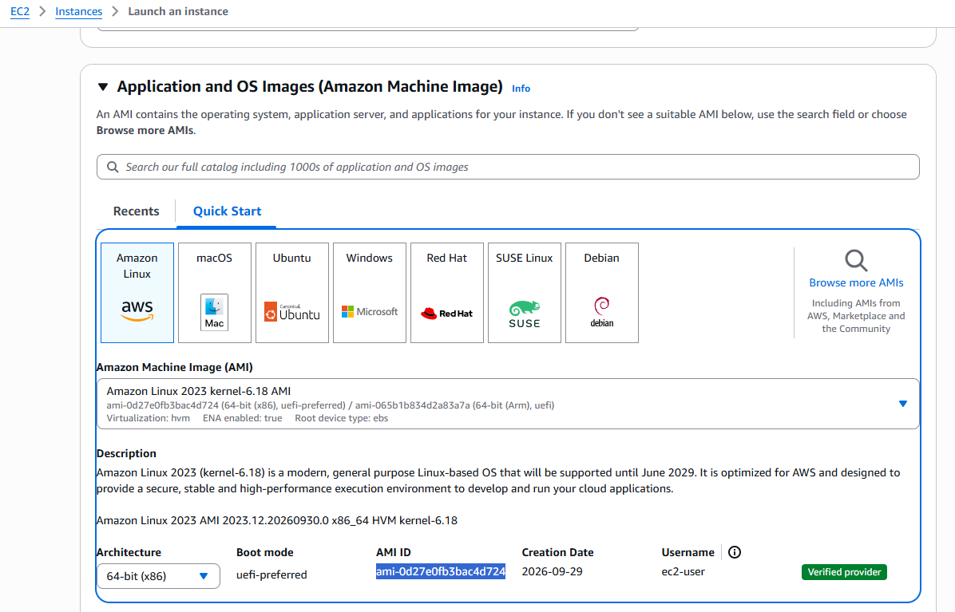

We have to check 2 more data subnet_id and security_group
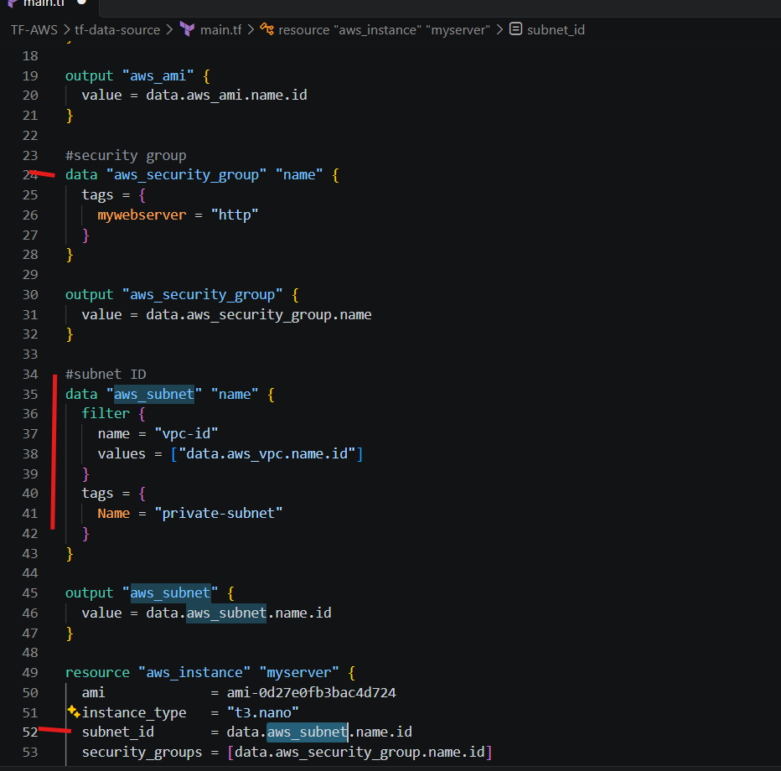
We find the subnet which is part of used VPC and also find security group. There can be multiple subnet in one VPC so we will filter it again on the basis of tag and env.
