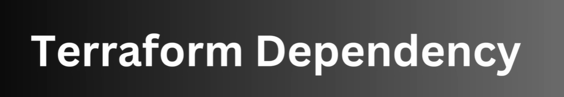
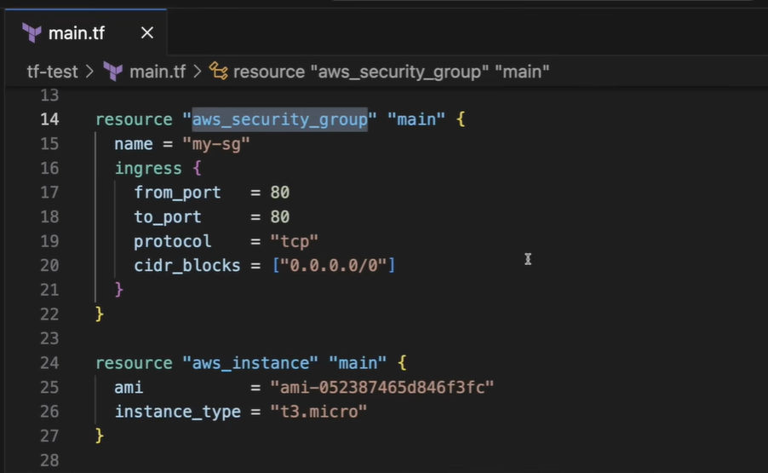
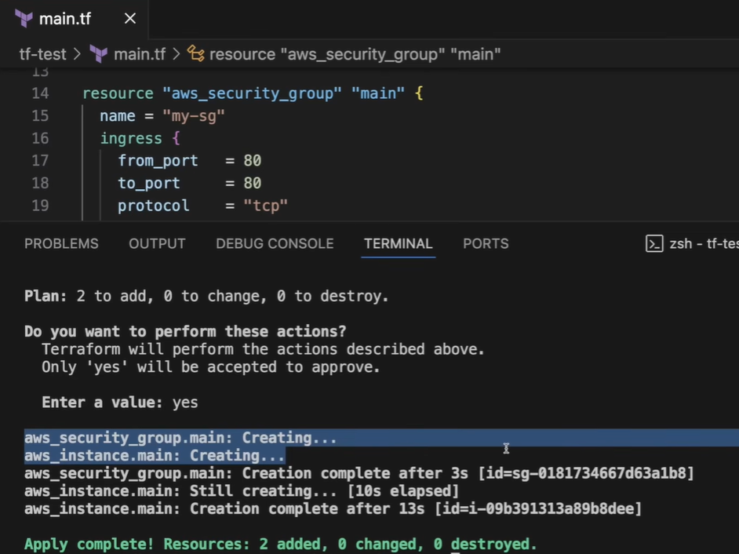
If we have multiple resources then security group and instances get created simultaneously.
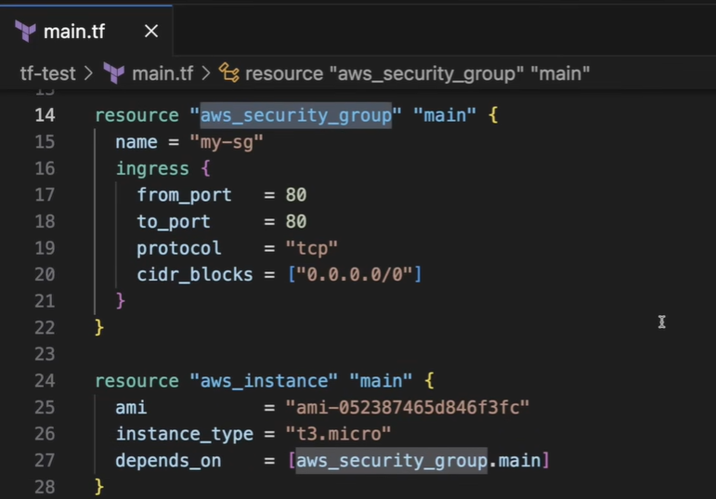
We want that EC2 should be only created when security group get created.
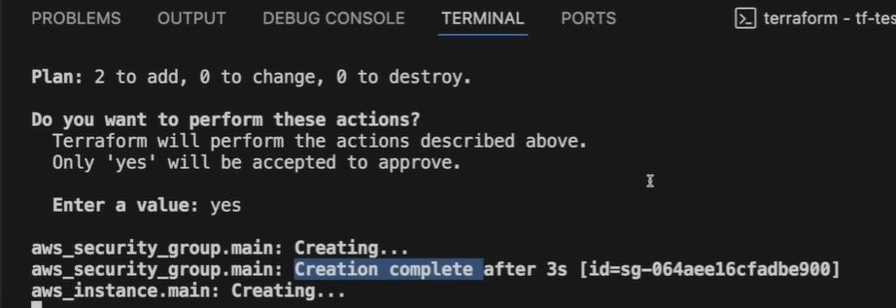
It will 1st create security group then instance.
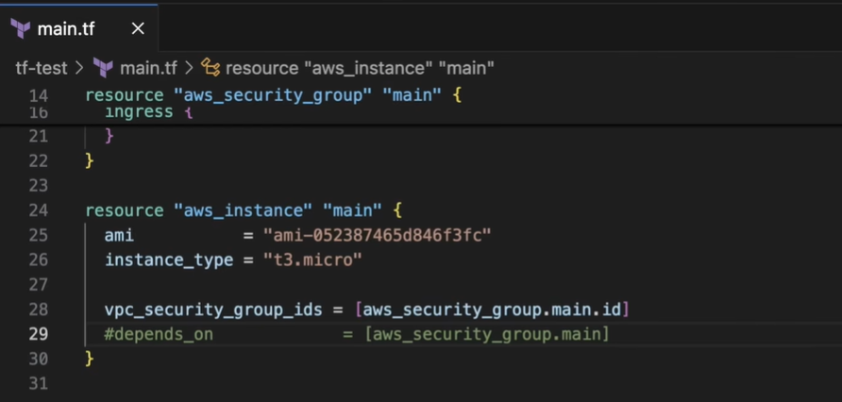
This is implicit dependency, we have used vpc_security_group_ids from above.
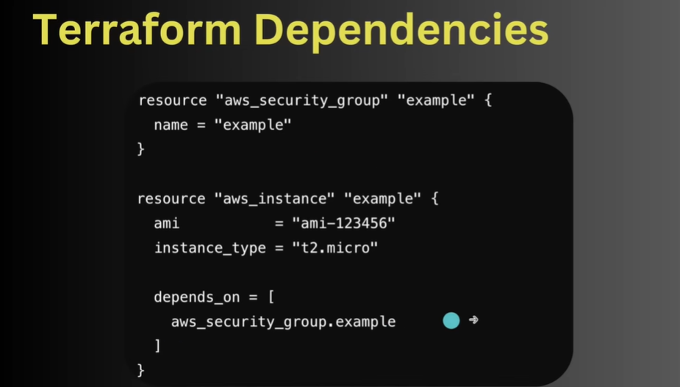

#######################################################################################=======================================================================================

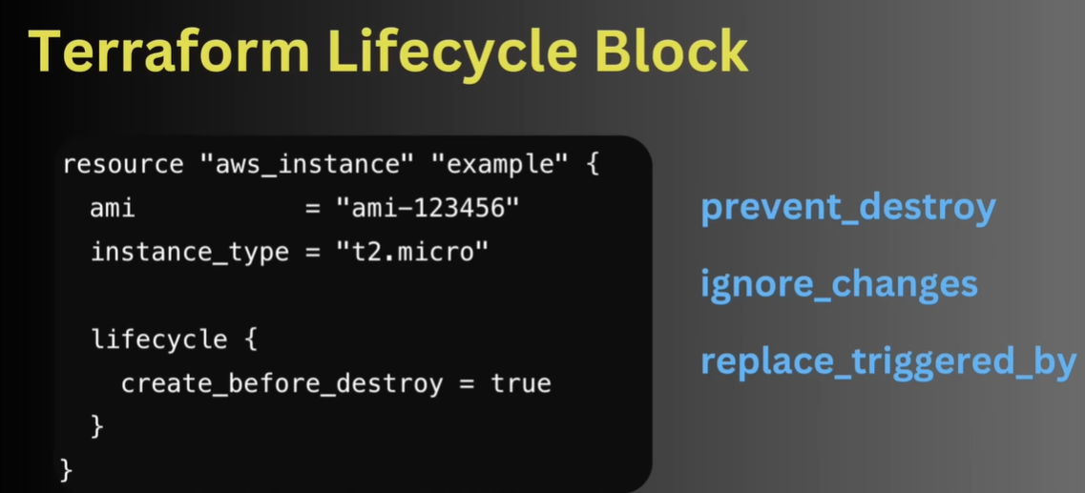
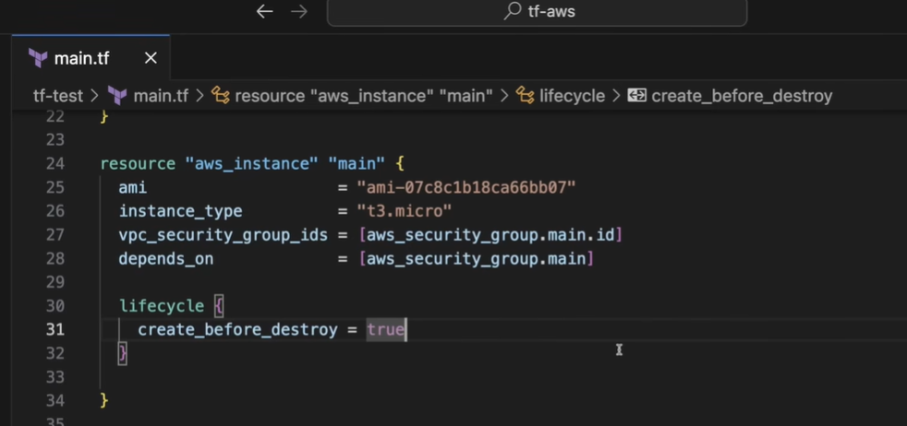
It will 1st create and then destroy so that project live on that will not go down.

++++++++++++++++++++++++++++++++++2nd -----------------------------------
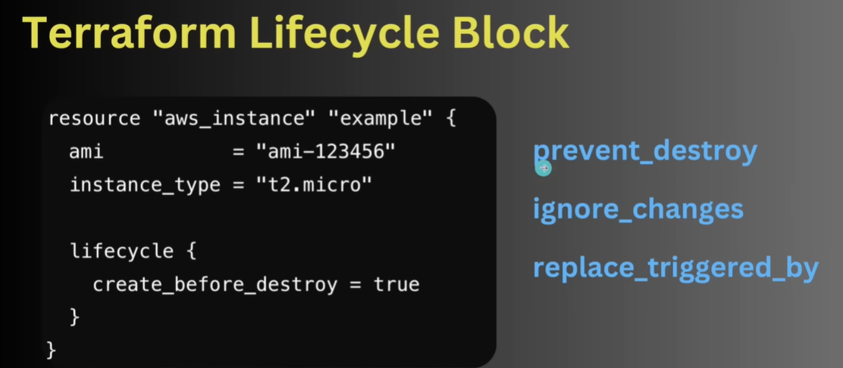
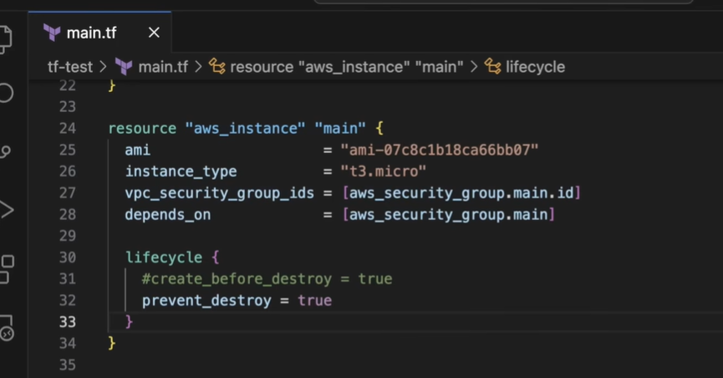
This will not let destroy the instance.
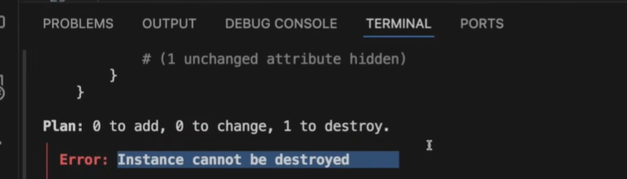

+++++++++++++++++++++++++++++++++++++++++++++++++++++++++++++++++++++++++++++++++++++
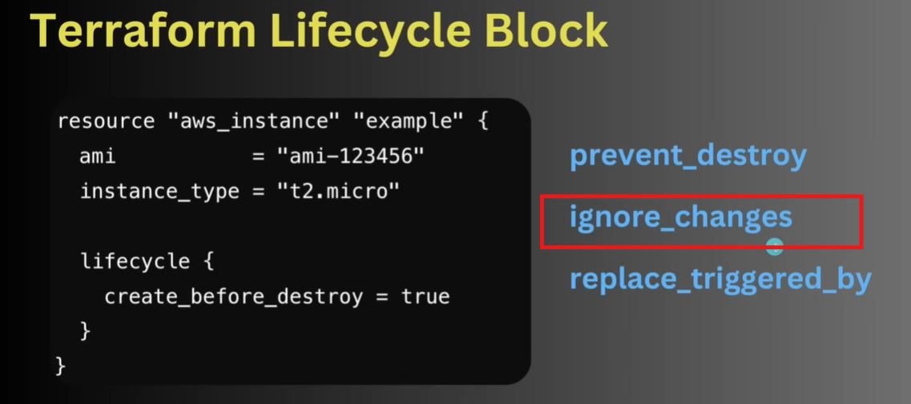
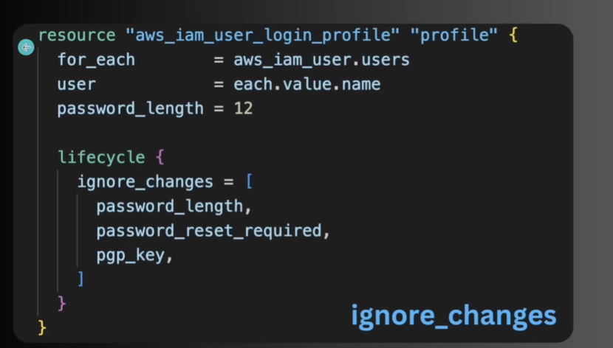
In this case if we change the password from 12 to 15 then it will rest the password of all the users to handle this change by ignore_changes. Mentioned parameter(password_length..) will not be change by this.

++++++++++++++++++++++++++++++++++++++++++++++++++++++++++++++++++++++++++++++++++++
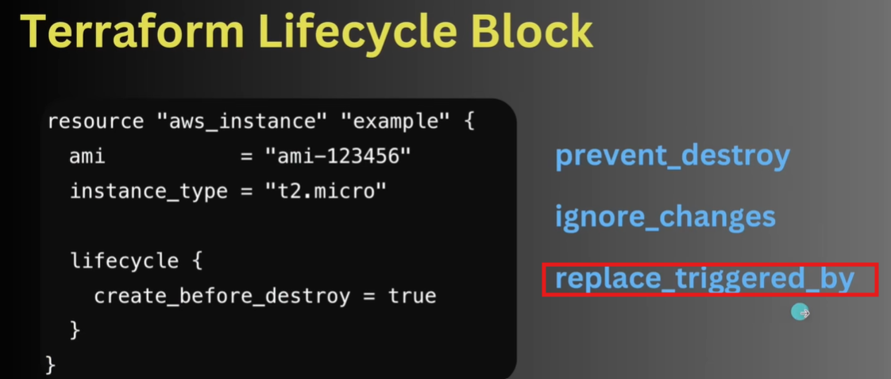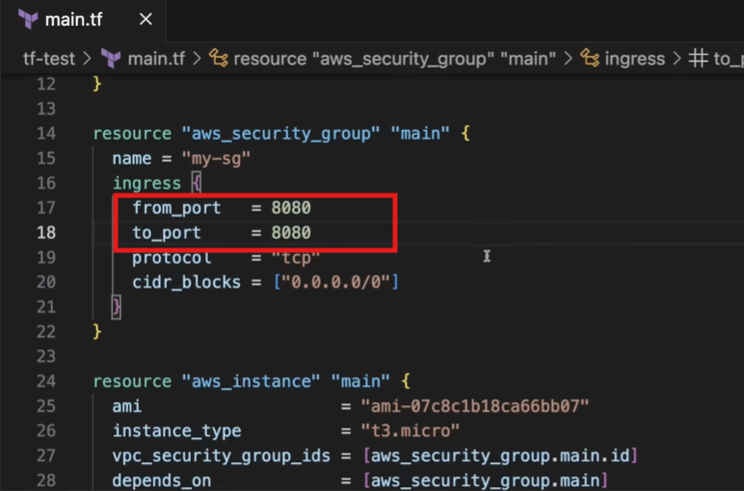
Suppose we change port from 80 to 8080.
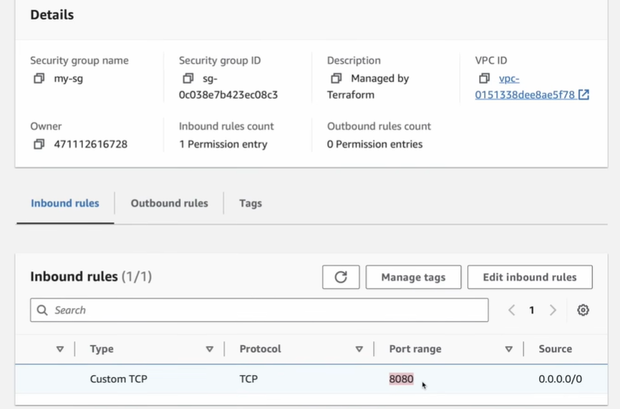
EC2 instance not affected but port updated in EC2.
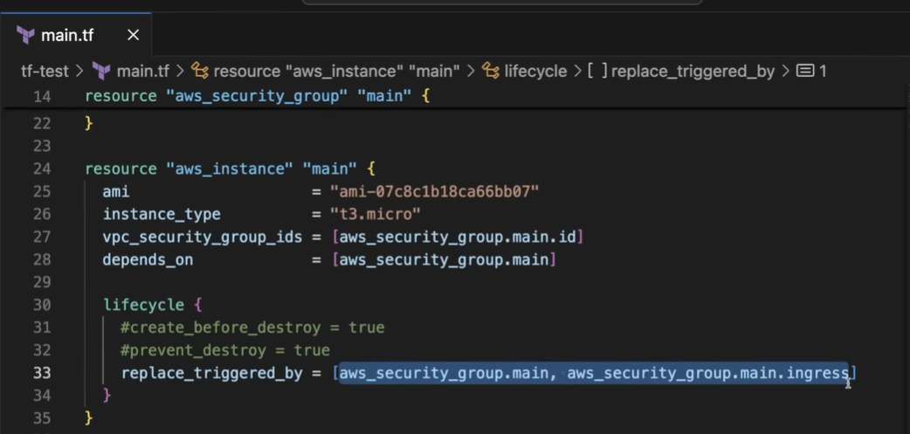
Now any change in security_group then it will create new instance.



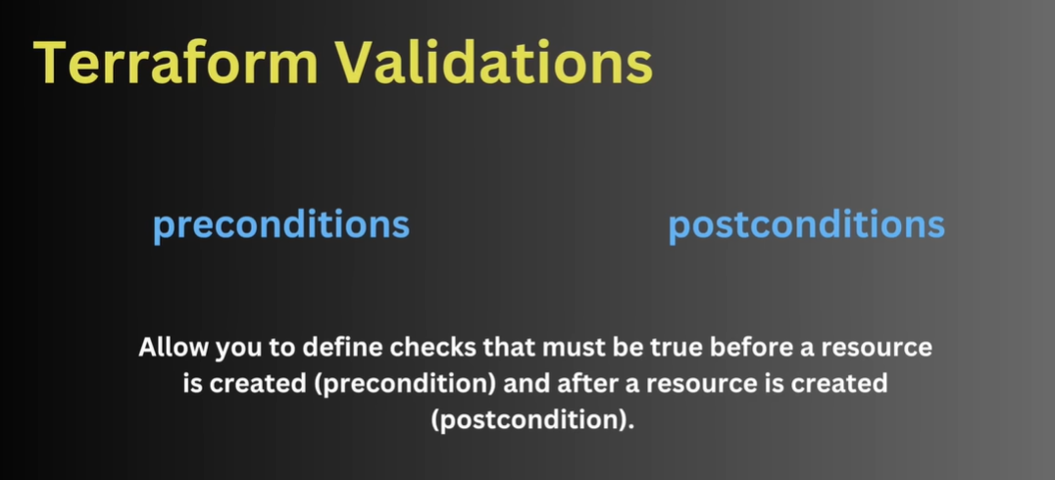

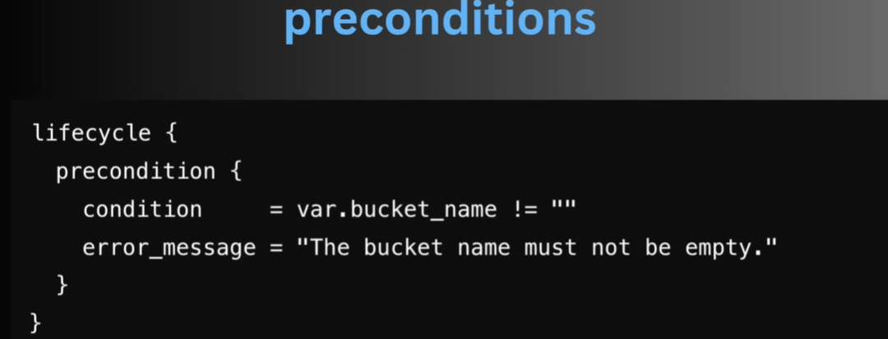
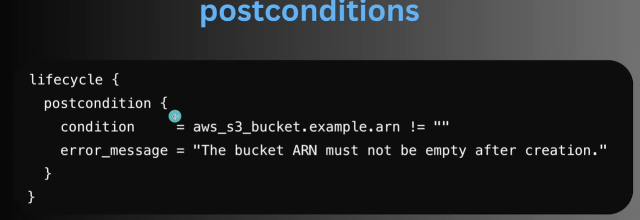
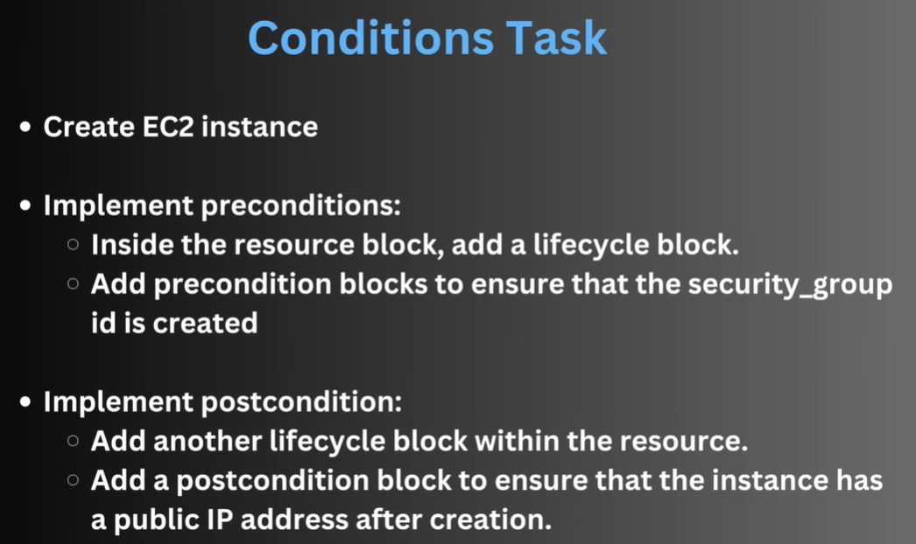
We can check pre and post condition
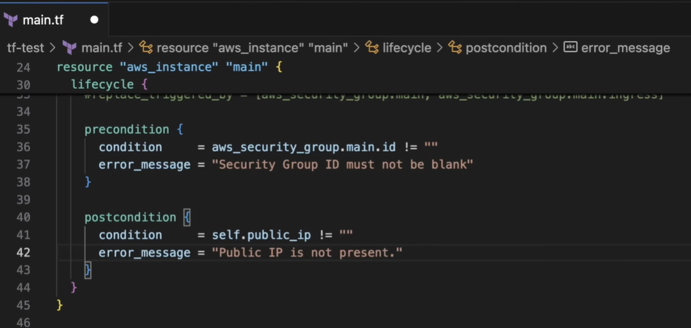

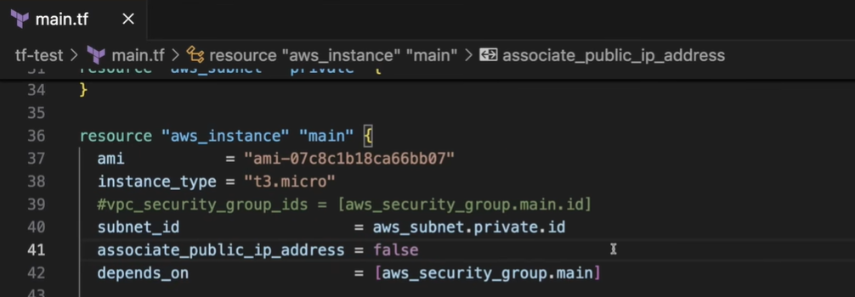
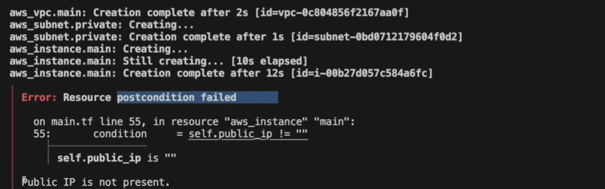

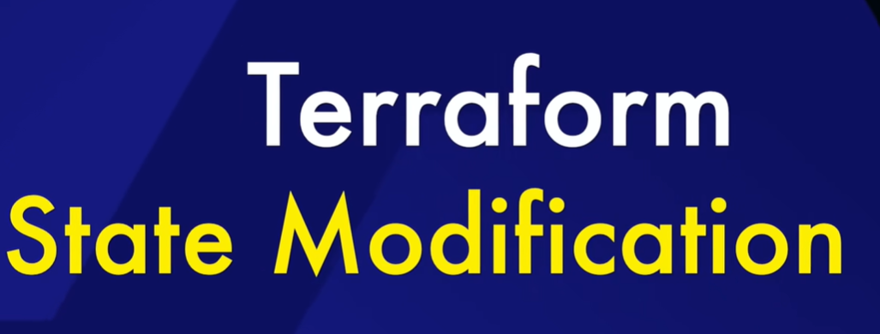
After apply we can track current stage
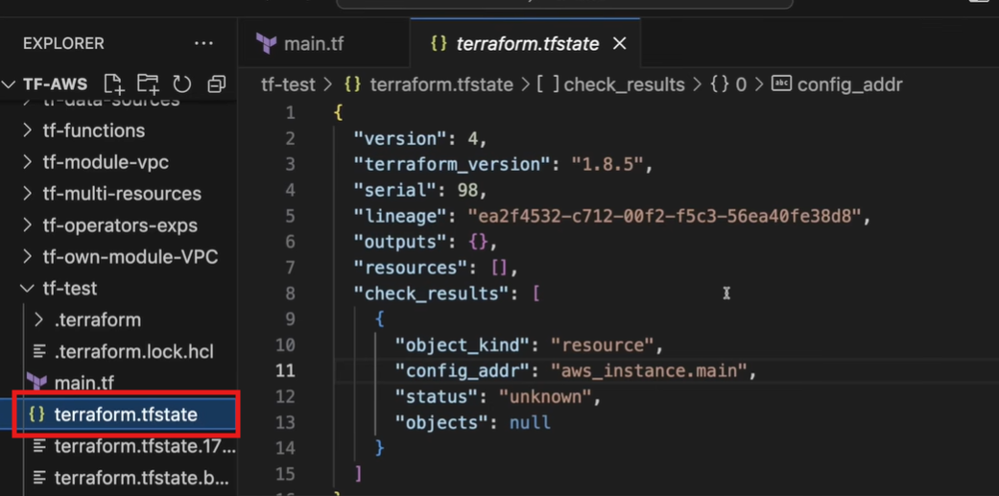
Now we can get all the state in terraform.tfstate
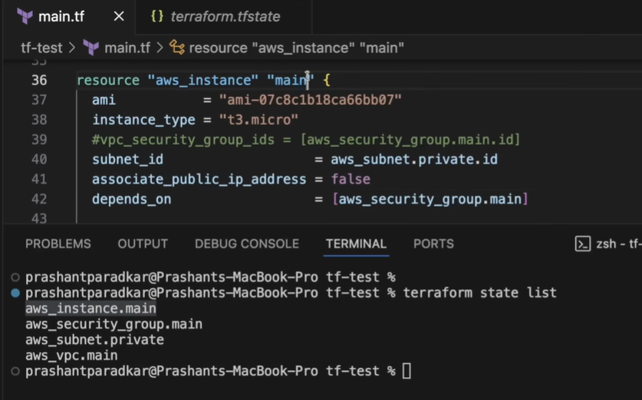
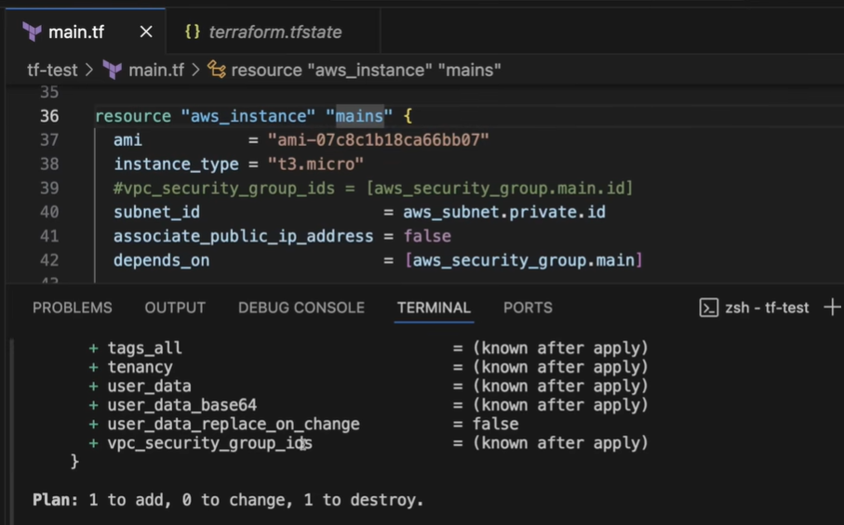
If we change the name of resource then it will create new resource. Main mains
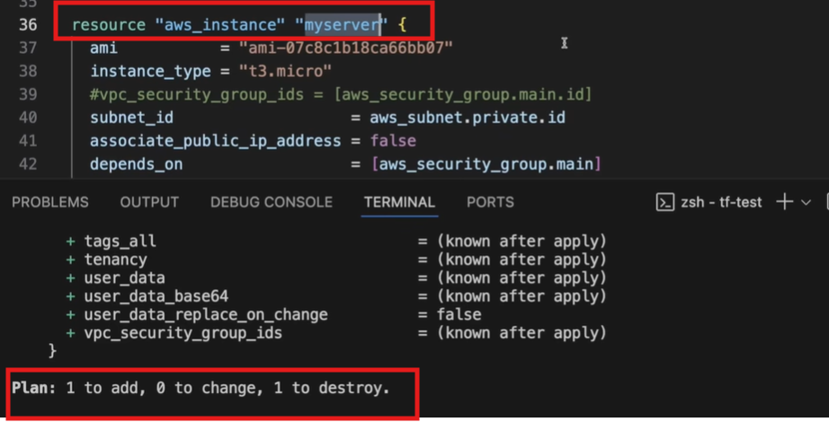
If we want to keep the same resource but only change the name then
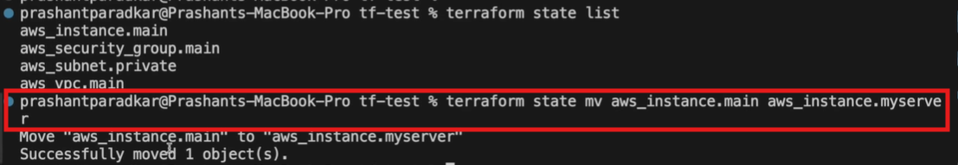
Name change from aws_instance.main to aws_instance.myserver
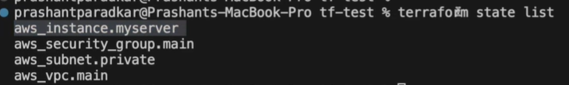
If we want to check the current state of any particular instance.
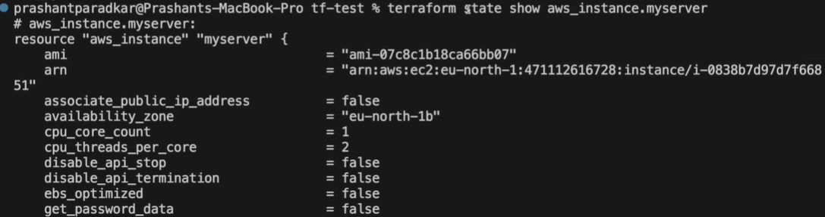

Commands
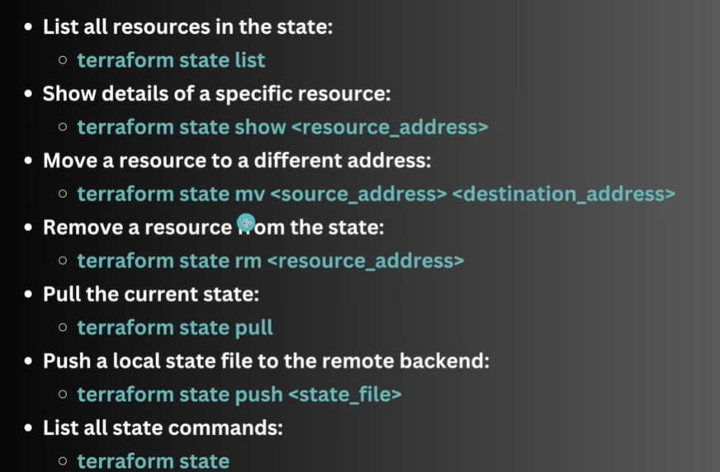

If we want to remove any instance

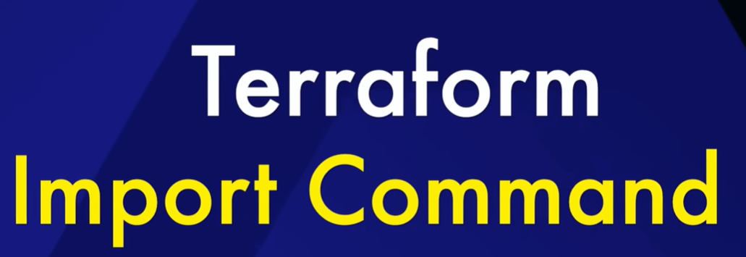
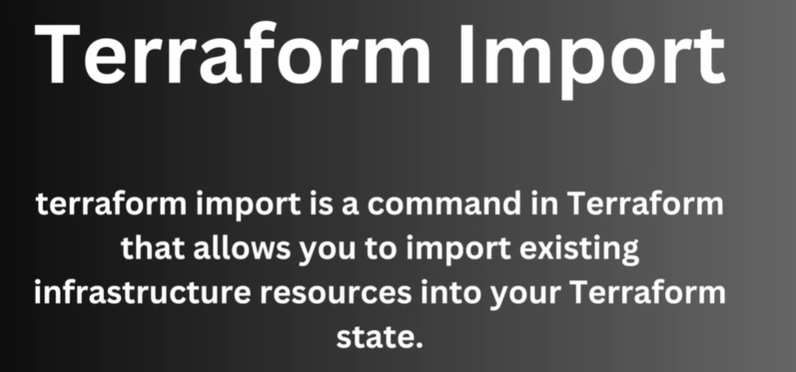
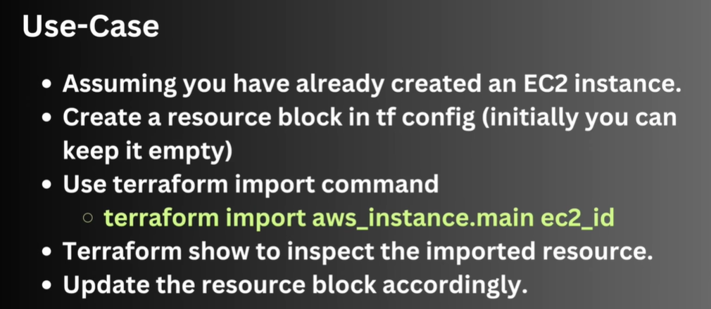

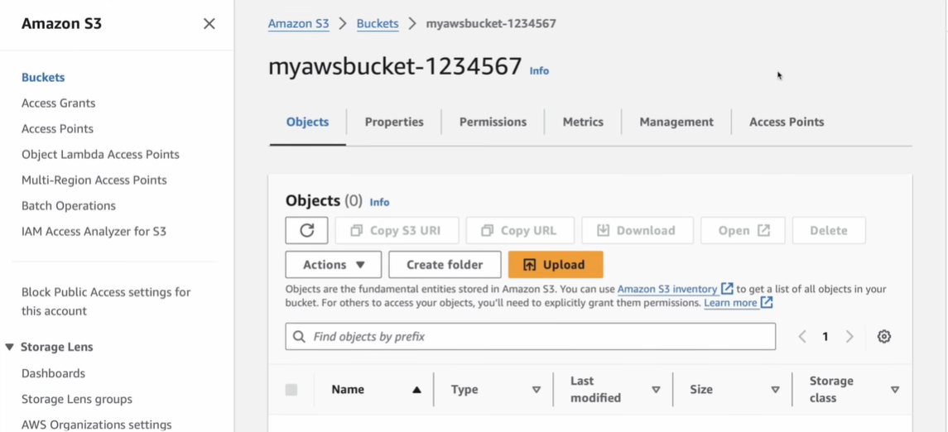
We don`t have to create new bucket but we have to use already created bucket.
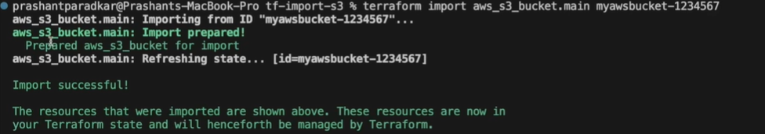

Now we can check the list

We can track the details of this bucket
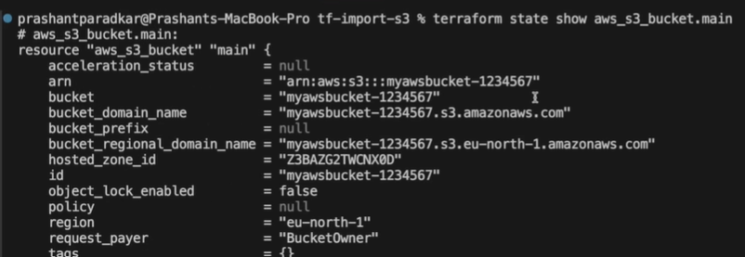
We can configure the other detail of bucket from information
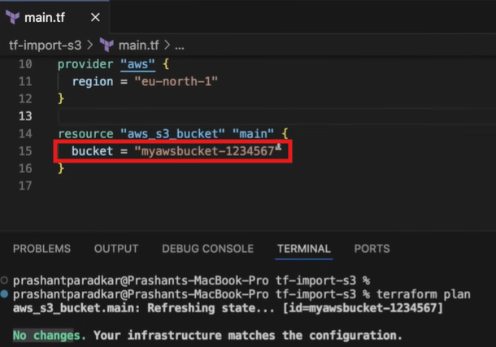

If we consider new name
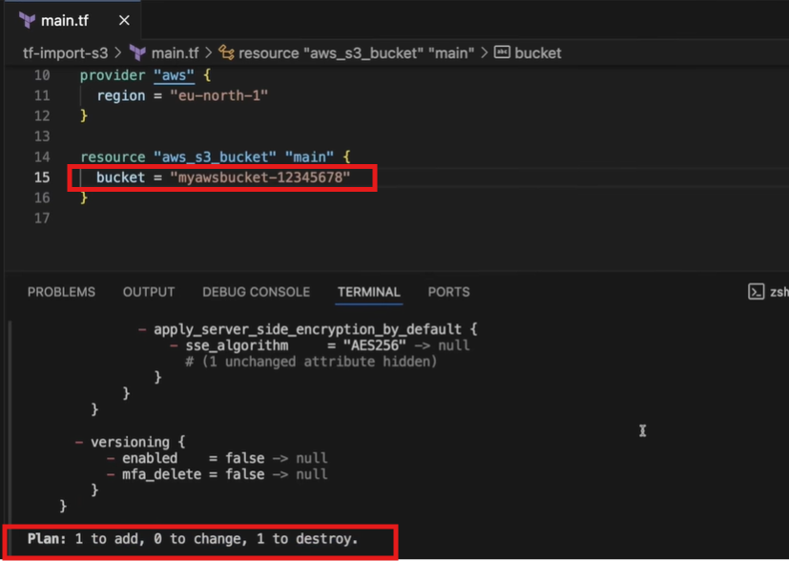

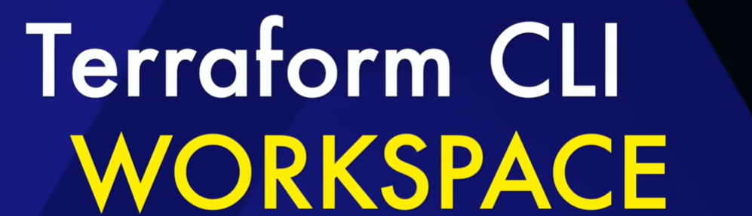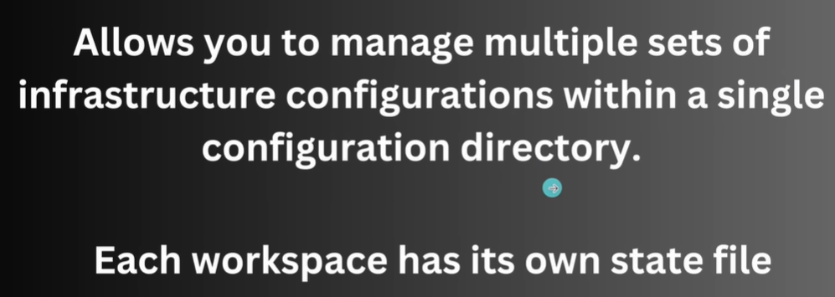

For different env there will be different workspace
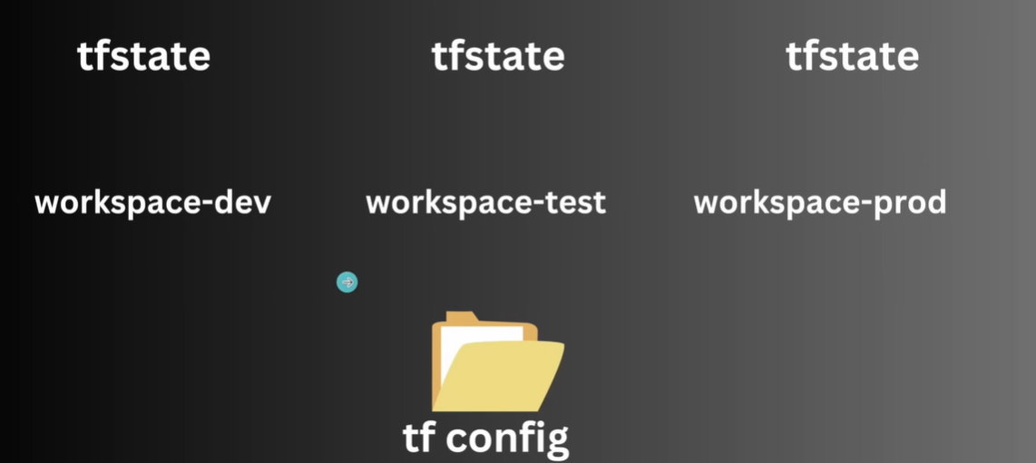

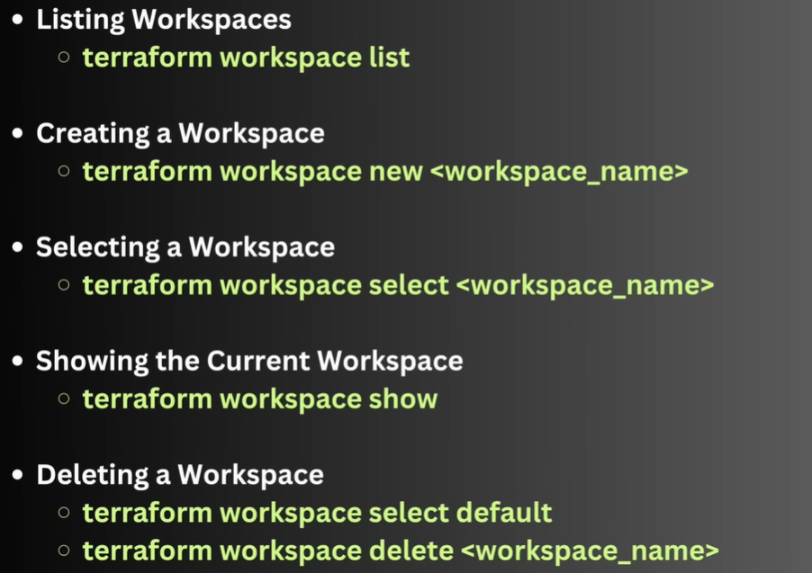

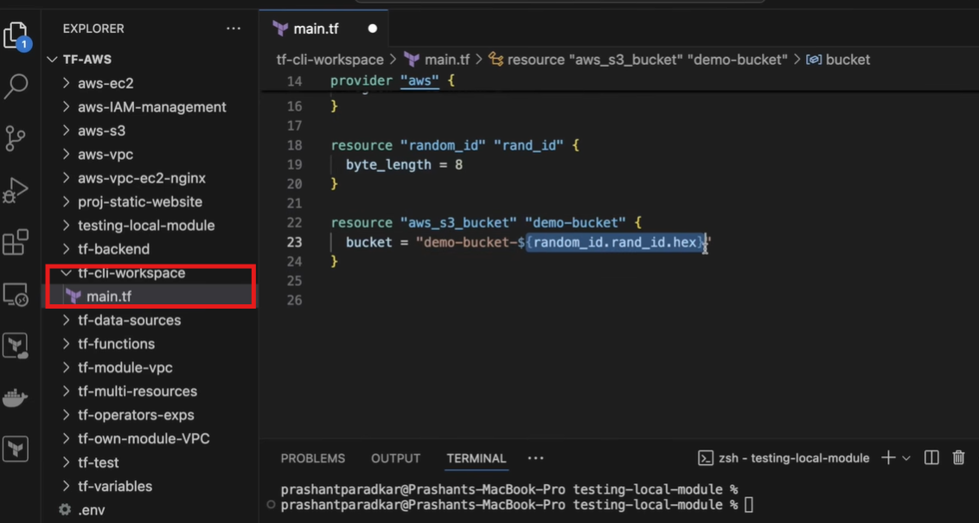
Workspace is created when we initialize it.
Teraaform provide the work space
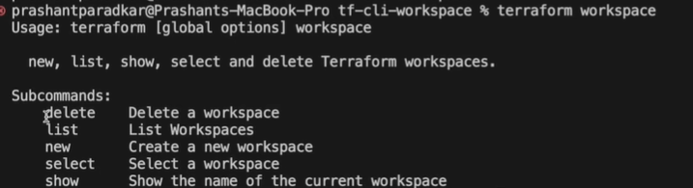

We can create new work space and it switched to new work space.
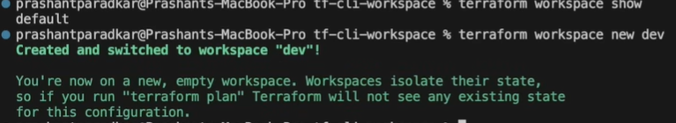
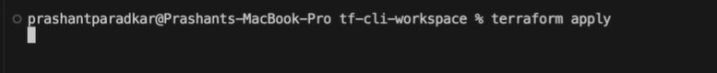
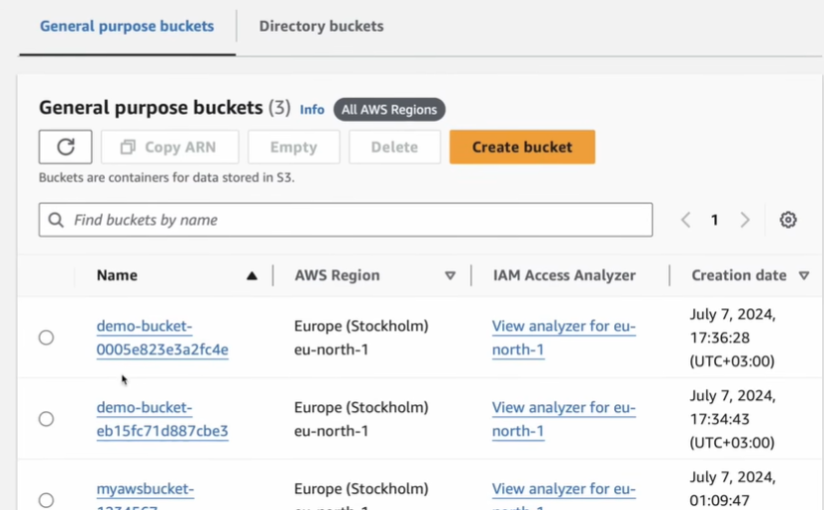
There are two buckets now.
Now how to differentialte for dev and default one.
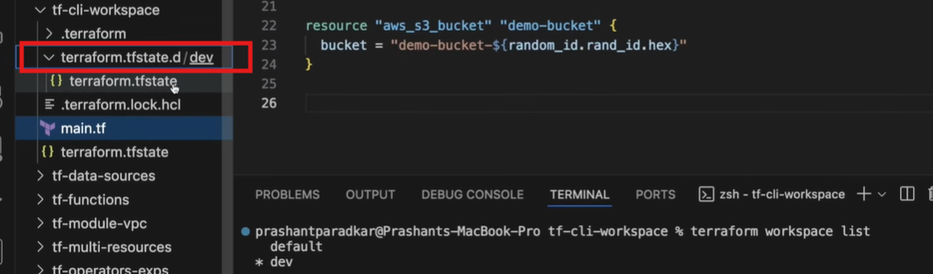
We can see that a new tfstage file is created.
Now we will make a small change to differentiate between workspace
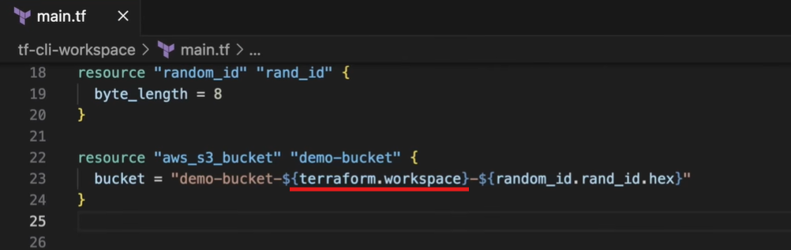
Now we will apply and check.
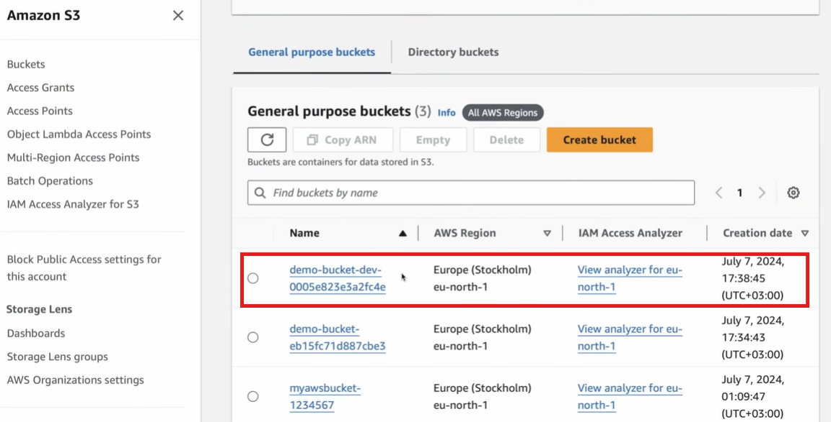

Now we will create one for Prod
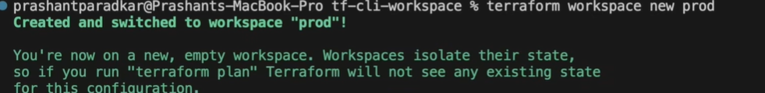

Now we will do terraform apply on Prod
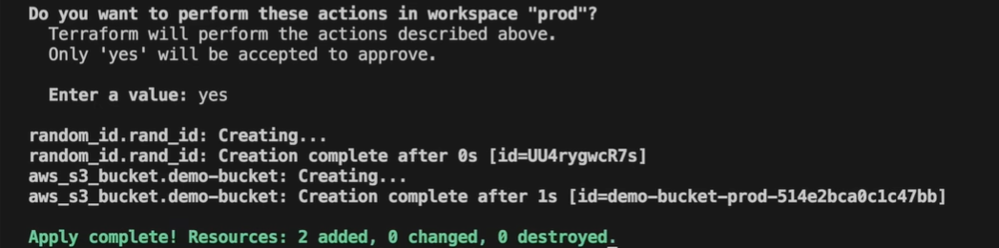

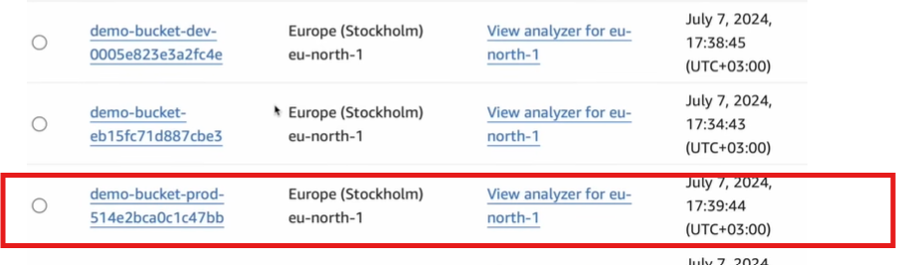
To switch on different work space
To delete a work space 1st we have switch to default then
We will get a warning
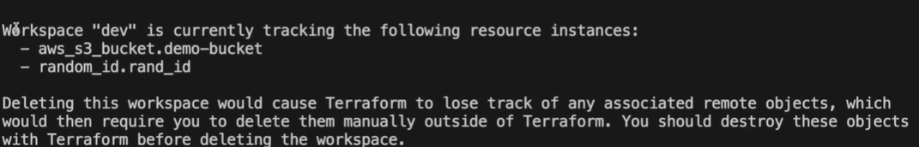

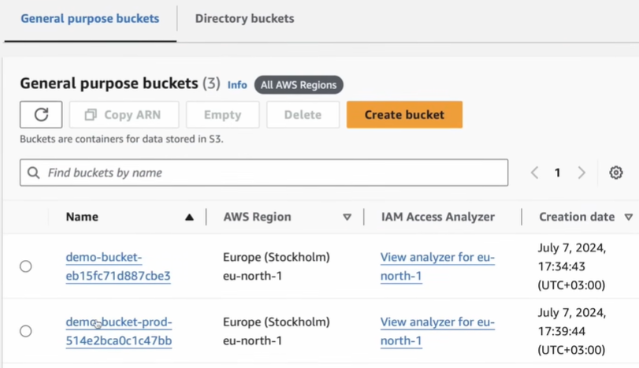

It`s not listing anything in dev
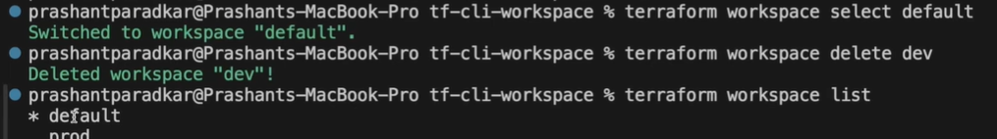
We can delete prod too

Now there is no any work space except default
