J P ACADEMY

**ASSIGNMENT (ACCOUNTANCY) XII**

(NON-TRADING CONCERN)

Date of allotment: Date of submission:

Q1. Shalimar Club had received in 2004-2005 As. 8,000 as subscription; Further information is:

Rs.

(i) Subscription due but not received on 1-4-2004 520

(ii) Subscription received in advance on 1-4-2004 240

(iii) Subscription due but not received on 31-3-2005 480

(iv) Subscription received in advance on 31-3-2005 70

What amount should be credited to Income and Expenditure Account as Subscription?

Q2. Gyandeep Society had received in 2004-05 Rs.15,000 towards subscription. Further information is:

Subscription for 2003-04 unpaid on 1-4-2004 were Rs. 1,000. Rs. 950 of which were received in 2004-05 Subscription paid in advance on 31-3-2004 were Rs. 400 and the same on 31-3-2005 were Rs. 525. Subscriptions for 2004-05 unpaid on 31-3-2005 were Rs. 1,275. What amount of subscription will be credited to Income and Expenditure Account?

Q3. The Income and Expenditure Account of Deshbandhu Education Society shows subscription for 2004-05 as   
 Rs. 30,000. Additional information is:

(i) Subscriptions for 2003-04 unpaid on 1-4-2004 was Rs. 1,800 ; Rs. 1560 of which was received in 2004-05.

(ii) Balance of subscription paid in advance on 1-4-2004, Rs. 780

(iii) Balance of subscription paid in advance on 31.3.2005, Rs. 420

(iv.) Balance of subscription for 2004-05 unpaid on 31.3.2005 Rs: 2100

Determine the amount of subscription received in cash during the year 2004-05.

Q4. In 2004-05, salaries paid in cash amounted to Rs. 2,000. Ascertain the amount chargeable to Income and   
 Expenditure Account for the year ending on 31st March, 2005 from the following additional information:

Rs.

Outstanding Salaries on 31-3-2004 150

Outstanding Salaries on 31-3-2005 225

Prepaid Salaries on 31-3-2004 90

Prepaid Salaries on 31-3-2005 70

Q5. From the following particulars, prepare Income and Expenditure Account of M/s Kalyan Club for the year   
 ended 31st March, 2005 and Balance Sheet as on that date:

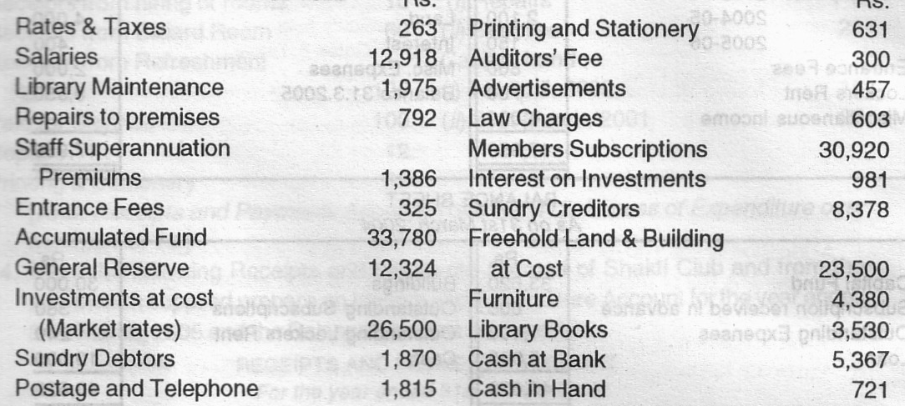

**Adjustments** : Members subscriptions to the extent of Rs. 785, are outstanding. Building Insurance Premium, (Included in postage and telephone) Rs. 240 annually has been prepaid for three months. Land and Building is to be depreciated © 2%, Furniture © 5% Books 10%, make a specific Reserve of 10% on Debtors.

Q6. The following is a summary of the cash transactions of Lakshmi Club for the year ended 31st March, 2005:

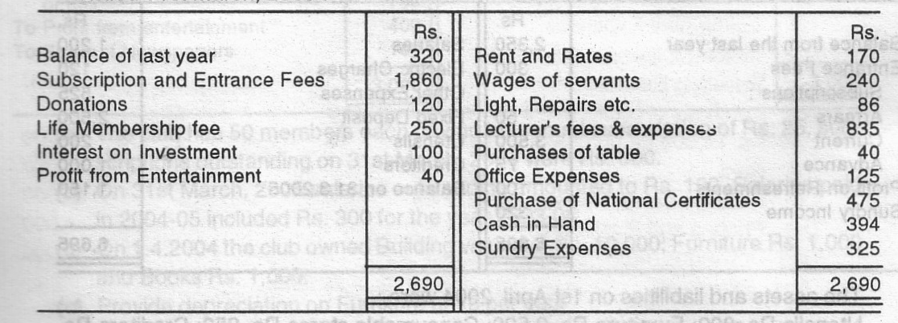

At the beginning of the year Lakshmi Club had investments worth As. 3,251 and musical instruments worth Rs. 870. There were 32 life members on that date, each of whom had paid to subscription of As 50. There was a separate fund for this purpose. Ordinary subscription in arrear at the beginning of the year amounted to As. 35 and at the end of the year to As. 45 and six months rent (Rs. 60) was due both at the beginning and at the end of the year.

Prepare Income and Expenditure Account of Lakshmi Club for the year ended 31st March, 2005 and Balance Sheet as on that date.

Q7. The following are the particulars of cash transactions for the year ended on 31st March, 2005 of the ‘Hindi Sahitya   
 Samiti:

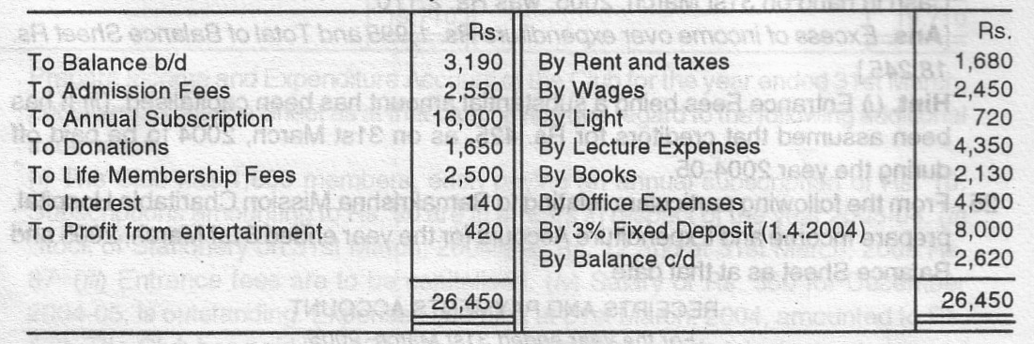

The following facts are furnished:

There were books costing Rs. 20,000 and Furniture worth Rs. 8,500 on April 1, 2004.   
 (i) Outstanding annual subscription on April 1, 2004 Rs. 350 and 31 .3.2005 Rs. 450.   
 (ii) Rs. 600 for Rent were outstanding on April 1, 2004 as well as on 31.3.2005.   
 (iii) Provide depreciation on books As. 1,130 and on Furniture Rs. 500.

Prepare Income and Expenditure Account for the year ended on 31st March, 2005 and a Balance Sheet

Q.8 Calculate the amount to be shown at respective places:

Balances of Prize fund as on 1-1-90 Rs.50000  
 Balance of Prize Fund Investment on 1-1-90 Rs.50000  
 (invested in 15% Govt. Bonds)   
 Prize distributed during the year Rs.6000  
 Interest on prize fund received Rs. 5000

Q9. From the following particulars relating to Ramakrishna Mission Charitable Hospital, prepare Income and   
 Expenditure Account for the year ended 31st March, 2005 and Balance Sheet as at that date.

RECEIPTS AND PAYMENTS ACCOUNT

For the year ended 31st March, 2005

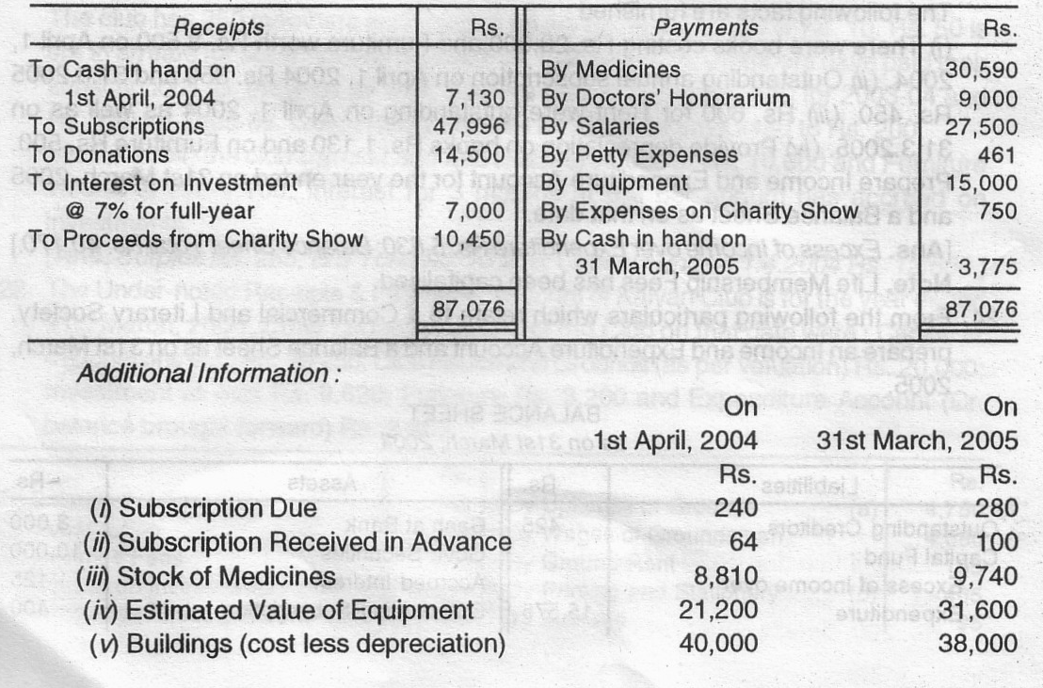

Q10. From the following Receipts and Payments Account of a Cricket Club and the additional information prepare   
 an Income and Expenditure Account for the year ended on 31st March, 2005:

RECEIPTS AND PAYMENTS ACCOUNT

For the year ended 31st March, 2005

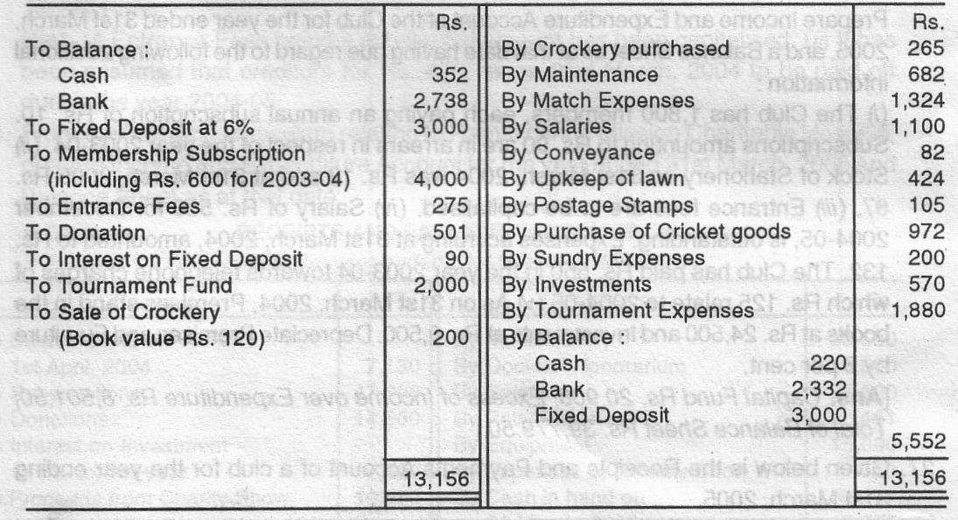

**Information:** (a) Monthly Salary is Rs. 100 (b) The value of unused postage stamps is as follows : 31st March, 2004 Rs. 75; 31st March, 2005 Rs. 90, (c) Stock of Cricket equipment is as follows : 31st March, 2004, Rs. 321; 31st March, 2005 Rs. 280, d) Arrear of membership subscription: 2003-04 Rs. 660 : 2004-05 Rs. 800. (e) Donation and Entrance Fees are not to be capitalised.

(Ans. Opening Balance Sheet: Capital Fund in the beginning As. 7,266. Excess 0f Income over Expenditure. Rs. 221 & Total of Closing Balance Sheet Rs. 7,707)