PARTS OF SPEECH

There are eight parts of speech in the English language: noun, pronoun, verb, adjective, adverb, preposition, conjunction, and interjection. The part of speech indicates how the word functions in meaning as well as grammatically within the sentence. An individual word can function as more than one part of speech when used in different circumstances.
Part -1

 | Parts of speech | Function or job | Example words | Example sentences
1. | NOUN | thing or person | pen, dog, work, music, town, London, teacher, John | My dogs are big. I like big dogs.
2. | PRONOUN | replaces a noun | I, we, you, they , he, she, it | Tara is Indian. She is beautiful.
3. | VERB | action or state | (to) be, have, do, like, work, sing, can, must | EnglishClub is a web site. I like EnglishClub
4. | ADJECTIVE | describes a noun | good, big, red, well, interesting | My dogs are big. I like big dogs.
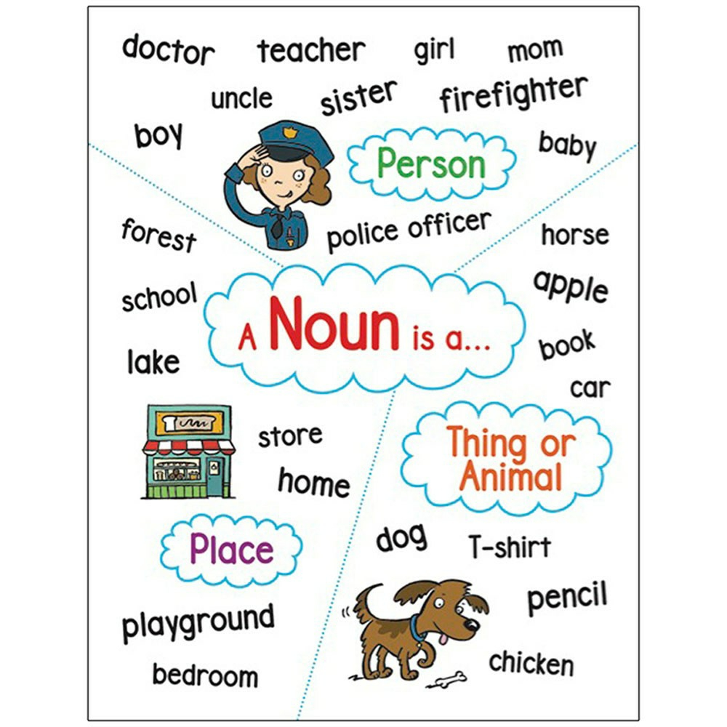

PRONOUN
