***High level Documentation of the RapidFort Internship Project Submission***

**NOTE:** To run the project locally, change the database to SQLite3 in settings.py and make migrations. Just uncomment the SQLite3 and comment out the online service (PostgreSQL).

**Technical Stack:**

* Python (Django and other system level libraries)
* HTML/CSS/JavaScript (For webpages and checkboxes)
* PostgreSQL (AIVEN Online PostgreSQL Hosting Database)
* Docker (Containerization)

***Description:***

* Users can convert files like, but not limited to, DOCX to a more portable and a lightweight format, PDF.
* Users can also retrieve their previous conversions in-case they lose a copy of their PDF.
* Users must login and then they can convert their files and have a password encryption.
* This encryption allows users to keep their pdfs safe.

***Technical Description:***

* API Endpoints:
  + login/ - for logging in.
  + register/ - for a new user signup.
  + upload/ - for uploading the files.
  + history/ - for previous downloads of the user.
  + logout/ - for logging out of the service.
* Services used:
  + Online PostgreSQL database by AIVEN for free hosting of PostgreSQL database
  + Docker – used for containerization
  + It is a microservices architecture.
* Programming:
  + Python (Django) is used for managing authentication, file uploading, conversion and database manipulation. HTML/CSS/JavaScript were used for the frontend which involved components-based design using Django templates.
  + Docker – used for containerization.

***Images of the project:***

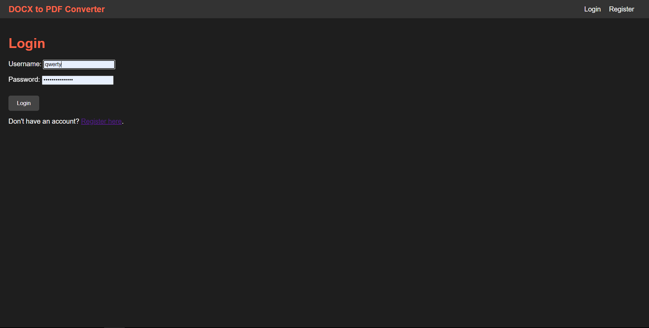

Figure Login Page

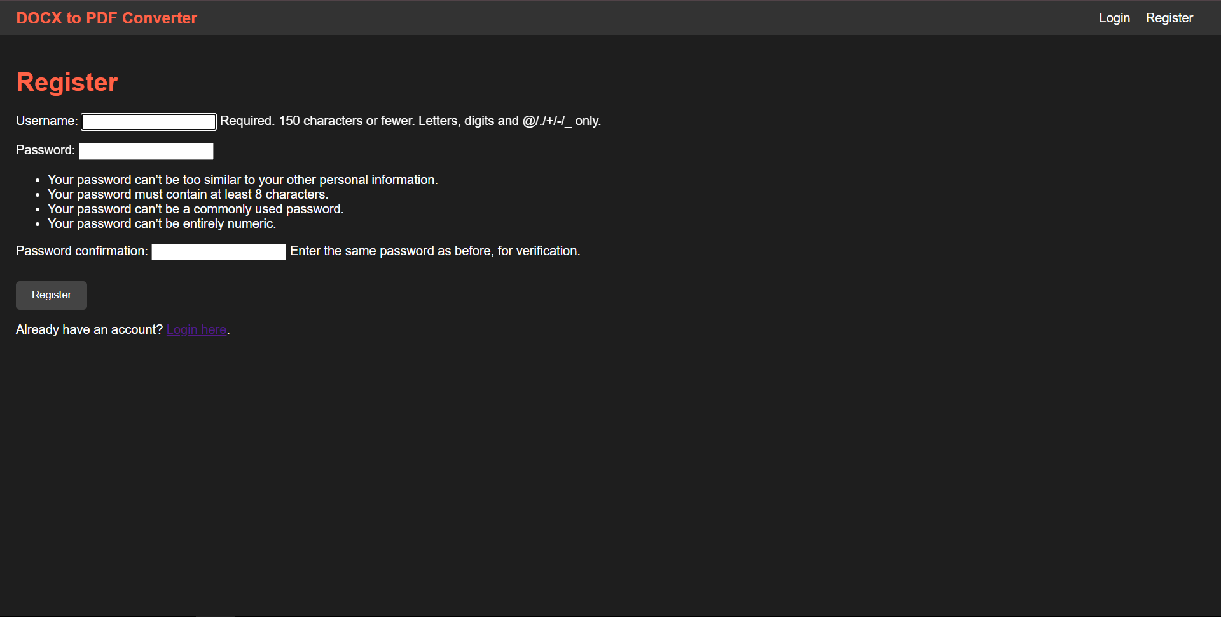

Figure Register Page

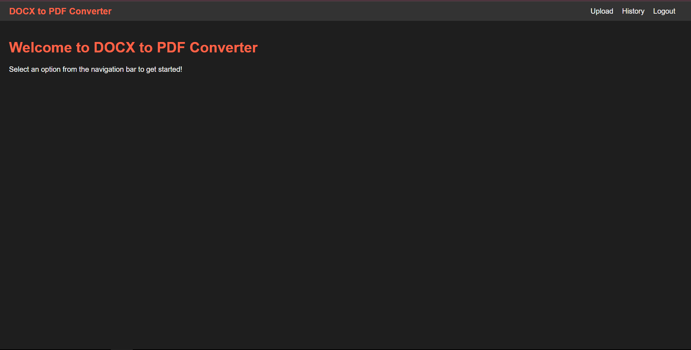

Figure Homepage

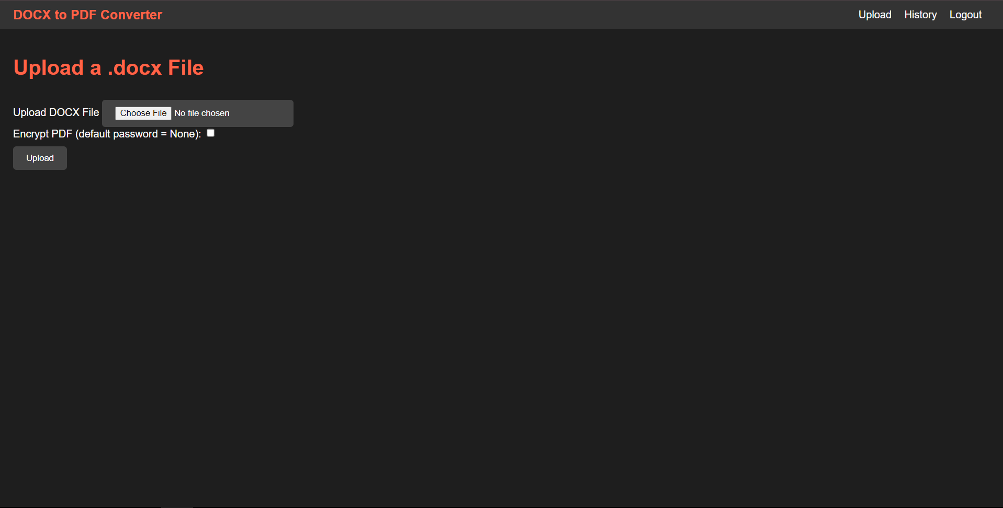

Figure Upload Page

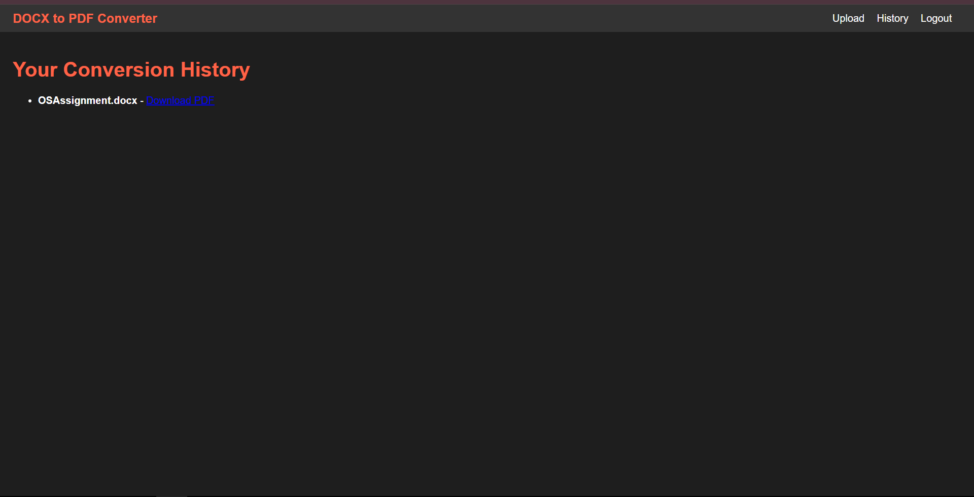

Figure History Page