**A PROJECT REPORT**

ON

**”Brain Tumor Detection Using Deep learning”**

**Submitted to**

**UNIVERSITY OF MUMBAI**

In partial fulfillment of the requirements for the degree of

**Bachelor of Engineering**

BY

Aryan Sarkar

Sarfaraz Haider Ali

Shaikh Mohammad Danish

Mohammad Suleman

RollNo.(20co44)

RollNo.(20co43)

RollNo.(20co51)

RollNo.(20co36)

UNDER THE GUIDANCE OF

**(Prof. Salim G.Shaikh)**



**Department of Computer Engineering,**

**Anjuman-I-Islam’s Kalsekar Technical Campus School of**

**Engineering and Technology**

Plot No. 2 & 3, Sector - 16, Near Thana Naka, Khanda Gaon, New Panvel, Navi Mumbai. 410206

**Academic Year : 2023-2024**

**AFFILIATED TO**

**UNIVERSITY OF MUMBAI**

**A Project II Report**

ON

**”Brain Tumor Detection Using Deep learning”**

**Submitted to**

**UNIVERSITY OF MUMBAI**

In partial fulfillment of the requirements for the degree of

**Bachelor of Engineering**

by

Aryan Sarkar

Sarfaraz Haider Ali

Shaikh Mohammad Danish

Mohammad Suleman

RollNo.(20co44) RollNo.(20co43) RollNo.(20co51) RollNo.(20co36)

UNDER THE GUIDANCE OF

**(Prof. Salim G.Shaikh)**



**Department of Computer Engineering,**

**School of Engineering and Technology Anjuman-I-**

**Islam’s Kalsekar Technical Campus**

Plot No. 2 & 3, Sector - 16, Near Thana Naka, Khanda Gaon, New Panvel, Navi Mumbai. 410206

**Academic Year : 2023-2024**

**AFFILIATED TO**



**UNIVERSITY OF MUMBAI**

**Anjuman-I-Islam’s Kalsekar Technical Campus Department of Computer Engineering,**

**School of Engineering and Technology, Anjuman-I-**

**Islam’s Kalsekar Technical Campus**

Khanda Gaon,New Panvel, Navi Mumbai. 410206



**CERTIFICATE**

This is to certify that the project entitled

***“Brain Tumor Detection Using Deep Learning ”***

submitted by

Aryan Sarkar

Sarfaraz Haider Ali

Shaikh Mohammad Danish

Mohammad Suleman

RollNo.(20co44)

RollNo.(20co43)

RollNo.(20co51)

RollNo.(20co36)

is a record of bonafide work carried out by them, in the partial fulfilment of the requirement for the award of Degree of Bachelor of Engineering (Computer Engineering) at **Anjuman-I- Islam’s Kalsekar Technical Campus, Navi Mumbai** under the University of MUMBAI. This work is done during year 2023-2024, under our guidance.

**Date: /04 /24**.

**Prof. Salim G. Shaikh**

Supervisor

**Prof. Tabrez Khan**

Head of Department

**Prof. Nusrat Jahan**

Project Coordinator

**Dr.Rajendra Magar**

Dean, SoET

**External Examiner**

**ACKNOWLEDGMENT**

We would like to take the opportunity to express our sincere thanks to our guide **Prof. Salim G. Shaikh**, Assistant Professor, Department of Computer Engineering, AIKTC, School of Engi- neering, Panvel for his/her invaluable support and guidance throughout our project research work. Without his/her kind guidance & support this was not possible.

We are grateful to his for his timely feedback which helped us track and schedule the process effectively.His time, ideas and encouragement that he gave is help us to complete our project efficiently.

We would like to express deepest appreciation towards **Dr.Rajendra Magar**, Dean, SoET, Navi Mumbai, **Prof. Tabrez Khan**, Head of Department of Computer Engineering and **Prof. Nusrat Jahan**, Project Coordinator whose invaluable guidance supported us in completing this project.

At last we must express our sincere heartfelt gratitude to all the staff members of Computer Engineering Department who helped us directly or indirectly during this course of work.

**Aryan Sarkar**

**Sarfaraz Haider**

**Shaikh Mohammad Danish Mohammad Suleman**

**Project II Approval for Bachelor of Engineering**

This project entitled ***Brain Tumor Detection Using Deep Learning*** by ***Aryan Sarkar, Sarfaraz Haider Ali , Shaikh Mohammad Danish , Mohammad Suleman ,*** is approved for the degree of ***Bachelor of Engineering in Department of Computer Engineering.***

Examiners

1. ..............................

2. ..............................

Supervisors

1. ..............................

2. ..............................

Chairman



**Declaration**

We declare that this written submission represents our ideas in our own words and where other ideas or words have been included, we have adequately cited and referenced the original sources. We also declare that we have adhered to all principles of academic honesty and in- tegrity and have not misrepresented or fabricated or falsified any idea/data/fact/source in our submission. We understand that any violation of the above will be cause for disciplinary action by the Institute and can also evoke penal action from the sources which have thus not been properly cited or fromwhom proper permission has not been taken when needed.

Aryan Sarkar

Sarfaraz Haider Ali

Shaikh Mohammad Danish Mohammad Suleman

RollNo.(20co44) RollNo.(20co43) RollNo.(20co51) RollNo.(20co36**)**

**Abstract**

**Tittle: Brain Tumor Detection Using Deep Learning**

This project, "Brain Tumor Detection Using Deep Learning," is a significant initiative in the field of medical diagnostics. It leverages the power of machine learning algorithms, specifically Convolutional Neural Networks (CNN) and Artificial Neural Networks (ANN), to predict the presence of brain tumors. The project involves training the models on a large dataset of brain scan images, allowing them to learn and identify the unique patterns and characteristics associated with brain tumors. The CNN model is particularly effective in identifying spatial patterns, making it ideal for image analysis. On the other hand, the ANN model excels at learning complex, non-linear relationships, which is crucial in medical diagnostics.The aim of this project is to provide a reliable, non-invasive method for early-stage brain tumor detection. By accurately identifying the presence of tumors, medical professionals can initiate treatment promptly, leading to improved patient outcomes, including higher survival rates and better quality of life. This project not only underscores the potential of deep learning in healthcare but also highlights the commitment to harnessing technology for societal benefit .It also explores various segmentation techniques, including clustering, edge-based methodology, compression-based methods, region- based strategies, pixel-level approaches, and graph-based algorithms. The study found that CNN- based models achieved the highest accuracy, averaging approximately 96%. However, classical deep learning methods also performed well, suggesting their continued utility in this field.

**Keywords: Deep Learning, Machine Learning, Convolutional Neural Networks (CNN), Artificial**

**Neural Networks (ANN), Brain Tumor Detection, Medical Diagnostics, Image Analysis, Spatial Patterns, Non-linear Relationships, Early Detection, Healthcare Technology, Survival Rates,**

**Quality of Life.**

Aryan Sarkar

Sarfaraz Haider Ali

Shaikh Mohammad Danish

Mohammad Suleman

RollNo.(20co44)

RollNo.(20co43)

RollNo.(20co51)

RollNo.(20co36)

B.E. (Computer Engineering)

University of Mumbai.

**Contents**

**1 Introduction 1**

1. 1 Purpose 2

1.2 Project Scope 2

1.3 Project Goals and Objectives 3

1.3. 1 Goals 3

1.3.2 Objectives 3

1.4 Organization of Report 3

**2 Literature Survey** **4**

2. 1 Paper Title-I 4

2. 1. 1 Advantages of Paper 4

2. 1.2 Disadvantages of Paper 4

2.1.3 How to overcome the problems mentioned in Paper 4

2.2 Paper Title-II 4

2.2. 1 Advantages of Paper 4

2.2.2 Disadvantages of Paper 4

2.2.3 How to overcome the problems mentioned in Paper 4

2.3 Paper Title-III 4

2.3. 1 Advantages of Paper 4

2.3.2 Disadvantages of Paper 4

2.3.3 How to overcome the problems mentioned in Paper 4

2.4 Technical Review 4

2.4. 1 Advantages of Technology 4

2.4.2 Reasons to use this Technology 4

**3 Project Planning** **5**

3. 1 Members and Capabilities 5

3.2 Roles and Responsibilities 5

3.3 Assumptions and Constraints 5

3.4 Project Management Approach 5

3.5 Ground Rules for the Project 5

3.6 Project Budget 5

3.7 Project Timeline 5

**4 Software Requirements Specification** **6**

4. 1 Overall Description 6

4. 1. 1 Product Perspective 6

4. 1.2 Product Features 6

4. 1.3 User Classes and Characteristics 6

4. 1.4 Operating Environment 6

4. 1.5 Design and Implementation Constraints 6

4.2 System Features 6

4.2. 1 System Feature 6

4.3 External Interface Requirements 6

4.3. 1 User Interfaces 6

4.3.2 Hardware Interfaces 6

4.3.3 Software Interfaces 6

4.3.4 Communications Interfaces 6

4.4 Nonfunctional Requirements 6

4.4. 1 Performance Requirements 6

4.4.2 Safety Requirements 6

4.4.3 Security Requirements 6

**5 System Design** **7**

5. 1 System Requirements Definition 7

5. 1. 1 Functional requirements 7

5.1.2 System requirements (non-functional requirements) 7

5.2 System Architecture Design 7

5.3 Sub-system Development 7

5.3. 1 Module1 7

5.3.2 Module2 7

5.3.3 Module3 7

5.4 Systems Integration 7

5.4. 1 Class Diagram 7

5.4.2 Sequence Diagram 7

**6 Implementation 8**

**7 System Testing 9**

7. 1 Test Cases and Test Results 9

7.2 Sample of a Test Case 9

7.2. 1 Software Quality Attributes 9

**8 Screenshots of Project 10**

**9 Conclusion and Future Scope 14**

9. 1 Conclusion 14

9.2 Future Scope 14

**References 15**

**Achievements** **1****6**



**Chapter 1**

**Introduction**

**1.1 Purpose**

The purpose of this project is to develop and implement a deep learning-based system for the detection and classification of brain tumors using MRI images. The project aims to leverage the capabilities of Convolutional Neural Networks (CNNs) and Artificial Neural Networks (ANNs) to automate the process of identifying various types of brain tumors, which is a critical step in the diagnosis and treatment planning for patients with brain cancer. By utilizing advanced deep learning models, the project seeks to improve the accuracy, efficiency, and reliability of brain tumor detection compared to traditional manual diagnosis methods.

**1.2 Project Scope**

Data Collection: Acquiring a comprehensive dataset of brain MRI images, which may include publicly available datasets such as TCGA-LGG, TCIA, and othersModel Development: Designing and training deep learning models, specifically CNNs and ANNs, to recognize and classify brain tumors from MRI imagesModel Optimization: Fine-tuning the models to achieve high accuracy and generalizability across different types of brain tumors, including glioma, meningioma, and pituitary tumorsValidation and Testing: Evaluating the performance of the models using appropriate metrics such as accuracy, precision, recall, and F1-score on a separate testing datasetImplementation: Developing a user-friendly interface or system that can be used by healthcare professionals to assist in the diagnosis of brain tumors.

**1.3 Goals**

**Enhance Diagnostic Accuracy:** To significantly improve the accuracy of brain tumor detection and classification, thereby aiding radiologists and oncologists in making more informed decisions

**Reduce Diagnosis Time:** To decrease the time required for diagnosing brain tumors by automating the detection process, allowing for quicker treatment initiationIncrease Accessibility: To create a system that can be easily accessed and used by medical professionals, potentially even in resource- limited settings.

**1.4 Objectives**

**Develop Robust Models:** To construct CNN and ANN models that are robust to variations in tumor size, shape, and location within the brain.

**Achieve High Performance:** To reach a target performance metric, such as an accuracy rate above a certain threshold, for the classification of brain tumors

Department of Computer Engineering, AIKTC, New Panvel, Navi Mumbail

10

**Chapter 2**

**Literature Survey**

[1]Saeedi et al. (2023) provide a comprehensive methodology that integrates deep learning and

machine learning methodologies for brain tumor classification. Their 2D Convolutional Neural Network (CNN) delivers great accuracy and recall, making it a feasible solution for healthcare applications and facilitating early tumor diagnosis.[2]Zaw et al. (2019) address the detection of grade- 4 tumor Glioblastoma multiforme (GBM) using Naïve Bayes classification. Their method demonstrates outstanding accuracy and detection rates for both tumor and non-tumor brain tissues, benefiting medical professionals in diagnosing brain cancer, particularly GBM.[3]Kshirsagar et al. (2020) propose an automated brain tumor diagnosis system employing texture information collected from MRI images. Their machine learning-based approach achieves great accuracy, highlighting the promise of automatingthe brain tumor identification procedure.[4]Siar and Teshnehlab (2019) offer a hybrid strategy integrating feature extraction techniques and Convolutional Neural Network (CNN) classifiers. Their approach dramatically enhances tumor detection accuracy, presenting a promising answer for precise diagnosis and treatment planning.[5]Hossain et al. (2019) handle the tough task of brain tumor segmentation using Fuzzy C-Means clustering and Convolutional Neural Networks (CNN). Their suggested CNN-based technique demonstrates excellent accuracy in discriminating between normal and diseased brain areas, boosting the accuracy and efficiency of brain tumor segmentation.[6] The article by Jianyi Wang presents a summary of current achievements in AI-driven brain tumor segmentation andclassification. The study highlights the use of Convolutional Neural Networks (CNN) in reaching above95% accuracy in clinical situations. While many advancements have focussed on network architecture, emerging techniques like Bayesian Neural Networks, Generative GAN, and bidirectional LSTM introduce uncertainty quantification vital for medical applications. The essay addresses restricted utility of reinforcement learning due to overfitting hazards and proposes researching unsupervised and reinforcement learning alternatives. The article underlines the need for breakthroughs beyond supervisedlearning and finishes by providing possibilities for enhancing brain tumor classification accuracy and dependability. (Published in IAES International Journal of Artificial Intelligence, 2023).[7] Dilber Uzun Ozsahin et al. propose a mathematical study of machine learning models for brain tumor diagnosis. The study used the fuzzy PROMETHEE approach to analyze nine machine learning models, finding CNN asthe best accurate. The robustness of the strategy is tested by sensitivity analysis, and potential enhancements are given for model selection. The study demonstrates the reliability of the fuzzy PROMETHEE technique in decision- making procedures. (Published in Diagnostics, 2023).[8] Shahab Wahhab et al. perform a comprehensive survey on brain tumor detection and classification using machine learning. The paper analyzes the impact of several machine learning algorithms in brain tumor diagnosis, emphasizing the need for higher precision in identifying tumor locations and the potential of merging handmade and deep characteristics. The paper underscores the significance of deep learning techniques in brain tumor research and proposes paths for boosting accuracy and efficiency.

(Published in International Journal of Scientific Research in Engineering and Management, 2022).[9]

The paper by Shahab Wahhab Kareem et al. gives a comparative evaluation of machine learning

Department of Computer Engineering, AIKTC, New Panvel, Navi Mumbail 11



methods for brain tumor diagnosis. The research examines the effectiveness of multiple algorithms, offering light on the obstacles and prospects in brain tumor diagnosis using machine learning. The research contributes to theexploration of machine learning's role in enhancing brain tumor detection accuracy. (Published in IAESInternational Journal of Artificial Intelligence, 2023).[10] In a study by Shahab Wahhab et al., the 10comparative evaluation of machine learning algorithms for brain tumor identification is undertaken.Department of Computer Engineering, AIKTC, New Panvel, Navi Mumbail 11Brain tumor using mlSeveral studies have investigated the application of machine learning in the detection and segmentation of brain tumors from MRI images. The conventional method for brain cancer identification primarily involves manual evaluation of MRI images. However, recent advancements in computer-assisted diagnosis, machine learning, and deep learning have transformed this process, providing rapid and accurate results.In one approach, Artificial Neural Networks (ANN) are used to detect brain tumors, and their performance is assessed based on various metrics, offering an efficient means of identifying tumor presence (Brown University, 2022) [13].Recognizing the urgency of early brain tumor detection, as these tumors can be aggressive and life-threatening, Magnetic Resonance Imaging (MRI) is the primary tool for identification. Nevertheless, manual examination is prone to errors. To address this, a Deep Learning-based Depth- wise Separable Convolution Neural Network is employed to detect tumors in MRI images, outperforming traditional methods like Support Vector Machine, K Nearest Neighbor, and Convolutional Neural Network (K J Somaiya Institute of Engineering and Information Technology) [15].Digital image processing plays a pivotal role in brain tumor diagnosis. The segmentation of brain tumors involves the separation of malignant brain tissues from normal ones. Researchers have explored various semi and fully automated segmentation approaches. The adoption of a segmentation method depends on its simplicity and the degree of human supervision required (ICCIDS, 2019) [16].Some studies focus on neural network-based approaches and the utilization of Probabilistic Neural Networks (PNN) with LVQ for automated brain tumor classification, achieving fast and accurate results (Sapra, Singh, and Khurana, 2013) [17]. Others describe a Fully Automatic Heterogeneous Segmentation using Support Vector Machine (FAHS-SVM) that significantly enhances classification accuracy (Ganesh, Kumar, and Kumar, 2021) [18]Additionally, deep learning algorithms have been employed for brain tumor identification and classification, emphasizing their efficiency in achieving accurate results (Jia and Chen, 2017) [19].Image segmentation is a critical aspect of medical image processing. One approach involves the use of the HSom algorithm for picture segmentation in two phases. This approach effectively separates and classifies MRI brain images (Logeswari and Karnan, 2010) [20].

Department of Computer Engineering, AIKTC, New Panvel, Navi Mumbail

12



**Chapter 3**

**Project Planning**

**3.1 Members and and Capabilities**

|  |  |
| --- | --- |
| Aryan Sarkar | Model develop of ANN and Testing of Model. |
| Sarfaraz Haider Ali | Model develop of CNN and Testing of Model. |
| Mohammad Suleman | Front end and Back-end Connection. |
| Shaikh Mohammad Danish | Front end and Back-end Connection. |

**3.2 Roles and Responsibilities**

**(Aryan Sarkar) Project Manager:** Responsible for overall project coordination, task assignment, and ensuring timely completion.

**(Mohammad Shaikh Danish, Mohammad Suleman) Data Acquisition Lead:** Responsible for collecting and curating the brain MRI image dataset.

**(Sarfaraz Haider Ali, Aryan Sarkar) Model Development Lead:** Responsible for designing, training, and optimizing the deep learning models (CNN and ANN).

**(Mohammad Shaikh Danish, Mohammad Suleman) Testing and Validation Lead**: Responsible for evaluating the performance of the models and conducting rigorous testing.

**(Sarfaraz Haider Ali, Aryan Sarkar ,Mohammad Shaikh Danish,Mohammad Suleman) Documentation and Reporting Lead:** Responsible for maintaining project documentation and preparing reports.

**3.3 Assumptions and Constraints**

◆ The project is based on the following assumptions and constraints:

◆ Availability of a large and diverse dataset of brain MRI images.

◆ Access to computational resources (GPUs) for training deep learning models.

◆ Adherence to ethical guidelines and data privacy regulations.

Department of Computer Engineering, AIKTC, New Panvel, Navi Mumbail

13



◆ Time constraints due to the project's academic nature.

**3.4 Project Management Approach**

The project will follow an agile project management approach, with iterative development cycles and

regular team meetings to discuss progress, challenges, and necessary adjustments.

**3.5 Project Timeline**

i. Data acquisition and preprocessing: January 5, 2024 - January 31, 2024

ii. Model development and training: February 1, 2024 - March 15, 2024

iii. Testing and validation: March 16, 2024 - March 31, 2024

iv. System integration and deployment: April 1, 2024 - April 7, 2024

v. Documentation and report preparation: April 1, 2024 - April 10, 2024

vi. Project completion: April 10, 2024

Department of Computer Engineering, AIKTC, New Panvel, Navi Mumbail

14



**Chapter 4**

**Software Requirements Specification**

**4.1 Overall Description**

**4.1.1 Product Perspective**

The "Brain Tumor Detection Using Deep Learning" system is a medical imaging software application that utilizes deep learning techniques, specifically Convolutional Neural Networks (CNNs) and Artificial Neural Networks (ANNs), to detect and classify brain tumors from MRI scans. The system aims to assist radiologists and healthcare professionals in the early and accurate diagnosis of brain tumors, leading to improved treatment planning and patient outcomes.

**4.1.2 Product Features**

- Preprocessing and augmentation of MRI brain scan images

- Training of deep learning models (CNNs and ANNs) on the preprocessed dataset

- Prediction and classification of brain tumors (glioma, meningioma, pituitary) from input MRI scans

- Visualization of prediction results and tumor segmentation

- User-friendly interface for seamless interaction

**4.1.3 Operating Environment**

The system should be compatible with modern operating systems (Windows, macOS, Linux) and should have the following minimum hardware requirements:

- Processor: Intel Core i5 or equivalent

- RAM: 8 GB or higher

- GPU: NVIDIA GPU with CUDA support (recommended for efficient training and inference)

- Storage: Sufficient storage space for the dataset and trained models

**4.1.4 Design and Implementation Constraints**

- The system should be developed using Python and popular deep learning libraries such as TensorFlow, PyTorch, or Keras.

- The system should be designed with scalability and extensibility in mind, allowing for future integration of additional deep learning models or techniques.

Department of Computer Engineering, AIKTC, New Panvel, Navi Mumbail

15



**4.2 System Features**

**4.2.1 System Features**

**1. Data Preprocessing and Augmentation:** The system should include functionality for preprocessing MRI brain scan images, such as resizing, normalization, and data augmentation techniques (e.g., rotation, flipping, scaling) to increase the diversity of the training dataset.

**2. Model Training:** The system should provide the capability to train deep learning models (CNNs and ANNs) on the preprocessed dataset. This may include features for hyperparameter tuning, model selection, and performance evaluation.

**3. Prediction and Classification:** The trained models should be able to predict the presence of brain tumors and classify them into different types (glioma, meningioma, pituitary) based on input MRI scans.

**4. Visualization and Reporting:** The system should provide visualizations of the prediction results, including segmentation masks highlighting the tumor regions. Additionally, it should generate reports summarizing the prediction results for easy interpretation by healthcare professionals.

**5. User Interface**: The system should have a user-friendly interface that allows users to upload MRI scans, initiate the prediction process, and view the results. The interface should be intuitive and accessible to users with varying levels of technical expertise.

**4.3 External Interface Requirements**

**4.3.1 User Interfaces**

The system should have a graphical user interface (GUI) that allows users to interact with the application seamlessly. The GUI should provide options for uploading MRI scans, initiating the prediction process, and viewing the results, including visualizations and reports.

**4.3.2 Hardware Interfaces**

The system should be compatible with standard input devices such as keyboards and mice. Additionally, it should support the integration of medical imaging devices (e.g., MRI scanners) for seamless data transfer and processing.

**4.3.3 Software Interfaces**

The system should provide APIs or software interfaces for integration with other medical software systems, such as electronic health record (EHR) systems or picture archiving and communication systems (PACS).

Department of Computer Engineering, AIKTC, New Panvel, Navi Mumbail

16



**4.4 Nonfunctional Requirements**

**4.4.1 Performance Requirements**

The system should provide real-time or near real-time performance for prediction and classification tasks, ensuring timely diagnosis and treatment planning. The system should also be scalable to handle large volumes of data and concurrent user requests.

**4.4.2 Safety Requirements**

The system should implement appropriate measures to ensure the safety and privacy of patient data, such as data encryption, access controls, and audit trails. Additionally, the system should comply with relevant medical device regulations and standards.

**4.4.3 Security Requirements**

The system should incorporate robust security measures to protect against unauthorized access, data breaches, and cyber threats. This may include features such as user authentication, role-based access control, and secure communication protocols.

Department of Computer Engineering, AIKTC, New Panvel, Navi Mumbail

17



**Chapter 4**

**System Design**

**4.1 System Requirements Definition**

**4.1.1 Data collecting:** Data collecting is the initial step in constructing a machine learningmodelfor applications like brain tumor diagnosis. In the context of brain tumordiagnosis, this includes

accumulating a diverse dataset of brain MRI images. Data sources mayinclude medical institutes, hospitals, research facilities, or publicly available datasets like those onKaggle.

**4.1.2 Data Preprocessing:** Data preprocessing involves preparing the acquired data for analysisand model training. For MRI pictures, preprocessing frequently includes scaling images to aconsistent resolution, leveling pixel values, and resolving any artifacts or noise. Proper preprocessingensures thatthe data is in a suitable format for later analysis.

**4.2 System Architecture Design**

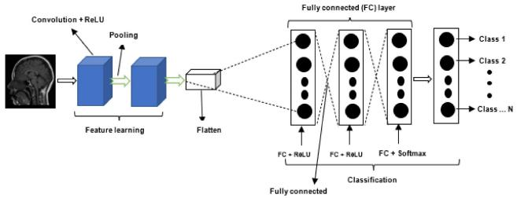

**CNN Architecture**

The architecture depicted in the image is a typical Convolutional Neural Network (CNN) used for image classification tasks. Here's a detailed explanation of each component of the architecture:

Department of Computer Engineering, AIKTC, New Panvel, Navi Mumbail

18



**Convolution + ReLU**

The first stage of the CNN is the feature learning stage, which consists of convolutional layers

followed by ReLU (Rectified Linear Unit) activation functions. The convolutional layers use filters (or kernels) to perform convolution operations on the input image, which helps in extracting various features such as edges, textures, and patterns. The ReLU activation function introduces non-linearity to the model, allowing it to learn more complex features by setting all negative values to zero.

**Pooling**

After the convolutional layers, the architecture includes pooling layers. Pooling layers reduce the

spatial dimensions of the feature maps generated by the convolutional layers. This is typically done using max pooling, which selects the maximum value from a set of values within a predefined

window, or average pooling, which calculates the average of the values within the window. Pooling helps to make the feature maps more abstract and invariant to small changes in the input image.

**Flattening**

Once the feature maps have been processed through several convolution and pooling layers, they are flattened into a one-dimensional vector. This step is necessary to transition from the spatially

structured output of the convolutional and pooling layers to the fully connected layers that follow.

**Fully Connected (FC) Layer**

The flattened vector is then fed into a series of fully connected layers. These layers are traditional

neural network layers where every input is connected to every output by a learnable weight. The fully connected layers are responsible for mapping the learned features to the final output classes. The

image shows three fully connected layers, with the first two followed by ReLU activation functions and the last one followed by a softmax activation function.

**Classification**

The final layer in the CNN architecture is the output layer, which typically uses a softmax activation function for multi-class classification tasks. The softmax function converts the logits (the raw output values from the last fully connected layer) into probabilities by exponentiating each logit and then

normalizing these values so that they sum up to one. The output of the softmax function is a

probability distribution over the classes, indicating the likelihood that the input image belongs to each class.

Department of Computer Engineering, AIKTC, New Panvel, Navi Mumbail

19



**Chapter 5**

**System Testing**

. **Comparative Analysis of Brain Tumor Detection Methods: Accuracy Assessment and Future Prospects**

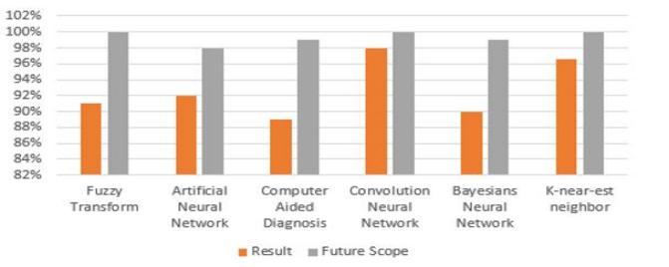

. **Comparative Analysis of Different Methods of Brain Tumor Detection Methods**

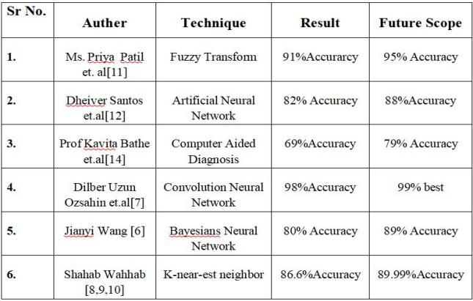

Department of Computer Engineering, AIKTC, New Panvel, Navi Mumbail

20



**Chapter 6**

**Implementation**

1. Model code of CNN :

**Error! File name not specified.**

2. Model code of ANN :

import os

import cv2

import numpy as np

from sklearn.model_selection import train_test_split

from keras.utils import to_categorical

from keras.layers import Input

from keras.models import Sequential

from keras.layers import Dense, Flatten

# Define the input size of the images

INPUT_SIZE = 64

# Define the directory where the images are stored

image_directory = 'C://Users//aryan//Desktop//braintumor//smallTrain//'

# Define the tumor types

tumor_types = ['no_tumor', 'meningioma_tumor', 'glioma_tumor', 'pituitary_tumor']

# Initialize the dataset and labels lists

dataset = []

labels = []

# Loop over the tumor types

for tumor_type_index, tumor_type in enumerate(tumor_types):

# Get the list of image file names for the current tumor type

images_path = os.listdir(image_directory + '/' + tumor_type)

# Loop over the image file names

for i, image_name in enumerate(images_path):

# Check if the image is a JPEG image

if image_name.split('.')[1] == 'jpg':

Department of Computer Engineering, AIKTC, New Panvel, Navi Mumbail

21



# Load the image

image = cv2.imread(image_directory + '/' + tumor_type + '/' + image_name)

# Resize the image to the input size

image = cv2.resize(image, (INPUT_SIZE, INPUT_SIZE))

# Convert the image to a numpy array

image = np.array(image)

# Add the image to the dataset

dataset.append(image)

# Add the tumor type index to the labels

labels.append(tumor_type_index)

# Convert the dataset and labels to numpy arrays

dataset = np.array(dataset)

labels = np.array(labels)

# Split the dataset and labels into training and testing sets

x_train, x_test, y_train, y_test = train_test_split(dataset, labels, test_size=0.4, random_state=0)

# Normalize the pixel values of the images

x_train = x_train / 255.0

x_test = x_test / 255.0

# Convert the labels to categorical labels

y_train = to_categorical(y_train, num_classes=len(tumor_types))

y_test = to_categorical(y_test, num_classes=len(tumor_types))

# Define the input layer

input_layer = Input(shape=(INPUT_SIZE, INPUT_SIZE, 3))

# Define the model

model = Sequential()

model.add(Flatten(input shape_=input_layer.shape[1:]))

model.add(Dense(64, activation='relu'))

model.add(Dense(64, activation='relu'))

model.add(Dense(len(tumor_types), activation='softmax'))

# Compile the model

model.compile(loss='categorical_crossentropy', optimizer='adam', metrics=['accuracy'])

# Evaluate the model on the testing data

score = model.evaluate(x_test, y_test, verbose=0)

# Print the accuracy of the model on the testing data

print('Testing Accuracy:', score[1])

# Train the model

history = model.fit(x_train, y_train,

batch_size=20,

verbose= 1,

epochs=20,

validation_data=(x_test, y_test),

shuffle=False)

Department of Computer Engineering, AIKTC, New Panvel, Navi Mumbail

22

# Save the model

model.save('BrainTumorTypes_ANN.keras')

3. Front-End Code :

import React, { useState } from "react";

import axios from "axios";

export default function Home() {

const [file, setFile] = useState(null);

const [previewSrc, setPreviewSrc] = useState(null);

const [prediction, setPrediction] = useState(null);

const [selectedModel, setSelectedModel] = useState("braintumorCnn");

const [model, setModel] = useState("CNN");

const handleFileChange = (e) => {

const file = e.target.files[0];

setFile(file);

const reader = new FileReader();

reader.onload = (e) => {

// @ts-ignore

setPreviewSrc(e.target.result);

};

reader.readAsDataURL(file);

};

const handleCnn = async () => {

const formData = new FormData();

// @ts-ignore

formData.append("file", file);

try {

const response = await axios.post(

"http://[127.0.0.1](https://127.0.0.1):8080/predict",

formData

);

Department of Computer Engineering, AIKTC, New Panvel, Navi Mumbail 23



setPrediction(response.data.result);

console.log(response.data.result, "CNN");

} catch (error) {

console.error(error);

}

};

const handleAnn = async () => {

const formData = new FormData();

// @ts-ignore

formData.append("file", file);

try {

const response = await axios.post(

"http://[127.0.0.1](https://127.0.0.1):5050/predictann",

formData

);

setPrediction(response.data.result);

setModel("ANN");

console.log(response.data.result, "ann");

} catch (error) {

console.error(error);

}

};

return (

<div className="flex flex-col items-center justify-center bg-blue- 100 w-full h-screen">

<h1 className="text-4xl mb-6 text-center font-extrabold uppercase animate-none underline"> Brain tumor Detection

</h1>

<label className="bg-blue-50 px-2 rounded-xl mb-4 font-semibold">

Select model :{""}

<select

value={selectedModel}

onChange={(e) => {

setSelectedModel(e.target.value);

}}

className=" rounded m-2 bg-gray-500 text-white "

>

<option value="braintumorCnn">Brain Tumor CNN</option>

<option value="braintumorAnn">Brain Tumor ANN</option>

</select>

</label>

<label className="bg-blue-50 px- 1 rounded-xl font-semibold">

Upload image:

<input

type="file"

accept="image/*"

onChange={handleFileChange}

className=" rounded m-2 bg-gray-500 text-white outline-none"

/>

</label>

Department of Computer Engineering, AIKTC, New Panvel, Navi Mumbail

24

{previewSrc && !prediction && (

<div role="status" className="relative left-32 w-[35%] mt-4 ">

<svg

aria-hidden="true"

className="w-8 h-8 text-gray-200 animate-spin dark:text-gray-600 fill-blue-600"

viewBox="0 0 100 101"

fill="none"

xmlns="<http://www.w3.org/2000/svg>"

>

<path

d="M100 50.5908C100 78.2051 77.6142 100.591 50 100.591C22.3858 100.591 0 78.2051 0

50.5908C0 22.9766 22.3858 0.59082 50 0.59082C77.6142 0.59082 100 22.9766 100 50.5908ZM9.08144

50.5908C9.08144 73.1895 27.4013 91.5094 50 91.5094C72.5987 91.5094 90.9186 73.1895 90.9186

50.5908C90.9186 27.9921 72.5987 9.67226 50 9.67226C27.4013 9.67226 9.08144 27.9921 9.08144 50.5908Z"

fill="currentColor"

/>

<path

d="M93.9676 39.0409C96.393 38.4038 97.8624 35.9116 97.0079 33.5539C95.2932 28.8227 92.871 24.3692 89.8167 20.348C85.8452 15.1192 80.8826 10.7238 75.2124 7.41289C69.5422 4.10194

63.2754 1.94025 56.7698 1.05124C51.7666 0.367541 46.6976 0.446843 41.7345 1.27873C39.2613 1.69328 37.813 4.19778 38.4501 6.62326C39.0873 9.04874 41.5694 10.4717 44.0505 10. 1071C47.8511 9.54855

51.7191 9.52689 55.5402 10.0491C60.8642 10.7766 65.9928 12.5457 70.6331 15.2552C75.2735 17.9648 79.3347 21.5619 82.5849 25.841C84.9175 28.9121 86.7997 32.2913 88.1811 35.8758C89.083 38.2158

91.5421 39.6781 93.9676 39.0409Z"

fill="currentFill"

/>

</svg>

<span className="absolute top-0 left- 10 text-xl animate-pulse">

Preprocessing Started...

</span>

</div>

)}

{previewSrc && (

<div>

<img

src={previewSrc}

alt="preview"

width="200"

className="mt-8 rounded-xl mr-52"

/>

{previewSrc && prediction && (

<p className="mt- 10 text-center text-xl animate-bounce font-semibold text-xl bg-emerald-50 px-[10px] py-[3px] rounded-2xl ">

<span className="animate-pulse">Preprocessing Complete </span>

</p>

)}

<button

className="py-2 px-4 rounded-full bg-green-200 mt-4 border-2 relative left-[40%] border-green- 400 font-bold"

onClick={() =>

selectedModel === "braintumorCnn" ? handleCnn() : handleAnn()

}

Department of Computer Engineering, AIKTC, New Panvel, Navi Mumbail 25



>

Predict

</button>

</div>

)}

{prediction && (

<p className="py-2 px-4 rounded bg-sky-200 border-2 relative top- 10 border-sky-400 font-bold w- fit uppercase">

<span className="font-semibold uppercase">Model :</span>

{model}

<br />

<hr />

<span className="font-semibold uppercase">Prediction :</span>

{prediction}

</p>

)}

</div>

);

}

Department of Computer Engineering, AIKTC, New Panvel, Navi Mumbail

26



**Chapter 6**

**Screenshots of Project**

**1.Start Screen in which you have choose model.**

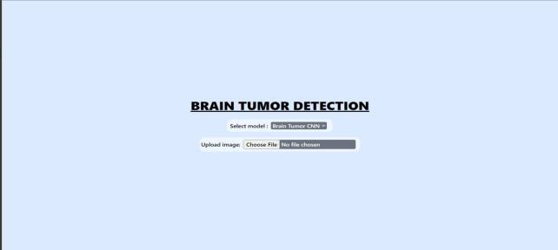

**2. After model selected , then choose image for prediction**

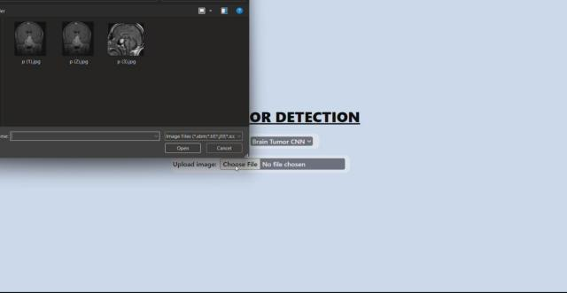

Department of Computer Engineering, AIKTC, New Panvel, Navi Mumbail

27



**3) Preprocessing of image has start , click on predict to get output**

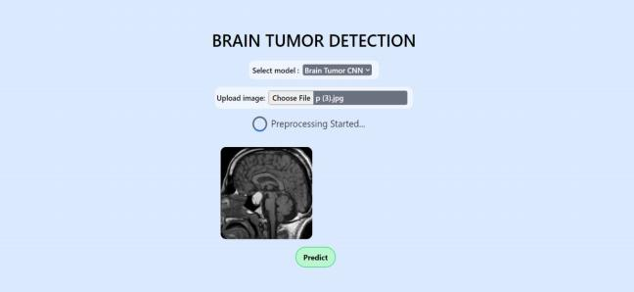

**4) Output : prediction of Model CNN**

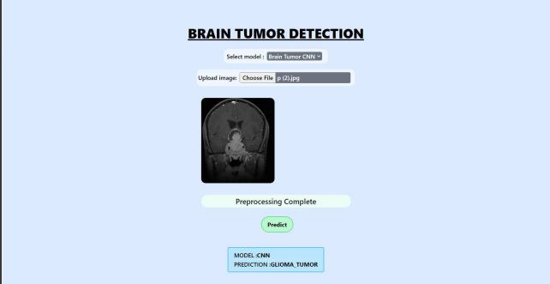

Department of Computer Engineering, AIKTC, New Panvel, Navi Mumbail

28



**5) Output : prediction of Model ANN**

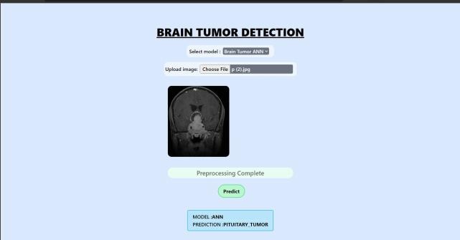

Department of Computer Engineering, AIKTC, New Panvel, Navi Mumbail

29



**Chapter 7**

**Conclusion and Future Scope**

**7.1 Conclusion**

In this project, we tested various machine learning and deep learning algorithms for detecting brain cancers using MRI data. Impressive accuracy levels have been reached utilizing a broad variety of tactics on this challenge. While deep learning techniques now outperform other approaches, classical algorithms still have some promise. Radiologists can profit overall from a "second opinion" supplied by automatic tumor identification and segmentation systems.In conclusion, our study reveals that CNNs , ANNs and Deep learning are successful at detecting and categorizing brain cancers from MRI scans.

**7.2 Future Scope**

Department of Computer Engineering, AIKTC, New Panvel, Navi Mumbail

30



**References**

1.Saeedi, S., Rezayi, S., Keshavarz, H., et al. (2023). MRI-based brain tumor detection usingconvolutional deep learning methods and chosen machine learning techniques. BMC MedicalInformatics and Decision Making, 23, 16.

2. Abdalla, H. E. M., & Esmail, M. Y. (2018). Brain tumor detection by using artificial neuralnetwork. In

Proceedings of the 2018 International Conference on Computer, Control, Electrical

, and Electronics Engineering (ICCCEEE), Khartoum, Sudan.

3.Kshirsagar, P. R., Rakhonde, A. N., & Chippalkatti, P. (2020). MRI image-based brain tumordetection using machine learning. Test Engineering and Management, 81.

4. Siar, M., & Teshnehlab, M. (2019). Brain Tumor Detection Using Deep Neural Network andMachine Learning Algorithm. 2019 9th International Conference on Computer and KnowledgeEngineering (ICCKE), Mashhad, Iran.

5. Hossain, T., Shishir, F. S., Ashraf, M., Al Nasim, M. A., & Muhammad Shah, F. (2019).Brain Tumor Detection Using Convolutional Neural Network. 2019 1st InternationalConference on Advances in Science, Engineering and Robotics Technology (ICASERT),Dhaka, Bangladesh.

6. Ozsahin, D. U., Onakpojeruo, E. P., Uzun, B., Mustapha, M. T., & Ozsahin, I. (2023).Mathematical Assessment of Machine Learning Models Used for Brain Tumor Diagnosis.Diagnostics, 13(4), 618.

7. Amin, J., Sharif, M., Haldorai, A., Mussarat, & Nayak, R. S. (2022). Brain Tumor Detectionand Classification Using Machine Learning: A Comprehensive Survey. International Journal ofScientific Research in Engineering and Management.

8. Wahhab, S. Kareem, Abdulrahman, S. W., Hawezi, B. F., Khoshaba, R. S., Askar, S.,Muheden, K. M., & Abdulkhaleq, I. S. (2023). Comparative Evaluation for Detection of BrainTumor Using Machine Learning Algorithms. IAES International Journal of Artificial Intelligence(IJ-A), 2(1).

9. Wang, J. (2023). The Role of Machine Learning in the Detection and Classification of BrainTumors: A Literature Review of the Past Two Years. IAES International Journal of ArtificialIntelligence (IJ-AI).

10. Patil, M., Pawar, S., Patil, S., & Nichal, A. (Authors and affiliations not fully provided). BEStudents, Electronics & Telecommunication Engineering, AITRC, Vita, India. AssistantProfessor, Electronics & Telecommunication Engineering, AITRC, Vita, India.

11. Santos, D., & Santos, E. (Authors and affiliations not fully provided). BRIDGE – Instituto deTecnologia e Pesquisa, Aracaju, Sergipe, Brazil.

12. Khan, M. S. I., Rahman, A., Debnath, T., Karim, M. R., Nasir, M. K., Band, S. S., Mosavi, A.,& Dehzangi, I. (Authors and affiliations not fully provided).

13. Agravat, R. R., & Raval, M. S. (Authors and affiliations not fully provided). "Prediction ofOverall Survival of Brain Tumor Patients." In 2019 IEEE Region 10 Conference (TENCON 2019)

Department of Computer Engineering, AIKTC, New Panvel, Navi Mumbail

31



14. Lather, M., & Singh, P. (Authors and affiliations not fully provided). Research Scholar,Department of Computer Science and Engineering, Deenbandhu Chhotu Ram University ofScience and Technology, Murthal, India. Professor and Dean, Department of Computer Scienceand Engineering, Deenbandhu Chhotu Ram University of Science and Technology, Murthal,India.

15. Department of Computer Science & Information Technology, Dr. B.A.M. University,Aurangabad, India. (Authors and affiliations not fully provided). "Image Processing Techniquesfor Brain Tumor Detection" (September-October 2015).

16. Sapra, P., Singh, R., & Khurana, S. (Authors and affiliations not fully provided). "Brain TumorDetection Using Neural Network" (August 2013).

17. Ganesh, P. S., Kumar, T. S., Kumar, M., & Kumar, S. R. (Authors and affiliations not fullyprovided). "Brain Tumor Detection and Classification Using Image Processing Techniques" (April2021).

18. Logeswari, T., & Karnan, M. (Authors and affiliations not fully provided). "An improvedimplementation of brain tumor detection using segmentation based on soft computing" (March2010).

19. Jia, Z., & Chen, D. (Authors and affiliations not fully provided). "Brain Tumor Identificationand Classification of MRI Images using Deep Learning Techniques" (2017).

20. 20. Zaw, H. T., Maneerat, N., & Win, K. Y. (Authors and affiliations not fully provided). "BrainTumor Detection based on Naïve Bayes Classification" (2019 5th International Conference onEngineering, Applied Sciences and Technology, ICEAST).

Department of Computer Engineering, AIKTC, New Panvel, Navi Mumbail

32