Practical 1: Plotting and Fitting of Binomial Distribution and Graphical Representation of Probabilities

Definition
The Binomial Distribution is a discrete probability distribution that gives the probability of exactly k successes in n independent trials, where each trial has only two outcomes: success or failure. It is applicable when the number of trials is fixed, each trial is independent, there are only two outcomes, and the probability of success remains constant.

Theory and Formula
Binomial Distribution Formula:
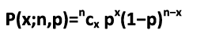

Terms Used in the Formula
P(x; n, p): is the probability of x successes in n trials in an experiment which can result in exactly two outcomes (success or failure).
n: Total number of independent trials
x: Number of successes
p: Probability of success on each trial
(1-p) or q: Probability of failure on each trial
C(n , x): Binomial coefficient = n! / (x! * (n-x)!)
• Mean: μ = n * p
• Variance: σ² = n * p * (1 - p)
Excel Implementation
=BINOM.DIST(x, n, p, FALSE)
- x=Number of successes (the value you want probability for)
- n=Total number of trials
- p=Probability of success in one trial (between 0 and 1)
- FALSE=Tells Excel to return exact probability P(X = x)

Skewness In Case Binomial Distribution Can Be Defined As Follows:

- If p = 0.5, the binomial distribution will be symmetrical, regardless of the value of n.

- If p≠ 0.5, the distribution will be skewed.

- If p < 0.5, the distribution will be positively skewed or right-skewed. This means the bulk of the probability falls in the smaller numbers and the distribution tails off to the right.

- If p > 0.5, the distribution will be negatively skewed or left-skewed. This means the

- bulk of the probability falls in the larger numbers and the distribution tails off to the left.

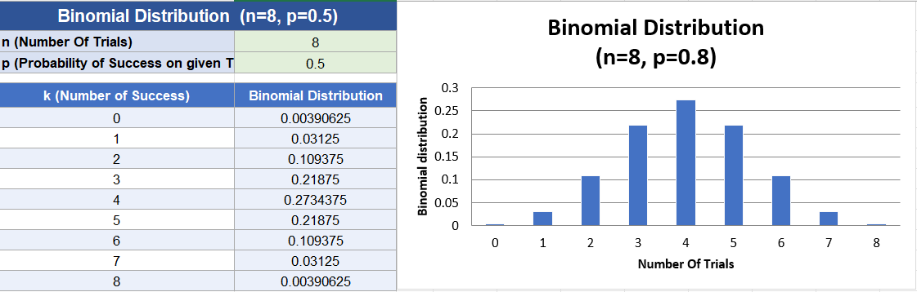

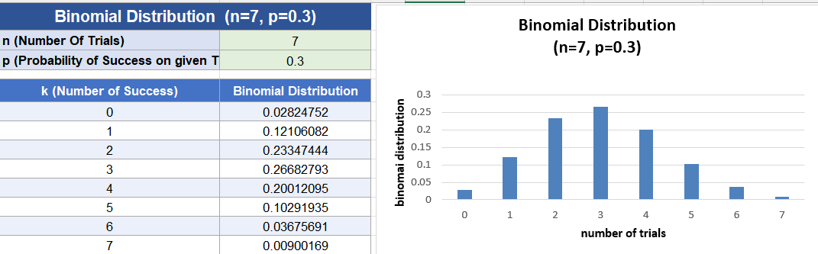

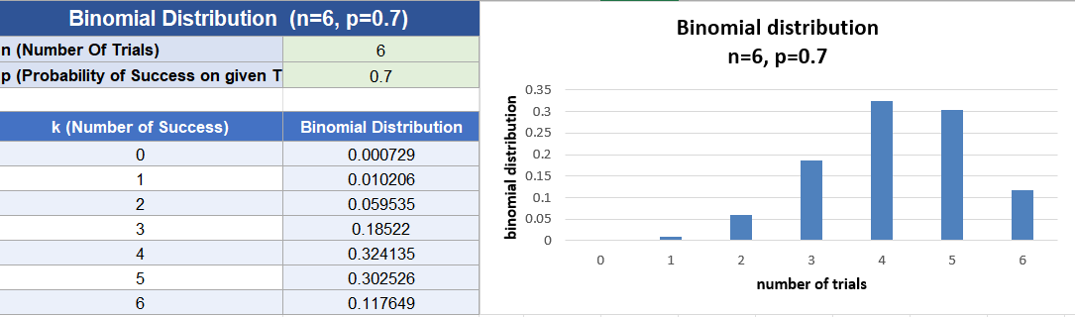

Interpretation / Result
The Binomial Distribution graph shows a bell-shaped symmetric curve when p = 0.5, and a skewed curve when p is not equal to 0.5. The probabilities calculated using BINOM.DIST confirm that the highest likelihood clusters around the mean (mean = np), with probabilities decreasing as x moves away from the mean.

Practical 2: Plotting and Fitting of Multinomial Distribution and Graphical Representation of Probabilities

Definition
The Multinomial Distribution is a multivariate generalization of the Binomial Distribution. It models the probability of counts for each side of a k-sided die rolled n times. It considers a trial that results in exactly one of k possible outcomes, with probabilities p1, p2, ..., pk (so that pi >= 0 and their sum = 1), and there are n independent trials.

Theory and Formula
Multinomial Distribution Formula:
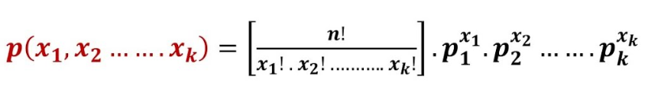

Terms Used in the Formula
n: Total number of trials
x1, x2, ..., xk: Number of times each outcome i occurred
p1, p2, ..., pk: Probability of each outcome (must sum to 1)

Excel Implementation
• Multinomial coefficient = MULTINOMIAL(X1, X2, X3)
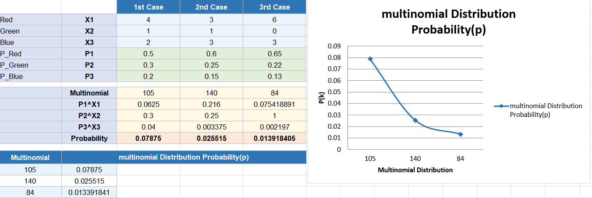
• Probability = MULTINOMIAL * PRODUCT(p1^X1, p2^X2, p3^X3)

Interpretation / Result
The Multinomial Distribution graph shows probabilities spread across multiple outcome categories. The calculated probabilities confirm that outcomes with higher assigned probability dominate, and the sum of all multinomial probabilities equals 1, validating the result.

Practical 3: Plotting and Fitting of Poisson Distribution and Graphical Representation of Probabilities

Definition
The Poisson Distribution is a discrete probability distribution that determines the likelihood of an event occurring a specific number of times (k) within a designated time or space interval. It is used when events occur independently and at a constant average rate. This distribution is characterized by a single parameter λ (lambda), representing the average number of occurrences.

Theory and Formula
Poisson Distribution Formula:
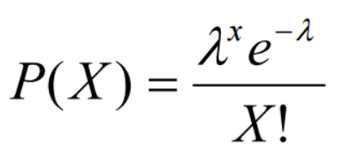

Terms Used in the Formula
P(X): Probability of observing exactly k events
e: Base of natural logarithm (≈ 2.71828)
λ (lambda): Mean number of successes in a given interval; λ = np
x: Number of successes (events) observed
• Mean: μ = E(X) = λ
• Variance: σ² = V(X) = λ
• Standard Deviation: σ = √λ

Excel Implementation

POISSON.DIST(x, lambda, cumulative)

x → Number of occurrences (events you are checking for)

lambda (λ) → Mean (average number of occurrences in a fixed interval)

cumulative → FALSE → Gives P(X = x) (exact probability)

TRUE → Gives P(X ≤ x) (cumulative probability)

Interpretation / Result
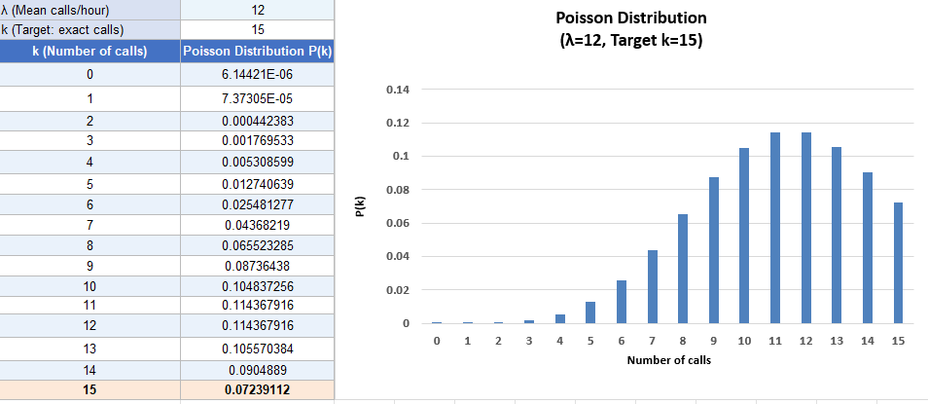
The Poisson Distribution graph shows a right-skewed curve that becomes more symmetric as lambda increases. The probabilities calculated using POISSON.DIST confirm that events near the mean lambda have the highest probability, and probabilities decrease rapidly for values far from lambda.

Practical 4: Plotting and Fitting of Geometric Distribution and Graphical Representation of Probabilities

Definition
The Geometric Distribution is a discrete probability distribution that represents the likelihood of achieving the first success after a series of failures in repeated Bernoulli trials. A Bernoulli trial is a test that can only have one of two outcomes: success or failure. In Geometric Distribution, the trial is repeated until success is obtained. The number of attempts can go on indefinitely. It is based on three key assumptions: (1) Trials are self-contained/independent, (2) Each trial has only two outcomes, (3) The probability of success p is the same for each trial.

Theory and Formula
Geometric Distribution Formula:
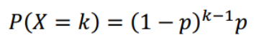

Terms Used in the Formula
P(X = k): Probability of first success occurring after k failures
k: Number of failures before the first success
p: Probability of success on each trial
(1 - p) or q: Probability of failure on each trial; q = 1 – p
• Mean: μ = E(X) = 1 / p
• Variance: σ² = V(X) = (1 - p) / p²

Excel Implementation
Probability = (1-p)^k * p

Interpretation / Result
The Geometric Distribution graph shows a rapidly decreasing curve, confirming that the probability of first success decreases as the number of trials increases. A higher value of p leads to a steeper decline, meaning success is more likely to occur in fewer trials.

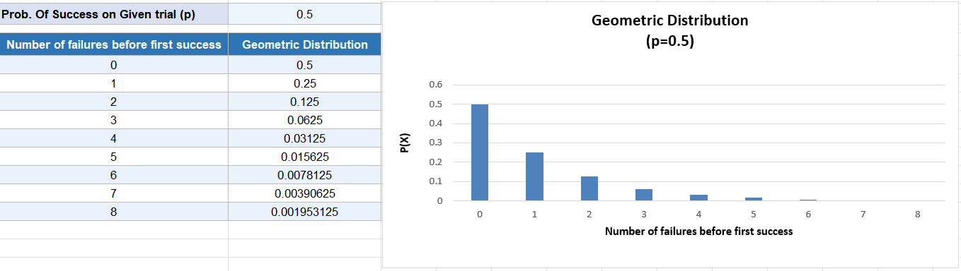
Practical 5: Plotting and Fitting of Uniform Distribution and Graphical Representation of Probabilities

Definition
A Uniform Distribution (also known as Rectangular Distribution) is a probability distribution where every possible outcome has an equal probability of occurring. It has constant probability due to equally likely occurring events. It has two parameters: a (minimum) and b (maximum). The distribution is written as U(a, b).

Theory and Formula
Uniform Distribution PDF Formula:
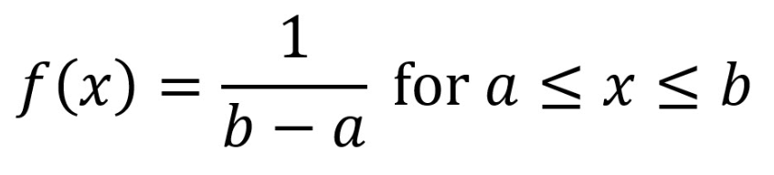

Terms Used in the Formula
f(x): Probability Density Function value at x
a: Minimum value in the distribution
b: Maximum value in the distribution
x: Value of the random variable (a ≤ x ≤ b)
• Mean: μ = (a + b) / 2
• Variance: σ² = (b - a)² / 12

Excel Implementation
P = (x2 - x1) / (b - a)
• Where x1 is the minimum value of interest and x2 is the maximum value of interest.
• All values within the range [a, b] are equally likely to be observed.
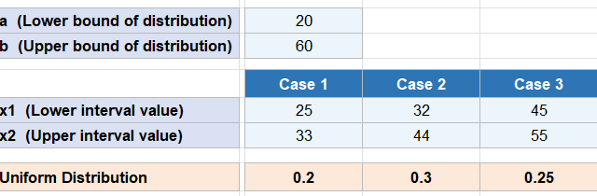
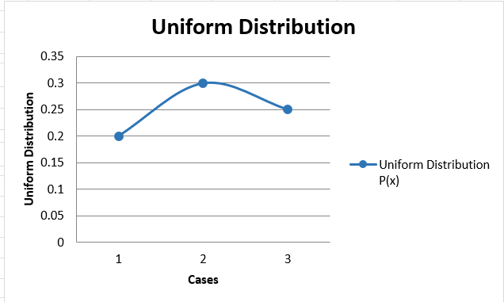

Interpretation / Result
The Uniform Distribution graph shows a flat rectangular shape, confirming that all outcomes between a and b have equal probability f(x) = 1/(b-a). The calculations confirm that the mean is exactly at the midpoint (a+b)/2 and the distribution has no peaks or skewness.

Practical 6: Plotting and Fitting of Exponential Distribution and Graphical Representation of Probabilities

Definition
The Exponential Distribution is a continuous probability distribution used to model the time between events in a Poisson process. It is used when we need to find the time we need to wait before a given event occurs. If the probability of an event happening in a given interval is proportional to the length of the interval, the Random Variable has an exponential distribution. Its support is the set of all positive real numbers. Real-life uses: time until a customer enters a shop, battery life, time before computer breakdown.

Theory and Formula
Exponential Distribution PDF Formula:
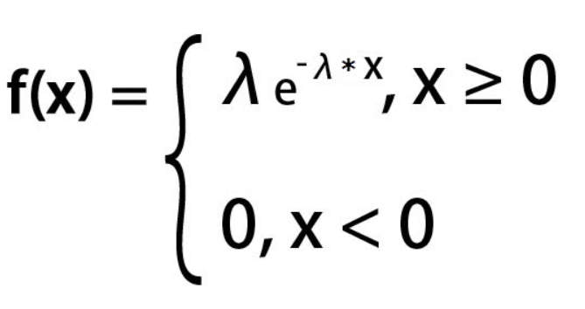

Terms Used in the Formula
f(x): Probability Density Function at x
λ (lambda): Rate parameter (controls how fast the distribution decays)
e: Mathematical constant ≈ 2.718
x: Time or space value (must be ≥ 0)
• Mean: E(X) = 1 / λ
• Variance: Var(X) = 1 / λ²

Excel Implementation
EXPON.DIST(X, lambda, FALSE)
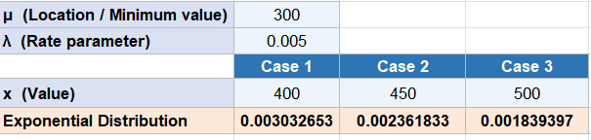
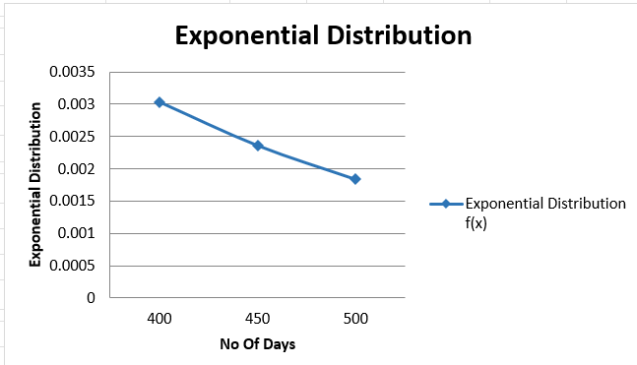

Interpretation / Result
The Exponential Distribution graph shows a rapidly decreasing curve starting from the rate parameter at x = 0, confirming that smaller waiting times are more probable. The EXPON.DIST calculations verify that as x increases, the probability density decreases exponentially, consistent with the memoryless property of this distribution.

Practical 7: Plotting and Fitting of Normal Distribution and Graphical Representation of Probabilities

Definition
The Normal Distribution (also called Gaussian Distribution) is a continuous probability distribution that is symmetric about its mean, showing that data near the mean is more frequent than data far from it. It is defined as the probability density function of any continuous random variable. It is the most widely used distribution in statistics.

Theory and Formula
Normal Distribution PDF Formula:
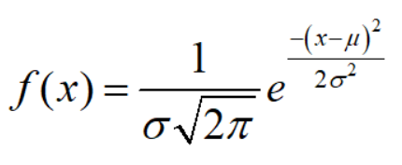

Terms Used in the Formula
f(x): Probability Density Function at x
x: Random variable
μ (mu): Mean (average) of the distribution
σ (sigma): Standard deviation of the distribution
π (pi): Mathematical constant ≈ 3.14159
e: Mathematical constant ≈ 2.71828
Properties:
- Mean = Median = Mode (symmetric distribution)
- Total area under the normal curve = 1
- The curve is symmetric at the center along the mean
- It is a Unimodal Curve (only one peak)

Excel Implementation

Input your data set into an excel spreadsheet

Find the mean of your data set

=AVERAGE( cell range )

Find the standard deviation of your data set

=STDEV(cell range)

Select a value for the distribution

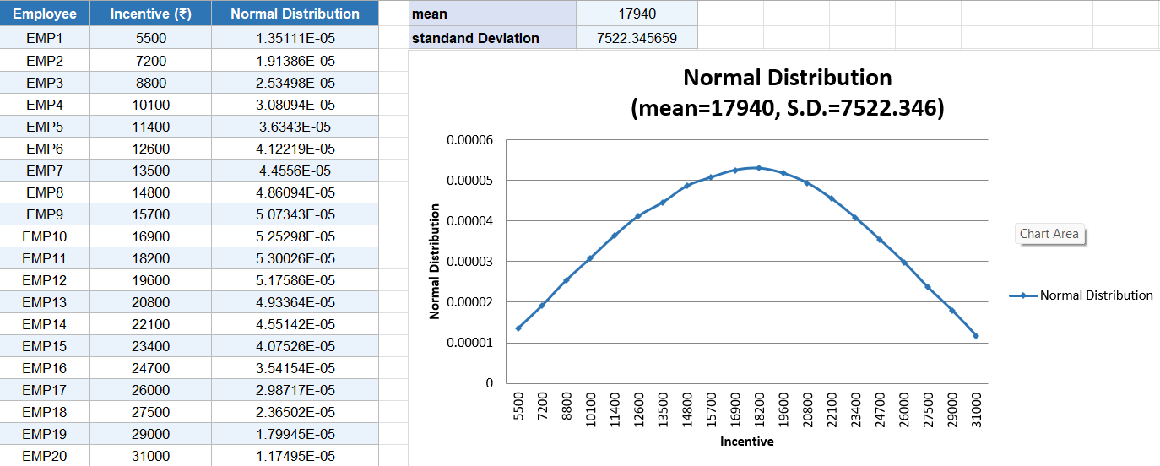
Type the NORM.DIST function and fill

Interpretation / Result
The Normal Distribution graph shows a symmetric bell-shaped curve centered at the mean. The NORM.DIST calculations confirm that approximately 68% of values fall within one standard deviation of the mean, validating the empirical rule. Data points farther from the mean have significantly lower probability density.

Practical 8: Calculation of Cumulative Distribution Functions for Exponential and Normal Distribution

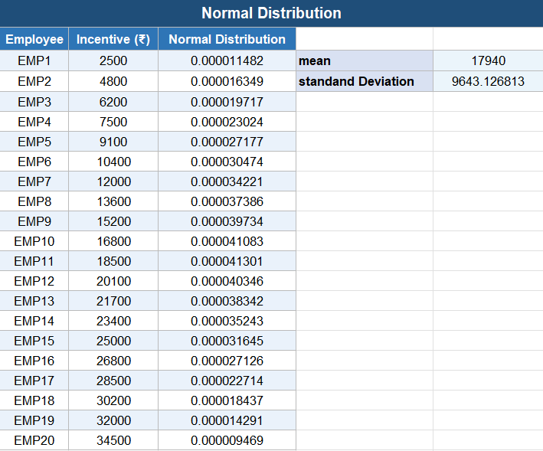

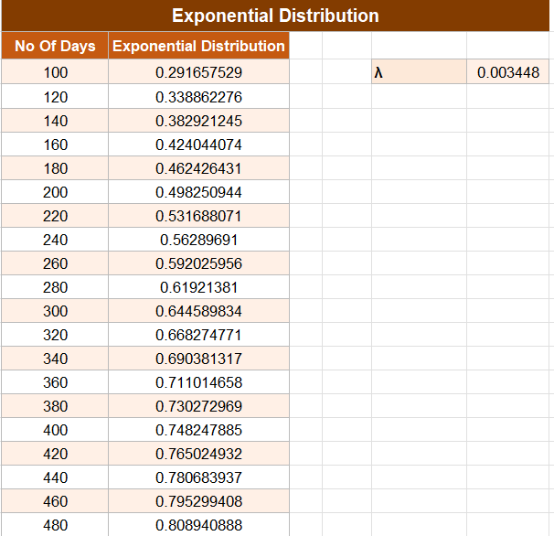

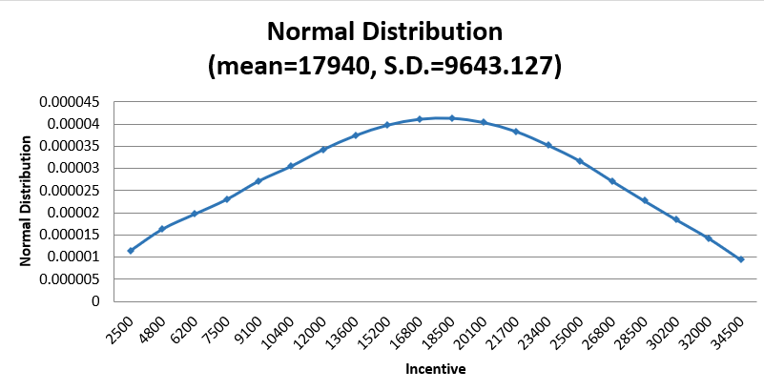
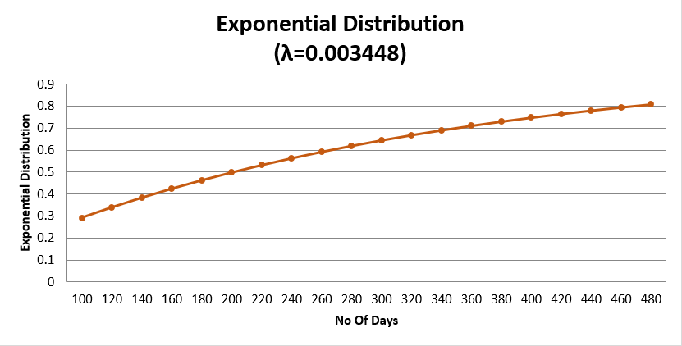

Interpretation / Result
The CDF graphs for both Exponential and Normal distributions are S-shaped curves rising from 0 to 1. The Exponential CDF rises steeply at first and flattens quickly, while the Normal CDF rises gradually and symmetrically around the mean, confirming the distinct behavior of both distributions.

Practical 9: Given Data from Two Distributions, Find the Distance Between the Distributions

Definition
The Euclidean Distance is a measure of the straight-line distance between two points (or vectors) in a coordinate plane. When applied to two probability distributions, it measures how different or similar the two distributions are. It is calculated as the square root of the sum of the squared differences between corresponding elements in two vectors.

Theory and Formula
Euclidean Distance Formula:
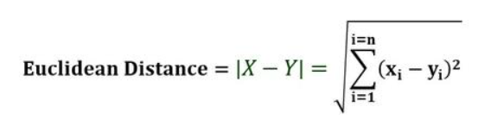

Terms Used in the Formula
X: Array or vector X (first distribution values)
Y: Array or vector Y (second distribution values)
xi: Values of horizontal axis in the coordinate plane (from distribution X)
yi: Values of vertical axis in the coordinate plane (from distribution Y)
n: Number of observations

Excel Implementation
SORT (SUM X MYZ(array X, array Y))
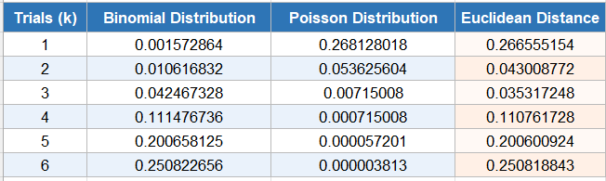

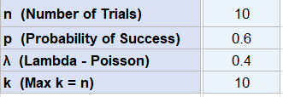

Interpretation / Result
The Euclidean distance calculated between the two distributions quantifies how far apart they are in probability space. A smaller distance confirms the distributions are similar in shape, while a larger distance confirms significant differences. The SQRT(SUMXMY2()) formula efficiently computes this measure in Excel.

Practical 10: Application Problems Based on the Binomial Distribution

Question: Tech Edge Components Pvt Ltd. produces circuit boards and historical production data shows that the probability of a circuit board being defective is p = 0.15 (15%). Suppose a quality inspector randomly selects n = 10 circuit boards from a production batch for inspection.
Each circuit board will either be classified as Defective (a 'success' in statistical terms) or Non-Defective (a 'failure'). Let X denote the number of defective circuit boards found among the 10 selected boards. It follows that X is a Binomial random variable, as:
- The number of trials n = 5 is fixed.
- Each board inspection is independent of others.
- The probability of a defect p = 0.15 remains constant across all boards.
- Each outcome is binary — Defective or Non-Defective.

Therefore, X can take any value from 0 to 10, i.e., anywhere between no defective boards and all ten boards being defective

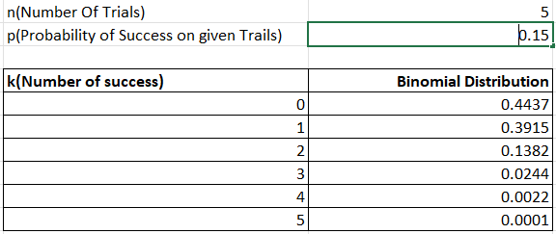

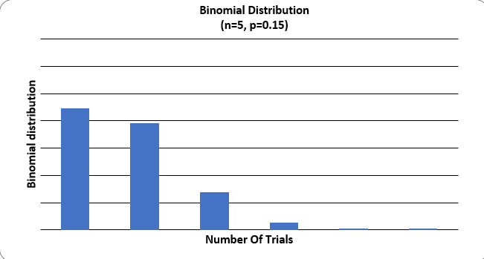

Interpretation / Result
For Tech Edge Components with p = 0.15 and n = 10, the Binomial calculations show that the most likely number of defective boards is 1 to 2 (near mean = np = 1.5). The probability of zero or very high defect counts is very low, confirming the production process has manageable defect rates.

Practical 11: Application Problems Based on the Poisson Distribution

Question: An emergency services center (911) receives calls throughout the day. Based on historical data spanning over 600,000 records, it has been observed that the number of calls received per hour follows a Poisson distribution. Medium Suppose that during a particular hour of the day, the average number of emergency calls received is λ = 12 calls per hour. Find the probability of receiving exactly 10 calls in that hour.

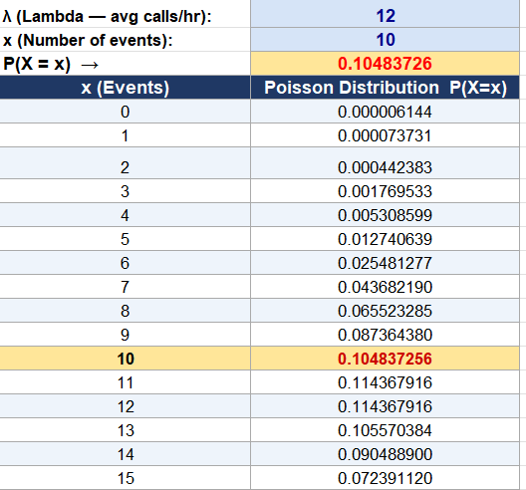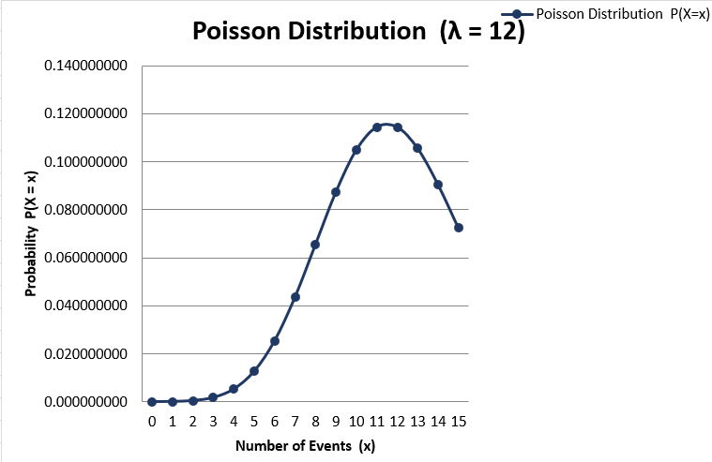

Interpretation / Result
With lambda = 12 calls per hour, the Poisson calculation gives P(X = 10) approximately 0.1048, meaning there is about a 10.48% chance of receiving exactly 10 calls. This confirms that values close to the mean lambda are the most probable outcomes in a Poisson process.

Practical 12: Application Problems Based on the Normal Distribution

Question: A dataset on Heights and Weights records physical measurements of a large sample of individuals. Analysis of this data reveals that the heights of individuals are normally distributed. The distribution follows the typical bell-curve pattern — most people are close to the average height, and small differences from the mean occur more frequently than large deviations
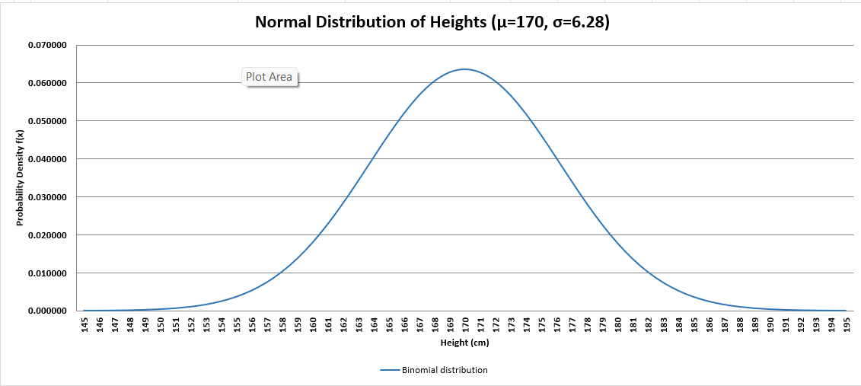
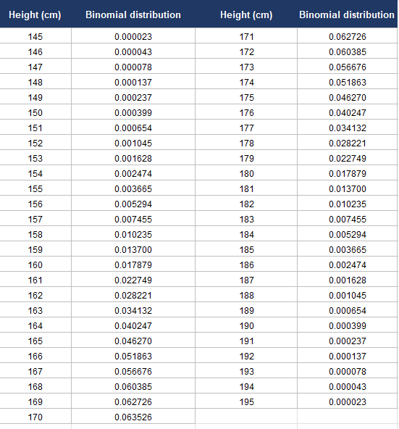
Based on the dataset, the mean height of individuals is μ = 170 cm and the standard deviation is σ = 6.28 cm. find the z-score and the normal distribution of a person who is 176 cm tall?

Interpretation / Result
For a person 176 cm tall with mean = 170 cm and standard deviation = 6.28 cm, the z-score is approximately 0.955. The Normal Distribution result shows this height is about 0.95 standard deviations above the mean, meaning approximately 83% of individuals in the dataset are shorter than 176 cm.

Practical 13: Presentation of bivariate data through scatter-plot diagram and Calculations of Covariance

Bivariate Data/Bivariate Analysis
Bivariate analysis is a type of statistical analysis in which exactly two variables are studied together at the same time. In any such study, one variable is considered dependent (the outcome being measured) and the other is considered independent (the factor that may influence the outcome). These two variables are conventionally denoted as X and Y.
The main purpose of bivariate analysis is to examine how changes in one variable are associated with changes in the other, and to determine the extent of that relationship. In other words, it helps us understand whether a meaningful connection exists between the two variables being observed.
There are three widely used techniques to carry out bivariate analysis. Each method serves a different purpose and offers a different level of insight:

- Scatter Plots — A graphical method that visually displays the relationship between the two variables by plotting data points on a two-dimensional graph. The pattern of the points reveals whether the relationship is positive, negative, or non-existent.
- Correlation Coefficient — A numerical value (ranging from -1 to +1) that quantifies the strength and direction of the linear relationship between the two variables.
- Simple Linear Regression (SLR) — A statistical technique used to model and predict the value of the dependent variable (Y) based on the value of the independent variable (X), using a straight-line equation.

A Bivariate Frequency Distribution is a statistical table that records and displays the frequency of occurrence of two variables at the same time. Unlike a univariate frequency distribution which tracks only one variable, a bivariate frequency distribution considers both variables simultaneously and shows how often different combinations of their values appear in the data.

Real-world examples of bivariate data include:
- Sales revenue and Advertisement expenditure of a company
- Height and Weight of individuals in a population
- Study hours and Exam marks of students
- Age and Income levels of employees
How to implement in excel:
= COVARIANCE.P(array1, array2)
- Array1 = the range of cells containing your X values
- Array2 = the range of cells containing your Y values

Few things to remember about arguments
1. If the array contains any text or logical values (TRUE/FALSE), the COVARIANCE function in Excel simply ignores them.
2. The data should be numeric. If any cell has non-numeric data, Excel automatically ignores it during calculation.
3. Both arrays must have the same number of data points, otherwise Excel will return an error.
4. Neither array should be empty and the standard deviation of the data should not be zero.
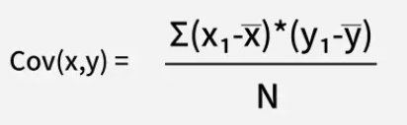
5. Covariance measures the extent to which two random variables change together in tandem.
6. Correlation measures how strongly two random variables are related to each other.
7. Covariance is nothing but the base form of correlation.
8. Correlation is simply the scaled and standardised form of covariance.
9. Covariance can range anywhere from −∞ to +∞, whereas correlation always stays between −1 and +1.
10. Covariance only tells us the direction of the linear relationship between two variables.
11. Correlation tells us both the direction and the strength of the linear relationship between two variables.
12. Covariance is affected by any change in the scale or units of the data.

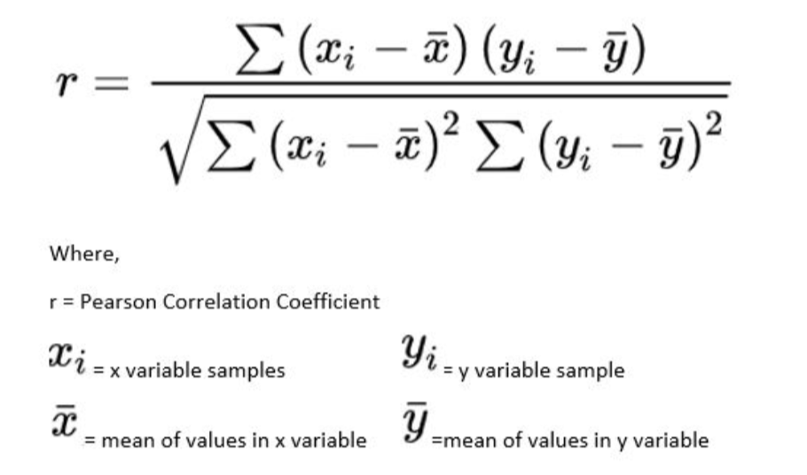
13. Correlation is not affected by any change in the scale or units of the data.

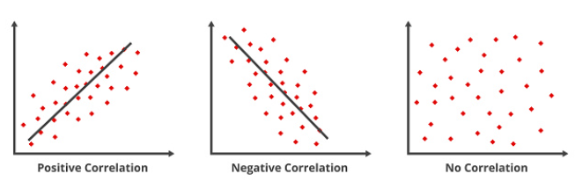

= PEARSON (array1, array2)
Scatter plots
A scatter plot is basically a graph that helps you visually see how two variables are related to each other. Imagine you have data of students — their study hours and their marks. If you plot each student as a dot on a graph, with study hours on the horizontal side (X-axis) and marks on the vertical side (Y-axis), the overall pattern of those dots will tell you whether studying more actually leads to better marks or not.
Scatter plots are highly effective for visualizing large datasets. They work best when:
- The dataset contains a large number of data points
- Each data point consists of a pair of values
- The data being represented is numerical in nature
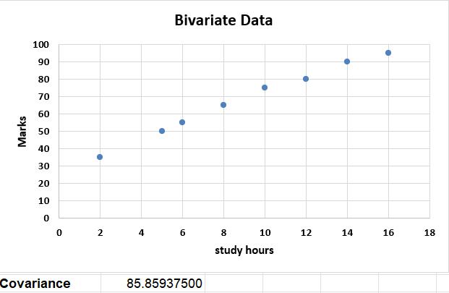
Click insert tab along the top ribbon then click scatter chart within chart group.
CORRELATION in excel and COVARIANCE in excel –
= CORREL (hours, score)
= COVARIANCE.P(hours, score)

Interpretation / Result
The scatter plot visually reveals the direction and strength of the relationship between the two variables. The covariance value calculated using COVARIANCE.P() indicates whether the variables move together (positive covariance) or in opposite directions (negative covariance), with near-zero covariance suggesting no linear relationship.

Practical 14: Calculation of Karl Pearson's Correlation Coefficients

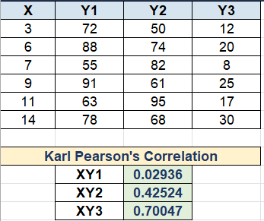

Interpretation / Result
Karl Pearson's Correlation Coefficient (r) lies between -1 and +1. A value close to +1 indicates a strong positive linear relationship, close to -1 indicates a strong negative relationship, and near 0 indicates no linear correlation between the two variables studied.

Practical 15: To Find the Correlation Coefficient for a Bivariate Frequency Distribution

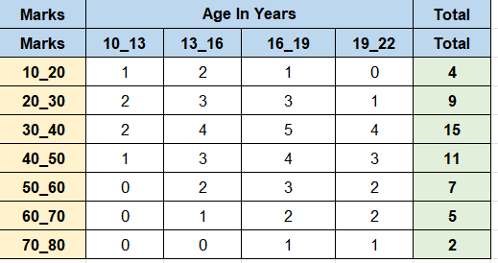
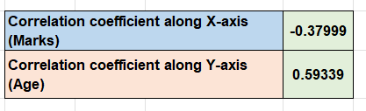
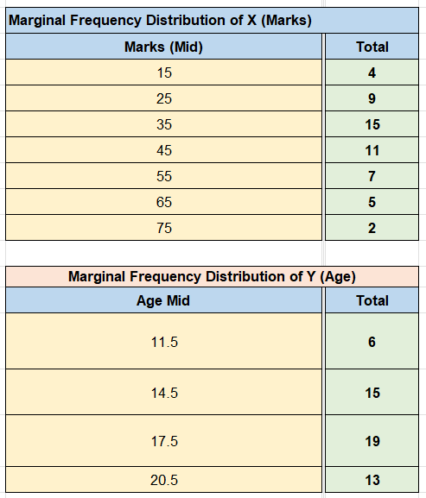

Interpretation / Result
The correlation coefficient derived from the bivariate frequency distribution confirms the strength and direction of the association between the two grouped variables. This method accounts for all frequency pairs simultaneously, providing a reliable measure of linear relationship even when data is in tabular form.

Practical 16: Generating Random Numbers from Discrete (Bernoulli, Binomial, Poisson) Distributions

How to implement in excel
= BINOM.INV (1, P, RAND ()) will generate 1 or 0 with chance of 1 being P random number
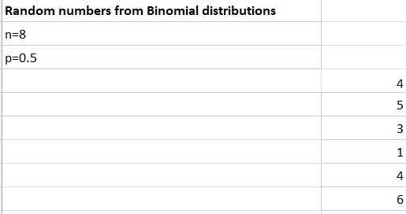

Interpretation / Result
The random numbers generated using BINOM.INV and RAND() simulate real-world discrete events for Bernoulli, Binomial, and Poisson distributions. Each recalculation produces different values, confirming the stochastic nature of these distributions while remaining within their expected probability ranges.

Practical 17: Generating Random Numbers from Continuous (Uniform, Normal) Distributions

= NORMINV(RAND(),B2,C2)
Where this RAND () function create your probability . B2 provides you mean , C2 refers your standard deviation.

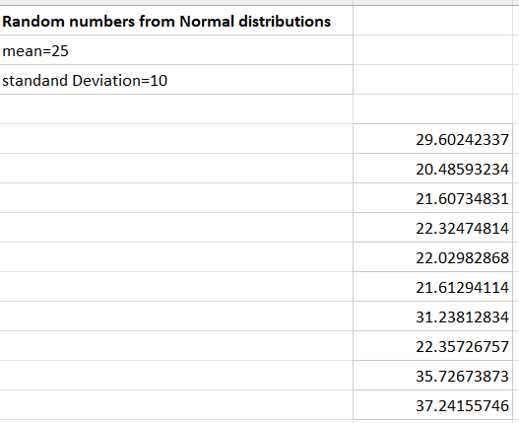

Interpretation / Result
The random numbers generated using NORMINV(RAND(), mean, sigma) for Normal and uniform formulas for Uniform distributions confirm the continuous nature of these distributions. Normal random numbers cluster around the mean within two standard deviations, while Uniform random numbers spread evenly across the range [a, b].

Practical 18: Find the Entropy from the Given Data Set

The entropy of a random variable measures how uncertain or unpredictable its outcomes are. For a discrete random variable X that can take values from a set x, with probabilities defined by P ranging between 0 and 1, the entropy is denoted as S[X].

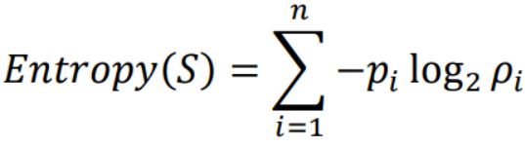

Where:
- S = the set of outcomes
- n = total number of possible outcomes
- pi = probability of the i-th outcome
- log₂ = logarithm with base 2 (giving units in bits)

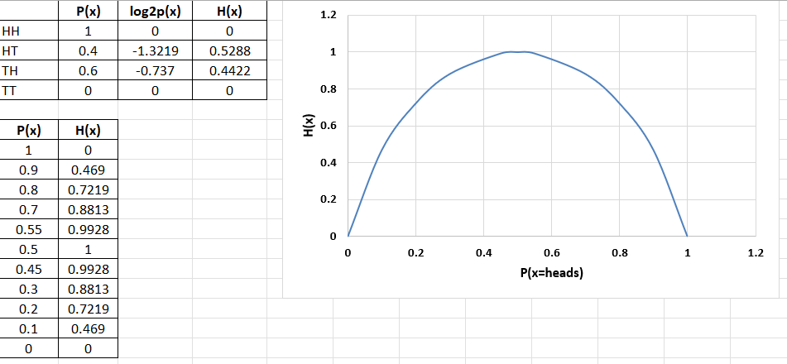
An equivalent definition of entropy is the expected value of the self information of a variable

Interpretation / Result
The entropy value H(X) calculated from the dataset quantifies the uncertainty of the random variable. A higher entropy (closer to log2 of n outcomes) indicates maximum unpredictability, while entropy near 0 indicates the outcome is nearly certain. The graph of H(X) vs P(x) confirms the bell-shaped relationship, peaking at p = 0.5 where uncertainty is greatest.

