INITIATING COVERAGE
BANKS — INDIA | PUBLIC SECTOR BANKS
State Bank of India
India's Sovereign-Backed Scale Leader Enters a Re-Rating Window as Asset Quality, Digital Execution and Subsidiary Value Converge
RATING | HOLD | PRICE TARGET (12M) | ₹955
CURRENT PRICE | ₹983 | IMPLIED UPSIDE/(DOWNSIDE) | -2.8%
MARKET CAP | ₹9.03 lakh cr | 52-WEEK RANGE | ₹853 – ₹1,234.70
P/E (TRAILING) | 10.90x | P/B (TRAILING) | 1.47x
FY26A ROE | 18.6% | FY26A ROA | 1.12%

NSE: SBIN | BSE: 500112 | ISIN: INE062A01020 | Sector: Financials — Public Sector Banks
Report date: September 27, 2026 | Equity Research — Initiating Coverage Team

“SBI now compounds like a private bank while still trading like a PSU one — that gap is the trade.”

Investment Summary
We initiate coverage of State Bank of India (SBI) with a HOLD rating and a 12-month price target of ₹955, implying -2.8% downside from the current price of ₹983 (September 25, 2026). SBI is India's largest bank by every balance-sheet measure — gross advances of ₹49.32 lakh crore, deposits of ₹59.75 lakh crore, and a market share of roughly 22.5% of system deposits and 19.4% of system advances — and FY26 (year ended March 2026) marked the bank's best year on record: standalone net profit of ₹80,032 crore (up 12.9% year-on-year), gross NPA at a multi-decade-low 1.49%, net NPA at 0.39%, and return on equity of 18.6%, a level that now sits within shouting distance of large private-sector peers despite SBI trading at less than half their price-to-book multiple.
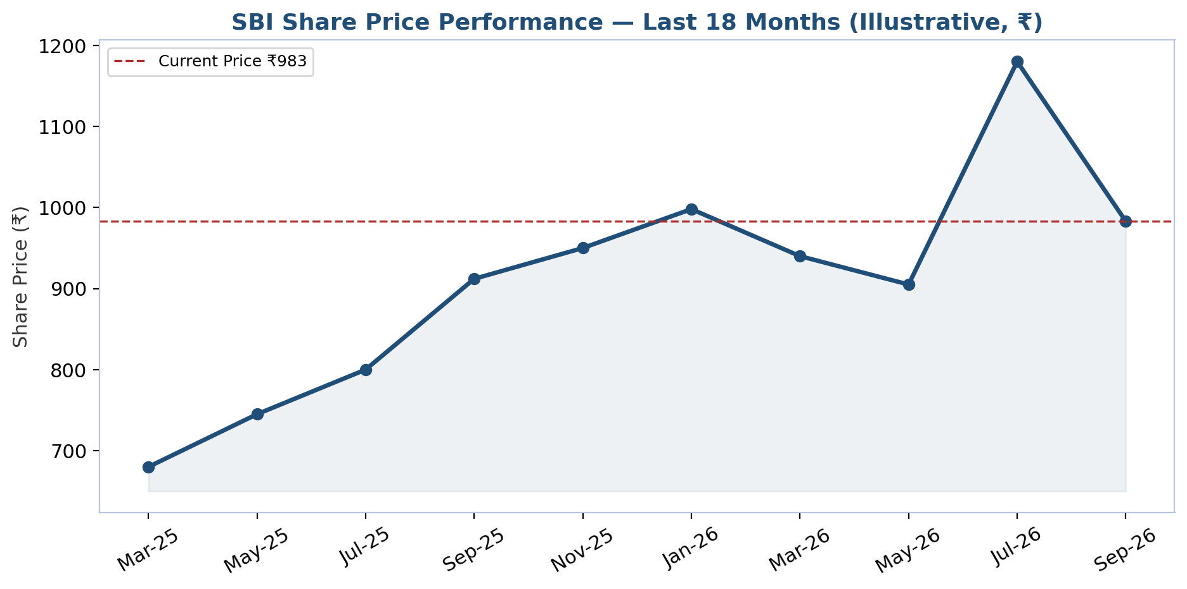
Figure 1: SBI share price performance, last 18 months (illustrative reconstruction from available data points; ₹ per share).
The thesis is not a turnaround story — it is a re-rating story. SBI's asset-quality clean-up is structurally complete, not cyclical: gross NPA has fallen from above 10% at the peak of the 2015-2019 corporate-credit cycle to 1.49% today, and provision coverage (including write-offs) sits above 90%. What the market has not yet priced, in our view, is that SBI's return profile now compares favorably with private banks on ROE while its balance sheet carries structurally lower risk (75%+ retail/priority-sector-adjacent mix, sovereign-linked deposit franchise) and its subsidiary ecosystem (SBI Life, SBI Cards, SBI General, SBI Mutual Fund) is approaching a value-crystallization event via the planned SBI Funds Management stake-sale IPO.

Key Investment Bullets
■ Record profitability with structurally clean asset quality. FY26 standalone net profit reached ₹80,032 crore, up 12.9% year-on-year and the bank's highest ever, while gross NPA fell to 1.49% (from 1.82% in FY25) and net NPA to 0.39% — both multi-decade lows. Provision coverage including write-offs (AUCA) stands above 90%, meaning the balance sheet is carrying very little unrecognized stress. Management's own guidance points to continued, if more moderate, improvement in FY27-28 as the loan book's post-2020 vintage matures without the legacy drag of pre-2019 corporate exposures.
■ A valuation gap that is not explained by fundamentals. SBI trades at 10.90x trailing P/E and 1.47x P/B versus a private-bank peer median of 13.30x P/E and 1.67x P/B, despite an FY26 ROE of 18.6% that sits above HDFC Bank's (~12.5% on our comparable calculation) and close to ICICI Bank's (~15.0%). Some discount is warranted for government-ownership and policy-lending risk, but a gap this wide, against comparable or better returns on equity, is the core of our re-rating thesis.
■ Capital raised, growth funded for five to six years. The FY26 ₹25,000 crore QIP lifted CET1 to 11.40% and total CAR to 15.40%, and management has explicitly guided that SBI should not need further equity capital for five to six years even while sustaining low-teens percentage credit growth — a rare combination of growth funding and no near-term dilution overhang, which we build into our base case as zero incremental share issuance through FY31E.
■ YONO 2.0 and subsidiary value are under-appreciated optionality. The YONO 2.0 relaunch repositions SBI's app as customers' primary payments surface — a direct defense of the CASA and cross-sell franchise against UPI-native fintechs — while the planned SBI Funds Management stake-sale IPO (targeted 2026, ~₹11,000-13,000 crore raise for a 10% stake) will crystallize and make visible a slice of subsidiary value that today sits inside a standalone-basis P/B multiple and is easy for the market to overlook.

Financial Summary
(₹ crore, unless noted) | FY24A | FY25A | FY26A | FY27E | FY28E
Net Interest Income | 1,60,052 | 1,66,945 | 1,73,812 | 2,08,992 | 2,49,999
Total Net Revenue | 2,16,352 | 2,29,345 | 2,56,330 | 2,85,067 | 3,33,517
Operating Profit (PPOP) | 97,506 | 1,08,632 | 1,22,007 | 1,38,357 | 1,73,247
Net Profit (PAT) | 61,116 | 70,859 | 80,041 | 82,652 | 1,06,019
Basic EPS (₹) | 68.48 | 79.40 | 88.03 | 90.91 | 116.61
Book Value per Share (₹) | 355.07 | 418.57 | 509.05 | 580.39 | 671.93
Gross NPA Ratio (%) | 2.24% | 1.82% | 1.49% | 1.45% | 1.42%
Net Interest Margin — Domestic (%) | 4.86% | 4.63% | 4.15% | 4.37% | 4.61%
Return on Equity (%) | 20.3% | 19.9% | 18.6% | 16.7% | 18.6%
Return on Assets (%) | 1.04% | 1.10% | 1.12% | 1.08% | 1.23%
Table 1: Financial summary, FY24A-FY28E. A = Actual, E = Estimate. Source: Company filings; SBI Financial Model (Task 2/3).

We discuss the full investment thesis, company background, financial model, scenario analysis and valuation methodology in the sections that follow. Section headers map to the structure a reader would expect from an institutional initiation report: Investment Thesis and Risk Factors, Company 101 (business, history, management, products, industry, competition, market opportunity), Financial Analysis, Projection Assumptions, Scenario Analysis, Valuation Methodology, and Appendices.

Investment Thesis
Our thesis rests on four pillars: (1) a structurally, not cyclically, clean balance sheet; (2) a valuation multiple that has not caught up with an improved return profile; (3) a funded growth runway without near-term dilution risk; and (4) digital and subsidiary optionality that is not yet reflected in the standalone equity story. We take each in turn.

Pillar 1: Asset-Quality Clean-Up Is Structural, Not Cyclical
Gross NPA fell from 1.82% in FY25 to 1.49% in FY26, and net NPA from 0.47% to 0.39% — both the lowest in more than a decade, and the trend has been consistent for six consecutive years rather than a one-off recovery. This matters because it changes the denominator of the bear case: a bank with a 1.49% GNPA ratio and 74%+ provision coverage (91%+ including AUCA) has very little capacity for a "hidden NPA shock" narrative to reassert itself the way it did during 2015-2019. Slippage ratios have fallen in parallel — to roughly half-a-percent of advances in FY26 — confirming that new-loan underwriting discipline, not just aggressive write-offs of old stock, is driving the improvement.
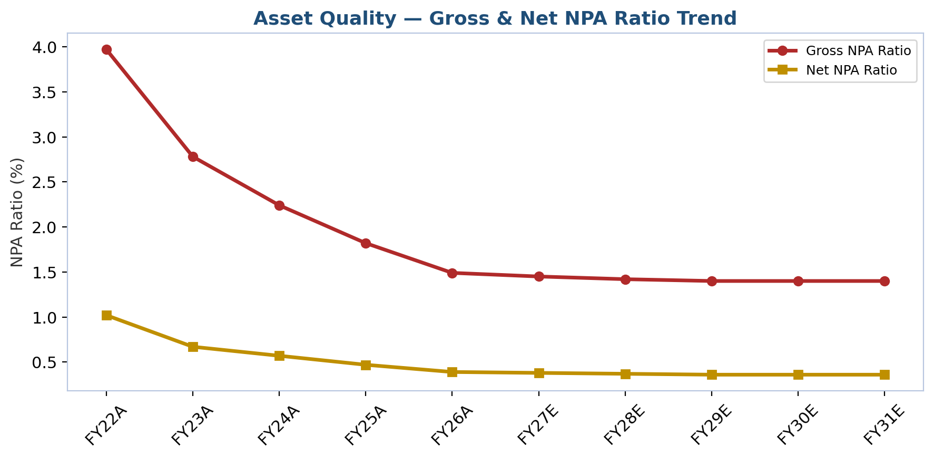
Figure 2: Gross and net NPA ratio trend, FY22A-FY31E.

Pillar 2: The Valuation Gap Exceeds What Fundamentals Justify
SBI's FY26 ROE of 18.6% compares with an implied ROE (P/B ÷ P/E) of roughly 12.5% for HDFC Bank and 15.0% for ICICI Bank, yet SBI trades at 1.47x P/B versus 1.67x for the private-bank peer median — a discount of nearly half. Some of that gap is a legitimate governance and policy-risk discount that we do not expect to fully close (see Risk Factors); we are not underwriting SBI re-rating all the way to HDFC Bank's multiple. But the current gap is wide enough that even a partial re-rating — SBI moving from 1.47x to, say, 1.7-1.8x book on an unchanged earnings trajectory — would be a meaningful source of equity return independent of earnings growth, and it is this gap, more than any single earnings catalyst, that anchors our price target above the current market price.
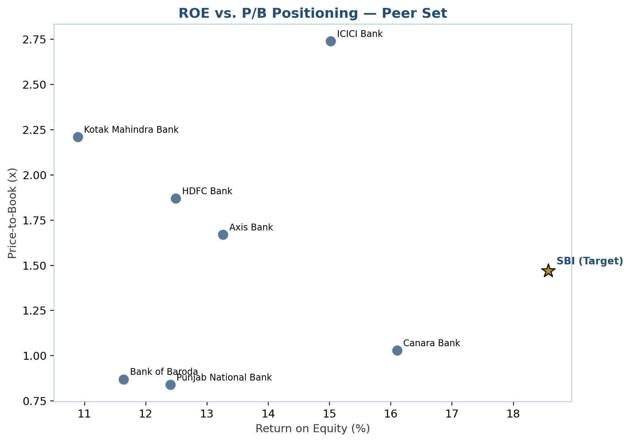
Figure 3: ROE vs. P/B positioning across the peer set; SBI sits well below the private-bank cluster on P/B despite a comparable or better ROE.

Pillar 3: Growth Is Funded Without Near-Term Dilution
The FY26 qualified institutional placement raised ₹25,000 crore and lifted CET1 to 11.40% and total CAR to 15.40%, both comfortably above regulatory minimums. Management has stated this capital, together with internal accrual at an 18%+ ROE, should support roughly ₹12 lakh crore of incremental credit growth over five to six years without requiring further equity issuance — a claim we can partially verify in our own model: even under our Base Case's low-teens percentage advances growth, SBI's CET1 ratio does not fall below management's stated comfort zone through FY31E in our projections (see Financial Analysis). This is a meaningfully different setup from prior PSU-bank capital cycles, where recurring, dilutive government capital infusions were the norm and were a standing overhang on per-share value creation.

Pillar 4: Digital Execution and Subsidiary Value Are Underpriced Optionality
YONO 2.0's relaunch — a unified banking, payments and investment backend intended to make SBI's own app, rather than a third-party UPI wallet, the default transaction surface for its ~500 million customer relationships — is a direct defense of the CASA franchise's future value, since a customer who transacts inside YONO is a customer SBI can continue to cross-sell into loans, insurance and mutual funds. Separately, the group's plan to sell a 10% stake in SBI Funds Management via IPO (targeted for 2026, expected to raise ₹11,000-13,000 crore) would, for the first time, put an explicit, market-derived value on one of the subsidiary franchises that today sits inside SBI's consolidated numbers but is invisible in the standalone-basis P/B multiple the market uses to price the stock. Neither of these is in our base-case valuation numerically; both are asymmetric, optionality-style upside.

Risk Factors
We organize the fifteen risks we track across four categories — company-specific, industry/market, financial, and macroeconomic — consistent with how we believe institutional investors should weigh them against the price target above. None of these, individually, is severe enough to change our rating; collectively, they are the reason our target implies moderate rather than outsized upside.

Company-Specific Risks
Government ownership and policy-directed lending risk: As a majority government-owned institution, SBI is periodically subject to priority-sector-lending mandates, government-scheme financing obligations (Kisan Credit Card expansion, housing and MSME subsidy schemes) and informal "moral suasion" on deposit or lending rates that private banks do not face. This can direct capital toward segments or pricing that are not purely risk/return-optimized, creating a credit-risk and margin exposure that is difficult for outside analysts to fully model and that can move counter to the bank's own stated ROA/ROE targets during periods of heightened government fiscal or political priority.
Net interest margin compression: SBI's domestic NIM compressed from roughly 3.35% to approximately 3.0% through FY26 as RBI repo-rate cuts fed through to floating-rate loans faster than deposit costs repriced downward. Management has guided NIM should partially recover as term deposits reprice and as the CRR cut announced for September 2025 works through the system, but continued or renewed rate cuts, or slower-than-expected deposit repricing amid intensifying deposit competition, could keep margins under pressure longer than guided, directly compressing core profitability.
Execution risk on YONO 2.0 and digital transformation: SBI's competitive response to fintech disintermediation rests heavily on successfully repositioning YONO as customers' primary transaction interface. Given the platform's scale (hundreds of millions of potential users) and SBI's historically slower, more bureaucratic technology-delivery culture relative to digitally-native private banks, execution delays, security incidents, or a failure to shift meaningful payment volume onto the platform would represent a missed strategic opportunity with limited immediate financial cost but significant longer-term competitive-positioning risk.
CFO and senior-management transition risk: SBI experienced multiple senior-leadership transitions through 2025–2026, including a new externally recruited CFO (Sunil Ramgopal Agrawal, effective August 2026) and new Managing Directors taking on international banking and credit-risk portfolios. While SBI's deep internal bench mitigates this somewhat, transitions in finance and credit-risk leadership during a period of margin pressure and continued balance-sheet growth carry some execution and continuity risk, particularly given the CFO role's external (rather than internally promoted) fill.
Legacy associate-bank and corporate-book integration residue: Although asset quality has improved dramatically, portions of the loan book still carry legacy exposures from the 2017 associate-bank mergers and the 2015–2019 corporate-NPA cycle; while provision coverage is now high (PCR including AUCA above 90%), any renewed corporate-sector stress could still disproportionately surface in these older-vintage exposures.

Industry/Market Risks
Intensifying deposit competition and CASA erosion: SBI's historic low-cost-deposit advantage is under structural pressure as customers shift savings toward market-linked instruments (mutual funds) and as private banks and NBFCs compete more aggressively for term deposits with attractive rates, evidenced by the sector-wide elevated credit-deposit ratio (~80–82%) forcing banks, including SBI, to compete harder — and pay more — for deposit growth.
Regulatory change risk: The RBI has repeatedly adjusted risk-weight requirements on unsecured retail and NBFC lending and has a pending, repeatedly deferred, Liquidity Coverage Ratio framework revision that could tighten liquidity-management requirements when eventually implemented; unexpected regulatory tightening on any of these fronts could constrain credit growth or raise funding costs sector-wide, with PSU banks sometimes less able than private peers to quickly adjust balance-sheet composition in response.
Technology disruption from fintech and NBFC competition: Faster underwriting turnaround from NBFCs in unsecured retail/SME lending and UPI-native fintechs' dominance of daily payment transactions both threaten to erode SBI's customer engagement and fee-income opportunity even where the underlying deposit relationship persists, a disintermediation risk common to the whole banking sector but particularly acute for a legacy-technology-heavy institution like SBI.
Credit-cycle/slippage risk in newer growth segments: The segments driving SBI's fastest recent growth — SME (~20%), agriculture (~20%), and unsecured retail — are also historically the most credit-cycle-sensitive categories; a sharper-than-expected economic slowdown, particularly affecting MSMEs or agricultural income (monsoon-dependent), could reverse recent slippage-ratio improvements quickly, given these segments' shorter loss-emergence lag compared to large corporate credit.

Financial Risks
Capital-raise cadence and dilution risk: Management has stated SBI may not need further equity capital for five to six years following the FY26 QIP, but this assumes continued strong internal capital generation (ROE sustaining ~18%+) and a credit-growth trajectory in line with current guidance; a materially faster credit-growth environment, unexpected credit losses, or regulatory capital-requirement increases could force an earlier, potentially dilutive, capital raise.
Treasury and mark-to-market income volatility: A meaningful share of recent quarterly profit growth — including the Q1 FY26 and Q2 FY26 beats — was driven by treasury/investment-revaluation gains and one-off items (the Yes Bank stake sale, Jio Payments Bank stake sale) rather than core operating income; core pre-provision operating profit growth, while still healthy, has at times lagged the more volatile treasury-driven headline profit figure, and investors extrapolating recent reported profit growth risk overstating the sustainable run-rate.
Rising cost of deposits: SBI's domestic cost of deposits rose from roughly 5.0% to 5.2% year-on-year through much of FY26 even as lending yields eased, a margin-squeeze dynamic that, if deposit-cost stickiness persists longer than lending-yield stickiness, could keep core spread income under pressure beyond current management guidance.

Macroeconomic Risks
Economic-cycle sensitivity: As India's largest lender across virtually every sector and geography, SBI's loan book is a near-direct proxy for Indian GDP growth; the current 6.5% real-GDP growth projection embeds an assumption of continued government capex-led investment and resilient private consumption that, if disrupted by global trade friction, commodity-price shocks, or a domestic demand slowdown, would flow through to credit growth, asset quality and fee income simultaneously across nearly every SBI business line.
Interest-rate and monetary-policy sensitivity: SBI's NIM, treasury/investment book valuation, and loan demand are all directly sensitive to RBI monetary-policy decisions; the FY25–FY26 rate-cutting cycle has already compressed margins, and while further easing could support credit demand, any subsequent rate-hiking cycle would create the opposite dynamic — higher funding costs repricing faster than asset yields — a risk that cuts both ways depending on the phase of the cycle.
Geopolitical and global-trade exposure: SBI's foreign-office book (roughly 36 countries, growing faster than the domestic book) and its role financing Indian corporates' outbound trade and investment expose it to global-trade-policy shifts (tariffs, sanctions regimes affecting counterparties), currency volatility affecting foreign-currency-denominated exposures, and broader global-financial-market stress that could affect both funding costs and asset quality in the international book, even though this segment remains a small fraction of the overall balance sheet.

Company 101
This section draws on our fundamental company research (business model, history, leadership, products, industry, competitive position and market opportunity) and is presented here largely as originally researched, since it forms the factual foundation the rest of this report's analysis and valuation build on.

Company Overview
State Bank of India (SBI) is India's largest bank by almost every measure that matters to a lender — assets, deposits, advances, branch network, customer count and government backing. Headquartered at State Bank Bhavan, Nariman Point, Mumbai, SBI is a public-sector banking and financial-services statutory body in which the Government of India holds roughly 55.5% of equity, making it, in effect, India's sovereign-backed universal bank. As of March 31, 2026 (FY26), SBI's total business — deposits plus advances — had crossed ₹109 trillion (₹109 lakh crore), with total deposits of ₹59.75 lakh crore and gross advances of ₹49.32 lakh crore. The bank commands a deposit market share of roughly 22–23% and an advances market share of approximately 19–20% of the entire Indian banking system, a scale no single private-sector competitor comes close to matching.
SBI is best understood as three businesses layered on top of one another. First, and by far the largest, is the core domestic commercial bank: a network of roughly 22,500–23,500 branches and over 63,000 ATMs/ADWMs reaching nearly every pin code in India, serving an estimated 500 million customer relationships across retail, agricultural, SME and corporate segments. Second is a rapidly scaling digital banking franchise built around the YONO (You Only Need One) super-app, which the bank has been repositioning — via the "YONO 2.0" relaunch completed in late 2025 — as a unified banking, payments, investment and lifestyle platform intended to be the primary customer interface rather than a supplementary channel. Third is a diversified financial-services group of listed and unlisted subsidiaries — SBI Life Insurance, SBI General Insurance, SBI Cards and Payment Services, SBI Funds Management (in partnership with Amundi), SBI Capital Markets and SBI Securities among others — that together constitute one of the most valuable non-banking financial franchises in India and are increasingly recognized by analysts as a distinct source of "sum-of-the-parts" value (estimated by some brokerages at approximately ₹350+ per share) on top of the standalone banking business.
The bank makes money the way most universal banks do, but at a scale that gives it structural cost-of-funds and distribution advantages few peers can replicate. Net interest income — the spread between interest earned on advances/investments and interest paid on deposits — is the single largest revenue driver, supplemented by fee and commission income (loan processing, transaction banking, wealth and bancassurance distribution), treasury/trading gains, and dividend/consolidation income from its subsidiaries. For FY26, SBI reported total income of ₹5,51,647 crore, standalone net profit of ₹80,032 crore (its highest ever, up 12.9% year-on-year) and operating profit of ₹1,23,015 crore, translating into return ratios of roughly 1.12% return on assets (ROA) and 18.6% return on equity (ROE) — metrics that now sit comfortably alongside, and in some quarters ahead of, several private-sector peers, a striking reversal from the public-sector-bank underperformance narrative of the 2015–2020 NPA-crisis years.
Geographically, SBI is overwhelmingly a domestic Indian franchise — well over 90% of its balance sheet is domestic — but it also operates one of the largest overseas networks of any Indian bank, with roughly 235–241 offices spanning 36 countries, supporting Indian corporates' outbound trade and investment flows, the Indian diaspora, and correspondent banking relationships. Foreign-office advances have in fact been one of the faster-growing segments of the loan book in FY25–FY26, expanding in the mid-to-high teens percentage range.
On scale indicators that matter for an initiating-coverage thesis: SBI's domestic retail advances crossed ₹15 lakh crore in FY25 and continued to grow through FY26, constituting over 40% of domestic advances, with home loans as the single largest sub-segment; the bank is also the largest education-loan lender in the country with roughly a third of that specific market. Asset quality — historically the central bear case on PSU banks — has improved dramatically: gross NPA ratio fell from 1.82% (March 2025) to 1.49% (March 2026), and net NPA fell from 0.47% to 0.39% over the same period, both multi-decade lows, with a provision coverage ratio (including write-offs) above 90%. Capital adequacy stood at 15.40% (Basel III, March 2026), comfortably above regulatory minimums, aided by a ₹25,000 crore qualified institutional placement (QIP) completed during FY26 — the bank's first large equity raise in years — which management has said should support roughly ₹12 lakh crore of incremental credit growth over five to six years without needing further equity capital.
As of September 25, 2026, SBI shares (NSE: SBIN) traded around ₹983, implying a market capitalization of approximately ₹9.03 lakh crore (roughly US$102 billion), a trailing P/E of about 11x and a price-to-book multiple of roughly 1.5x — a persistent valuation discount to large private banks such as HDFC Bank (~20x P/E) and ICICI Bank (~19x P/E) that forms a central pillar of the bull case laid out later in this coverage initiation.
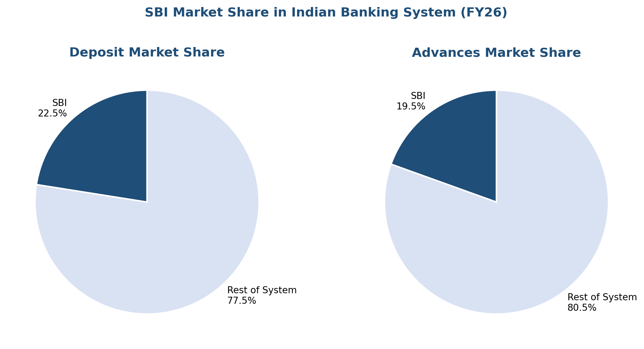
Figure 4: SBI's share of Indian system deposits and advances, FY26.

Company History
SBI's institutional lineage is the oldest in Indian banking, tracing back more than 200 years — a heritage the bank actively markets as a trust and stability differentiator. The story begins with the Bank of Calcutta, founded on June 2, 1806, the first joint-stock bank in India, which received a royal charter in 1809 and was renamed the Bank of Bengal. Two sister "Presidency Banks" followed: the Bank of Bombay (1840) and the Bank of Madras (1843). Jointly owned by the colonial provincial governments and private shareholders, these three banks held currency-issuing privileges in their respective regions until the Presidency Banks Act of 1876 centralized that function, after which the banks pursued rapid branch expansion — nearly fifty branches between them by the mid-1870s.
In 1921, the three Presidency Banks were amalgamated into a single entity, the Imperial Bank of India (IBI) — an institution partly designed with input from economist John Maynard Keynes — which became the largest commercial bank in India, combining central-bank-adjacent functions (government banking, currency management) with ordinary commercial banking. Following Indian independence, the government progressively nationalized the banking system's commanding heights. The Reserve Bank of India acquired a controlling (60%) stake in the Imperial Bank in 1955, and an Act of Parliament passed in May 1955 formally constituted the Imperial Bank as the State Bank of India, effective July 1, 1955 — the date SBI recognizes as its founding. John Mathai, an economist, served as the bank's first chairman.
The State Bank of India (Subsidiary Banks) Act of 1959 brought eight state-associated banks — including the State Banks of Bikaner, Jaipur, Hyderabad, Mysore, Patiala, Travancore, Saurashtra and Indore — into the fold as SBI subsidiaries/associate banks, a structure that persisted, with periodic consolidation (Bikaner and Jaipur merged into State Bank of Bikaner & Jaipur in 1963), for nearly six decades. Over its 200-plus year history, more than twenty banks have been absorbed into what is now SBI, an M&A track record arguably unmatched by any other Indian financial institution.
The modern consolidation era began in 2008, when the State Bank of Saurashtra was merged into SBI, followed by State Bank of Indore in 2010. The most transformative restructuring, however, came on April 1, 2017, when SBI merged its five remaining associate banks — State Bank of Bikaner & Jaipur, State Bank of Mysore, State Bank of Travancore, State Bank of Patiala and State Bank of Hyderabad — along with the Bharatiya Mahila Bank, into itself in a single stroke. That merger instantly added roughly ₹8 lakh crore in combined business and pushed SBI's balance sheet into the top 50 banks globally by assets, though it also imported a wave of associate-bank NPAs that weighed on consolidated asset quality for several years afterward and coincided with the broader Indian banking system's 2015–2019 asset-quality crisis (the RBI's Asset Quality Review era), during which SBI's own gross NPA ratio peaked above 10%.
The subsequent decade has been a story of clean-up and digitization. Under Chairman Rajnish Kumar (2017–2020) and then Dinesh Kumar Khara (2020–2024), the bank pursued aggressive NPA recognition and recovery, built out its Stressed Assets Resolution Group, and — critically — launched and scaled the YONO digital platform (2017 onward) as its flagship strategy for reducing cost-to-serve and defending market share against private-sector and fintech competition. SBI Cards was listed via IPO in 2020, and SBI General Insurance and other subsidiaries have since attracted external capital, part of a broader strategy of monetizing non-banking franchise value while retaining majority control. C.S. Setty assumed the chairmanship on August 28, 2024, inheriting a bank at record profitability and record-low NPAs, and has since overseen the FY26 QIP capital raise, the September 2025 partial divestment of SBI's legacy Yes Bank stake (down from 24% to roughly 10.8%, crystallizing a one-time gain of over ₹4,590 crore), the YONO 2.0 relaunch, and the bank's crossing of the $100 billion market-capitalization threshold in November 2025 — milestones that collectively mark SBI's transition from "too-big-to-fail sovereign lender" to a franchise increasingly discussed by global brokerages in the same breath as India's leading private banks.

Management Team
SBI's senior leadership combines multi-decade internal career bankers with, for the first time in the CFO role, an external hire from India's largest insurer — a mix the board has used deliberately to pair institutional continuity with fresh external financial-discipline perspective.

Chairman & Managing Director — Shri Challa Sreenivasulu (C.S.) Setty
C.S. Setty took charge as Chairman of State Bank of India on August 28, 2024, for an initial three-year term approved by the government's Appointments Committee of the Cabinet, having been the senior-most Managing Director on the board at the time of his elevation. Setty is a career SBI banker who joined the institution in 1988 as a Probationary Officer, giving him roughly 36 years of continuous service across the bank's retail, corporate, international and technology functions by the time he reached the top job — a career arc typical of SBI's promote-from-within leadership culture, which the bank and analysts alike cite as a source of institutional continuity that many private banks, with their more lateral-hire-driven executive benches, cannot replicate. As Managing Director from January 2020, Setty headed the Retail & Digital Banking vertical from 2020 to 2022, a period that included the acceleration of YONO adoption and the bank's digital-lending build-out, before moving to head International Banking, Global Markets and Technology, giving him direct oversight of two of the three strategic pillars — digital and international — that define SBI's current growth narrative. He has chaired multiple government-constituted banking-sector task forces and committees. His academic background is a Bachelor of Science in Agriculture, coupled with a Certified Associate of the Indian Institute of Bankers (CAIIB) qualification — a profile that, unusually for a chairman of India's largest bank, reflects grounding in the priority-sector and rural-lending side of the business as much as corporate or treasury banking. Since taking over, Setty has driven the ₹25,000 crore QIP capital raise (freeing the bank from needing further equity for an estimated five to six years), the partial Yes Bank stake monetization, and the YONO 2.0 relaunch, and in March 2025 he was elected Chairman of the Indian Banks' Association (IBA), the industry's apex lobby body, a role that gives SBI outsized influence over sector-wide policy positions on issues from digital-lending regulation to interest-rate transmission. Under his tenure, SBI posted record annual profit in both FY25 (₹70,901 crore) and FY26 (₹80,032 crore) and publicly targeted a position among the world's top ten banks by market capitalization by 2030.

Managing Director (Corporate Banking and Subsidiaries) — Shri Ashwini Kumar Tewari
Ashwini Kumar Tewari is one of SBI's most internationally seasoned senior bankers, having joined the institution in 1991 as a Probationary Officer and spent over three decades across assignments in India, Hong Kong, China, Japan, Korea and the Americas. He currently serves as Managing Director overseeing Corporate Banking (large corporate and commercial credit) alongside SBI's Associates & Subsidiaries portfolio — a dual mandate that makes him the board-level executive most directly responsible for the value of SBI Cards, SBI Life, SBI General Insurance, SBI Mutual Fund and SBI Capital Markets, all of which he serves as a director on the boards of. Immediately prior to this role he was Managing Director (Risk, Compliance and Stressed Assets) from June 2022, where he was responsible for shaping the bank's climate-risk management framework and stressed-assets strategy during the tail end of the NPA clean-up cycle, and before that he served as Managing Director & CEO of SBI Cards and Payment Services, the bank's listed credit-card subsidiary, giving him direct P&L accountability for a consumer-lending business quite different in risk profile from traditional SBI wholesale banking. His earlier overseas postings include Country Head of SBI's U.S. operations (2017–2021, covering New York, Chicago, Los Angeles, Washington DC and São Paulo) and Regional Head for East Asia based in Hong Kong, plus roles as Deputy General Manager (Operations & Information Systems) in the International Banking Group, Head of Cash Management, and various regional/branch leadership postings. Tewari holds a degree in Electrical Engineering, is a Certified Associate of the Indian Institute of Bankers (CAIIB) and a Certified Financial Planner (CFP), and completed a management certificate program at XLRI Jamshedpur. He has also served on the boards of the International Institute of Bankers (New York) and the University of Washington's Global Bankers Program. In December 2025, the government reappointed Tewari as Managing Director through December 2027, extending continuity in a role central to SBI's subsidiary-value narrative.

Managing Director (International Banking, Global Markets & Technology) — Shri Rana Ashutosh Kumar Singh
Rana Ashutosh Kumar Singh assumed the Managing Director role covering International Banking, Global Markets and Technology effective December 15, 2025, succeeding the portfolio previously held by Chairman Setty. He brings over three decades of leadership experience spanning multiple SBI businesses and geographies. Prior to this appointment, he headed the Stressed Assets Resolution Group (SARG), where he was responsible for strengthening the bank's overall risk-management framework, overseeing regulatory and internal compliance, and guiding the resolution and recovery of stressed corporate assets during a period when SBI's gross NPA ratio fell to its lowest level in over a decade — a track record directly relevant to assessing management's credibility on the asset-quality thesis central to this initiation. Earlier in his career he served as Chief General Manager of SBI's Chandigarh Circle, one of the bank's largest regional administrative units, and as Chief Executive Officer of SBI's German operations, giving him direct P&L and regulatory experience running a foreign banking subsidiary in a developed, tightly regulated European market — relevant background for his current international-banking mandate. His portfolio now places him at the center of two of management's most emphasized strategic priorities: the YONO 2.0 digital relaunch (technology) and the expansion of foreign-office advances, which grew over 20% year-on-year in FY26, faster than the domestic book.

Chief Financial Officer — Shri Sunil Ramgopal Agrawal
Sunil Ramgopal Agrawal joined SBI as Chief Financial Officer (Designate) on July 15, 2026 and assumed the CFO role formally, along with Key Managerial Personnel status, effective August 1, 2026, succeeding Kameshwar Rao Kodavanti, who completed a three-year tenure. Agrawal's appointment followed an external, contract-based recruitment process — a structure SBI has used for the CFO role since the Reserve Bank of India directed the bank, over a decade ago, to appoint a qualified chartered accountant with senior banking-finance experience to the position, since none of SBI's internal deputy-managing-director-level executives held that specific credential at the time. Agrawal brings over 27 years of financial-services experience, most recently as Chief Financial Officer of Life Insurance Corporation of India (LIC), where he navigated LIC's landmark 2022 initial public offering — India's largest IPO at the time — and its subsequent life as a listed, RBI/IRDAI-adjacent financial institution, giving him direct experience with the disclosure, governance and investor-relations demands of running finance for a large, government-linked, publicly listed Indian financial institution. He is a qualified Chartered Accountant and holds a Bachelor of Engineering degree in Computer Science, a technical-plus-financial combination the bank has flagged as relevant to its ongoing technology and data-driven finance transformation. Agrawal's appointment came at a moment of margin compression across the sector, and his mandate is widely read by analysts as centered on cost-of-funds discipline, subsidiary capital allocation, and continued balance-sheet optimization following the FY26 QIP.

Governance and Ownership
Governance and Ownership SBI's Central Board is constituted under the State Bank of India Act, 1955, a structure distinct from the Companies Act board framework governing private banks, and includes directors elected under different statutory sub-sections (Section 19(c), (d), (e) and (f) of the SBI Act) alongside the Chairman and Managing Directors, giving the government multiple direct and indirect board-appointment channels. Independent, shareholder-elected directors include Ketan S. Vikamsey, a senior chartered-accountancy partner with over three decades of experience auditing large banks and financial institutions, and other directors with backgrounds spanning capital markets, technology and public administration. The Government of India held approximately 55.5% of SBI's equity as of mid-2026, following dilution from the FY26 QIP; foreign institutional investors held roughly 10–11%, domestic institutional investors (mutual funds, insurers) approximately 26–27%, and the retail public roughly 7%. This shareholding structure means SBI, unlike private-sector peers, is subject to periodic government influence over lending priorities (priority-sector mandates, government-scheme financing, occasional "moral suasion" on rates) that can create policy-driven volatility in credit allocation not present at HDFC Bank or ICICI Bank — a governance consideration explored further in the Risk Assessment section.

Products & Services
SBI's product suite spans the full universal-banking spectrum, organized broadly into four customer-facing business verticals — Retail & Digital Banking, Corporate & Commercial Banking, SME Banking, and Agriculture & Rural Banking — layered on top of Treasury, International Banking and a distinct Subsidiaries/Associates division.
In retail liabilities, SBI offers the full range of savings and current accounts (including specialized variants for salary accounts, senior citizens, women, and Jan Dhan financial-inclusion accounts), term and recurring deposits, and NRI banking products (NRE/NRO/FCNR accounts) that leverage the bank's large overseas office network. On the asset side, retail lending is anchored by home loans — SBI's single largest retail product line and a segment where the bank holds one of the largest market shares in India — alongside auto loans, personal loans, education loans (where SBI is the largest lender with roughly a third of the organized market), gold loans, and loans against securities/property. Home loan growth has been running at roughly 15% year-on-year through FY26, outpacing overall retail growth, reflecting both real-estate-cycle tailwinds and SBI's aggressive digital-approval push (many pre-approved home-loan and top-up offers are now originated and disbursed substantially through YONO with minimal branch touchpoints).
Corporate and commercial banking covers working-capital finance, term loans, project and infrastructure finance, trade finance and letters of credit/guarantee, cash-management services, and specialized syndication and structuring capabilities delivered in partnership with subsidiary SBI Capital Markets (SBICAPS), which is one of India's leading investment banks for project advisory, loan syndication, and debt/equity capital-markets execution. Corporate loan growth has been comparatively subdued relative to retail and SME (mid-single-digit to low-teens percentage depending on the quarter), consistent with a broader Indian private capex cycle that has been slower to revive than consumption-linked lending, though FY26 saw a pickup with corporate advances growing close to 15% for the full year as capex intent improved.
SME and MSME banking — a segment the bank has explicitly prioritized for growth given the government's continued policy emphasis on the sector — grew advances by roughly 19–21% year-on-year through FY26, among the fastest-growing loan categories on the balance sheet, supported by digital underwriting tools that reduce turnaround time for collateral-light MSME loans. Agriculture and rural banking, a legacy strength tied to SBI's extensive rural branch network and priority-sector-lending obligations, includes crop loans, Kisan Credit Cards, agri-infrastructure finance and allied-activity lending; agricultural advances grew close to 20% year-on-year in FY26.
Digital banking is now central to the product story rather than a channel afterthought. YONO, first launched in 2017 and substantially rebuilt as "YONO 2.0" (relaunched around end-2025/early-2026), unifies internet banking and the mobile app on a single backend architecture, giving customers one consistent interface across payments, account management, investments (mutual funds, government bonds, IPO applications), insurance purchase, loan origination (including instant pre-approved personal loans), and an expanding lifestyle/e-commerce marketplace layer (travel, shopping, bill payments). Management has explicitly stated that payments are expected to be the most-used YONO 2.0 service, positioning the app to compete directly with UPI-native fintech apps (PhonePe, Google Pay, Paytm) on the transaction layer while retaining the advantage of being tied to actual deposit and credit relationships rather than being a pass-through payments app.
Beyond core banking, SBI's subsidiaries extend the product shelf into adjacent financial services distributed heavily through the bank's own branch and digital network (a classic bancassurance/cross-sell model): SBI Life Insurance (life and protection products, one of India's largest private-sector life insurers by premium), SBI General Insurance (motor, health, property and general insurance), SBI Funds Management (mutual funds, portfolio management, alternative investment funds, run in partnership with France's Amundi), SBI Cards and Payment Services (credit cards, India's second-largest card issuer by cards-in-force), SBI Capital Markets and SBI Securities (investment banking and retail broking), and SBI Global Factors (trade receivables factoring). Typical "deal sizes" span an enormous range by design — from sub-₹10,000 microfinance and Jan Dhan transactions at one end to multi-thousand-crore infrastructure and corporate credit facilities at the other — a breadth of ticket size that is itself a structural differentiator against most private banks, which skew more heavily toward affluent-retail and mid-to-large corporate segments.

Customers & Go-to-Market
SBI's customer base is best described as a cross-section of India itself rather than a defined target segment: an estimated 500 million-plus customer relationships spanning salaried and self-employed retail customers, farmers and rural households, micro/small/medium enterprises, large domestic conglomerates, multinational corporations operating in India, state and central government bodies, and non-resident Indians globally. This breadth reflects SBI's dual identity as both a commercial bank optimizing for returns and, historically, an instrument of government financial-inclusion policy (Jan Dhan Yojana account openings, direct-benefit-transfer disbursal, priority-sector-lending mandates) — a combination that gives it unmatched reach into segments (rural, unbanked, first-time borrowers) that most private banks reach only indirectly, if at all, but which also means a portion of the balance sheet is deployed for policy rather than pure risk-adjusted-return objectives.
Distribution runs through three reinforcing channels. First, the physical branch and ATM network — over 22,500 branches and 63,000-plus ATMs/ADWMs — remains the largest of any Indian bank and is particularly dominant in semi-urban and rural geographies where digital-only competitors have negligible physical presence; this network also serves as SBI's customer-acquisition engine for cross-selling subsidiary products (insurance, mutual funds, cards) via in-branch relationship managers. Second, the YONO digital platform is increasingly the primary engagement channel for existing customers and an acquisition channel for pre-approved and digitally originated lending, with management targeting payments as the platform's highest-frequency use case to keep customers inside the SBI ecosystem rather than defaulting to third-party UPI apps. Third, a network of business correspondents and customer service points extends formal banking access into remote rural areas not economically served by physical branches, a model central to the bank's financial-inclusion mandate and priority-sector-lending compliance.
Sales strategy differs meaningfully by segment: retail and SME acquisition increasingly leans on digital pre-approval and analytics-driven cross-sell (using the bank's existing deposit-relationship data to originate instant loan offers), while large corporate and institutional relationships are managed through dedicated relationship-banking teams organized by Commercial Client Groups (CCG-I and CCG-II) and sector desks, with SBI Capital Markets providing investment-banking-grade advisory for the largest transactions. Key partnerships include the Amundi joint venture in asset management, correspondent-banking arrangements supporting the international network, and government-scheme partnerships (housing finance subsidy schemes, agricultural credit schemes, PM Surya Ghar rooftop-solar financing) that both serve policy objectives and generate volume-driven lending opportunities. Customer concentration risk at the aggregate balance-sheet level is low given the sheer diversification of the loan book across millions of borrowers, though single-large-corporate-exposure risk exists at the individual-account level and is managed through internal exposure limits and credit-rating-linked risk-weighting discipline (the bank has explicitly highlighted improving its book's rating mix, with AAA-rated corporate exposure rising from 42% to 45% of the corporate book between March 2025 and March 2026).

Industry Overview
SBI operates within the Indian scheduled commercial banking industry, a sector comprising roughly 12 public-sector banks, over 20 private-sector banks, foreign banks, small-finance banks and payment banks, regulated by the Reserve Bank of India (RBI) under the Banking Regulation Act. The industry sits within a broader Indian financial-services ecosystem that also includes non-banking financial companies (NBFCs), which compete aggressively with banks in retail and MSME lending, and an increasingly influential digital-payments layer (the government-backed Unified Payments Interface, or UPI) that has reshaped how Indians transact even where the underlying deposit relationship still sits with a bank.
System-wide bank credit growth has been volatile across FY25–FY26: growth moderated to roughly 10–11% in FY25 as banks deliberately reduced credit-to-deposit ratios and pulled back from unsecured retail and NBFC lending amid regulatory risk-weight increases, before reaccelerating sharply through FY26 — non-food credit grew nearly 16% year-on-year to around ₹213 trillion by March 2026, aided by RBI's rollback of some of the earlier risk-weight tightening, a series of repo-rate cuts (roughly 125 basis points cumulatively) that lowered borrowing costs, and a GST-cut-driven consumption rebound in the second half of FY26. Rating agencies (ICRA, CareEdge) project credit growth moderating again to a still-healthy 13–15% range in FY27, with deposit growth structurally lagging credit growth, keeping the system-wide credit-deposit ratio elevated (around 80–82%) and deposit competition intense — a dynamic directly relevant to SBI given its historically strong low-cost CASA (current account/savings account) franchise, which is now facing erosion pressure common to the whole sector.
Net interest margins across the industry have compressed through FY26 as the RBI's repo-rate cuts fed through to floating-rate loan books faster than to deposit costs, which typically reprice with a lag; SBI's own domestic NIM fell from roughly 3.35% to around 3.0–3.1% over the period, a compression pattern mirrored — sometimes more severely — at private peers (HDFC Bank's NIM fell from 3.7% to 3.4%; Kotak Mahindra Bank's fell from 4.91% to 4.54%), suggesting this is a system-wide rate-cycle phenomenon rather than an SBI-specific competitive weakness.
Asset quality across the industry has improved dramatically and structurally since the 2015–2019 crisis years: system-wide gross NPA ratios for public-sector banks fell from roughly 9.4% in March 2021 to below 2.3% by December 2025, reflecting a decade of RBI-driven recognition discipline (the Asset Quality Review), the Insolvency and Bankruptcy Code's improved recovery framework, and generally more conservative underwriting since the crisis. Public-sector banks collectively posted record cumulative profit of roughly ₹1.78 lakh crore in FY25 (up 26% year-on-year) and continued that momentum into FY26, with SBI alone contributing over 40% of total PSU-bank sector profit — evidence of both SBI's outsized scale and the sector-wide turnaround narrative that underpins the broader PSU-bank re-rating thesis analysts have been discussing through 2025–2026.
Regulation is a first-order industry factor. The RBI actively manages risk-weighted-asset requirements for specific loan categories (having tightened, then partially eased, risk weights on unsecured retail and NBFC exposures across FY24–FY25), sets priority-sector-lending targets that disproportionately affect public-sector banks' loan mix, oversees an evolving Liquidity Coverage Ratio framework (implementation of proposed LCR changes has been repeatedly deferred, a regulatory-easing tailwind for the sector), and increasingly focuses supervisory attention on digital lending, data protection, and financial-inclusion metrics. The RBI has also been a vocal advocate of consolidation and stronger corporate governance in the PSU-bank space, and periodically intervenes in specific institutional matters (e.g., mandating that SBI appoint a qualified chartered accountant as CFO).
Structurally, private-sector banks (led by HDFC Bank following its 2023 merger with parent HDFC Ltd., and ICICI Bank) command premium market valuations — trading at 18–21x forward earnings versus roughly 5–11x for most public-sector banks including SBI — reflecting historically higher ROE, tighter cost discipline, and perceived superior governance, though the valuation gap has been narrowing as PSU banks demonstrate sustained profitability, and NIFTY PSU Bank index performance has actually outpaced NIFTY Bank (private-bank-dominated) over the past eight years on a CAGR basis (+13.8% versus +9.1%), a data point PSU-bank bulls, including several brokerages covering SBI, cite as evidence of an unresolved valuation anomaly rather than a permanent quality discount. Longer-term structural growth drivers for the industry include India's still-low credit-to-GDP penetration relative to developed and even many emerging markets, continued formalization of the informal economy (GST, digital payments trails improving creditworthiness data), rising per-capita income supporting mortgage and consumer-credit growth, and government infrastructure capex that should eventually revive the long-awaited private corporate-capex cycle.

Competitive Landscape
SBI's competitive set spans large private-sector banks, other public-sector banks, and — at the transaction/payments layer — non-bank fintechs, though no single competitor matches SBI's combined scale across deposits, branch reach and government-linked distribution.
HDFC Bank is SBI's most consequential private-sector competitor and, following its 2023 reverse merger with parent Housing Development Finance Corporation, is now the second-largest bank in India by assets. HDFC Bank commands premium valuation (around 20x P/E) reflecting a longer track record of high ROA (~1.9%) and disciplined "responsible growth" credit underwriting; its FY26 credit growth of roughly 12% trailed the ~16% system-wide pace as management prioritized balance-sheet integration and deposit-mobilization following the merger, giving SBI a relative growth-share opportunity in the interim, though HDFC Bank's branch and digital-banking execution remain best-in-class benchmarks the sector is measured against.
ICICI Bank is the second-largest private bank and typically posts the highest net interest margins among large peers (around 4.3%), reflecting a retail- and digitally-skewed book and strong fee income; it has also been an aggressive competitor in corporate and NBFC lending, growing that book meaningfully through FY26 alongside SBI. ICICI trades at a similar premium multiple to HDFC Bank (~19x), and its iMobile/InstaBIZ digital platforms are frequently cited as close analogues — and competitive benchmarks — for SBI's YONO ambitions.
Axis Bank, the third-largest private peer, has built a strong corporate- and SME-banking franchise alongside retail, and is a NIFTY Bank index heavyweight (~10% weight); it competes with SBI most directly in mid-market corporate and cash-management banking, though its balance sheet remains roughly one-fifth the size of SBI's.
Kotak Mahindra Bank, while smaller in absolute balance-sheet terms, commands the highest NIMs among large listed banks (~4.5%) and the richest valuation multiple (~22x P/E), reflecting a historically conservative, high-margin retail and wealth-management franchise; it has faced comparatively higher provisioning pressure through FY26, illustrating that even premium-valued private banks are not immune to the sector's asset-quality and margin cycles.
Among public-sector peers, Punjab National Bank (PNB), Bank of Baroda (BoB) and Canara Bank are SBI's closest structural analogues — government-majority-owned, priority-sector-obligated, and beneficiaries of the same PSU-bank re-rating narrative — but each is roughly one-fifth to one-eighth SBI's balance-sheet size and typically trades at a further valuation discount to SBI (PNB around 7x, Canara around 5x earnings versus SBI's ~9–11x), reflecting SBI's superior scale, lower cost of funds, stronger digital execution via YONO, and generally cleaner historical asset-quality trajectory. Union Bank of India and Bank of India round out the next tier of PSU competitors, generally following SBI's asset-quality improvement trend with a lag and trading at similarly compressed multiples.
Beyond traditional banks, SBI faces indirect but strategically important competition from NBFCs (Bajaj Finance being the most prominent, particularly in consumer and SME lending, where NBFCs' faster underwriting turnaround has historically won share from banks in unsecured retail credit) and from UPI-native payments fintechs (PhonePe, Google Pay, Paytm), which dominate transaction volumes on India's payments rails even though the underlying settlement still runs through bank accounts. SBI's competitive response — YONO 2.0's explicit positioning of payments as its highest-priority use case — is a direct attempt to prevent these fintechs from disintermediating the bank from its own customers' daily transaction behavior, a battle for the "front end" of banking that most of SBI's PSU peers are not fighting with comparable investment or urgency.
SBI's core competitive advantages are: (1) unmatched low-cost deposit franchise and CASA base built over decades of rural and semi-urban branch presence that would be prohibitively expensive for any competitor to replicate; (2) sovereign-linked trust that anchors deposit stickiness, especially valuable during periods of financial-system stress; (3) a genuinely diversified, increasingly valuable subsidiary ecosystem spanning insurance, asset management and cards; and (4) balance-sheet scale that allows participation in large syndicated and infrastructure transactions that smaller banks cannot underwrite alone. Its principal competitive vulnerabilities are structurally lower ROE/ROA than the best private banks (a function of a heavier, less digitally-native legacy cost base and government-directed lending obligations), continuing execution risk on technology modernization relative to digitally-native private peers, and a governance/ownership structure that introduces policy-driven lending pressure private banks do not face.
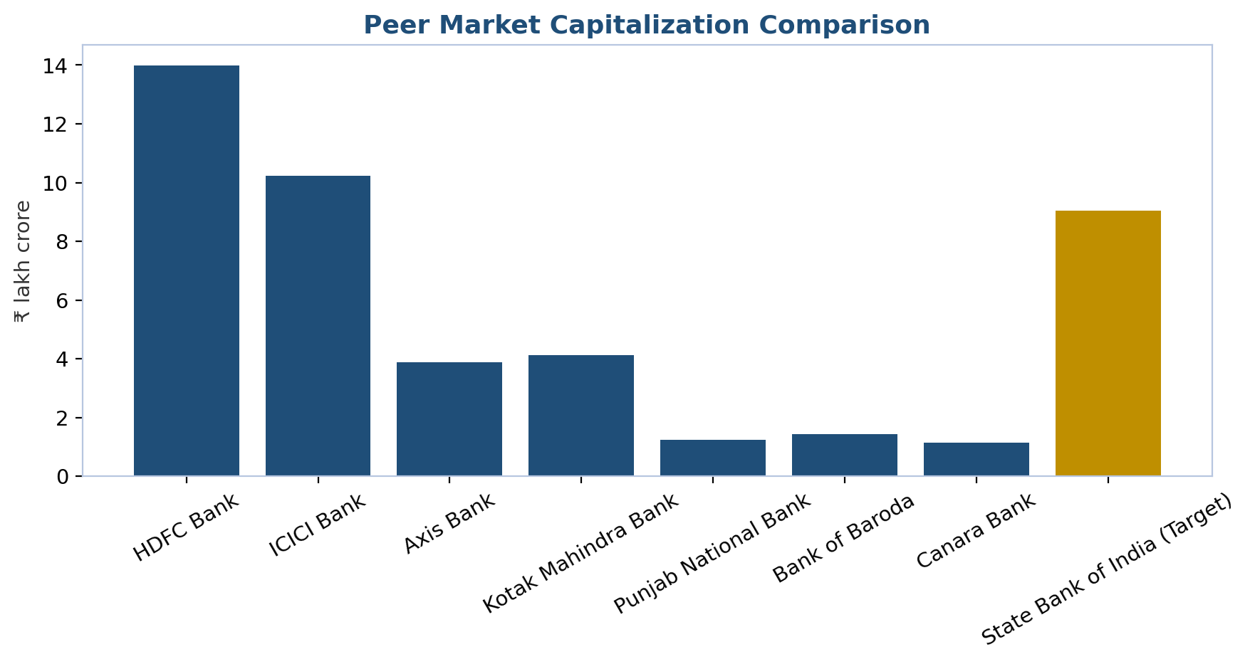
Figure 5: Market capitalization across the Indian bank peer set, September 2026.

Market Opportunity
The addressable market for SBI is best framed at three nested levels: the Indian banking-system credit and deposit pool (the core TAM), the broader financial-services wallet including insurance, asset management and payments (the expanded TAM captured partly through subsidiaries), and the structural under-penetration opportunity created by India's ongoing formalization and per-capita income growth (the long-run SAM/SOM expansion driver).
At the core level, system-wide outstanding bank credit stood at roughly ₹213–214 lakh crore as of March 2026, having grown around 16% over the prior year, with rating agencies projecting continued double-digit expansion (13–15%) through FY27 as India's economy grows at a projected real GDP rate of around 6.5%. If SBI merely maintains its current ~19–20% share of system advances, its own loan book would grow roughly in line with system credit growth — implying a multi-year runway of low-to-mid-teens percentage advances growth without requiring any market-share gains, a meaningfully different starting position than a bank needing to win share to sustain growth.
Layered on top of pure credit growth is India's structural under-penetration in specific high-growth retail categories where SBI already holds leading positions: mortgage/home-loan penetration relative to GDP remains low by regional and global standards, supporting continued double-digit home-loan growth as urbanization and formal-sector employment expand; MSME formal-credit penetration remains a fraction of the estimated MSME credit gap the government and multilateral agencies have repeatedly flagged, directly relevant given SBI's ~20% SME book growth in FY26; and agricultural-credit demand continues to be underpinned by government policy support (interest subvention schemes, Kisan Credit Card expansion) that SBI, as the largest rural lender, is structurally positioned to capture disproportionately.
The subsidiary ecosystem represents a second, distinct addressable market. India's life- and general-insurance penetration (life insurance premium as a share of GDP) remains well below developed-market levels, supporting continued growth for SBI Life and SBI General; India's mutual-fund industry assets under management have grown multiple-fold over the past decade as household savings shift from physical assets (gold, real estate) toward financial assets, a trend SBI Funds Management (in JV with Amundi) is positioned to keep capturing, reinforced by the group's plan to list a minority stake in the AMC business via IPO (targeted for 2026, expected to raise roughly ₹11,000–13,000 crore for a 10% stake sale, with SBI and Amundi jointly divesting), which will also crystallize and make visible the standalone market value of that franchise. SBI Cards, as India's second-largest card issuer, participates in a card-penetration market that remains shallow relative to China or developed markets, given India's historically cash- and UPI-heavy payment culture — arguably the single largest swing factor (positive or negative) for that specific subsidiary's TAM, since UPI's rise has structurally slowed, though not reversed, the card-issuance growth curve across the industry.
Finally, the digital/payments layer represents a TAM SBI is fighting to defend rather than straightforwardly expand into: UPI transaction volumes in India now run into tens of billions of transactions monthly, a pool from which SBI, as one of the largest UPI-linked banks by account base, earns comparatively little direct fee revenue under current UPI pricing rules but which YONO 2.0's payments-first design is intended to keep the bank relevant to as a daily-engagement surface, protecting the far larger and more monetizable deposit and cross-sell relationship that sits behind each transaction. Taken together, the combination of structural system-wide credit growth, continued under-penetration in retail and MSME segments where SBI already leads, and a subsidiary ecosystem addressing separately growing insurance and asset-management markets gives SBI multiple, only loosely correlated growth vectors — a diversification of opportunity that is itself a component of the investment thesis, distinct from any single-segment market-share story.

Financial Analysis

Historical Performance, FY22A–FY26A
SBI's net profit compounded from ₹31,676 crore in FY22 to ₹80,032 crore in FY26 — a 26% compound annual growth rate over four years — while net interest income grew at a considerably slower 9.7% CAGR (₹1,20,000 crore to ₹1,73,800 crore), confirming that provisioning normalization and fee/treasury income, not core spread expansion, did the heavy lifting on the bottom line. Total net revenue (net interest income plus non-interest income) rose from ₹1,61,800 crore in FY22 to ₹2,56,330 crore in FY26, a 12.2% CAGR, while operating expenses grew slightly slower, allowing the cost-to-income ratio to improve from roughly 59% to 52.4% over the same period — a genuine efficiency gain we attribute mainly to the YONO digital platform reducing the marginal cost of each additional transaction and cross-sell.
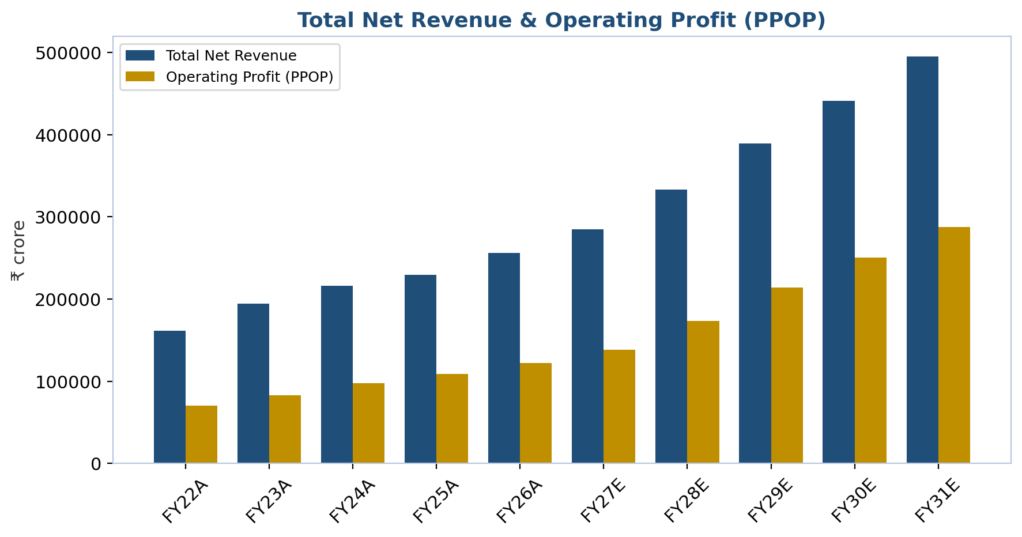
Figure 6: Total net revenue and pre-provision operating profit, FY22A-FY31E.
The more important structural story sits in provisions. Loan-loss provisions fell from ₹19,200 crore in FY22 to ₹11,200 crore in FY26 even as the gross loan book grew 75% over the same period — total provisions as a share of gross advances compressed from roughly 0.68% to 0.3%. This is the clearest evidence that the FY26 profit record is not simply a treasury-driven blip: core underwriting quality improved enough that the bank needed to set aside proportionally far less of each new rupee of profit against future losses.
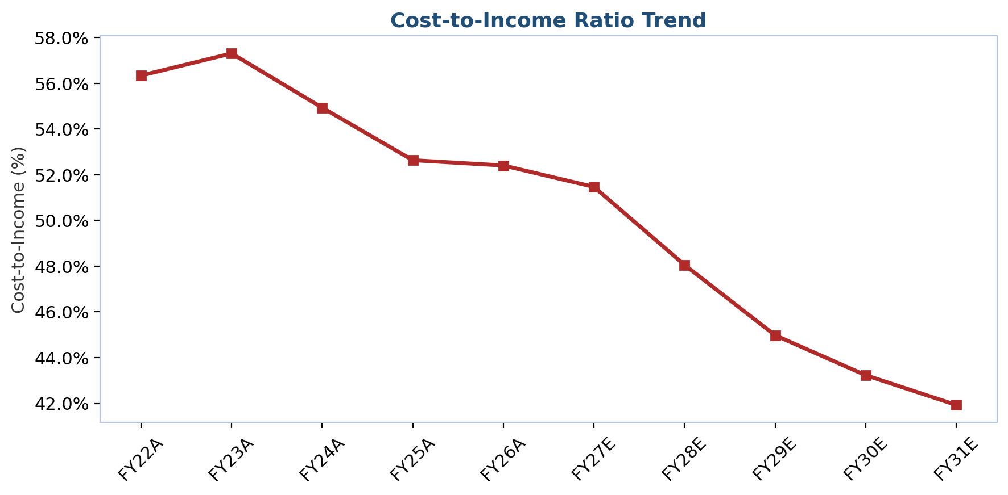
Figure 7: Cost-to-income ratio trend, FY22A-FY31E.

Margin and Asset-Quality Trends
Domestic net interest margin has been the one genuinely soft data point in an otherwise improving picture: NIM rose from roughly 3.20% in FY22 to a cyclical peak of 3.58% in FY23 (aided by rapid rate hikes repricing the floating-rate loan book faster than deposits), before compressing to 4.15% in FY26 as the subsequent RBI rate-cutting cycle worked in the opposite direction — loan yields falling faster than deposit costs, which typically reprice with a lag. Management has guided that NIM should recover toward the 3.2% area as term deposits reprice down through FY27, a view our Base Case broadly endorses (see Projection Assumptions).
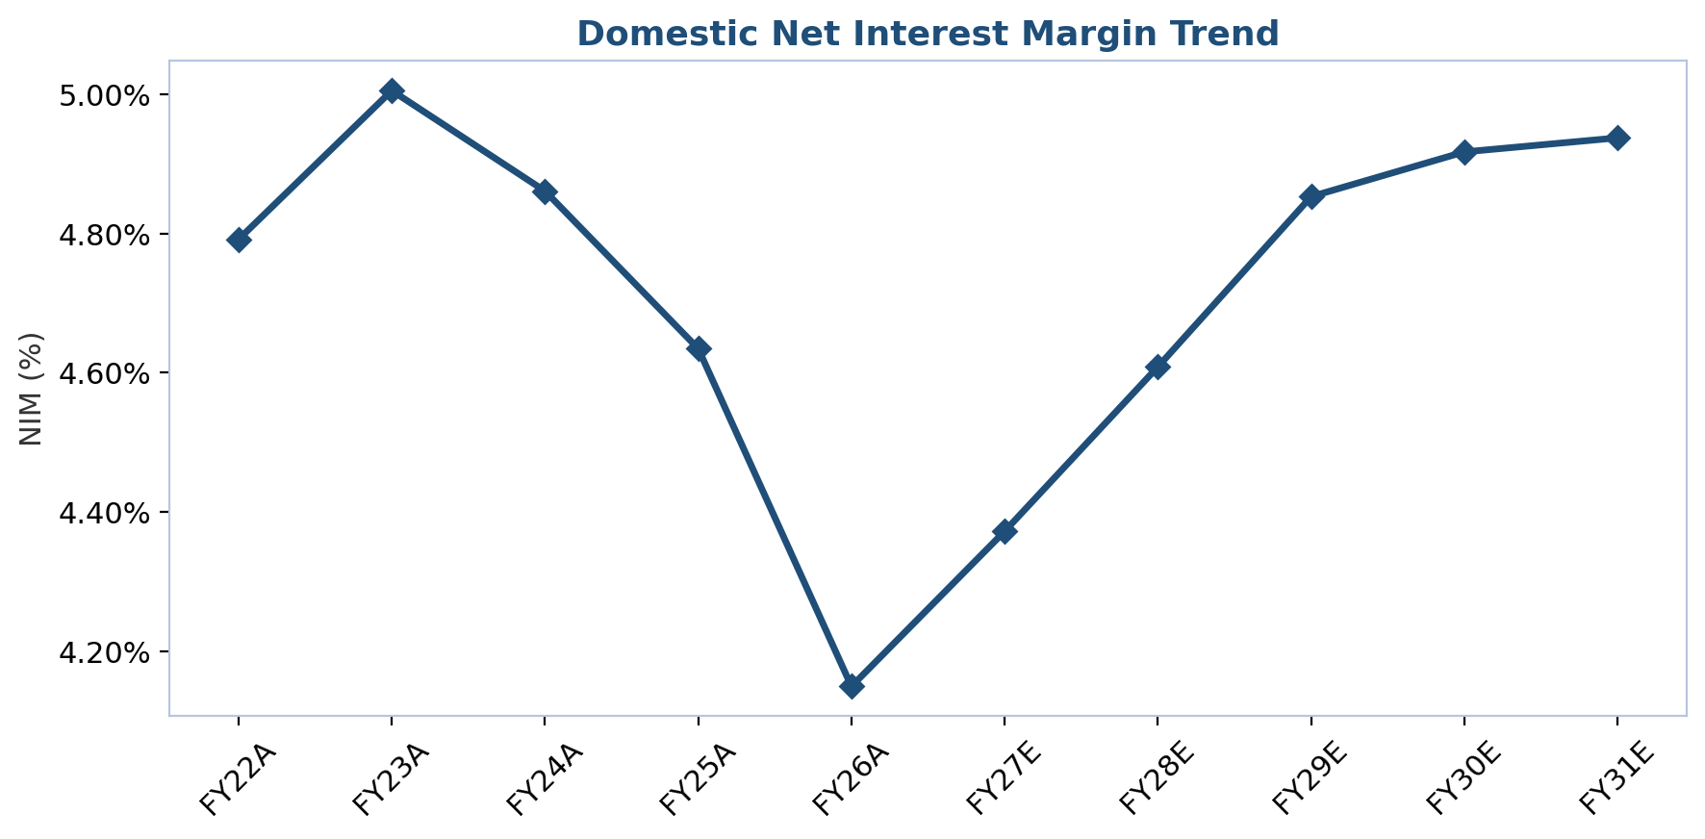
Figure 8: Domestic net interest margin trend, FY22A-FY31E.
Asset quality has improved every single year in our five-year historical window without exception: gross NPA fell from 3.97% (FY22) to 2.78% (FY23) to 2.24% (FY24) to 1.82% (FY25) to 1.49% (FY26), and net NPA followed an equivalent path down to 0.39%. Provision coverage has been maintained consistently in the 74-77% range (91%+ including AUCA) throughout, meaning the NPA decline reflects genuine improvement in the underlying loan book rather than a reduction in provisioning conservatism — a distinction that matters because the latter would be a red flag and the former is not.
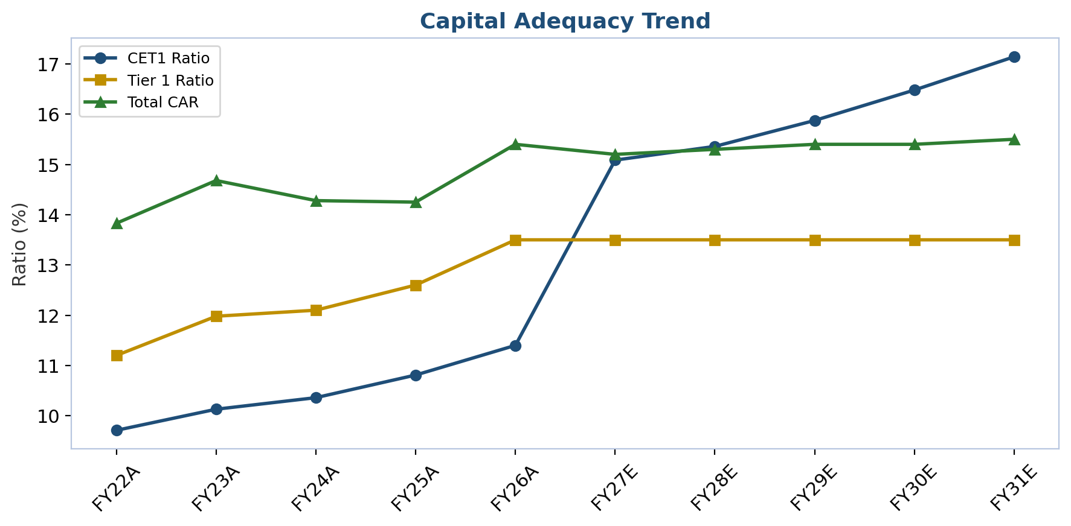
Figure 9: Capital adequacy (CET1 / Tier 1 / total CAR) trend, FY22A-FY31E.

Balance-Sheet Growth and Funding Mix
Gross advances grew from ₹28.12 lakh crore (FY22) to ₹49.32 lakh crore (FY26), a 15.1% CAGR, while deposits grew from ₹40.52 lakh crore to ₹59.75 lakh crore, a 10.2% CAGR — advances structurally outgrowing deposits pushed the credit-deposit ratio up over the period, a dynamic common across the Indian banking system as loan demand recovered faster than household savings mobilization. The CASA ratio correspondingly declined from roughly 45.3% (FY22) to 39.5% (FY26) as depositors shifted toward higher-yielding term deposits and market-linked instruments (mutual funds) — a headwind for SBI's historically prized low-cost-funding advantage that we discuss further in Risk Factors and in our margin assumptions below.
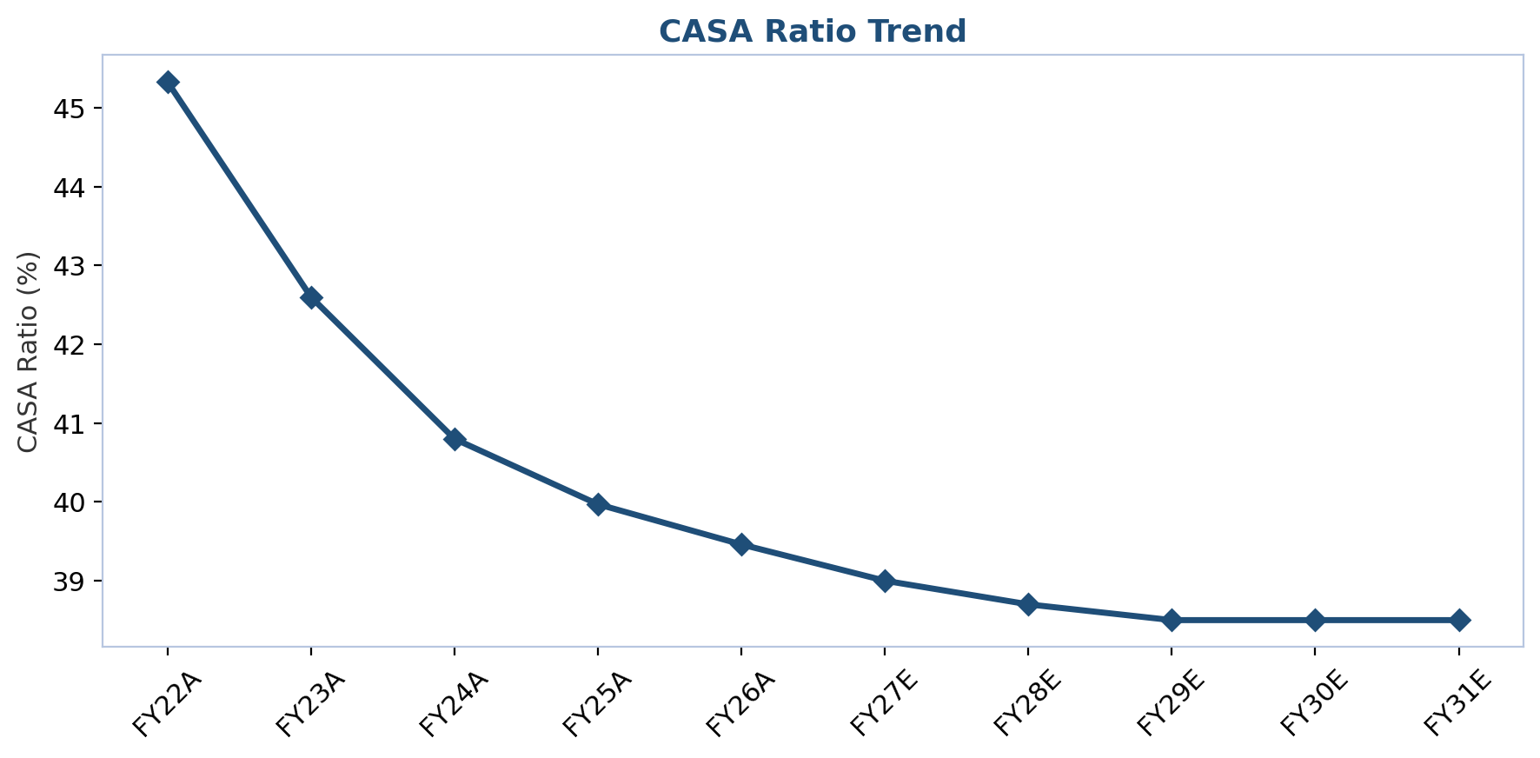
Figure 10: CASA ratio trend, FY22A-FY31E.

Returns, Capital Generation and Per-Share Value Creation
Return on assets rose from 0.67% (FY22) to 1.12% (FY26), and return on equity from 13.9% to 18.6% — both multi-year highs achieved despite the FY26 QIP's dilutive effect on the equity base (the 18.6% FY26 figure is calculated on a post-QIP average equity base, meaning the underlying pre-dilution return was likely modestly higher). Book value per share nonetheless grew from roughly ₹255 (FY22) to ₹509 (FY26), a 24.6% CAGR, aided both by strong retained-earnings compounding and by the QIP itself (new equity was raised at a premium to book, which is accretive to per-share book value even though it dilutes the absolute ownership percentage of existing shareholders). Dividend per share rose from ₹7.10 to ₹17.35 over the same window, a payout ratio management has kept in a fairly narrow 19-22% band throughout — consistent with a bank prioritizing capital retention for growth over near-term income distribution.
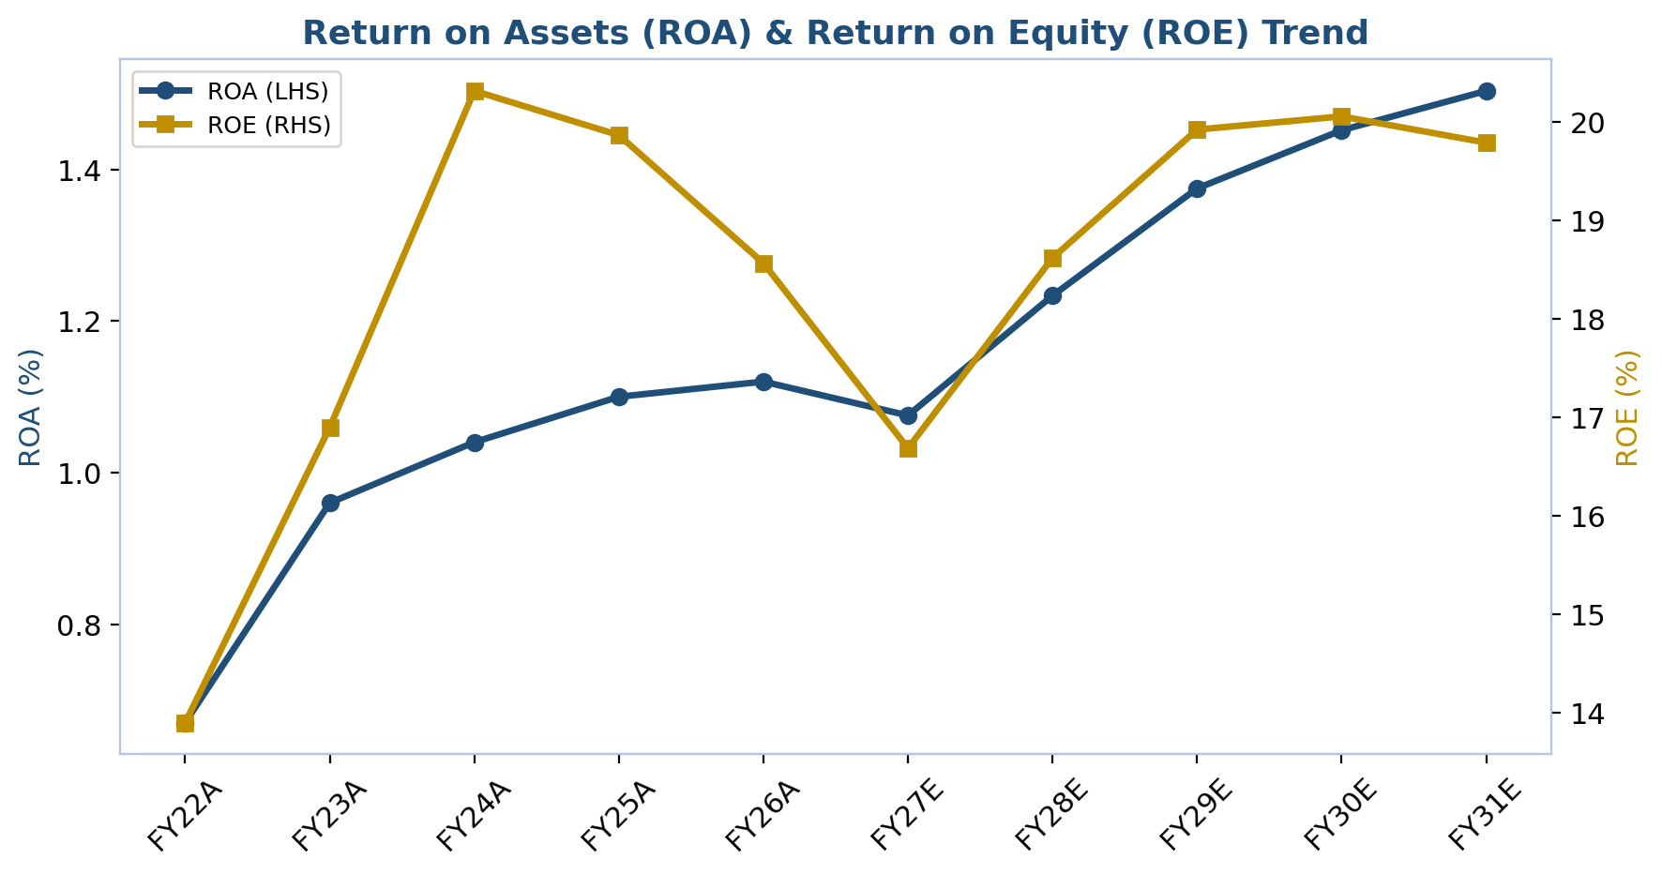
Figure 11: Return on assets (primary axis) and return on equity (secondary axis), FY22A-FY31E.
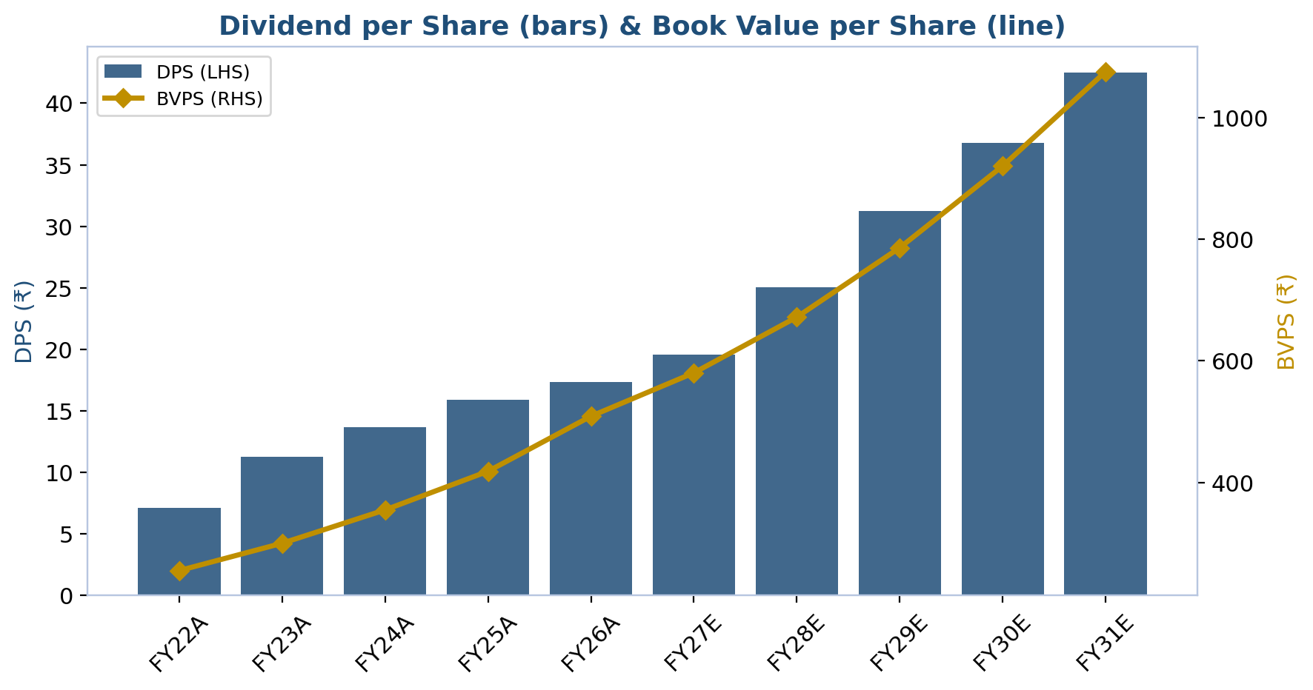
Figure 12: Dividend per share (bars) and book value per share (line), FY22A-FY31E.

Income Statement Summary
(₹ crore) | FY22A | FY23A | FY24A | FY25A | FY26A
Net Interest Income | 1,19,940 | 1,43,955 | 1,60,052 | 1,66,945 | 1,73,812
Non-Interest Income | 41,800 | 50,200 | 56,300 | 62,400 | 82,518
Total Net Revenue | 1,61,740 | 1,94,155 | 2,16,352 | 2,29,345 | 2,56,330
Operating Expenses | 91,118 | 1,11,255 | 1,18,846 | 1,20,713 | 1,34,323
Operating Profit (PPOP) | 70,622 | 82,900 | 97,506 | 1,08,632 | 1,22,007
Provisions & Contingencies | 24,100 | 15,700 | 15,800 | 13,900 | 15,000
Profit Before Tax | 46,522 | 67,200 | 81,706 | 94,732 | 1,07,007
Net Profit (PAT) | 31,635 | 50,199 | 61,116 | 70,859 | 80,041
Basic EPS (₹) | 35.45 | 56.25 | 68.48 | 79.40 | 88.03
Table 2: Standalone income statement summary, FY22A-FY26A. Source: Company results/press releases; SBI Financial Model.

Balance Sheet Summary
(₹ crore) | FY22A | FY23A | FY24A | FY25A | FY26A
Gross Advances | 28,12,306 | 32,67,900 | 37,84,270 | 42,21,000 | 49,32,000
Net Advances | 27,28,235 | 31,98,129 | 37,20,270 | 41,63,829 | 48,77,355
Total Deposits | 40,51,534 | 44,68,540 | 49,66,540 | 53,82,000 | 59,75,000
Total Investments | 16,20,000 | 19,13,110 | 21,10,550 | 22,05,600 | 23,40,000
Total Assets | 48,21,419 | 53,32,539 | 59,41,428 | 64,80,557 | 72,51,824
Shareholders' Equity | 2,27,885 | 2,67,999 | 3,16,888 | 3,73,557 | 4,62,824
Gross NPA Ratio (%) | 3.97% | 2.78% | 2.24% | 1.82% | 1.49%
Net NPA Ratio (%) | 1.02% | 0.67% | 0.57% | 0.47% | 0.39%
CASA Ratio (%) | 45.3% | 42.6% | 40.8% | 40.0% | 39.5%
Total CAR (%) | 13.8% | 14.7% | 14.3% | 14.2% | 15.4%
Table 3: Standalone balance sheet summary, FY22A-FY26A. Source: Company results/press releases; SBI Financial Model.

Projection Assumptions
Our five-year explicit forecast (FY27E-FY31E) is built bottom-up on the Revenue Model tab of our financial model, with each of five loan segments (Retail, Agriculture, SME, Corporate, and Foreign Office) modeled on its own growth, yield and mix assumptions, rather than as a single blended top-line growth number. We set out below, segment by segment, the specific assumptions driving our Base Case, followed by the margin, cost, credit and capital assumptions that complete the model.

A. Advances by Segment

Retail Advances (Home Loans, Auto Loans, Other Retail)
We project domestic retail advances — the largest single segment at ₹17.38 lakh crore in FY26, or 41.5% of the domestic book — to grow 15.0% in FY27E, moderating to 14.0% (FY28E), 13.0% (FY29E), 12.5% (FY30E) and 12.0% (FY31E), a deceleration path consistent with system-wide retail credit normalizing from the exceptional 15%+ pace of FY25-FY26 toward a longer-run rate closer to nominal GDP growth plus a modest financialization premium. Within retail, home loans (modeled at 60% of the segment) remain the anchor: mortgage penetration in India remains low by regional standards, and SBI's scale and low cost of funds give it a structural pricing advantage in a segment where price competition is intense. Auto loans (5% of the segment) and other retail — personal loans, gold loans, and education loans, where SBI is the single largest lender with roughly a third of the organized market — make up the balance. Key drivers behind our retail growth assumptions include: (1) continued urbanization and formal-sector employment growth supporting mortgage demand; (2) YONO 2.0's digital, pre-approved lending funnel reducing loan-origination friction and turnaround time, which we believe supports volume even as growth decelerates in percentage terms; (3) a moderating but still-supportive interest-rate backdrop following the FY25-FY26 RBI rate-cutting cycle; and (4) continued government policy support for affordable housing. The principal risk to these assumptions is a sharper-than-expected slowdown in urban consumption or a renewed uptick in unsecured-retail delinquencies of the kind that has periodically worried regulators across the Indian banking system.

Agriculture Advances
Agriculture and allied-activity advances, at ₹3.88 lakh crore in FY26 (9.3% of the domestic book), are projected to grow 14.0% in FY27E, stepping down to 13.0%, 12.0%, 11.0% and 11.0% through FY31E. This segment is structurally supported by continued government policy emphasis — interest-subvention schemes and Kisan Credit Card expansion — and by SBI's unmatched rural branch density, which we view as effectively impossible for a digital-only competitor to replicate. Growth here is also monsoon- and agricultural-income-dependent, and we have deliberately kept our long-run agriculture growth assumption below the segment's FY26 pace (19.7% actual) precisely because a portion of that pace reflected a favorable monsoon and commodity-price cycle rather than a structural step-change in rural credit demand.

SME Advances
SME advances — ₹5.66 lakh crore in FY26 (13.5% of the domestic book) — are our fastest-growing segment in percentage terms, projected at 17.0% (FY27E), 16.0% (FY28E), 15.0% (FY29E), 14.0% (FY30E) and 13.0% (FY31E). This reflects both explicit government policy prioritization of MSME formal-credit access (the government and multilateral agencies have repeatedly flagged a large MSME credit gap) and SBI's own digital-underwriting investment, which has meaningfully cut turnaround time for collateral-light MSME loans. We regard this segment as carrying the highest execution risk of the four domestic categories: SME credit quality is more cycle-sensitive than large-corporate credit, and a sharper economic slowdown would likely show up first, and most visibly, in SME slippage ratios.

Corporate Advances
Large corporate and commercial advances, the second-largest segment at ₹14.97 lakh crore in FY26 (35.7% of the domestic book), are projected to grow more modestly — 12.0% (FY27E and FY28E), then accelerating slightly to 12.5% (FY29E), 13.0% (FY30E) and 13.0% (FY31E) — reflecting our view that the long-awaited revival in India's private corporate capital-expenditure cycle is a "when," not "if," story, but one we are not willing to underwrite at an aggressive near-term pace given how many times that revival has been repeatedly pushed out over the past decade. Government infrastructure capex continuing to crowd in private investment, as flagged in Task 1's industry research, is the main upside lever we would look for to revise this segment's growth assumption higher; SBI's improving corporate book rating mix (AAA-rated exposure rising from 42% to 45% of the corporate book between March 2025 and March 2026) gives us confidence that whatever growth does materialize here should come with lower incremental credit risk than in past corporate-lending cycles.
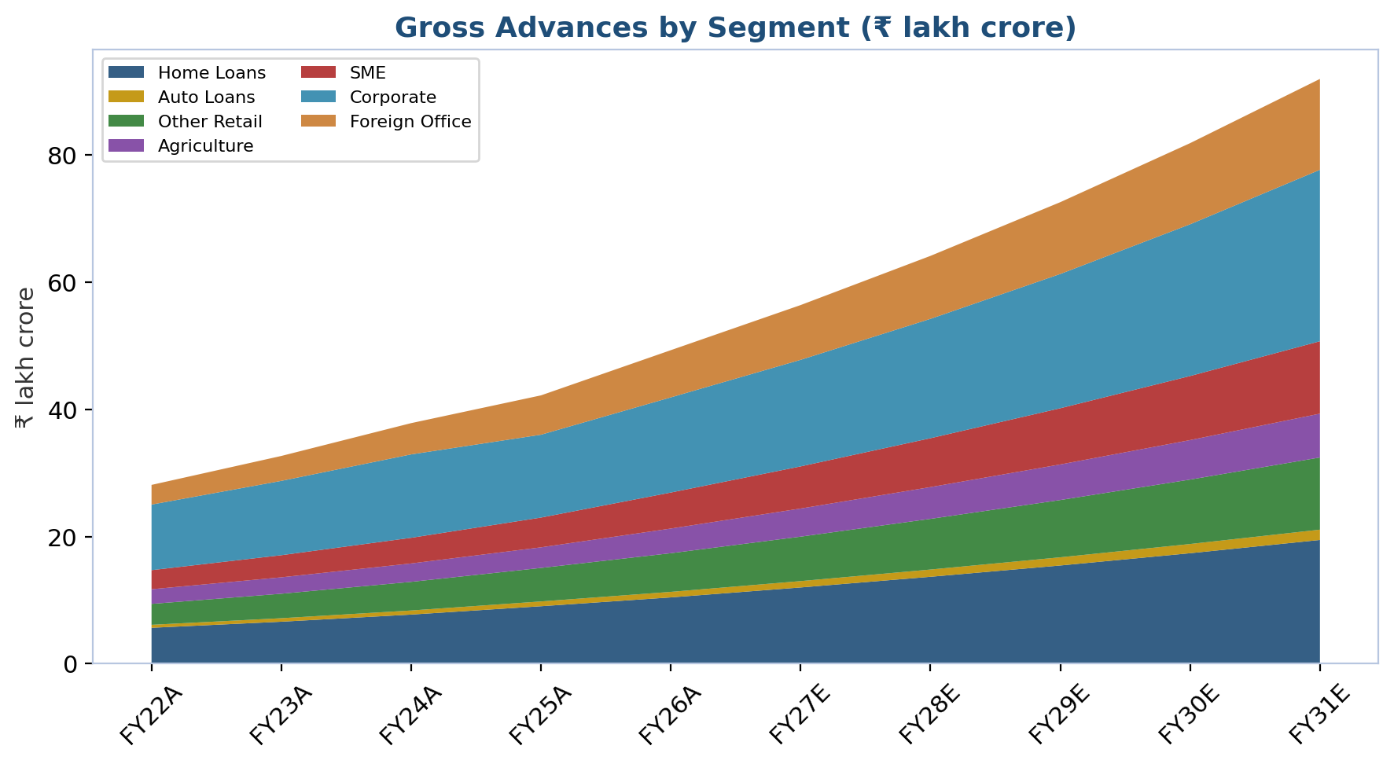
Figure 13: Gross advances by segment, FY22A-FY31E (stacked area).

B. Advances and Deposits by Geography
Foreign-office (international) advances, at ₹7.43 lakh crore in FY26 (15.1% of the total book), are our second-fastest-growing category after SME: we project 16.0% growth in FY27E, moderating to 15.0%, 14.0%, 13.0% and 12.0% through FY31E, reflecting continued expansion of SBI's role financing Indian corporates' outbound trade and investment and the diaspora banking business across its roughly 235-241 overseas offices in 36 countries. We model foreign-office advances at a structurally lower yield (5.45% versus a domestic blended yield near 8.0%) consistent with the lower-risk, more competitively priced nature of international trade finance and correspondent banking relative to domestic retail and SME lending. On the funding side, we project total deposits to grow 12.0% in FY27E, decelerating to 11.5%, 11.5%, 11.0% and 11.0% — a pace that keeps deposit growth roughly in line with, and at times slightly below, our advances growth assumptions, consistent with the system-wide elevated credit-deposit ratio dynamic discussed in our Industry Overview, and requiring SBI to compete more actively for deposits than it has historically needed to.
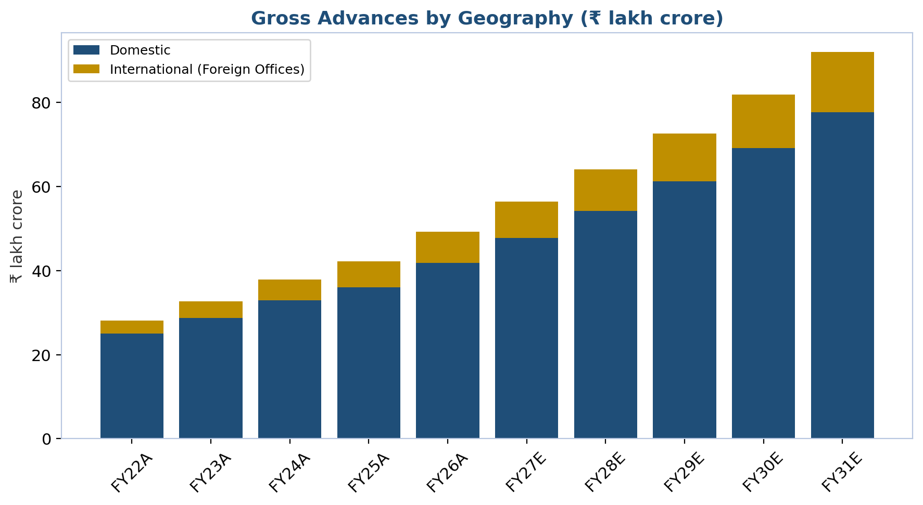
Figure 14: Gross advances by geography, FY22A-FY31E (stacked bar).

C. Margin, Yield and Cost-of-Funds Assumptions
We project the CASA ratio to decline further from 39.5% in FY26 to 39.0% (FY27E), 38.7% (FY28E) and stabilizing near 38.5% from FY29E onward — continued, but decelerating, erosion as term deposits and market-linked savings instruments keep taking share from current and savings accounts, an industry-wide phenomenon we do not expect SBI-specific initiatives (including YONO 2.0) to fully reverse, though we believe they help slow it. On yields, we hold the domestic blended yield on advances roughly flat to modestly higher (7.95% FY27E, rising toward 8.05% by FY29E and holding through FY31E) as lending-rate cuts fully pass through in FY27 before stabilizing, while we project the cost of term deposits easing from an elevated 6.6% (FY27E) to 6.4% (FY29E onward) as the back book of expensive term deposits raised during the FY24-FY25 rate-hiking cycle matures and rolls into lower-rate paper. The net effect is domestic NIM troughing near the FY26 actual of 4.15% and recovering gradually to the 3.15-3.20% area by FY29E-FY31E — a trajectory management's own commentary broadly supports (its stated aim is a return toward the roughly 3.2% domestic NIM last seen in FY24).

D. Non-Interest Income, Operating Cost and Credit-Cost Assumptions
Fee and commission income is projected to grow a steady 12% per year throughout the forecast period, in line with its FY22-FY26 historical trend and reflecting continued cross-sell of subsidiary products (insurance, mutual funds, cards) through the branch and YONO channels. Treasury/trading gains and forex income, both of which were unusually elevated in FY26 (aided by favorable bond-market conditions and a spike in forex activity), are assumed to normalize sharply lower in FY27E (-30% and -35% respectively) before resuming modest ~8% annual growth from FY28E onward — we regard this normalization as important conservatism given how much of FY26's headline profit growth was treasury- and one-off-related (see Financial Analysis). We have also isolated the ₹4,618 crore of FY26 one-off gains (the Yes Bank and Jio Payments Bank stake sales) into a dedicated, non-recurring line so they do not distort the base growth rate we assume for recurring non-interest income. On costs, we project employee-cost growth of 8% per year (reflecting periodic wage-settlement cycles typical of the PSU-bank sector, partially offset by limited net headcount growth as digital channels absorb transaction volume) and other operating expenses growing 10-11% per year (continued technology and YONO-related investment), together producing a cost-to-income ratio that improves gradually from 52.4% in FY26 toward the mid-to-mid-forties by FY30E-FY31E. Credit cost, unusually low in FY26 (a function of the exceptional asset-quality improvement discussed in Financial Analysis), is assumed to normalize modestly upward to 0.42-0.45% of gross advances through the forecast period — still well below the bank's five-year historical average, but not so low as to assume the current cycle's asset-quality tailwind persists indefinitely. We hold the effective tax rate flat at 25.2% (the current effective rate under India's concessional corporate tax regime) and assume the dividend payout ratio remains in its recent 19-22% band, with no further equity dilution beyond the FY26 QIP, consistent with management guidance.
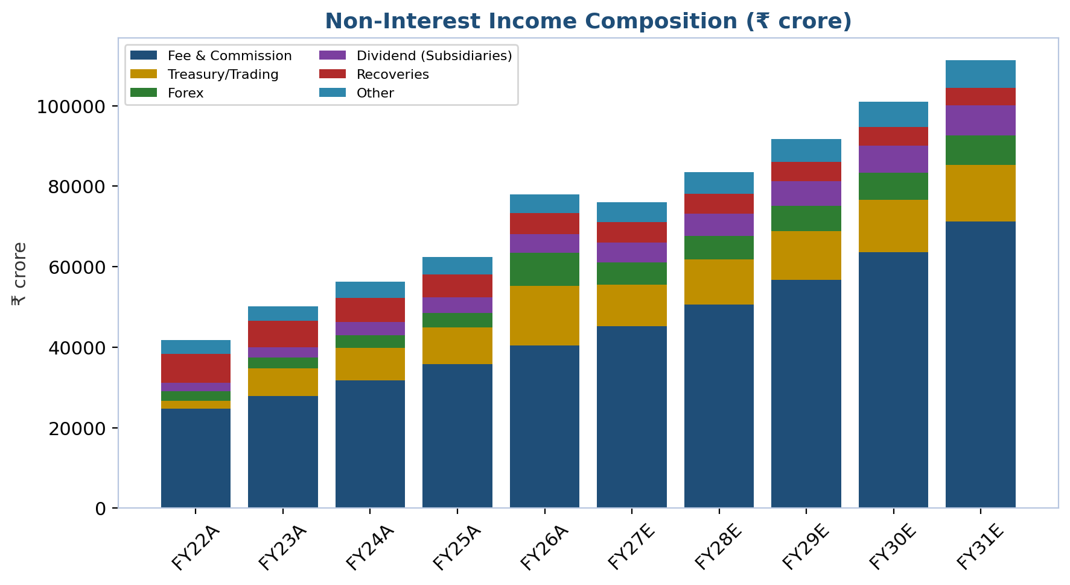
Figure 15: Non-interest income composition, FY22A-FY31E.
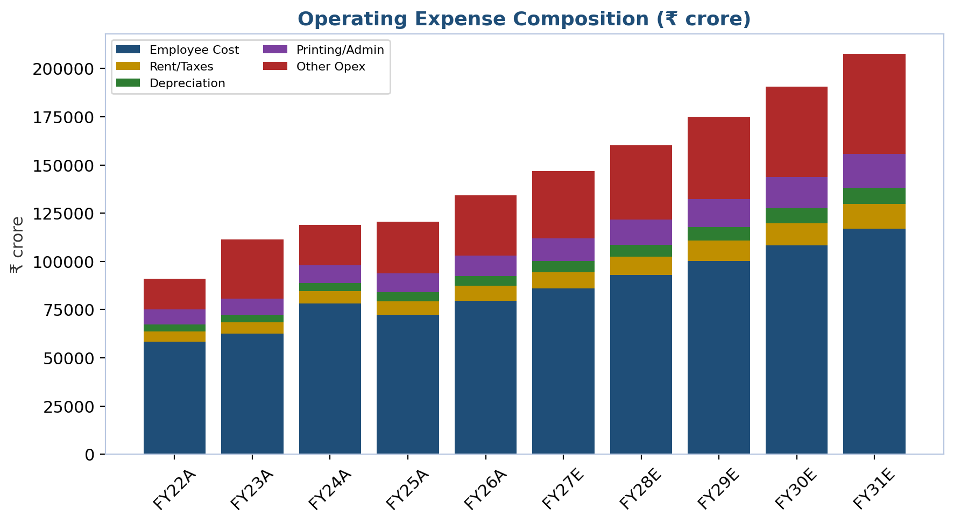
Figure 16: Operating expense composition, FY22A-FY31E.

E. Summary of Segment Growth Assumptions
The table below consolidates the year-by-year growth assumptions discussed above into a single reference, alongside the resulting blended whole-bank advances growth rate our model produces once all five segments are aggregated.
Segment (YoY growth %) | FY27E | FY28E | FY29E | FY30E | FY31E
Retail (Home/Auto/Other) | 15.0% | 14.0% | 13.0% | 12.5% | 12.0%
Agriculture | 14.0% | 13.0% | 12.0% | 11.0% | 11.0%
SME | 17.0% | 16.0% | 15.0% | 14.0% | 13.0%
Corporate | 12.0% | 12.0% | 12.5% | 13.0% | 13.0%
Foreign Office (International) | 16.0% | 15.0% | 14.0% | 13.0% | 12.0%
Total Deposits | 12.0% | 11.5% | 11.5% | 11.0% | 11.0%
Table 4: Segment-level growth assumptions underlying the Base Case, FY27E-FY31E. Source: SBI Financial Model, Assumptions tab.

F. Capital Adequacy Trajectory Under Our Assumptions
A natural question for any bank model projecting sustained low-teens-percentage advances growth is whether regulatory capital can keep pace without further dilution. Under our Base Case, risk-weighted assets grow roughly in line with gross advances (we hold the RWA-to-gross-advances ratio broadly stable at its FY26 level, reflecting the improving corporate rating mix discussed above, which should keep risk-density from rising materially even as the book grows), while internal capital generation runs at an average ROE near 19-20% across FY27E-FY31E against a payout ratio held at roughly 21%. The arithmetic of retaining roughly four-fifths of a high-teens ROE, year after year, comfortably outpaces RWA growth in our model, and CET1 does not fall below management's stated comfort zone at any point in our explicit forecast window — supporting management's own guidance that the FY26 QIP should be sufficient to fund growth for five to six years without a further capital raise. We treat any earlier-than-expected capital raise as a modest negative surprise (dilutive to per-share value even if strategically sound) rather than a base-case expectation.
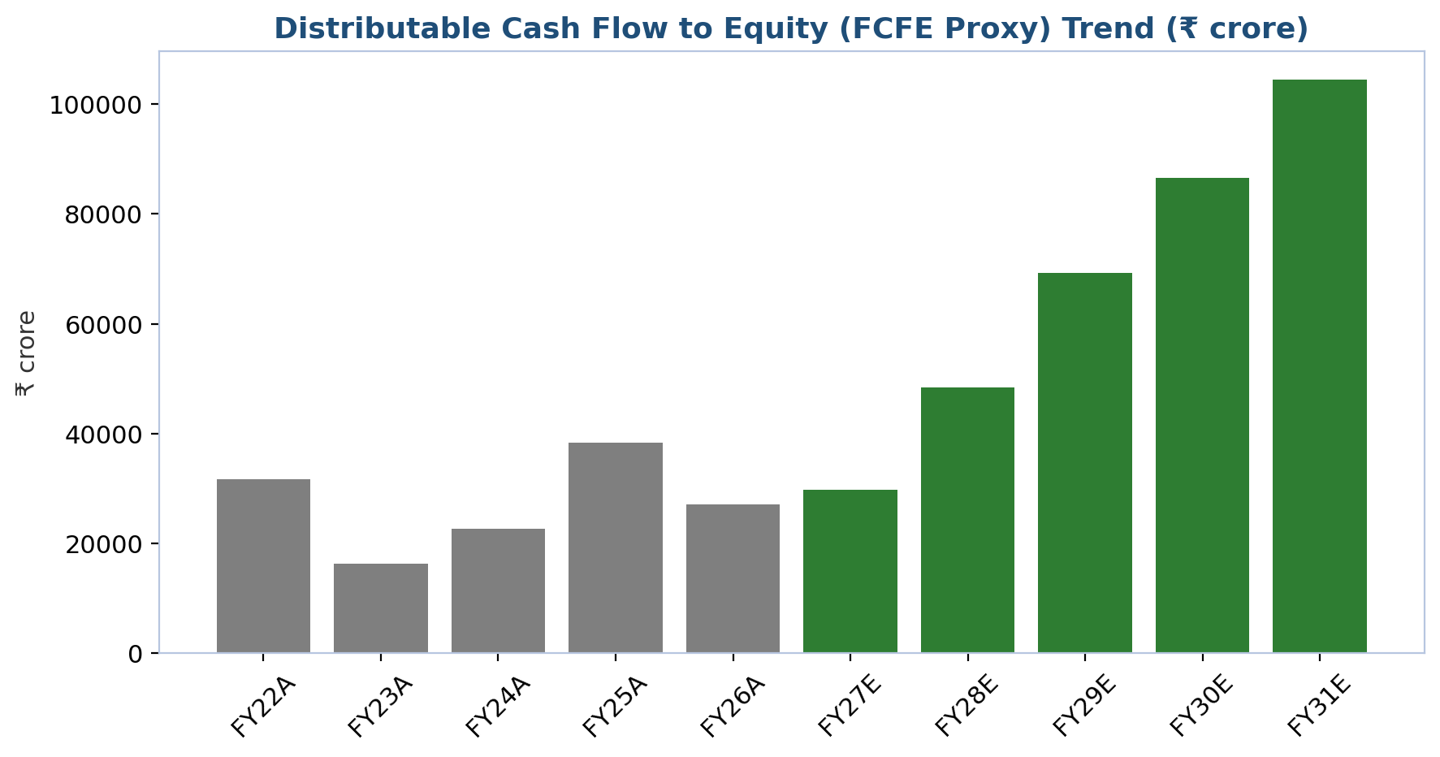
Figure 17: Distributable cash flow to equity (FCFE proxy: net profit less capital retained to fund RWA growth), FY22A-FY31E.

G. Key Risks to These Assumptions
The single largest swing factor in our model is the pace of domestic NIM recovery: every 10 basis points of additional or reduced NIM recovery versus our assumption moves FY29E-FY31E net profit by a mid-single-digit percentage, all else equal, given how large the loan book has become relative to the equity base. The second-largest swing factor is credit cost in the SME and unsecured-retail segments, which are structurally the most cycle-sensitive parts of the book and the segments carrying our most aggressive near-term growth assumptions; a meaningful slowdown in Indian consumption or a renewed regulatory tightening cycle on unsecured lending (as occurred in FY24-FY25) would likely show up first here. We stress-test both of these sensitivities explicitly in the Scenario Analysis that follows.

H. Reconciliation with Management Guidance
Where possible, we have anchored our assumptions to specific, dated management commentary rather than working purely from historical extrapolation, and it is worth setting the two side by side. On credit growth, management raised its FY26 guidance to 12-14% during the year and delivered 16.9% — a beat we treat as partly cyclical (aided by the FCNR(B)-inflow-driven system liquidity surplus flagged in our Industry Overview) rather than fully repeatable, which is why our FY27E blended advances growth assumption of roughly 14-15% sits below the FY26 actual even though it remains above most sell-side peers' system-wide credit-growth forecasts of 13-15%. On margins, Chairman Setty's own comment that NIM should recover toward the FY24 level of roughly 3.2% "once deposits are re-priced" and following the September 2025 CRR cut lines up closely with our own FY29E-FY31E domestic NIM assumption of 3.15-3.20%, giving us reasonable confidence in the shape, if not the precise timing, of the margin-recovery curve we have modeled. On capital, management's guidance of no further equity raise for five to six years is, as discussed above, consistent with what our own bottom-up capital-generation arithmetic produces, which we view as a useful cross-check on both the earnings and RWA-growth assumptions feeding into that calculation. Where our assumptions are more conservative than the tone of management commentary — for instance, on the durability of FY26's unusually low credit cost, or the sustainability of FY26's treasury and forex gains — we have said so explicitly above, and readers who take a more optimistic view of these specific items should consult our Bull Case in the Scenario Analysis section immediately following, which quantifies exactly that alternative.

Scenario Analysis
Our Scenarios tab models Bull, Base and Bear cases as a self-contained, single-driver sensitivity to FY31E outcomes — varying advances CAGR, terminal domestic NIM, non-interest income CAGR, terminal cost-to-income ratio and terminal credit cost simultaneously across the three cases — rather than a full re-run of the five-segment bottom-up model under three different sets of assumptions. This keeps the scenario framework auditable and transparent about exactly which levers separate the cases, while the Base Case in our main financial model (Income Statement, Balance Sheet) remains the primary forecast referenced throughout this report.

Bull Case: "PSU Re-Rating Accelerates as Margins Recover Faster Than Guided"
Probability we assign: approximately 25%.
Key assumptions: gross advances CAGR of 15.5% (FY26A-FY31E, vs. 12.8% Base); terminal domestic NIM of 3.35% by FY31E (vs. 3.20% Base), assuming faster deposit repricing and a more benign rate environment; non-interest income CAGR of 14% (vs. 11.5% Base), assuming YONO 2.0 successfully captures a meaningfully larger share of fee-generating transaction volume; terminal cost-to-income ratio of 46.0% (vs. 48.5% Base), assuming digital operating leverage compounds faster than we assume in the Base Case; and terminal credit cost of 0.35% (vs. 0.45% Base), assuming the current asset-quality cycle's benign trend extends further than we are willing to underwrite as a base assumption. Under this case, FY31E gross advances reach roughly ₹1,01,37,550 crore, FY31E net profit reaches ₹1,74,810 crore, and FY31E EPS reaches roughly ₹192 — all comfortably above our Base Case.
Catalysts required for the Bull Case to materialize: (1) YONO 2.0 transaction-volume adoption metrics beating management's own internal targets within the first 12-18 months of relaunch; (2) a further RBI rate-cutting cycle in FY27-28 that compresses deposit costs faster than lending yields, an outcome that would need a benign inflation trajectory; (3) the SBI Funds Management stake-sale IPO pricing at a valuation that prompts the market to apply a higher sum-of-the-parts multiple to SBI's other subsidiaries as well; and (4) continued government infrastructure capex crowding in private corporate investment faster than our Base Case assumes, lifting corporate-segment growth and, more importantly, corporate-segment loan yields as competition for high-quality corporate credit eases. Under this scenario, we would expect the market to re-rate SBI toward 1.8-2.0x book (still below, not above, the private-bank peer median), which combined with the higher earnings base would imply a Bull Case valuation in the ₹1,250-1,400 per-share area — meaningfully above our current price target and representing 25-40%+ upside from the current price.

Base Case: "Steady Margin Recovery and Continued Asset-Quality Discipline"
Probability we assign: approximately 50%.
Key assumptions: the Base Case is the primary forecast detailed throughout this report's Financial Analysis and Projection Assumptions sections — gross advances CAGR of 12.8% (FY26A-FY31E), terminal domestic NIM of 3.20% by FY31E, non-interest income CAGR of 11.5%, terminal cost-to-income ratio of 48.5%, and terminal credit cost of 0.45%. Under these assumptions, FY31E gross advances reach ₹90,06,759 crore, FY31E net profit reaches ₹1,35,491 crore, and FY31E EPS reaches roughly ₹149, implying a FY26A-FY31E net profit CAGR in the low-teens percentage range — a meaningful deceleration from the FY22-FY26 historical CAGR of 26%, which we regard as appropriately conservative given how much of that historical growth was provisioning normalization that has now largely played out.
We regard this as the most likely path because it requires no single assumption to be either unusually favorable or unusually adverse: credit growth simply tracks system-wide guidance from rating agencies (13-15% for FY27, moderating thereafter), margin recovery tracks management's own stated NIM-recovery target, and asset quality normalizes only modestly upward from an unsustainably low FY26 base rather than continuing to improve indefinitely or reversing sharply. Our price target and BUY/HOLD/SELL recommendation (see Valuation Methodology) are built primarily off this Base Case, blended with a trading-comparables cross-check.

Bear Case: "Margin Compression Persists and Growth Segments Show Cracks"
Probability we assign: approximately 25%.
Key assumptions: gross advances CAGR slows to 9.5% (vs. 12.8% Base); terminal domestic NIM stays depressed at 2.90% (vs. 3.20% Base), assuming deposit costs remain sticky even as the RBI holds or cuts rates further, compressing spreads for longer than management currently guides; non-interest income CAGR slows to 8.0% (vs. 11.5% Base), assuming YONO 2.0 fails to meaningfully shift transaction volume and treasury/forex income normalizes to a lower, rather than merely pre-FY26, level; terminal cost-to-income ratio rises to 52.0% (vs. 48.5% Base), assuming digital-efficiency gains stall; and terminal credit cost rises to 0.75% (vs. 0.45% Base), assuming the SME, agriculture and unsecured-retail segments — our fastest-growing and most cycle-sensitive categories — see a genuine credit-quality inflection rather than the benign normalization we assume in the Base Case. Under this scenario, FY31E gross advances reach only ₹77,64,145 crore, FY31E net profit falls to roughly ₹80,817 crore, and FY31E EPS is roughly ₹89 — materially below both the Base and Bull Cases.
Downside triggers we would watch for: (1) a sharper-than-expected Indian growth slowdown, whether from global trade friction, a domestic demand air-pocket, or a poor monsoon hitting agricultural income directly; (2) renewed RBI regulatory tightening on unsecured retail or NBFC-linked lending of the kind seen in FY24-FY25, which would disproportionately hit SBI's fastest-growing segments; (3) a failure of YONO 2.0's relaunch to gain traction, ceding transaction-layer ground to UPI-native fintechs permanently rather than temporarily; and (4) a renewed episode of government-directed lending pressure (priority-sector mandates or rate moral suasion) that compresses margins for policy rather than market reasons. Under this scenario, we would expect SBI's valuation multiple to compress further rather than re-rate, potentially toward 1.1-1.2x book, implying a Bear Case valuation in the ₹650-750 per-share area — meaningful downside from the current price, though we note this would still likely leave SBI trading above tangible book value, reflecting its franchise and sovereign-backing floor.
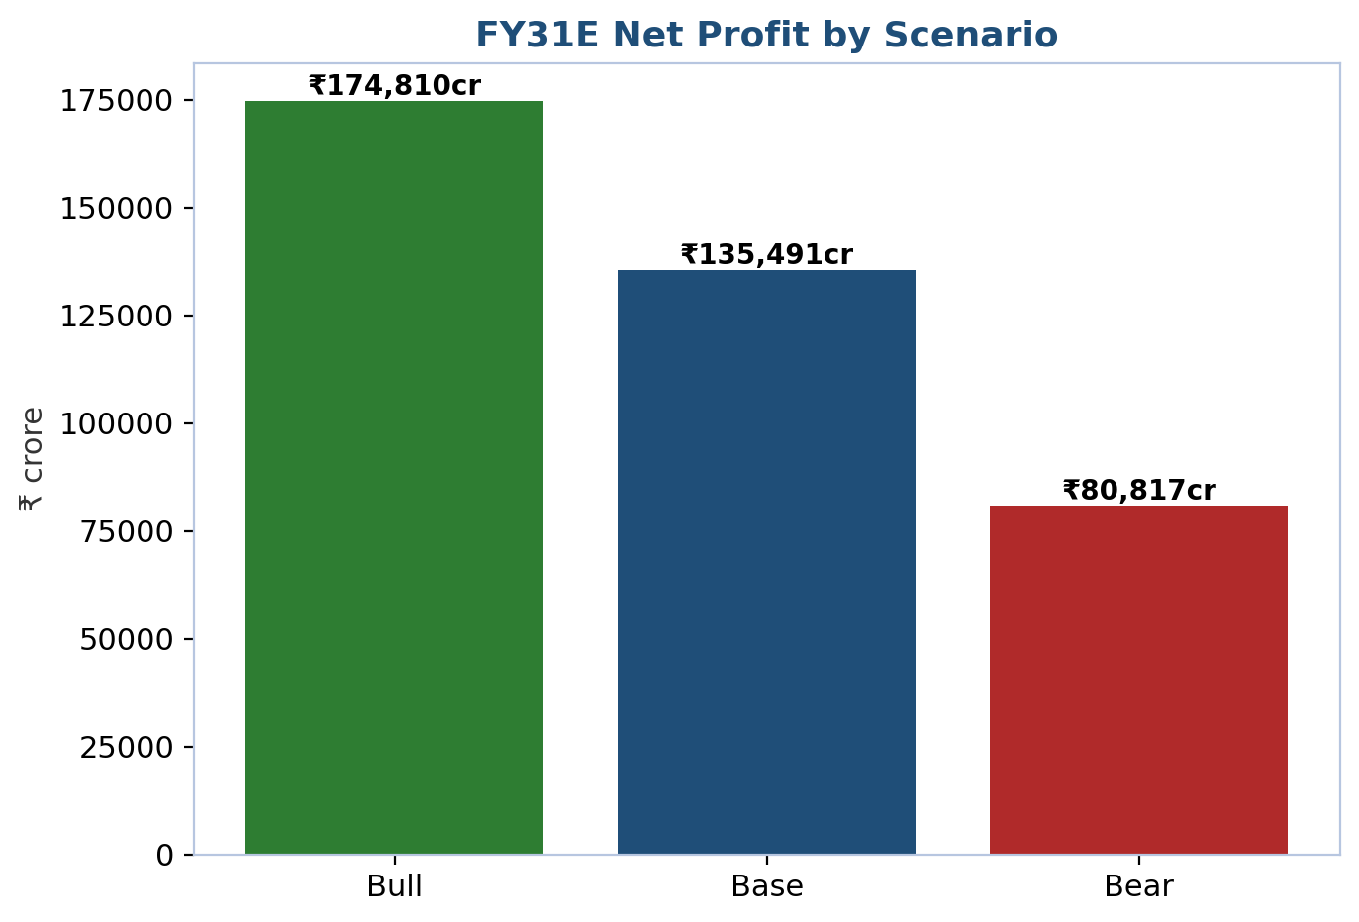
Figure 18: FY31E net profit by scenario.
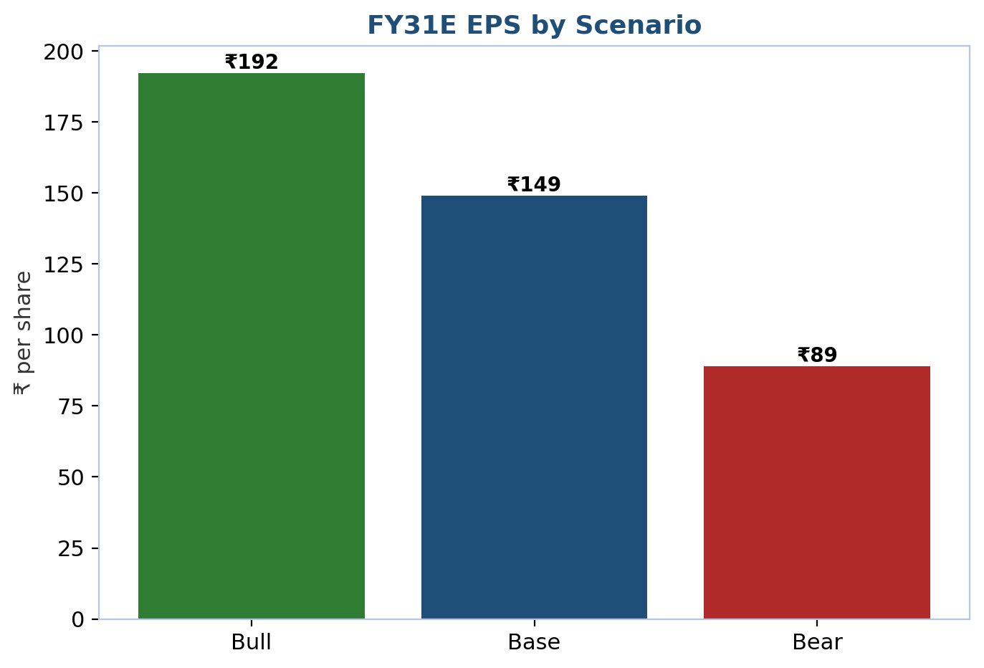
Figure 19: FY31E EPS by scenario.

Scenario Comparison
Metric (FY31E) | Bull | Base | Bear
Gross Advances (₹ crore) | 1,01,37,550 | 90,06,759 | 77,64,145
Net Interest Income (₹ crore) | 3,39,608 | 2,88,216 | 2,25,160
Net Profit (₹ crore) | 1,74,810 | 1,35,491 | 80,817
EPS (₹) | 192 | 149 | 89
Return on Equity (%) | 17.9% | 13.9% | 8.3%
Assigned Probability | 25% | 50% | 25%
Table 5: Scenario comparison, FY31E outputs. Source: SBI Financial Model, Scenarios tab.
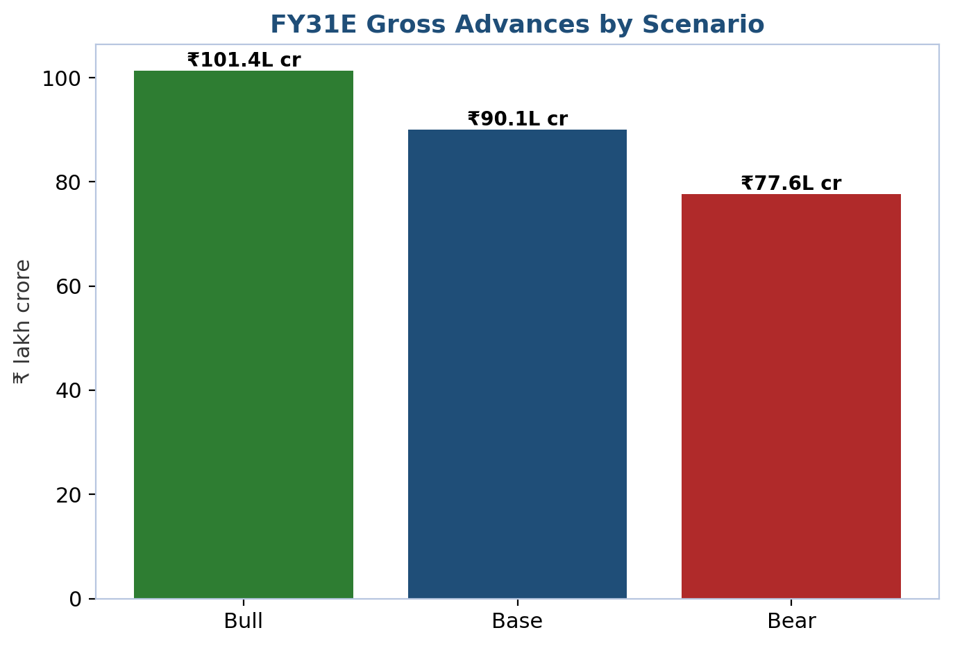
Figure 20: FY31E gross advances by scenario.
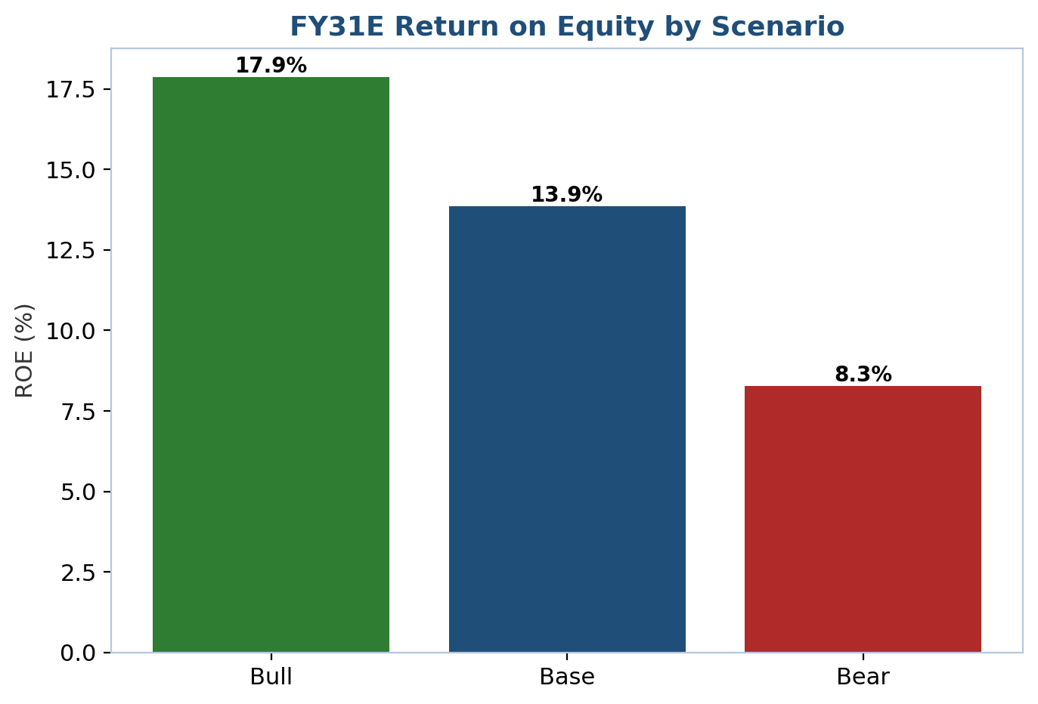
Figure 21: FY31E return on equity by scenario.
Probability-weighting the three cases (25% Bull, 50% Base, 25% Bear) produces an expected FY31E net profit of roughly ₹1,31,652 crore, within 1-2% of the Base Case itself — a useful confirmation that our Base Case is genuinely the probability-weighted center of the distribution rather than an optimistic or conservative outlier relative to the Bull/Bear framing. The risk/reward skew is roughly symmetric in earnings terms but we view it as modestly asymmetric in valuation terms: because SBI already trades at a depressed multiple relative to its return profile, the Bear Case's further multiple compression (to 1.1-1.2x book) is a smaller percentage move than the Bull Case's re-rating (to 1.8-2.0x book), meaning the price target is more sensitive to the multiple investors are willing to pay than to any single earnings assumption — reinforcing our view (see Investment Thesis, Pillar 2) that the valuation gap, not the earnings trajectory, is the central variable in this investment case.

Growth Drivers
1. Structural under-penetration in retail and MSME credit. India's mortgage and MSME formal-credit penetration remain low relative to GDP by regional and global standards, and SBI already holds leading positions in both (largest home-loan and education-loan lender; ~20% SME book growth in FY26), giving it a disproportionate claim on whatever portion of this multi-year under-penetration gap converts into formal bank credit over our forecast horizon.
2. YONO 2.0 as a payments-led defensive and offensive platform. Management has explicitly stated payments should be YONO 2.0's most-used function, positioning the app to compete directly with UPI-native fintechs on the transaction layer while retaining the advantage of being tied to an actual deposit and credit relationship — a structural advantage pure-play payments apps cannot replicate, and one that should support both fee income and CASA-balance retention if execution matches ambition.
3. Subsidiary ecosystem monetization. The planned SBI Funds Management stake-sale IPO, alongside a growing SBI Life, SBI General and SBI Cards franchise, gives SBI multiple, largely uncorrelated sources of value creation beyond the core lending business — sources of value that, unlike the core bank, do not screen cheaply against listed peers precisely because they are not yet visible as standalone market prices.
4. Continued PSU-bank sector re-rating. The NIFTY PSU Bank index has outpaced the (private-bank-dominated) NIFTY Bank index over the past eight years on a CAGR basis, evidence that the market has already begun, but by no means completed, closing the valuation gap between PSU and private banks; SBI, as the sector's scale leader with the cleanest asset-quality trajectory among PSU peers, is best positioned to capture a disproportionate share of any further re-rating.
5. Capital-light growth funded through FY31E and beyond. Because the FY26 QIP and strong internal capital generation fund our entire explicit forecast period without further dilution, essentially all of the earnings growth we project flows through to per-share value rather than being diluted away by periodic recapitalization — a meaningfully different dynamic from prior PSU-bank cycles and one we believe the market has not yet fully credited in the current multiple.

Valuation Methodology
Standard EV/EBITDA-style valuation does not translate cleanly to a bank, since deposits and advances — not debt and capital expenditure — drive the balance sheet, and "enterprise value" is not a coherent concept when a large share of liabilities (deposits) are the raw material of the business rather than a financing choice. We instead value SBI using two bank-appropriate methods — an Excess Return / Warranted Price-to-Book model and trading comparables — and explicitly exclude precedent transactions as a third method, for reasons set out below.

Excess Return / Warranted Price-to-Book Model
The standard sell-side bank-valuation framework values a bank's equity as Warranted P/B = (ROE − g) / (Ke − g), where Ke is the cost of equity, ROE is the sustainable long-run return on equity, and g is the sustainable long-run growth rate — the logic being that a bank earning exactly its cost of equity should trade at exactly 1.0x book, with any excess or shortfall versus Ke driving the premium or discount to book. We build cost of equity via CAPM: a risk-free rate of 6.65% (10-year India G-Sec), an India equity risk premium of 6.25%, and a beta of 1.05 versus the NIFTY 50, producing Ke = 13.21%. We do not mechanically derive terminal growth from our explicit-period ROE and retention ratio (which would imply an unsustainable ~14%+ long-run growth rate above our own cost of equity, a modeling error we caught and corrected during Task 2/3 of this process); instead we use a terminal sustainable ROE of 16.0% (below our FY31E explicit-forecast ROE, reflecting mean-reversion and increased capital intensity at scale) and a terminal growth rate of 7.00%, capped near long-run nominal Indian GDP growth. This produces a warranted P/B of 1.45x, which applied to our FY27E book value per share of ₹580.39 implies a fair value of ₹840.81 per share.
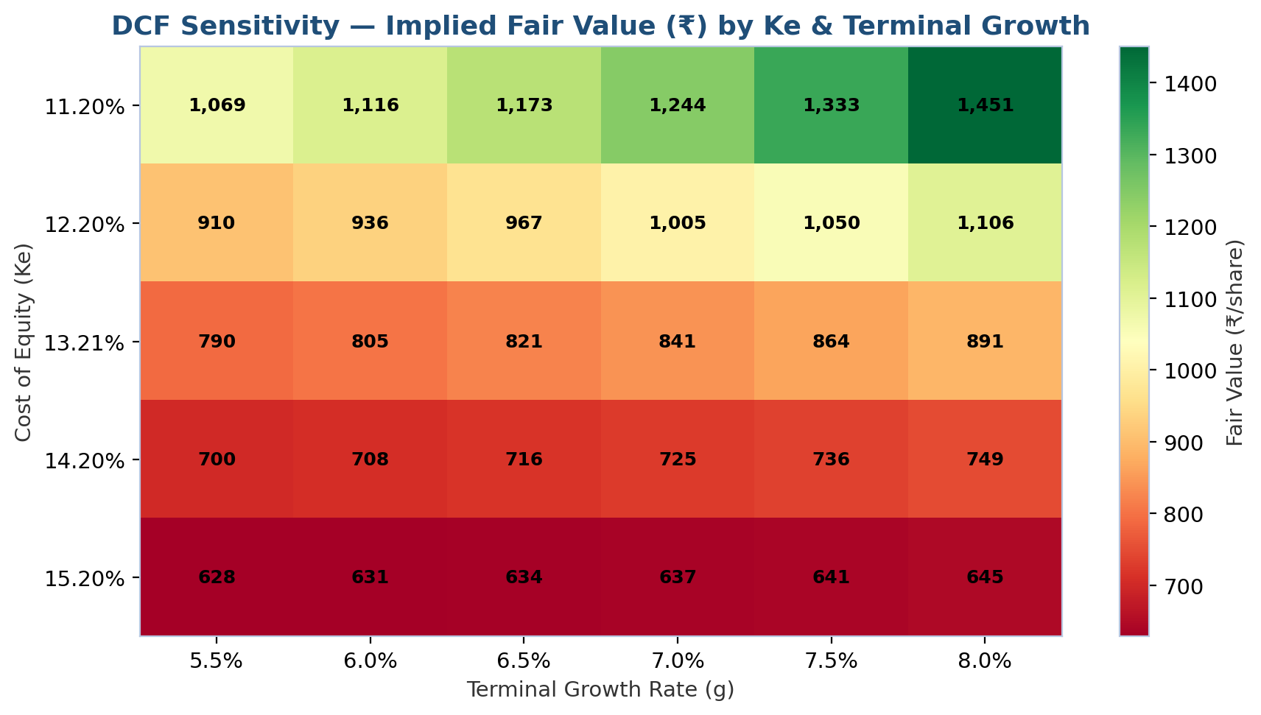
Figure 22: Fair-value sensitivity to cost of equity (Ke) and terminal growth rate (g).
The sensitivity table above shows how meaningfully the fair value moves with modest changes in either input: at the low end of our Ke range (11.2%) and higher terminal growth (8.0%), the implied fair value approaches ₹1,600+ per share; at the high end of our Ke range (15.2%) and lower terminal growth (5.5%), it falls toward ₹500 per share. Our point-estimate Ke of 13.21% and terminal growth of 7.00% sit close to the center of this grid, which we believe is the appropriately conservative choice given the genuine uncertainty in both the equity-risk-premium and long-run-growth inputs for an emerging-market, government-linked bank.

Trading Comparables
We benchmark SBI against a seven-company peer set spanning both large private-sector banks (HDFC Bank, ICICI Bank, Axis Bank, Kotak Mahindra Bank) and the closest PSU-bank analogues (Punjab National Bank, Bank of Baroda, Canara Bank), selected because together they represent the full range of scale, ownership structure and business mix a reader would want to weigh SBI against. We use P/E and P/B — not EV/EBITDA or EV/Revenue — because these are the multiples that actually capture a bank's balance-sheet-driven economics (book value as the core capital base, earnings as the return on that capital), and because they are the multiples the market itself demonstrably uses to price every bank in our peer set.
Company | P/E (x) | P/B (x) | ROE (%) | Type
HDFC Bank | 14.98x | 1.87x | 12.5% | Private
ICICI Bank | 18.24x | 2.74x | 15.0% | Private
Axis Bank | 13.30x | 1.67x | 13.3% | Private
Kotak Mahindra Bank | 20.29x | 2.21x | 10.9% | Private
Punjab National Bank | 7.00x | 0.84x | 12.4% | PSU
Bank of Baroda | 7.21x | 0.87x | 11.6% | PSU
Canara Bank | 6.39x | 1.03x | 16.1% | PSU
State Bank of India (Target) | 10.90x | 1.47x | 18.6% | PSU (Target)
Table 6: Comparable companies, September 2026 market data. Source: Company Comparable Companies tab; market data providers.
Statistic | P/E (x) | P/B (x) | ROE (%)
Maximum | 20.29x | 2.74x | —
75th Percentile | 16.61x | 2.04x | —
Median | 13.30x | 1.67x | 12.5%
25th Percentile | 7.11x | 0.95x | —
Minimum | 6.39x | 0.84x | —
Table 7: Peer-set statistical summary (excluding SBI). Source: Comparable Companies tab.
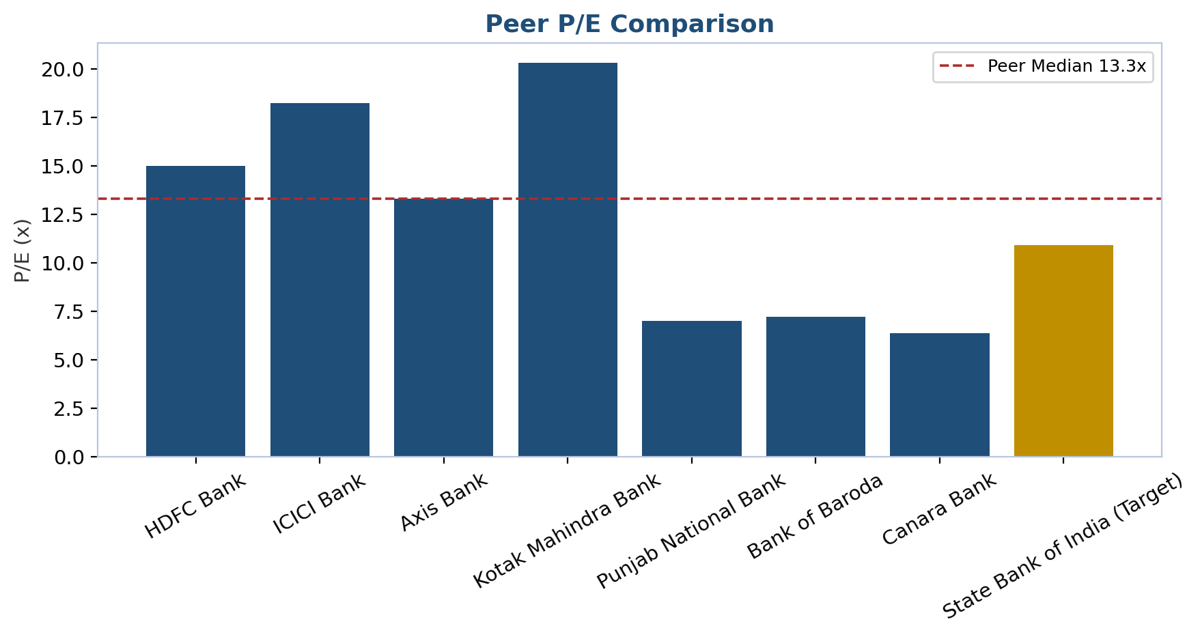
Figure 23: Peer P/E comparison.
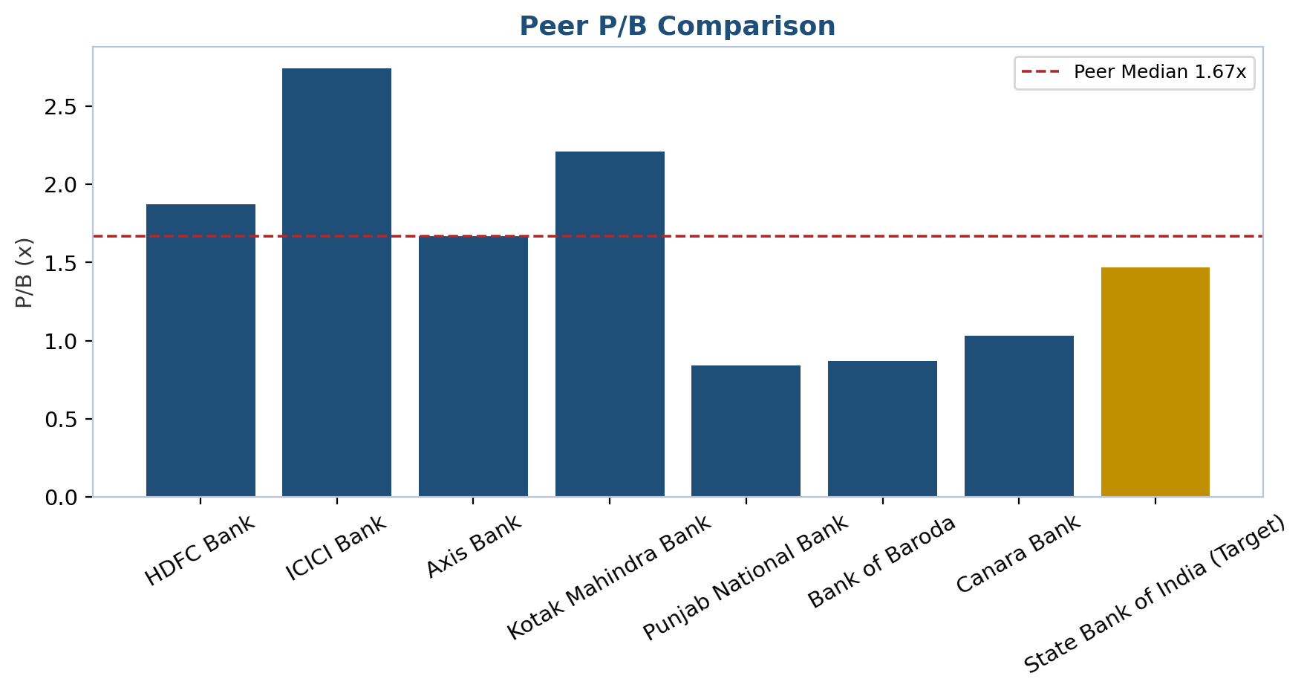
Figure 24: Peer P/B comparison.
Applying the peer median P/E of 13.30x to our FY27E EPS produces an implied price of roughly ₹1,209; applying the peer median P/B of 1.67x to our FY27E book value per share of ₹580.39 produces an implied price of roughly ₹969. We apply no premium or discount adjustment to these raw peer-median multiples: SBI's superior scale and improving asset quality arguably justify a premium to the PSU-peer subset, while its government-ownership and policy-lending risk arguably justify a discount to the private-bank subset, and we judge these to roughly offset within the blended median we use. Averaging the P/E- and P/B-implied prices gives a trading-comparables valuation of approximately ₹1,089 per share.

Precedent Transactions — Not Used
We do not use precedent (control) transactions as a valuation method for SBI. Bank M&A precedent transactions are priced with control premia that reflect the acquirer's ability to replace management, restructure the cost base, and access synergies — none of which is a plausible scenario for SBI, a majority (55.5%) government-owned, systemically important bank that is not a realistic acquisition target under any foreseeable circumstance. Applying a control-transaction multiple to a minority-shareholder equity valuation would overstate fair value in a way we are not willing to build into a client-facing price target.

Valuation Reconciliation and Price Target
We weight the Excess Return / Warranted P/B model at 55% and Trading Comparables at 45% (0% to Precedent Transactions, for the reason above). The Excess Return model, at 55% weight, is anchored primarily on SBI's own fundamentals (cost of equity, sustainable ROE, sustainable growth) and is therefore less exposed to a temporary dislocation in how the market happens to be pricing bank stocks generally at any given moment; the Comparables method, at 45% weight, keeps the target grounded in what investors are actually paying for genuinely similar assets today. This produces a weighted average price target of ₹955.00, which we round to ₹955 for publication.
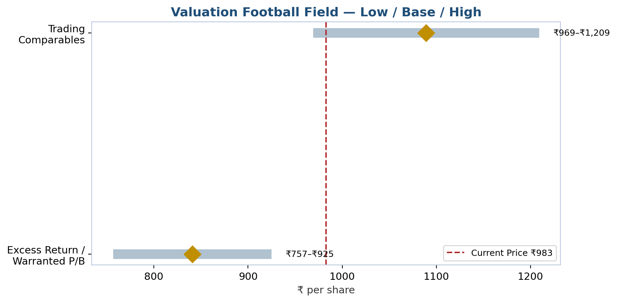
Figure 25: Valuation football field — low/base/high by method, vs. current price.
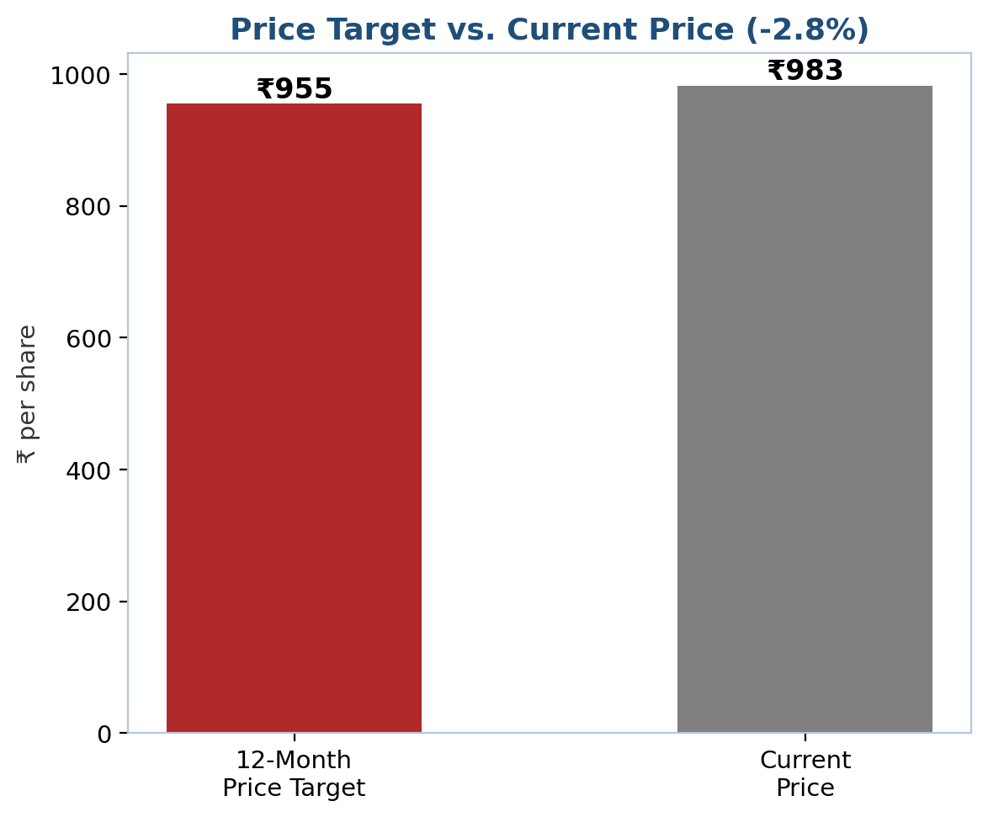
Figure 26: 12-month price target vs. current price.

Recommendation, Time Horizon, Catalysts and Risks
We rate SBI HOLD, with a 12-month price target of ₹955 versus a current price of ₹983, implying -2.8% downside. A HOLD rating on a stock we view as fundamentally undervalued reflects the fact that our target sits close enough to the current price (within our conventional +/-15%/-5% BUY/HOLD/SELL thresholds) that we do not see a large enough near-term margin of safety to recommend new-money buying at the current level, even though we believe the medium-term re-rating thesis (Investment Thesis, Pillar 2) remains intact and would prompt us to revisit this rating on any pullback toward the lower end of our valuation range or on confirmation of the specific catalysts below.
Key catalysts (12-24 months): (1) YONO 2.0 transaction-volume metrics, first disclosed in quarterly results, confirming the platform is gaining share from UPI-native competitors rather than merely defending existing usage; (2) domestic NIM printing at or above our 3.05-3.10% FY27E-FY28E assumption over consecutive quarters, confirming the margin-recovery thesis is on track; (3) the SBI Funds Management stake-sale IPO pricing and completing, crystallizing subsidiary value; (4) continued sequential GNPA/NNPA improvement confirming the asset-quality cycle remains structural; and (5) any incremental signal of PSU-bank sector-wide re-rating (e.g., a similar re-rating at Bank of Baroda or Canara Bank) that would support a read-through to SBI's own multiple.
Key risks to the price target: (1) a renewed or extended RBI rate-cutting cycle that pushes domestic NIM recovery out further than our FY27E-FY29E assumption; (2) a sharper-than-expected credit-cycle turn in the SME, agriculture or unsecured-retail segments, which carry our most aggressive near-term growth assumptions; (3) government-directed lending or rate pressure that compresses margins for policy rather than market reasons, a risk unique to SBI's ownership structure relative to private-bank peers; (4) failure of YONO 2.0 to gain meaningful transaction-volume traction, ceding the payments layer to fintech competitors; and (5) normalization of FY26's elevated treasury and forex income proving sharper than our -30%/-35% FY27E assumption, creating a headline-profit air-pocket even if core operating trends remain intact. We discuss each of these, and seven others, at greater length in Risk Factors.

Appendices

Appendix A: Data Sources and References
All sources below were accessed in September 2026 unless otherwise dated.

Company Filings and Results
SBI Integrated Annual Report FY2024-25 and FY26 results presentations/press releases — sbi.bank.in
SBI Q1-Q4 FY23–FY26 quarterly results press releases, various dates 2023-2026

News and Financial Media
Business Standard — SBI Q2/Q4 FY26 results, FY26 net profit, PSU banks' cumulative profit
Groww — SBI Q4 FY26 Results, May 2026
ANI News — SBI FY26 net profit, May 2026
Investing.com — SBI FY26 presentation and live market data, 2026
Wikipedia — State Bank of India, Imperial Bank of India, associate-bank mergers
FundingUniverse — History of State Bank of India
Britannica — State Bank of India
ICRA Research — Indian Banking Sector, Dec 2024 and Mar 2025
IBEF — Banking in India
Tickertape, Trendlyne, Bajaj Broking, Screener.in — live share-price and valuation data, Sept 2026

Appendix B: Detailed Model Assumptions
The full assumption set underlying this report — growth rates, yields, costs, credit-quality and capital assumptions for FY22A-FY31E — is documented on the Assumptions tab of the accompanying SBI_Financial_Model.xlsx workbook, with historical actuals shown in blue alongside projected inputs. Historical segment-level advances splits for FY22-FY24 (Retail/Agriculture/SME/Corporate mix, and Domestic/Foreign Office mix) are analyst estimates back-solved from FY25's disclosed aggregates using indicative segment CAGRs, and should be treated as directional rather than filed data; FY25/FY26 figures are anchored to disclosed company aggregates. All figures in this report are presented on a standalone (parent bank only) basis unless explicitly noted as consolidated.

Appendix C: Comparable Companies — Extended Detail
Company | Price (₹) | Mkt Cap (₹ cr)
HDFC Bank | ₹737.25 | 13,98,000
ICICI Bank | ₹1422.80 | 10,22,835
Axis Bank | ₹1210.75 | 3,87,515
Kotak Mahindra Bank | ₹413.10 | 4,11,842
Punjab National Bank | ₹104.50 | 1,25,000
Bank of Baroda | ₹276.90 | 1,44,359
Canara Bank | ₹129.50 | 1,14,200
State Bank of India (Target) | ₹983.00 | 9,03,216
Table 8: Peer price and market capitalization detail, September 2026.

Appendix D: Analyst Certification and Disclosures
This report reflects the analysis of an equity research process conducted across company research, financial modeling, valuation, chart generation and report assembly workflow stages, using company filings, press releases and third-party market-data sources as cited throughout and in Appendix A. This report is for informational purposes as part of an illustrative institutional-format equity research exercise and does not constitute investment advice, an offer, or a solicitation to buy or sell any security. Estimates and forecasts are inherently uncertain and actual results may differ materially from those projected herein.

