YT_insights
YouTube Comment Sentiment Analysis
Project Report

Domain | Machine Learning · NLP · Browser Extension
Stack | Python FastAPI · LightGBM · TF-IDF · Chrome Extension
Data | ~5 MB annotated social-media text (CSV)
Output | Sentiment scores, pie charts, trend graphs, word clouds

TEAM MEMBERS

E23cseu0242 | Aryan Patel
E23cseu0243 | Pranay Prasoon
E23cseu0354 | Arjun Mehra

Chapter 1: Problem Analysis

1.1 Background
YouTube accumulates millions of comments that serve as critical feedback for creators, brands, and advertisers. Manual review of this volume is impractical. Understanding audience sentiment—whether viewers react positively, negatively, or indifferently—is essential for data-driven content strategy.

1.2 Problem Statement
Existing tools offer only surface-level metrics (likes, views) without qualitative audience insight. There is a clear need for an automated, browser-native system that evaluates comments, predicts sentiment, and visualises findings in real time—without context switching.

1.3 Objectives
- Train a LightGBM + TF-IDF model to classify comments as Positive, Negative, or Neutral.
- Build a reproducible data pipeline with DVC, NLTK lemmatization, and stop-word removal.
- Implement a FastAPI backend that returns sentiment charts and time-trend analyses.
- Deliver a Chrome Extension that fetches comments via the YouTube Data API v3 and renders insights inline.

1.4 Scope & Constraints
Language | English only (NLTK English stop-words & lemmatizer)
Comment type | Top-level comments only (no replies)
Sentiment scale | Trichotomous: −1 Negative · 0 Neutral · +1 Positive
Visualisations | Pie chart · Trend line · Word cloud
Out of scope | Sarcasm detection, emoji analysis, authentication

1.5 Gap in Existing Systems
Existing social-media listening tools are not tailored to YouTube. Standalone web apps require manual URL entry, disrupting natural workflow. Browser extensions are either overly simplified (a single score) or locked behind paywalls. YT_insights combines MLOps practices, a custom LightGBM model, and rich visualisations inside a lightweight plugin.

Chapter 2: Design & Methodology

2.1 System Overview
YT_insights is a decoupled client-server application. The Chrome Extension queries the YouTube Data API for comments and POSTs them to a FastAPI backend. The backend preprocesses text (NLTK), vectorises it (TF-IDF), runs the LightGBM classifier, generates visualisations (Matplotlib, WordCloud), and returns results as JSON and images to the extension.

2.2 System Architecture
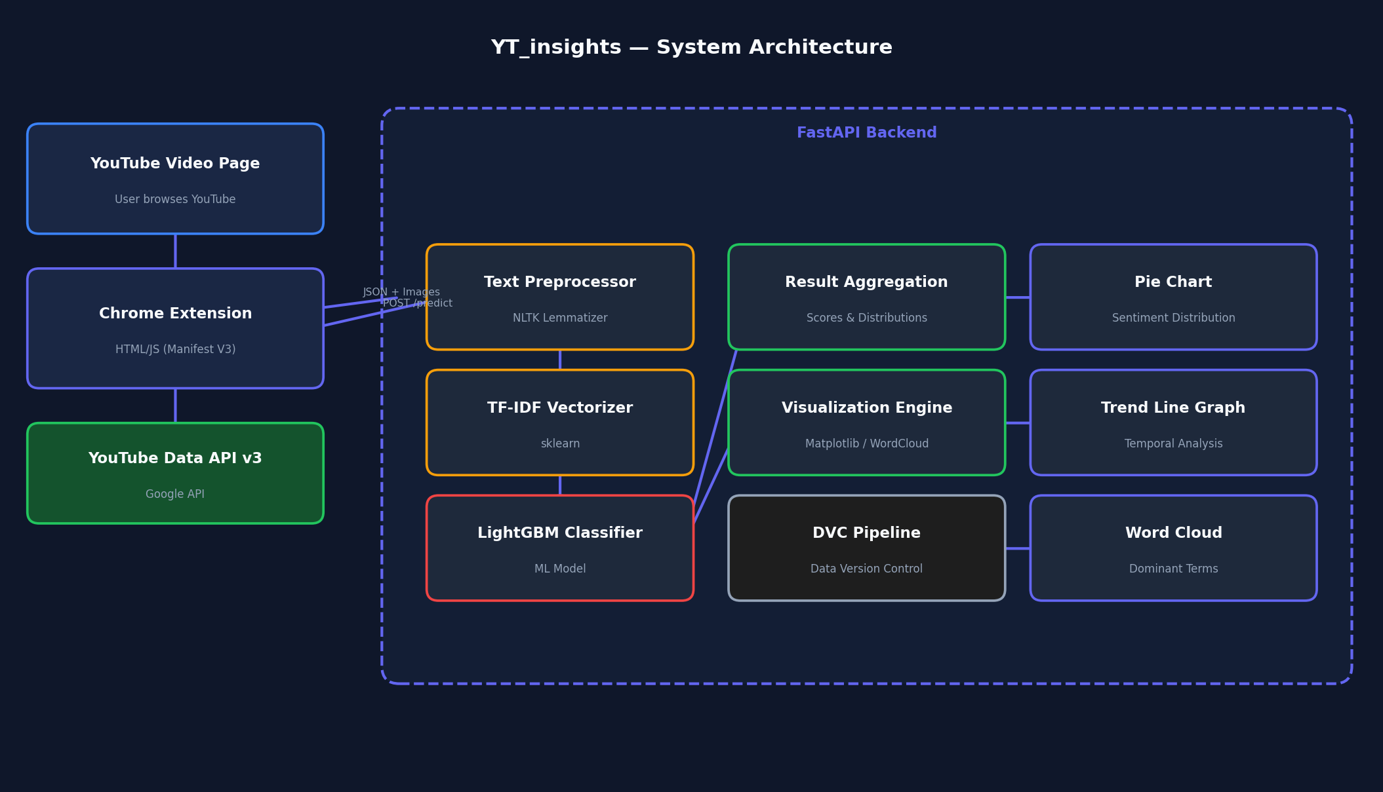
Figure 1 — End-to-end system architecture of YT_insights

2.3 Technology Stack
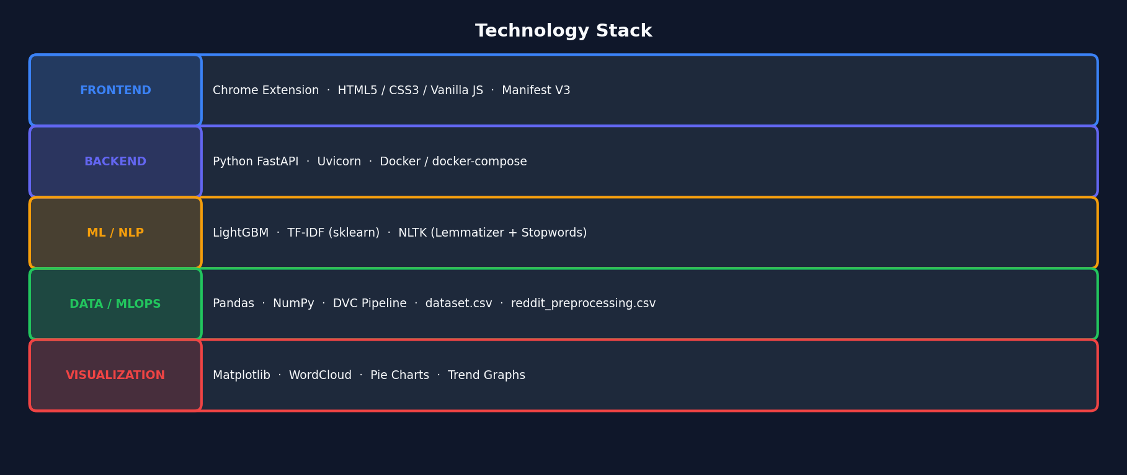
Figure 2 — Layered technology stack

2.4 ML Pipeline
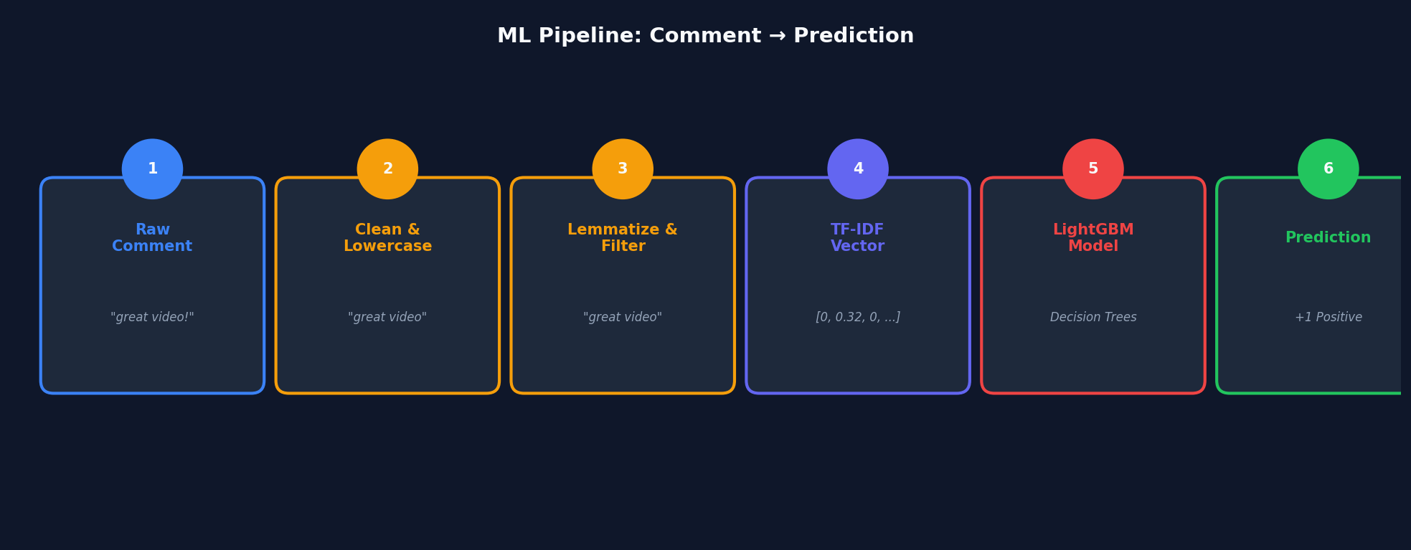
Figure 3 — Six-step ML pipeline: raw comment → sentiment prediction

2.5 Methodology Flowchart
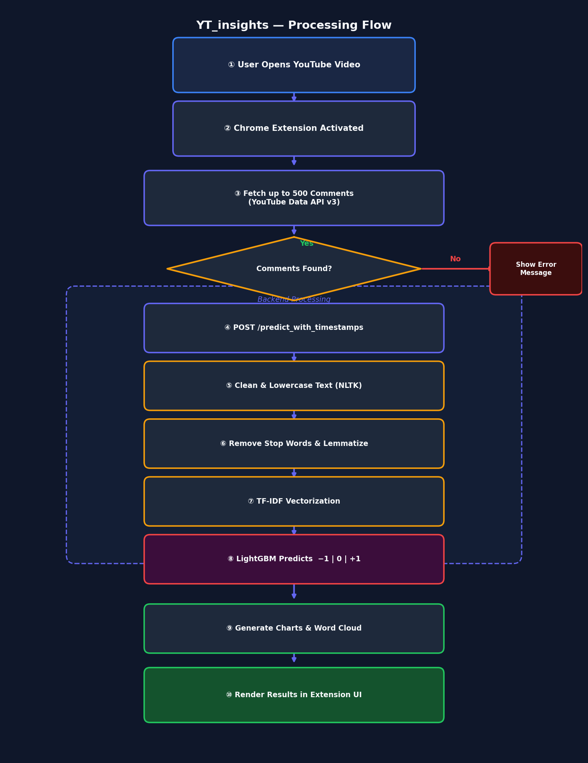
Figure 4 — End-to-end processing flow from user action to rendered result

2.6 Algorithms
LightGBM | Gradient boosting framework; efficient on sparse NLP vectors; handles class imbalance well
TF-IDF | Term Frequency–Inverse Document Frequency; converts text to weighted numeric features
WordNet Lemmatizer | Reduces inflected words to base lemma; reduces feature-space dimensionality
DVC Pipeline | Tracks data mutations, train/test splits, and model artefacts for reproducibility

2.7 Experimental Setup
Development runs inside Docker containers (x86_64 / arm64) orchestrated via docker-compose. The Chrome Extension is loaded as an unpacked extension via chrome://extensions/ and communicates with the FastAPI server at localhost:8000 for real-time testing.

2.8 Dataset
Primary dataset | dataset.csv — ~5 MB annotated social-media text
Secondary dataset | reddit_preprocessing.csv — Reddit data for linguistic robustness
Label schema | text (string) · label (−1 Negative, 0 Neutral, +1 Positive)
Versioning | All splits tracked via dvc.yaml pipeline

