**EXPERIMENT NO 1**

**NAME**-Aryan Dangat

**CLASS**-D15A

**ROLL NO** -12

**AIM:** Installation and Configuration of Flutter Environment.

**CODE:**

Install Flutter

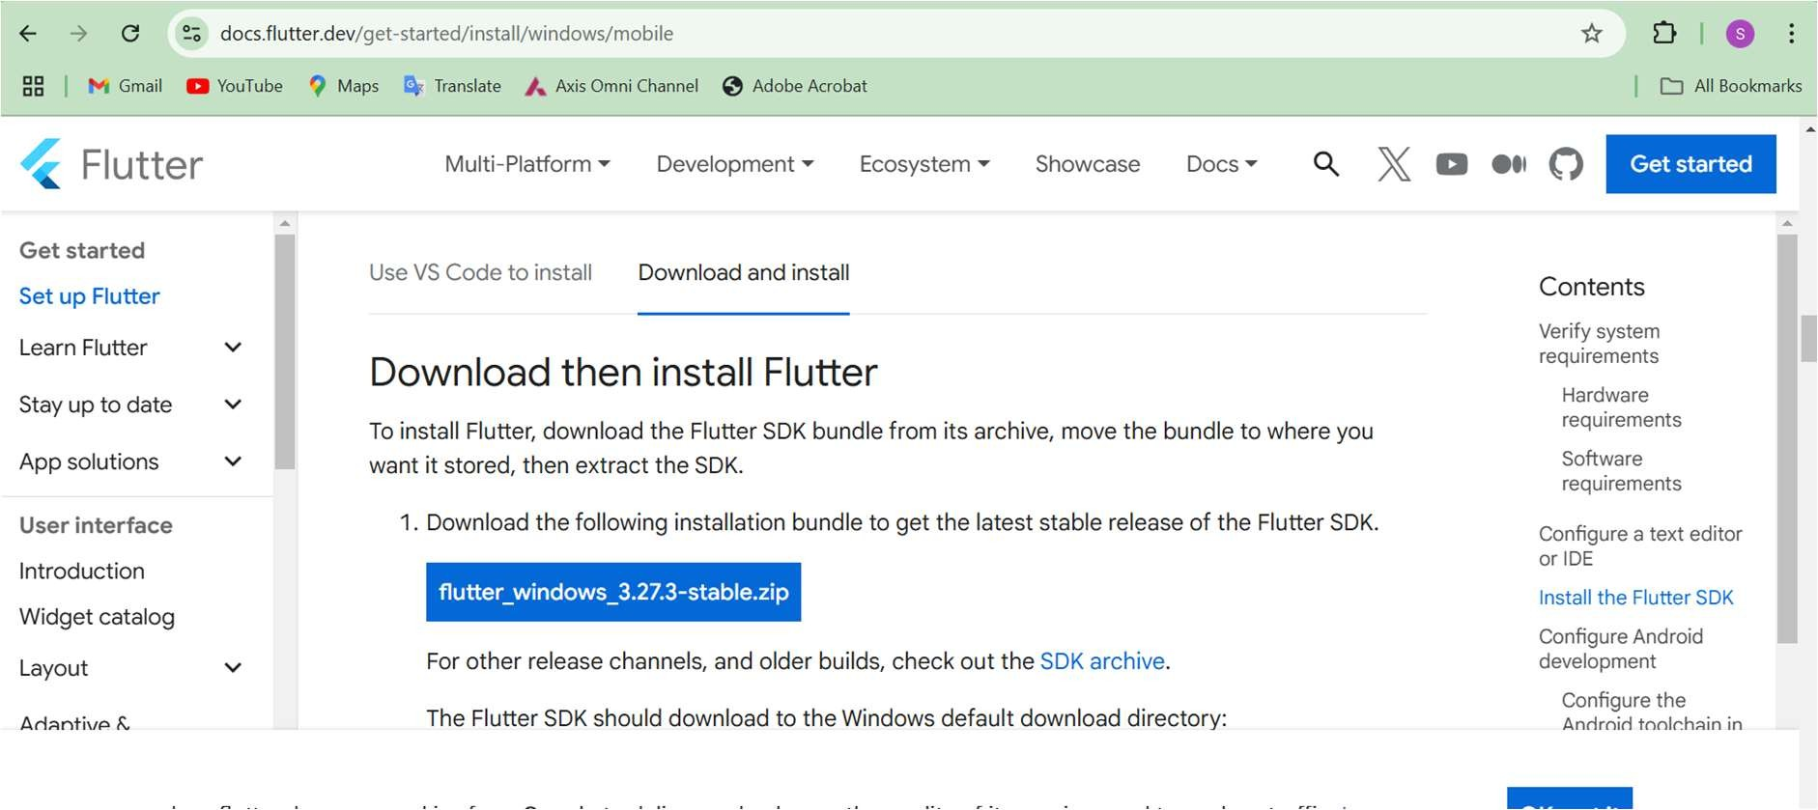

Setting the Environment Variable

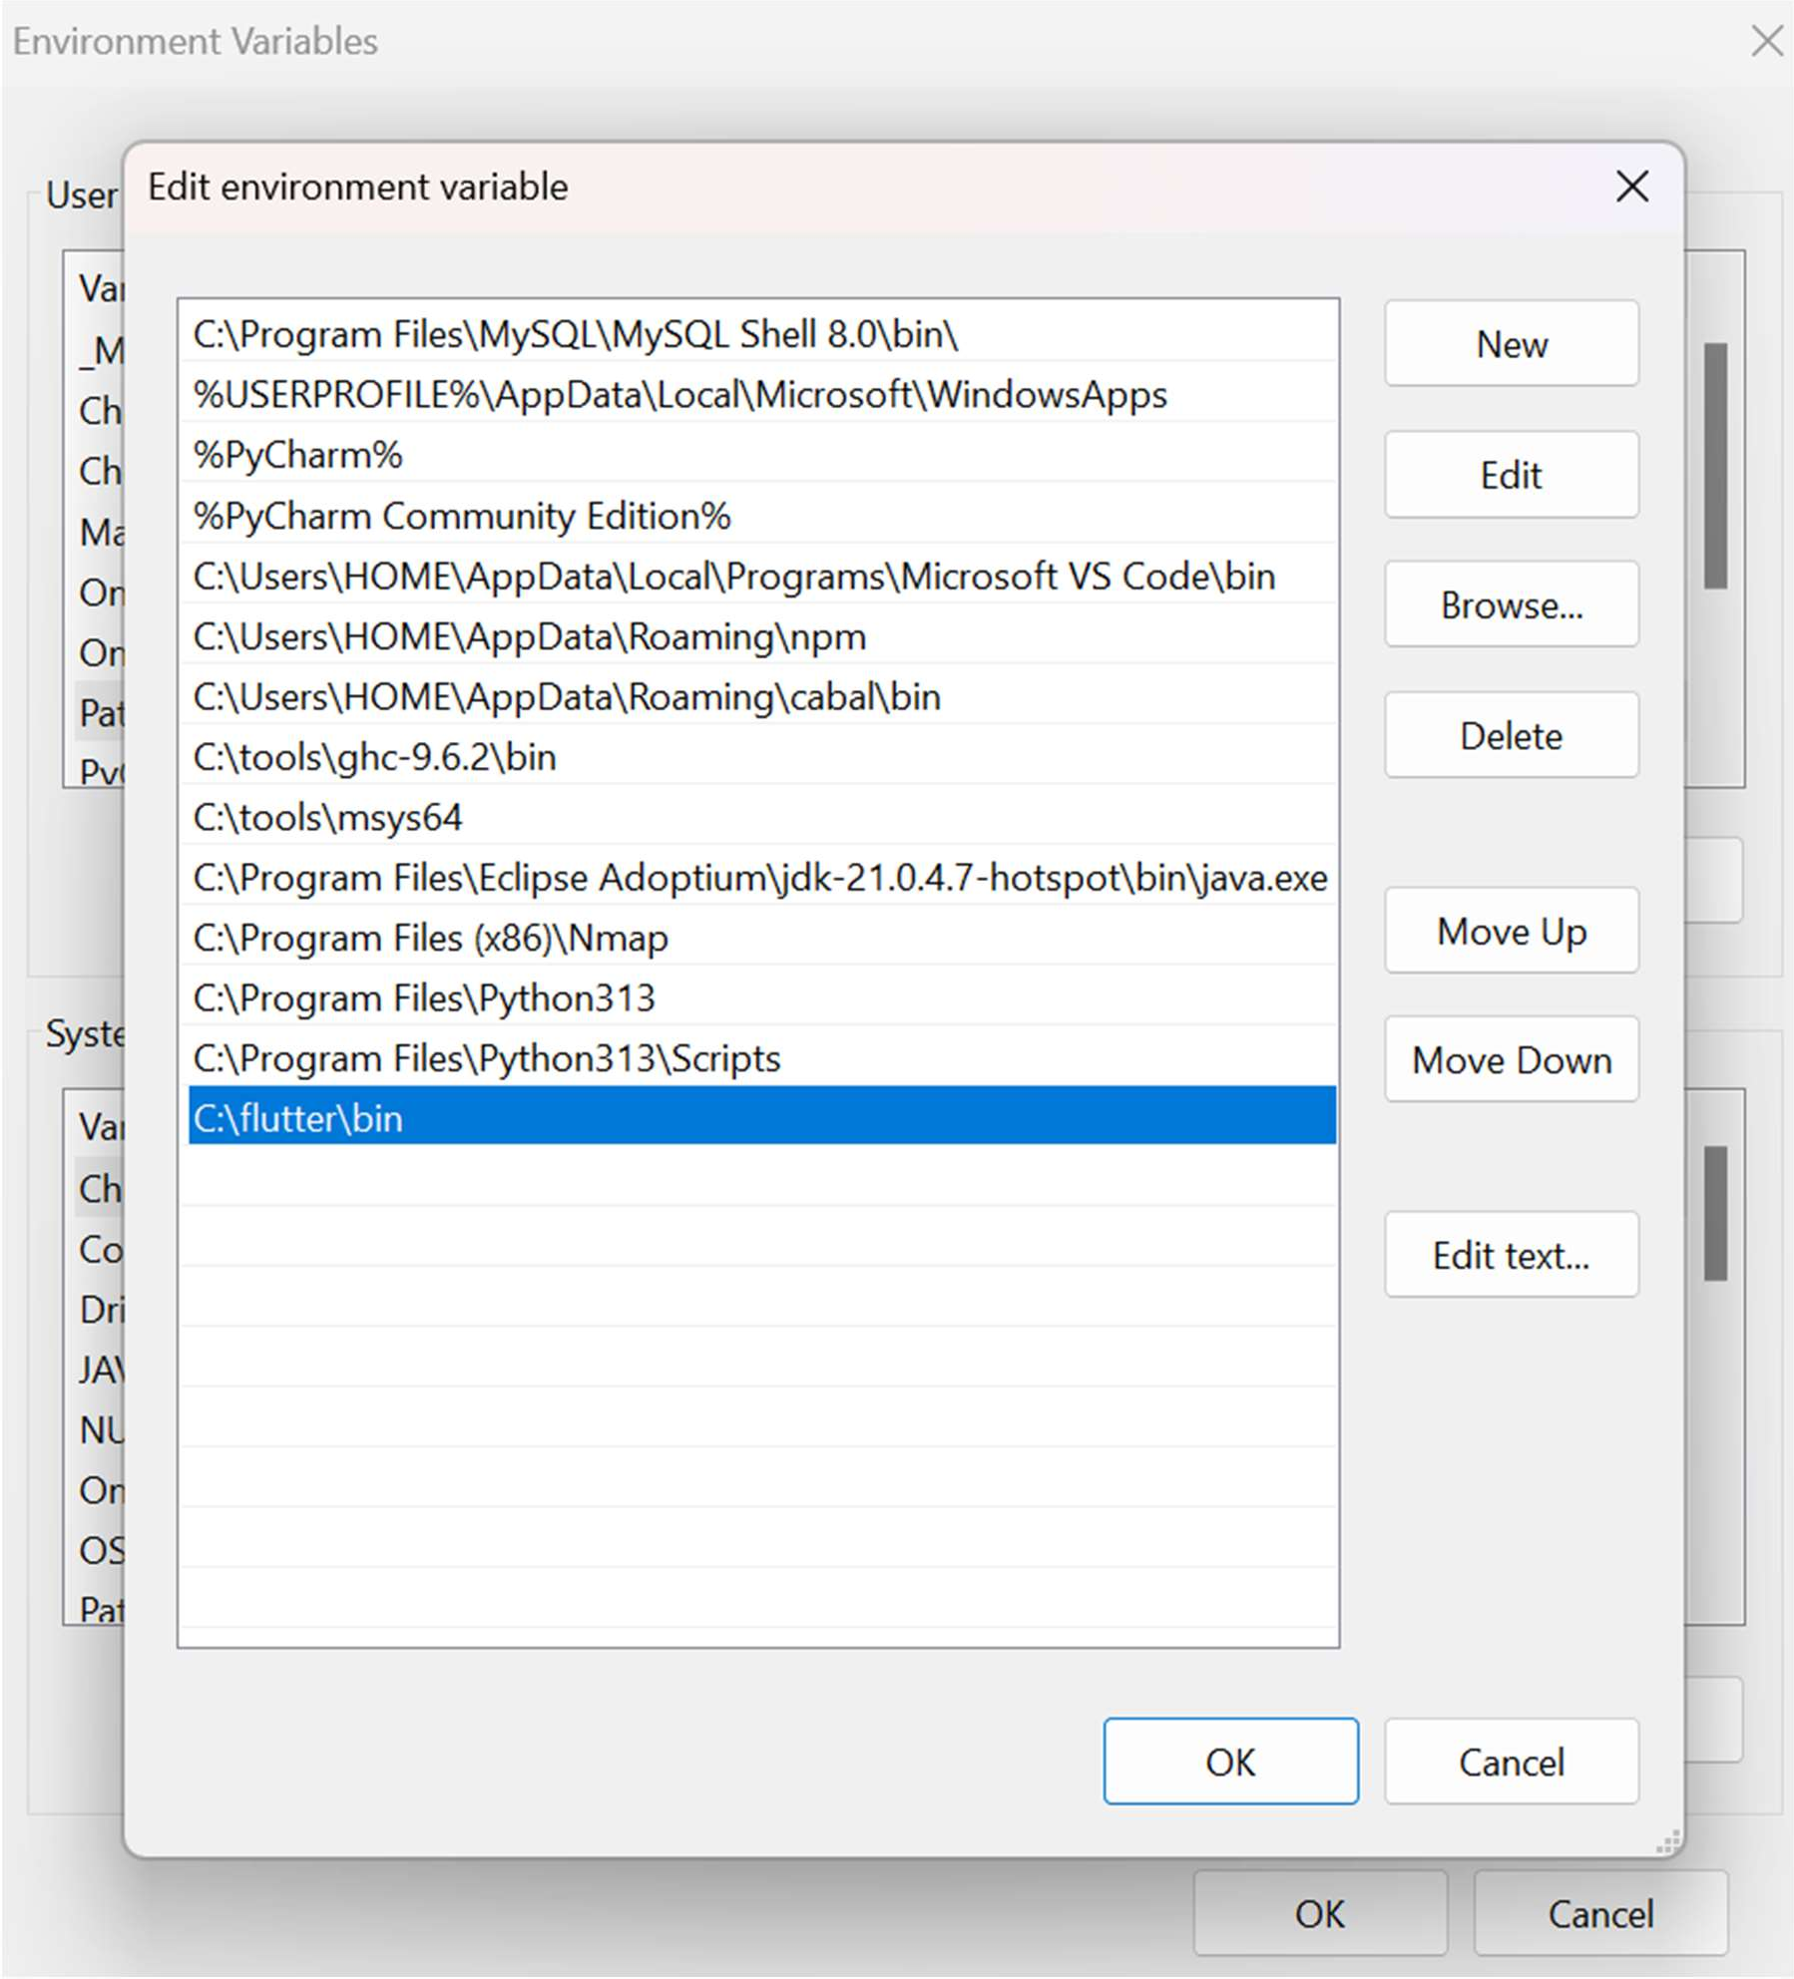

Running Flutter command

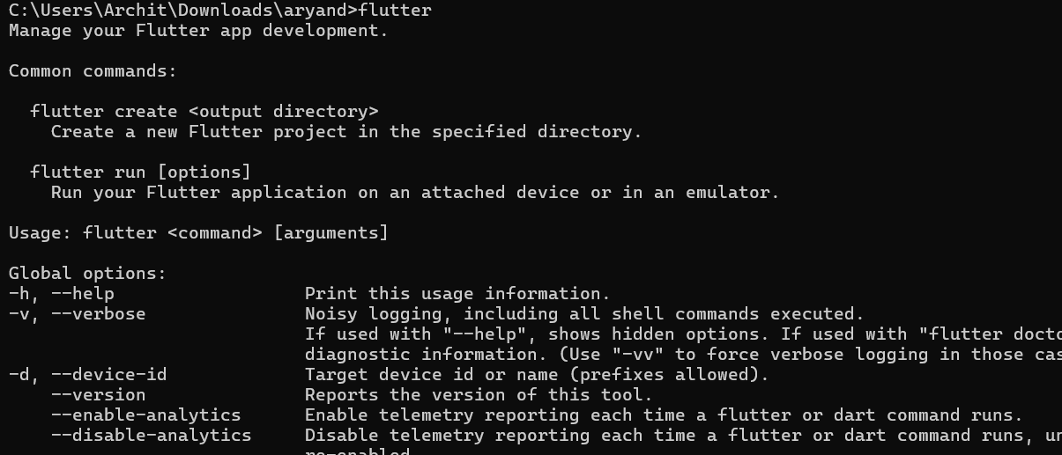

Running flutter doctor

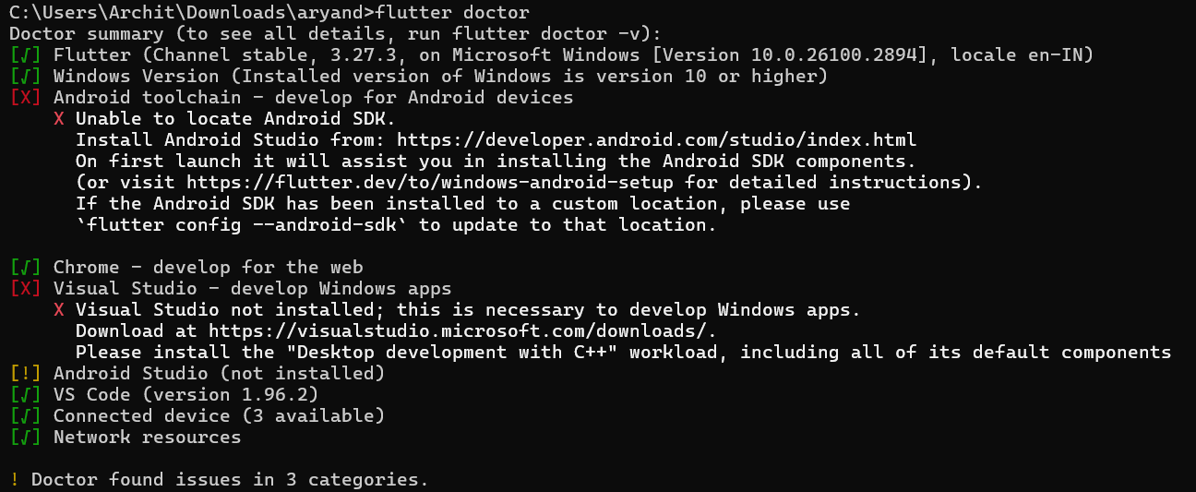

Downloading Android SDK

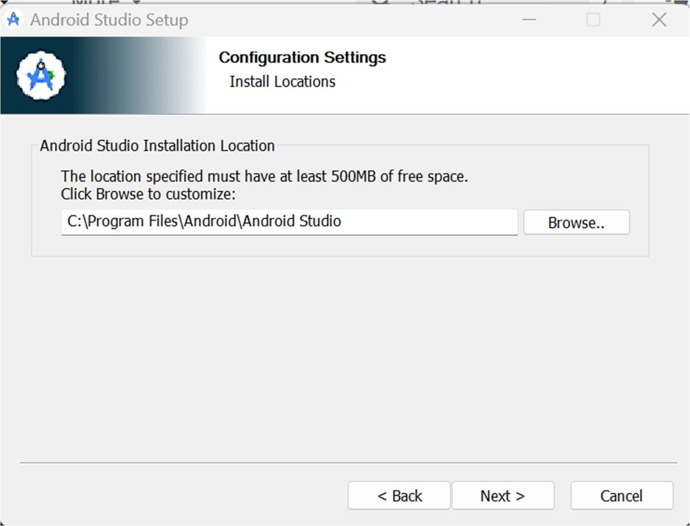

Downloaded command line tools of Android SDK

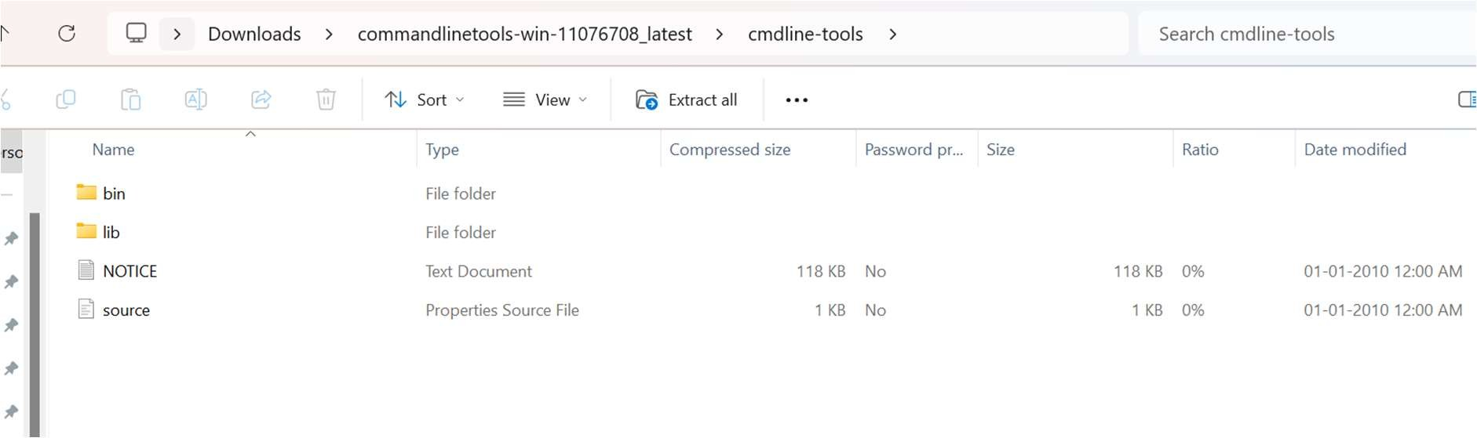

There are 2 issues according flutter doctor

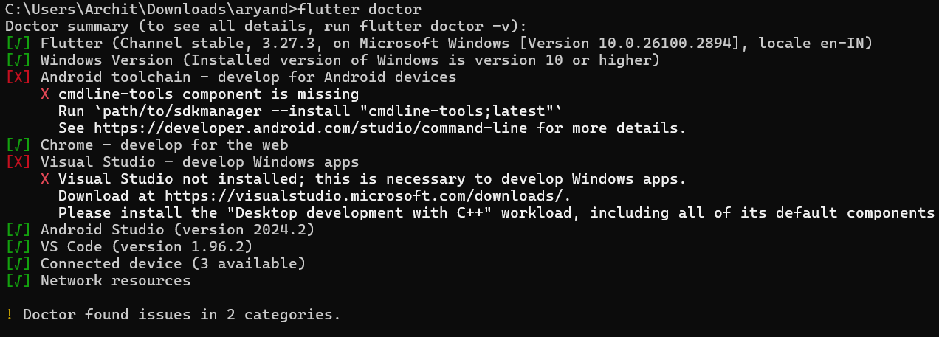

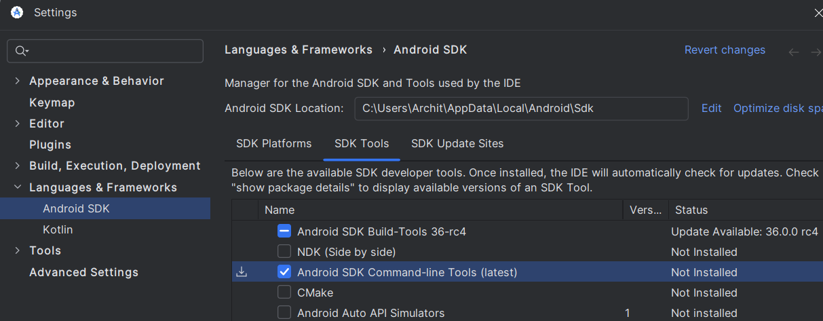

Downloading the command line tools

Accepted the Android licenses

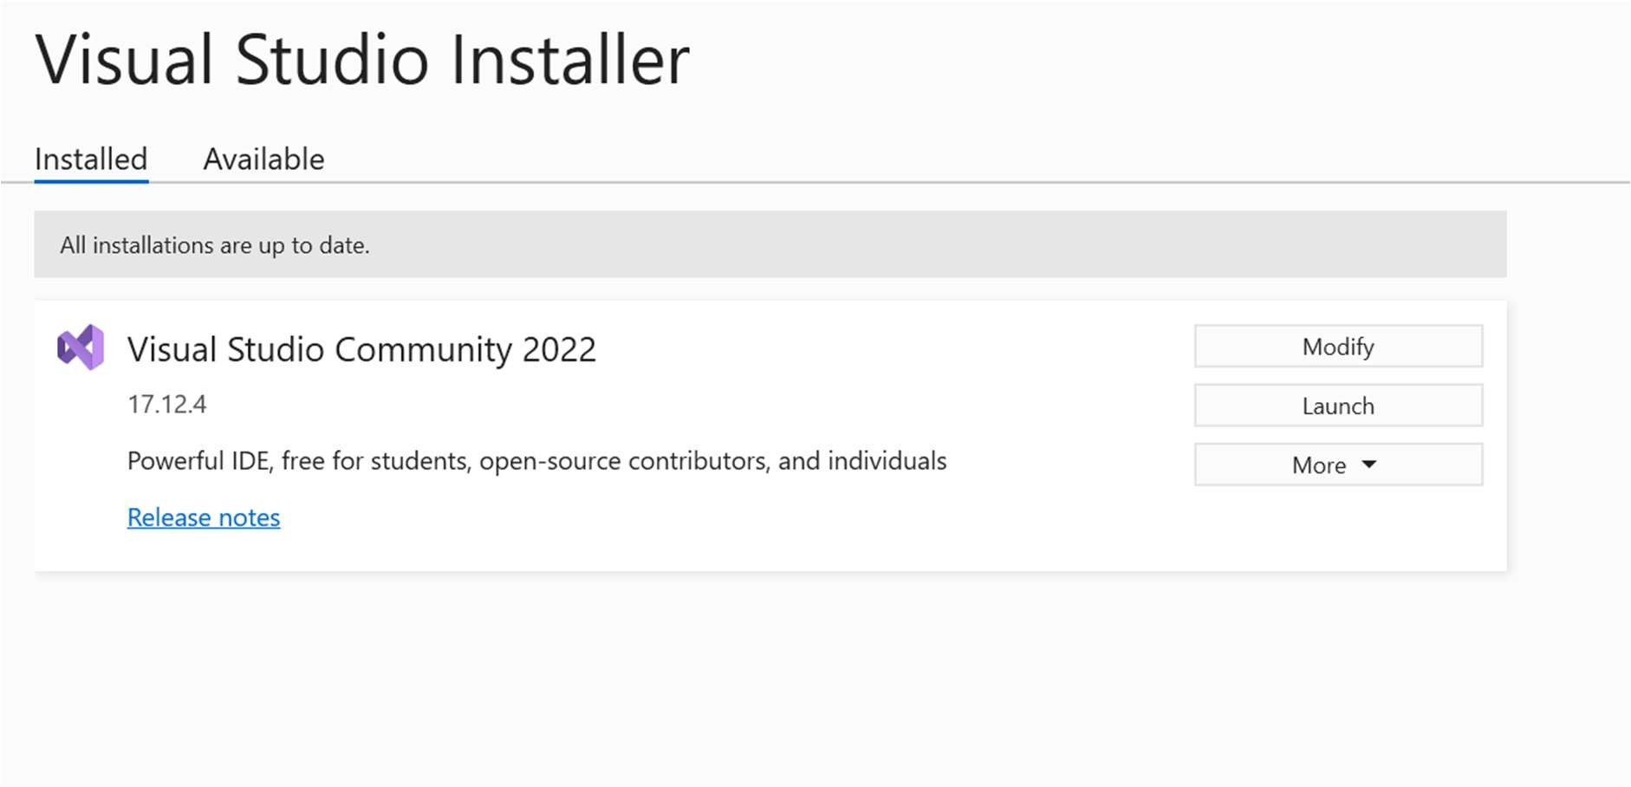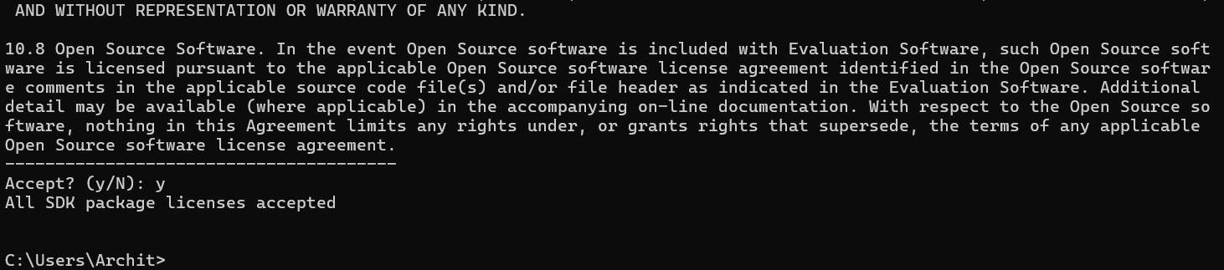

Installing visual studio

Installed Visual Studio

Successful Running of flutter doctor command

