Activity-3:

Program-1:

<!DOCTYPE html>

<html lang="en">

<head>

    <meta charset="UTF-8">

    <meta name="viewport" content="width=device-width, initial-scale=1.0">

    <title>Document</title>

</head>

<body bgcolor="black">

      <font color="white"><center><h1><i><u>ARYAN</u></i></h1></center>

      <h1><center>Welcome to my personal profile page!</center> </h1>

    <h1><center><img src="https://www.softwaretestinghelp.com/wp-content/qa/uploads/2023/09/Eilik.png" width="500" height="500"></center></h1>

    <center> <p>&nbsp<a href="file:///C:/Users/Balaji/Pictures/Desktop/New%20folder/About%20Me.html">About me&nbsp; </a><a href="file:///C:/Users/Balaji/Pictures/Desktop/New%20folder/projects.html">Projects &nbsp; </a><a href="file:///C:/Users/Balaji/Pictures/Desktop/New%20folder/Contact.html">Contact &nbsp; </a></p></font><center>

</body>

</html>

Output:

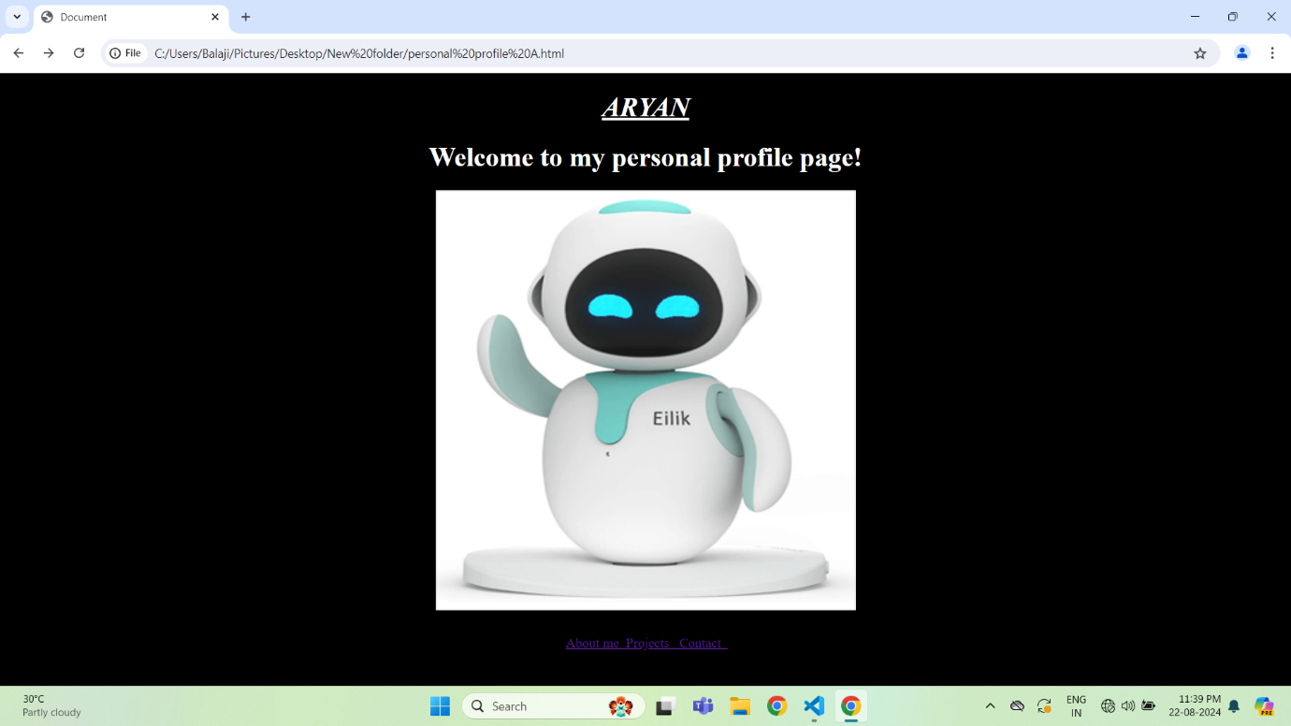

Program-2:

<!DOCTYPE html>

<html lang="en">

<head>

    <meta charset="UTF-8">

    <meta name="viewport" content="width=device-width, initial-scale=1.0">

    <title>Document</title>

</head>

<body bgcolor="black">

   <font color="white"><center><u> <h1>About Me</h1></u></center>

   <h2><center><i><b>I am a web developer with a passion for creating intuitive and user-friendlywebsites.</b></i></center></h2>

   <center><img src="https://img.freepik.com/premium-psd/psd-male-developer-3d-illustration_1169368-1289.jpg?semt=ais_hybrid" width="600" height="600"</center></font>

</body>

</html>

Output:

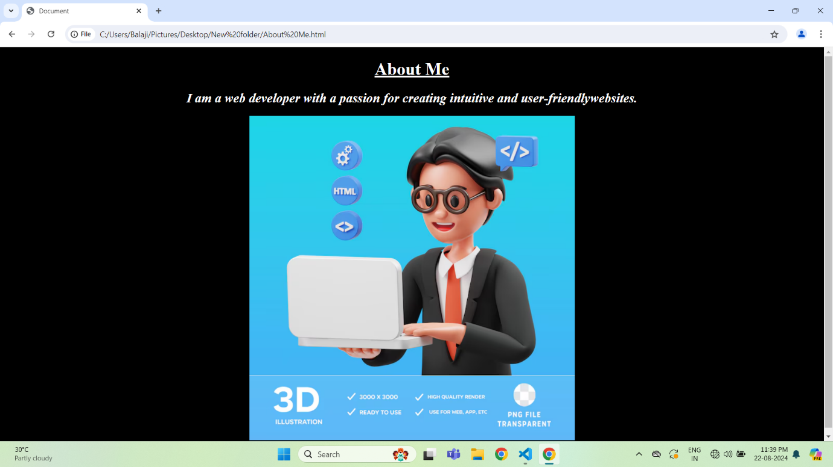

Program-3:

<!DOCTYPE html>

<html lang="en">

<head>

    <meta charset="UTF-8">

    <meta name="viewport" content="width=device-width, initial-scale=1.0">

    <title>Document</title>

</head>

<body bgcolor="black">

   <font color="white"<center><h1><u><i>Projects</i></u></h1></center>

   <h2><a href="file:///C:/Users/Balaji/Pictures/Desktop/HTML%20practise/AI.html">Project 1:</a></h2>

   <h2><a href="file:///C:/Users/Balaji/Pictures/Desktop/HTML%20practise/ML.html">Project 2:</a></h2>

</body>

</html>

Output:

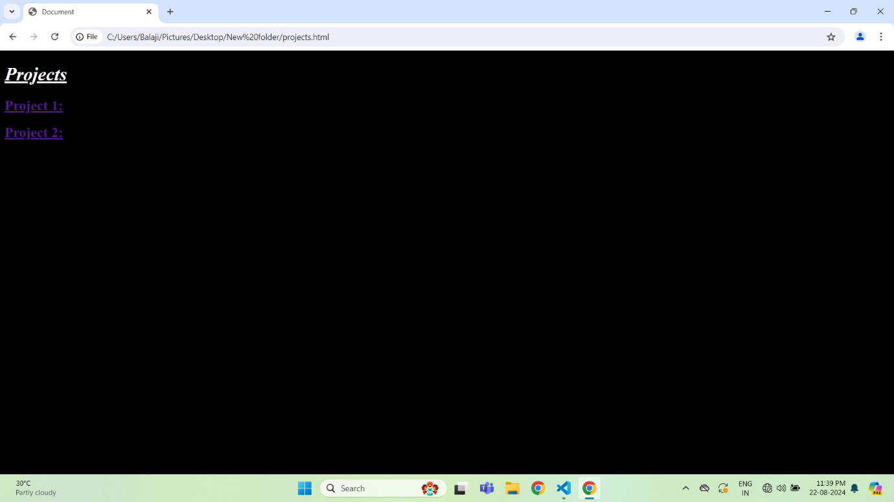

Project 1:

Project 2:

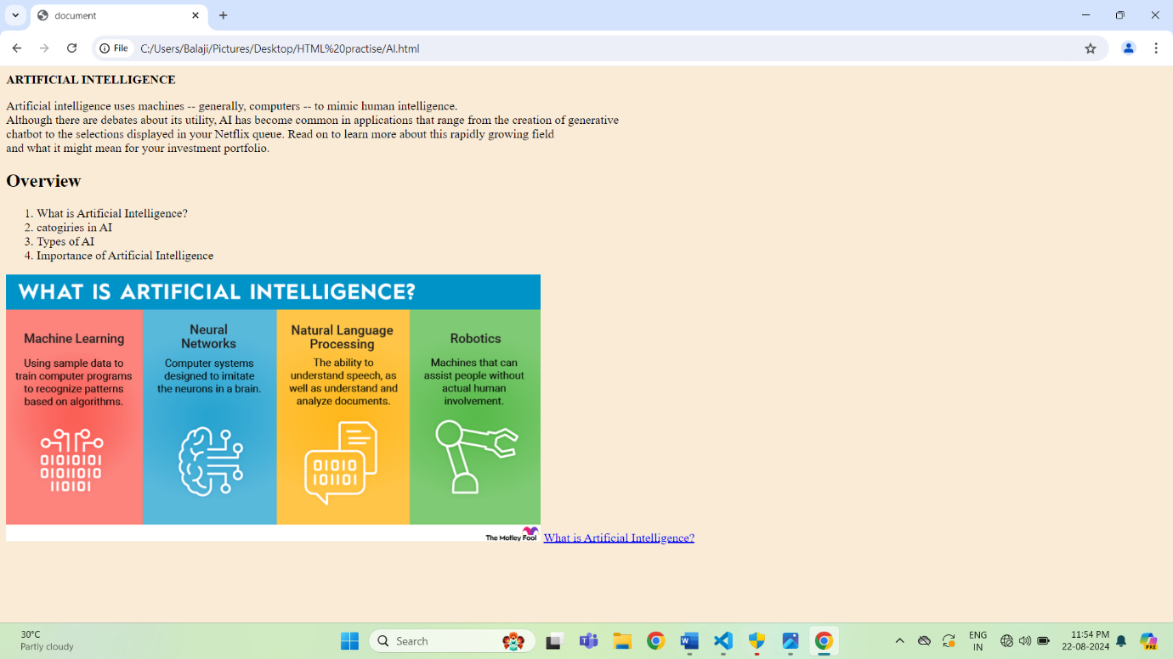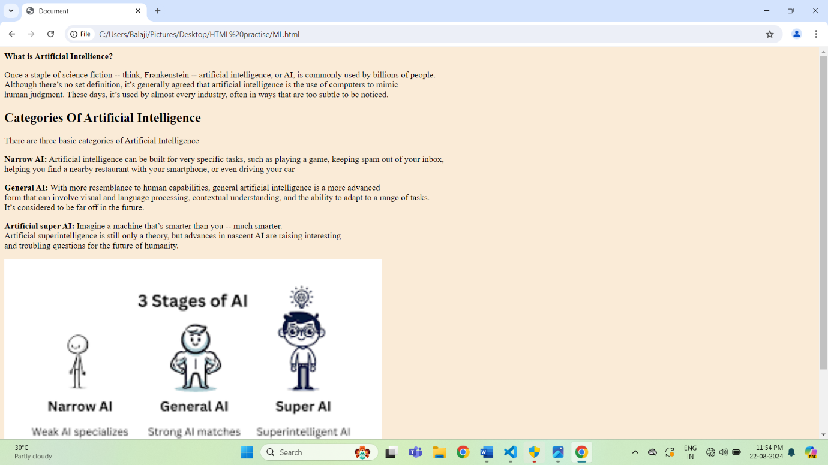

Program-4:

<!DOCTYPE html>

<html lang="en">

<head>

    <meta charset="UTF-8">

    <meta name="viewport" content="width=device-width, initial-scale=1.0">

    <title>Document</title>

</head>

<style>

    p{

        font-size: 50px;

    }

</style>

<body bgcolor="black">

    <font color="red"<center></center><h1><u><b>Contact</b></u></h1></center>

    <p>Feel free to reach out to me through the following channels:<br>

       Contact: 6304540489<br>

       Email: arayanbanda@gmail.com

    </p>

</body>

</html>

Output:

