**Welcome to Markdown!**

This is a **basic example** to help you get started with Markdown formatting.

**Headings**

Use # for headings. Add more # for smaller headings:

# creates the largest heading



## creates a medium heading



### creates a smaller heading



**Lists**

**Unordered List**

Item 1



Item 2



Sub-item 2.1



Sub-item 2.2



**Ordered List**

1. First item
2. Second item
3. Third item

**Emphasis**

**Bold** text: **Bold**



*Italic* text: *Italic*



~~Strikethrough~~: ~~Strikethrough~~



**Links**

[Click here to visit Google](https://www.google.com/)

**Images**



**Code Blocks**

Inline code: Use `backticks` for inline code

Block of code:

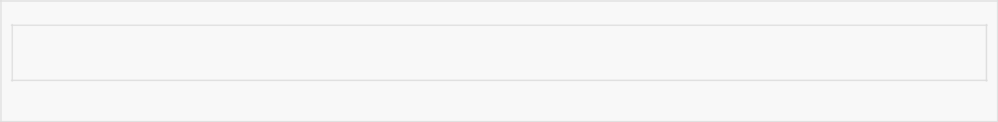

def hello_world():

print("Hello, world!")