Fake Logo Detection System

A

AI and Machine Learning Mini Project

Submitted in the partial fulfillment of the requirement for the award of Bachelor of Technology

in

CCE (Computer and Communications Engineering)

By: **Aryan Soni 219303159**



April 2024

Department of Computer and Communications Engineering

School of Computing and Intelligent Systems

Manipal University Jaipur

VPO. Dehmi Kalan, Jaipur, Rajasthan, India – 303007

**Fake Logo Detection System**

# Background/ Problem Statement

Every year, brands lose a significant portion of their sales to unauthorized knock off brands and counterfeits. Moreover, since such counterfeit products are usually of an inferior quality, they also end up damaging the credibility of the brand.

Many a times consumers also get cheated out of their hard-earned money as they end up shelling out an exorbitant amount of money for a mere counterfeit.

This Logo Detection app aims to help consumers distinguish forgeries from the original product. Using this system, a consumer can verify whether a product is in fact an original.

This application can also be helpful for brands struggling to fight against forged products.

# Working of the Project

* + Counterfeit products usually have an inferior built quality and along with stealing sales, they also damaging a brand’s reputation in the long run.
  + Along with harming a brand’s sales and reputation, unaware consumers also get cheated out of their money.
  + This Logo Detection project aims to help users identify forgeries by analysing the logo on the product.
  + Along with helping users identify the logo, this app also helps brands combat logo piracy.
  + This project is developed using the Django framework with Python as programming language.

Training the model upto 12th epoc:

1. ***Working model output***

: real logo

: fake logo recognized

# Advantages

* This project can help customers verify the authenticity of a product before purchasing it. Thereby, preventing them from getting swindled.
* Along with helping consumers, this project is also helpful for brands in their fight against logo piracy and counterfeit goods.
* This system has been designed to be extremely simple and user friendly and can be used by anyone.

# System Description

The system is comprised of 1 entity and its modules:

* User

## Upload Image

* + - The user can click and upload images in .jpg or .png format of the logo they want to detect.

## Logo Detection

* + - Once the logo is uploaded, the system will analyse the image based on parameters such as dimensions, colour, text, etc.
    - After examining these parameters, the system generates a confidence score.
    - A confidence score of less than 90% means that the logo is fake.

# Project Life Cycle

The waterfall model is a classical model used in system development life cycle to create a system with a linear and sequential approach. It is termed as waterfall because the model develops systematically from one phase to another in downward fashion. The waterfall approach does not define the process to go back to the previous phase to handle changes in requirement. The waterfall approach is the earliest approach that was used for software development

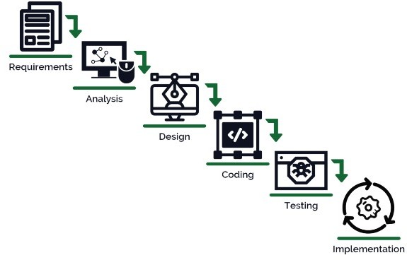

# System Requirements

1. ***Hardware Requirement***

## Laptop or PC

* + - I3 processor system or higher
    - 4 GB RAM or higher
    - 100 GB ROM or higher

# Software Requirement

## Laptop or PC

* + - Windows 7 or higher
    - XAMP or WAMP Server
    - Python
    - Text Editor (Notepad++ or Sublime Text)

# Limitation/Disadvantages

* This system can be affected due to bad network.
* Incorrect inputs will generate unfavourable results.

# Application

* Along with helping users identify the logo, this app also helps brands combat logo piracy.

# Reference

* en.wikipedia.org
* https://ieeexplore.ieee.org/document/9440236/
* https://ieeexplore.ieee.org/document/8986207/
* https://ieeexplore.ieee.org/document/9391842/
* https://ieeexplore.ieee.org/document/8293825