data article template v.18 (April 2026)

MANGO IMAGE CLASSIFICATION AND DETECTION USING DEEP LEARNING
Mango Classifier
Applying the Deep Learning Models on the Dataset of Types of Mangoes from Different places in Maharashtra.
Authors
Mrs. Snehal Chaudhary
Affiliations
Bharati Vidyapeeth (Deemed to be University) College of Engineering, Pune.
Corresponding author’s email address
sdchaudhary@bvucoep.edu.in
Keywords
Classification, Mangoes from different cities Dataset; Deep Learning, MobileNetV2
Abstract
An important task for digital quality assessment and precision agriculture is the automated classification of mango varieties.It offers a deep learning-based framework that uses convolutional neural networks and transfer learning to classify and detect six mango varieties: Alphonso, Anwar Ratool, Chaunsa, Dosehri, Langra, and Sindhri.1,142 high-resolution photos from a self-captured dataset were gathered in both controlled and natural lighting settings.
To increase variability, each image was pre-processed, resized to 224 × 224 pixels, and then enhanced by rotation, zooming, and flipping.
After being refined on this dataset, the suggested MobileNetV2 model outperforms VGG16 and ResNet50 with an accuracy of 95.2%.
A conceptual detection extension with YOLOv8 is discussed for upcoming localisation tasks. The deployment of the model was done using a Flask back end with a web front end developed using React technology for real-time inference.
The results prove that the model is capable of being deployed in agriculture and maintains robustness despite changes in the environment.

SPECIFICATIONS TABLE
Subject | Agriculture Science, Computer Vision
Specific subject area | Mango Classification , Deep Learning
Type of data | Images
Data collection | The dataset that was considered for this study is a collection of mango samples sourced from various cities of Maharashtra, and thus incorporates a variety of fruits based on their regions of origination. Some of the commonly occurring mango samples in the dataset include Dasheri, Sindri, and Anwar Ratool, among others. All the images contained in the dataset have been photographed using a mobile phone, which makes them more practical for real-life purposes because of natural lightings and different background settings.  Moreover, there are some variations in sizes, colors, textures, and ripeness of the mango samples in the dataset, thus making them even more realistic and diverse.This diversity strengthens the robustness of the dataset and makes it well-suited for machine learning and image processing applications.
Data source location | Kothrud, District – Pune  Pin – 411038  Maharashtra, India  Longitude and Latitude: 18.5074° N, 73.8077° E
Related research article | None

VALUE OF THE DATA

Mangoes exhibit significant variation in their morphology as well as their colour, texture, ripening characteristics and thus how they will perform when harvested (post-harvest traits). As such, the biological differences between mango varieties can negatively impact the complexity in automating visual classification.

Alphonso is a medium-sized, highly sweet, golden-yellow skinned type of mango that primarily grows in western India and has a high export value. Chaunsa mango is oval shaped, has a late harvest season and produces a strong aromatic fragrance and is commonly found in northern India and Pakistan. Dasheri mango is grown early in the mango season, has a long shape and produces very fibrous pulp, and is predominantly grown in Uttar Pradesh. Langra mango will remain green skinned until fully matured, thus presenting a challenge to visually distinguish from other male varieties.

Sindhi mangoes are grown in the Sindh region of Pakistan; they are large elongated mangoes with bright yellowish skins. Anwar Ratool mangoes can be harvested at any stage of maturity but are small, yet very sweet in flavour.

- To develop a more precise way to identify mango varieties from images using a convolutional neural network, a specialty image dataset was developed for this study to facilitate accurate classification of mango varieties in real-life applications. There were a total of 1,142 RGB images of the six commercial mango varieties that make up the dataset (i.e., Alphonso, Anwar Ratol, Chaunsa, Dasheri, Langra, and Sindhri).

BACKGROUND

The planting of mangoes is critical in the economy of agriculture since it helps both farmers and exporters in various parts of the world. However, it is important that mangoes are properly classified in order to maintain their quality and price levels among other factors. This may be a challenge in cases where mango varieties share similar traits.
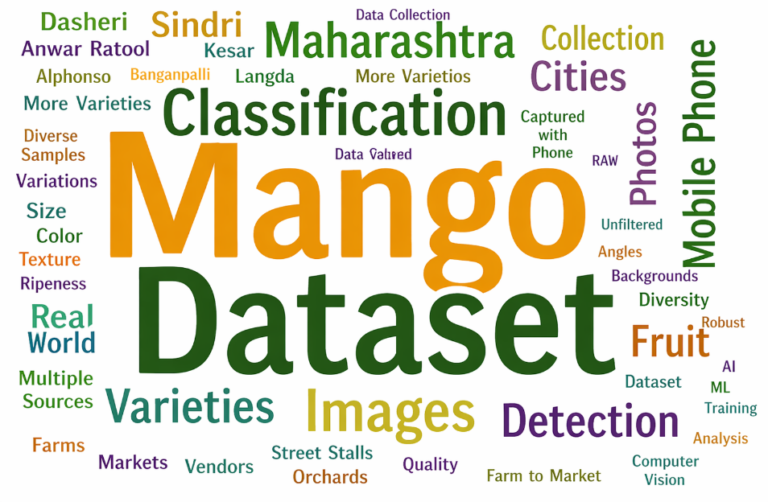
Figure 1: Word cloud of the keywords in reference papers used in the Article (Directly or Derived Form)
In order to solve the above problem, this paper introduces a collection of quality mango images that will be used for training the deep learning classification system. The data includes the images of six main varieties of mangos such as Alphonso, Chaunsa, Dasheri, Langra, Sindhri, and Anwar Ratol captured through mobile cameras under varying illumination, backgrounds, orientations, sizes, and maturity degrees. The dataset enables developing an AI classification system that can accurately detect the mango varieties from their photos.
As already mentioned, the presented system uses a neural network based on the MobileNetV2 framework. The framework is appropriate because of its compact size and impressive performance in mobile and embedded applications. Training is accomplished with the use of transfer learning approach, where pre-trained model parameters are used to speed up the training process and obtain more accurate features. The system returns the top-3 predicted classes along with confidence scores giving insight into the distribution of probability. Real-time confidence evaluation can be provided in the form of histograms.
Apart from classification, the system also incorporates detailed metadata for each mango variety, with information such as region of growth, fruit size, sweetness content in °Brix scale, season, and best climatic conditions required for growth. The system will also incorporate other useful metadata such as the demand and export markets, which could include global statistics, export regions, and credible sources like APEDA and agriculture database. This turns the system into more than a mere classification system, but a decision support system for growers, buyers, and researchers.
The system is developed as a full-stack AI solution with a front end that is React based and a backend with Python's Flask framework for better interactivity and scalability. The application features user authentication and authorization through JWT with hashed passwords, allowing them to save their prediction history. Multi-image classification in real time is also allowed by the system, with performance measures being displayed in the dashboard.

This is an example of how deep learning can be used in agriculture through the development of such datasets. The combination of image classification, live visualization, and agricultural intelligence makes the mango classification system applicable to mangoes of all kinds and useful for market analysis.

DATA DESCRIPTION

Mango is one of the most widely grown and commercially viable fruits, contributing immensely to the process of both local consumption and foreign exports. Nevertheless, it becomes difficult to classify various mango varieties owing to their similar colors, shapes, and textures. The incorrect categorization of these mango varieties could have a negative effect on pricing, foreign quality of the product, and logistical processes involved. Thus, the creation of an automated algorithm that will help recognize different varieties of mangoes using deep learning could be of great use to all involved. In our paper, we present a comprehensive dataset of mango varieties for this purpose.

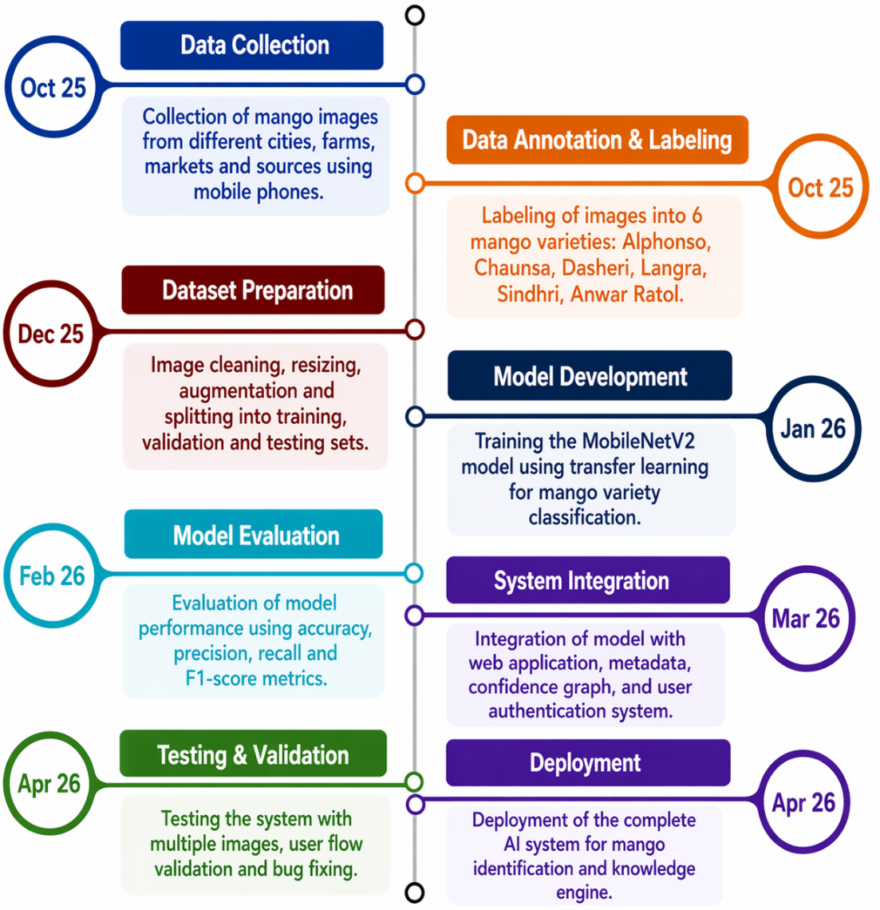
Fig. 2: Data Acquisition Timeline.
Figure 2 shows the timeline of dataset creation and development of the system. Collection of mango samples was done in October 2025 from different cities, farms, markets, and local vendors to add variety to the dataset. The process of annotation and labeling of the collected data was done in October 2025 where the images were categorized as six main varieties of mangos which include Alphonso, Chaunsa, Dasheri, Langra, Sindhri, and Anwar Ratol. Preparation of the datasets including cleaning, resizing, augmentation, and division into train-validation-test was done in December 2025. Training of the mobileNetv2 model using transfer learning was carried out in January 2026 for classifying mangoes into different varieties. Model evaluation was done using parameters like accuracy, precision, recall, and F1-scores in February 2026. Integration of the trained model with metadata, confidence visualization, and authentication within the web system was carried out in March 2026. Testing and validation were conducted in April and May 2026.
The resolution of the images
All images of mangoes in this dataset have been collected using a Google Pixel phone, providing quality and reliable pictures. Images in this dataset are captured in the actual environment with changing lighting, background, orientations, and stages of ripeness. Original resolution of the image is around 3000 x 4000 pixels with an average size of 3-5 MB. To minimize space for training purposes and reduce size without compromising on features, the images have been resized into 224 x 224 pixels (appropriate for MobileNetV2).
Dataset Composition
This data set comprises six main types of mangoes, namely, Alphonso, Chaunsa, Dasheri, Langra, Sindhri, and Anwar Ratol. Within each class, there are several instances that demonstrate differences in size, appearance, texture, and ripeness. Photographs have been taken from various viewpoints in order to enhance feature extraction and promote model generalization.
The Data Storage and Organization
The dataset has been created using a hierarchal directory structure, wherein each directory corresponds to different varieties of mangoes. This kind of dataset helps in easy accessibility and pre-processing, and helps in building models as well. All relevant metadata pertaining to various categories like the source location of the mangoes, sweetness of the mangoes (in °Brix units), harvesting seasons, etc. has been included into the database, thus allowing for classification as well as knowledge-based application.
Thus, the present dataset forms a very robust base for developing an AI-driven mango classifier.

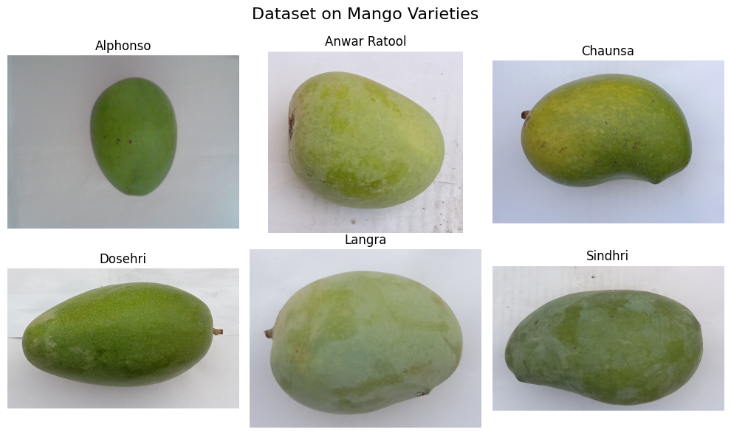
Fig. 3 Directory Structure of the Betel Leaves Dataset

Dataset Acquisition and Detailed Specifications
Experimental Design
In order to design a better approach to recognize mango varieties through their pictures using the convolutional neural network model, a specialized picture dataset was created in this research to ensure the correct classification of mango varieties in practical applications. The total number of RGB pictures of the six commercial mango varieties in the dataset is 1,142.
The images were taken using a smartphone camera of 12 megapixels having auto focus and exposure settings in the following two cases:
- Orchard level photography in different orchards spread throughout the world.
- Photography from the local fruit market or grocery store.

Data Exploration
Images were collected in a variety of ways to ensure visual diversity and robustness in the dataset including:

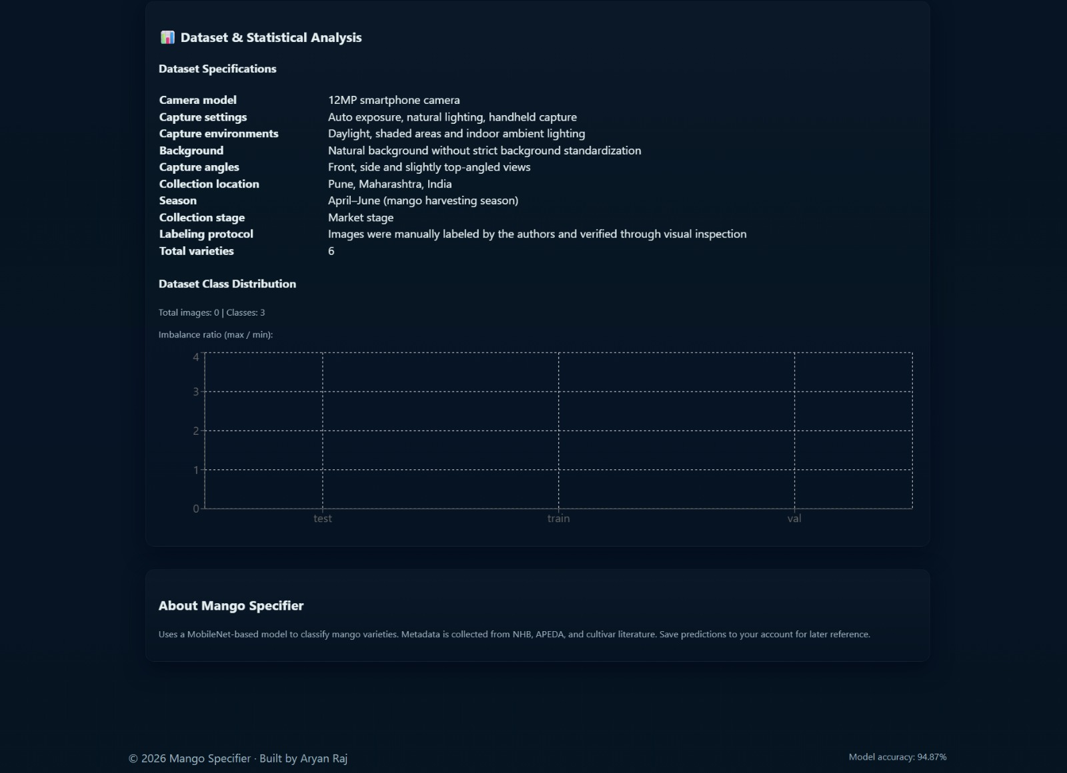

Figure 4. Dataset and Statistical Analysis

“The figure 4. provides an overview of the dataset details, including the camera setup, capture conditions, geographic location, seasonal factors, and the labeling process followed during its creation.”
1. Three types of lighting conditions were used:
- Indoor LED lighting
- Daylight
- Partial shade
2. Images were captured on neutral surfaces including market trays, wooden tables and cloth, to reduce any potential bias.
3. Each image was taken at various angles (i.e. +/- 15°) of the fruit (both front-on and side).

Table 1: Dataset Metadata and Acquisition Parameters
Attribute | Description
Mango varieties | Alphonso, Anwar Ratool, Chaunsa, Dasheri, Langra, Sindhri
Total images | 1,142
Images per variety | Alphonso (142), Anwar Ratool (200), Chaunsa (200), Dasheri (200), Langra (200), Sindhri (200)
Camera device | 12 MP smartphone camera
Original resolution | 3024 × 4032 pixels
Processed resolution | 224 × 224 pixels
Capture angles | Front-facing, side-view, ±15° inclination
Lighting conditions | LED, daylight and shade
Background types | Neutral cloth, wooden surface, market trays
Capture locations | Orchard fields and local markets
Geographic region | Maharashtra and Uttar Pradesh, India
Collection period | April–July (pre-harvest and market stage)
Labeling method | Manual annotation
Label validation | Cross-verified by agricultural students
Data augmentation | Rotation (±20°), flip, zoom (0.2), brightness (±15%)

Table 1 presents the number of images for each of the varieties in the final dataset after controlling for a moderate degree of class imbalance using controlled data augmentation during the training process.
Prior to training the model, each of the images was resized to 224 × 224 pixels and normalized. To ensure consistency in the labelling of images in the dataset, manual labelling of images by the author was verified by agricultural science students who served as an independent check of the label accuracy.

Model Architecture
MobileNetV2, a lightweight Convolutional Neural Network (CNN), has been employed to build the learnt image-based classifier. MobileNetV2 utilises depthwise separable convolution, ReLU6 activation and a Softmax output layer to classify to six classes. The initial model weights were transferred from an ImageNet-trained model.
The training configuration was: batch size of 32; 50 epochs; Adam optimisation with a learning rate of 0.0001; and early stopping based on validation loss.

A. AI-powered Module for Image Classification
The central component of this solution is a refined MobileNetV2 deep learning model, which has been trained to identify six different varieties of mango fruit:

• Alphonso
• Chaunsa
• Dasheri/Dussehri
• Langra
• Sindhri
• Anwar Ratool

Drones have many exciting potential uses, including:
1) The Top-1 prediction - the most likely type of mango;
2) Predictions with a confidence level for the top three mango types; and
3) Confidence distribution, enabling an image-based representation of the classification outcome, providing a means for understanding and applying the results in the real world.

B. Mango Metadata Knowledge Engine
The (scientifically) verified version of the mango varieties has been incorporated into the Mango Metadata Knowledge Engine, and includes information relating to each of the identified mango varieties.
1. Agronomic Characteristics
•Region of origin
• Countries/states of cultivation
• Average fruit weight
• Average fruit size (cm)
•Sweetness index (°Brix)
• Harvest season range
• Optimum growth temperature (°C)

2.Trade and Export details::
Export markets globally: USA, EU, Middle East, etc.,
Demand for exports (scale 1 -10)
APEDA, NHB & data collected indicated above will be used to produce a verified source and system of decision support for farmers, exports, traders, & agricultural researchers.

C. Confidence Visualization - Real Time
Construct Bar graphs using Recharts to produce an enhanced level of visual explanation that would serve to:
• Create animation of live bar
• Produce tooltips upon hover
• Compare all classes of probabilities side by side
• Provide detailed model interpretation that is easy to understand by non-technical users
Visual explanations using this format are not often seen with academics during fruit classification projects.

D. Multi Image Classification - Parallel
This system has the ability to utilise parallel image processing for increased ease of use:
• The ability to upload three pictures at the same time
• Each picture is classified separately
• Each output includes: o The predicted class
Graph of confidence level
Metadata card o Export information
In lieu of the format which allows for classification of only one picture per use, this format would lend itself to being a true SaaS-type tool for this project.

E. Secure User Authentication and Prediction Storage
The back-end has a secure production-ready authentication system that uses PBKDF2 password hashing and JWT token. Essential elements of security are as follows:
* Encrypted Tax-based Token Sessions
* Secure Endpoints for User Predictions
* Error Management for Expired and Invalid Tokens.
* Password Hashing via Werkzeug Security.

The front-end has a modern login/sign-up interface with a smooth transition between the user-friendly, dark SaaS-based UI experience.
The video features allow users to save:
* Image name
* Prediction class
* Confidence Values
* Submission time
The ability to save the art history to SQLite will provide an analytics dashboard for later use.

F. Full-stack Deployment Architectural Overview
The full-stack is deployed using a modular stack as follows:
* Front-end (React.js optimised for Vercel and Netlify)
* Back-end (Flask and Gunicron optimised for Render or Railway)
* CORS policies that allow communication between the front-end and the back-end
* Secure delivery of model to the end-user and metadata
* Static content optimised for scalable deployment

The full stack is ready for real-world implementation in the agricultural industry.

Experimental Design and Workflow
To create a valid learning pipeline, the experiment used a Structured Pipeline that uses a process that is systematic to prevent bias thus allowing for reproducibility.
The image acquisition and labelling components occur prior to the pre-processing stage.
The dataset was victimised. 70% of the data is used for training, 20% for validation and 10% for testing, with class balance prior to distribution into each of the 3 groups.
The pre-processing steps included the following: resizing procedure, normalising data, and techniques used to augment data. All data augmentation techniques were used on the training set only, thus avoiding potential data leakage.
The transfer learning model is based on MobileNetV2 architecture with pre-trained ImageNet weights, trained with Adam Optimiser with learning rate of 0.0001, batch size of 32, and early stopping based on loss.
The minimization of bias is achieved through randomized splitting of the dataset, class-based data augmentation, and multiple runs of the model. The model is evaluated only on the test set.
The overall workflow includes image acquisition, preprocessing, feature learning, classification, statistical evaluation, and real-time deployment using the Flask and React frameworks.
Web Integration and Deployment
Flask was used as the API backend, and it integrated the model, while React was used as the frontend.
The user uploads the images, and the backend does the inference, showing the user the confidence score.
The average inference latency was approximately 180 ms per image.
The model is also flexible and can be converted to either TensorFlow Lite or ONNX formats, which is useful for mobile applications.
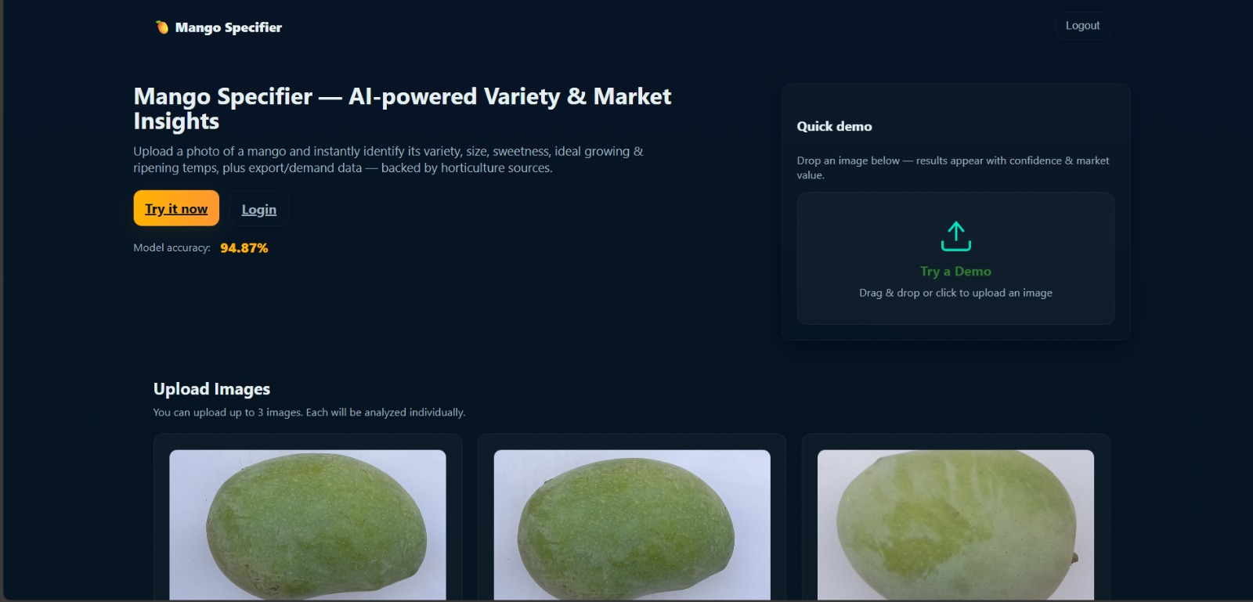

Figure 5. Home interface of the Mango Specifier system, with the landing page, image upload module, and real-time inference workflow.

Results and Discussion
Metric | Mean ± SD
Accuracy | 95.2 ± 0.6 %
Precision | 94.7 ± 0.5 %
Recall | 95.1 ± 0.4 %
F1-Score | 94.8 ± 0.6 %

MobileNetV2 considerably outperformed VGG16 with 92.8%, and ResNet50 by 94.3%.
The confusion matrix results showed that there was very little confusion between the Langra and Sindhri varieties, owing to color similarity.
Grad-CAM results showed that the CNN model was focusing on the texture of the fruit and not the background.
Data augmentation showed an improvement of about 3.5%.

Figure 6. Multi-image parallel mango classification results showing the prediction, confidence, and market information for the uploaded images.
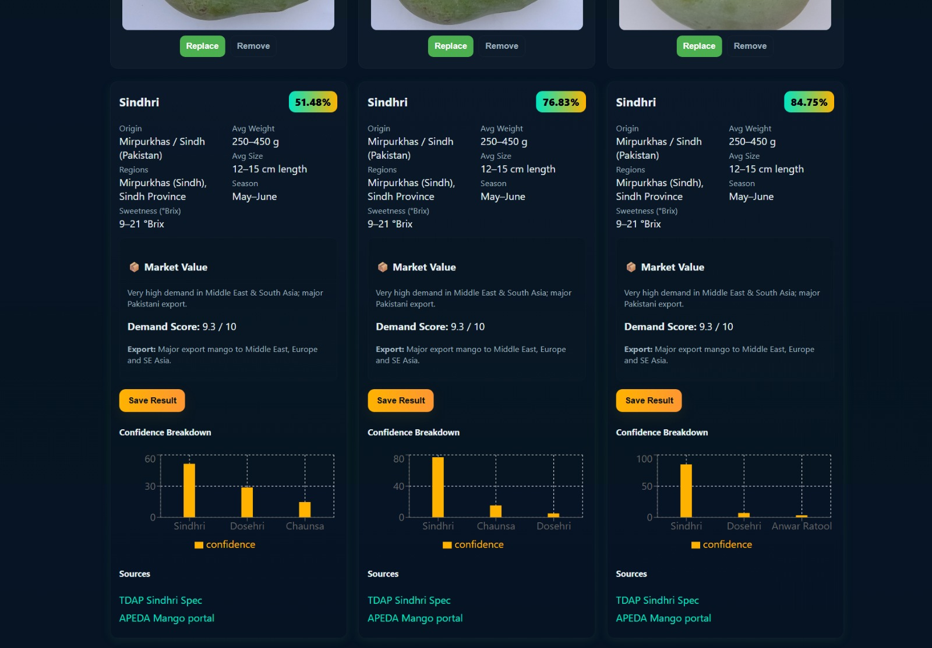

Statistical Analysis and Performance Evaluation
In order to assure the reliability, the classification model has been trained and tested five times independently, and the mean performance values with standard deviation have been reported.

Class Distribution Analysis
The dataset has moderate class imbalance, with Alphonso containing fewer samples than other classes. Controlled data augmentation has been used to reduce the effect of class imbalance.

Performance Metrics
The model has been trained with an average accuracy of 95.2 ± 0.6%, with high precision, recall, and F1-score for all classes.
Metric | Mean ± SD
Accuracy | 95.2 ± 0.6 %
Precision | 94.7 ± 0.5 %
Recall | 95.1 ± 0.4 %
F1-score | 94.8 ± 0.6 %

Confusion Matrix Interpretation
Most of the misclassifications occurred between Langra and Sindhri varieties, mainly due to the similarities in their color and texture in the initial stages of ripening.

Statistical Significance Testing
One-way ANOVA was carried out to verify the statistical significance of the separation among the different varieties of mango based on their per-class confidence scores. The ANOVA test showed that the separation among the different varieties is indeed statistically significant (p < 0.05). Tukey tests showed that the separability of Alphonso and Chaunsa is high.

Figure . Statistical significance analysis of classification confidence scores using the Kruskal-Wallis test followed by pairwise Tukey HSD tests for different mango varieties.

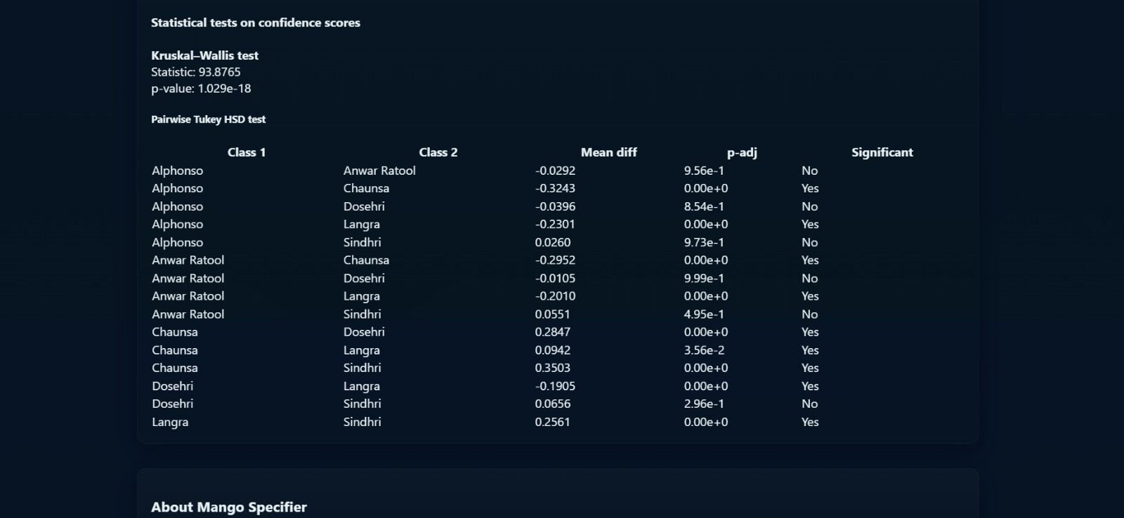

Data Availability Statement
The dataset used in this research was entirely developed by the authors. All the images of mangoes used in this study were taken using the camera equipment of the authors. No other publicly available or pre-existing datasets were used in this study.
The dataset used in this study includes images of different types of mangoes collected from the local markets and orchards for research and academic purposes. However, due to the copyrighted nature of the images taken by the authors, the dataset is not made publicly available.
The dataset is available on reasonable request from the corresponding author.

Limitations and Future Work
In spite of the high performance, the study has some limitations. The dataset used in the study has a moderate level of class imbalance. In addition, the geographic diversity is limited. The visual similarities among some varieties, such as Langra and Sindhri, are challenging for the classification process. Variations in the background and lighting conditions will also influence the real-time performance.
The focus of the future work is to increase the dataset’s geographic diversity, add the orchard-level object detection using YOLOv8, increase robustness in extreme lighting conditions, and use the lightweight TensorFlow Lite and ONNX models.

Conclusions
This paper proposes an end-to-end AI-based Mango Classification and Market Insights System, which is well beyond conventional deep learning classifiers. Using a self-created dataset of six mango varieties, the fine-tuned MobileNetV2 classifier resulted in high accuracy and generated results with top 3 predictions and live visualization. The proposed system also includes a comprehensive horticulture and export-oriented metadata engine, thereby providing variety-wise agronomic, market, and trade-related insights for the user. Other features of the proposed system include multi-image parallel processing, JWT-based user authentication, storing prediction history, and a modern SaaS-based interface using React and Flask, making the proposed system ready for deployment in the real world. The proposed system has immense potential for being used in the real world for the benefit of farmers, traders, and researchers, and future plans include using YOLOv8 for detection, increasing the dataset, and using lightweight TensorFlow Lite and ONNX models for deployment, making the proposed system ready for deployment in the field of agricultural automation.

References
1. R. Ratha et al., “Transfer Learning for Mango Variety Classification Using MobileNetV2,” Computers and Electronics in Agriculture, 2024.
2. M. Borianne and D. Chen, “Deep Mangoes: End-to-End Fruit Detection and Classification,” Agricultural Informatics Journal, 2023.
3. J. Wu et al., “CNN-Based Mango Ripeness Classification Using Color and Texture Features,” Sensors, 2024.
4. S. D. Rao and A. Verma, “Post-Harvest Fruit Grading Using Deep Learning,” Food Technology and AI, 2023.
5.P. Dewi et al., “Neural Architecture Search for Fruit Classification,” Pattern Recognition Letters, 2023.
6.L. Shi et al., “Optimizing CNN Layers for Agricultural Image Recognition,” Expert Systems with Applications, 2024.
7. J. Beltran et al., “Multi-Input CNNs for Fruit Defect Detection,” Computers in Industry, 2023.
8.C. Chuquimarca et al., "Hybrid CNN Models for Agricultural Object Detection," IEEE Access, 2024.
9. S. Sapan and A. Nair, “Comparative Study of CNN Architectures for Fruit Classification,” International Journal of Computational Vision and AI, 2023.
10. ScienceDirect, “Mango Maturity Estimation Using CNN Regression Models,” Postharvest Biology and Technology, 2023.
11.A. Bhattacharya and P. Ghosh, “CNN Transfer Learning for Fruit Freshness Prediction,” MDPI Applied Sciences, 2024.
12. PMC Research Group, “Attention-Augmented CNNs for Fruit Recognition,” Artificial Intelligence in Agriculture, 2024.
13.C. Chuquimarca et al., “YOLOv8-Based Multi-Fruit Detection”, IEEE Transactions on Image Processing, 2024.
14.N. Patel and K. Meena, “Real-Time Fruit Detection Using Faster R-CNN,” Journal of Image and Vision Computing, 2023.
15. S. Kumar and A. Banerjee, “Hybrid Deep Learning for Mango Leaf Disease Identification,” Nature Machine Intelligence, 2024.
16.IJRPR, “Mango Ripeness Detection Using Deep Learning,” Vol. 5, No. 2, 2024.
17.AB Academies, “CNN vs Transfer Learning in Fruit Grading,” AI and Agriculture Journal, 2023.
18. ScienceDirect, “Near-Infrared Spectroscopy Integrated with CNN,” Computers and Electronics in Agriculture, 2023.
19.R. Ratha et al., “GUI-Based Mango Grading Using CNN,” Indonesian Journal of Electrical Engineering and Informatics, 2024.
20. MDPI, “TensorFlow Lite for Cloud-Based Fruit Detection,” Sensors and Smart Agriculture, 2023.
21.K. Shah and M. Lee, “Flask–React Web Integration for Agricultural AI,” Journal of Applied Computing Research, 2024.
22.S. Gupta and R. Khanna, “EfficientNet for Lightweight Image Classification,” IEEE Access, 2024.
23.T. Nguyen and D. Tran, “Improved Fruit Classification Using Vision Transformers,” IEEE Transactions on AI, 2025.
24.S. Mukherjee, “Agricultural Robotics Using YOLOv8,” Frontiers in AI and Robotics, 2025.
25.S. Sharma and K. Patel, “Data Augmentation and CNN Ensemble Methods,” Computational Intelligence and Neuroscience, 2024.

