**INTRADAY TELEGRAM BOT**

**A PROJECT REPORT**

***Submitted by***

ARYAN MISHRA SANJAY SINGH OM CHAUHAN

**Bachelor of Technology IN**

**Computer Engineering and Application**



**GLA University, Mathura**

APRIL 2022

#### BONAFIDE CERTIFICATE

Certified that this project report **“INTRADAY TELEGRAM BOT”** is the bonafide work of **ARYAN MISHRA SANJAY SINGH OM CHAUHAN** who carried out the project work under my/our supervision.

|  |  |
| --- | --- |
| <<Signature of the HoD>>  **SIGNATURE**    <<Name of the Head of the Department>>    **HEAD OF THE DEPARTMENT**    <<Department>> | <<Signature of the Supervisor>>  **SIGNATURE**    <<Name>>  **SUPERVISOR**  <<Academic Designation>>    <<Department>> |

Submitted for the project viva-voce examination held on_27th April 2023.

1

# TABLE OF CONTENTS

ABSTRACT

ABBREVIATIONS

SYMBOLS

INTRODUCTION

DESIGN FLOW/PROCESS

SETTING UP AN INTRADAY TELEGRAM BOT

USING AN INTRADAY TELEGRAM BOT

ADVANCED FEATURES AND TECHNIQUES.

BEST PRACTICE AND TIPS

CONCLUSION

REFERENCES

2

## ABSTRACT

An intraday Telegram bot is a software program designed to provide real-time updates and analysis for trading activity within a given market or financial instrument. This bot is designed to monitor changes in prices, volume, and other key indicators throughout the trading day, and can provide users with alerts and recommendations based on pre-programmed rules and algorithms. The bot can be accessed through the popular messaging app Telegram, providing users with a convenient and accessible way to stay informed and make informed trading decisions in real-time. Overall, an intraday Telegram bot offers a powerful tool for traders seeking to stay ahead of market trends and maximize their trading perfor

3

### Introduction:

Intraday trading in the stock market can be a fast-paced and dynamic environment where timing is everything. To stay on top of the latest developments, traders often rely on real-time data and analysis to make informed decisions. One way to access this information is through an intraday Telegram bot API, which can provide traders with up-to-the-minute updates on stock prices, trading volumes, and other key metrics.

#### Features:

**The features of Intraday telegram bot.**

* Real-time market updates: The bot can scrape data from websites in real-time and provide users with up-to-the-minute updates on stock prices, trading volumes, and other key metrics. This enables traders to make informed decisions based on the most recent information.
* Customized alerts and notifications: The bot can be programmed to send customized alerts and notifications based on specific criteria. For example, it can notify traders when a stock's price reaches a certain level or when trading volumes exceed a certain threshold.
* Historical data analysis: The bot can also scrape historical data from websites and provide users with insights into long-term market trends. This can help traders make more informed decisions about when to buy or sell a particular stock.
* Technical analysis tools: The bot can be programmed to perform technical analysis on market data, using a range of indicators and algorithms. This can help traders identify patterns and trends in the market that may not be immediately apparent.
* User-friendly interface: The bot can be integrated with Telegram, providing a user-friendly interface that is accessible from any device with an internet connection. This enables traders to stay informed about market activity, no matter where they are.

Overall, an intraday Telegram bot using web scraping represents a powerful tool for traders seeking to stay ahead of the curve in the stock market. By leveraging real-time data and analysis, traders can make smarter trading decisions and potentially increase their chances of success

4

### ABBREVIATIONS

· API: Application Programming Interface

· SMA: Simple Moving Average

· EMA: Exponential Moving Average

· RSI: Relative Strength Index

· MACD: Moving Average Convergence Divergence

· VWAP: Volume Weighted Average Price

· OHLC: Open, High, Low, Close (used to describe stock price data)

· ROI: Return on Investment

· EPS: Earnings Per Share

· P/E: Price to Earnings Ratio

NSE: NATIONAL STOCK EXCHANGE

**5**

### SYMBOL

1. NIFTY: NSE index
2. BANKNIFTY: NSE Banking index
3. RELIANCE: Reliance Industries Limited
4. TATAMOTORS: Tata Motors Limited
5. SBIN: State Bank of India
6. INFY: Infosys Limited
7. ICICIBANK: ICICI Bank Limited
8. AXISBANK: Axis Bank Limited
9. HDFCBANK: HDFC Bank Limited
10. TCS: Tata Consultancy Services Limited

**6**

**DESIGN FLOW/PROCESS**

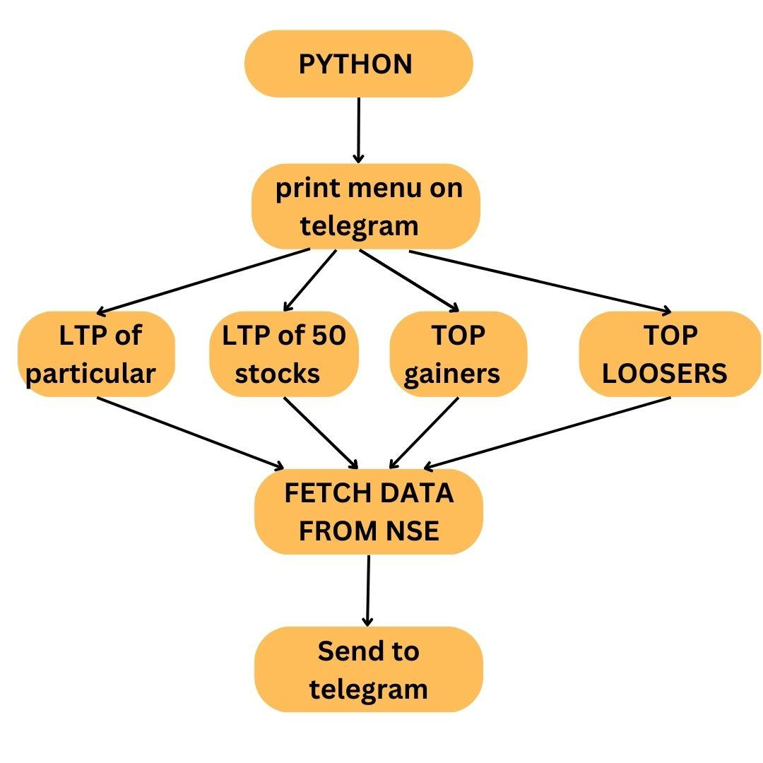

**7**

**8**

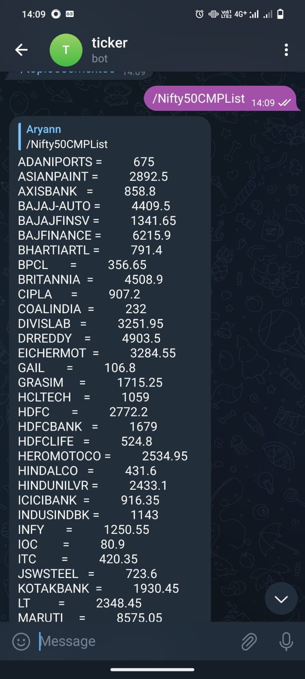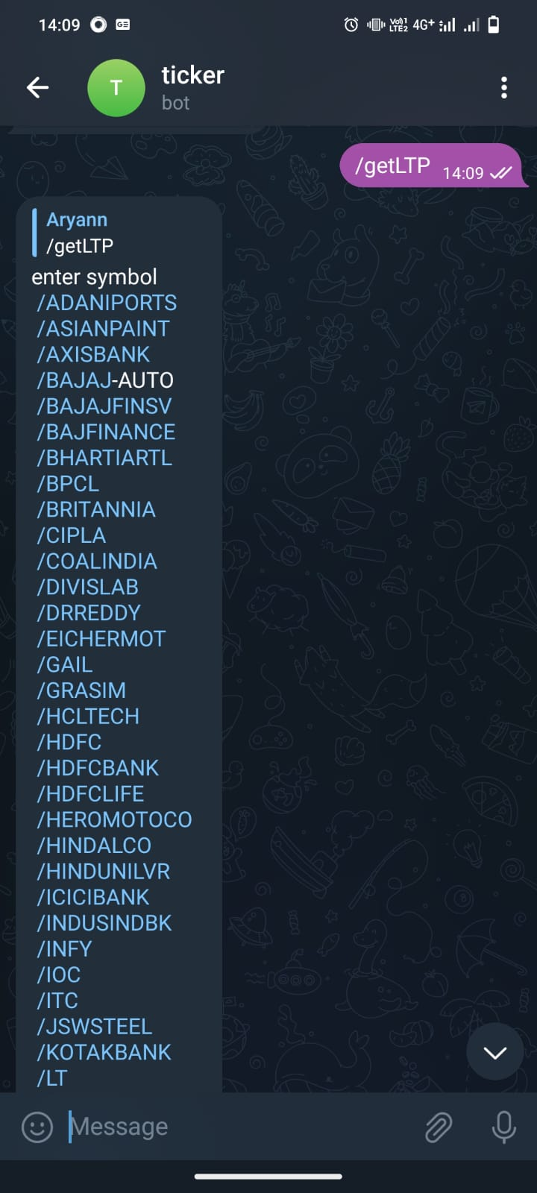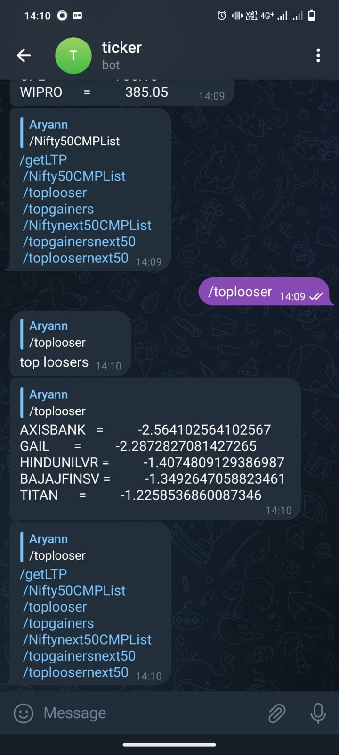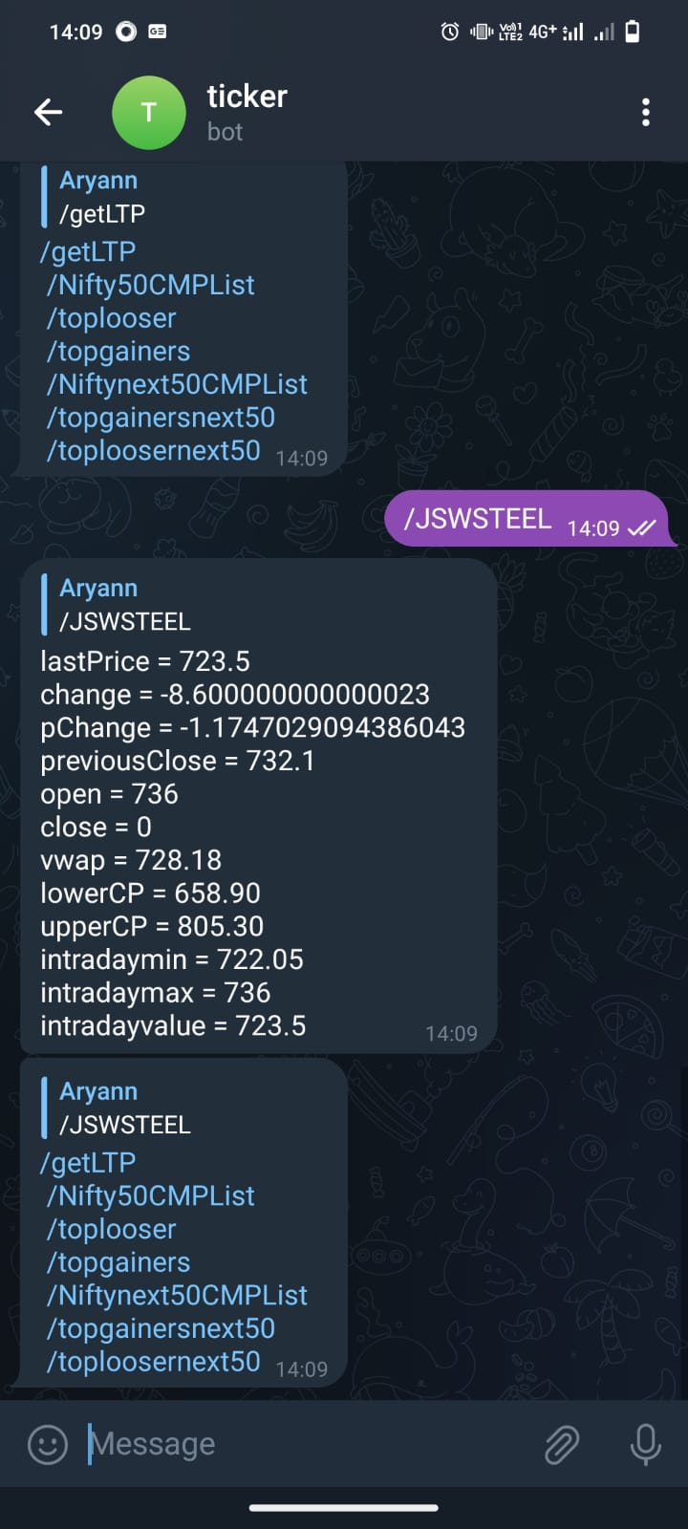

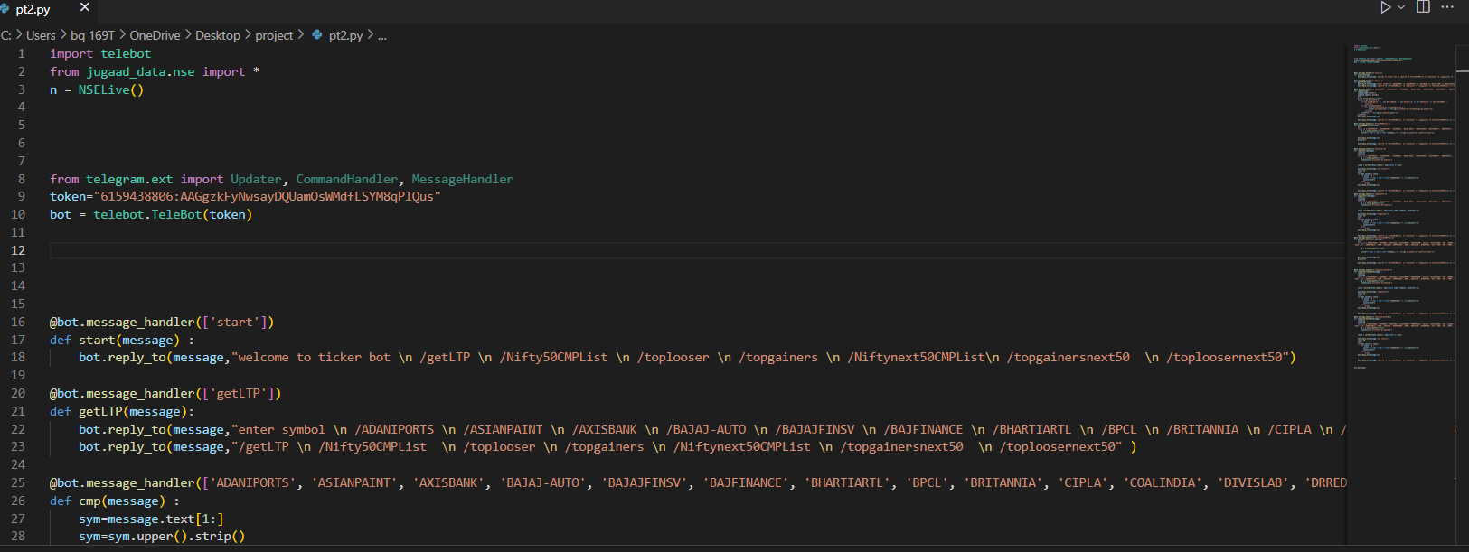

### 

#### Conclusion:

Taking into account all the mentioned details, we can make the conclusion that the Telegram Bot System is the inevitable part of the lifecycle of the modern Trading system. It automates numerous daily trades and enables smooth interactions of the users.

Developing the intraday system API is a great opportunity to create the distinct, efficient and fast trades. Implementation of Telegram Bot System project helps to give all kinds of data, provide coordination and user communication, implement policies, improve day-to-day trades, arrange the supply chain, manage stocks, and stock marketing services. This beneficial decision covers the needs of the traders, and simplifies their interactions. It has become the usual approach to manage the trades. Many traders have already experienced its advantages and continue developing new Telegram Bot System API project modules.

12

**REFRENCES**

* YouTube

# 

* GOOGLE

# FACULTY GUIDELINES

Ms. Ruchi Talwar

13