TRINETRA
Real-time anomaly detection for AWS temperature, pressure and humidity sensors
Use cases, method and results — SIH 2026, problem statement SIH26073 (IMD, Ministry of Earth Sciences). Team Secure OOPS, Team ID 126173.
Important: every number and chart in this document comes from the code in this project running on a simulated 57-station network with injected faults. It has not yet been tested on real IMD data.

1. What the system does
An Automatic Weather Station reports temperature, pressure and humidity every minute. When one of those readings is wrong (a damaged probe, a frozen logger, a power dip) the forecast models that use it are misled. But when a reading is unusual because the weather really is unusual, deleting it would be just as harmful. TRINETRA reads the stream, decides which of the two it is, and says why.
For every alert it gives:
- a plain-language reason a duty officer can read in ten seconds;
- the likely root cause (spike, level shift, drift, stuck value, noise burst, communication error, power glitch);
- a confidence and a severity;
- the share of evidence behind the decision;
- a corrected value estimated from neighbours (or the station's own history if it is isolated);
- a suggested maintenance action.

2. How it works
The engine is layered. Each layer looks only at the past, so the same code gives identical answers on stored data and on a live minute-by-minute stream (checked: 11 of 11 alerts identical).
Layer | What it checks | Why it is needed
1. Quick check | Range, jump size, stuck value, missing or sentinel values | Cheap, catches gross faults immediately (WMO quality-control practice)
2. Physics | Temperature and humidity imply a dew point that cannot jump | Catches faults that stay inside the normal range
3. Temporal AI | IsolationForest and an autoencoder on the station's own learned daily pattern | Catches faults that look strange for this station
4. Neighbours | Compares with up to 6 stations within 100 km, in anomaly space | Separates real weather (neighbours agree) from a fault (only this station is off)
5. Learned fusion | Gradient-boosted classifier combines all evidence, then an alert state machine | One calibrated fault probability; fewer false alarms

Real weather is recognised when the neighbours show the same departure: thunderstorm outflow, cold front, fog, heatwave and cold spell. These are reported as events, not faults.

3. How to run it
Install: pip install -r requirements.txt
Quick start (55 °C example): python examples/quickstart.py
Live stream demo: python examples/stream_demo.py
Your own CSV: python examples/custom_csv.py
Full evaluation: python -m trinetra evaluate
Rebuild the website data: python -m trinetra export
Input files: a CSV of 1-minute readings with columns station, time, T (°C), P (hPa), RH (%), and a station list with station, lat, lon, elevation.

4. Use cases
Each case below is a real output of the engine on a 2-hour window. The top chart shows the station (green) against what its neighbours expect (dashed grey). The bottom chart is the fault probability; the dotted line is the alert threshold (0.7).

Use case 1 — The 55 °C reading (the example in the problem statement)
A Delhi station suddenly reports about 57 °C while six stations within 56 km stay normal.
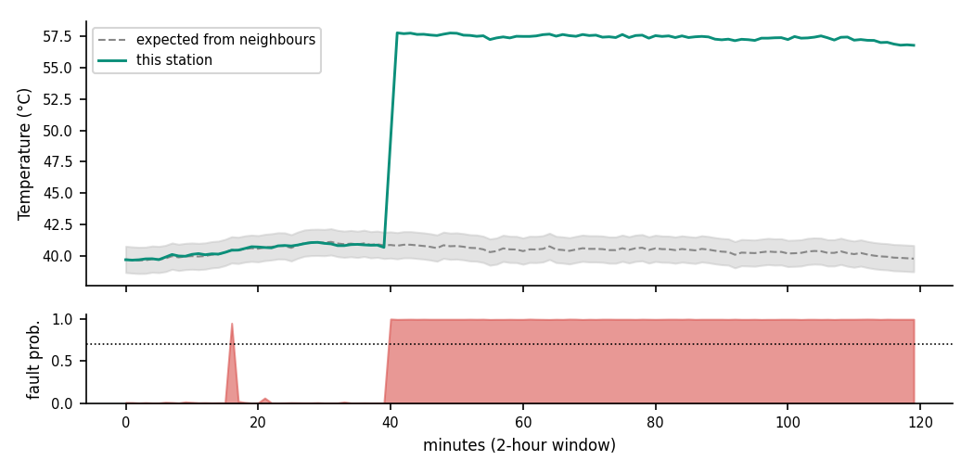
Station | AWS-DEL-014
Decision | Sensor fault — Sudden jump
Root cause | Sensor damage or a sudden calibration shift
Confidence | 99.0%
Severity | high
Raised at | 14:40 (fault began 14:40)
Explanation | Flagged: temperature jumped +17.3 °C within minutes and stayed there, while 6 nearby stations stayed normal.
Corrected value | T: 56.8 → 39.8
Suggested action | Replace or recalibrate the temperature probe within 48 hours

Use case 2 — A real heatwave must not be deleted
Delhi really is hotter than usual, and all six neighbours show the same rise. A threshold system would flag it; TRINETRA keeps it.
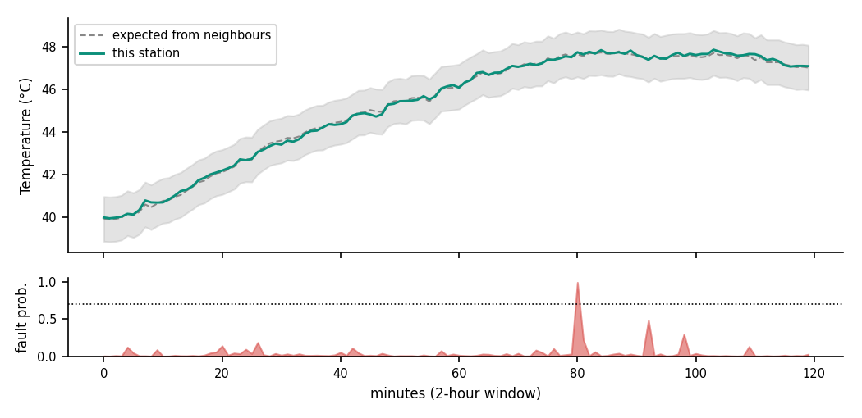
Station | AWS-DEL-014
Decision | Real weather — Heatwave
Confidence | 97.0%
Explanation | Not a fault: temperature is +6.0 °C from normal, and 6 of 6 nearby stations show the same departure. Real weather is kept, not deleted.

Use case 3 — A thunderstorm gust front
Temperature falls, pressure jumps and humidity rises together at Chennai, and the neighbours see it too. This is real weather that a plain outlier detector would wrongly remove.
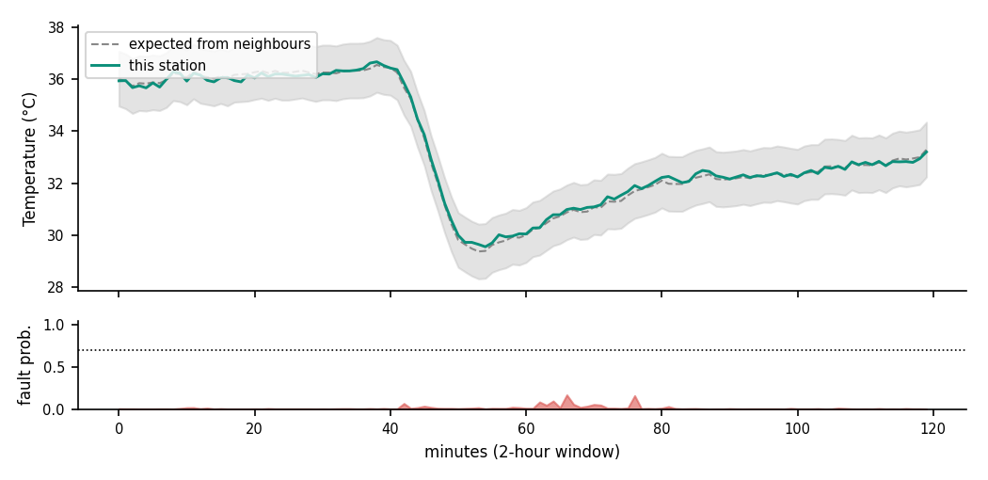
Station | AWS-CHN-021
Decision | Real weather — Thunderstorm outflow
Confidence | 97.0%
Explanation | Not a fault: temperature, pressure and humidity changed together, and 6 of 6 nearby stations saw the same change. Real weather is kept, not deleted.

Use case 4 — A frozen barometer
Pune pressure stops changing while the rest of the network moves. Every reading is inside the allowed range, so only a stuck-value check plus neighbours can see it.
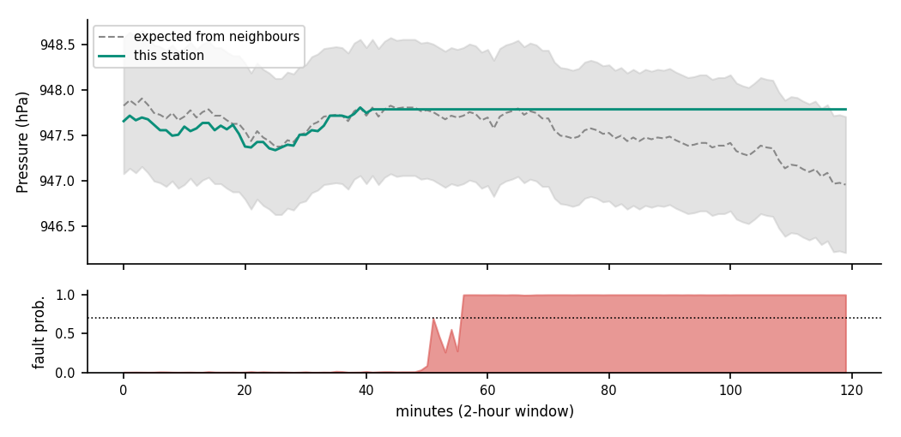
Station | AWS-PUN-003
Decision | Sensor fault — Stuck reading
Root cause | Frozen sensor or a logger that has hung
Confidence | 99.0%
Severity | high
Raised at | 14:59 (fault began 14:42)
Explanation | Flagged: pressure have not changed for 64 minutes while 6 nearby stations kept moving.
Corrected value | P: 947.79 → 947.0
Suggested action | Check the logger and wiring of the barometer, power-cycle and verify within 24 hours

Use case 5 — Slow calibration drift
Pune pressure slowly walks away from what its neighbours expect. No single reading is abnormal; the trend is.
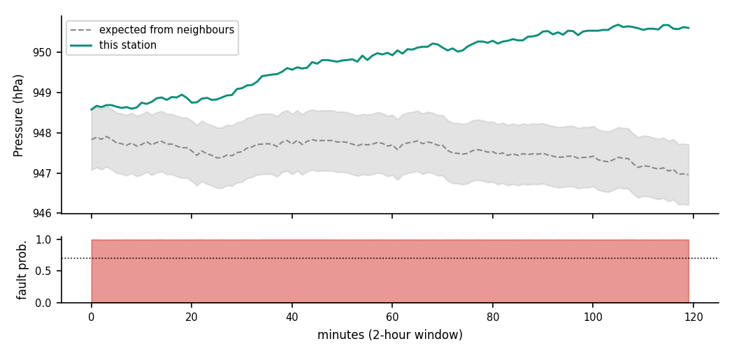
Station | AWS-PUN-003
Decision | Sensor fault — Slow drift
Root cause | Calibration drift or sensor ageing
Confidence | 99.0%
Severity | medium
Raised at | 13:51 (fault began 13:47)
Explanation | Flagged: pressure has crept +3.6 hPa away from the expected value over 133 minutes, while 6 nearby stations stayed normal.
Corrected value | P: 950.61 → 947.0
Suggested action | Recalibrate the barometer within 7 days

Use case 6 — Lost packets and sentinel values
Mumbai's logger sends missing or invalid values (for example 0 or −999). These are caught by the quick check and replaced by a neighbour estimate.
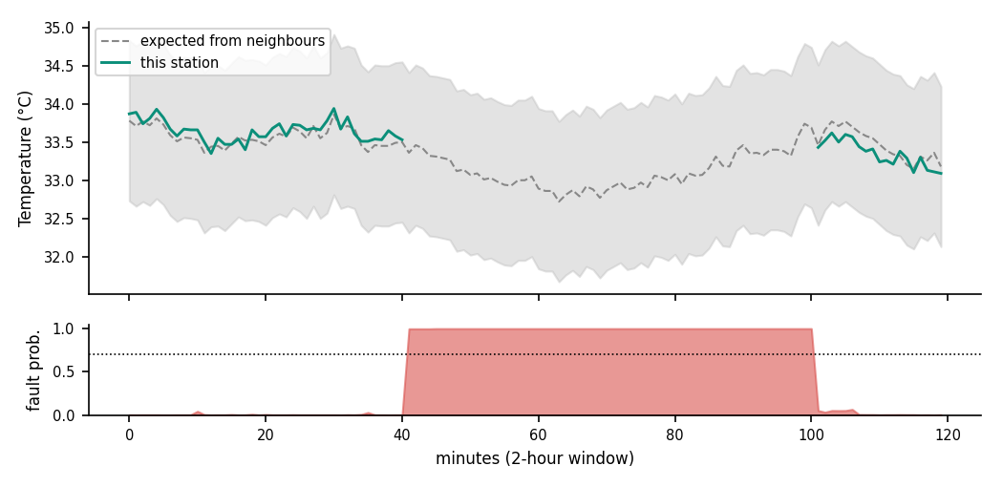
Station | AWS-MUM-007
Decision | Sensor fault — Communication error
Root cause | Communication, logger or power-supply failure
Confidence | 99.0%
Severity | medium
Raised at | 14:44 (fault began 14:41)
Explanation | Flagged: packets are missing or invalid for 60 minutes, so all three readings are unusable.
Corrected value | T: null → 33.7; P: 0 → 1010.2; RH: null → 52.7
Suggested action | Check the GPRS/modem link, logger and power supply within 24 hours

Use case 7 — A humidity sensor with a loose connection
Hyderabad humidity becomes erratic. The average is fine, the jitter is not.
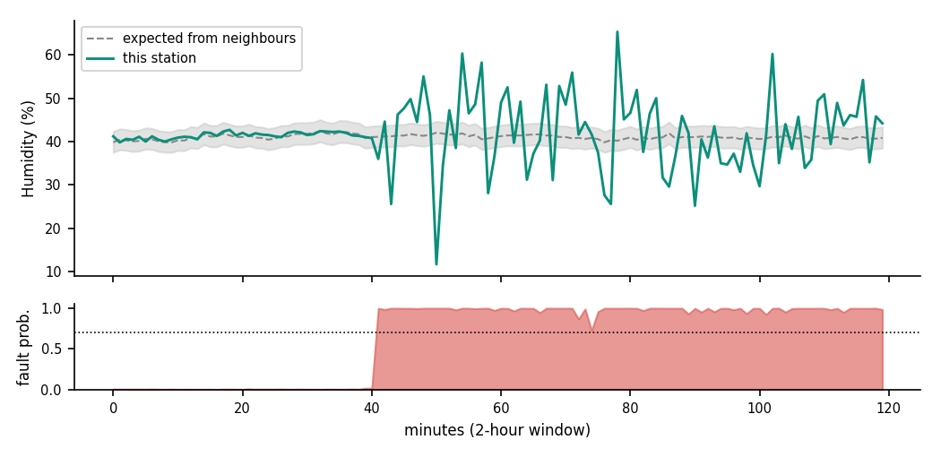
Station | AWS-HYD-019
Decision | Sensor fault — Noise burst
Root cause | Loose connection or moisture in the sensor
Confidence | 99.0%
Severity | medium
Raised at | 14:44 (fault began 14:41)
Explanation | Flagged: humidity readings became erratic for 79 minutes with no matching weather change, while 6 nearby stations stayed normal.
Corrected value | RH: 44.196072531196016 → 40.8
Suggested action | Check connectors and moisture ingress on the humidity sensor within 72 hours

Use case 8 — A power fluctuation
Kolkata's readings go wrong on several sensors at once for a short while, the signature of a battery or solar-controller problem.
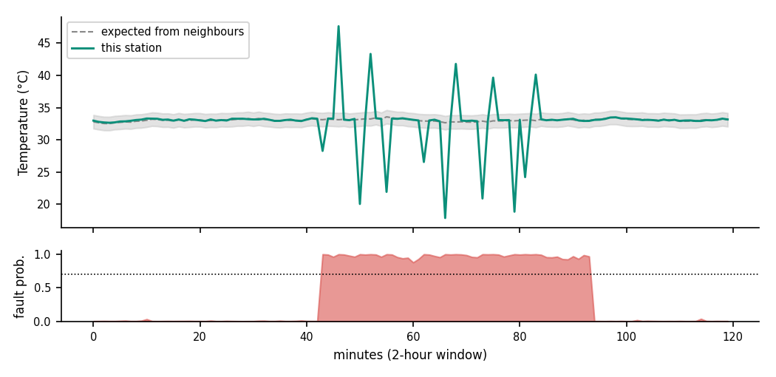
Station | AWS-KOL-005
Decision | Sensor fault — Power glitch
Root cause | Power fluctuation (battery, solar controller or brown-out)
Confidence | 99.0%
Severity | high
Raised at | 14:43 (fault began 14:43)
Explanation | Flagged: temperature, pressure and humidity jumped together at random for 51 minutes, the signature of a power fault, while 6 nearby stations stayed normal.
Corrected value | T: 32.93 → 33.0; P: 1013.12 → 1013.0; RH: 64.7 → 64.4
Suggested action | Check the battery, solar charge controller and power supply within 48 hours

Use case 9 — A short electrical spike
Jaipur pressure spikes for a few minutes. Short spikes are easy to miss; the engine raises an instant alert on gross values.
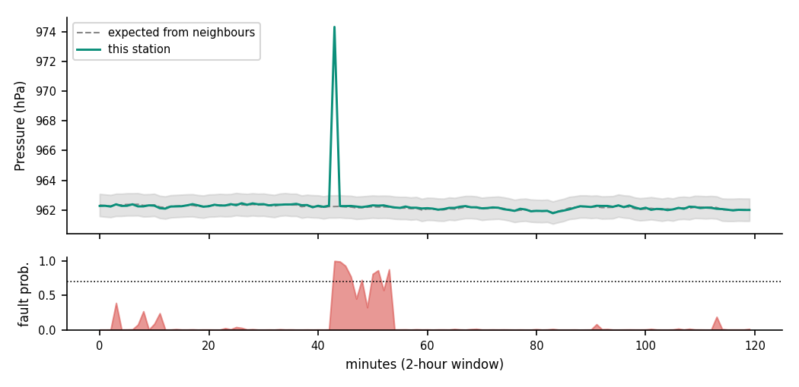
Station | AWS-JPR-011
Decision | Sensor fault — Transient spike
Root cause | Electrical interference or a transient sensor fault
Confidence | 79.4%
Severity | high
Raised at | 14:43 (fault began 14:43)
Explanation | Flagged: pressure jumped +12.0 hPa for 11 minutes and returned, while 6 nearby stations stayed normal.
Corrected value | P: 962.24 → 962.2
Suggested action | Inspect wiring and shielding of the barometer within 48 hours

Use case 10 — A station with no neighbours (Leh)
Leh is deliberately isolated in the simulation. Without neighbours the engine falls back to physics, quick checks and the station's own history. Jumps, stuck values, noise, dropouts and power glitches are still caught. Slow drift, storms and heatwaves are not reported there, because there is nothing to compare against. This is a limit, and it is why the network stress test below matters.

Use case 11 — Predicting which sensor needs maintenance
The health module fits the slope of each sensor's disagreement with its neighbours over 72 hours and estimates the days until it exceeds its tolerance. In a test with three sensors given a hidden slow drift, it recovered the drift rate and the state:
Station / sensor | Status | True drift / day | Estimated / day | Days to limit
AWS-PUN-003 P | degraded | 0.3 | 0.295 | 0.6
AWS-DEL-014 T | degraded | 0.35 | 0.366 | 0.2
AWS-KOL-005 RH | watch | -1.2 | -0.874 | 3.2

5. Evaluation on anomaly-injected data
Protocol: 8 clean days to train the models, a separate 3-day simulation with injected faults to train the fusion stage, then 4-day unseen test sets from 3 different random seeds (550 injected faults, 57 stations). An alert counts as correct if it overlaps an injected fault at the right station.
Method | Recall | Precision | F1 | False alarms / station-day | Median delay (min) | Real weather kept
Threshold QC only | 0.835 | 1.000 | 0.910 | 0.000 | 2.3 | 100.0%
Temporal AI only | 0.783 | 0.766 | 0.773 | 0.258 | 4.3 | 54.5%
TRINETRA (full) | 0.995 | 0.998 | 0.996 | 0.002 | 3.0 | 100.0%

Root-cause accuracy of TRINETRA: 99.3%. Threshold-only and AI-only baselines cannot name a cause.

Recall by fault type
Fault type | Injected | Recall
spike | 81 | 0.975
level shift | 110 | 1.000
stuck | 92 | 1.000
drift | 72 | 0.986
noise burst | 62 | 1.000
comm error | 72 | 1.000
power glitch | 61 | 1.000

Stress tests
Scenario | Recall | Precision | F1 | False alarms / station-day | Real weather kept
No neighbours (physics + AI only) | 1.000 | 0.934 | 0.966 | 0.079 | 76.2%
Dense faults (2.5 per station-day) | 0.998 | 0.985 | 0.992 | 0.037 | 81.2%

Without neighbours the engine still finds every injected fault, but it raises more false alarms and removes more real weather. Neighbours are what make it trustworthy.

Real-time behaviour
Streaming 57 stations with a 150-minute window: median 584 ms per minute of data for the whole network, worst case 795 ms (a new reading arrives every 60 000 ms). Stream alerts matched batch alerts: 11 of 11.

6. Edge layer (on the station)
edge/edge_qc.h is a small C++11 header with no dynamic memory and a state of 112 bytes. It runs the range, jump, stuck-value, dew-point and moving-average checks on the microcontroller itself, so gross faults are flagged even if the link to the server is down. It was compiled and tested on a PC (23 faulty minutes flagged, 0 false alarms in the test). The Arduino sketch has not been run on real hardware.

7. Answer to the grand challenge
The problem statement asks for a system that can tell the difference between real weather and a sensor fault, in real time, and explain itself. TRINETRA does this by requiring agreement between independent kinds of evidence: physics, the station's own history and its neighbours. A sensor fault fails at least one of these while the neighbours stay normal; real weather moves the neighbours too.

8. Honest limitations
- All results are on simulated data. Real IMD data will contain faults and weather patterns we did not simulate; the models must be retrained and re-evaluated on it before deployment.
- Very slow drift cannot be seen at a station with no neighbours.
- The engine expects 1-minute data. Coarser data needs a new training run.
- Attribution shares are computed by the engine itself; the optional SHAP library path was not tested.
- The Arduino sketch is untested on hardware.
- LSTM, TFLite Micro, Kafka, FastAPI and React from the presentation are roadmap items; the working detection uses scikit-learn, and the website is static HTML reading engine output.
- A few injected faults are still missed or mislabelled (recall 0.995); short pressure spikes are the hardest.

