**MINI-PROJECT – II**

**(2021-2022)**



**Institute of Engineering & Technology**

**Mid Term Report:Shopify**

**Submitted By: Submitted to:**

Aryan Saxena(181500136) Faculty : Mr. Akash Choudhary

Aryan Garg(181500135)

Ritik Goyal(181500575)

**DECLARATION**

We hereby declare that the work which is being presented in the MINI PROJECT **“Title…Shopify…”, will be fulfilled** of the requirements for Mini Project viva voce, is an authentic record of my work carried under the supervision of **Mr. Akash Choudhary.**

Signature of Candidates:

Name of Candidate/Roll No:

Aryan Saxena (181500136)

Aryan Garg (181500135)

Ritik Goyal (181500575)

Course: B-tech CSE

Year: III

Semester: 6th

**ACKNOWLEDGEMENT**

We express our sincere indebtedness towards our guide mentor. Mr. Akash Choudhary, Computer Science & Engineering.GLA University, Mathura for his invaluable guidance, suggestions, and supervision throughout the work. Without his kind patronage and guidance, the project would not have taken shape. We would also like to express our gratitude and sincere regards for his kind approval of the project, time-to-time counseling, and pieces of advice.

We would also like to thank HOD Mr. Anand Singh Jalal Department of Computer Science & Engineering.GLA University, Mathura for her expert advice and counseling from time to time.

We owe sincere thanks to all the faculty members in the department

of Computer Science & Engineering for their kind guidance and

encouragement from time to time.

Aryan Saxena (181500136)

Aryan Saxena(181500135)

Ritik Goyal(181500575)

**Abstract**

In this we will build a web app using the concept of React by using the front end and back end technologies in which Front end technology includes HTML,CSS and JavaScript and React and Back-end technology includes Firebase, javaScript that we have used in our web App which makes the App efficient and effective. This application has various functions to perform such as the option of adding and removing the Products from Home Screen and add to cart as Customer need and make Shopping easy. It is Direct Selling Online website from company to Consumer (B2C). By which the customers had various options available in this application like he/she can remove the cart and check the subtotal which is placed top right most and proceed for the delievery. This application can enhance the order-making feature.

|  |  |  |
| --- | --- | --- |
| S.NO | Topic | Pages No. |
|  |  |  |
| 1 | Declaration | 2 |
|  |  |  |
| 2 | Acknowledgment | 3 |
|  |  |  |
| 3 | Abstract | 4 |
|  |  |  |
| 4 | Introduction | 6 |
|  |  |  |
| 5 | System and Hardware Requirements | 6 |
|  |  |  |
| 6 | Frontend and Backend | 7 |
|  |  |  |
| 7 | Idea and Objective | 8 |
|  |  |  |
|  |  |  |
| 8 | Module Description | 9 |
| 9 | Flow Chart | 10 |
| 10 | DFD 0level ,1level | 11 |
| 11 | Codes and Screenshorts | 14 |
| 12 | BIBLIOGRAPHY | 35 |

**INDEX**

**INTRODUCTION**: -

Shopify is an E-commerce Website For Purchasing Daily Products Made To Bring Traditional Home Business To Online Mode. The Customer Can Select Any Product like electronics , Women Style Products, Man Style Products ,Quantity of each Product According To Their Need In Add to Cart Section. The Users Need To Authenticate Themselves Before Accessing The Application Using Firebase Authentication Services. The Application Will Show Ring Notification When Client Add the Product ,Remove the Product From The Cart. It consists of Mainly Four Modules such as Home, Cart, Checkout Page, Login Page. It is Direct Selling Online Website from Company to Customer (B2C). It is single vendor online Farm. There is no multiple vendor online website like Amazon, Meso etc. Add our data on Cloud Fire store. Admin can Add the Product on Home Screen , Remove the Product and Admin can Remove the Product Of the user when the Product is unavailable. Deploy this project on Firebase. User can Add the Multiple products check the Subtotal of all Products on the Top right Most box.When user remove the Product Subtotal will decrease simultaneously.Only Offline Payment Mode is available. Admin can see the Products what the user added and then Admin will shipped the product where user wants to.

**System Requirements:** -

**Supported Operating system: -**

Windows 10 Windows 8 Windows 7

**Software Required: -**

* VS Code
* Firebase

**Hardware Requirements: -**

**For VS Code: -**

**Intel i3 6th Gen (1.6 GHz minimum)**.

**1 GB** of RAM.

Internet Connection

Frontend and Backend: -

**Frontend**

Front-end web development, also known as client-side development is the practice of producing HTML, CSS and JavaScript, React for a website or Web Application so that a user can see and interact with them directly. The challenge associated with front end development is that the tools and techniques used to create the front end of a website change constantly and so the developer needs to constantly be aware of how the field is developing.

The objective of designing a site is to ensure that when the users open up the site, they see the information in a format that is easy to read and relevant. This is further complicated by the fact that users now use a large variety of devices with varying screen sizes and resolutions thus forcing the designer to take into consideration these aspects when designing the site. They need to ensure that their site comes up correctly in different browsers (cross-browser), different operating systems (cross-platform) and different devices (cross-device), which requires careful planning on the side of the developer.

**Backend**

It has a backend with implementation of Firebase for the database and hosting. The project was built using the React . The user can create their own account, login and check their Cart of Products. . User can Add the Multiple products check the Subtotal of all Products on the Top right Most box.When user remove the Product Subtotal will decrease simultaneously.Only Offline Payment Mode is available. Admin can see the Products what the user added and then Admin will shipped the product where user wants to.

**Idea: -**

Idea behind this Project to made a Traditional Home business to online Mode.and not only does it require low requirement full time commitment of Product.

**Objective: -**

1. The main objective of the project is to make your own Daily Shopping Easier in Covid Situation..
2. It will help customers to shipped their Daily Products on Their Home Place.

**Module Description:**

**Home activity:** The main activity consists of Login , Product and Cart as a SubModule. Home page is having the Multiple Daily Products like Electronics, Cloths, Furniture.

**Cart Module:**  Cart is Fully Functional Customer can Add their Products and Remove their Products and see the subtotal which is top right most.

**Login Module:**  In this Module user can Register and the login themselves.

**Scope: -** we will Add the Online Payment Mode for user in this website. We will Make this Website on Multiple vendor basis So that multiple vendor can open their shops on this website and sell their product in reasonable price. We will store the data in Mongo DB later on.

**Use Case Diagram:**

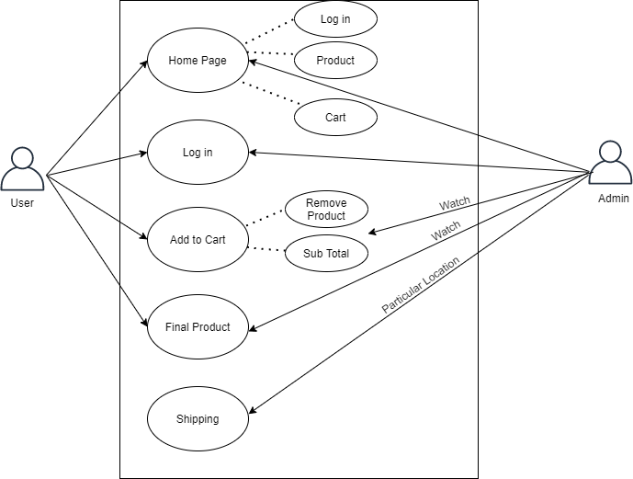

**DFD: -** A data flow diagram (DFD) illustrates how data is processed by a system in terms ofinputs and outputs. As its name indicates its focus is on the flow of information, where data comes from, where it goes and how it gets stored.

**0 Level DFD: -**DFD Level 0 is also called a Context Diagram. It’s a basic overview of the whole system orprocess being analyzed or modeled. It’s designed to be an at-a-glance view, showing the system as a single high-level process, with its relationship to external entities. It should be easily understood by a wide audience, including stakeholders, business analysts, data analysts and developers.

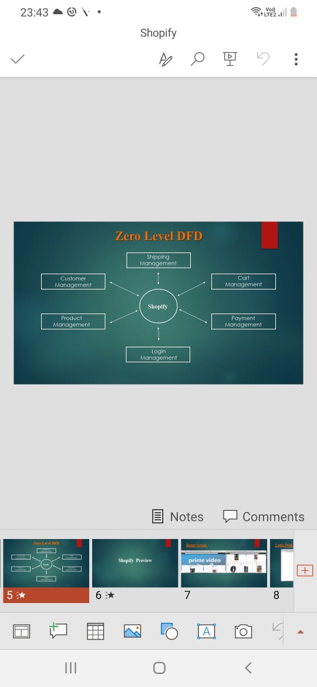

**Codes and ScreenShorts**

App.js

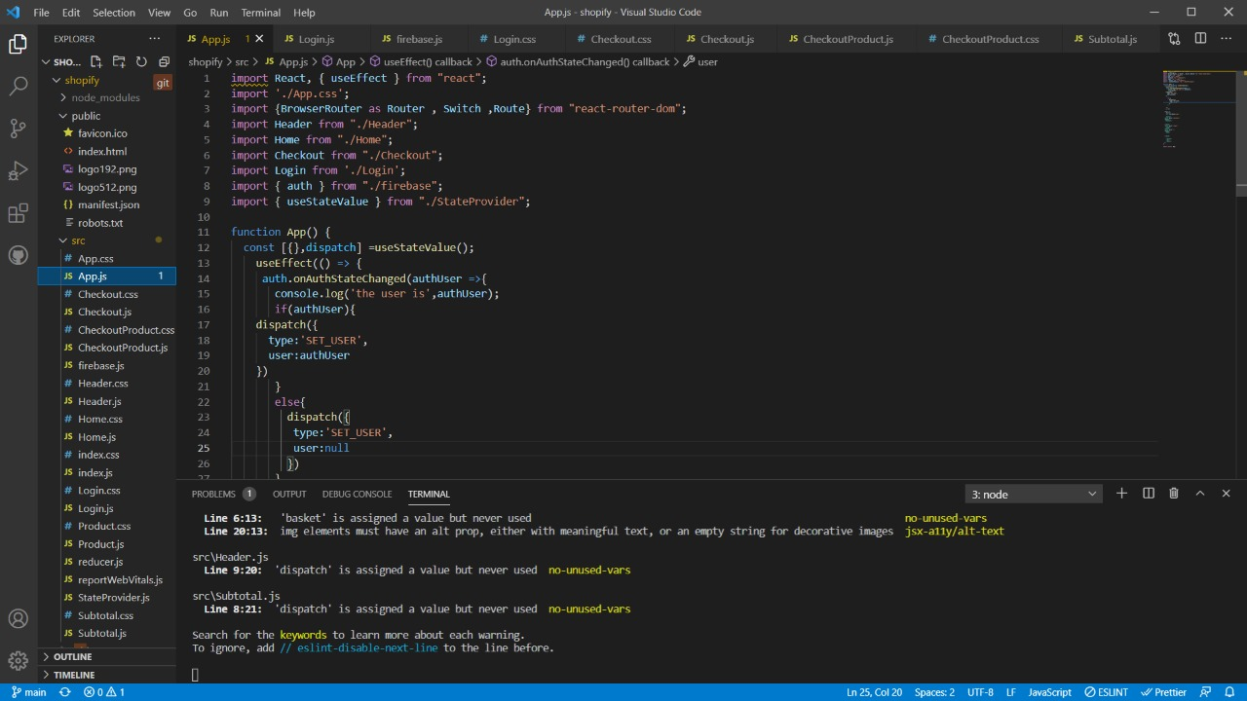

Firebase,js

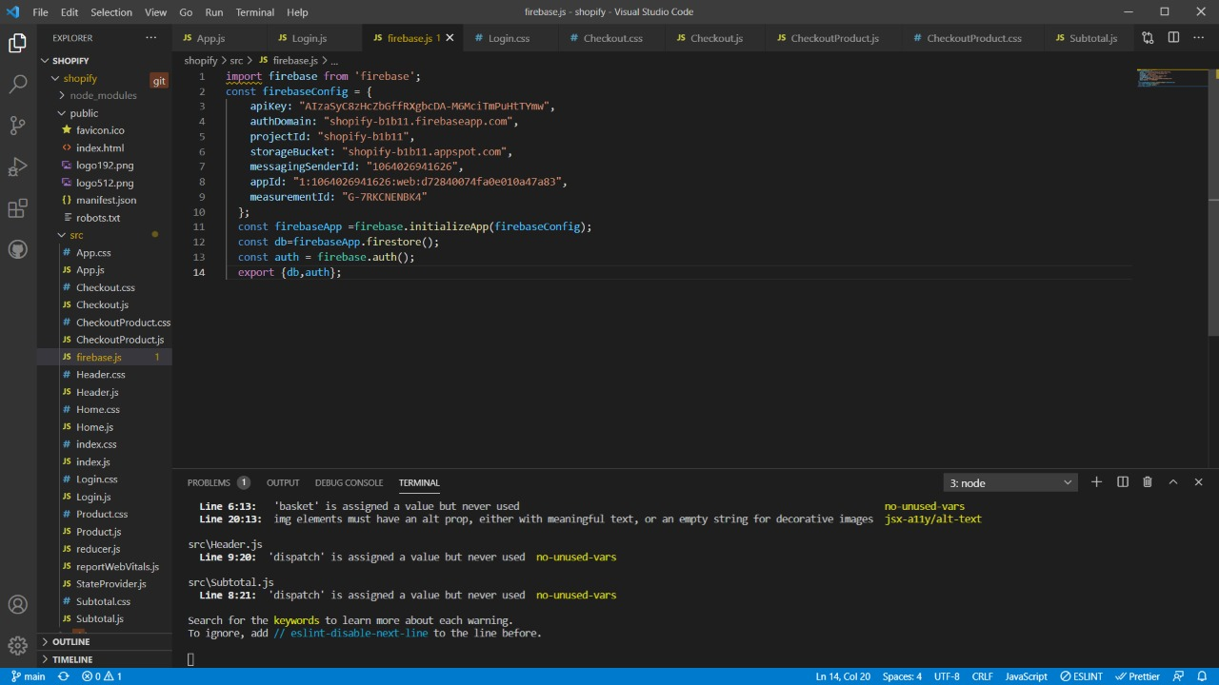

Header.css

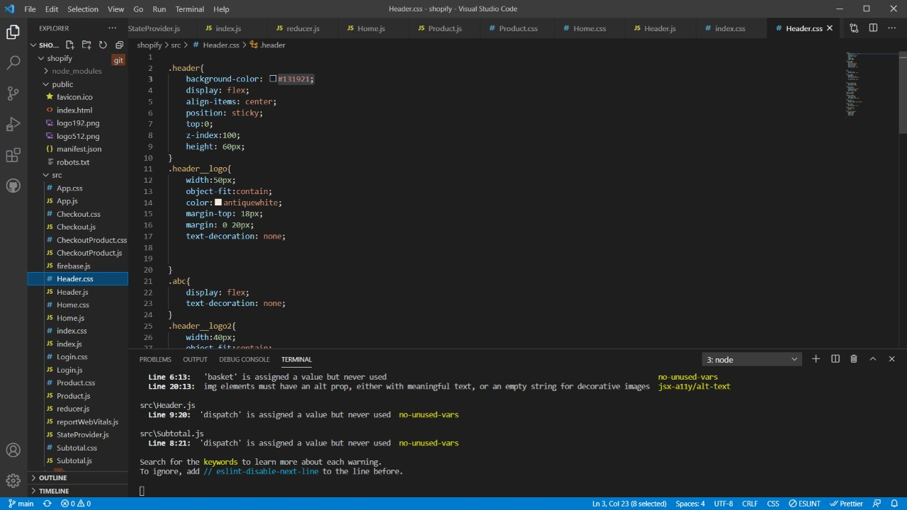

Header.js

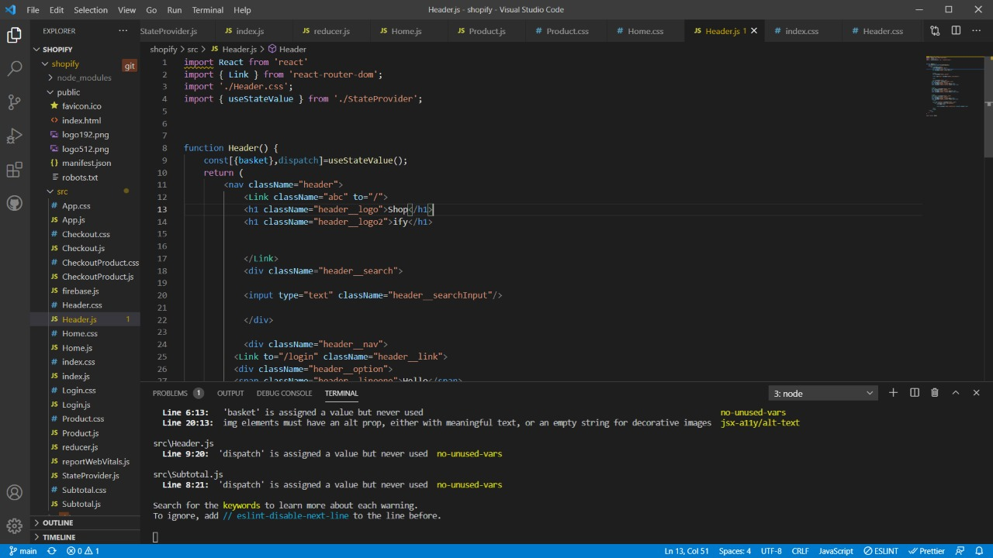

Checkout.css

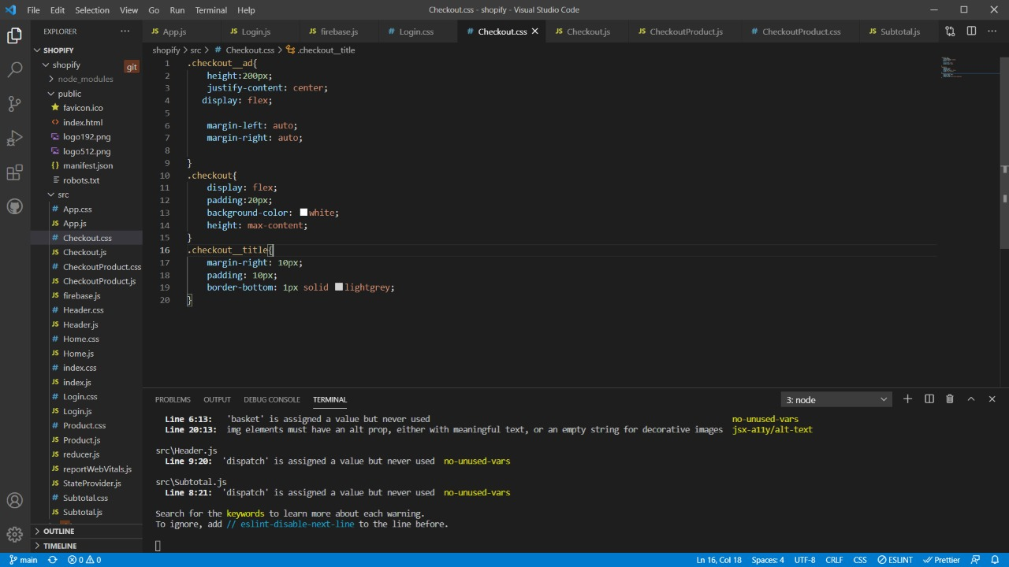

Login.css

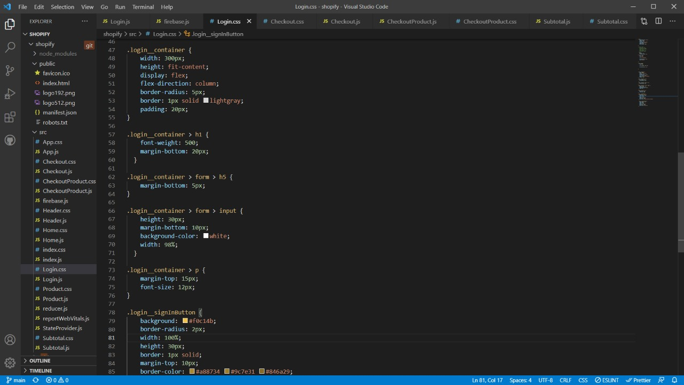

Login.js

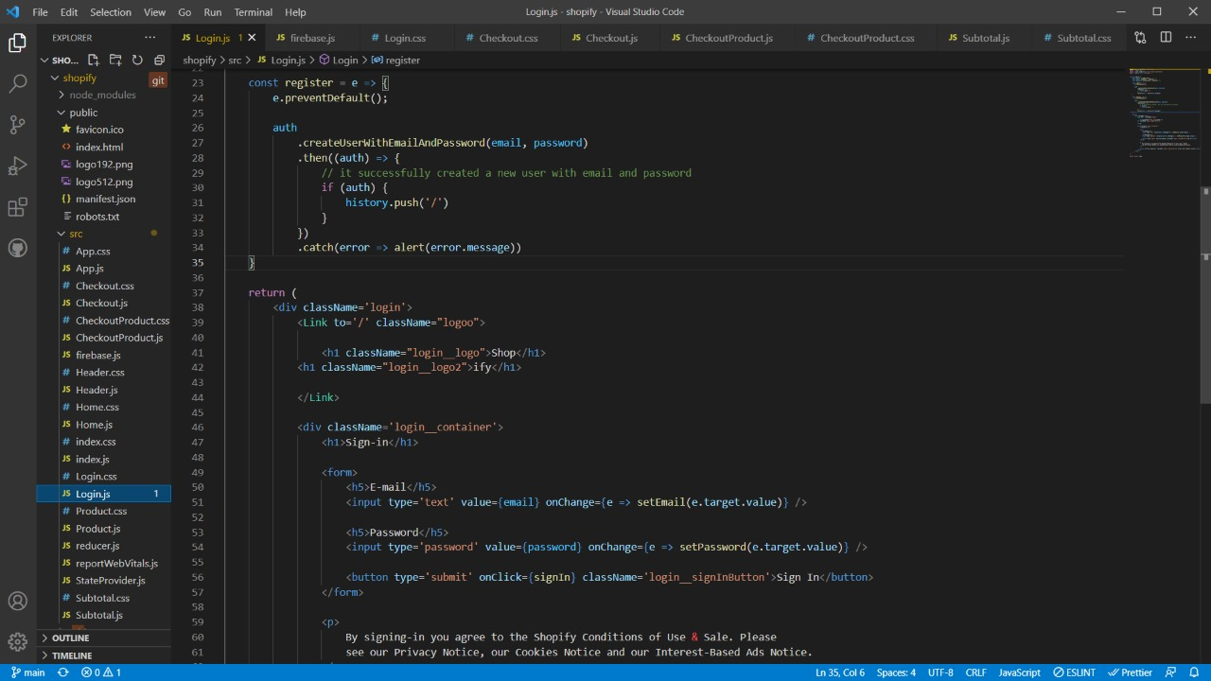

Product.css

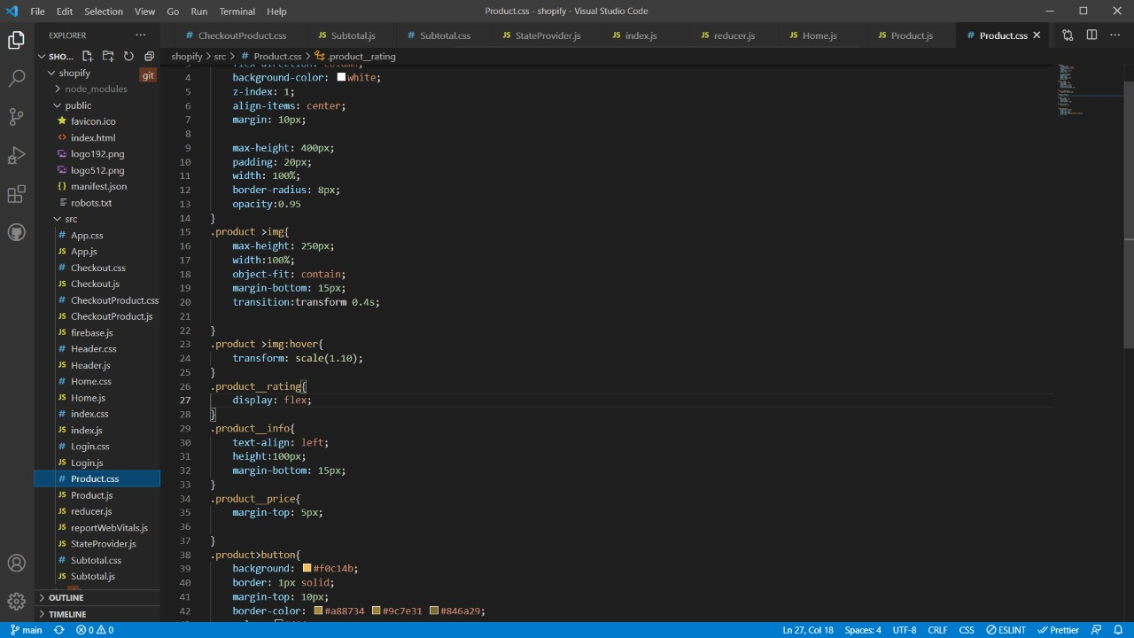

Reducer.js

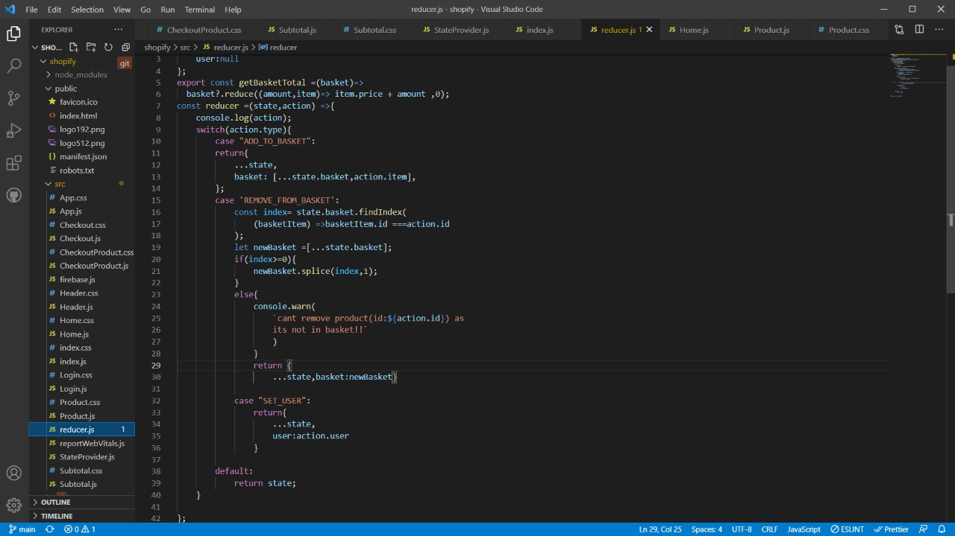

Checkout.js

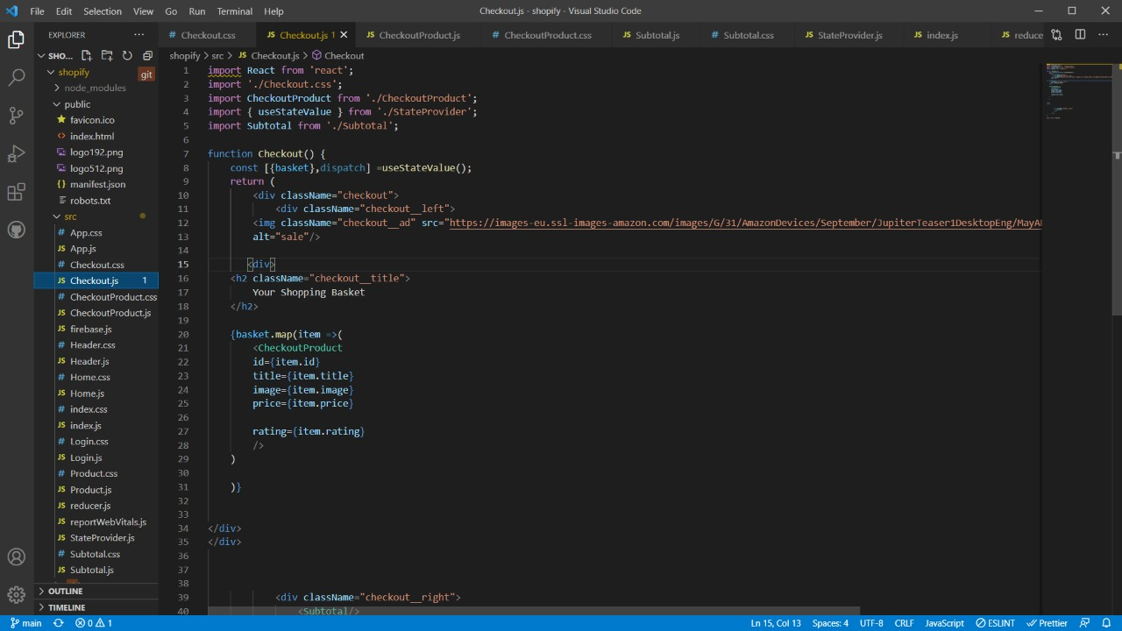

Product.js

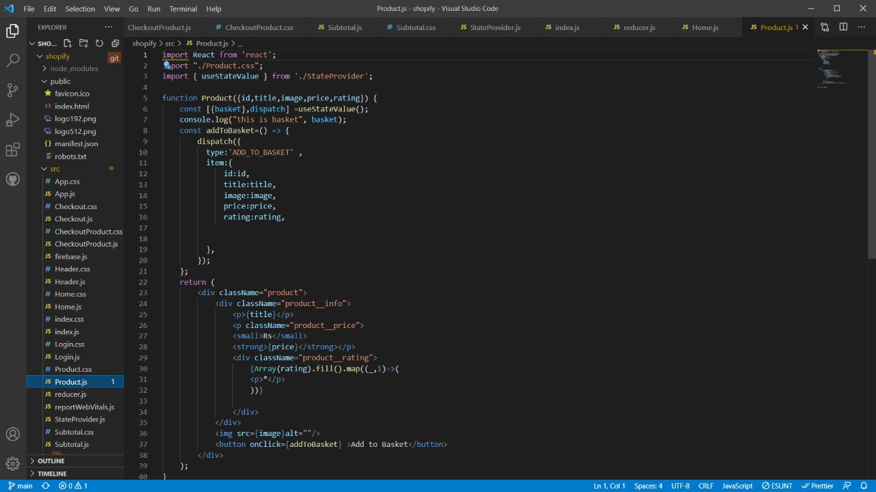

Working Website Screenshots

Login Page

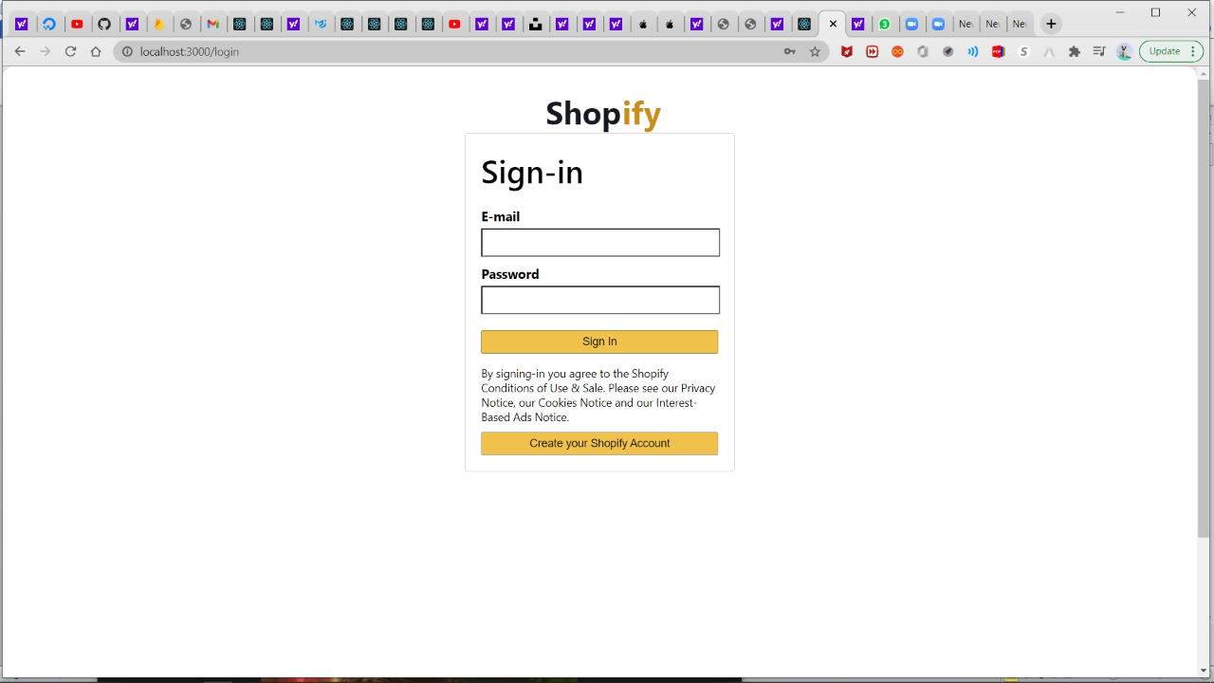

Home Page

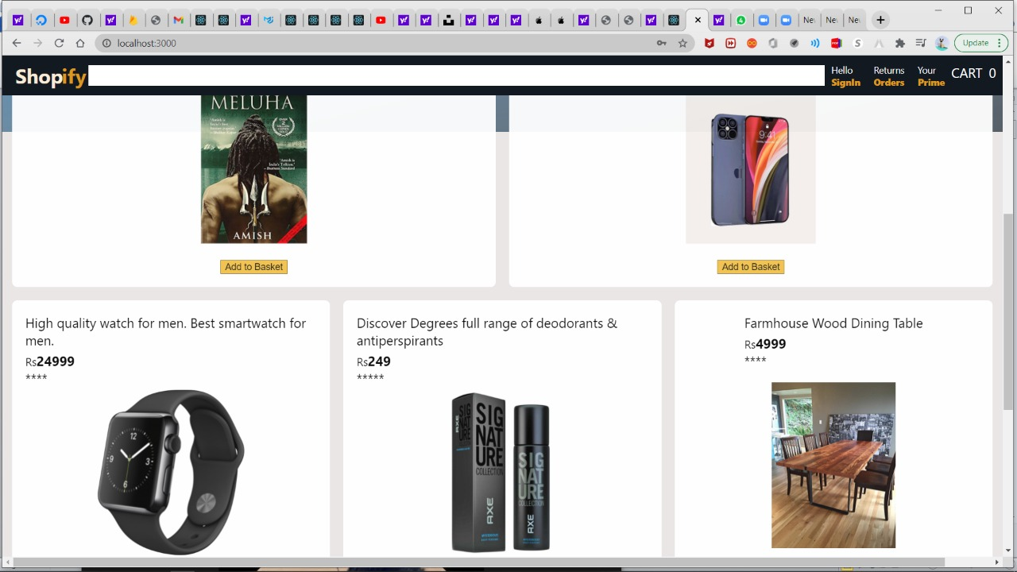

Empty Cart

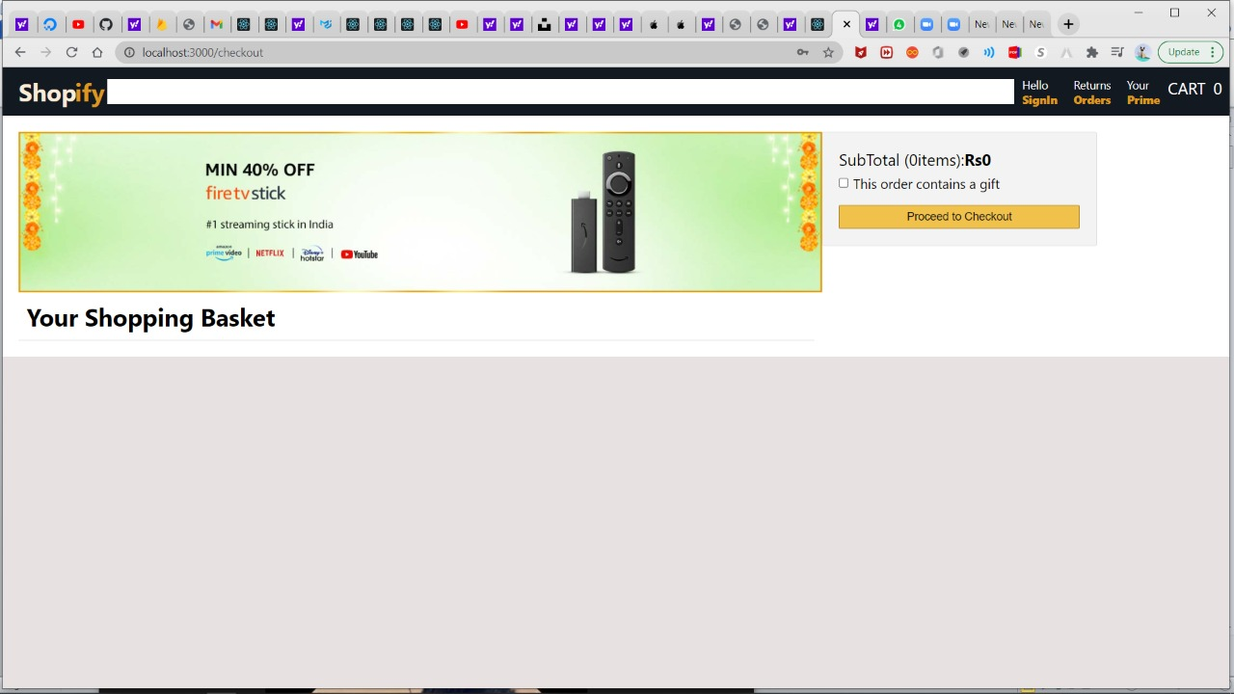

Full Cart

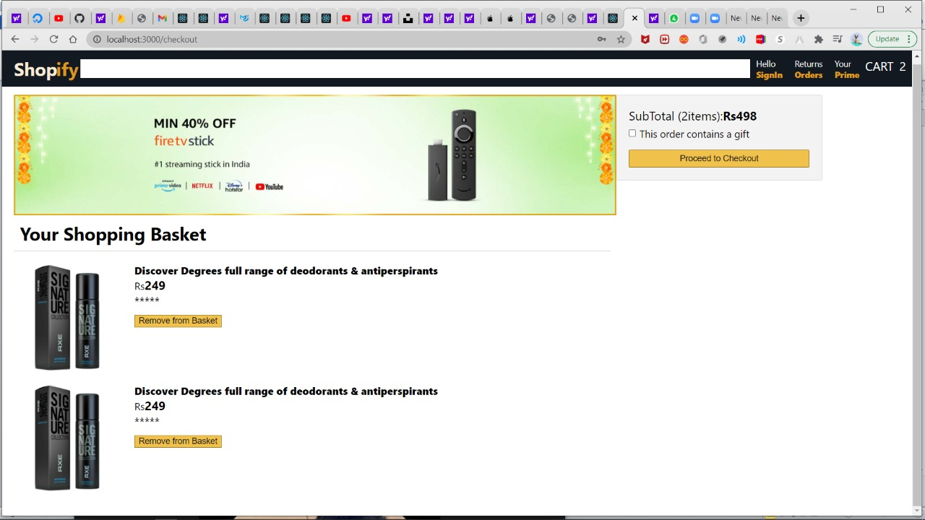

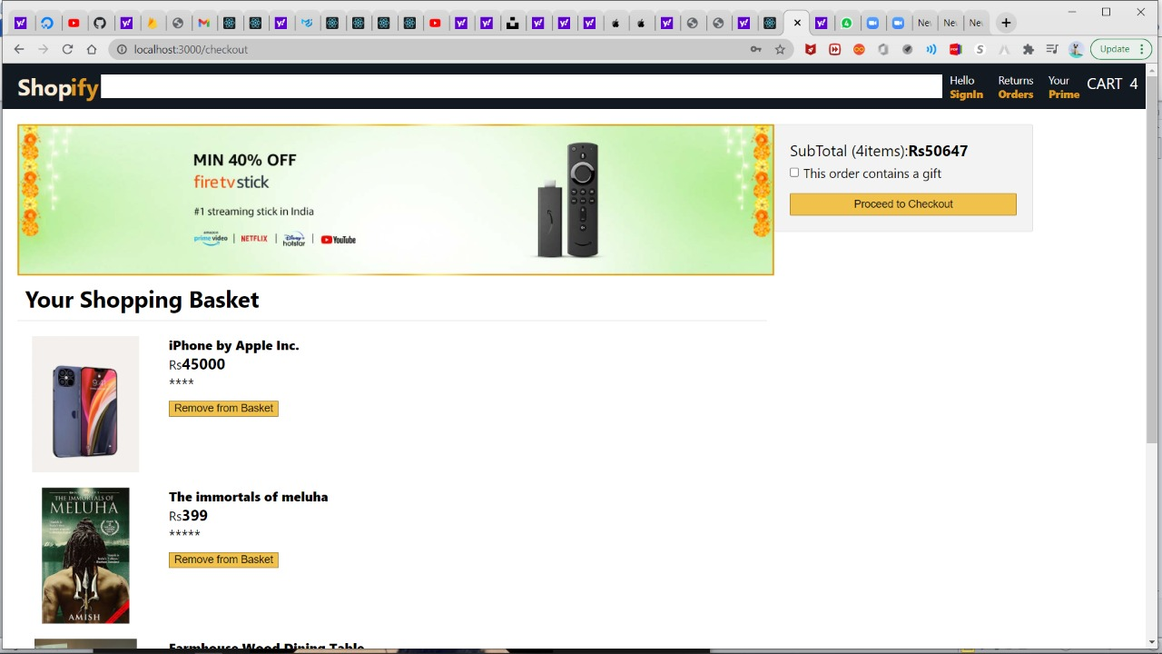

**BIBLIOGRAPHY**

* <https://reactjs.org/docs/getting-started.html>
* <https://www.youtube.com/watch?v=RDV3Z1KCBvo>
* <https://www.beta-labs.in/>