Financial Performance Analysis – Business Analyst Portfolio Case Study

Company: NorthStar Retail Group
Industry: Retail / E-commerce
Analysis Period: 2014–2017
Tools: Excel, SQL, Power BI
Dataset: Superstore_Cleaned

# 1. Project Overview

NorthStar Retail Group is a retail/e-commerce business selling office supplies, furniture, and technology products across the United States.

This project was developed as a Business Analyst-led financial performance analysis to determine where the company generates revenue and profit, where profitability is weak, and what management should consider when making commercial decisions.

The objective was not simply to create a dashboard, but to translate management questions into measurable business requirements, validate the underlying data, analyze financial performance, and convert the findings into actionable recommendations.

# 2. Business Problem

Management identified a potential growth paradox: sales activity may be increasing without generating equivalent profitability.

The central business questions were:

- Where is the company generating revenue?
- Where is the company generating profit?
- Which categories and customer segments contribute most to profitability?
- Are high-sales categories necessarily highly profitable?
- Are there periods of stronger or weaker performance?
- Is discounting associated with weaker profitability?
- Where should management focus its attention to improve commercial performance?

The analysis therefore focused on understanding the relationship between sales volume and profitability, rather than evaluating performance using revenue alone.

# 3. Business Objectives

The project objectives were to:

1. Evaluate overall sales and profitability performance.
2. Compare profitability across product categories and sub-categories.
3. Compare sales and profitability across customer segments.
4. Analyze historical performance across time.
5. Identify high-sales but low-profitability areas.
6. Assess discounting patterns and their relationship with profitability where supported by the available data.
7. Provide evidence-based business recommendations for management.
8. Develop an interactive Power BI dashboard for management-level performance analysis.

# 4. Stakeholder Requirements

The analysis was designed around management and stakeholder questions covering five major areas:

Overall Performance

- Total revenue and profit
- Profitability performance over time
- Strongest and weakest periods

Product Performance

- Revenue contribution by category
- Profit contribution by category
- Profit margin by category
- Identification of high-sales but weak-profitability areas

Customer Performance

- Revenue and profit contribution by customer segment
- Comparison of revenue versus profitability

Geographic Performance

- Sales and profitability by region and state
- Identification of locations where sales and profitability diverge

Discounting

- Analysis of discount levels
- Relationship between discounting and profitability

The detailed Business Requirements and Functional Requirements are documented separately in the project's BRD.

# 5. Dataset & Data Structure

The analysis used the Superstore_Cleaned dataset.

Dataset Summary

- Records: 9,994
- Columns: 21
- Analysis Period: 2014–2017
- Unique Orders: 5,009
- Unique Customers: 793
- Granularity: Transaction / Order-line level

Key analytical fields included:

- Order ID
- Order Date
- Customer ID
- Segment
- Category
- Sub-Category
- Sales
- Quantity
- Discount
- Profit
- Region
- State
- Ship Mode

The dataset structure supported financial, product, customer, geographic, time-based, and discounting analysis.

# 6. Data Quality & Feasibility Assessment

Before conducting the analysis, the dataset was assessed for structural and analytical quality.

Data Quality Findings

- Duplicate records: 0
- Missing values: 0
- Invalid negative sales: None identified
- Invalid discount percentages: None identified outside the expected 0%–80% range
- Data types: Consistent with expected business usage

The analysis also identified 1,871 negative-profit transactions, representing a total negative profit of approximately $156,131.29. These transactions were treated as business anomalies requiring analytical attention rather than data-quality errors.

KPI Feasibility

The available dataset supported calculation of:

- Total Sales
- Total Profit
- Profit Margin
- Average Order Value
- Sales Growth
- Profit Growth
- Category profitability
- Segment profitability
- Geographic profitability
- Discount-related analysis

However, some business metrics could not be reliably calculated because the necessary data was unavailable.

Examples include:

- Customer Acquisition Cost (CAC)
- Customer Lifetime Value (LTV)
- Cost to Serve
- Gross Profit Margin based on COGS

These limitations were documented rather than estimated.

# 7. Analytical Approach

The project followed a structured Business Analyst workflow:

Business Problem Definition
↓
Stakeholder & Requirement Analysis
↓
Data Understanding & Quality Assessment
↓
KPI Definition & Feasibility Assessment
↓
SQL Analysis & Validation
↓
Power BI Dashboard Development
↓
KPI Reconciliation & QA
↓
Business Insights
↓
Recommendations & Expected Impact
↓
Executive Conclusion

This approach ensured that the dashboard was driven by business requirements rather than being developed as a visualization exercise alone.

# 8. KPI Framework

The primary performance indicators used in the final analysis were:

Total Sales

Measures the total revenue generated during the analysis period.

Total Profit

Measures the total recorded profit generated by the business.

Profit Margin

Calculated as:

Profit Margin = Total Profit / Total Sales × 100

This metric was used to evaluate how effectively sales translated into profit.

Total Orders

Calculated using the distinct count of Order ID rather than transaction rows.

Average Order Value

Calculated as:

AOV = Total Sales / Distinct Orders

This provides a view of average revenue generated per order.

# 9. SQL Analysis & Validation

SQL was used to validate the underlying dataset and calculate key financial metrics before and alongside Power BI analysis.

The core validation included:

- Record count
- Distinct order count
- Total sales
- Total profit
- Overall profit margin

Validated Results

KPI | Validated Result

Total Records | 9,994

Distinct Orders | 5,009

Total Sales | $2,297,201.07

Total Profit | $286,397.79

Overall Profit Margin | 12.47%

The SQL reconciliation was then used to verify that the corresponding Power BI KPI values were consistent with the underlying data.

# 10. Power BI Dashboard

The validated data was transformed into an interactive Power BI dashboard designed to provide management with a consolidated view of financial performance.

The dashboard enables analysis across dimensions including:

- Time
- Product Category
- Sub-Category
- Customer Segment
- Region
- State
- Profitability

The dashboard was also subjected to KPI validation, filter/interaction testing, and label/presentation QA before being finalized.

Dashboard

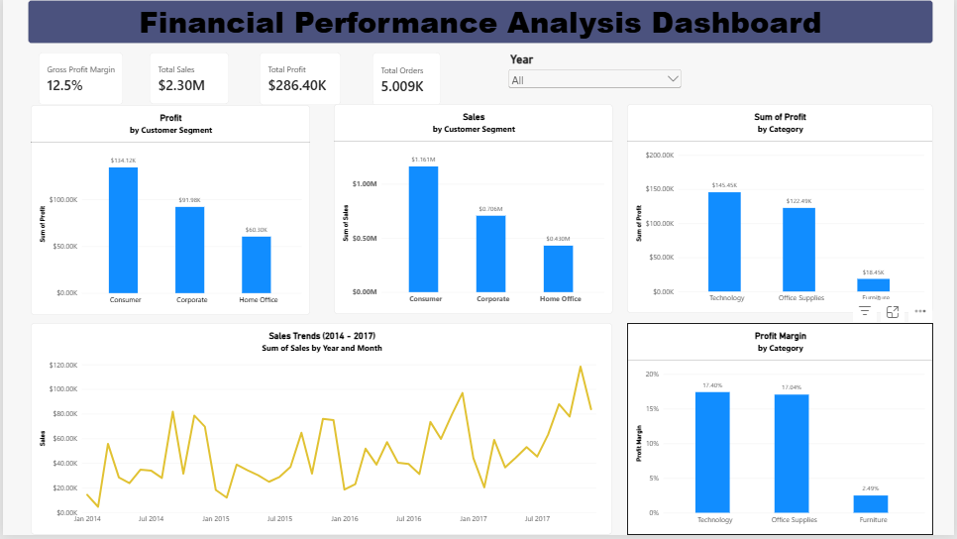

Figure 1 – Financial Performance Analysis Dashboard

11. Key Business Insights

Insight 1 – Furniture Shows Significant Profitability Weakness

Furniture generates substantial sales activity but produces only a 2.49% profit margin and approximately $18.45K in total profit.

This is materially weaker than the profitability achieved by Technology and Office Supplies.

Business Interpretation

The finding indicates that high revenue contribution does not necessarily translate into strong profitability.

The analysis therefore supports a deeper product and sub-category profitability review before making any category-wide strategic decision.

Insight 2 – Consumer Is the Primary Revenue and Profit Contributor

The Consumer segment generated approximately:

$1.161M in Sales
$134.12K in Profit

This makes Consumer the company's largest revenue and profit contributor among the customer segments analyzed.

Business Interpretation

Consumer performance should be protected because of its importance to overall profitability.

At the same time, management should evaluate opportunities to strengthen Corporate and Home Office performance to reduce excessive reliance on the dominant segment.

Insight 3 – Historical Sales Exhibit Recurring Seasonal Fluctuations

The time-based analysis identifies recurring historical fluctuations in sales performance, including weaker January periods and stronger activity during Q3 and Q4.

Business Interpretation

These historical patterns can be considered when planning procurement, inventory, staffing, and promotional activity.

However, historical seasonality should not automatically be interpreted as a guarantee of future performance without additional forecasting analysis.

Insight 4 – Category Profitability Is Uneven

The analysis demonstrates a significant difference in profitability across product categories.

Furniture generates substantially weaker profitability than Technology and Office Supplies despite contributing meaningful sales activity.

Business Interpretation

Management should evaluate categories based on their profitability contribution rather than relying solely on sales volume when making resource allocation decisions.

12. Business Recommendations

Recommendation 1 – Conduct a Furniture Profitability Audit

Initiate a product-level and sub-category profitability audit of Furniture before making any category-wide strategic decision.

The analysis should evaluate:

- Product mix
- Discounting
- Sub-category profitability
- Geographic profitability
- Fulfillment economics where additional cost data is available

Underperforming products can then be selectively repriced, promotionally restricted, restructured, or discontinued based on their individual economics.

Expected Impact

Potential improvement in Furniture profitability while avoiding premature elimination of the entire category.

Recommendation 2 – Protect Consumer While Developing Other Segments

Consumer should remain a priority because it currently represents the strongest combination of sales and profit contribution.

At the same time, management should evaluate Corporate and Home Office to identify opportunities for profitable growth and reduce excessive concentration in the dominant segment.

Expected Impact

Protection of the company's primary profit engine
More balanced customer-segment contribution
Better allocation of commercial resources

Recommendation 3 – Align Planning with Historical Seasonality

Management should incorporate observed historical seasonal patterns into procurement, inventory planning, staffing, and promotional planning.

Periods of historically weaker demand can be managed differently from stronger periods, while targeted promotional or corporate-sales initiatives can be evaluated where appropriate.

Expected Impact

Improved planning efficiency
Better resource allocation
Potential reduction in revenue volatility
Reduced risk of inefficient inventory positioning where inventory data supports the conclusion

Recommendation 4 – Adopt Profitability-Focused Resource Allocation

Management should move beyond evaluating performance primarily through sales volume and establish a resource allocation approach that considers profitability contribution.

Higher-profitability categories can receive greater consideration for incremental investment, while granular analysis should be conducted within Furniture to identify specific low-margin products requiring intervention.

Expected Impact

More efficient allocation of discretionary resources
Greater emphasis on profitable growth
Potential improvement in overall profitability
More informed category-level decision-making

13. Expected Business Impact

The recommendations are intended to support four primary business outcomes:

1. Improved Profitability

Identifying and addressing low-margin products can improve profitability without requiring the elimination of an entire category.

2. Better Resource Allocation

Management can evaluate investment decisions using profitability contribution rather than sales volume alone.

3. Reduced Segment Concentration Risk

Protecting Consumer while developing Corporate and Home Office can create a more balanced customer portfolio where underlying economics support further investment.

4. Improved Planning

Using observed historical seasonality can support better planning around periods of stronger and weaker demand.

The exact financial impact should be quantified only after additional product-level, cost, customer, and operational data is available.

14. Executive Conclusion

The four-year historical analysis demonstrates a commercially active business with significant differences in profitability across customer segments and product categories. The Consumer segment serves as the company's primary revenue and profit contributor, making it important to protect while evaluating opportunities to strengthen the Corporate and Home Office segments.

At the category level, Furniture presents the most significant profitability concern, generating substantial sales activity but achieving only a 2.49% profit margin compared with materially stronger margins in Technology and Office Supplies. This demonstrates that sales volume alone does not necessarily translate into equivalent profitability. The analysis also identifies recurring historical seasonal fluctuations, including weaker January sales and stronger activity during Q3 and Q4, which should be considered in business planning.

Overall, management should move beyond evaluating performance primarily through sales volume and adopt a profitability-focused resource allocation approach. Priority should be given to understanding and improving low-margin product economics, protecting high-value segments, and aligning planning decisions with observed historical demand patterns. This approach can support more efficient resource allocation and improve overall profitability while avoiding premature decisions based solely on revenue performance.

15. Project Deliverables

The completed project consists of:

- Business Requirements Document (BRD)
- Cleaned analytical dataset
- SQL analysis and validation
- KPI reconciliation and QA
- Power BI Financial Performance Dashboard
- Business Insights
- Management Recommendations
- Expected Business Impact
- Executive Conclusion

16. Tools Used

SQL – Data analysis, aggregation, KPI calculation, and validation

Power BI – Interactive dashboard development, KPI visualization, filtering, and business analysis

Excel – Data preparation and supporting analysis

Microsoft Word – Business requirements and portfolio case-study documentation

17. Final Project Outcome

The project demonstrates an end-to-end Business Analyst workflow in which a business problem was translated into measurable requirements, evaluated against available data, analyzed using SQL and Power BI, validated through QA, and converted into evidence-based management recommendations.

The final outcome is therefore not only a dashboard, but a complete analytical decision-support case study demonstrating the ability to connect:

Business Requirements → Data → Analysis → Validation → Insight → Recommendation → Business Impact

