**Tribhuvan University**

**Faculty of Humanities and Social Science**

**A PROJECT REPORT**

**ON**

**SARAL ADMIN**

**Submitted to**

**Department of Computer Application**

**Koshi Saint James College, Itahari**

***In the partial fulfilment of the requirements for the Bachelors in Computer Applications***

Submitted by

Name: Aryan Adhikari

TU Reg No: 6-2-737-3-2022

**Tribhuvan University**

**Faculty of Humanities and Social Science**

**Koshi Saint James College, Itahari**

**Supervisor’s Recommendation**

I hereby recommend that this project prepared under my supervision by **Aryan Adhikari** entitled **Saral Admin** in partial fulfillment of the requirements for the degree of **Bachelor of Computer Application (BCA)** is recommended for the final evaluation.

...........................

**Signature**

**Mr. Amit Shah**

**Supervisor**

**Tribhuvan University**

**Faculty of Humanities and Social Science**

**Koshi Saint James College**

**Letter of Approval**

This is to certify that this project prepared by **Aryan Adhikari** entitled **Saral Admin** in partial fulfilment of the requirements for the degree of **Bachelors in Computer Application** has been evaluated. In my opinion it is satisfactory in the scope and quality as a project for the required degree.

|  |  |
| --- | --- |
| **Mr. Amit Shah**  **Supervisor**  Itahari-9, Sunsari, Nepal | **Mr. Navaraj Karki**  **Coordinator**  Itahari-9, Sunsari, Nepal |
| **Internal Examiner** | **External Examiner** |

**STUDENT’S DECLARATION**

This is to certify that the project report entitled **Saral Admin** submitted in partial fulfilment of the requirements of **Koshi Saint James College, Nepal** is my original work and not submitted for the award of any other degree or any other similar title or prize. I have worked under the supervision and guidance of **Mr. Amit Shah**. and no part of this report has been published in any journal or magazine.

_______________

Aryan Adhikari

# **ACKNOWLEDGEMENT**

I sincerely acknowledge and express my heartfelt appreciation to all the teachers and mates who have contributed their valuable time in helping me to achieve success in my project work.

Firstly, I want to thank **Koshi Saint James College** for giving me opportunity for doing this project. And my sincere thanks go to my supervisor **Mr. Amit Shah** and our Coordinator **Mr. Navaraj Karki**, for their assistance, insightful comments invaluable guidance and constant support throughout the project. Their timely advice has been instrumental in my achievements.

I am also grateful to the principal, teachers, and everyone who supported and encouraged me during the development of this project. Their cheerful assistance made a significant difference in my journey.

Lastly, I want to express my thanks to everyone involved for their support and encouragement throughout this project by sharing their expertise with me. Your contributions have been invaluable, and I couldn't have done it without you.

# **ABSTRACT**

**Saral Admin** is an admin dashboard designed to help businesses streamline their operations, manage data effectively, and make informed decisions. Acting as a centralized platform, it connects administrators with key business metrics, tools, and functionalities, making the management process more efficient and user-friendly. The platform offers a variety of features to support businesses in their day-to-day operations, including real-time data visualization through charts and graphs, task management for coordinating workflows, and user role management to control access and permissions.

This platform plays a crucial role in enhancing business productivity by providing a unified interface for managing various aspects of operations. Efficient business management is a fundamental aspect of organizational success, as it ensures smooth workflows, reduces operational costs, and improves decision-making. Beyond these practical benefits, having a centralized dashboard like **Saral Admin** instills confidence in administrators, allowing them to focus on strategic activities rather than routine tasks. It fosters a sense of control and organization within the business, contributing to overall growth and stability.

**Saral Admin’s** efforts in aiding businesses to manage their operations more effectively help them become more competitive and efficient. By facilitating real-time monitoring and data-driven insights**, Saral Admin** not only supports business growth but also promotes economic well-being. It is an essential tool for businesses seeking to optimize their workflows, reduce manual errors, and enhance productivity. **Saral Admin** significantly contributes to the overall improvement of business operations and the achievement of long-term success.

**Keywords:** admin dashboard, business management, task management, data visualization, real-time monitoring, workflow optimization, productivity.

# **TABLE OF CONTENTS**

**ACKNOWLEDGEMENT** v

**ABSTRACT** vi

**TABLE OF CONTENTS** vii

**LIST OF FIGURES** ix

**LIST OF TABLES** x

**ABBREVIATIONS** xi

**Chapter 1: Introduction** 1

1.1 Introduction 1

1.2 Problem Statement 2

1.3 Objectives 2

1.4 Scope and Limitation 2

1.5 Report Organization 3

**Chapter 2: Background Study and Literature Review** 5

2.1 Background Study 5

2.2 Literature Review 5

**Chapter 3: System Analysis and Design** 8

3.1 System Analysis 8

3.1.1 Requirement Analysis 9

3.1.2 Feasibility Analysis 10

3.1.3 Data Modeling (ER Diagram) 11

3.1.4 Logical Level DFD 12

3.2 System Design 13

3.2.1 Architectural Design 13

3.2.2 Database Schema Design 14

3.2.3 Interface Design 14

3.2.4 Physical DFD Design 15

**Chapter 4: Implementation and Testing** 16

4.1 Implementation 16

4.1.1 Tools Used 16

4.1.2 Implementation Details of Modules 16

4.2 Testing 19

4.2.1. Test Cases for Unit Testing 19

4.2.2. Test Cases for System Testing 20

**Chapter 5: Conclusion and Future Recommendations** 21

5.1 Lesson Learnt / Outcome 21

5.2 Conclusion 21

5.3 Future Recommendations 22

**APPENDIX** 23

**REFERENCES** 25

# **LIST OF FIGURES**

Figure 1: Iterative Model of Software Development 8

Figure 2: Use-Case Diagram of system above 9

Figure 3: ER Diagram 11

Figure 4: Context Diagram 12

Figure 5: DFD level 1 12

Figure 6: Three Tier Architecture 13

Figure 7: Database Schema Diagram 14

Figure 8: Homepage UI of Saral Admin 15

Figure 9: Physical DFD Diagram 15

Figure 10: Folder Structure of the Project 17

Figure 11: User Management 23

Figure 12: Add Clients 23

Figure 13: Edit Project 24

Figure 14: Task Details 24

# **LIST OF TABLES**

Table 1: Gantt Chart 11

Table 2: Sign Up 19

Table 3: Add Category 19

Table 4: System Testing 20

# **ABBREVIATIONS**

|  |  |
| --- | --- |
| **Abbreviations** | **Definition** |
| CRUD | Create, Read, Update, Delete |
| ERP | Enterprise Resource Planning |
| CRM | Customer Relationship Management |
| HR | Human Resource |
| UI | User Interface |
| UX | User Experience |
| MERN | MongoDB, Express.js, React, Node.js |
| DB | Database |
| CSS | Cascading Style Sheets |
| SQL | Structured Query Language |
| ER | Entity Relationship |
| DFD | Data Flow Diagram |
| OOP | Object Oriented Programming |
| API | Application Programming Interface |
| IDE | Integrated Development Environment |
| JSON | JavaScript Object Notation |
| ORM | Object Relational Mapping |
| DND | Drag and Drop |

# **Chapter 1: Introduction**

## **Introduction**

An admin dashboard is software that gives administrators an overview of key metrics, data visualizations, and tools to manage and control various aspects of a business. It includes data display and task management, offering a centralized platform for efficient decision-making and management.

Saral Admin is an admin dashboard where the admin can easily track the transactions and status of the business from a single web application. The dashboard will allow administrators to visualize data through charts and graphs, monitor key performance indicators, manage user roles and permissions, and maintain an organised workflow, all from a single interface. The dashboard will be user-friendly, allowing the users to access real-time data, manage staff and perform necessary operations with minimal effort.

The main focus of Saral Adminis to enhance the efficiency and effectiveness of business operations by providing a centralized platform for data management, task coordination, and real-time data monitoring and visualization.

In the modern business landscape, the ability to manage and analyse data efficiently is crucial. Without proper tools, businesses fall behind in decision-making, leading to lost opportunities and reduced competitiveness. An Admin Dashboard contributes to the economy by enabling companies to operate more efficiently, ultimately supporting economic growth and stability.

Saral Admin helps reduce operational costs, improves overall productivity and provides businesses with a powerful tool to manage their operations effectively. This leads to job creation, better service delivery, and a stronger economy, benefiting society.

## **Problem Statement**

In the context of modern business operations, companies face several challenges related to data management and operational efficiency.

* Businesses often struggle with scattered data across multiple systems, making it difficult to access, manage, and analyse information efficiently.
* Coordinating tasks across different departments without a centralized system leads to miscommunication, missed deadlines, and reduced productivity.
* Many businesses lack the tools to perform in-depth data analysis, which is crucial for making informed and effective decisions, ultimately driving growth.
* Without automation and streamlined processes, businesses spend unnecessary time on routine tasks, diverting focus from strategic activities.
* The inability to monitor key performance indicators in real-time results in missed opportunities and delayed responses to critical issues.

## **Objectives**

* To provide companies with powerful intercompany management tool.
* To facilitate easy access and organization of business data.
* To provide data visualization in the form of graphs and charts.

## **Scope and Limitation**

**Scope:**

* The time a company spends on data and task management will be reduced by the use of a centralized platform where all essential operations can be managed efficiently.
* Enhances productivity by automating routine tasks and providing easy access to real-time data, the dashboard boosts overall productivity within the organization.
* Provides improved decision making with comprehensive data analysis tools and automated reporting, businesses can make more informed decisions, driving better outcomes.
* The platform simplifies complex processes, reducing the burden on staff, and allowing them to focus on more strategic activities.
* The system can be accessed by authorized users from anywhere, allowing for flexibility in management and remote operation.
* By automating and centralizing data handling, the chances of manual errors are minimized, leading to more accurate and reliable business operations.

**Limitations:**

* Access Control: Only authorized users can access the admin dashboard, limiting usage.
* Technical Dependency: As Saral Admin is a web-based application, it requires a stable internet connection to function which might not always be a viable option.
* Initial Setup and Training: Implementation and initial setup of the dashboard, and training of the employee takes some time and could pose temporary challenges.
* Customization Limitations: The dashboard offers a standardized set of features and functionalities, which can not be customized by the user and might take some time to get used to.
* Manual Role: The developer has to manually set the user’s role to “admin” in the database if an existing admin account is deleted and a new one is created.

## **Report Organization**

This report contains five chapters that define its structure and organization as a whole. The five chapters are as follows:

* **Chapter 1:** Contains introduction of the project. It discusses what the project is and why is it developed along with its scope and limitations.
* **Chapter 2:** Analyses the existing systems similar to this system and discusses about their shortcomings. It contains detailed summary of background study and literature review.
* **Chapter 3:** Summarizes the system design along with the requirement analysis and feasibility analysis. The system design can be database schema design, interface design, process modelling.
* **Chapter 4:** Explains the tools used in the project along with their purpose. The Unit testing and system testing along with test cases performed are also explained in this segment.
* **Chapter 5:** Discusses the conclusion of how the project is accomplished, its findings and many more while also discussing the recommendation for future enhancement of the project.

# **Chapter 2: Background Study and Literature Review**

## **2.1 Background Study**

The internet has proven itself to be a powerful tool to help businesses communicate with employees, customers, suppliers, and more[1]. The implementation of software that enhances productivity of the workspace has been popular for a long time. An admin dashboard is an important resource for a business organization as it helps in various aspects of the business organization.

Due to the highly saturated market, admin dashboard is an essential software that gives administrators an overview of key metrics, data visualizations, and tools to manage and control various aspects of a business. It can give you real-time insight into how well your company is performing while also allowing you to utilize data more effectively when making business decisions [2].

The purpose of my study is to investigate how admin dashboards like Saral Admin contribute to the business’s overall success in the short and long run. I aim to improve and evolve my software’s functionality and user experience based on the analysis of user preference and feedback. This allows me to build a platform that provides the client exactly what they want and how they want.

## **2.2 Literature Review**

For the preparation of this project, I was engaged in thorough research on existing softwares that provide similar services to Saral Admin**.** This research focused on ERP (Enterprise Resource Planning) and CRM (Customer Relationship Management) systems, which share similarities with the goals of Saral Admin. Below is a detailed review of the systems studied, highlighting their strengths, limitations, and how Saral Admin intends to address these shortcomings.

* **SAP ERP**: - It is a comprehensive enterprise resource planning system renowned for its extensive modules that span critical areas such as finance, HR, supply chain, and analytics. However, the system is not without its challenges. Implementing SAP ERP is often a complex and costly endeavor, requiring significant customization to align with specific business needs [3].
* **Salesforce CRM: -** It is a leading CRM platform known for its exceptional capabilities, strong customer support, and extensive third-party integration options. Salesforce offers an extensive set-up of CRM instruments, including deals force mechanization, client support, showcasing robotization, and investigation [4]. However, its primary limitation lies in its narrow focus, as it is primarily centered on CRM functionalities and offers limited features beyond sales and customer service, which may not fully address broader business needs outside these areas[5].
* **Microsoft Dynamics 365: -** It is a versatile platform that seamlessly integrates ERP and CRM functionalities, offering businesses a unified solution for managing operations and customer relationships. The platform comes with notable limitations, including high ownership costs and a steep learning curve, which can pose challenges for new users and require significant investment in training and resources[6].
* **Zoho CRM: -** It is a cost-effective and user-friendly customer relationship management solution that offers solid CRM features and strong customization options. However, Zoho CRM is primarily focused on CRM functionalities and lacks comprehensive ERP capabilities, which may limit its suitability for organizations needing broader business management tools[7].

The projects studied are best at providing comprehensive business management tools in their respective areas. SAP ERP and Microsoft Dynamics 365 are notable for their wide-ranging modules and powerful data-handling capabilities. Salesforce CRM and Zoho CRM excel in customer relationship management, delivering deep insights and excellent tools for engaging with customers.

A big problem that these platforms fail to fully address is finding the right balance between comprehensive functionality and user-friendliness. Many ERP systems are overly complex, demanding extensive resources for deployment, while CRM systems often lack the broader functionalities needed for business management. Furthermore, most of these platforms do not effectively integrate task management and real-time data monitoring, which can negatively impact productivity and decision-making processes.

Saral Admin is designed to fill the gaps between ERP and CRM systems by offering an integrated platform that merges key features from both without the complexity and high costs. Unlike traditional ERP systems, Saral Admin is accessible to small and medium-sized enterprises, offering advanced data analysis, task management, and real-time monitoring in an intuitive interface. It meets the demand for a streamlined, efficient, and cost-effective solution, allowing businesses to manage their operations and customer relationships seamlessly within a single platform.

# **Chapter 3: System Analysis and Design**

## **3.1 System Analysis**

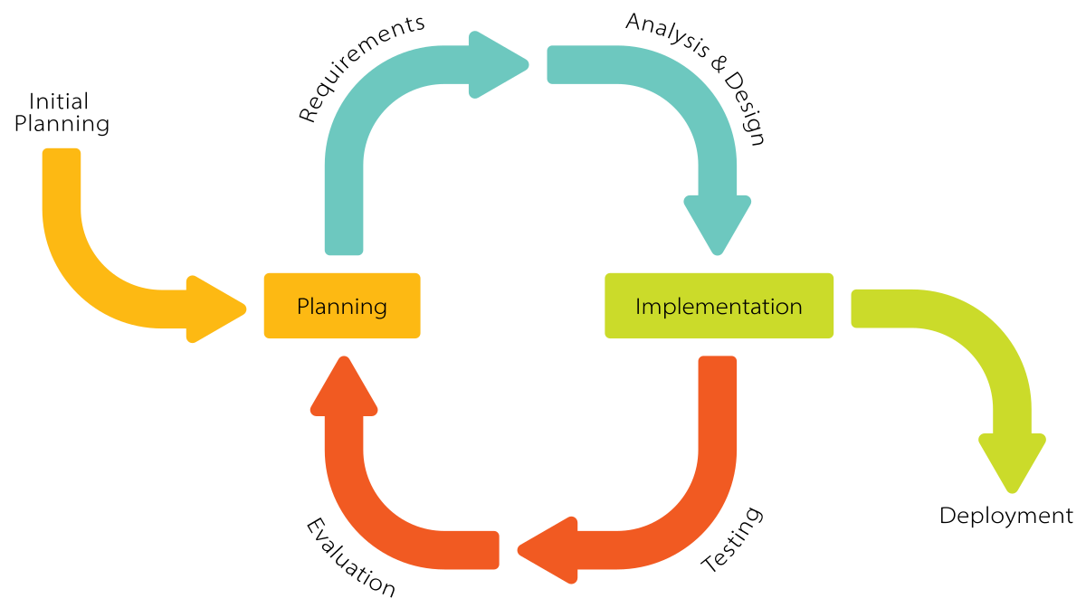 I chose the Iterative approach for this project because it allows me to develop the dashboard step by step, focusing on one part at a time. This method makes it easier to adjust to any changes or new ideas that come up, ensuring that the project stays on track and delivers a high-quality result.

**Figure 1: Iterative Model of Software Development**

The development of Saral Admin followed the Iterative Development Model, where features were implemented in cycles. Each iteration involved planning, designing, coding, testing, and reviewing, ensuring continuous improvements and refinements. This approach allowed flexibility in development, making it well-suited for a single developer working independently

The main goal during this system analysis phase is to create a clear and simple dashboard that helps businesses manage their work more easily. By understanding how users will interact with the system and focusing on their needs, I can design features that make their tasks faster and more efficient.

### **3.1.1 Requirement Analysis**

#### **i. Functional Requirements**

* Administrators can create, edit, and delete user accounts and manage client records.
* Administrators can create, assign, and track projects while monitoring progress and deadlines.
* Displays key metrics through charts and graphs for informed decision-making.
* Provides secure options for adding, editing, deleting, and retrieving business-critical data.
* Ensures a seamless experience across various devices.
* Ensures smooth navigation with clear layouts, menus, and responsive actions.

**Figure 2: Use-Case Diagram of system above**

#### **ii. Non-Functional Requirements**

* Responsive UI and effective UX.
* Role-based access to make the system secure.
* Error free and Uninterrupted performance.
* Easy to use, user friendly user interface.

### **3.1.2 Feasibility Analysis**

#### **i. Technical Feasibility**

The project depends on the MERN stack, known for its scalability, flexibility, and robust performance. The stack leverages the strengths of each component, allowing developers to build efficient, scalable, and responsive web applications [8]. TypeScript enhances code quality by reducing runtime errors, while Tailwind CSS ensures a responsive and visually appealing user interface. All these technologies are widely supported and have extensive documentation, which minimizes technical risks.

#### **ii. Operational Feasibility**

The Saral Admin project is operationally feasible as it aligns well with the needs of businesses looking to streamline their administrative tasks. By focusing on ease of use and essential functionality, Saral Admin ensures that businesses can adopt the system without significant disruptions to their current operations.

#### **iii. Economical Feasibility**

From an economic perspective, Saral Admin is a cost-effective solution. The development relies on open-source technologies like the MERN stack, replacing MongoDB with MySQL database, Tailwind CSS for styling, and TypeScript for added reliability. These choices eliminate the need for expensive software licenses and reduce development costs

#### **iv. Schedule Feasibility**

Timely completion of the project is critical to its success. A detailed Gantt chart was prepared to outline tasks, milestones, and deadlines, ensuring that the project remains on schedule. Regular progress reviews and adjustments ensure that all development activities are completed within the allotted time frame using the available resources.

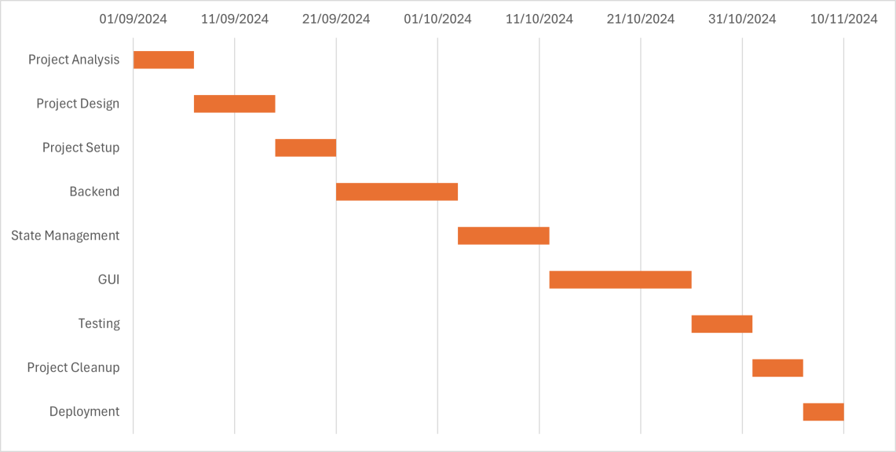

**Table 1: Gantt Chart**

### **3.1.3 Data Modeling (ER Diagram)**

The model for this project is represented by this ER diagram. It displays every visual tool for the database table as well as the relationships between the various entities.

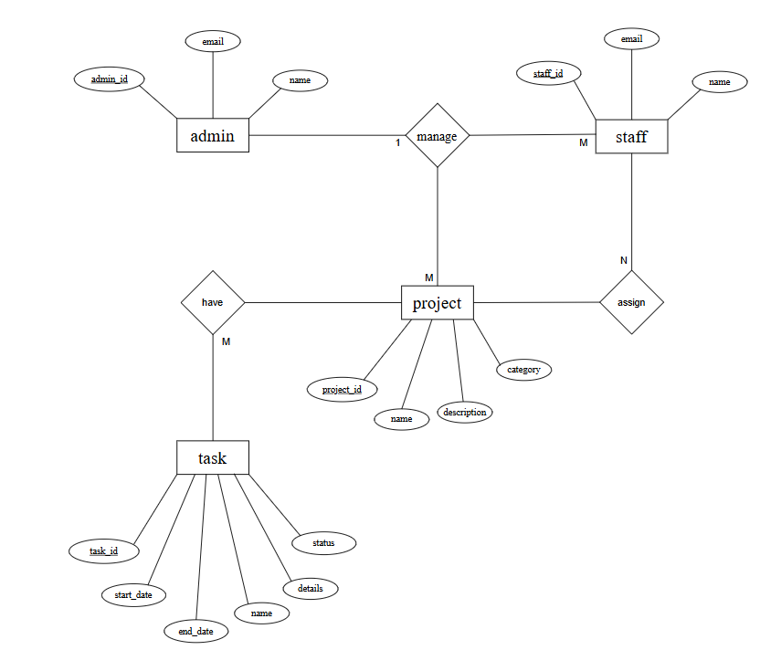

**Figure 3: ER Diagram**

### **3.1.4 Logical Level DFD**

Data Flow Diagrams (DFDs) illustrate how data moves through the system, starting from external users and processes, and flowing into internal operations and data stores. These diagrams help visualize how various components interact with each other, making it easier to understand and design the system's functionality.

**Figure 4: Context Diagram**

**Figure 5: DFD level 1**

## **3.2 System Design**

### **3.2.1 Architectural Design**

The architectural design of Saral Admin focuses on creating a structured and scalable application that separates the user interface, business logic, and data storage layers. This modular approach enhances flexibility and maintainability.

The presentation layer will handle the user interface and interaction. It will be built using ReactJS to ensure a responsive and intuitive experience for users. The business layer will be completely independent, managing all core functionalities, logic, and processes.

Data will be stored securely in a SQL database, which will handle all storage and retrieval operations. The backend layer, implemented using Node.js, will act as a bridge between the frontend and the database.

This architecture promotes a clean separation of concerns, making the system easier to update, debug, and scale. It ensures that Saral Admin can adapt to future requirements without major overhauls, maintaining performance and reliability throughout its lifecycle.

**Figure 6: Three Tier Architecture**

### **3.2.2 Database Schema Design**

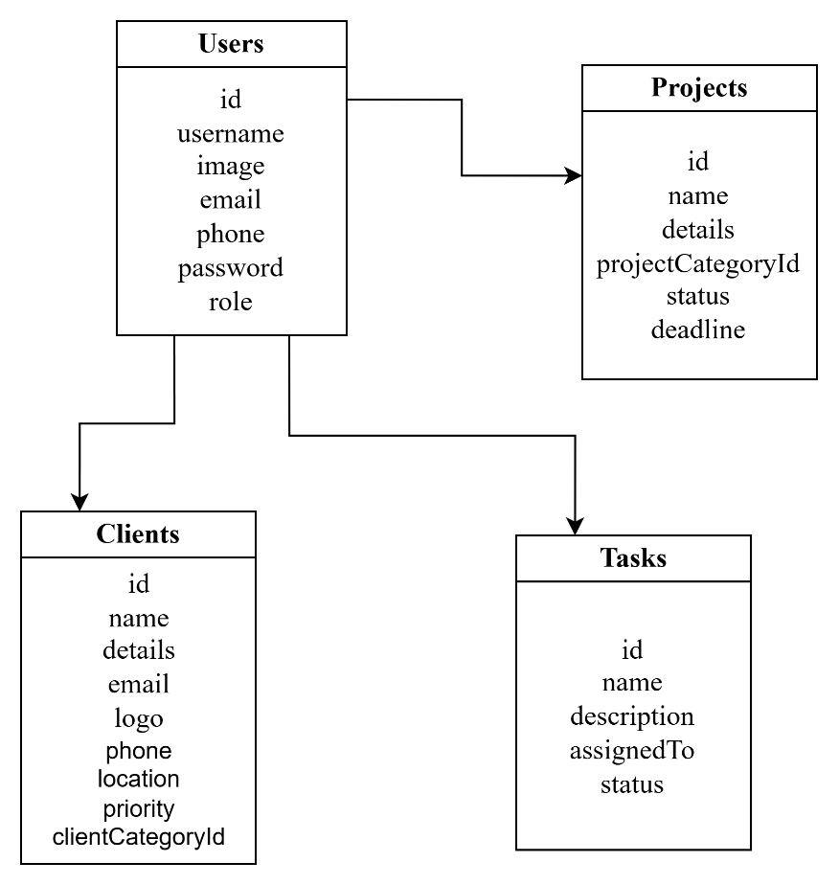

**Figure 7: Database Schema Diagram**

### **3.2.3 Interface Design**

Before starting the actual design phase of the project, interface designs were created to visually represent how users will interact with the system. These designs emphasize key features, including a homepage with dynamic charts and graphs to provide real-time data insights.

As a web application, Saral Admin focuses on interactivity and responsiveness across devices. The interface designs follow a structured approach to ensure clear navigation and intuitive functionality.

This process ensures that the application is user-friendly, meets the diverse needs of administrators, and supports efficient decision-making. The focus on simplicity and clarity in the interface design helps reduce the learning curve, allowing users to leverage the dashboard’s full potential from the start.

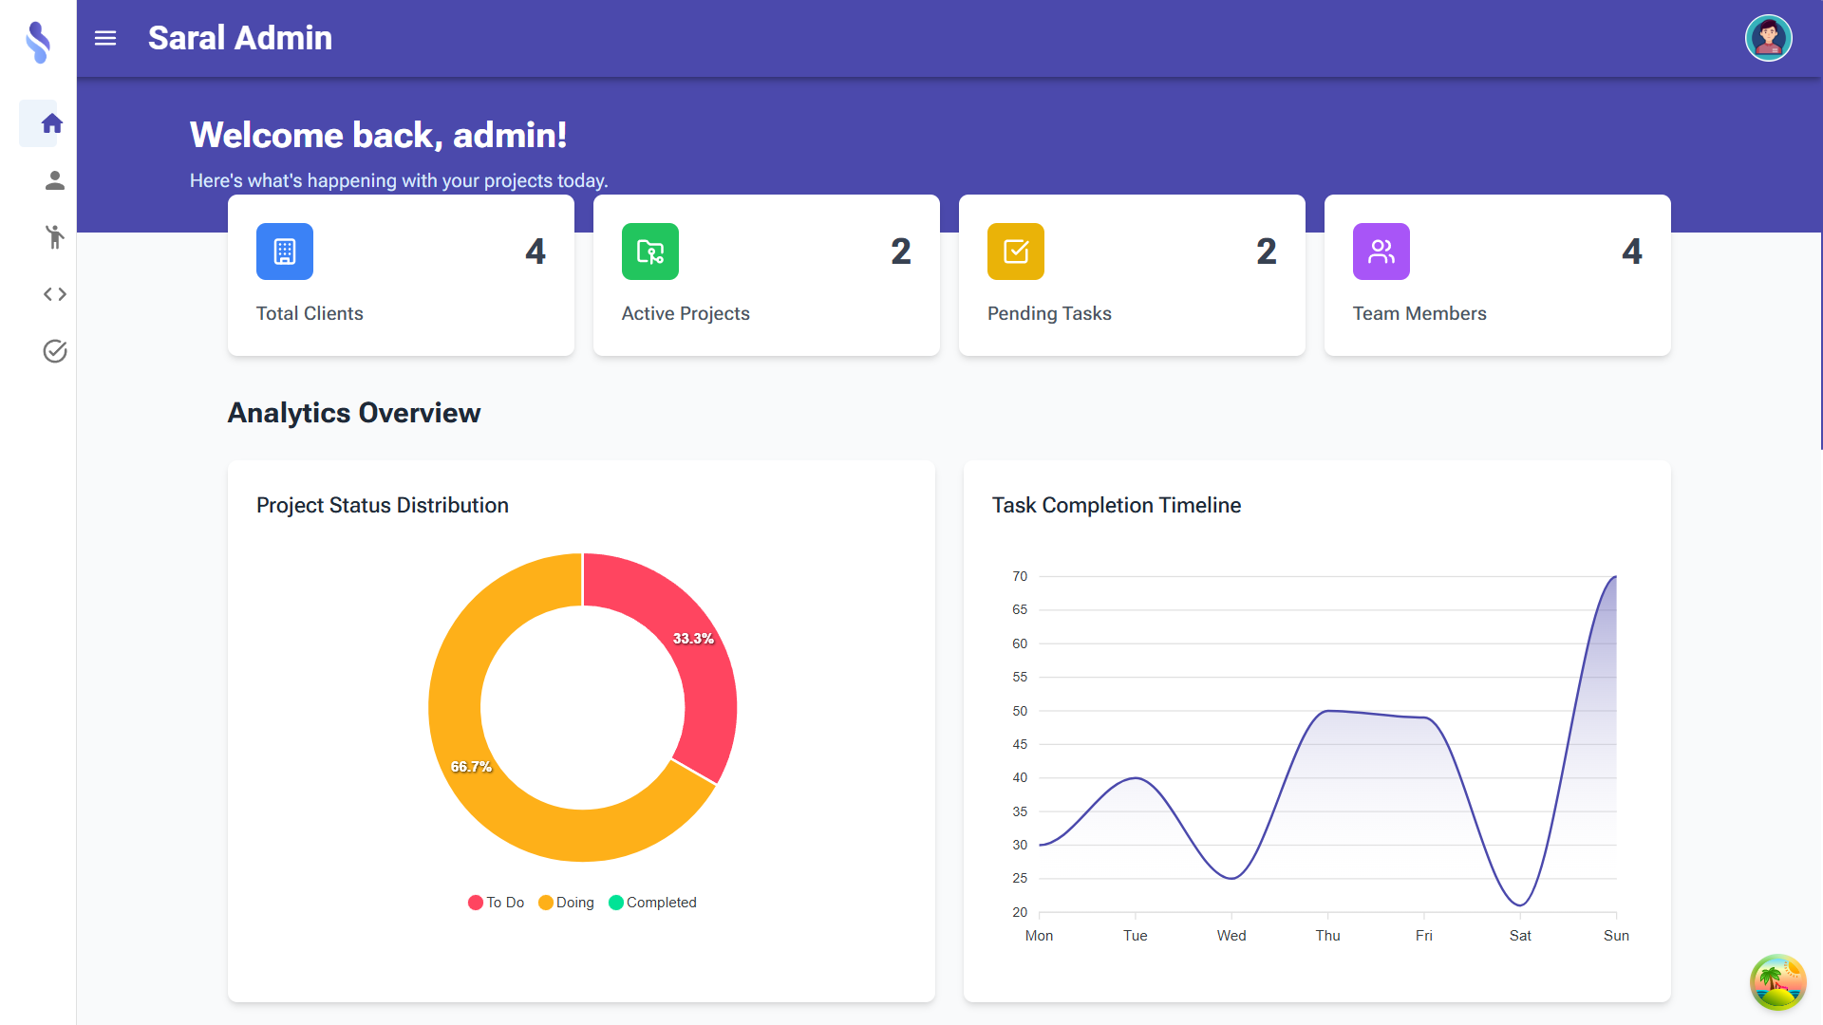

**Figure 8: Homepage UI of Saral Admin**

### **3.2.4 Physical DFD Design**

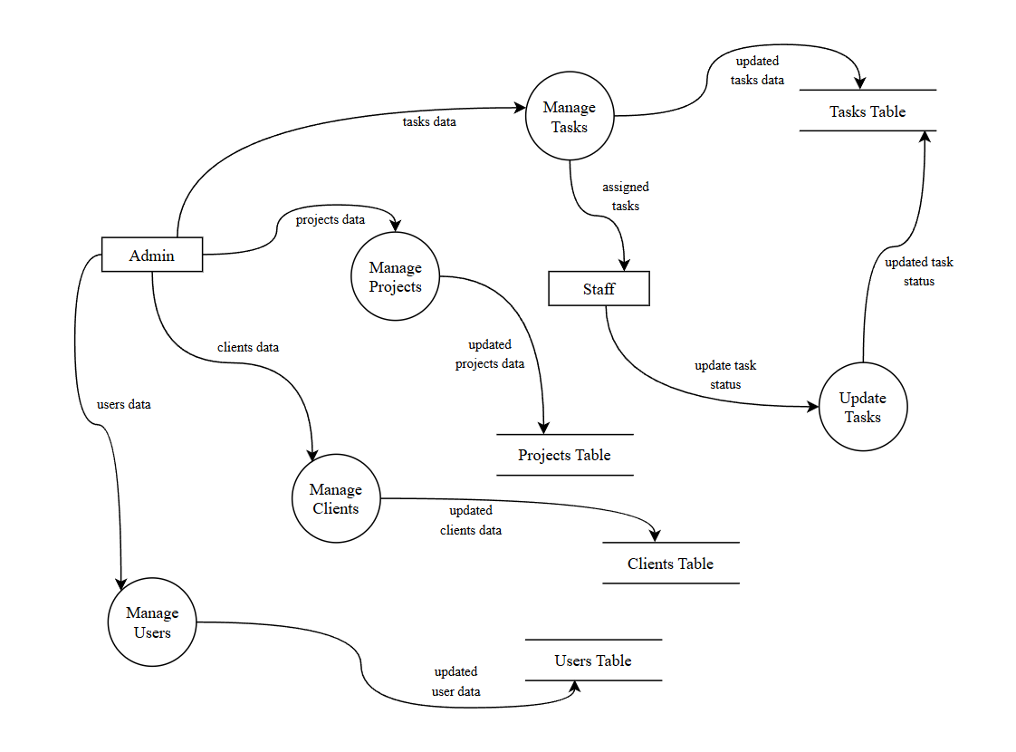

**Figure 9: Physical DFD Diagram**

# **Chapter 4: Implementation and Testing**

## **4.1 Implementation**

### **4.1.1 Tools Used**

The following tools and technologies were used in the development of the software. The list of tools below includes the technologies, database and tools used:

1. **Frontend Development:** React.js is a popular JavaScript library used to develop frontend applications. TypeScript is a type safe version of JavaScript that is strict on OOP. Similarly, TailwindCSS is a CSS framework that provides utility classes for CSS. I have used React, TypeScript and TailwindCSS in order to build the frontend of this project.
2. **Backend Development:** Nodejs is a JavaScript runtime that allows for development of scalable server side applications. It is used to handle server logic in the project. Expressjs is a nodejs framework that simplifies the process of building nodejs applications. I have used nodejs, expressjs and sequalize in order to build the backend of this project.
3. **Database:** MySQL is used as database in this project as it provides structured and efficient way to store and manage data and it can be easily accessed by localhost/phpmyadmin.
4. **Other Tools:** Beside the main tools used in this project, I have used Visual Studio Code as my IDE, Git and GitHub for version control and Postman for API testing.

### **4.1.2 Implementation Details of Modules**

The details of some key functions and modules that exists in my project are provided below:

1. **Login Controller**

This is a backend function for login that handles login in the server. Email and password of the user are requested from frontend and the function checks for existing user in the database, filtering by email provided. Then the server creates an access token and returns the data in the form of a JSON with status code 201. If the password or email provided are invalid, the server throws an error and does not provide a token that would be used to access the application.

*const* loginUser = asyncHandler(*async* (*req*, *res*) => {

*const* { email, password } = *req*.body;

*const* user = *await* User.findOne({ where: { email } });

*if* (user && (*await* bcrypt.compare(password, user.password))) {

*const* token = createToken(*res*, user.id);

*res*.status(201).json({

      id: user.id,

      username: user.username,

      email: user.email,

      phone: user.phone,

      role: user.role,

      image: user.image,

      token: token,

    });

  } *else* {

*res*.status(401);

*throw* new Error("Invalid email or password");

  }

});

1. A screenshot of a computer

   AI-generated content may be incorrect.**File Structure**

**Figure 10: Folder Structure of the Project**

1. **Database Schema**

I have created schema of the different tables in my code using sequalize. Sequalize is a ORM library for SQL databases, It translates JavaScript codes into SQL queries and enables efficient implementation and management of the database directly from the code. The code below is a schema for client_categories table. I have defined schemas for other tables in a similar manner inside the models folder in my backend.

*import* { DataTypes } *from* "sequelize";

*import* sequelize *from* "../../config/database.js";

*const* ClientCategory = sequelize.define(

  "ClientCategory",

  {

    id: {

      type: DataTypes.INTEGER,

      autoIncrement: true,

      primaryKey: true,

    },

    name: {

      type: DataTypes.STRING,

      allowNull: false,

      validate: {

        notEmpty: { msg: "Category name is required" },

      },

    },

  },

  {

    timestamps: true,

    tableName: "client_categories",

  }

);

*export* *default* ClientCategory;

## **4.2 Testing**

Testing was a crucial part of the development process for Saral Admin, ensuring that the application met its functional and non-functional requirements. A combination of manual and automated testing approaches was used to validate the system's performance, functionality, and user experience. Below is an overview of the testing process and the steps taken to ensure the application's reliability:

### **4.2.1. Test Cases for Unit Testing**

**Table 2: Sign Up**

|  |  |  |  |  |  |
| --- | --- | --- | --- | --- | --- |
| SN | Test Case Description | Data Tested | Expected Result | Actual Result | Status |
| 1 | Empty Field Submitted | email:  password: admin | Please fill in all fields | expected | Pass |
| 2 | Invalid Email Format | email: abc.c.c  password: admin | Please include an ‘@’ in email. ‘abc.c.c’ is missing an ‘@’ | expected | Pass |
| 3 | All Valid Details Entered | email: admin@admin.com password: admin | Login Successful | expected | Pass |
| 4 | Unauthorized Access | email: user@user.com  password: user123 | Error: User is not an admin | expected | Pass |
| 5 | Wrong Password | email: admin@admin.com  password: hero122 | Login Failed: Please Try Again | expected | Pass |

**Table 3: Add Category**

|  |  |  |  |  |  |
| --- | --- | --- | --- | --- | --- |
| SN | Test Case Description | Data Tested | Expected Result | Actual Result | Status |
| 1 | Add Category | Name: Technology | ‘Technology’ successfully created | expected | Pass |

### **4.2.2. Test Cases for System Testing**

**Table 4: System Testing**

|  |  |  |  |  |  |
| --- | --- | --- | --- | --- | --- |
| SN | Test Case Description | Data Tested | Expected Result | Actual Result | Status |
| 1 | Create New User | email: test@test.com  password: user | User is created and is displayed in Table | expected | Pass |
| 2 | Assign Project and Client to multiple users | userId: [1, 2]  projectId: 4  clientId: 6  title: Within 9 days | Task is created and is displayed in table’ | expected | Pass |
| 3 | Open profile Page | Click on profile menu | Display profile Info | expected | Pass |
| 4 | Delete Client from Table | supply client id to delete function | Task is deleted and table is updated | expected | Pass |
| 5 | Update Task Status | Edit status of task from todo to doing | Task’s status updated successfully | expected | Pass |
| 6 | View Client Details | Click on client name in the table | Single Client Page Opened | expected | Pass |
| 7 | Redirect after adding (client, users, projects, tasks) | Add task and click submit | Redirected to specified page on success | expected | Pass |
| 8 | Return to Login page | logout | Removed app access and redirected to login | expected | Pass |

# **Chapter 5: Conclusion and Future Recommendations**

## **5.1 Lesson Learnt / Outcome**

The expected outcome of Saral Admin is to create a user friendly, highly productive, inter company software that assists businesses with automation, decision making, human resource management and enhances overall productivity of the organization. Admin will be the one that utilized the software the most as admin will be the one responsible to manage everything through the software. Staffs can simply view the tasks assigned to them and mark them completed when they have finished their task. Saral Admin, as its name suggests, aims to provide a very simple and easy admin focused management system for businesses, leading to proper time management, proper decision making, data visualization, increasing the overall efficiency of the business

## **5.2 Conclusion**

Saral Admin was developed as an intercompany management tool to help businesses with their operations. The project successfully achieved its main goals by providing a centralized platform for managing business data, coordinating tasks, and visualizing key metrics through charts and graphs.

One of the main objectives was to offer companies a powerful management tool, and Saral Admin accomplishes this by allowing businesses to organize their operations efficiently. The platform also ensures easy access and organization of business data, making it simpler for users to retrieve and manage information. Additionally, with the integration of data visualization features, users can analyze business performance more effectively through real-time graphs and charts.

The development process involved using modern technologies like the MERN stack (with MySQL), TypeScript, and Tailwind CSS, which helped me build a scalable, responsive, and maintainable application. The project went through multiple phases of development, testing, and improvements to ensure a user-friendly experience with robust functionality.

Saral Admin provides businesses with a powerful and efficient solution for managing their workflows, enhancing productivity, and making informed decisions based on real-time data. With further improvements, it aims to become an essential tool for businesses seeking long-term efficiency and growth.

## **5.3 Future Recommendations**

To further enhance Saral Admin and to ensure it remains a top notch solution for businesses, I have some future plans. With enough time and effort, I believe these goals are achievable and if successful they will further improve the quality of the software enhancing the business ultimately. I have listed the future ideas below:

* Enhanced Mobile Support
* Advanced Analytics and Reporting
* Enhanced Security Measures
* Customizable Dashboard
* Notifications Reminders
* Data Filtering
* DND Task Management
* Notices and Updates
* Staff Applications and Attendance

# **APPENDIX**

**Figure 11: User Management**

**Figure 12: Add Clients**

**Figure 13: Edit Project**

**Figure 14: Task Details**

# **REFERENCES**

[1] Scott Rigdon “How Has the Internet Changed Communication in Business?,” Vonage, 2023[Online]. Available: <https://www.vonage.com/resources/articles/how-the-internet-changed-communication-in-business/>

[2] Rapid E Suite “How Important are Dashboards for Business?,” LinkedIn, 2023 [Online] Available:<https://www.linkedin.com/pulse/how-important-dashboards-business-rapid-e-suite/>

[3] SAP SE, "SAP ERP: Enterprise Resource Planning Software," SAP, 2022. [Online]. Available: <https://www.sap.com/products/erp.html>

[4] Nitish Arora “Why did you choose to work on Salesforce rather than another CRM software?,” Quora, 2023. [Online]. Available: <https://www.quora.com/Why-did-you-choose-to-work-on-SalesForce-rather-than-another-CRM-software>

[5] Salesforce, Inc., "Salesforce CRM: Customer Relationship Management," Salesforce, 2023. [Online]. Available: <https://www.salesforce.com/crm/>

[6] Microsoft Corporation, "Microsoft Dynamics 365: Business Applications," Microsoft, 2024. [Online]. Available: <https://dynamics.microsoft.com/>

[7] Zoho Corporation, "Zoho CRM: Customer Relationship Management Software," Zoho, 2023. [Online]. Available: <https://www.zoho.com/crm/>

[8] Coursera Staff, “MERN Stack: An Overview,” Coursera 2024. [Online]. Available: <https://www.coursera.org/articles/mern-stack>