KIIT DU — SAP Integration Developer
Batch: CSE ,Group: 2027_SAP(OE)

SAP CAPSTONE PROJECT REPORT

Blueprint Document: SAP Configuration for a Fictitious Enterprise
Company: Nexora IT Services Pvt. Ltd.

Submitted By
Name: ARYAN AMITANSHU SAHU
Roll Number: 23052788
Program: SAP Integration Developer
Batch: 2027_SAP(OE)
Submission Date: April 21, 2026
KIIT DU | School of Computer Engineering

1. Project Title & Problem Statement

1.1 Project Title
SAP Enterprise Blueprint: End-to-End Configuration of Nexora IT Services Pvt. Ltd. across Financial Accounting (FI), Materials Management (MM), and Sales & Distribution (SD) Modules.

1.2 Problem Statement
IT services companies in India typically operate with fragmented systems for resource procurement, project billing, and financial reporting. Separate tools for vendor management, internal asset procurement, and client invoicing lead to reconciliation errors, delayed revenue recognition, and poor cost visibility across projects and service lines.

This project defines and blueprints the SAP configuration for Nexora IT Services Pvt. Ltd., a fictitious Indian IT services company, covering all major sub-organizations and customization steps across the FI, MM, and SD functional modules. The blueprint serves as a complete implementation guide that an SAP consultant would follow to configure the system from scratch — enabling unified procurement, billing, and financial operations on a single platform.

2. Company Profile — Nexora IT Services Pvt. Ltd.

2.1 About the Company
Nexora IT Services Pvt. Ltd. is a fictitious mid-sized IT services company headquartered in Bengaluru, Karnataka, India. The company delivers software development, cloud infrastructure management, and IT consulting services to enterprise clients across BFSI, retail, and manufacturing sectors. It operates with approximately 2,800 employees across two delivery centres.

2.2 Company Overview Table
Company Name | Nexora IT Services Pvt. Ltd.
Industry | Information Technology & IT-Enabled Services
Headquarters | Bengaluru, Karnataka, India
Founded | 2011
Annual Revenue | INR 420 Crores (approx.)
Employees | ~2,800
Delivery Centres | Bengaluru (Primary), Hyderabad (Secondary)
Currency | Indian Rupee (INR)
Fiscal Year | April to March (Indian FY)
SAP System | SAP ECC 6.0 / S/4HANA

2.3 Organizational Structure Overview
The SAP organizational structure for Nexora mirrors its real-world delivery model. The hierarchy flows from the Client level down through Company Code, Plants (Delivery Centres), Purchase Organizations, Storage Locations (IT Asset Stores), Sales Organizations, and Distribution Channels (Direct, Partner, Offshore). This structure ensures accurate financial reporting by project, efficient IT asset procurement, and seamless client billing.

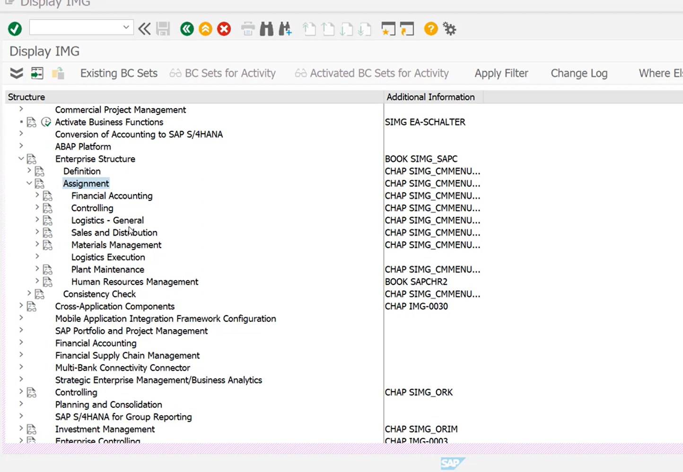
Figure 1: SAP Enterprise Structure showing FI, MM, and SD hierarchy.

3. Financial Accounting (FI) Module Configuration

3.1 Module Overview
The Financial Accounting (FI) module is the financial backbone of Nexora IT Services. It records all business transactions in real time — covering accounts payable (vendor payments for hardware/software), accounts receivable (client billing), general ledger, and asset accounting for IT infrastructure. All FI entries are triggered automatically by MM procurement events and SD billing events.

3.2 Client Configuration
In SAP, the Client is the highest organizational unit. All company codes, master data, and configurations are contained within a single client. Nexora operates on Client 200.
Client ID | 200
Client Name | Nexora SAP Production
Currency | INR
Language | EN (English)

3.3 Company Code
The Company Code is the central FI organizational unit representing Nexora as an independent legal accounting entity.
Company Code | NXPL
Company Name | Nexora IT Services Pvt. Ltd.
City | Bengaluru
Country | India (IN)
Currency | INR
Language | EN
Chart of Accounts | NXCA
Fiscal Year Variant | V3 (Apr–Mar)

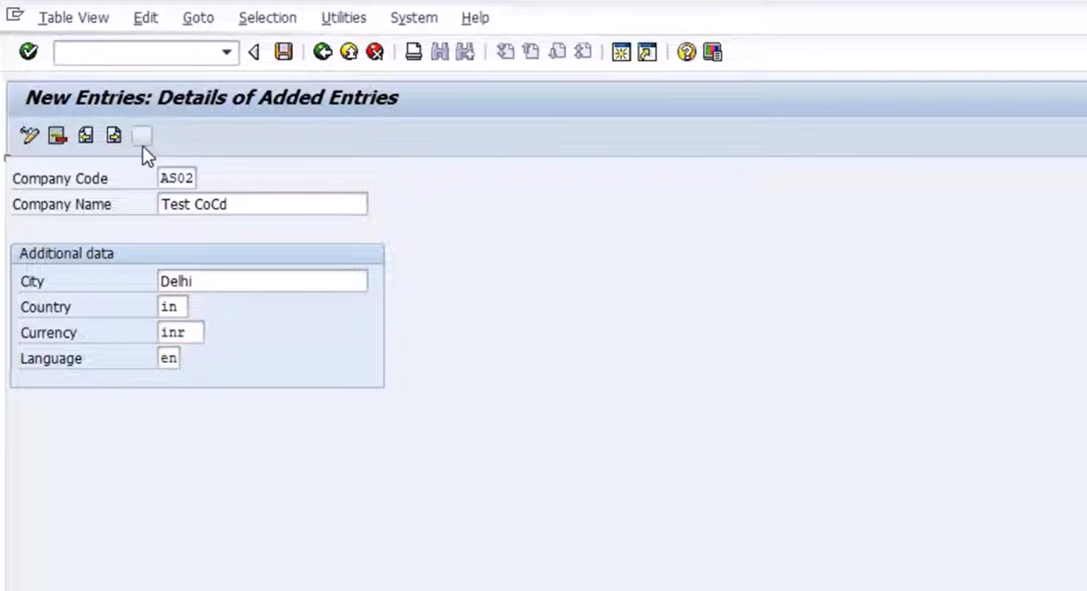
Figure 2: Sample Company Code configuration for Nexora IT Services Pvt. Ltd.

3.4 Chart of Accounts (COA)
Nexora uses a custom Chart of Accounts called NXCA, aligned to the Indian Companies Act 2013 framework and suitable for an IT services company with project-based revenue and capitalised software assets.
Account Range | Account Type | Description
100000–199999 | Balance Sheet | Assets — Fixed, Current & Intangible
200000–299999 | Balance Sheet | Liabilities & Equity
300000–399999 | P&L | Revenue — Professional Services & Products
400000–499999 | P&L | Direct Costs — Salaries & Subcontracting
500000–599999 | P&L | Operating Expenses — Rent, Utilities, SaaS
600000–699999 | P&L | Tax & Statutory Accounts (GST, TDS)

3.5 Fiscal Year Variant
Nexora follows the Indian Financial Year: April 1 to March 31. Fiscal Year Variant V3 is configured with 12 posting periods (April to March) and 4 special periods for year-end adjustments.

3.6 Posting Period Variant
Period | Month | Open/Close Status
Period 1 | April | Open
Period 2 | May | Open
Period 3 | June | Open
Period 4–12 | July–March | Controlled by Finance Team
Special 13–16 | Year-End | Open during closing only

3.7 Document Types & Number Ranges
Document Type | Code | Description | Number Range
Vendor Invoice | KR | AP Invoice — Hardware/Software | 1900000000–1999999999
Customer Invoice | DR | AR Invoice — Client Billing | 1800000000–1899999999
General Journal | SA | GL Journal Entry | 1000000000–1099999999
Payment | ZP | Outgoing Payment | 1700000000–1799999999
Credit Memo | KG | Vendor Credit Adjustment | 1600000000–1699999999

3.8 Key FI Customization Steps
Step 1: Define Company
- Path: SPRO → Enterprise Structure → Definition → Financial Accounting → Define Company
- Company ID: NXPL | Name: Nexora IT Services Pvt. Ltd. | Country: IN | Currency: INR
Step 2: Define Company Code
- Path: SPRO → Enterprise Structure → Definition → Financial Accounting → Edit, Copy, Delete, Check Company Code
- Company Code: NXPL | Assign to Company: NXPL | T-Code: OX02
Step 3: Assign Company Code to Chart of Accounts
- Path: SPRO → Financial Accounting → General Ledger → GL Accounts → Master Data → Assign COA
- Company Code NXPL → COA: NXCA | T-Code: OB62
Step 4: Define Fiscal Year Variant
- Path: SPRO → Financial Accounting → FA Global Settings → Fiscal Year → Maintain Fiscal Year Variant
- Variant: V3 | Description: April–March (Indian FY) | 12 Normal + 4 Special Periods | T-Code: OB29
Step 5: Assign Fiscal Year Variant to Company Code
- T-Code: OB37 — Assign V3 to Company Code NXPL
Step 6: Define Document Types & Number Ranges
- T-Code: OBA7 — Define document types KR, DR, SA, ZP, KG
- T-Code: FBN1 — Maintain number ranges for each document type per fiscal year

4. Materials Management (MM) Module Configuration

4.1 Module Overview
The Materials Management (MM) module manages Nexora's complete Procure-to-Pay cycle for IT assets and services — hardware procurement (laptops, servers, networking gear), licensed software, cloud infrastructure subscriptions, and third-party subcontracting services. It covers purchase requisition, vendor selection, goods/service receipt, and invoice verification.

4.2 Plant Configuration
In SAP MM, a Plant represents a delivery centre or operational unit. Nexora operates two delivery centres configured as plants:
Plant Code | Plant Name | Location | Type
NX01 | Nexora Bengaluru Delivery Centre | Bengaluru, Karnataka | Primary Delivery & HQ
NX02 | Nexora Hyderabad Delivery Centre | Hyderabad, Telangana | Secondary Delivery

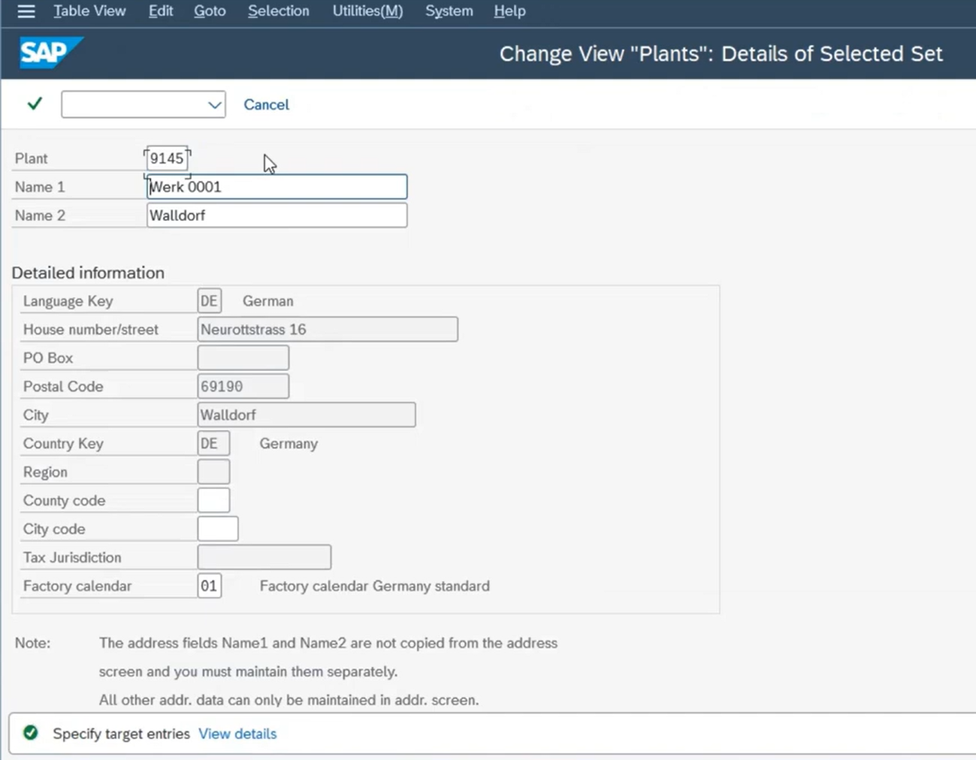

Figure 3: Sample Plant configuration representing Nexora delivery centres.

4.3 Storage Locations
Storage Locations represent physical areas within a plant for managing IT assets and consumables inventory.
Plant | Storage Location | Code | Description
NX01 | IT Asset Store | AS01 | Laptops, desktops, peripherals — Bengaluru
NX01 | Server Room | SR01 | Servers, networking equipment — Bengaluru
NX01 | Consumables Store | CS01 | Stationery, cables, accessories
NX02 | IT Asset Store | AS02 | Laptops, desktops, peripherals — Hyderabad
NX02 | Server Room | SR02 | Servers, networking equipment — Hyderabad

4.4 Purchase Organization
Parameter | Value
Purchase Org Code | NX_PO
Purchase Org Name | Nexora Central Procurement
Assignment | Cross-Plant (NX01 and NX02)
Currency | INR

4.5 Purchase Groups
Purchase Group | Code | Responsible For
IT Hardware Group | PG01 | Laptops, servers, networking devices, peripherals
Software & Licensing | PG02 | ERP licenses, SaaS subscriptions, OS & productivity
Services Group | PG03 | Subcontracting, AMC, cloud managed services

4.6 Material Types
Material Type | Code | Description
IT Hardware | ZITW | Laptops, servers, networking gear — stock-managed
Software License | ZSWL | Perpetual and subscription software licenses
IT Consumables | CONS | Cables, accessories — low-value, non-capitalised
Services | DIEN | Maintenance, consulting, cloud services (non-stock)
Capital Equipment | EQUI | High-value server/storage assets — capitalised

4.7 Key MM Customization Steps
Step 1: Define Plant
- Path: SPRO → Enterprise Structure → Definition → Logistics General → Define, Copy, Delete, Check Plant
- Plant NX01 — Bengaluru | Plant NX02 — Hyderabad | T-Code: OX10
Step 2: Assign Plant to Company Code
- Path: SPRO → Enterprise Structure → Assignment → Logistics General → Assign Plant to Company Code
- NX01 & NX02 → NXPL | T-Code: OX18
Step 3: Define Storage Locations
- Path: SPRO → Enterprise Structure → Definition → Materials Management → Maintain Storage Location
- AS01, SR01, CS01 for NX01 | AS02, SR02 for NX02 | T-Code: OX09
Step 4: Define Purchase Organization & Groups
- Path: SPRO → Enterprise Structure → Definition → MM → Maintain Purchase Organization
- Code: NX_PO | T-Code: OX08
- Purchase Groups PG01–PG03 defined via T-Code OME4
Step 5: Assign Purchase Org to Company Code & Plant
- Path: SPRO → Enterprise Structure → Assignment → MM → Assign Purchase Org to Company Code & Plant
- NX_PO → NXPL → NX01, NX02
Step 6: Define Valuation Area
- Valuation at Plant level — each delivery centre maintains independent IT asset valuation
- IT Hardware: Moving Average Price (MAP) | Capital Equipment: Standard Price | T-Code: OMWM
Step 7: Define Vendor Account Groups
- Domestic Vendors (VEND): Indian hardware/software vendors — taxable with GST
- Foreign Vendors (FVND): International SaaS and OEM vendors
- One-Time Vendors (OTVE): Petty purchases and emergency procurement

5. Sales & Distribution (SD) Module Configuration

5.1 Module Overview
The Sales & Distribution (SD) module manages Nexora's complete Order-to-Cash cycle — from client engagement and quotation to project work order creation, milestone billing, and payment collection. It is tightly integrated with MM (for billable asset delivery) and FI (for revenue posting) to ensure real-time financial visibility on all client contracts.

5.2 Sales Organization
Parameter | Value
Sales Org Code | NX_SO
Sales Org Name | Nexora Sales Organization
Company Code | NXPL
Currency | INR

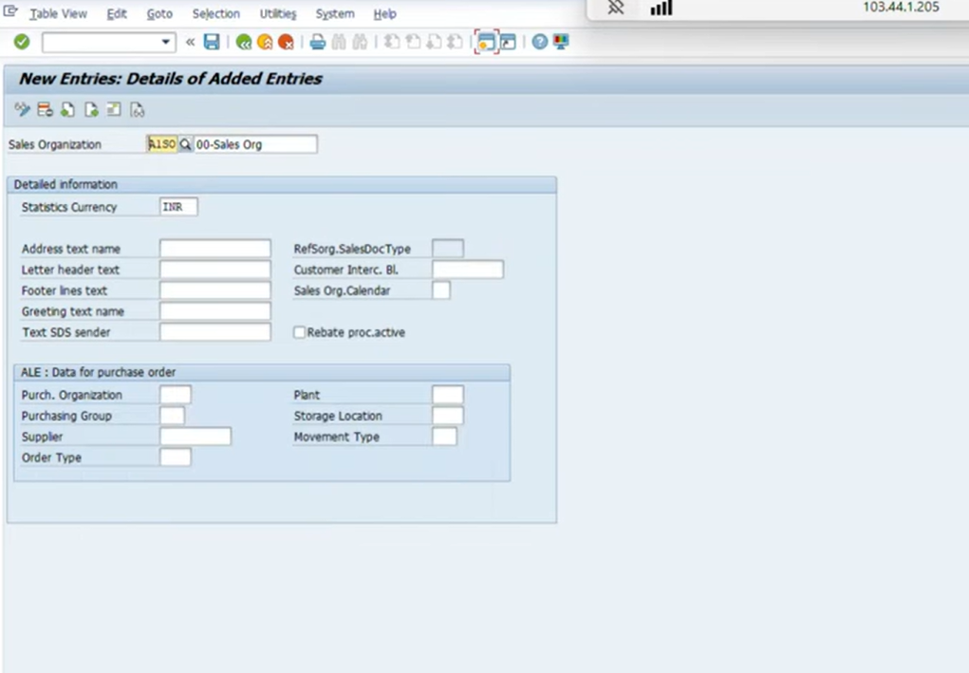

Figure 4: Sales Organization setup for client billing and sales structure.

5.3 Distribution Channels
Distribution Channels define how Nexora delivers its services to clients.
Channel Code | Channel Name | Description
DI | Direct Engagement | Direct B2B contracts with enterprise clients
PT | Partner Channel | Sales through system integrator partners
OF | Offshore Delivery | Fixed-price offshore project contracts

5.4 Divisions
Division Code | Division Name | Services
SW | Software Services | Custom development, QA, digital transformation
IN | Infrastructure Services | Cloud, networking, IT infrastructure management
CS | Consulting Services | SAP, ERP, IT advisory, business analysis

5.5 Sales Area
The Sales Area is the combination of Sales Organization + Distribution Channel + Division. Each unique combination forms a Sales Area with its own pricing, customer master data, and sales document configuration.
Sales Org | Distribution Channel | Division | Sales Area Description
NX_SO | DI | SW | Direct — Software Services
NX_SO | DI | IN | Direct — Infrastructure Services
NX_SO | PT | SW | Partner — Software Services
NX_SO | OF | SW | Offshore — Software Services
NX_SO | DI | CS | Direct — Consulting Services

5.6 Shipping Point
Shipping Point | Code | Location
Bengaluru Dispatch Point | SPBG | NX01 Plant — Bengaluru (for hardware deliveries)
Hyderabad Dispatch Point | SPHY | NX02 Plant — Hyderabad (for hardware deliveries)

5.7 Customer Account Groups
Account Group | Code | Description
Domestic Enterprise | CENT | Indian B2B corporate clients
Export Client | EXCU | International clients billed in USD/EUR
Government Client | GOVC | Central/State Government IT contracts
One-Time Client | OTCU | Short-term or one-off engagement clients

5.8 Key SD Customization Steps
Step 1: Define Sales Organization
- Path: SPRO → Enterprise Structure → Definition → Sales & Distribution → Define Sales Organization
- Code: NX_SO | T-Code: OVX5
Step 2: Assign Sales Org to Company Code
- Path: SPRO → Enterprise Structure → Assignment → SD → Assign Sales Organization to Company Code
- NX_SO → NXPL | T-Code: OVX3
Step 3: Define Distribution Channels & Assign to Sales Org
- Path: SPRO → Enterprise Structure → Definition → SD → Define Distribution Channel
- DI, PT, OF — T-Code: OVX1 | Assign to NX_SO — T-Code: OVX4
Step 4: Define Divisions & Assign to Sales Org
- T-Code: OVX2 (Define) | T-Code: OVX5 (Assign to Sales Org)
- SW — Software Services | IN — Infrastructure Services | CS — Consulting Services
Step 5: Set Up Sales Areas
- Path: SPRO → SD → Sales → Sales Documents → Define Sales Area
- All five combinations of NX_SO + Channel + Division configured
Step 6: Define Pricing Procedure
- Nexora uses a milestone-based billing pricing procedure for project contracts with GST compliance:
Step | Condition Type | Description
10 | PR00 | Base Service Price / Milestone Value
20 | ZD01 | Volume / Long-term Contract Discount
30 | MWST | GST (18% for IT Services — IGST/CGST+SGST)
40 | SKTO | Early Payment Cash Discount
50 | NETWR | Net Invoice Value

6. Integration Between FI, MM & SD

6.1 Overview of Module Integration
SAP's real-time integration between FI, MM, and SD is central to Nexora's operational efficiency. Every procurement event (hardware purchase, software subscription renewal) and every billing event (client invoice, milestone payment) automatically generates the corresponding financial accounting entry — eliminating manual reconciliation between project managers, procurement, and finance teams.

6.2 MM–FI Integration
MM Event | FI Posting Generated | T-Code
Goods Receipt (Hardware) | IT Asset Stock Dr, GR/IR Clearing Cr | MIGO
Service Entry Sheet (SES) | Service Expense Dr, GR/IR Clearing Cr | ML81N
Invoice Verification (LIV) | GR/IR Clearing Dr, Vendor Payable Cr | MIRO
Vendor Payment | Vendor Payable Dr, Bank Account Cr | F110
Asset Capitalisation (EQUI) | Fixed Asset Dr, GR/IR Clearing Cr | MIGO + AS01

6.3 SD–FI Integration
SD Event | FI Posting Generated | T-Code
Milestone Billing / Invoice | Client Receivable Dr, Revenue Cr | VF01
Client Payment Receipt | Bank Dr, Client Receivable Cr | F-28
Credit Memo (SLA Penalty) | Revenue Dr, Client Receivable Cr | VF01 (Credit)
Down Payment (Advance) | Bank Dr, Advance Liability Cr | F-29

6.4 MM–SD Integration
When a Sales Order for hardware supply is created (VA01), the system checks IT asset inventory at the assigned plant (MM availability check). Upon delivery (VL01N), a goods issue reduces the IT Asset Store inventory. This simultaneously triggers a COGS entry in FI, ensuring the P&L accurately reflects the cost of hardware delivered to the client — without any manual journal entries.

7. Tech Stack & Tools

7.1 SAP Components Used
Component | Purpose
SAP ECC 6.0 / S/4HANA | Core ERP platform for all configurations
SAP FI (Financial Accounting) | General Ledger, AP, AR, Asset Accounting
SAP CO (Controlling) | Cost Centre (by project/BU) & Profit Centre Accounting
SAP MM (Materials Management) | IT Procurement, Asset Inventory, Vendor Management
SAP SD (Sales & Distribution) | Client Contracts, Milestone Billing, Order-to-Cash
SAP PS (Project System) | Integration layer for project-based revenue recognition
SAP SPRO (IMG) | SAP Project Reference Object — configuration tool
SAP GUI / Fiori | Front-end interface for SAP transactions

7.2 Key Transaction Codes Reference
T-Code | Module | Purpose
OX02 | FI | Define Company Code
OB29 | FI | Maintain Fiscal Year Variant
OB62 | FI | Assign COA to Company Code
OB37 | FI | Assign Fiscal Year Variant to Company Code
OX10 | MM | Define Plant
OX09 | MM | Define Storage Locations
OX08 | MM | Define Purchase Organization
OX18 | MM | Assign Plant to Company Code
OVX5 | SD | Define Sales Organization
OVX1 | SD | Define Distribution Channel
OVX2 | SD | Define Division
ME21N | MM | Create Purchase Order
MIGO | MM | Goods Receipt
ML81N | MM | Service Entry Sheet
MIRO | MM | Invoice Verification (Logistics)
VA01 | SD | Create Sales Order
VF01 | SD | Create Billing / Milestone Invoice
F110 | FI | Automatic Payment Run
F-28 | FI | Customer Payment Posting
AS01 | FI-AA | Create Asset Master Record

8. Unique Points & Highlights

8.1 What Makes This Blueprint Distinctive
- Designed specifically for an Indian IT Services company — most SAP blueprints target manufacturing. This blueprint reflects IT-sector realities: service-based revenue, non-physical "goods", milestone billing, and GST at 18% for services.
- Three distinct service divisions (Software, Infrastructure, Consulting) with separate Sales Areas allow independent pricing strategies, revenue reporting, and profitability analysis per practice.
- IT-specific material types (ZITW for hardware, ZSWL for software licenses) are custom-configured to handle the dual nature of IT procurement: physical assets and intangible licenses.
- Service Entry Sheet (ML81N) integration enables SAP to track and validate subcontracting services receipt — critical for IT companies using third-party developers and managed service providers.
- Full integration map between FI, MM, and SD with IT-specific transaction scenarios (milestone billing, advance payments, SLA credit memos) provides a complete audit trail for every client engagement.
- Indian Fiscal Year (April–March) and GST-compliant pricing procedure configured for both direct client billing and partner channel transactions.

9. Future Improvements

9.1 Planned Enhancements
- SAP PS (Project System) Integration: Extend the blueprint to include Work Breakdown Structure (WBS), Network Activities, and project-level cost/revenue recognition — essential for fixed-price and T&M project billing.
- SAP HR/HCM Module: Add Hire-to-Retire configuration covering Personnel Area, Personnel Subarea, Employee Groups, and Payroll integration with FI — especially important for an IT company where people costs dominate.
- SAP S/4HANA Migration: Migrate the ECC 6.0 blueprint to S/4HANA, leveraging the Universal Journal (ACDOCA), simplified asset accounting, Fiori apps for mobile approvals, and embedded analytics for real-time dashboards.
- GST Configuration: Implement full GST tax procedure (TAXINN) with SAC codes for IT services, e-invoicing (IRN/QR) integration with the GSTN portal, and automated GSTR-1/GSTR-3B report generation.
- SAP Business Partner (BP): Transition from legacy vendor/customer master records to unified Business Partner model — mandatory for S/4HANA and enabling single-record management for clients who are also vendors.
- Automated Testing & Solution Documentation: Develop end-to-end test scripts using SAP Solution Manager for all configured business processes, covering IT asset procurement, service entry, milestone billing, and payment cycles.

10. Conclusion
This blueprint document presents a comprehensive SAP configuration design for Nexora IT Services Pvt. Ltd., covering the three core functional areas of Financial Accounting (FI), Materials Management (MM), and Sales & Distribution (SD). The organizational structures, customization steps, and integration points documented here provide a complete reference for implementing SAP at a mid-sized Indian IT services enterprise.

The configuration follows SAP best practices while being tailored to the specific operational model of an IT services company: service-based revenue recognition, milestone billing, IT asset and software license procurement, subcontracting management, and compliance with Indian statutory requirements including the April–March fiscal year and GST at 18% for IT services.

The integration between FI, MM, and SD ensures that every procurement event, service delivery, and client billing transaction is automatically reflected in the financial books — eliminating manual reconciliation and providing real-time visibility into project profitability and company financial position.

This project demonstrates a thorough understanding of SAP enterprise structure design, module configuration principles, and cross-module integration in the context of an IT services business — forming a solid foundation for further extension into SAP PS, HR/HCM, and S/4HANA capabilities.

— End of Document —

Submitted by: ARYAN AMITANSHU SAHU | Roll No: 23052788
SAP Integration Developer | Batch: 2027_SAP(OE) | KIIT DU | April 2026

