Database Management System

Semester-III(Batch-2024)

# Online Donation System



**Group - G11(9)**

## Supervised By: Submitted By:

Sachin Garg Sir Agrim Gupta (2410990824) Arshdeep Singh(2410990860) Aryan Bansal(2410990863) Aseem Kamra(2410990868)

**Department of Computer Science and Engineering Chitkara University Institute of Engineering & Technology,**

**Chitkara University, Punjab**

**Table Of Content**

1. Problem Statements
2. Introduction
3. Scope
4. Objectives
5. Main Entities and Attributes
6. Relationships
7. ER Diagram and Model
8. Relational Table(Schema)
9. Queries

# Project Title: Online Donation System

**Problem Statements:**

In today’s digital age, managing charitable donations efficiently is crucial for organizations as well as donors. Traditional methods of handling donations often rely on scattered spreadsheets, manual receipts, or fragmented tools, which are time-consuming, error-prone, and lack transparency.

Donors face difficulties such as:

* No centralized platform to track their contributions.
* Inability to view past donations or monitor campaign progress.
* Lack of transparency in how funds are utilized.

Organizations also struggle with:

* Managing large donor records and multiple campaigns.
* Tracking payment histories and generating accurate reports.
* Ensuring data consistency and transparency in fundraising.

To overcome these challenges, an Online Donation System is proposed. This system will allow donors to register, contribute to campaigns, view their donation history, and track fundraising progress online. Organizations can securely manage donor profiles, campaigns, and transactions through a centralized Database Management System (DBMS). Administrators will also be able to generate real-time reports and monitor incoming funds efficiently.

This system reduces manual effort, ensures data integrity, and builds trust by providing a transparent and reliable platform for donors, organizations, and administrators.

**Introduction:**

The Online Donation System is a web-based application that simplifies and streamlines the donation process for both donors and organizations. Instead of relying on scattered spreadsheets, paper receipts, or outdated tools, donors can contribute online and track their contributions easily.

Organizations can manage donor profiles, campaigns, and transactions digitally, while administrators can generate accurate reports and monitor fundraising progress in real time. This system ensures data integrity, reduces errors, and improves transparency in financial records.

By benefiting donors, organizations, and administrators alike, the system makes the donation process efficient, reliable, and trustworthy.

## Scope:

The Online Donation System will:

* Manage donor records, including personal details, contact information, and login credentials.
* Store campaign details, including title, description, fundraising goals, and associated organizations.
* Track all donation transactions, including donor ID, campaign ID, amount, date, and payment method.
* Allow organizations to manage multiple campaigns simultaneously.
* Enable administrators to generate reports on donations by campaign, donor, or date range.
* Support relational queries for quick retrieval of donor history and campaign performance data.

**Objectives:**

The primary objectives of the Online Donation System DBMS are:

* To create a centralized database for storing and managing donor, organization, campaign, and donation information.
* To ensure data integrity and security by implementing relational database design and appropriate constraints.
* To provide real-time access to campaign progress, donation history, and fundraising totals for administrators.
* To improve transparency and trust between donors and organizations through accurate and accessible reporting.
* To reduce redundancy and errors in donation tracking by eliminating manual record-keeping methods.
* To allow scalability for future expansion, such as adding new payment methods, more organizations, and advanced analytics.

## Main Entities and Attributes:

1. **Donor Field**

Donor_ID (Primary Key)

Name

Email

Phone

Address

Password

1. **Organization Field**

Organization_ID (Primary Key)

Name

Email

Phone

Address

1. **Campaign Field**

Campaign_ID (Primary Key)

Title

Description

Target_Amount

Start_Date

End_Date

Organization_ID (Foreign Key)

1. **Donation Field**

Donation_ID (Primary Key)

Donor_ID (Foreign Key)

Campaign_ID (Foreign Key)

Amount

Donation_Date

Payment_Method

1. **Admin Field**

Admin_ID (Primary Key)

Name

Email

Password

## Relationship:

**Donor - Donation:** One donor can make many donation. One to many relation. (1:n)

**Campaign –** **Donation:** One campaign can make many donations. One to many relation. (1:n)

**Organization – Campaign:** One organization can run many campaigns. One to many relation. (1:n)

Admin manages Organizations and Campaigns

## Example Attributes to Include in ERD:

**Entity Attributes**

**Donor** Donor_ID(PK), Name, Phone, Address, Password.

**Organization** Organization_ID(PK), Name, Email, Phone, Address.

**Campaign** Campaign_ID(PK), Title, Description, Target_Amount, Start_Date, End_Date, Organization_ID(FK).

**Donation** Donation_ID(PK), Donor_ID(FK), Campaign_ID(FK), Amount, Donation_

Date, Payment_Method.

**Admin** Admin_ID(PK), Name, Email, Password.

**ER Diagram**

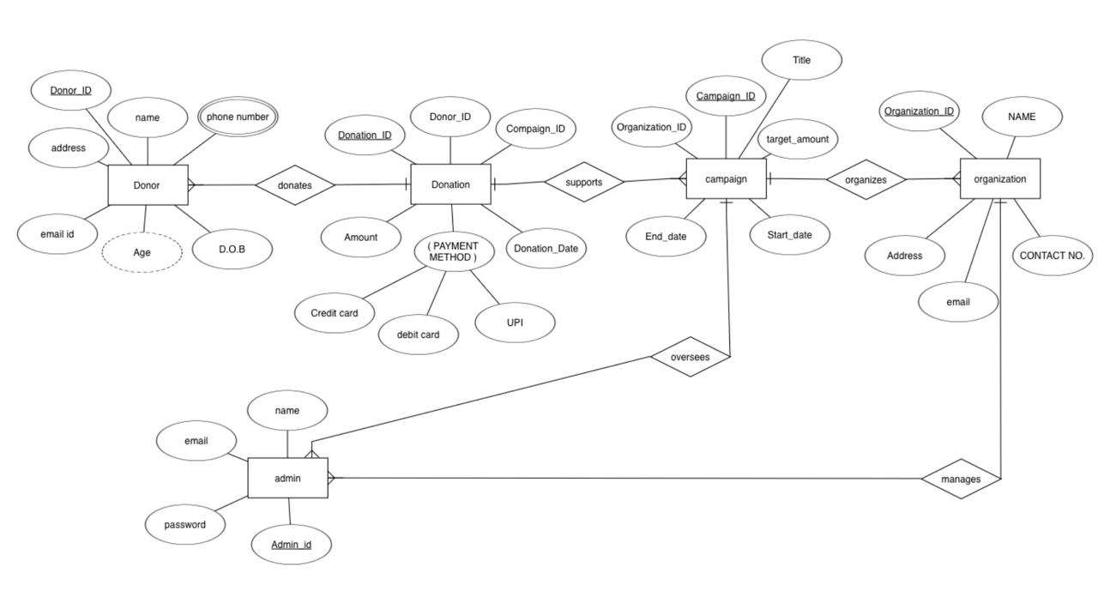

**ER Model**

**Relational Table(Schema)**

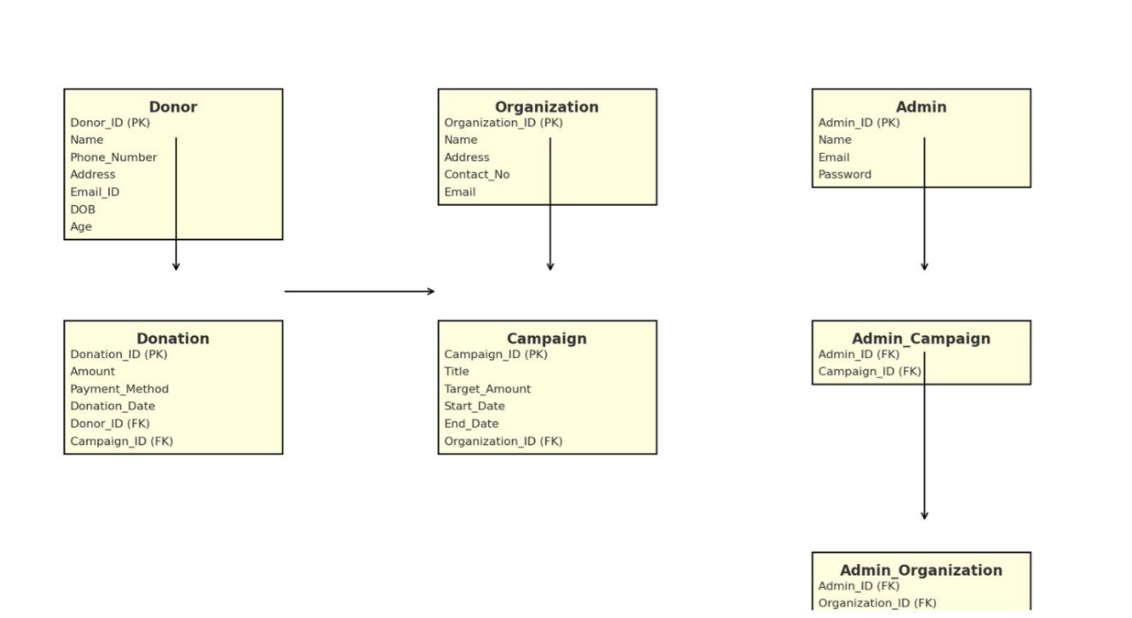

**Queries**

**Q1.** Get names of all donors.  
 π_Name(Donor)

**Q2.** Retrieve details of all campaigns run by organization ID = 101.  
 σ_Organization_ID = 101(Campaign)

**Q3.** List donor names who have made donations.  
π_Name(Donor ⨝ Donation)

**Q4.** Find all campaigns that have received donations greater than 10,000.  
π_Title(σ_Amount > 10000(Donation ⨝ Campaign))

**Q5.** Get email addresses of all organizations.  
π_Email(Organization)

**Q6.** List donor names who donated to campaign ID = 202.  
π_Name(σ_Campaign_ID = 202(Donor ⨝ Donation))

**Q7.** Find campaigns managed by a specific admin (say Admin_ID = 1).  
π_Title(Campaign ⨝ Organization ⨝ Admin σ_Admin_ID = 1)

**Q8.** Retrieve all donations made on “2025-01-01”.  
σ_Donation_Date = '2025-01-01'(Donation)

**Q9.** List donors who have donated more than once.  
π_Name(γ_Donor_ID, COUNT(Donation_ID) > 1(Donation ⨝ Donor))

**Q10.** Get campaigns whose target amount is greater than 1,00,000.  
σ_Target_Amount > 100000(Campaign)

**Q11.** Find donors who have not made any donations.  
π_Name(Donor) – π_Name(Donor ⨝ Donation)

**Q12.** Retrieve the total donation amount per campaign.  
γ_Campaign_ID, SUM(Amount)(Donation)

**Q13.** List organizations that have not started any campaign.  
π_Name(Organization) – π_Name(Organization ⨝ Campaign)

**Q14.** Get all campaigns that are currently active between ‘2025-01-01’ and ‘2025-12-31’.  
σ_Start_Date ≥ '2025-01-01' ∧ End_Date ≤ '2025-12-31'(Campaign)

**Q15.** Find donors who donated using “Credit Card”.  
π_Name(σ_Payment_Method = 'Credit Card'(Donation ⨝ Donor))

**Q16.** Retrieve campaign titles and their organizations’ names.  
π_Title, Name(Campaign ⨝ Organization)

**Q17.** Find campaigns that have received no donations.  
π_Campaign_ID(Campaign) – π_Campaign_ID(Donation)

**Q18.** List all donors and the campaigns they supported.  
π_Name, Title(Donor ⨝ Donation ⨝ Campaign)

**Q19.** Get the maximum donation amount received in any campaign.  
γ_MAX(Amount)(Donation)

**Q20.** Retrieve total donations received by each organization.  
γ_Organization_ID, SUM(Amount)(Donation ⨝ Campaign)

**Q21.** List donor names who contributed to more than one campaign.  
π_Name(γ_Donor_ID, COUNT(DISTINCT Campaign_ID) > 1(Donation ⨝ Donor))

**Q22.** Find campaigns where collected donations exceeded target amount.  
π_Title(γ_Campaign_ID, SUM(Amount)(Donation) ⨝ σ_SUM(Amount) > Target_Amount(Campaign))

**Q23.** Get details of admins who manage at least one organization.  
π_Name, Email(Admin ⨝ Organization)

**Q24.** List organizations with campaigns ending in December 2025.  
π_Name(σ_End_Date LIKE '2025-12-%'(Organization ⨝ Campaign))

**Q25.** Generate a summary report: campaign title, total donations, and number of donors.  
γ_Title, SUM(Amount), COUNT(Donor_ID)(Campaign ⨝ Donation)