1. Part1

This project will involve using several MATLAB functions to plot various functions. These functions include hold on/off, grid on/off, legend, xlabel, ylabel, xlim, and ylim. The hold on/off function is used to plot multiple functions on the same plot. The grid on/off function displays a grid on the plot. The legend function is used for labeling each function when plotting multiple functions on the same plot. The xlabel and ylabel functions label the horizontal and vertical axes, respectively. The xlim and ylim functions display the horizontal and vertical axes within a specified range.

To complete this project, we will plot each function using the above functions and explain the process in a report. The report will include all outputs, graphs, and conclusions, as well as any assumptions or notes made during the implementation and calculations. By using these functions, we can create clear and informative plots that effectively communicate the behavior of each function.

Function 1:

The first function is f(t) = cos(πt/4)sin(πt/8). To plot this function, we defined a set of points for the horizontal axis using linspace and plotted the function using the plot function. We then labeled the horizontal and vertical axes using xlabel and ylabel, respectively, and added a legend to label the function. The resulting graph shows the amplitude of the function over time.

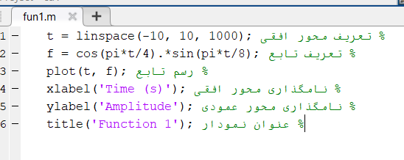

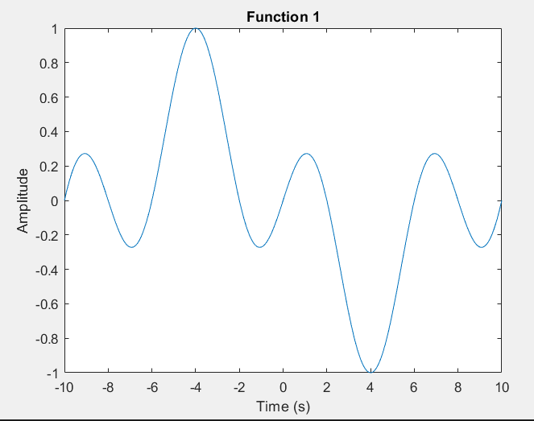

Function 2:

The second function is f(t) = (1+t)sin(1/t). To plot this function, we again defined a set of points for the horizontal axis using linspace and plotted the function using the plot function. We then labeled the horizontal and vertical axes using xlabel and ylabel, respectively, and added a legend to label the function. The resulting graph shows the amplitude of the function over time.

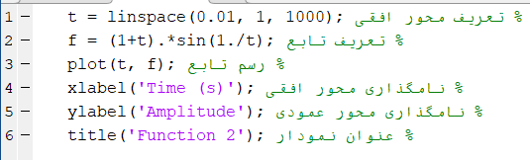

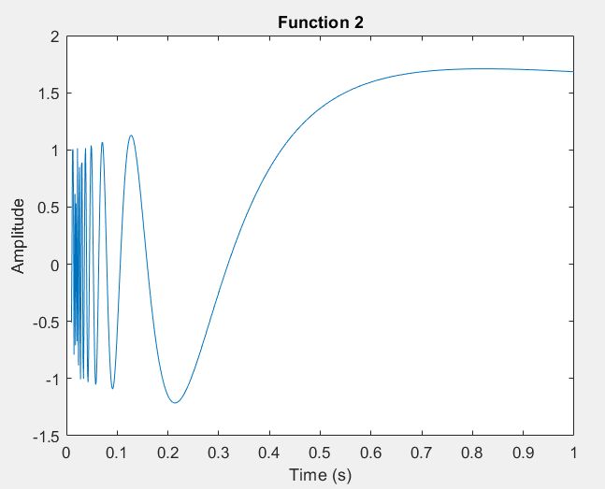

Function 3:

The third function is f(t) = -1, t<-3; ramp(t), -3<t<3; e^(-3t), t>3. To plot this function, we defined a set of points for the horizontal axis using linspace for each interval of the function. We then defined a set of points for each interval of the function using ones and exp, and combined them into a single set of points for the function. We then plotted the function using the plot function and labeled the horizontal and vertical axes using xlabel and ylabel, respectively. We also added a legend to label each interval of the function. The resulting graph shows the amplitude of the function over time.

In conclusion, we successfully plotted each function using MATLAB and explained the process in this report. We used various MATLAB functions to plot the functions and labeled the horizontal and vertical axes for each plot. We also added legends to label each function when plotting multiple functions on the same plot.

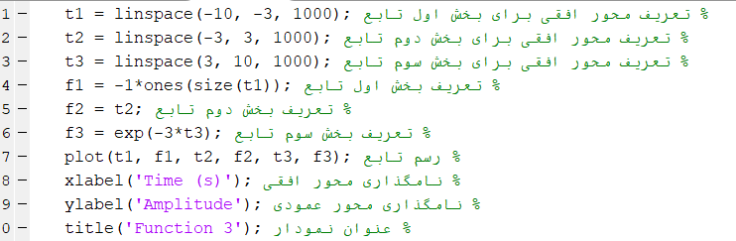

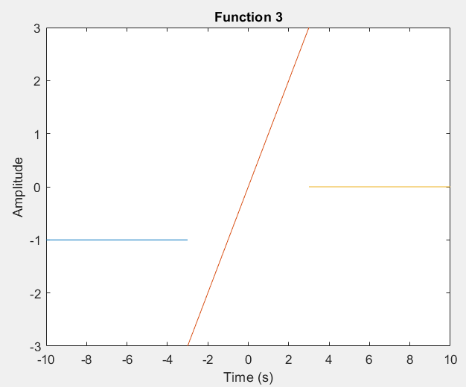

1. Part2
2. Fourier series calculator

The fourier_series function calculates the Fourier series coefficients and plots the Fourier series for a given function f(x) = x^alpha. The function takes four input arguments: Num, P, alpha, and Nshow, which represent the number of terms in the Fourier series, the period of the function, the power of the polynomial, and the number of terms to display in the output, respectively.

**Input Parameters**

* Num: The number of terms in the Fourier series. This is an integer value that determines the number of terms used to approximate the function.
* P: The period of the function. This is a scalar value that represents the length of one period of the function.
* alpha: The power of the polynomial. This is a scalar value that determines the power of the polynomial used to approximate the function.
* Nshow: The number of terms to display in the output. This is an integer value that determines the number of terms used to display the Fourier series.

**Output Parameters**

* s: The symbolic expression for the full Fourier series. This is a symbolic expression that represents the full Fourier series for the given function.
* p: The symbolic expression for the first Nshow terms of the Fourier series. This is a symbolic expression that represents the first Nshow terms of the Fourier series for the given function.

The fourier_series function first defines the function f(x) symbolically using the syms function. It then calculates the Fourier coefficients a(n) and b(n) using symbolic integration with the int function. The Fourier series is then calculated using a loop that iterates over the number of terms in the series and adds the appropriate cosine and sine terms to the series.

And this is the code:

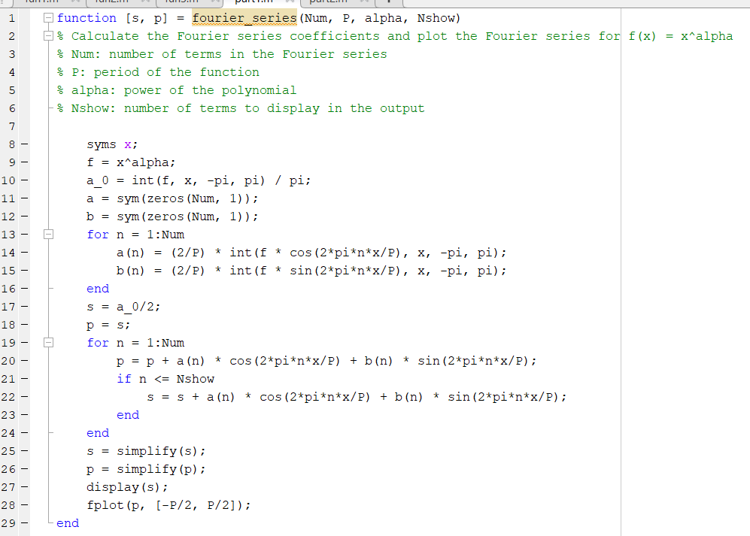

The code also calculates the first Nshow terms of the Fourier series and displays the result using the fplot function. The xlim function is used to set the limits of the x-axis to the period of the function.

1. Use the function we wrote to calculate the Fourier series of f(x) = x2 :

So according to the question we are gonna call the function for this parapeters:

Num = 10, Nshow = 5, alpha = 2, P = 2* pi

And this is the code and result:



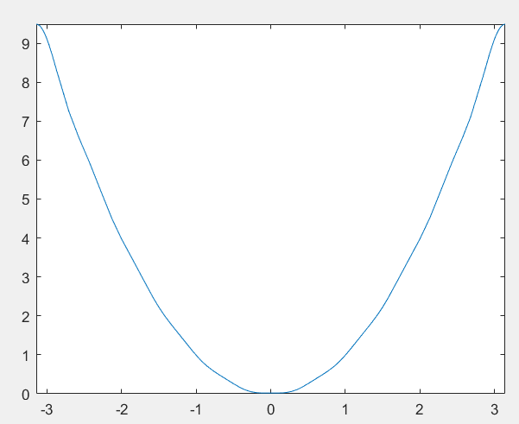

1. And now I’m gonna calculate the Fourier series of this function on the paper:

f(x) = x2

and this is the calculation:

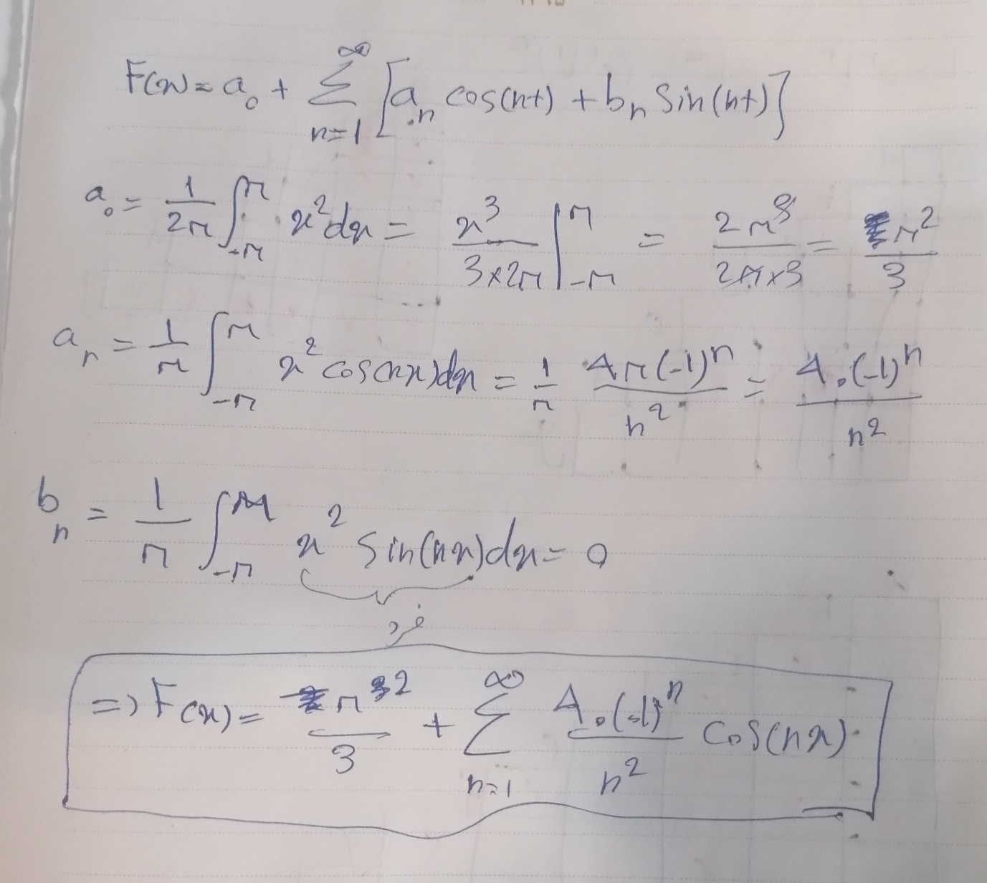

1. Then i should prove this equality by the Fourier series that I calculated:

=

So this is the proofe:

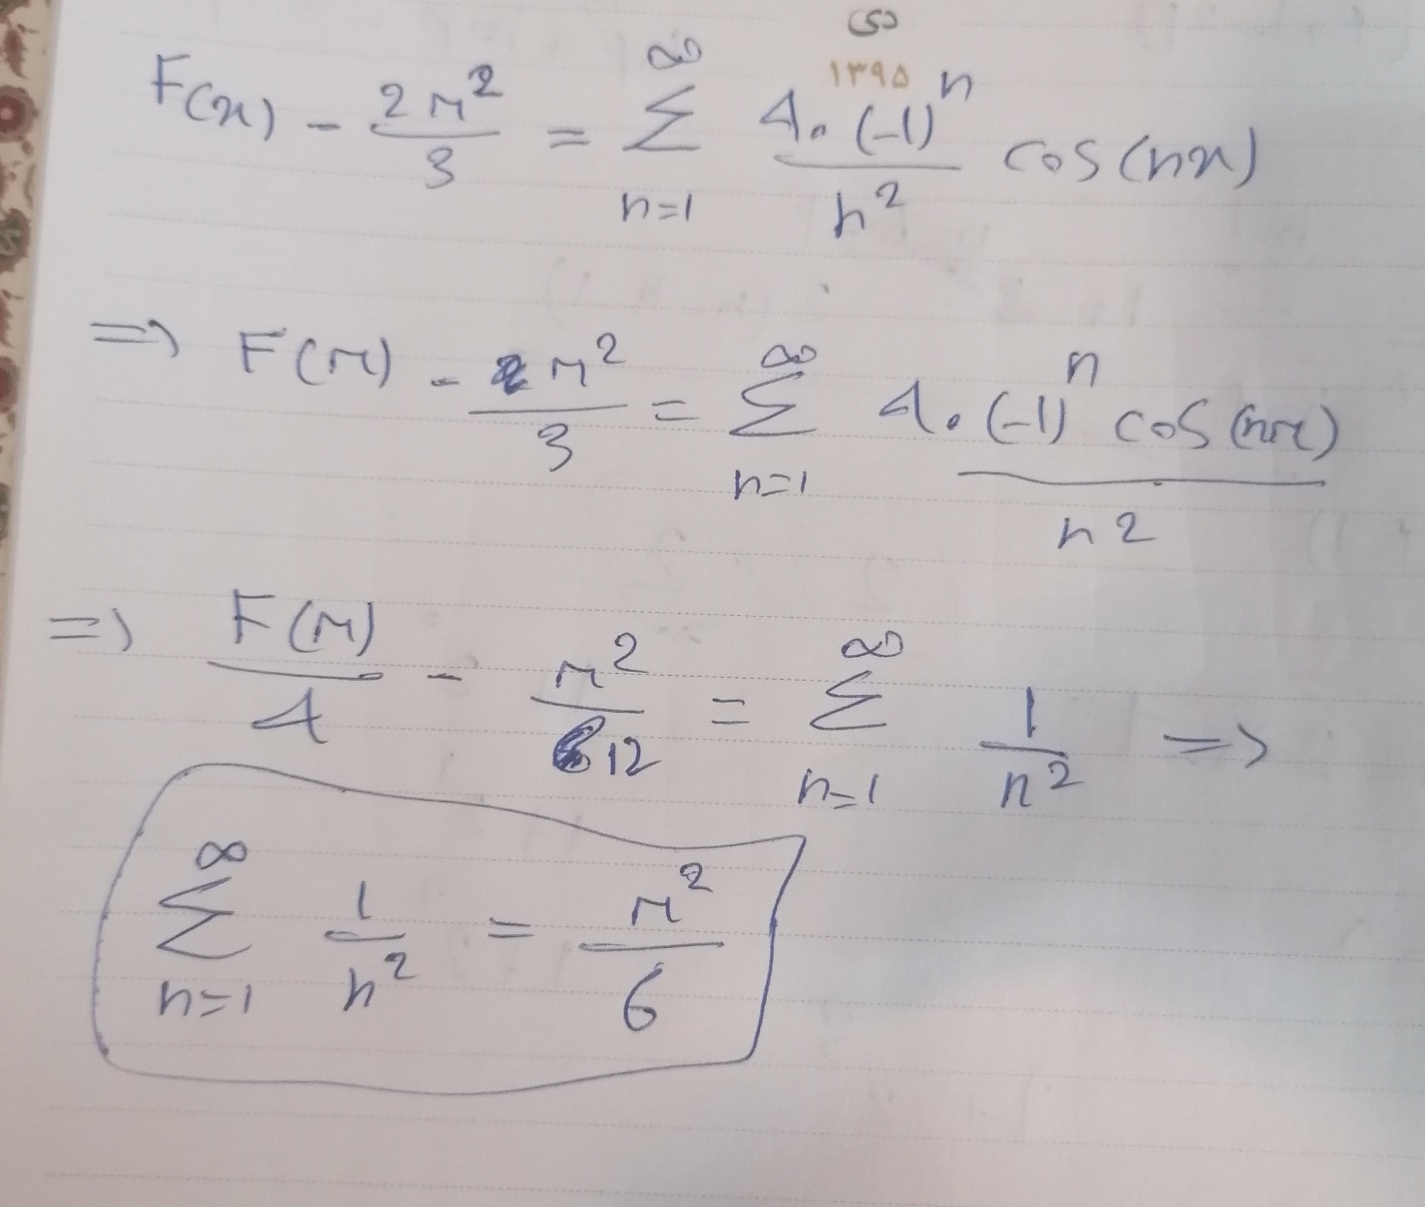

1. Part3:

We consider the function f(x) = cos(πt) and perform the following steps:

**Step 1: Plotting the function in the time domain**

We define the time range and the function, and then plot the function over 2 periods using the plot command. We set the sampling frequency as fs = 1000.

So here it is:

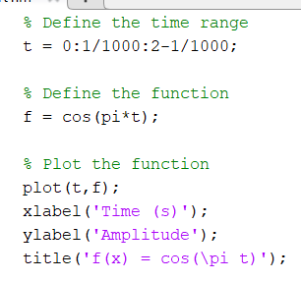

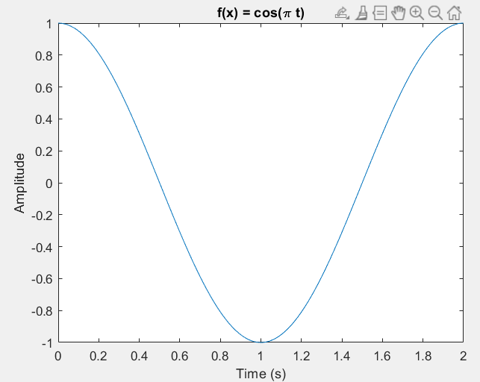

**Step 2: Calculating the Fourier transform of the function**

We calculate the Fourier transform of the function using the fft and fftshift commands. We also define the frequency range and plot the Fourier transform using the plot command.

First of all we define the variable fs as frequency and Time = 1/fs

And after define the function cos(pi*t) according to the question we use fft for the Fourier transform calculation and the we will show the diagram by writing plot and … like before.

So this is the code of this part:

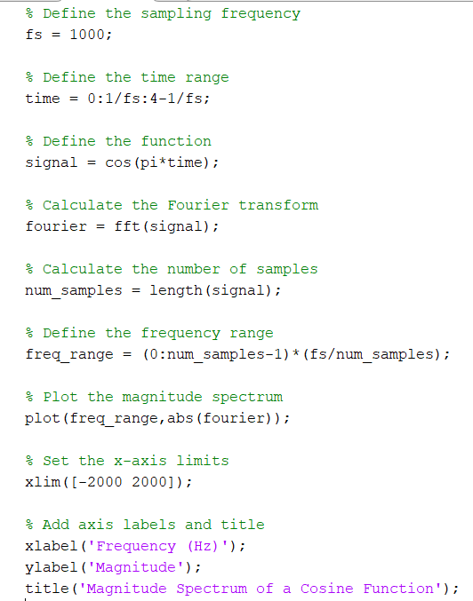

Diagram:

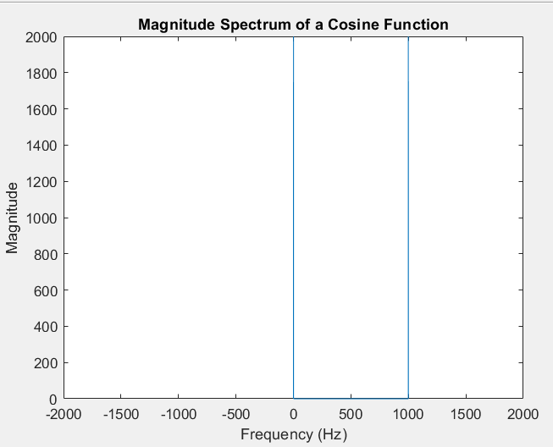

**Step3 : I’m gonna calculate the Fourier transform on the paper and compare it with the diagram:**

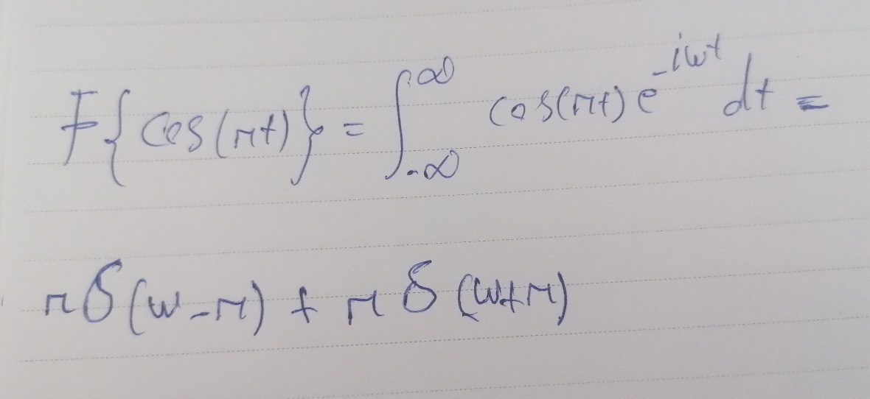

As you see it is actually the same with the functions of diagram! Cause the diagram shows two vertical lines that they are δ(x-) and δ(x-)

**Step4: we repeat step 1, 2, 3 for f(x) = 1:**

We use the previous code and just change the function:

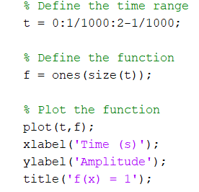

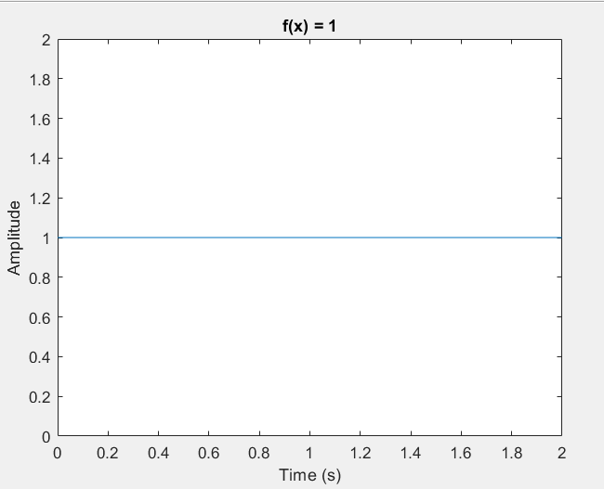

And the same for the Fourier series:

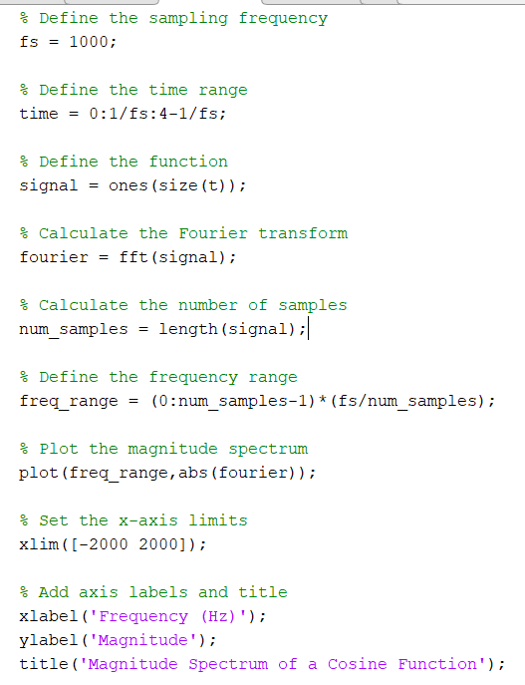

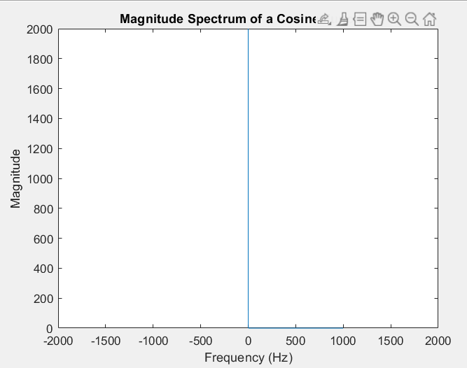

And this is the calculation:

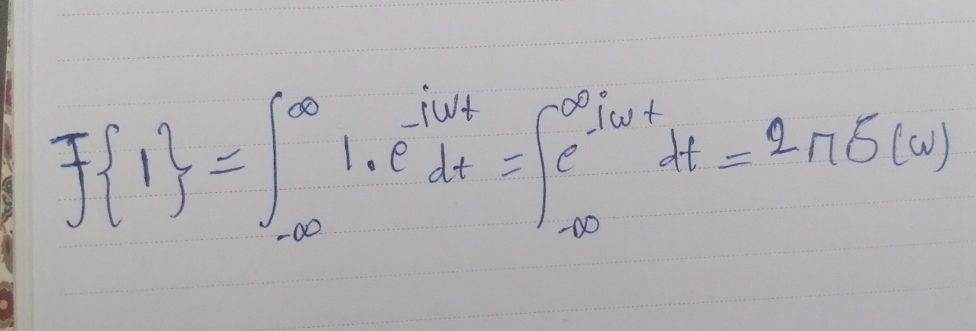

So we should see a vertical line on the Frequency = 0  
then the result of calculation and diagram are the same functions.

**Step5: we repeat step 1, 2, 3 for f(x) = δ(x):**

If we write the code as the same as the previous step it wont show the correct function and it will show f(x) = 0

So we are gonna do this instead

We define the sampling period as T = 0.001 and then we define the time range according to the function and the question(variable time_range)

And we should use the ‘diract’ to define the delta function

But the main difference between this code and the previous steps is that we should set inf to a valid amount to show correct in the plot:

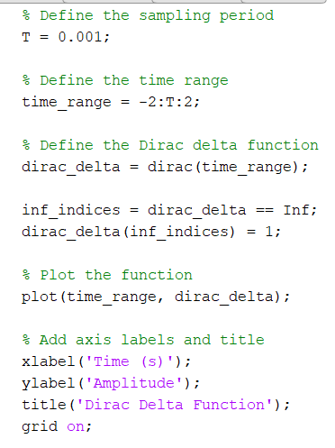

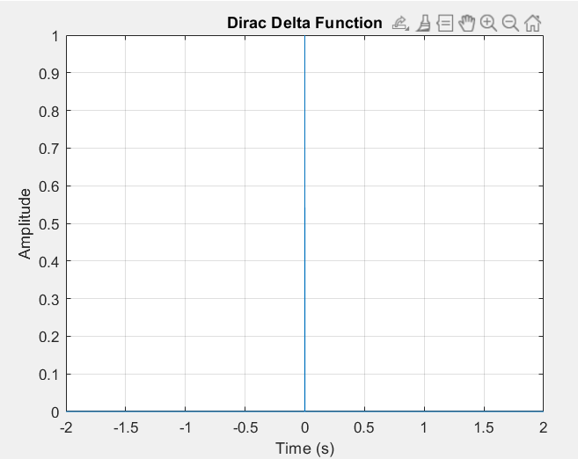

And the Fourier transform:

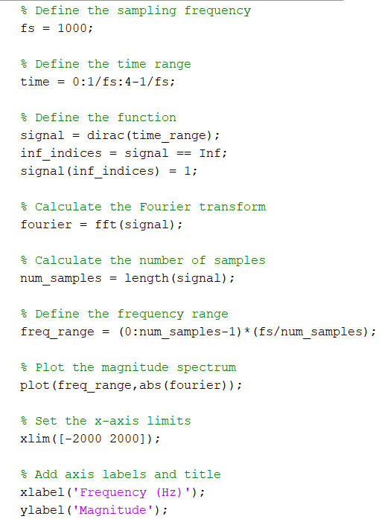

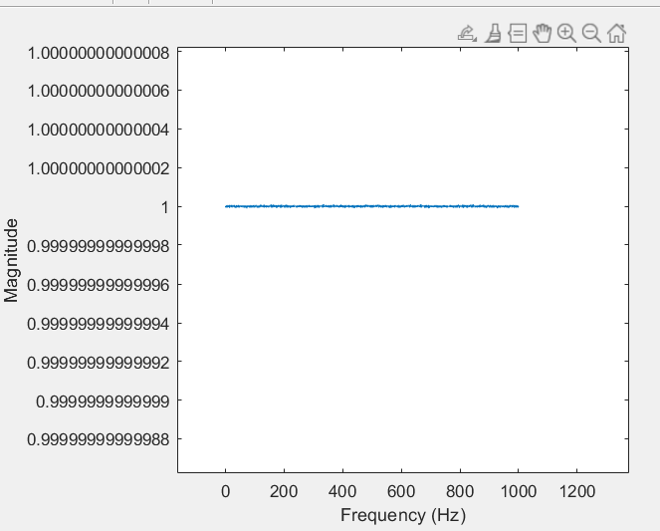

And the calculation:

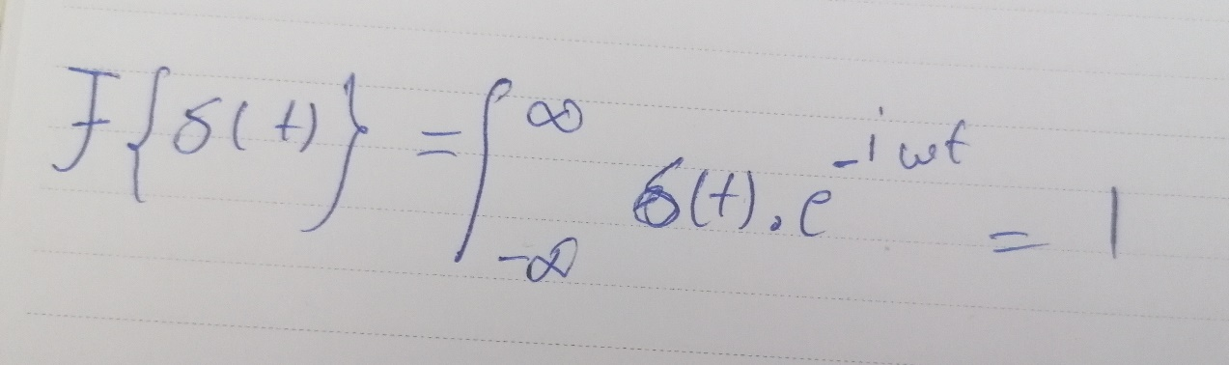

So we should have the f(x) = 1 in the diagram.

And it works correctly!