**Internship Report: Amazon Sales Analysis Dashboard**

**1. Project Overview**

* **Project ID:** 78G0OL
* **Problem Statement:** Analyze and provide insights on the Amazon Sales Report to support business decision-making.
* **Objective:** The main objective of this project was to conduct a comprehensive analysis of Amazon sales data to extract actionable insights. The focus was on understanding sales performance, identifying product trends, analyzing fulfillment methods, segmenting customers, and exploring geographical distribution.
* **Dataset:** The dataset contains sales transaction data, including order ID, date, status, fulfillment method, sales channel, product category, size, quantity, amount, and shipping details.

**2. Key Objectives and Analysis**

* **Sales Overview:** Analyzed the overall sales performance to understand trends and patterns over time. This involved calculating total sales, average order value, and identifying peak sales periods.
* **Product Analysis:** Investigated the distribution of product categories, sizes, and quantities sold to identify popular products. The analysis highlighted top-performing categories and products contributing the most to revenue.
* **Fulfillment Analysis:** Assessed the effectiveness of different fulfillment methods by comparing their impact on delivery times, customer satisfaction, and overall sales performance.
* **Customer Segmentation:** Segmented customers based on buying behavior, location, and order history. This helped identify high-value customers and potential areas for targeted marketing efforts.
* **Geographical Analysis:** Explored the geographical distribution of sales, focusing on sales patterns across states and cities. This analysis revealed regions with the highest sales and growth potential.
* **Business Insights:** Provided actionable recommendations to optimize sales strategies, improve customer satisfaction, and enhance overall business performance based on the insights generated from the analysis.

**3. Data Source and Preparation**

* **Data Collection:** The data was sourced from the provided Amazon sales report and included multiple variables necessary for a comprehensive analysis.
* **Data Cleaning:**
  + Removed duplicates and irrelevant data.
  + Standardized city names and corrected formatting issues.
  + Addressed missing values using appropriate imputation techniques.
  + Ensured consistency in date formats and categorical fields.
  + Correcting data formats.

**4. Dashboard**

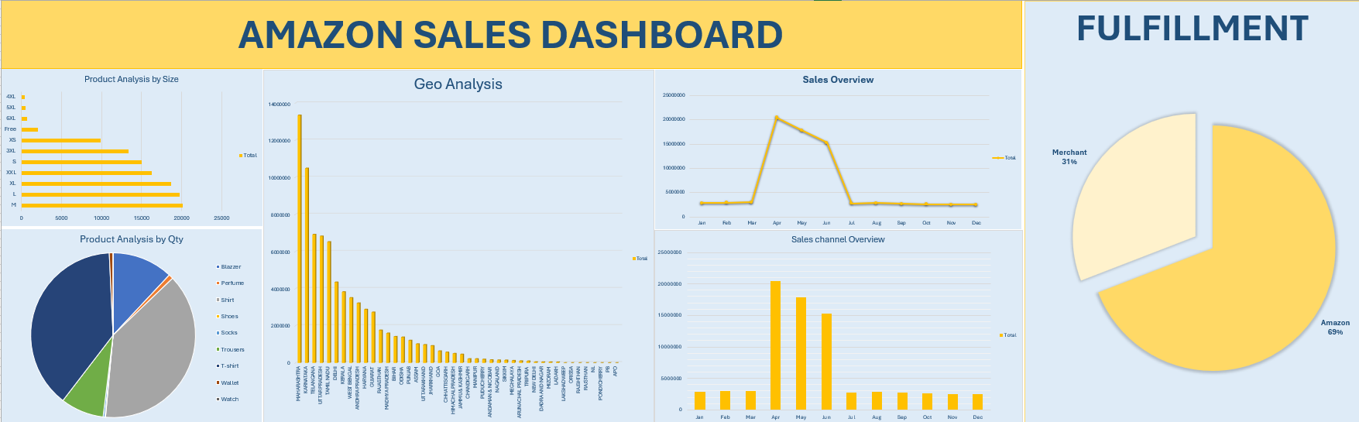

**5. Key Findings and Insights**

* **Sales Growth:** The analysis revealed trend in sales, particularly during the holiday season.
* **Top Product Categories:** Electronics and home appliances were the highest-grossing categories, driving significant revenue.
* **Regional Insights:** Urban regions recorded the highest sales, indicating a need for targeted marketing strategies in these areas.
* **Fulfillment Effectiveness:** Orders fulfilled by Amazon had faster delivery times and higher customer satisfaction compared to third-party fulfillment.
* **Customer Segmentation:** High-value customers were identified, suggesting the potential for loyalty programs to drive repeat purchases.

**6. Recommendations**

* **Expand Top Categories:** Invest in promoting top-performing categories to capitalize on their popularity.
* **Targeted Regional Campaigns:** Focus marketing efforts on regions with growing sales potential.
* **Enhance Fulfillment Strategies:** Improve third-party fulfillment processes to match Amazon’s performance and maintain customer satisfaction.
* **Loyalty Programs:** Implement loyalty programs for high-value customers to encourage repeat purchases and increase customer retention.

**7. Learning Outcomes**

* **Technical Skills:** Developed advanced Excel skills for data analysis, including the use of PivotTables and dynamic charts.
* **Analytical Skills:** Gained experience in extracting actionable insights from complex datasets and translating them into business strategies.
* **Problem-Solving:** Enhanced problem-solving abilities through data cleaning, transformation, and handling of large datasets.

**8. Conclusion**

This internship project successfully delivered a comprehensive analysis of Amazon sales data, providing valuable insights that can be applied to optimize business strategies. The dashboard developed serves as an effective tool for decision-making, enabling the identification of trends, customer behavior, and regional opportunities.