Data Analytics – R Programming



**Faculty of CHAIR & SCOPE**

BCSE351E L[25+26]

**Submitted By: Win Verma**

**Registration Number: 21BLC1219**

**Submitted To:**

**Dr. Vijayarajan**

**Date: 07/06/2023**

**Email:** [**win.verma2021@vitstudent.ac.in**](mailto:win.verma2021@vitstudent.ac.in)

Lab Report - 3

Data Analytics – R Programming

Lab Report – 3

Using R-Studio to Visualize Sample Codes

Aim:

* R programming and performing required operations.
* Reading datasets using RStudio.
* To view the details with RStudio.
* To learn about Data Framing using Data Structures in R programming with R Studio [Latest Version with ALL Required Packages Installed].

# Data_frame0.R:

celebrities <- data.frame(

name = c("Andrew", "Mathew", "Dany", "Philip", "John", "Bing", "Monica"), age = c(28, 23, 49, 29, 38, 23, 29),

income = c(25.2, 10.5, 11, 21.9, 44, 11.5, 45)

)

 Get elements from rows (2,5), columns (1,3) elements <- celebrities[c(2, 5), c(1, 3)]

print(elements)

age <- c(17, 19, 21, 37, 18, 19, 47, 18, 19)

score <- c(12, 10, 11, 15, 16, 14, 25, 21, 29)

who()

expt <- data.frame(age, gender, group, score)  Assuming gender and group are available variables

expt$score names(expt) who(expand = TRUE)

Lab Report - 3

Data Analytics – R Programming

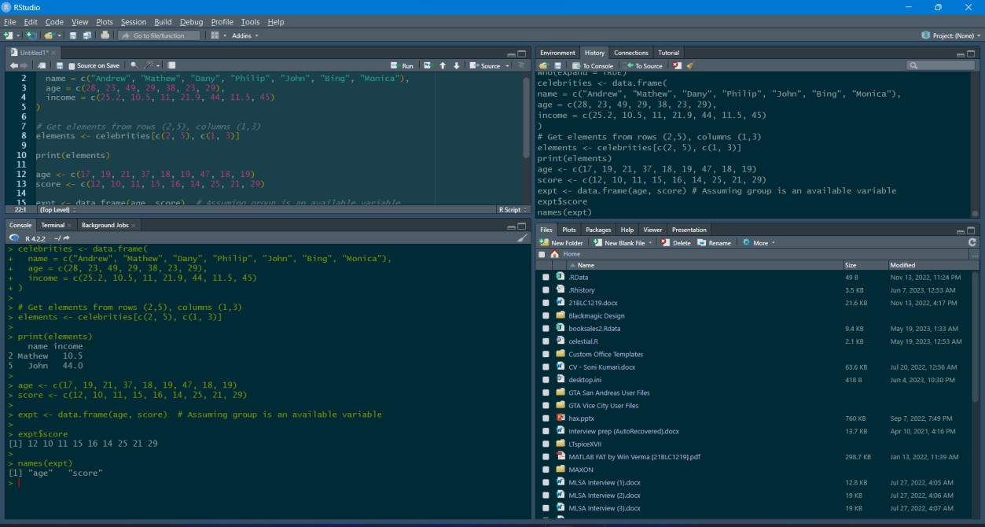

# Data_frame1.R:

 Write an R program to create an empty data frame. df <- data.frame(

Ints = integer(), Doubles = double(),

Characters = character(), Logicals = logical(), Factors = factor(), stringsAsFactors = FALSE

)

print("Structure of the empty dataframe:") print(str(df))

 Write an R program to create a data frame from four given vectors.

 Write an R program to get the structure of a given data frame.

 Write an R program to save the information of a data frame in a file and display the information of the file.

name <- c('Alex', 'Roy', 'Kathe', 'James', 'Emily', 'Mike', 'Matt', 'Little', 'Kevin', 'Jonas') score <- c(12.5, 9, 16.5, 12, 9, 20, 14.5, 13.5, 8, 19)

attempts <- c(1, 3, 2, 3, 2, 3, 1, 1, 2, 1)

qualify <- c('yes', 'no', 'yes', 'no', 'no', 'yes', 'yes', 'no', 'no', 'yes')

print("Original data frame:") print(name)

print(score) print(attempts) print(qualify)

Lab Report - 3

Data Analytics – R Programming

exam_data <- data.frame(name, score, attempts, qualify)

print("Original dataframe:") print(exam_data)

print("Structure of the said data frame:") print(str(exam_data))

save(exam_data, file = "data.rda") load("data.rda") file.info("data.rda")

 Write an R program to extract 3rd and 5th rows with 1st and 3rd columns from a given data frame.

print("Extract 3rd and 5th rows with 1st and 3rd columns:") result <- exam_data[c(3, 5), c(1, 3)]

print(result)

 Write an R program to replace NA values with 3 in a given data frame.

exam_data <- data.frame(

name = c('Alex', 'Roy', 'Kathe', 'James', 'Emily', 'Mike', 'Matt', 'Little', 'Kevin', 'Jonas'), score = c(12.5, 9, 16.5, 12, 9, 20, 14.5, 13.5, 8, 19),

attempts = c(1, NA, 2, NA, 2, NA, 1, NA, 2, 1),

qualify = c('yes', 'no', 'yes', 'no', 'no', 'yes', 'yes', 'no', 'no', 'yes')

)

print("Original dataframe:") print(exam_data)

exam_data[is.na(exam_data)] <- 3

print("After removing NA with 3, the said dataframe becomes:") print(exam_data)

 Write an R program to create a data frame using two given vectors and display the duplicated elements and unique rows of the said data frame.

a <- c(10, 20, 10, 10, 40, 50, 20, 30)

b <- c(10, 30, 10, 20, 0, 50, 30, 30)

print("Original data frame:") ab <- data.frame(a, b) print(ab)

print("Duplicate elements of the said data frame:") print(duplicated(ab))

Lab Report - 3

Data Analytics – R Programming

print("Unique rows of the said data frame:") print(unique(ab))

 Write an R program to count the number of NA values in a data frame column.

exam_data <- data.frame(

name = c('Alex', 'Roy', 'Kathe', 'James', 'Emily', 'Mike', 'Jonas'), score = c(12.5, 9, 16.5, 12, 9, 20, 13.5),

attempts = c(1, NA, 2, NA, 2, NA, NA),

qualify = c('yes', 'no', 'yes', 'no', 'no', 'yes', 'no')

)

print("Original dataframe:") print(exam_data)

print("The number of NA values in attempts column:") print(sum(is.na(exam_data$attempts)))

 Write an R program to find elements that come only once and are common to both given data frames.

a <- c("a", "ob", "eo", "dar", "Te")

b <- c("d", "Te", "new", "g")

print("Original Dataframes") print(a)

print(b)

print("Find elements that come only once and are common to both given dataframes:") result <- intersect(a[!duplicated(a) & !duplicated(a, fromLast = TRUE)], b[!duplicated(b) &

!duplicated(b, fromLast = TRUE)]) print(result)

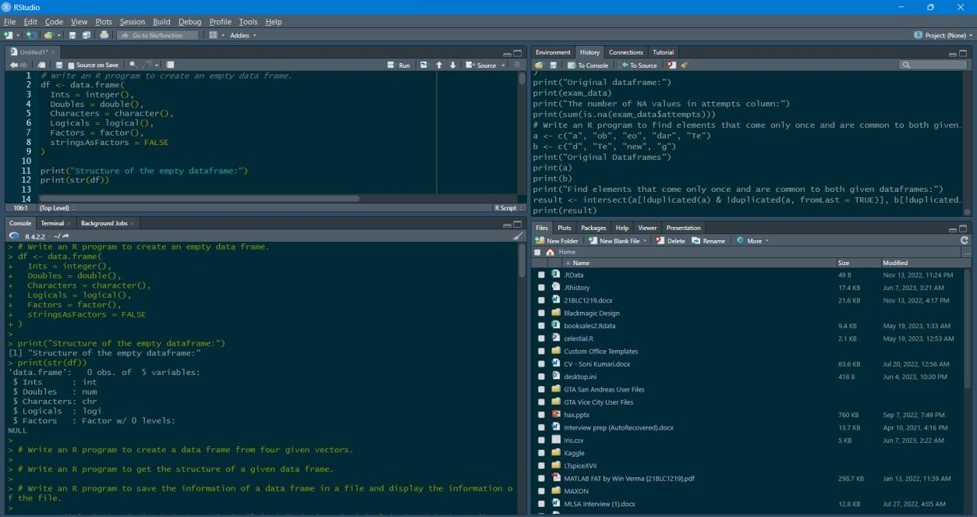

Lab Report - 3

Data Analytics – R Programming

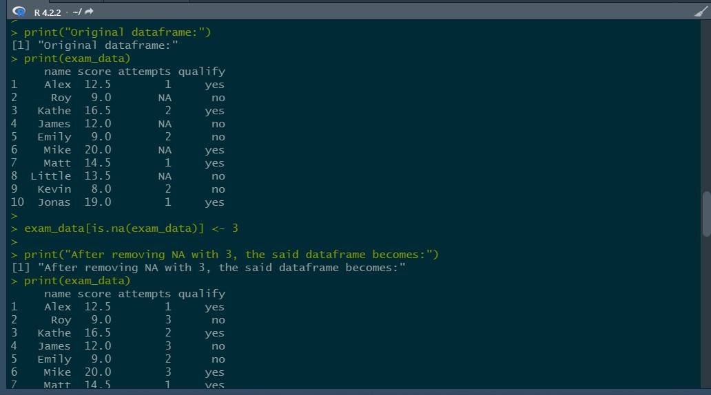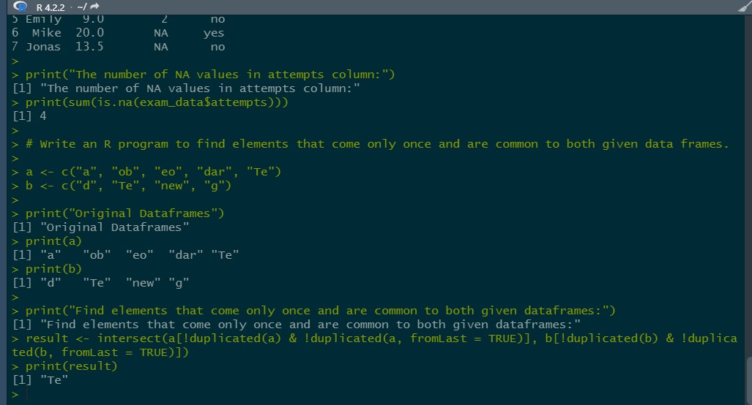

# Data_frame2.R:

 Write an R program to call the (built-in) dataset airquality. Check whether it is a data frame or not? Order the entire data frame

data <- airquality

print("Original data: Daily air quality measurements in New York, May to September 1973.")

print(class(data)) print(head(data, 10))

Lab Report - 3

Data Analytics – R Programming

result <- data[order(data[, 1], data[, 2]), ]

print("Order the entire data frame by the first and second column:") print(result)

data$Solar.R <- NULL data$Wind <- NULL

print("data.frame after removing 'Solar.R' and 'Wind' variables:") print(head(data, 10))

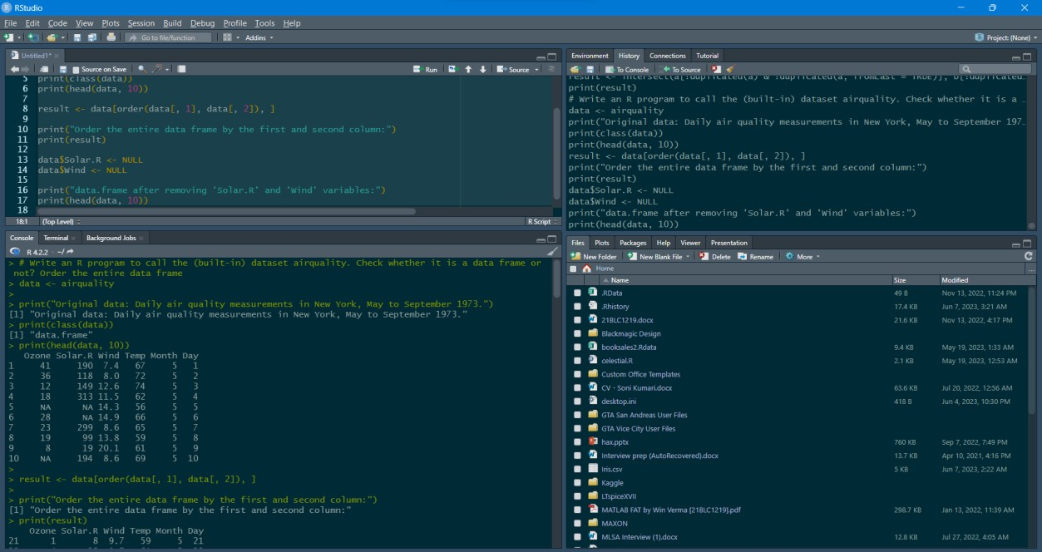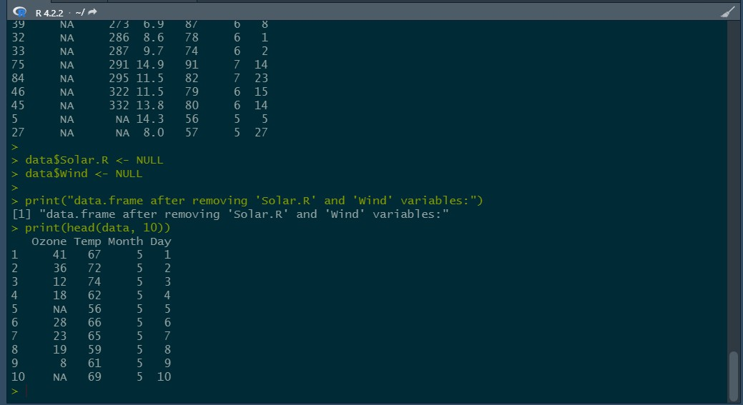

Lab Report - 3

Data Analytics – R Programming

# Data_frame3.R:

 Write an R program to add new row(s) to an existing data frame. exam_data <- data.frame(

name = c('Alex', 'Roy', 'Kathe', 'James', 'Emily', 'Jonas'), score = c(12.5, 9, 16.5, 12, 9, 20),

attempts = c(1, 3, 2, 3, 2, 3),

qualify = c('yes', 'no', 'yes', 'no', 'no', 'yes')

)

print("Original dataframe:") print(exam_data)

new_exam_data <- data.frame( name = c('Robert', 'Sophia'), score = c(10.5, 9),

attempts = c(1, 3), qualify = c('yes', 'no')

)

exam_data <- rbind(exam_data, new_exam_data)

print("After adding new row(s) to an existing data frame:") print(exam_data)

 Write an R program to add a new column in a given data frame. print("New data frame after adding the 'country' column:")

country <- c("USA", "USA", "USA", "USA", "USA", "USA", "USA", "USA")

n <- nrow(exam_data)

exam_data$country <- rep(country, length.out = n) print(exam_data)

 Write an R program to sort a given data frame by multiple column(s). exam_data <- exam_data[with(exam_data, order(name, score)), ]

print(exam_data)

exam_data <- exam_data[with(exam_data, order(attempts, score)), ] print(exam_data)

Lab Report - 3

Data Analytics – R Programming

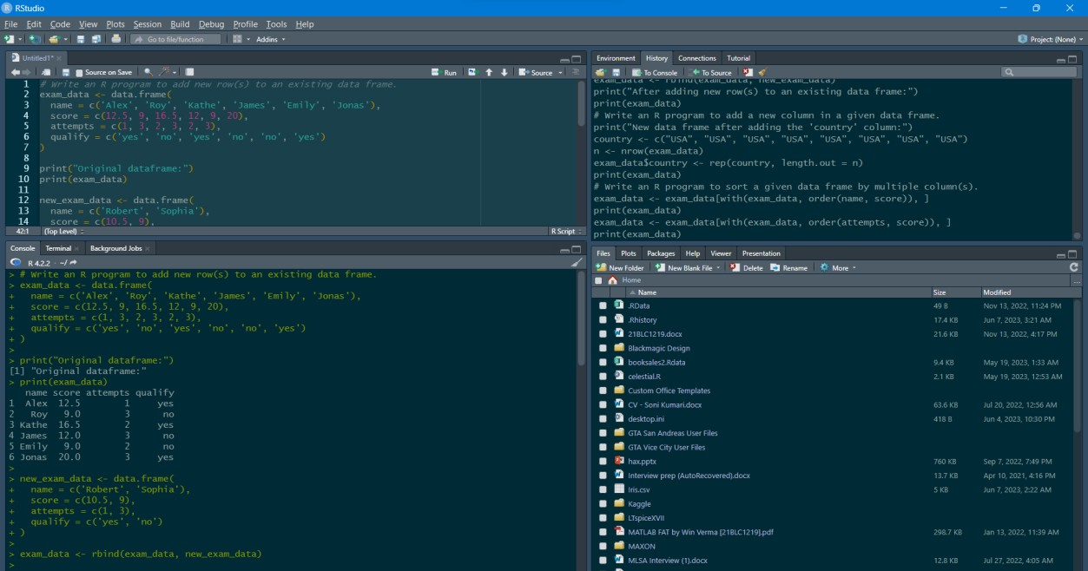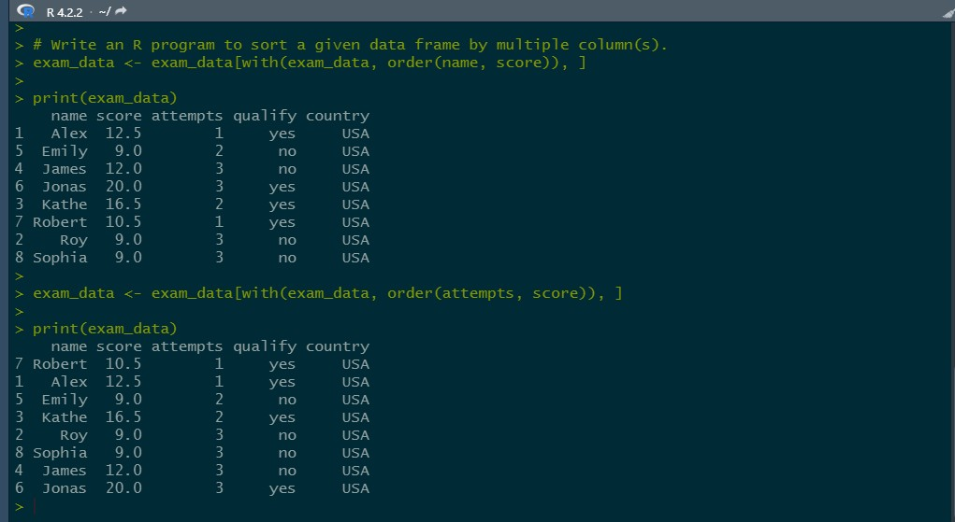

# Data_frame4.R:

 Write an R program to create inner, outer, left, right join (merge) from given two data frames.

dfl <- data.frame(numid = c(12, 14, 10, 11))

df2 <- data.frame(numid = c(13, 15, 11, 12))

print("Left outer Join:")

result <- merge(dfl, df2, by = "numid", all.x = TRUE) print(result)

Lab Report - 3

Data Analytics – R Programming

print("Right outer Join:")

result <- merge(dfl, df2, by = "numid", all.y = TRUE) print(result)

print("Outer Join:")

result <- merge(dfl, df2, by = "numid", all = TRUE) print(result)

print("Cross Join:")

result <- merge(dfl, df2, by = NULL) print(result)

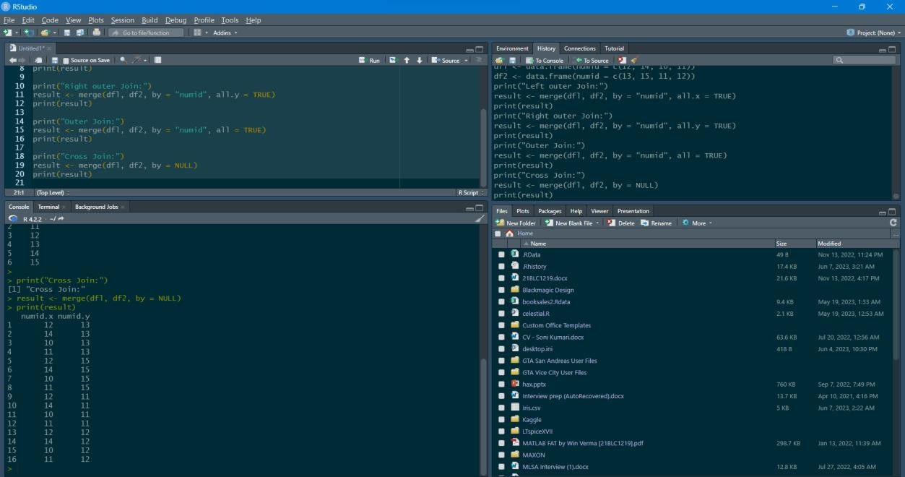

# Data_frame5.R:

 creating a data frame

data_frame <- data.frame(col1 = 1:10,

col2 = 11:20,

col3 = c(rep(TRUE, 4), rep(FALSE, 6)))

print("Original DataFrame") print(data_frame)

 defining the function user_defined_func <- function(x) {

 subtracting the value of 1 from each x - 1

K

data_frame_temp <- apply(data_frame[, c("col1", "col2")], 2, user_defined_func)

Lab Report - 3

Data Analytics – R Programming

print("Modified col2") print(data_frame_temp)

 retrieving the entire data frame data_frame_mod <- data_frame

 getting column names

colnames_mod <- colnames(data_frame_mod)

data_frame_mod[, colnames_mod %in% colnames(data_frame_temp)] <- data_frame_temp print("Modified DataFrame")

print(data_frame_mod)

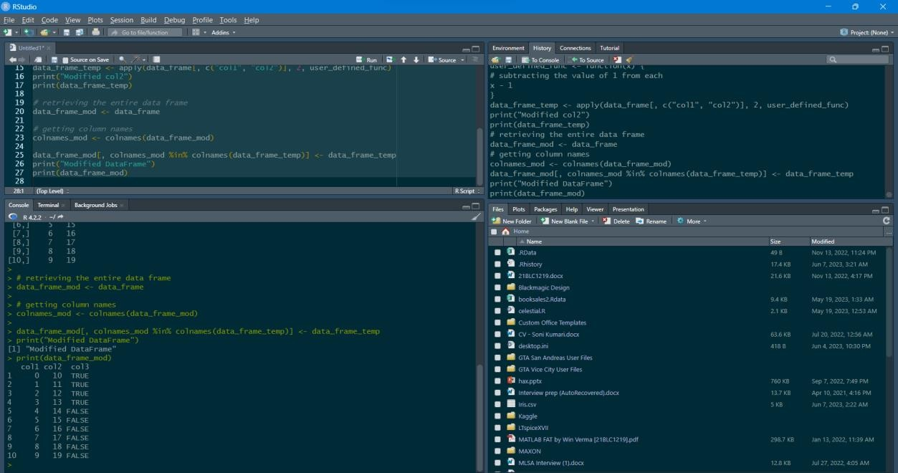

Thanks for scrolling all the way down till here! 😊

Lab Report - 3